1.Activity_Splash.xml
<?xml version="1.0" encoding="utf-8"?>
<RelativeLayout xmlns:android="http://schemas.android.com/apk/res/android"
android:layout_width="match_parent"
android:layout_height="match_parent"
android:background="#2196F3">
<!-- App Logo -->
<ImageView
android:id="@+id/logo"
android:layout_width="150dp"
android:layout_height="150dp"
android:src="@drawable/ic_launcher_foreground"
android:layout_centerInParent="true" />
<!-- App Name -->
<TextView
android:layout_width="wrap_content"
android:layout_height="wrap_content"
android:text="My App"
android:textSize="24sp"
android:textColor="#FFFFFF"
android:layout_below="@id/logo"
android:layout_centerHorizontal="true"
android:layout_marginTop="20dp"/>
</RelativeLayout>
2. SplashActivity.java
package com.example.myapplication;
import android.annotation.SuppressLint;
import androidx.appcompat.app.AppCompatActivity;
import android.content.Intent;
import android.os.Bundle;
import android.os.Handler;
@SuppressLint("CustomSplashScreen")
public class SplashActivity extends AppCompatActivity {
private static final int SPLASH_TIME_OUT = 3000; // 3 seconds
@Override
protected void onCreate(Bundle savedInstanceState) {
super.onCreate(savedInstanceState);
setContentView(R.layout.activity_splash);
new Handler().postDelayed(() -> {
// Start Main Activity
Intent i = new Intent(SplashActivity.this, MainActivity.class);
startActivity(i);
// Close Splash Activity
finish();
}, SPLASH_TIME_OUT);
}
}
3. MainActivity.java
package com.example.myapplication;
import androidx.appcompat.app.AppCompatActivity;
import android.os.Bundle;
public class MainActivity extends AppCompatActivity {
@Override
protected void onCreate(Bundle savedInstanceState) {
super.onCreate(savedInstanceState);
setContentView(R.layout.activity_main);
}
}
***OUTPUT***

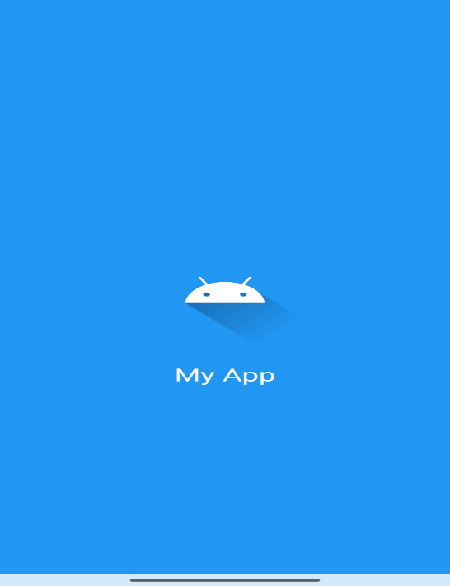

2. What is a Splash Screen?
A Splash Screen is the introductory screen that appears when an application is launched. It is the first interface the user sees before the main application screen loads. This screen is usually displayed for a few seconds and contains elements such as the application logo, name, tagline, animation, or loading indicator.
In mobile applications (like Android apps), the splash screen is implemented as a separate activity (e.g., SplashActivity) that runs before the main activity. It helps create a good first impression and provides a smooth transition into the application.
The splash screen may be static (just an image/logo) or dynamic (with animations, progress bars, or loading messages). After a specific time delay or after completing initialization tasks, it automatically redirects the user to the main screen of the application.

3. Why is it used?
A splash screen is used for several important purposes in application development:
1. Branding and Identity
It displays the application logo, name, and design theme, helping users recognize the app. This strengthens brand identity and gives a professional look.
2. Improves User Experience
Instead of showing a blank or unresponsive screen during app startup, a splash screen provides a visually appealing interface, making the app feel smoother and more user-friendly.
3. Loading and Initialization
It allows the application to perform background tasks such as:
- Loading resources (images, fonts, data)
- Initializing databases
- Setting up configurations or APIs
This ensures that the main screen loads properly without lag.
4. Navigation Control
Splash screens can be used to decide the next screen based on conditions such as:
- User login status (Login screen or Home screen)
- First-time user (Intro/Tutorial screen)
5. Professional Look
It enhances the overall look and feel of the application, making it appear more polished and well-designed.
6. Error Handling
In some cases, splash screens can be used to check for internet connectivity or app updates before moving forward.

