**INEURON-BATCH (2021-22)**

**NOVEMBER-27-2021**

**PYTHON BASIC ASSIGNMENT-1**

**Question-1:**

-> (*) is an expression

-> ‘hello’ is a value

-> -87.8 is a value

-> (-) is an expression

-> (/) is an expression

-> (+) is an expression

-> 6 is a value

**Question-2:**

String is a called as collection of characters which can be represented within “” or ‘ ’

“Variable” something acts like container which holds any value (any data type) in it

Variable reduces our hard coding task which helps us to save time

It doesn’t need to be mentioned in the “” or ‘’

Anything to the lefthand side of = (assigning operator) is a variable

**Question-3:**

**Lists:**

It can be represented syntactically as li= [ ]

It is an ordered collection of data. The data type of each element can be of any type

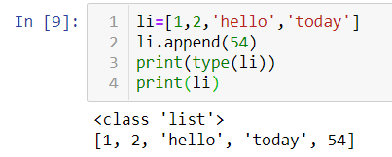

**Tuple:**

These are similar to the list but the main difference between the tuple and list is the mutability in the list (adding new elements to list is possible), but whereas the tuples are immutable which means adding new elements after the creation of the tuple is not possible.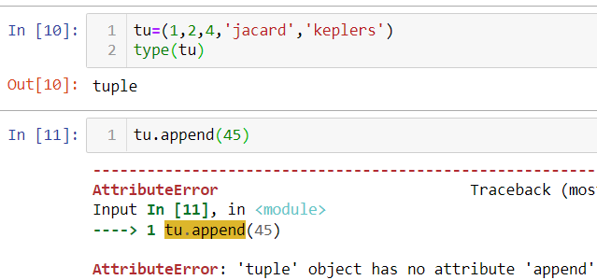

**Dictionary:**

Dictionary is one of the datatype in python. In which the data is embedded with key value pairs. This is mutable datatype, and it doesn’t accept if 2 keys have same name it will neglect all except the most recent one

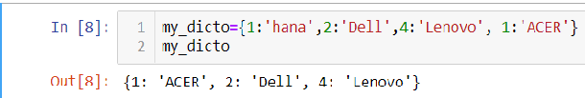

**Question-4:**

An expression is made up of mathematical operators, values, variables. And these can be reduced to some kind of value, which can be any python object.

**Question-5:**

Statement is anything which a python interpreter able to execute. While the expression is collection of operators, values, variables etc., so a statement may consist of the expression in them.

So here we are assigning the spam variable with operator (=) and with value 10.

**Question-6:**

The value will be equal to 22 because we added the bacon with 1 but we haven’t equalized the bacon with the bacon+1(like this bacon=bacon+1) so our value remains same

**Question-7:**

Both Values generated will be same because they both does the same thing which is multiplication is also called as repeated addition which is going here is that

But method2(‘spam’*3) is more appreciable because it reduces the hard coding

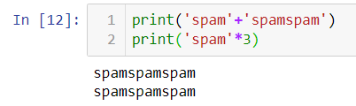

**Question-8**

Eggs can be a variable name but the 100 can’t be a variable name as it is an integer so we can’t take the integers as variables because the 100 will throw a problem in the further because if we write 100*12 what should the interpreter do will it multiply the 100 with the 12 or does it multiply the 12 with the value that stored in the 100.

**Question-9:**

**a=’10’**

The methods int(a) will return the int data type of ‘a’, float(a) returns the float data type of ‘a’, str(a) returns the string data type of ‘a’

**Question-10:**

The statement will throw error because it is concatenating the string with int which is not a good practice to do as we are not permit to do concatenate a string with int so It will throw error