**INEURON-BATCH (2021-22)**

**NOVEMBER-27-2021**

**PYTHON PROGRAMMING ASSIGNMENT-1**

**1.Write a Python program to print “Hello Python”?**

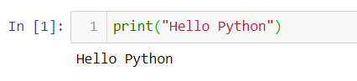

**2. Write a Python program to do arithmetical operations addition and division.?**

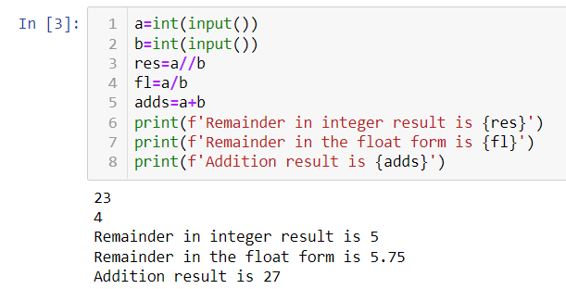

**3. Write a Python program to find the area of a triangle?**

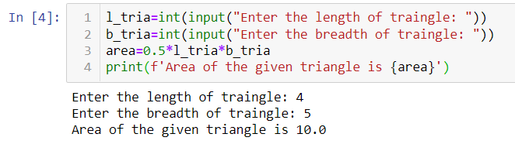

**4. Write a Python program to swap two variables?**

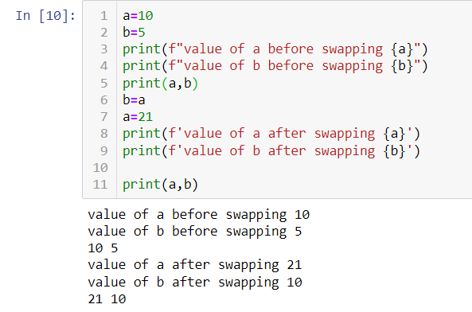

**5. Write a Python program to generate a random number?**

