**COMPONENT2**

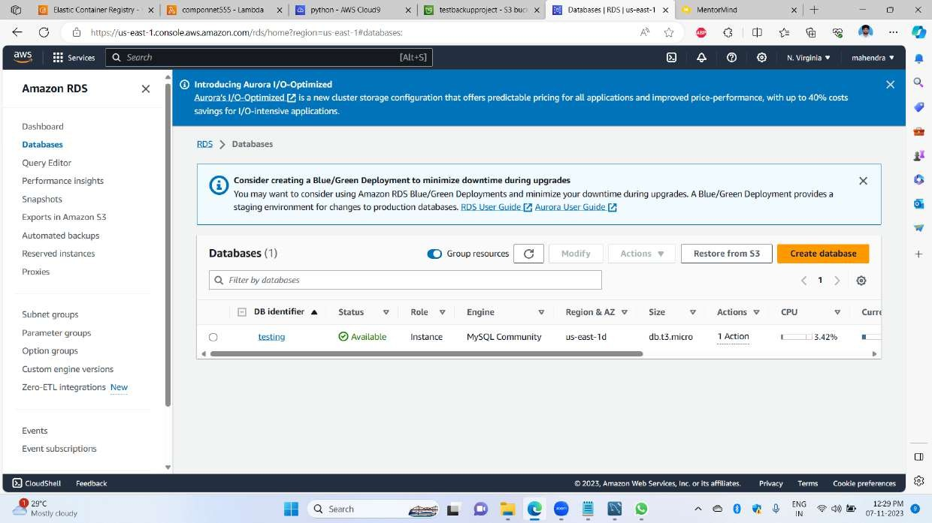 1st image tells like I created a database in RDS as a service of AWS

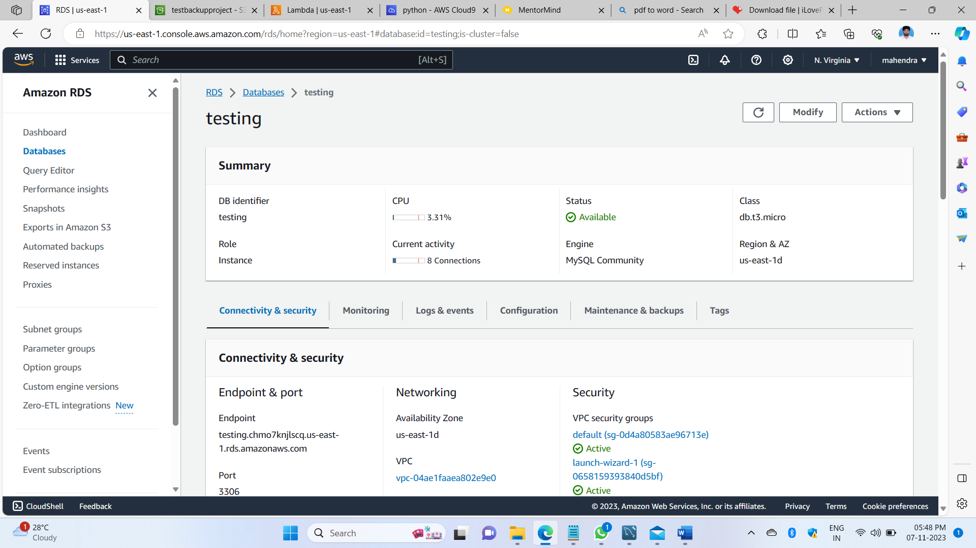

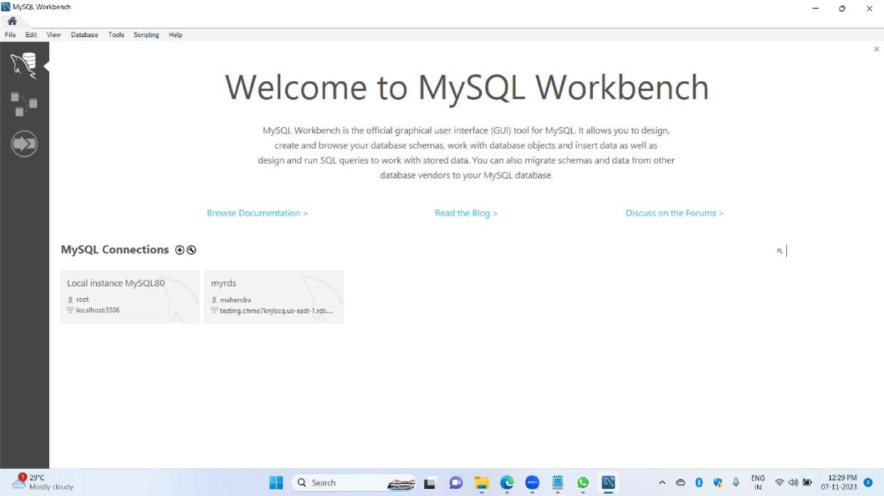2nd image tells us that inside of the RDS endpoint, we have to save that endpoint for future purposes connecting to MySQL workbench then we have to remerge of username and password

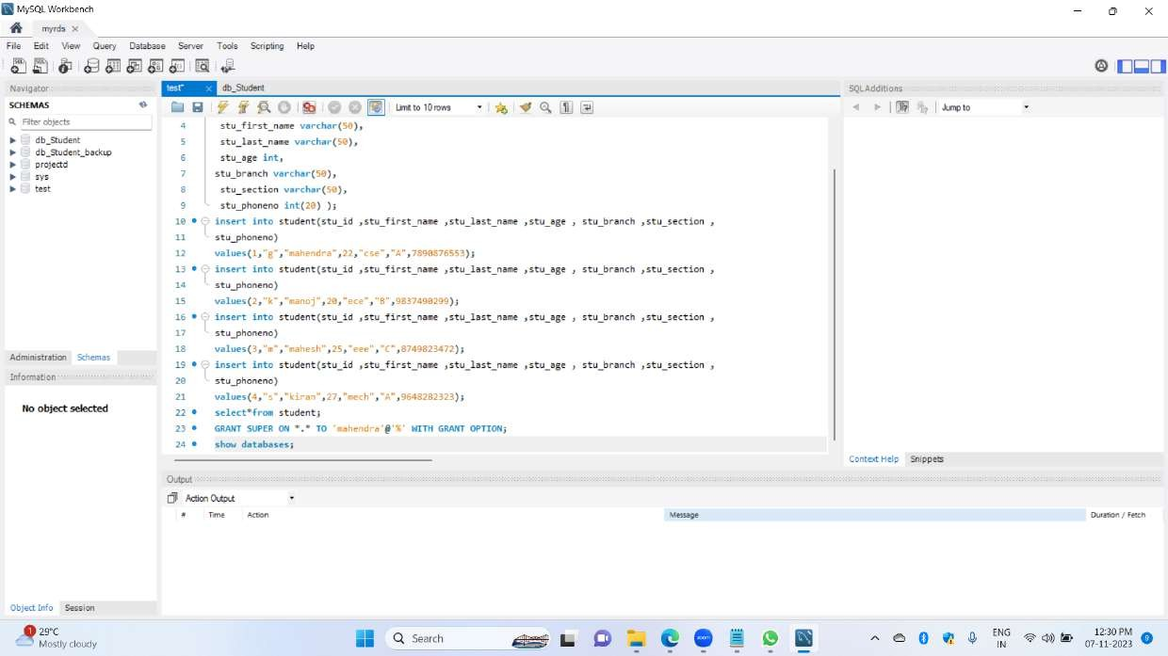3rd image tells that in this + button is there we have to add a host username and password then only these RDs will connect to the MySQL workbench

4th image tells this I created a database and created a tables inserted data in tables about this image

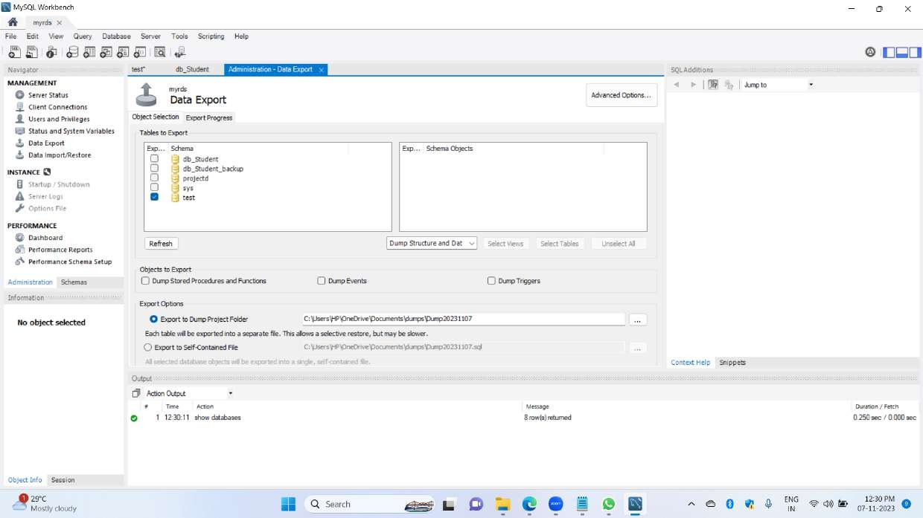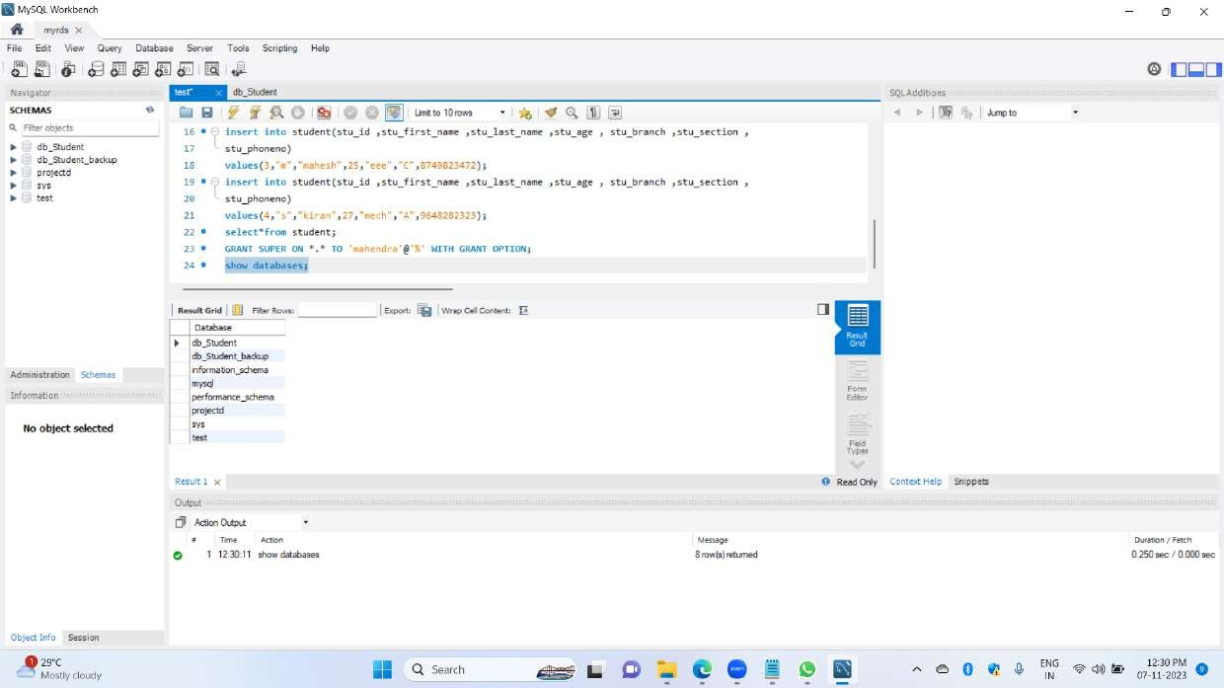 5th image shows how many databases are there to execute a query and shows the output

6th image shows that we have submitted output for that purpose we have to export the data so why use MySQL workbench data export it is there we can use for output

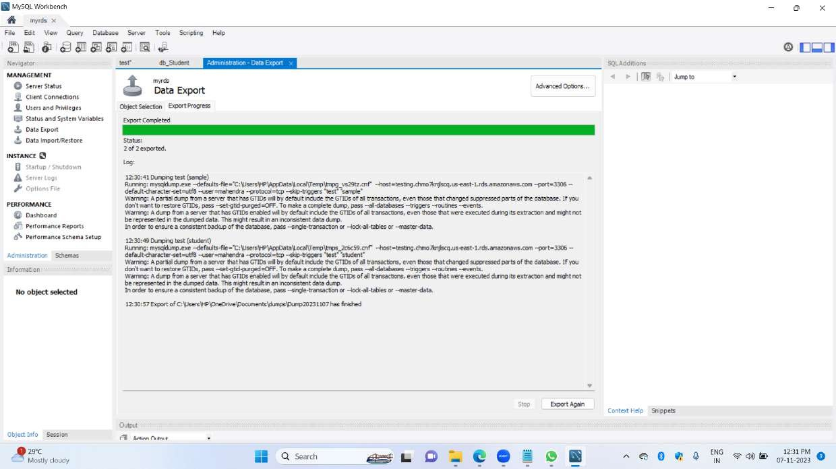

7th image done data export in connected rds and MySQL workbench connected successful and done execution of queries and data exported done component 2 is done