**COMPONENT3**

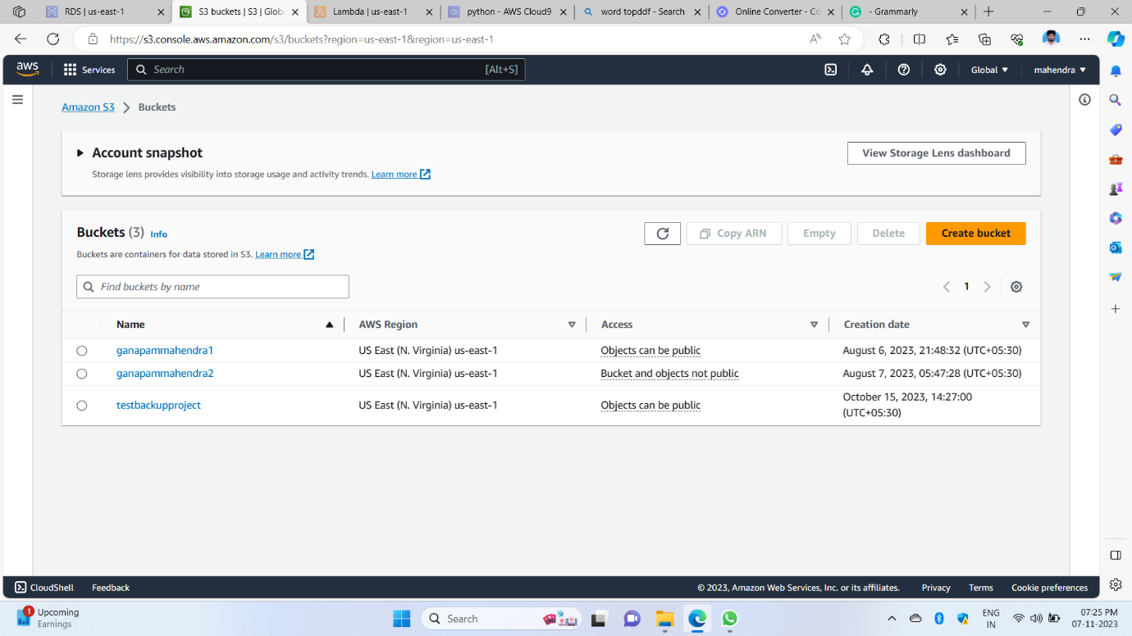

1st image in this showing like created a bucket it is an s3 service in the AWS

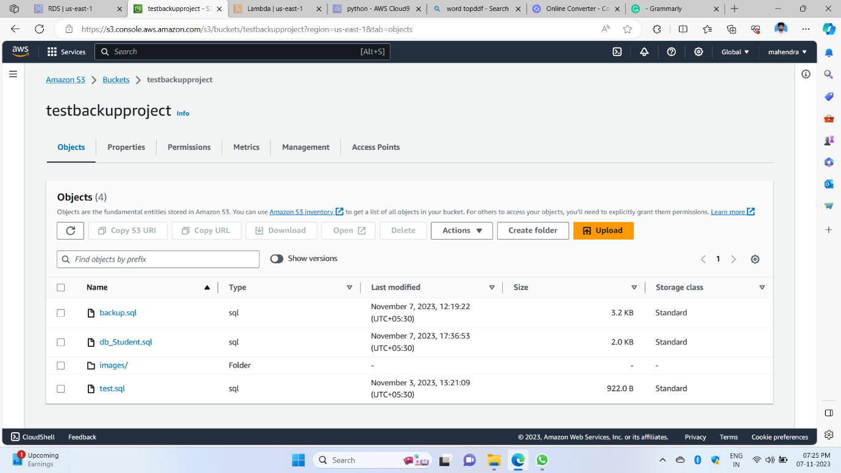

2nd image shows the bucket object stored data inside the bucket

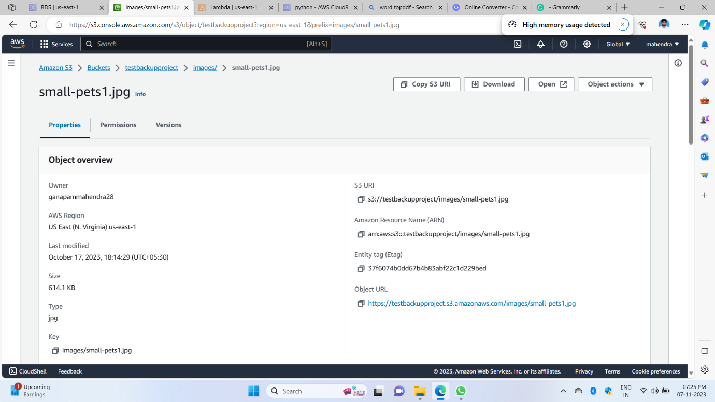

3rd image shows how to access an object to anyone in this picture object URL we can access the object to anyone if the object is public only otherwise not possible

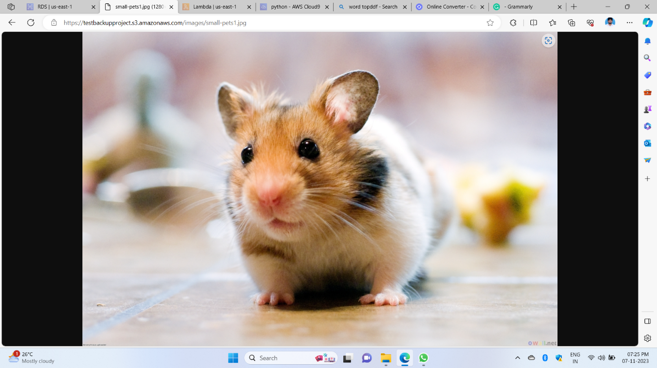

4th image is the output of the object I said anyone can access the object this is like if we send that link one can access the link, anyone

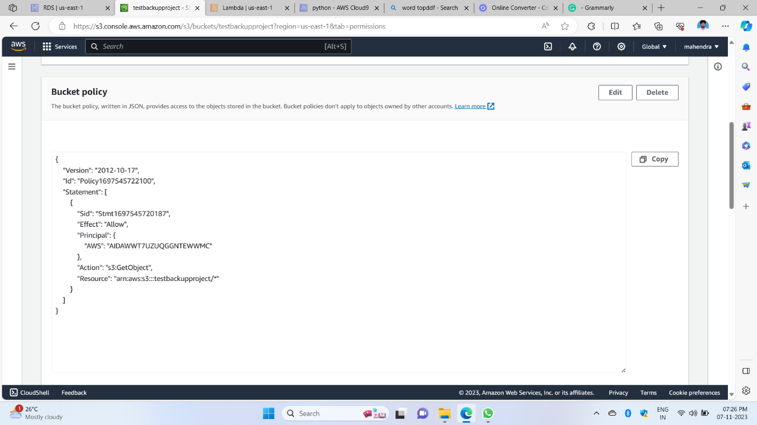

5th image shows an s3 bucket one can access the bucket for that purpose we give access like a call as a policy it has in JSON format

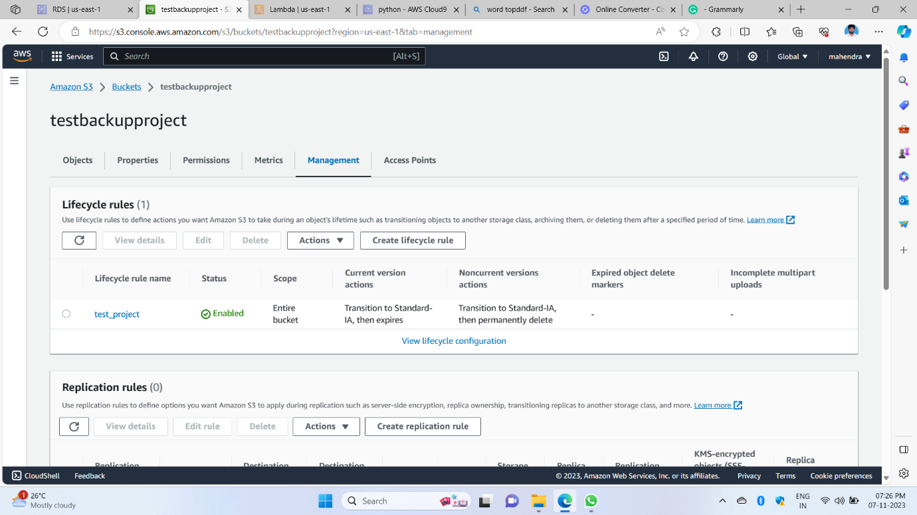

6th image showing like in this created lifecycle rule for the bucket is in the s3 service s3 bucket in management has the option that we have to create a cycle rule

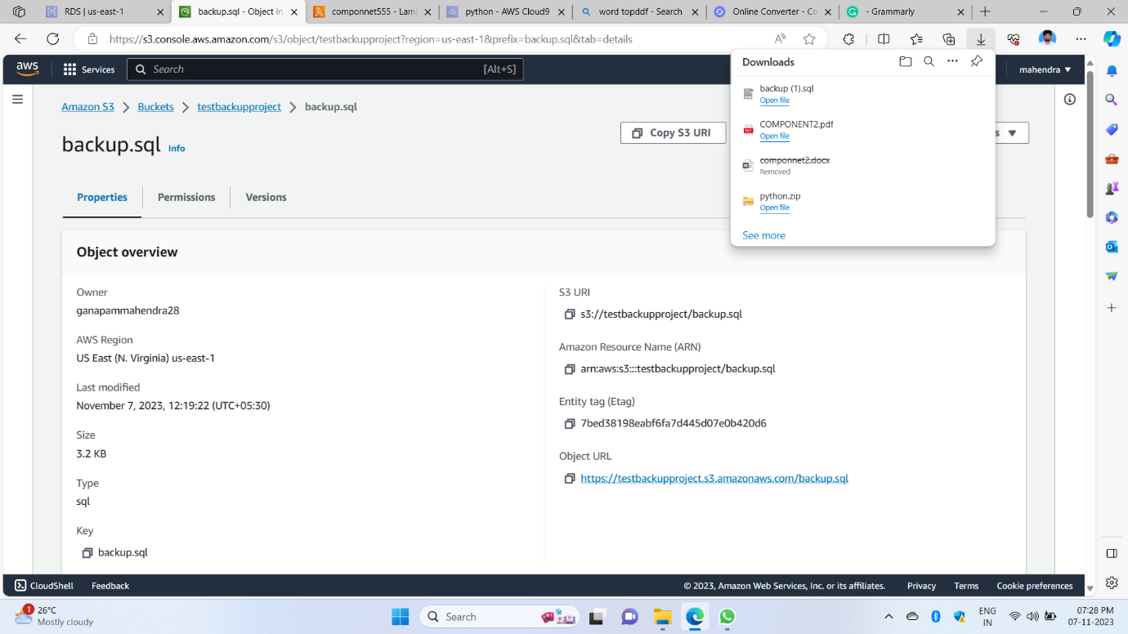

7th image shows like we .SQL file I have to access in this but it downloaded because in the s3 bucket, it only shows any HTML format or image format shows but if any extinction file is downloaded in our local system we have to see that file

Component3 3 We created a bucket created a policy created a lifecycle rule and inserted an object and we can access that object