PROJECT REPORT
AIML TRANSACTIONS & FRAUD ANALYSIS
An Interactive Power BI Dashboard Study of Account, Transaction and Alert Data

Submitted by
R. Ganapathy
Course: B.Com FinTech with AI
Tool Used: Microsoft Power BI Desktop
October 2026

Table of Contents

1. Abstract
Financial institutions process millions of transactions every day, and a very small share of them are fraudulent. Finding those few cases quickly is one of the central problems in modern FinTech. This report presents an AIML Transactions & Fraud Analysis built in Microsoft Power BI. The dataset contains three linked tables: accounts, transactions and alerts. About 1.32 million transactions across 10,000 accounts were analysed, with a total value of 153.48 billion.
The dashboard shows that 1,719 transactions (0.13%) are flagged as fraudulent, and that alerts are dominated by two money-laundering typologies, cycle and fan-in. The report explains the KPIs, charts and findings, and shows how AI and machine learning can support fraud detection.

2. Introduction
Digital payments have grown rapidly, and with them the scale and sophistication of financial crime. Banks and FinTech firms must monitor every transaction in near real time, which is not possible by manual review alone. Rule-based monitoring generates alerts, while Artificial Intelligence and Machine Learning (AIML) models learn from historical data to score transactions and rank the most suspicious ones.
For a student of B.Com FinTech with AI, this project combines three skills: understanding financial data, applying analytical thinking to fraud and anti-money-laundering (AML) problems, and presenting results through a clear business-intelligence dashboard.

2.1 Objectives
- To summarise the overall size and value of the transaction portfolio through KPIs.
- To measure the extent of fraud in terms of count, share and transaction value.
- To study the alert types generated by the monitoring system.
- To build an interactive, three-page Power BI dashboard (KPI, Interactive Dashboard and Tooltip).
- To recommend how AIML techniques can improve fraud detection.

2.2 Scope
The study covers the dataset named Ganapathy_power bi_Dataset_4. It focuses on descriptive and diagnostic analytics: what happened, and where the risk is concentrated. Predictive modelling is discussed as a future extension and is not part of the dashboard itself.

3. Data and Methodology

3.1 Dataset Description
The Power BI data model has three tables, shown in the Data pane of the report.
Table | Content | Role in analysis
accounts | Account-level records, including the initial balance of each account (10,000 accounts) | Measures account base and Total Initial Balance
transactions | Transaction records with amount, timestamp and the IS_FRAUD flag (about 1.32 million rows) | Measures volume, value and fraud
alerts | Alerts raised by the monitoring system, with ALERT_ID and ALERT_TYPE | Measures alert volume by typology

3.2 Tools and Approach
- Data loaded and modelled in Microsoft Power BI Desktop.
- DAX measures created for totals, averages and counts (for example, count of transactions where IS_FRAUD is True).
- Visuals used: KPI cards, donut chart, column charts, bar chart and line chart.
- Interactivity added through slicers (IS_FRAUD and ALERT_TYPE) and a custom tooltip page.

4. Key Performance Indicators
The first page of the dashboard (KPI page) presents the headline numbers. These cards give a quick health check of the portfolio.
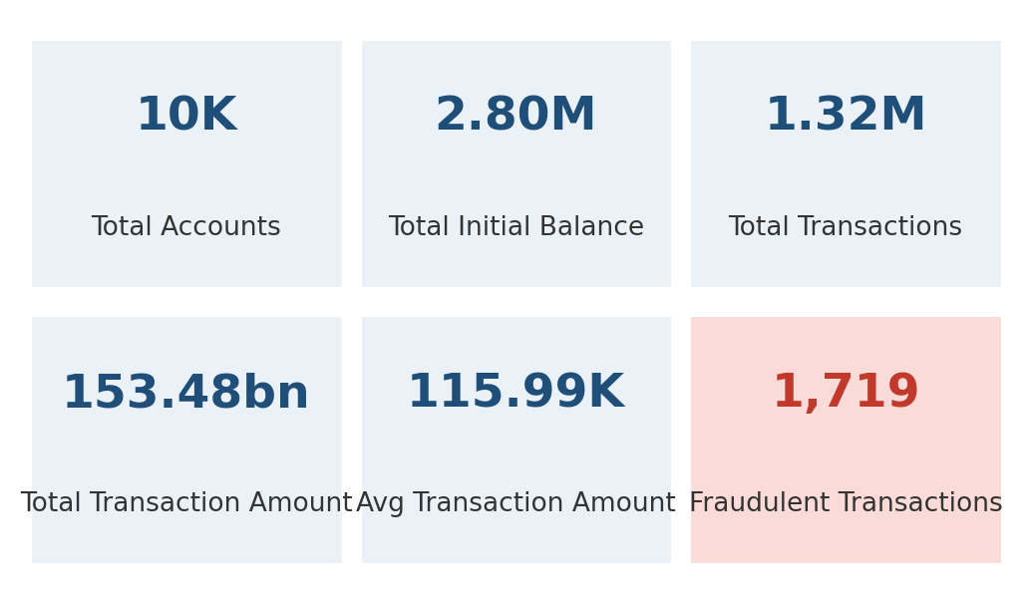
Figure 1: Key performance indicator summary
KPI | Value | Interpretation
Total Accounts | 10K (10,000) | Size of the customer account base
Total Initial Balance | 2.80M | Opening funds held across all accounts
Total Transactions | 1.32M (1,323,234) | Overall activity volume
Total Transaction Amount | 153.48bn | Gross value moved through the system
Average Transaction Amount | 115.99K | Mean value per transaction
Fraudulent Transactions | 1,719 (about 2K) | Transactions flagged IS_FRAUD = True
Table 1: KPI summary (values read from the Power BI dashboard)
The average transaction amount agrees with the totals: 153.48 billion divided by about 1.32 million transactions gives roughly 116 thousand per transaction. The initial balance of 2.80 million is very small beside the 153.48 billion that flowed through the accounts, which means funds were moved repeatedly. High turnover on small balances is itself a pattern that AML teams watch closely.
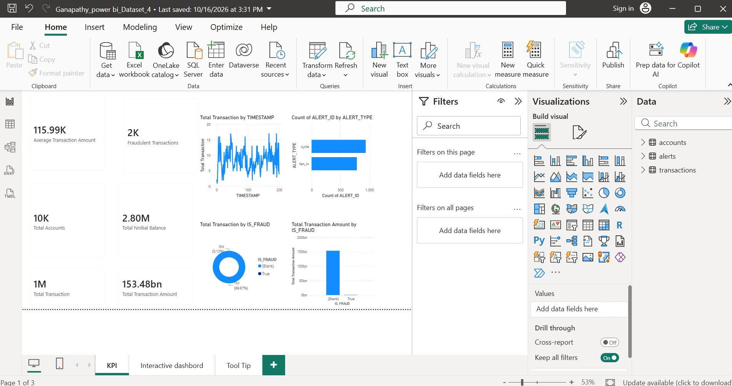
Figure 2: Dashboard Page 1 - KPI page (Power BI)

5. Fraud Analysis

5.1 Extent of Fraud
Out of about 1.32 million transactions, 1,719 are marked as fraudulent. This is 0.13% of all transactions, while 99.87% are non-fraudulent. Fraud is therefore a rare-event problem, and that has important consequences for how detection models are built and measured.
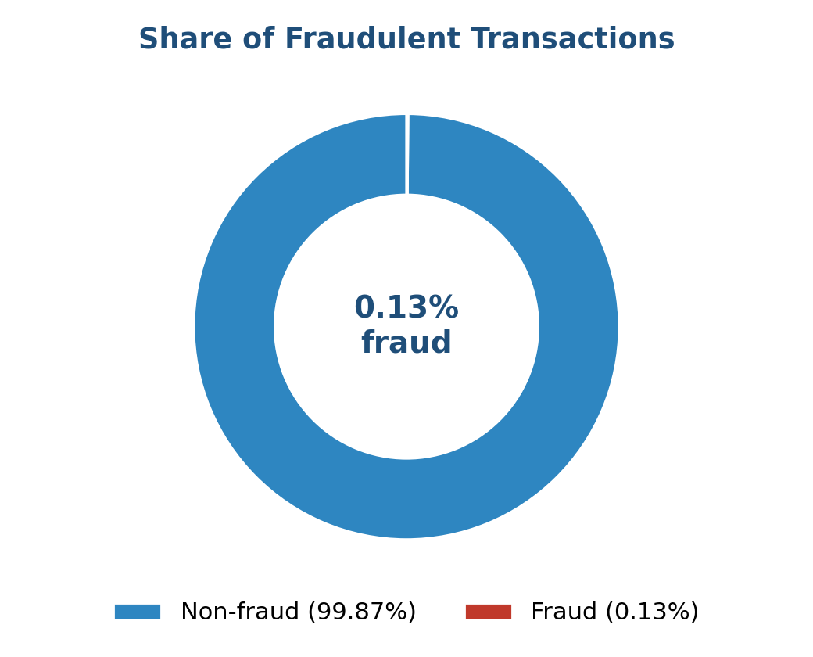
Figure 3: Fraud vs non-fraud share of transactions
Category | Transactions | Share
Non-fraudulent | 1,321,515 | 99.87%
Fraudulent | 1,719 | 0.13%
Total | 1,323,234 | 100%
Table 2: Fraud and non-fraud transaction counts
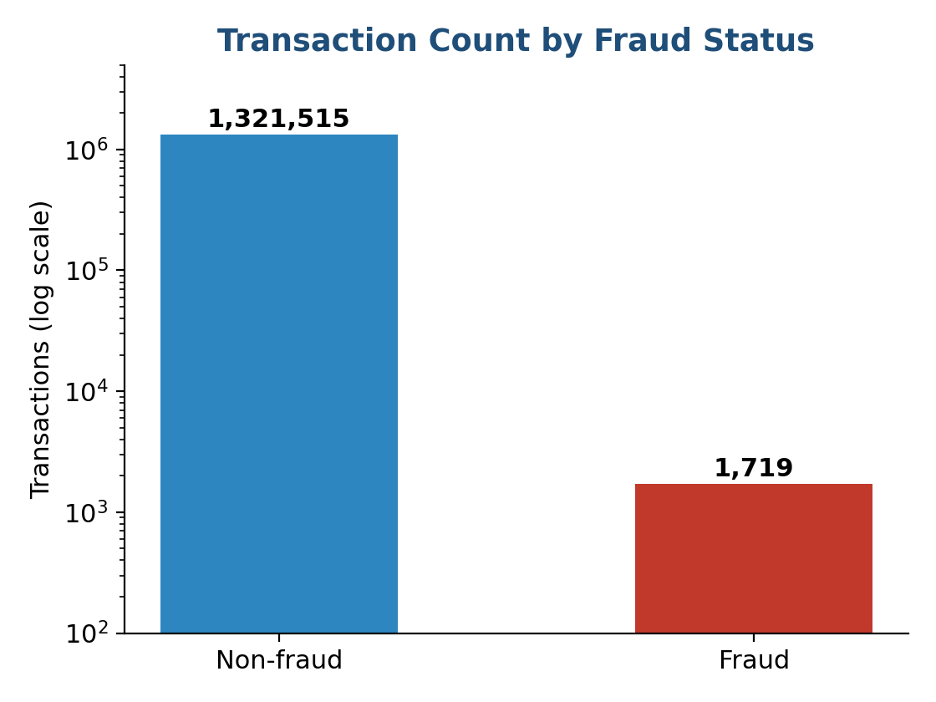
Figure 4: Transaction counts by fraud status (log scale)

5.2 Value of Transactions by Fraud Status
The Total Transaction Amount by IS_FRAUD chart shows that nearly all of the 153.48 billion in value sits in the non-fraud category, which is around 150 billion on the chart scale. The fraud column is barely visible beside it. In value terms, as in count terms, fraud is a very small slice of the total. Even so, each fraudulent transaction can cause direct financial loss, regulatory penalties and loss of customer trust, so the small share does not make it unimportant.

5.3 Transaction Pattern over Time
The line chart of total transactions by TIMESTAMP shows activity that moves up and down continuously in a band of roughly 5 to 20 transactions per timestamp interval across the observed period of about 200 steps, with no single dominant spike. Because the pattern is noisy, simple thresholds on volume alone would raise many false alarms. This supports the case for models that look at several behaviours at once.

6. Alert Analysis
The alerts table contains system-generated alerts classified by ALERT_TYPE. The bar chart in the dashboard shows two types, each with a count close to 1,000.
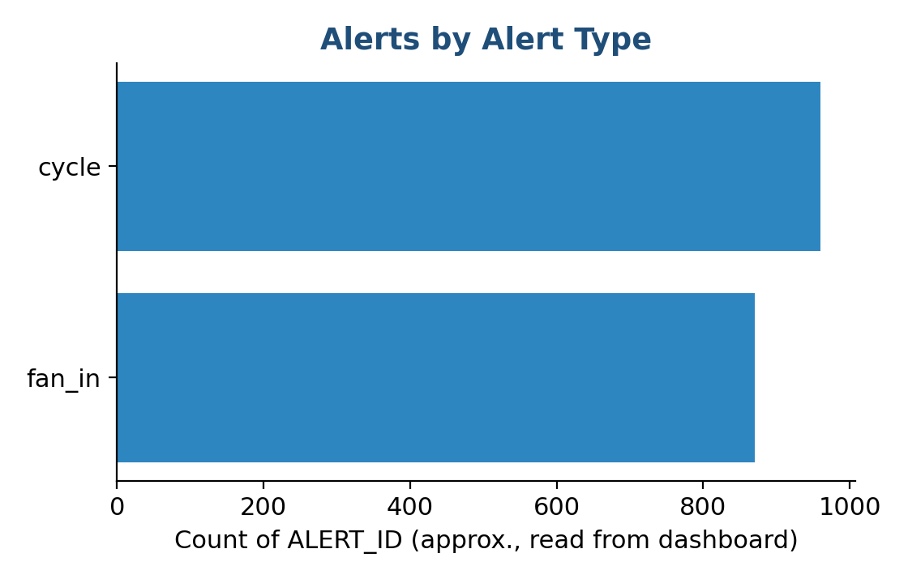
Figure 5: Count of alerts by alert type (approximate values)
Alert type | Meaning
cycle | Money moves through a chain of accounts and returns to its origin. Circular flows are a classic layering technique in money laundering.
fan_in | Many accounts send funds into a single account. This pattern is common with mule accounts that collect and aggregate illicit funds.
Table 3: Alert typologies in the dataset
Both alert types are network patterns: they depend on the relationships between accounts rather than on the amount of any one transaction. This is where graph-based machine learning has an advantage over simple rules.

7. Interactive Dashboard and Tooltip Page

7.1 Interactive Dashboard (Page 2)
The second page, titled AIML Transaction & Fraud Analysis, combines all KPIs and charts on one canvas. Two slicers let the user filter the whole page: an IS_FRAUD slicer (Blank / True) and an ALERT_TYPE slicer (cycle / fan_in). Choosing a value refreshes every visual, so an analyst can, for example, look only at fraudulent transactions and see how they are distributed over time.
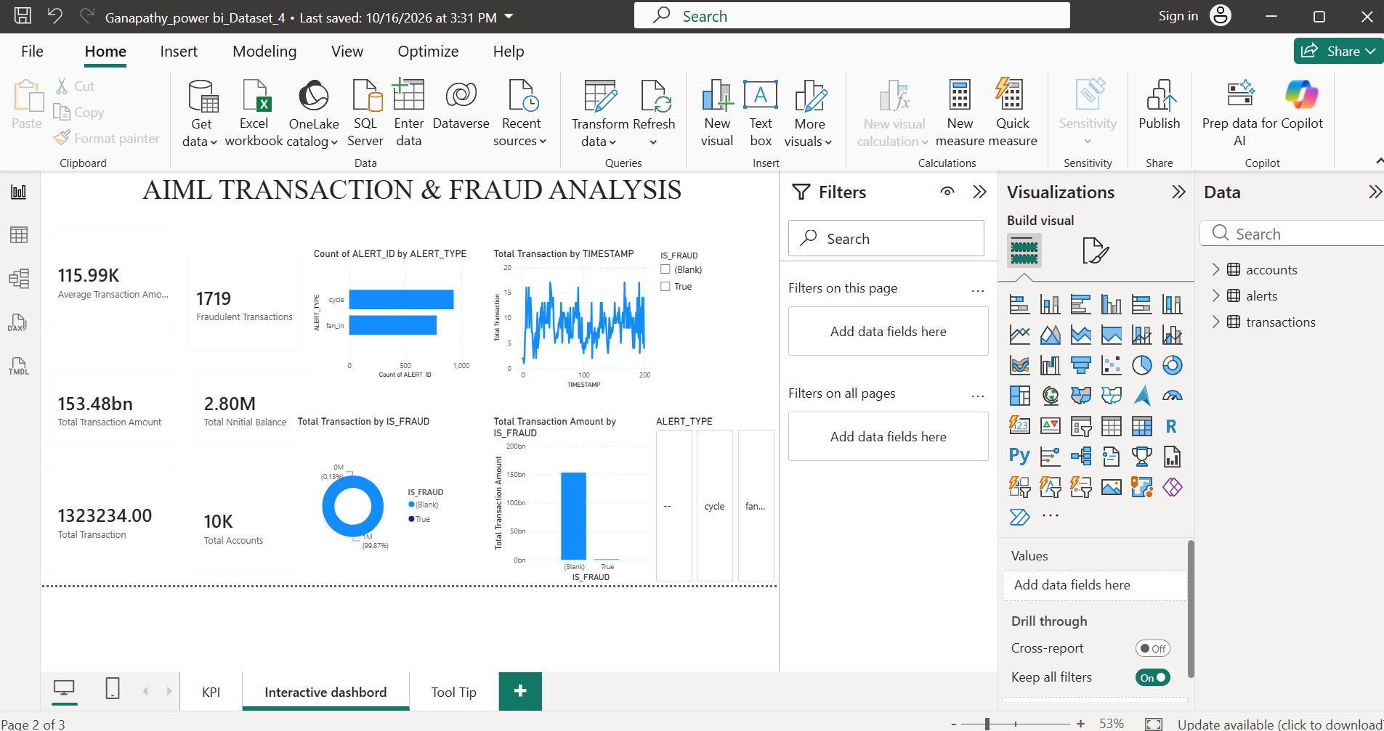
Figure 6: Dashboard Page 2 - Interactive dashboard with slicers

7.2 Tooltip Page (Page 3)
The third page is a tooltip page. When a user hovers over a chart, a small pop-up shows three cards: Fraudulent Transactions (1719), Total Transactions (1323234) and Total Transaction Amount (153.48bn). This gives context without adding clutter to the main page.
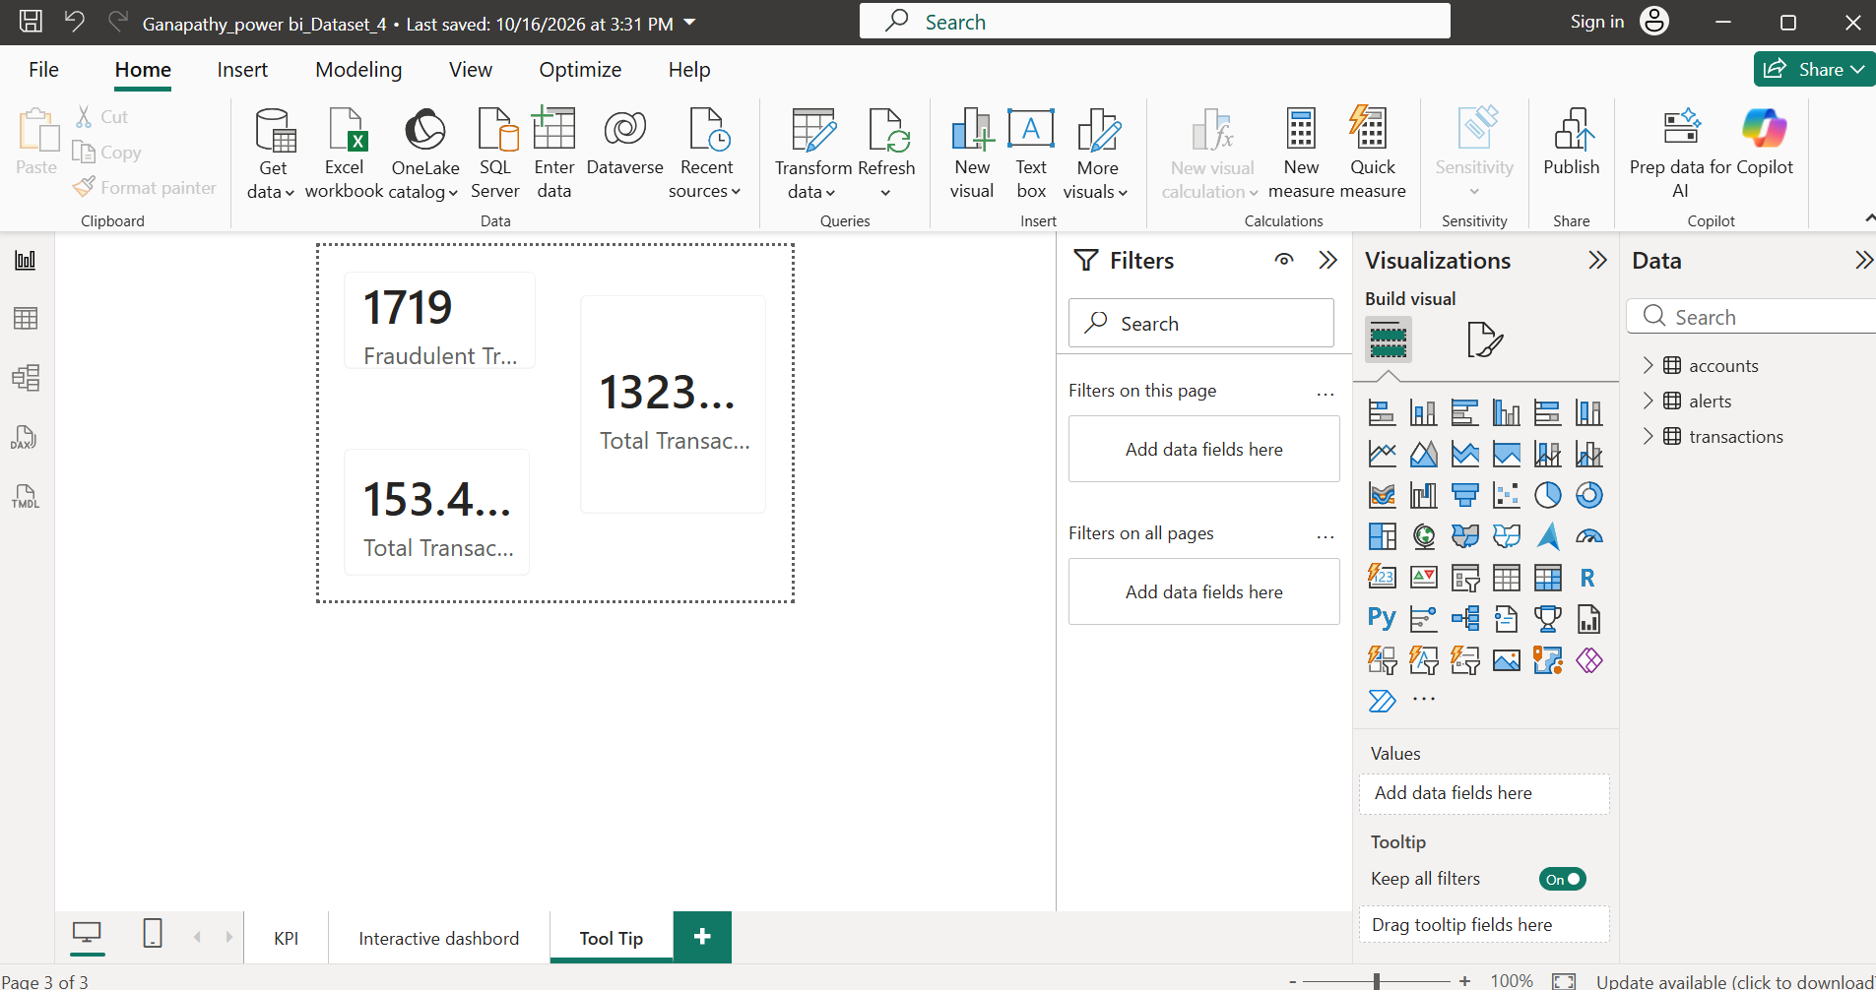
Figure 7: Dashboard Page 3 - Tooltip page

8. Role of AI and Machine Learning in Fraud Detection
The dashboard describes the data. AIML extends this by predicting which transactions and accounts are likely to be fraudulent. The main approaches are listed below.
- Supervised learning: models such as logistic regression, random forest and gradient boosting are trained on past transactions labelled with IS_FRAUD. They output a fraud probability for each new transaction.
- Anomaly detection: unsupervised methods such as isolation forest or autoencoders find transactions that differ sharply from normal behaviour, which helps when labels are scarce.
- Graph analytics: representing accounts as nodes and transfers as edges makes cycle and fan-in structures easy to find automatically.
- Handling class imbalance: with only 0.13% fraud, accuracy is a misleading metric. Precision, recall, F1-score and PR-AUC should be used, along with techniques such as SMOTE or class weighting.
- Explainability and governance: tools such as SHAP help investigators and regulators understand why a transaction was flagged.

9. Findings
- The portfolio is large: 10,000 accounts, about 1.32 million transactions and 153.48 billion in value.
- Fraud is rare, at 1,719 transactions or 0.13%, and the amount involved is a very small share of total value.
- The average transaction is about 115.99K, and total flows are very large relative to the 2.80M initial balance.
- Alerts are split between two network-based typologies, cycle and fan_in, in almost equal numbers.
- Transaction volume over time is noisy with no single spike, so volume alone is a weak fraud signal.

10. Recommendations
- Build a supervised fraud model on the IS_FRAUD label and evaluate it with precision, recall and PR-AUC rather than accuracy.
- Add graph features such as in-degree, out-degree and cycle membership, since the alert types are network based.
- Link alerts to transactions in the data model so analysts can move directly from an alert to the underlying transfers.
- Add the fraud amount as a separate measure on the dashboard to show monetary loss exposure clearly.
- Set up automatic data refresh and role-based access if the dashboard is published to the Power BI Service.

11. Limitations
- The report is based on the dashboard views; alert counts are read from the chart axis and are approximate.
- The analysis is descriptive. No predictive model has been trained or tested.
- The dataset appears to be simulated, so results should not be generalised to a real institution without validation.

12. Conclusion
The AIML Transactions & Fraud Analysis dashboard turns a large transaction dataset into a clear picture of portfolio size, fraud exposure and alert patterns. Fraud accounts for only 0.13% of transactions, yet the cycle and fan-in alerts show that suspicious behaviour is organised around account networks. Combining Power BI reporting with machine-learning models, especially graph-based and imbalance-aware methods, is a practical way for FinTech organisations to detect fraud earlier and with fewer false alarms.

13. References
- Microsoft Learn. Power BI documentation: https://learn.microsoft.com/power-bi
- Financial Action Task Force (FATF). Money laundering typologies and guidance: https://www.fatf-gafi.org
- Reserve Bank of India. Fraud risk management and payment systems publications: https://www.rbi.org.in
- Dataset: Ganapathy_power bi_Dataset_4 (accounts, alerts and transactions tables).

