NORTHWIND TRADE
Sales, Product and Customer Analysis using Power BI
Submitted by
R GANAPATHY
Course: B.Com Fintech with AI
Dataset / File: Ganapathy_powerbi_dataset_3
October 2026

Table of Contents

1. Introduction
Northwind Traders is a well-known sample company that imports and exports specialty food products around the world. Its database records customers, employees, products, orders, shippers and the individual order lines that link them together. This makes it an ideal dataset for practising business intelligence, because it contains everything a trading company needs to analyse: who buys, what is sold, who sells it, and how goods are shipped.
This report presents the Northwind Trade analysis built in Microsoft Power BI Desktop. The report file contains four pages: Sales Overview, Product & Customer Analysis, Interactive Sales Dashboard and a Tooltip page. Each page is explained below with its key figures, charts and tables, followed by the main findings and recommendations.

1.1 Objectives
- To summarise the overall trading performance of Northwind using key performance indicators (KPIs).
- To identify the best-performing product categories, products, employees and customer countries.
- To study the monthly pattern of orders and find peak and low-demand periods.
- To build an interactive dashboard with slicers so that users can filter the data themselves.
- To suggest practical business decisions based on the findings.

1.2 Tools Used
Tool / Feature | Purpose
Microsoft Power BI Desktop | Data modelling, DAX measures and report design
Cards | Display KPIs such as Total Sales and Total Orders
Line, column and bar charts | Trends and comparisons across months, categories and employees
Table visual | Product-level detail with sales values
Slicers | Filter by category, country and order date
Tooltip page | Hover pop-up showing orders, sales and quantity

2. Dataset and Data Model
The report is built on seven related tables. The relationships between them allow a single measure, such as Total Sales, to be sliced by category, employee, country or time.
Table | Description
customers | Customer company details including country (91 customers)
orders | Order header: order date, customer, employee, shipper and freight
order_details | Order lines: product, unit price and quantity for every order
products | Product names and their category
categories | Product category names (Beverages, Dairy Products, etc.)
employees | Sales employees who handled the orders
shippers | Shipping companies that delivered the orders

The main measures created in the report are Total Sales, Total Orders, Total Quantity Sold, Total Freight, Average Freight and Number of Customers.

3. Page 1 – Sales Overview
The first page gives a quick summary of the business. Six KPI cards sit at the top, followed by three charts showing orders over time, sales by category and orders by employee.

3.1 Key Performance Indicators
KPI | Value
Total Sales | 1.27M (1,265,793.04)
Total Orders | 809
Total Quantity Sold | 51K
Total Freight | 63.96K
Average Freight | 79.05
Number of Customers | 91

On average, each order carries a freight cost of about 79, and the 91 customers placed 809 orders, which is roughly 8.9 orders per customer. The business sold around 51 thousand units, giving an average sales value of about 1,565 per order.
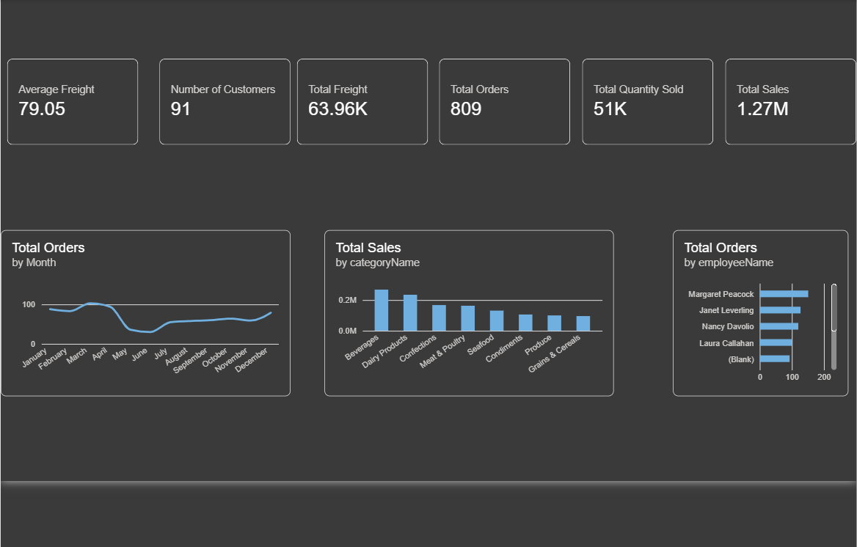
Figure 1: Power BI – Sales Overview page

3.2 Total Orders by Month
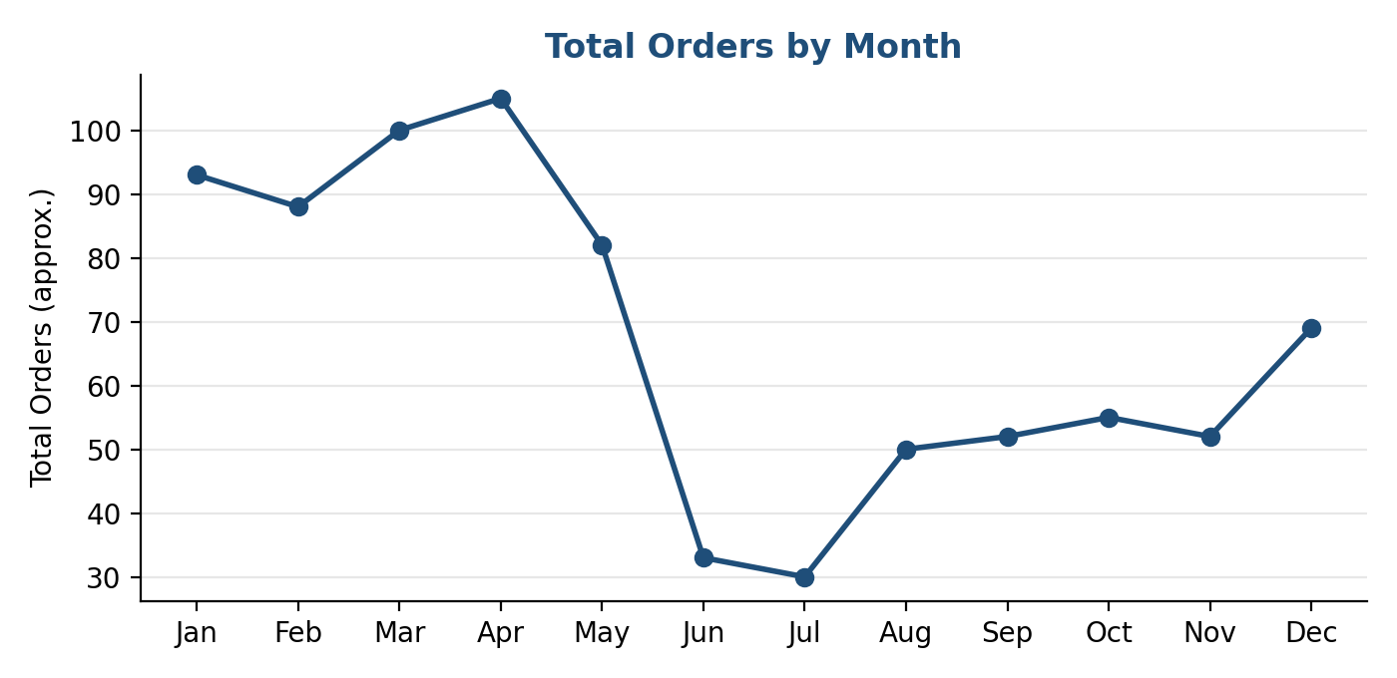
Figure 2: Total orders by month (values approximate, read from the dashboard)
Orders are strongest in the first four months of the year (January to April) at about 90–105 orders per month. Demand then falls sharply in June and July, and recovers gradually in the second half of the year, with a rise again in December. This indicates a seasonal pattern that should be considered in stock planning.

3.3 Total Sales by Category
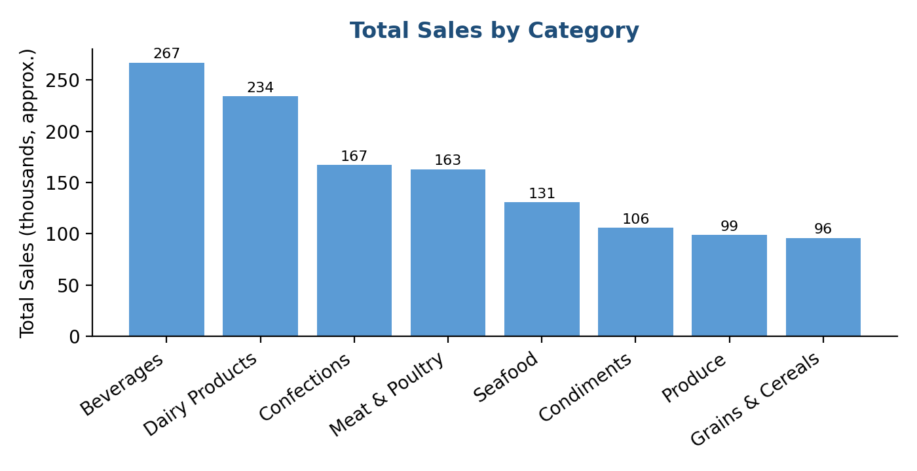
Figure 3: Total sales by product category (values approximate)
Rank | Category | Approx. Sales (thousands)
1 | Beverages | 267
2 | Dairy Products | 234
3 | Confections | 167
4 | Meat & Poultry | 163
5 | Seafood | 131
6 | Condiments | 106
7 | Produce | 99
8 | Grains & Cereals | 96

Beverages and Dairy Products are the two leading categories and together contribute about 40% of total sales. Produce and Grains & Cereals are the smallest categories.

3.4 Total Orders by Employee
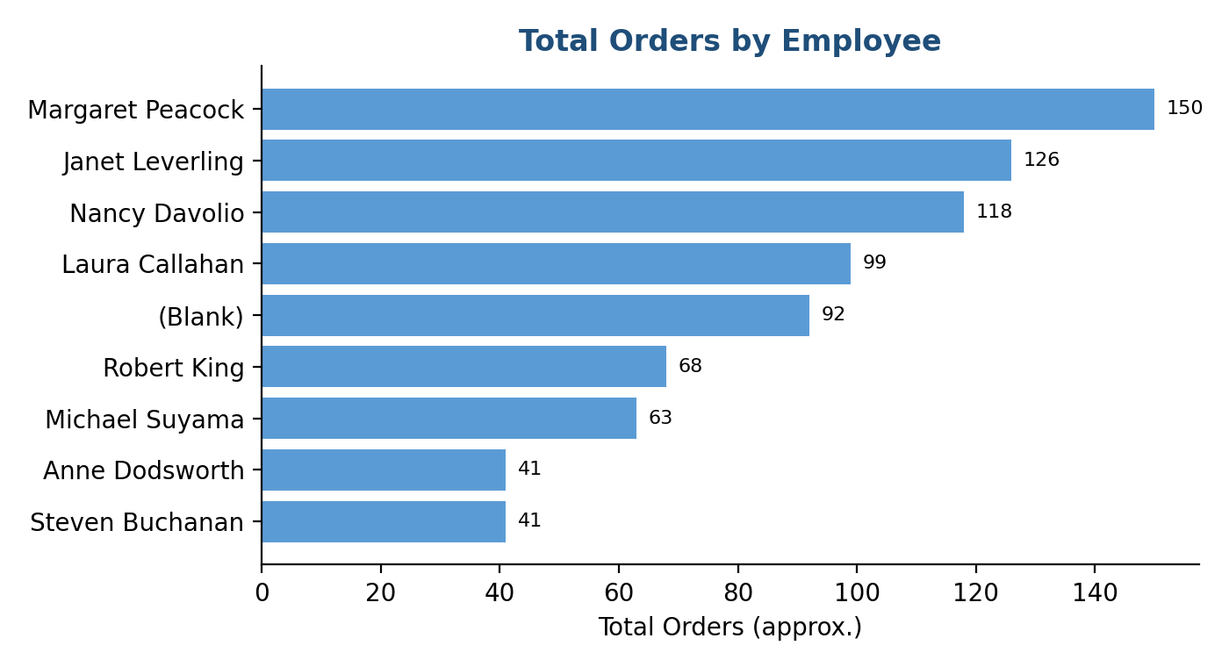
Figure 4: Total orders handled by each employee (values approximate)
Margaret Peacock handled the highest number of orders, followed by Janet Leverling and Nancy Davolio. Steven Buchanan and Anne Dodsworth handled the fewest. A group labelled (Blank) also appears, which means some orders in the data have no employee assigned and the data should be checked.

4. Page 2 – Product and Customer Analysis
The second page looks at where customers are located and how individual products are performing.
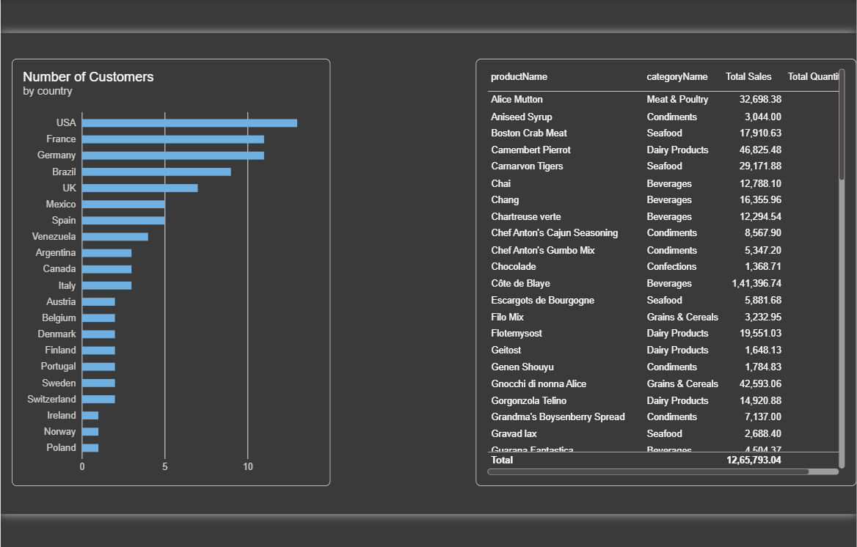
Figure 5: Power BI – Product & Customer Analysis page

4.1 Number of Customers by Country
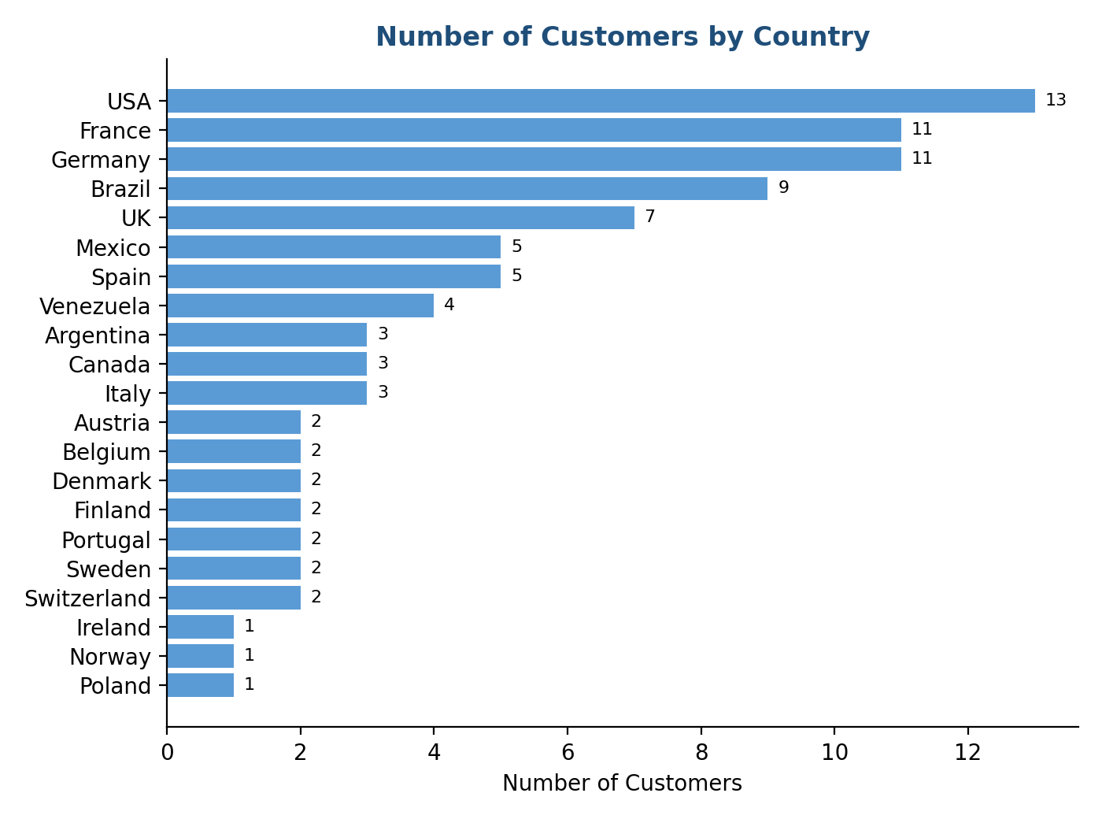
Figure 6: Number of customers by country
The USA has the largest number of customers (13), followed by France and Germany (11 each) and Brazil (9). The top four countries account for 44 of the 91 customers, nearly half of the customer base. Ireland, Norway and Poland have only one customer each, so there is room to grow in these markets.

4.2 Product-wise Sales
The table below lists the products with their category and total sales, as shown on the dashboard (first 21 products shown).
Product Name | Category | Total Sales
Alice Mutton | Meat & Poultry | 32,698.38
Aniseed Syrup | Condiments | 3,044.00
Boston Crab Meat | Seafood | 17,910.63
Camembert Pierrot | Dairy Products | 46,825.48
Carnarvon Tigers | Seafood | 29,171.88
Chai | Beverages | 12,788.10
Chang | Beverages | 16,355.96
Chartreuse verte | Beverages | 12,294.54
Chef Anton's Cajun Seasoning | Condiments | 8,567.90
Chef Anton's Gumbo Mix | Condiments | 5,347.20
Chocolade | Confections | 1,368.71
Côte de Blaye | Beverages | 141,396.74
Escargots de Bourgogne | Seafood | 5,881.68
Filo Mix | Grains & Cereals | 3,232.95
Flotemysost | Dairy Products | 19,551.03
Geitost | Dairy Products | 1,648.13
Genen Shouyu | Condiments | 1,784.83
Gnocchi di nonna Alice | Grains & Cereals | 42,593.06
Gorgonzola Telino | Dairy Products | 14,920.88
Grandma's Boysenberry Spread | Condiments | 7,137.00
Gravad lax | Seafood | 2,688.40
Total (all products) |  | 1,265,793.04

Côte de Blaye (Beverages) is by far the top-selling product with about 141 thousand in sales, which is more than 11% of total sales from a single item. Camembert Pierrot (46.8K) and Gnocchi di nonna Alice (42.6K) follow. At the lower end, Chocolade, Geitost and Genen Shouyu each sell under 2,000.

5. Page 3 – Interactive Sales Dashboard
The third page, titled "Northwind Interactive Sales Dashboard", combines the KPI cards and the main charts on one screen and adds three slicers so the viewer can explore the data.
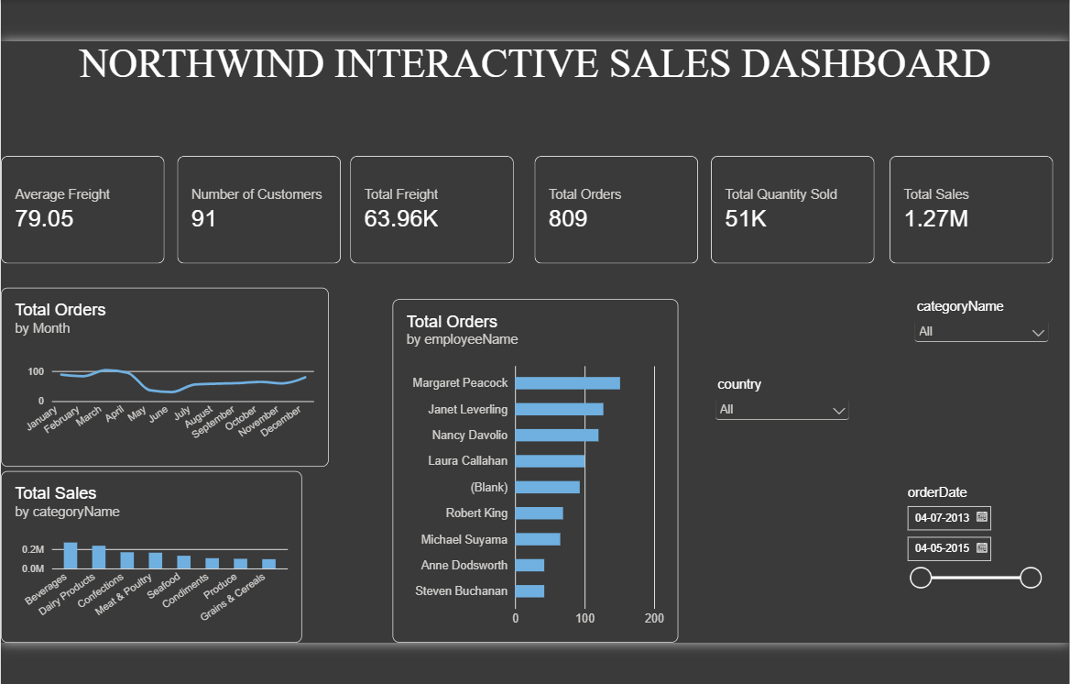
Figure 7: Power BI – Northwind Interactive Sales Dashboard

5.1 Slicers Available
Slicer | Use
categoryName | Dropdown to view results for one or more product categories
country | Dropdown to filter customers and orders by country
orderDate | Date range slider covering 04-07-2013 to 04-05-2015

When a slicer is changed, every card and chart on the page updates together. For example, selecting Beverages will show the orders, sales and quantity for that category only, and selecting a country shows how that market performs. This turns the report from a static summary into a decision-support tool.

6. Page 4 – Tooltip Page
The fourth page is a custom tooltip. When the user hovers over a chart on the other pages, a small pop-up appears showing three measures for the hovered item: Total Orders (809), Total Sales (1.27M) and Total Quantity Sold (51K). The values above are the overall totals shown while designing the page; on hovering they change to match the selected bar or point.
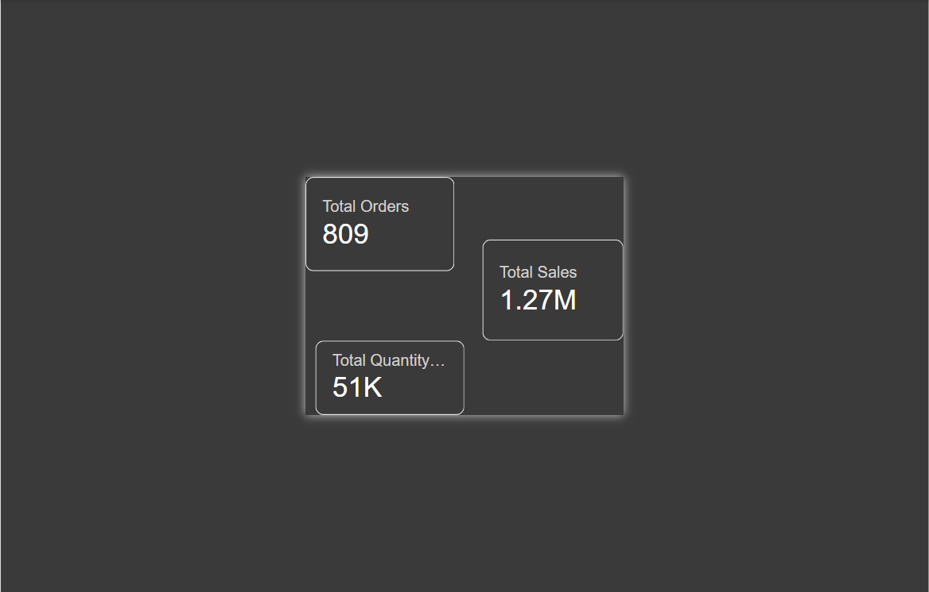
Figure 8: Power BI – Tooltip page

7. Key Findings
- Northwind generated total sales of about 1.27 million from 809 orders placed by 91 customers.
- Beverages and Dairy Products are the leading categories, while Côte de Blaye is the single biggest product.
- The USA, France, Germany and Brazil are the biggest customer markets.
- Orders are high from January to April and low in June–July, showing a seasonal pattern.
- Margaret Peacock is the top employee by orders; some orders have no employee recorded.
- The average freight cost is 79.05 per order, with total freight of 63.96K.

8. Recommendations
- Plan inventory and promotions around the seasonal low in June–July to even out sales.
- Protect the supply of high-value products such as Côte de Blaye, since one item drives a large share of revenue.
- Increase marketing in under-served countries (Ireland, Norway, Poland) and strengthen the key four markets.
- Clean the data so every order has an employee, which will make performance reports more accurate.
- Review shipper contracts to reduce freight cost, which is 5% of sales.

9. Conclusion
The Northwind Trade Power BI report shows how raw order data can be turned into clear business insight. The four pages together answer the main management questions: how much is being sold, which products and markets matter most, who is delivering the sales, and when demand rises and falls. The interactive slicers and tooltip make the report easy to explore. With the recommendations above, the company can improve planning, grow its smaller markets and manage costs better.
Note: Values for monthly orders, category sales and employee orders are read from the dashboard charts and are approximate. Exact figures can be seen by hovering over each visual in Power BI.

