Unit-1

Introduction
Data are the known facts that can be recorded and have an implicit meaning.
A database is a collection of logically related data.
Properties of a database:
o It represents some aspect of real world (miniworld).
o It is a logically coherent collection of data with some inherent meaning.
o It is designed, built and populated with data for a specific purpose.
A database can be of any size and complexity.
Ex1: A university database
o Entities such as students, faculty, courses
o Relationships between entities such as students’ enrollment in courses,
faculty teaching courses

Ex2: A Hospital database
o Entities such as doctors, patients, nurses, wards
o Relationships between entities such as doctors visiting patients, patients in
rooms.
A database may be generated and maintained manually or it may be computerized.
A Database Management System (DBMS) is a software package (collection of programs) that enables users to create, store and maintain a database.
The DBMS is a general purpose software system that facilitates the process of defining, constructing, manipulating, and sharing databases among various users and applications.

Introduction (functionalities of DBMS)
A DBMS is a general purpose software system facilitating each of the following
(with respect to a database):
Defining a database
o Specifying data types, structures, and constraints of the data to be stored in the database.
Constructing the database
o The process of storing the data on some storage medium (e.g., magnetic disk) that is controlled by the DBMS
Manipulating the database

o Querying the database to retrieve specific data, updating the database to reflect changes in the miniworld, and generating reports
Sharing a database
o Allowing multiple users and programs to access the database
"simultaneously"
Maintaining the database
o Allowing the system to evolve as requirements change over time
Protection includes system protection and security protection.
System protection
o Preventing database from becoming corrupted when hardware or software failures occur
Security protection
o Preventing unauthorized or malicious access to database.

A Simplified Database Environment
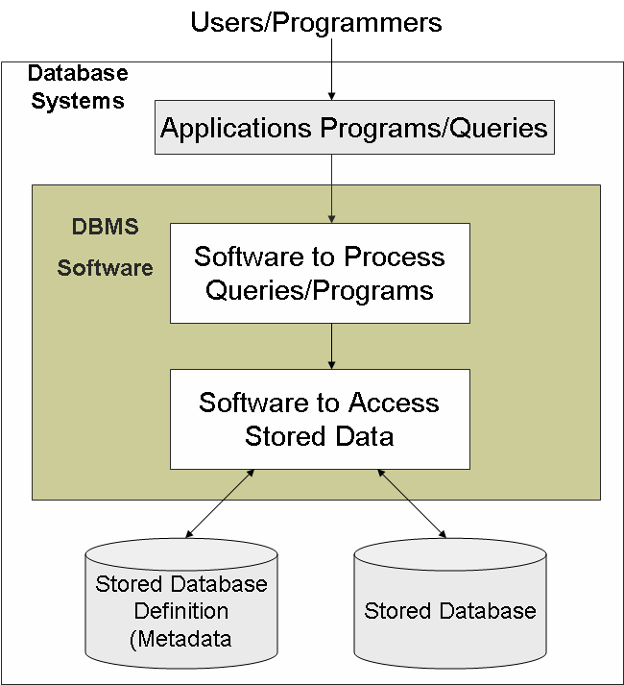

An Example
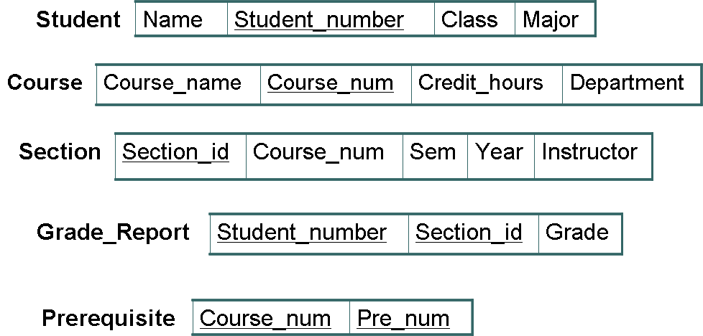

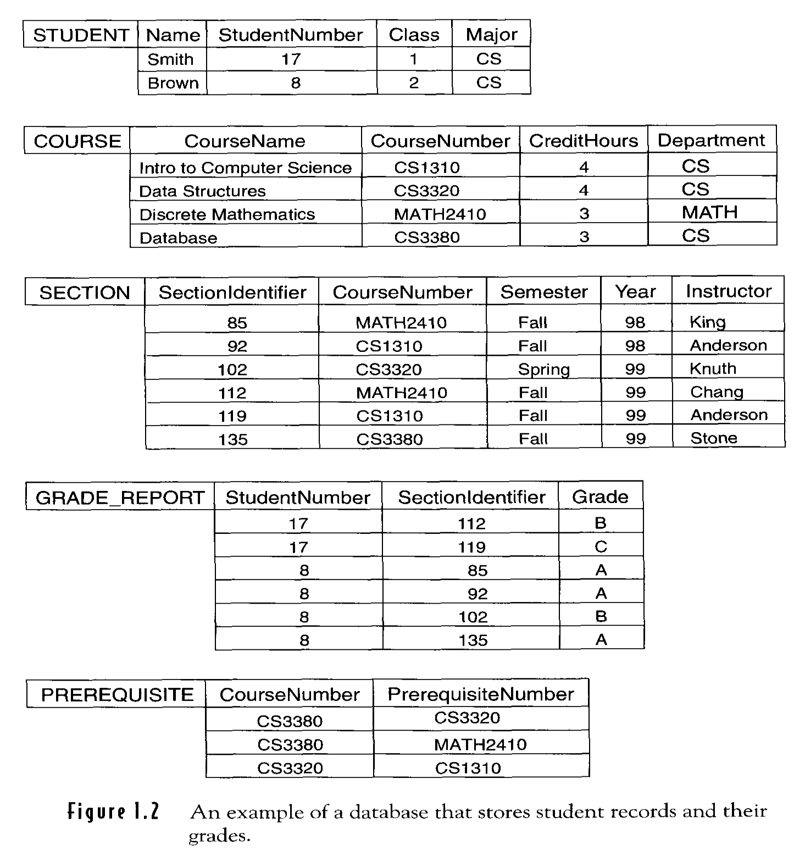

Define UNIVERSITY database
Structure of the record
STUDENT ( Name , Number, Class, Major)
COURSE ( Name , Number, Credit, Dept.)
Data type of data element
Name: a string of characters
Number: integer
Grade: {A,B,C,D,F,I}
Constraints
The sections that students take must be taught by some instructors.

Construct UNIVERSITY database
Store data on storage medium
store data for each student, course, section, grade, prerequisite
records in various files may be related to one another

Manipulate UNIVERSITY database
Query:
Retrieve the transcript (a list of all courses and grades) of Smith.
Update:
Create a new section for the database course for this semester.

Database Design
1st Step: Requirements definition & analysis
2nd Step: Conceptual design
3rd Step: Logical design or data model mapping
4th Step: Physical design

Characteristics of a Database system
File System vs a DBMS
In the file processing approach
o Each user defines and implements the files needed and software applications to manipulate those files.
o Data definition is part of the application programs, thus, programs must be changed to change definition of files.
o A program can access only specific files and special programs should be written for every query.
o This redundancy in defining and storing data results in wasted storage space and in redundant efforts to maintain up-to-date data.
o In file system, each application is free to name data elements independently.

In the database approach
o A single repository of data is defined once, maintained and is then accessed by various users.
o In database, names or labels of data are defined once and used repeatedly in different applications/queries.

Characteristics of a Database system
Self-describing nature of a database system
Insulation between programs and data, and data abstraction
Support of multiple views of the data
Sharing of data and multiuser transaction processing

Self describing nature of a Database system

In DBMS
A database system has self-describing nature.
A complete definition and description of the database structure and constraints is stored in the DBMS catalog (known as metadata),
Application software need not be changed to change description of databases.
A general purpose DBMS software package is not written for a specific database application.
Application must refer to the catalog to know the structure of the files in a specific database.

In Traditional file processing System
The structure of the data files accessed by an application is "hard-coded" in its source code.
To change the structure of the data, every application in which a description of that file's structure is hard-coded must be changed.

Insulation between programs and data, and data abstraction

In DBMS
DBMS provides an abstract view of the data that hides the details.
A DBMS provides users with a conceptual representation of data that does not include the details of how data is stored and how the operations are implemented.
o Program-data independence
o Program-operation independence

Program-data independence
The definition and description of the database is stored in the catalog (known as metadata); to change description of databases, application software are not
changed.

Program-operation independence
In object-oriented relational system, users can define operations on data as part of the database definitions
An operation is specified in two parts:
o The interface of an operation name and data types of its arguments.
o The implementation of the operation is specified separately and can be
changed without affecting the interface.

User application programs can operate on the data by invoking on these operations through their names and arguments, regardless of how the operations are implemented.

Support of multiple views of the data

A database has many users, different users may have different requirements i.e. each user requires a different view of the database.
A view may be a subset of the database or it may contain virtual data that is derived from the database files but is not explicitly stored.
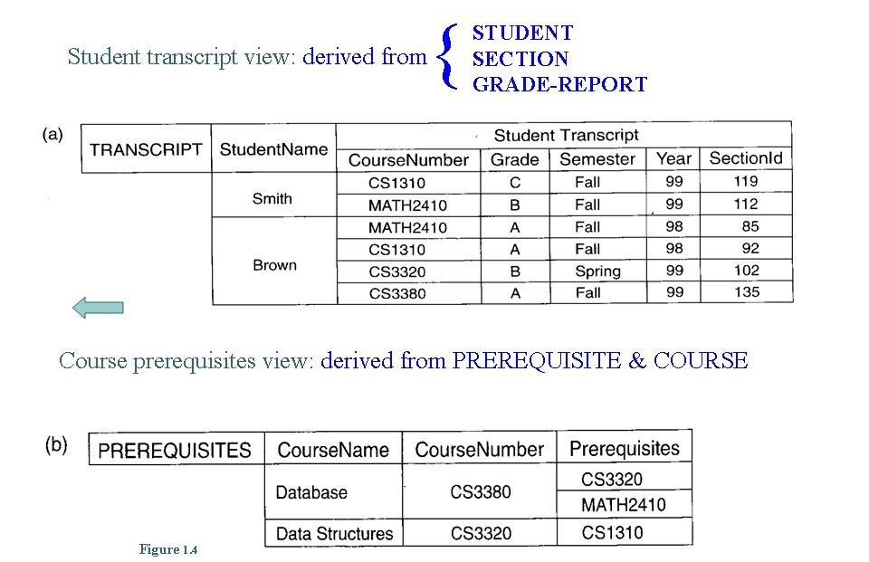

Sharing of data and multiuser transaction processing
A multiuser DBMS must allow multiple users to access the database at the same time.
DBMS includes concurrency control software to ensure that several users updating the same data, should update in a controlled manner so that the result of the every update is correct.
Each transaction should possess ACID properties.

Actors on the Scene
Database Administrator
Database Designers
End Users
o Casual end users
o Naive/Parametric end users
o Sophisticated end users
o Stand-alone users
System Analysts and Application Programmers

Database Administrator (DBA)
This is the chief administrator, who oversees and manages the database system. Duties include
1. Security & Authorization
o authorizing users to access the database, coordinating/monitoring its use
2. Database recovery after failures
o restoring the data, maintaining the log files
3. Database tuning
o acquiring hardware/software for upgrades, etc.

Database Designers
They are responsible for identifying the data to be stored and for choosing an appropriate structure to represent and store this data.
They also define views for different categories of users. The final design must be able to support the requirements of all the user sub-groups.

End-users
These are persons who access the database for querying, updating, and report generation. They are main reason for database's existence!

1. Casual end users
o They use database occasionally, needing different information each time.
o They use query language to specify their requests.
o They are middle- or high-level software literate managers.
2. Naive/Parametric end users
o Typically the biggest group of users; frequently query/update the database using standard front end based application that have been carefully programmed and tested in advance.
Examples:
o Bank tellers check account balances, post withdrawals/deposits
o Reservation clerks for airlines, hotels, etc., check availability of
seats/rooms and make reservations.
3. Sophisticated end users
o They are engineers, scientists, business analysts who implement their own applications to meet their complex needs.
4. Stand-alone users
o They use "personal" databases,
o A tax program user that creates his or her own internal database by using
ready-made package.

System Analysts and Application Programmers
They develop the packages that facilitate the data access for end users using the host language, DBMS packages, other DBMS related software tools like report writers.

Workers behind the Scene
Database system designers & implementers
Tool Developers
Operators and maintenance personnel

Database system designers & implementers
They design and implement the DBMS modules and interfaces as a software packages.
DBMS consists of many components e.g. for implementing the catalog,
processing query language, processing the interface, accessing and buffering data,
controlling concurrency and handling data recovery and security
It should also interface operating system and compilers of various programming languages

Tool Developers
They design and implement tools – the software packages that facilitate database modeling design.
These tools include packages for database design, performance monitoring, natural language or graphical interfaces, prototyping, simulation, and test data
generation.
Tools can be purchased separately which are developed by different vendors.

Operators and maintenance personnel
They are responsible for the actual running and maintenance of the hardware and software environment for the database system.

Advantages of using the DBMS approach
1. Controlled Redundancy
2. Restricting Unauthorized Access
3. Providing Persistent Storage for Program Objects
4. Providing Storage Structures for Efficient Query Processing
5. Providing Backup & Recovery
6. Multiple user interfaces
7. Representing Complex Relationships among data
8. Enforcing Integrity Constraints
9. Permitting Inferencing and Action Using Rules

1. Controlled Redundancy
In the file processing approach, each user defines and implements the files needed and software applications to manipulate those files.
Various files are likely to have different formats and programs may be written in different languages and same information may be duplicated in several files.
Data redundancy leads to
o wasted storage space,
o duplication of effort (when multiple copies of a datum need to be
updated),
o a higher likelihood of the introduction of inconsistency.

Database design stores each logical data item at one place to ensure consistency and saves storage.
But sometimes, controlled redundancy is necessary to improve the performance.
Database should have capability to control this redundancy & maintain consistency by specifying the checks during database design.

2. Restricting Unauthorized Access
A DBMS provides a security and authorization subsystem, which is used by DBA
to create user accounts and to specify restrictions on user accounts.
File processing system provides password mechanism and very less security which is not sufficient to enforce security policies like DBMS.

3. Providing Persistent Storage for Program Objects
Object oriented database systems are compatible with programming languages such as C++ and Java.
A OODBMS software automatically performs the conversion of a complex object which can be stored in OODBMS, thus an object is said to be persistent due to its
survival after the termination of the program.

4. Providing Storage Structures for Efficient Query Processing
The DBMS utilizes a variety of sophisticated techniques (view, indexes etc.) (auxiliary files) to store and retrieve the data efficiently that are utilized to improve the execution time of queries and updates.
DBMS provides indexes and buffering for fast access of query result, the choice of index is part of physical database design and tuning.
The query processing and optimization module is responsible for choosing an efficient query execution plan for each query submitted to the system.

5. Providing Backup & Recovery
Data should be restored to a consistent state at the time system crash and changes being made
If hardware or software fails in the middle of the update program, the recovery subsystem of DBMS ensures that update program is resumed at the point of
failure.

6. Multiple user interfaces
DBMS provides a variety of user interfaces for the users of varying level of technical knowledge.
These includes query language for casual users, programming language interfaces for application programmers, forms and command codes for parametric users,
menu driven interfaces and natural language interfaces for stand alone users etc

7. Representing Complex Relationships among data
A DBMS have the capability to represent a variety of complex relationship among the data, to define new relationships as they arise, and to retrieve and update the
related data easily and efficiently.

8. Enforcing Integrity Constraints
The DBMS have certain integrity constraints that hold on data.
These constraints are derived from the meaning of the data and of the miniworld.
Some constraints can be specified to the DBMS at the time of defining data definitions and automatically enforced.
Database does not allow violation of constraints at the time of updating the database.

9. Permitting Inferencing and Action Using Rules
Deductive database systems provide capabilities for defining deduction rules for inferencing new information from the stored database facts.
Triggers can be associated with tables.
A trigger is a form of a rule activated by updates to the table, which results in performing some additional operations to some other tables, sending messages
and so on.
Stored procedure can also be used as a part of the overall database definition and are invoked appropriately when certain conditions are met.
Active database provides more powerful functionality by providing the active rules that can automatically initiate actions when certain events and conditions
occur.

Additional Implications of using the DBMS approach

1. Potential for Enforcing standards
The database approach permits the DBA to define and enforce standards among database users in a large organization.
Standards can be defined for names and formats of data elements, display formats, report structures, terminology etc.
This facilitates communication and cooperation among various departments, projects and users within the organization.

2. Reduced application time
DBMS applications are more robust because many important tasks are handled by
DBMS, thus do not have to be debugged and tested.
Programmer can concentrate more on the specific functionality required by the users.

3. Flexibility
It may be necessary to change the structure of a database as requirements change.
Modern DBMS allows certain type of changes to the structure of database without affecting the stored data and the existing application programs.

4. Availability of Up-to date information
Availability of immediate up to date information is essential for many transaction processing applications.
In DBMS, update applied to database by one user can immediately be seen by other users.

5. Economies of scale
The DBMS approach permits consolidation of data and applications, thus reducing the amount of wasteful overlap between the activities of data processing personnel, also reduce the storage space.

When not to use DBMS
A database is a complex piece of software, optimized for certain kind of workload
(e.g. answering complex queries or handling many concurrent requests), and its
performance may not be fit for certain specialized applications such as:
Applications with tight real time constraints need efficient custom code.
Multiple user access is not required.
Manipulation and processing of data is simple and does not match with DBMS
features.
The overhead costs of using a database which would not be incurred in traditional file processing system are due to following reasons:
o High initial investment in hardware, software and training
o Generality that a database provides for defining and processing data.
o For providing security, concurrency control, recovery, and integrity
functions.

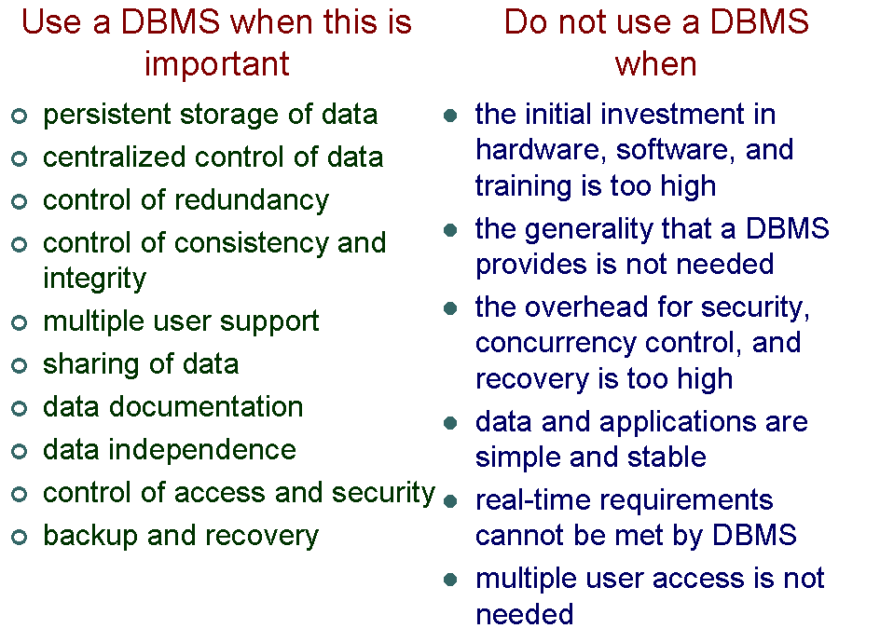

Questions

1. What is DBMS? Discuss the functionalities of a DBMS
2. Write short notes on
a) Database b) DBMS c) DBA
3. What is DBMS? Discuss the main characteristics of database approach.
4. Compare DBMS and file processing system.
5. Discuss the self-describing nature of a DBMS.
6. DBMS exhibits the characteristic “Insulation between program and data”.
Discuss.
7. Comment on “DBMS support of multiple views of the data”.
8. Comment on “DBMS allows sharing of data”.
9. Explain the basic concepts of DBMS and in what way it is advantageous over conventional file processing. (any advantage can be asked individually)
10. Discuss various types of actors for DBMS and workers behind DBMS.
11. a) What are the responsibilities of DBA?
b) What are the different types of database end users?
12. When we should not use DBMS?

Database System Concepts and Architecture

Introduction
The architecture of DBMS packages has evolved as follows:
o Early monolithic systems: whole DBMS package was one tightly integrated system
o Modern DBMS packages are modular in design with client/server system architecture.

Data Models, Schemas, and Instances
Database approach provides data abstraction.
Database abstraction refers to the suppression of details of data organization and storage and the highlighting of the essential features for an improved understanding of data.
Structure of a database includes data types, relationships, and constraints that should hold on the data.
A data model is a collection of concepts that can be used to describe the structure of a database and thus it provides the necessary means to achieve this abstraction.
Most data models also include a set of basic operations for specifying retrievals and updates on the database.
Data models also include the dynamic aspect or behavior of a database application.
Concepts to specify behavior are fundamental to object oriented data models but are also being incorporated in more traditional relational data models (e.g. stored procedures)

Categories of Data Models
A number of models for data representation have been proposed.
High level or conceptual data models
o Provide concepts that how users perceive the data, e.g. ER model (entities, attributes, relationships, constraints)
o Object data model group (ODMG): a conceptual model for object oriented database
Low level or physical data models
o Provide concepts that describe the details of how data is stored in the computer e.g. record formats, record orderings, access path, index etc.
Representational data models
o Provide the concepts which is in between two extremes
o They hide some details of data storage but can be implemented on a computer
system directly
Most frequently used in commercial applications is relational data model (also called record-based data models)
Other legacy data models are network and hierarchical models.

Schemas, Instances, and Database State

Description of structure of database & Database itself
The description of a database is called the database schema which is specified during database design and is not expected to change frequently.
Schema diagram displays structure of each record type but not the actual instances of records.
Each object in the schema is known as a schema construct e.g. student table.
A schema diagram displays only some aspects of a schema such as names of record types and data items, and some type of constraints; other aspects are not specified.

An Example
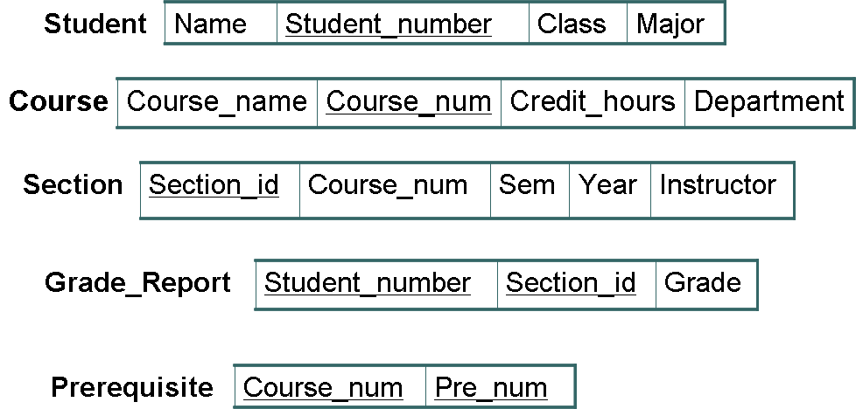

The data in the database at a particular moment is called a database state or snapshot.
This state is also called the current set of occurrences or instances in the database.
Many database states can be constructed to correspond to a particular database.
When a new database is defined; database state is empty state with no data.
When database is populated, database enters in initial state.
The DBMS is partly responsible for ensuring that every state of the database is a valid state - that is, a state that satisfies the structure and constraints specified in the schema.
Hence, specifying a correct schema to the DBMS is extremely important.
DBMS stores the descriptions of the schema constructs and constraints in the catalog
(meta-data).
Schema is called the intension and state is called as extension.
Changes in application requirements result in schema evolution.

Three-Schema Architecture and Data Independence

Three-Schema Architecture
The schema in DBMS can be described at three levels:
o Internal level has an internal schema
o Conceptual level has a conceptual schema
o External level includes a number of external schemas or user views
The information about all three schemas is stored in the system catalog.

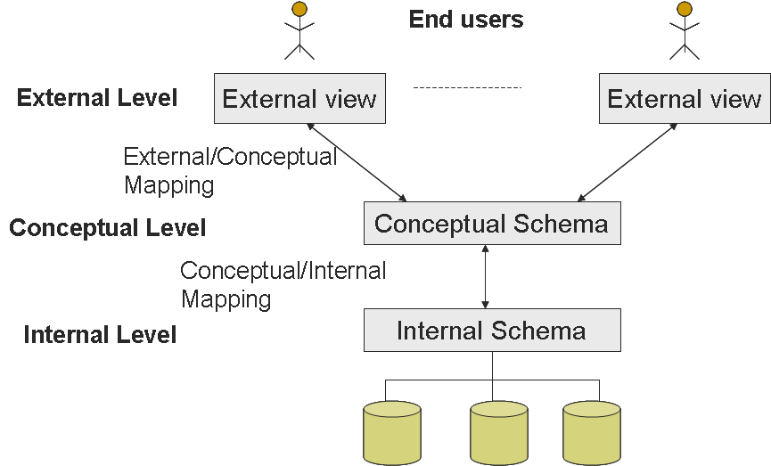
Internal Schema
The internal schema specifies complete details of storage and access paths for the database.
File organization on the disk should be decided e.g. hashing, indexing etc.
The process of arriving at a good physical database schema is called physical database design.

Conceptual Schema
The conceptual schema (or logical schema) describes the structure of the database.
The conceptual schema hides the details of physical storage structures and concentrates on describing entities, data types, relationships, user operations, and constraints.
A representational data model is used to describe the conceptual schema when a database is implemented.
The process of arriving at a good conceptual database schema is called conceptual database design.
Conceptual Schema (example)
Students (sid: string, sname: string, login: string, age: integer, gpa: real)
Faculty (fid: string, fname: string, sal: real)
Courses (cid: string, cname: string, credits: integer)
Rooms (rno: string, address: string, capacity: integer) Enrolled (sid: string, cid: string, grade: string) Teaches (fid: string, cid: string)
Meets_In (cid: string, rno: integer, time: string)

External Schema
The external schemas allow data access to be customized at the level of individual users and hide rest of the details from the users.
Any database has exactly one conceptual schema and one physical schema but may have many external schemas in view to support different users.
Each external schema consists of a collection of one or more number of views or tables.

The external schema design is guided by end user requirements e.g. courseinfo (cid, fname, sid)

Important points
Three schemas are only descriptions of data; the stored data that actually exists is at the physical level.
DBMS must transform a request specified on an external schema into a request against
the conceptual schema, and then into a request on the internal schema for processing over
the stored database.
The process of transforming requests and results between levels are called mappings.

Data Independence
One of the most important benefits of using three schema architecture is its support for data independence.
Applications are insulated from how data are structured and stored.
Data independence is the capacity to change the schema at one level of a database without changing the schema at the next higher level.
o Logical data independence
o Physical data independence

Logical data independence
Protection of user views from changes in logical structure of data.
Logical data independence is the capacity to change the conceptual schema without having to change external schemas or application programs.

Physical data independence
Protection of logical structure from changes in physical structure of data.
Physical data independence is the capacity to change the internal schema without having to change conceptual schemas.

Important points
Physical data independence exists in most databases.
But logical data independence is hard to achieve.
Data independence occurs because when the schema is changed at some level, the schema at higher level remains unchanged; only the mapping between the two levels is
changed.
Two levels of mappings create an overhead during compilation or execution of a query or program, leading to inefficiencies in the DBMS.

Database Languages
Data Definition Language (DDL)
Storage Definition Language (SDL)
View Definition Language (VDL)
Data Manipulation Language (DML)
o A high level or nonprocedural DML
o A low level or procedural DML

Data Definition Language (DDL)
In most of the DBMS, there is no separate language for internal and conceptual schema, DDL is used by DBA and Designers.
The DBMS will have a DDL compiler which process the DDL statements.

Storage Definition Language (SDL)
If distinct languages are used, DDL is used to specify conceptual schema and SDL is used to specify internal schema.
The mapping between the two schemas may be specified in either of the language.

View Definition Language (VDL)
For true three-schema architecture, VDL is required for external schema and its mapping with conceptual schema.
In relational DBMSs, SQL is used in the role of VDL to define views as results of predefined queries.

Data Manipulation Language (DML)
DBMS provides a set of operations like insertion, modification and deletion through
DML

High level or nonprocedural DML
It can be used on its own to specify complex database operations.
These statements can be entered interactively from a display monitor or terminal.
These can be embedded in a general purpose programming language where they can be extracted by a precompiler and processed by the DBMS.
This can specify and retrieve many records in a single DML statement, thus known as set-at-a-time or set-oriented DMLs (eg. SQL)
Also known as declarative language

Low level or procedural DML
It must be embedded in a general purpose programming language.
This retrieves individual records from the database and processes each separately.
Thus it needs programming language constructs like loops.
This is also known as record-at-a-time (eg. DL/1)

Important points
Whenever a DML is embedded in a general purpose language, that language is called host language and DML is data sublanguage.
A high level DML used in a standalone interactive manner is called a query language.
Naïve and parametric users generally interact with database through user friendly interfaces.

Database Interfaces
User-friendly interfaces provided by a DBMS include:
1. Menu-based Interfaces for Web Clients or Browsing
2. Form-based Interfaces
3. Graphical Interfaces
4. Natural Language Interfaces
5. Speech Input and Output
6. Interfaces for parametric Users
7. Interfaces for DBA

Menu-based Interfaces for Web Clients or Browsing
These interfaces present the users with lists of options (called menus) that help the user in formulation of query request.
The query is composed step by step by picking options from a menu that is displayed by the system.
Pull-down menu is a popular technique in Web-based user interfaces.
They are used in browsing interfaces, which allow a user to browse the content of a database in an exploratory and unstructured manner.

Form-based Interfaces
Forms are designed and programmed for naïve users.
User can fill up the form for new entries in database.
User can also fill up few entries and rest of the matching entries are retrieved from the database.
Many DBMSs have specification languages, which help programmers specify such forms.
Oracle Forms, a component of Oracle Developer suite, provides an extensive set of features to design and build applications using forms.

Graphical Interfaces
A GUI displays a schema to the user in diagrammatic form.
Users can specify a query by manipulating the diagram.
GUIs utilize both menus and forms.
A pointing device, mouse, can be used.

Natural Language Interfaces
A natural language interface has its own schema and a dictionary of important words.
The natural language interface refers to the words in its schema and to the set of standard words in dictionary.
If the interpretation is successful, the interface generates a high level query corresponding to the natural language request and submits it to DBMS for further processing.
If interpretation is not successful, a dialogue is started with the user to clarify the request.

Speech Input and Output
It provides limited use of speech as an input query and speech as an answer to a question or result of a request e.g. Telephone directory, Flight arrival /departure, and Bank account information etc.
The speech input is detected using a library of predetermined words and used to set up the parameters that are supplied to the queries.
For output, similar conversion from text or numbers into speech takes place.

Interfaces for parametric Users
A special interface is implemented for each known class of naive users e.g. bank tellers
Special function keys can be programmed to do repeated work fast.

Interfaces for DBA
DBA Staff can use privileged commands for creating accounts, setting system parameters, granting account authorization, changing a schema and reorganizing the
storage structure of the database.

The Database System Environment
The database and DBMS catalog are stored on disk.
A stored data manager (module of DBMS) controls access to DBMS information that is stored on disk whether it is part of the database or catalog.
Various users such as
o DBA staff & casual users work with interactive interfaces to formulate queries.
o Application programmers write programs using host language.
o Parametric users make data entry to database through predefined forms.
DBA staff works on defining the database and tuning it using DDL and other privileged commands.
DDL compiler processes schema definitions, specified in the DDL, and stores description of the schema in the DBMS catalog.
Queries are parsed, analyzed for correctness of the operations and names of data elements by query compiler that compiles them into an internal form.
Internal query is subjected to query optimization by query optimizer.
The precompiler extracts DML commands from an application program and sends to
DML compiler for compilation.
Rest of the program is sent to host language compiler.
The object codes for the DML commands and rest of the program are linked, forming a canned transaction whose executable code includes calls to runtime database processor.
Parametric users supply the parameters to these canned transactions directly so they can run transactions repeatedly.
Runtime database processor executes
o Privileged commands
o Executable query plans
o Canned transactions with runtime parameters.
It works with the system dictionary, stored data manager which in turn uses basic OS
services for carrying out low level input/output operations between disk and memory.

It also handles some aspects of management of buffers in main memory; some DBMS
have their own buffer management.
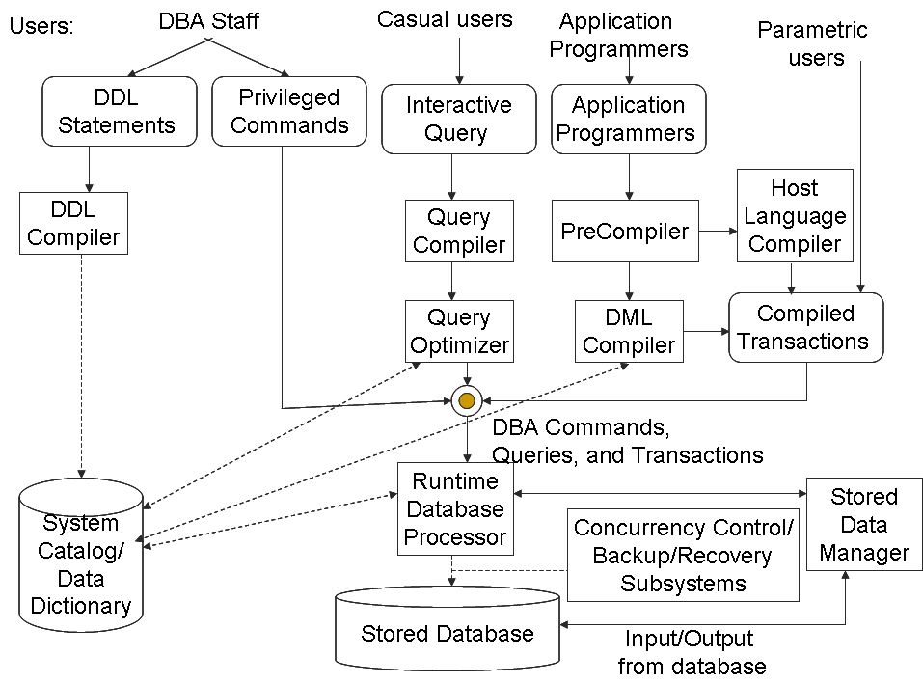
Concurrency control, back up and recovery manager are integrated into the working of the runtime database processor for purposes of transaction management.

Database System Utilities
Loading
Backup
Database storage reorganization
Performance monitoring

Few other utilities
Sorting files
Handling data compression
Monitoring access by users
Interfacing with networks

Loading
It is used to load existing data files (text files or sequential files) into the database.
Format of source data file and target data file are specified to the utility.
Utility reformats the data and stores it in the database
Some vendors offer the tools, conversion tools, with loading programs, formats of source data file and target database.
e.g. IMS (IBM), IDMS (Computer Associates), SUPRA (CINCOM), IMAGE (HP)

Backup
It creates backup copy of the database, usually dumping the entire database onto the tape.
Back up copy can be used to restore the database in case of catastrophic failure.
Incremental backups can also be used, where only changes since previous backup are recorded.
Incremental backup is more complex but saves memory.

Database storage reorganization
It can be used to reorganize a set of database files into a different file organization to improve performance.

Performance monitoring
It monitors database usage and provides statistics to DBA in making decisions such as whether or not to reorganize files or whether to add or drop indexes to improve performance.

Tools, Application Environments, and Communications Facilities

Tools
CASE tools are used in design phase of database systems.
Expanded Data dictionary (data repository) is used to store catalog information about schema & constraints, and also design decision, usage standards, application program
descriptions, and user information, thus known as information repository.
This information can be accessed directly by users and DBA.

Application Environments
These system provide an environment for developing database applications and includes facilities that help in many facets of database systems,
These include database design, GUI development, querying and updating and application program development.
e.g. PowerBuilder (Sybase), JBuilder (Borland)

Communications software
This software allows the users to access remotely located database through computer terminals, workstations or other personal computers.
These users are connected to the database site through data communications hardware such as phone lines, local networks, or satellite.
The integrated DBMS and data communications system is called a DB/DC system.

Centralized DBMSs Architectures
Earlier architectures used mainframe computers to provide the main processing for all system functions, user application programs, user interface programs, and also all
DBMSs functionality.
User accessed such systems via computer terminals that did not have processing power and only provided display capabilities.

These computer terminals are connected to the central computer via various types of communication network.

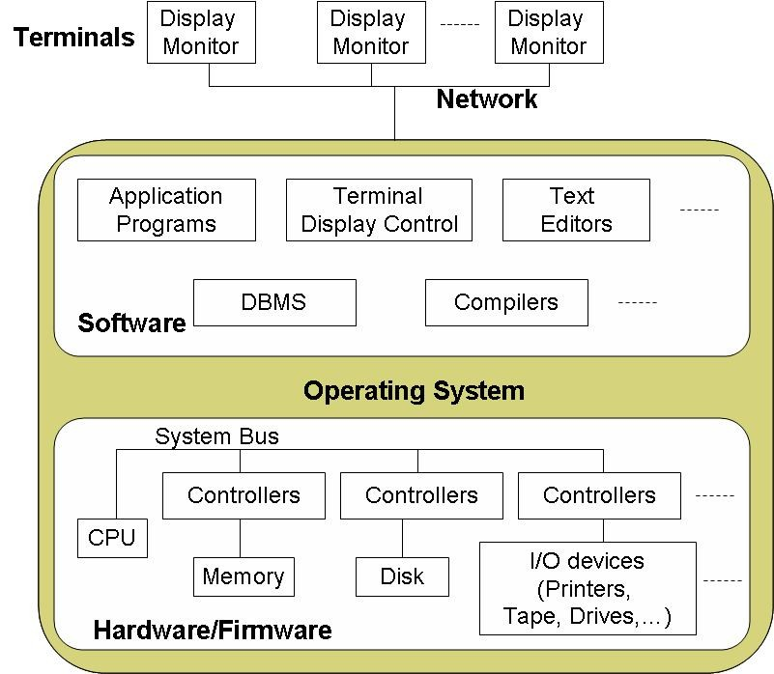

Basic Client/Server Architectures
Specialized servers are responsible for specific functionalities e.g. print server, file server, web server, e-mail servers etc.
The client machines provide the user with the appropriate interfaces to utilize these services, as well as with local processing power to run local applications.
Some clients may be diskless workstations, some may be dedicated server, and some may work both as client and server.

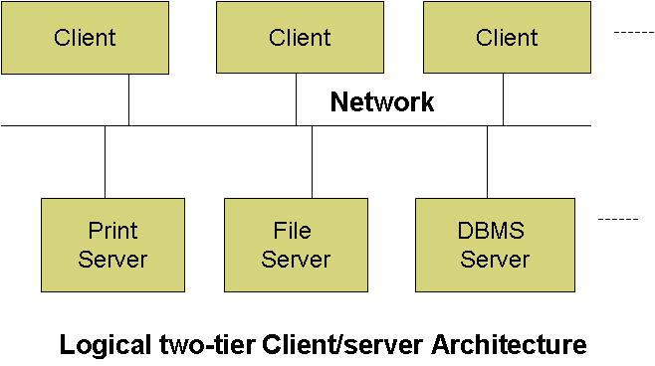

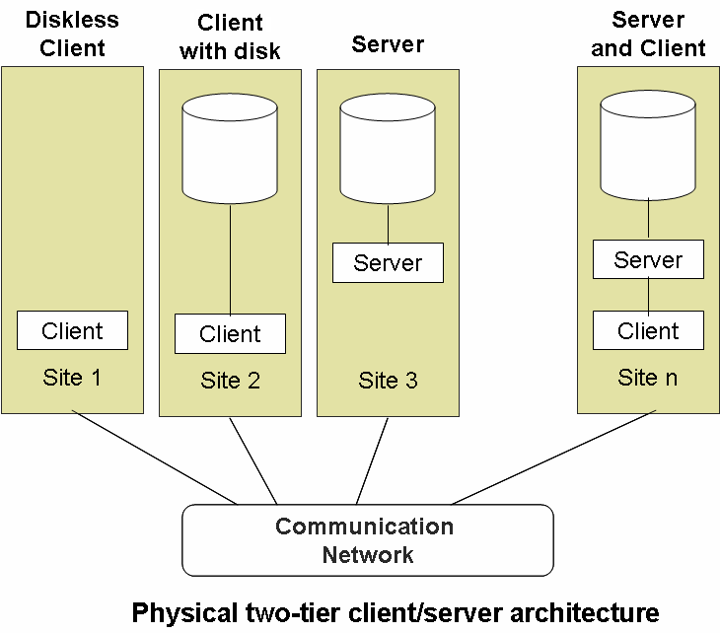

Two-Tier Client/Server Architectures for DBMSs
In RDBMSs
Client had user interface and application programs
Server provided query and transaction functionalities related to SQL
Server is called a query server or transaction server or SQL server.
When DBMS access is required, the program establishes a connection to DBMS
Once connection is established, client program can communicate with DBMS.
A standard called Open Database Connectivity (ODBC) provides an application programming interface (API), which allows client-side programs to call DBMS.
Any query results are sent back to the client program and can be displayed or used for further process.
Most DBMS vendors provide ODBC drivers for their systems.
JDBC is a standard that allows Java client programs to access the DBMS.
In object oriented DBMSs,
Software modules of the DBMS are divided between client and server in a more integrated way.
Server may include the part of the DBMS software responsible for handling data storage on disk pages, local concurrency control and recovery, buffering and caching of disk pages etc.
Client may handle the user interface, data dictionary functions, DBMS interactions with programming language compilers, structuring of complex objects from the buffers etc.
In this approach the client and server interaction is more tightly coupled.
The exact division of the functionality varies from system to system.
In this case server is called data server.

Three-Tier Architectures for Web Applications
Web applications use an architecture called the three-tier architecture, which adds an intermediate layer between client and the database server.
Thus, three tiers provide the following:
o User interface
o Application rules
o Data access
Clients contain GUI (user interface) and some additional application specific business rules.
Database server includes database services.
The intermediate layer or middle tier is also known as application server or Web server depending on the application.
Middle layer stores business logic (procedures, constraints) that are used to access data from the database server.
Middle layer also improve database security by checking a client’s details before forwarding a request to the database server.

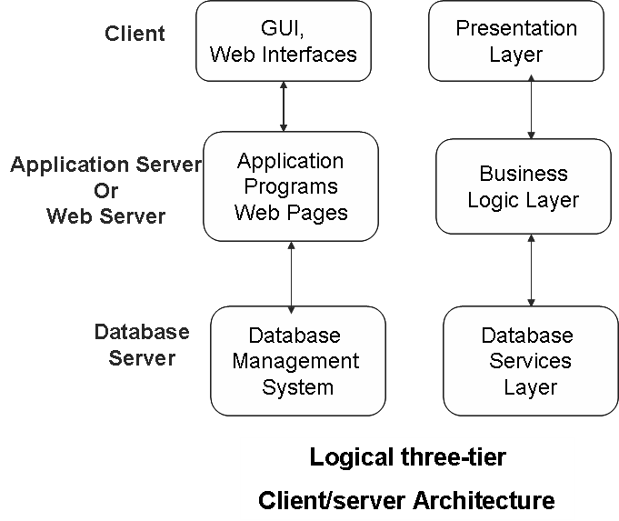

n-Tier Architectures for Web Applications
Bottom layer in three-tier architecture includes all data management services.
If the bottom layer is split into two layers (a web server and a database server), then this becomes a four tier architecture.
Layers between user and the stored data can be defined into finer components, thus gives n-tier architecture

Question Bank:

1. What is data model? Discuss the different categories of data models.
2. Explain the three-schema architecture with neat diagram.
3. What is data independence? Explain the different levels of data independence.
4. Discuss various DBMS languages.
5. Discuss different types of user interfaces for a DBMS.
6. Explain database system environment with illustration.
7. Discuss various utilities related to DBMS.
8. Explain centralized and client-server architecture for DBMS.
9. Explain 2-tier and 3-tier client server architecture for DBMS.

