Unit-2 :Relational Model and Relational Algebra

Relational Model Concepts

The relational model is based on a collection of mathematical principles drawn primarily from set theory and predicate logic.
The model was first proposed by Dr. E.F. Codd of IBM in 1970 in the following paper: "A Relational Model for Large Shared Data Banks," Communications of the ACM, June

1970.

First commercial implementations of the relational model became available in early 1980s:
o SQL/DS System on MVS operating system by IBM o Oracle DBMS

Current popular RDBMSs are:
- Oracle by Oracle

  - DB2 and Informix Dynamic Server by IBM o SQL Server from Microsoft

A relation may be thought of as a set of rows.
A relation may alternately be thought of as a set of columns. or
A relation is a table consisting of rows (tuples) and columns (attributes). Each row corresponds to a real-world entity or relationship.

Each row has a value of an item or set of items that uniquely identifies that row in the table.
Sometimes row-ids or sequential numbers are assigned to identify the rows in the table. Name of table and columns are necessary to interpret the meaning of values.

Each column typically is called by its column name or column header or attribute name.
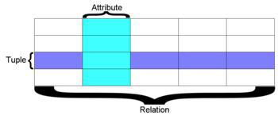

Domain

A set of atomic (indivisible) values for each attribute. Thus a domain has a name, data type & format.
Additional information for interpreting the values of a domain can also be given e.g. dollar, kg etc. e.g.
o Phone_number: Set of all Phone Numbers in India having 10 digits

o Employee age: All possible ages (20 – 70)

Relational Schema: relation name and a list of attributes e.g.

R(A1, A2, A3, ……..An) o R → Relation

o A1, A2, A3, …An → set of attributes in relation R dom (Ai): domain of attribute of Ai
dom (A1): domain of attribute A1

Degree (arity) of relation is number of attributes

Relation name: STUDENT

List of attributes: USN, Name, Address, DOB, GPA

Dom (name): All possible Names

Degree of relation: 5


Using data type of each attribute

STUDENT (USN: string, Name: string, Address: string, DOB: Date, GPA: real) r (R) denotes a relation r on the relation schema
R (A₁, A₂, A₃…..A_{n}) and is a set of n-tuples
r= {t₁, t₂, t₃, ….., t_{m}}
where t ={v₁, v₂, v₃,….v_{n}}
v_{i} = t [A_{i}]

R: schema of the relation

r of R: a specific "value set" or population of R. R is also called the intension of a relation

r is also called the extension of a relation
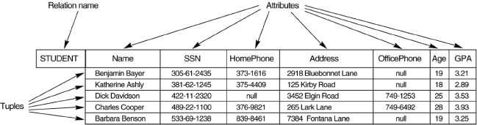

A relation r(R) is a mathematical relation of degree n on the domains dom(A1), dom(A2),….,dom(An).

It is a subset of the Cartesian product of the domains that define R

r(R) = (dom (A1) * dom (A2) * .... * dom(An))

The Cartesian product specifies all possible combinations of the values from the underlying domains.
Total no of tuples in the Cartesian product is

|dom(A1)| * |dom(A2)| * …….* |dom(An)|
where cardinality of the domain (finite) is |D|.

r(R) is the current relation state i.e. valid tuples that represent a particular state of the real world (or few tuples out of the combinations resulted from Cartesian product)

Relation schema is relatively much more stable.

Relation state changes as the state of the real world changes.

Characteristics of Relations

Each value is derived from an appropriate domain. A relation may be regarded as a set of tuples (rows).

Columns in a table are also called attributes of the relation. Ordering of tuples in a relation

- The tuples are not considered to be ordered physically, even though they appear to be in the tabular form.
  - Many logical orders can be specified in a relation

Ordering of attributes in a relation schema R (and of values within each tuple):
  - A tuple is an ordered list of n values

- e.g. the attributes in R(A1, A2, ..., An) and the values in t=<v1, v2, ..., vn> are ordered.

  - At the logical level order of attributes and their values is not important as long as correspondence between attributes and values is maintained.

Values and NULLs in the Tuples

  - Each value is an atomic value, composite and multivalued attributes are not allowed (due to first normal form).
- Multivalued attributes must be represented by separate relations.

  - Composite attributes are represented by their simple component attributes in the basic relational model.

NULL represents the values of attributes because

  - Value unknown

- Value exists but not available o Attribute not applicable

Relational Model Notation

A relation schema R of degree n: R(A1,A2,…..An)

Tuple t in a relation: t = <V1, V2,…. Vn>
  - Vi belongs to Ai

Q, R, S → Relation names q, r, s → Relation states t, u, v → tuples

E.g. Student (USN, Name, Address) → Relation schema

Student (111, Meena, #508 RRNagar) → one tuple from the current Relation state R.A → Student.Name
Student.Address
Example
CUSTOMER (Cust-id, Cust-name, Address, Phone#)
Each row in the CUSTOMER table may be referred to as a tuple in the table and would consist of four values.
<632895, "John Smith", "101 Main St. Atlanta, GA 30332", "(404) 894-2000"> is a tuple belonging to the CUSTOMER relation.

Relational Model constraints & Relational Database Schema

Relational Model constraints

Constraints are restrictions specified on a relational database and must hold on all valid relation instances.
These constraints are derived from the rules in the miniworld that the database represents. Various restrictions can be specified on a relational database.

Constraints can be divided into three main categories:
- Inherent model-based or implicit constraints

Constraints that are inherent in the data model
- Schema based or explicit constraints

Constraints that are directly expressed in schema of the data model specifying in DDL
- Application-based or semantic constraints or business rules

Constraints that can not be directly expressed in schema of the data model and hence must be expressed and enforced by the application programs.

There are following main types of constraints which can be specified in DDL : o Domain Constraints
o Key Constraints and Constraints on NULL values o Entity Integrity

o Referential Integrity

Domain Constraints

Within each tuple, the value of each attribute must be an atomic value from that domain. Data type
- Integers, real

  - Characters, fixed & variable length strings o Date, time etc.

Range of values can be specified for each attribute

Key Constraints

A relation is a set of tuples and all elements of a set are distinct. Thus, all tuples in a relation state must be distinct.
Superkey is set of attributes that identifies the tuples uniquely in a valid relation state. Any such set of attributes is called a Superkey

Default superkey is a set of all attributes

t1[SK] # t2[SK]
Minimal superkey is a superkey from which we can not remove any attributes and still

have uniqueness constraint.
or

A "minimal" superkey is a superkey K such that removal of any attribute from K results in a set of attributes that is not a superkey.
A minimal superkey is called a key attribute of the relation.

Key Constraints (Example-1)

Relation schema
Student {USN, Name, Address} Default Superkey →

  - {USN, Name, Address} Removing redundant attributes

  - {USN, Name} → Superkey
- {USN} → Minimal Superkey (or key)

Key Constraints (Example-2)

Relation schema
Order_details {Order_no, item_no, Quantity } Default Superkey →

  - {Order_no, item_no, Quantity } Removing redundant attributes

  - {Order_no, item_no} → Minimal Superkey (or key)

Candidate Keys

Candidate keys are those key attributes which can uniquely identifies tuples separately. Candidate key must satisfy the following properties:
•Uniqueness property:

•No two distinct tuples have the same value for the key.
•Minimality property:

•None of the attributes of the key (in case of composite key) can be discarded from the key without destroying the uniqueness property.

Primary Key

Primary Key is the candidate key that is chosen to identify the tuples uniquely.

•Only one candidate key can be chosen as Primary key.

•It should be underlined.

•Value of primary key can not be null.
•It may be single attribute or a small set of attributes. (if more than one attribute can identify the tuples uniquely together, those attributes together form composite primary key)
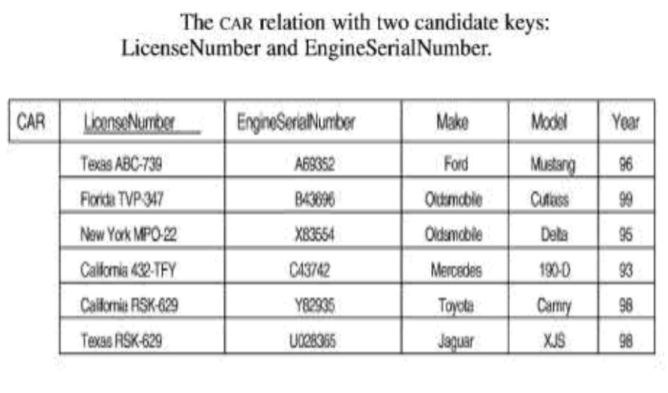

NULL Constraints

Some of the Attributes can be restricted not to allow NULL values. NOT NULL constraint can be declared.

Relational Database Schema

A relational database contains many relations which may have certain relationships and integrity constraints.
S is a set of relation schemas that belong to the same database. S is the name of the database.

S = {R1, R2, ..., Rn}

E.g.
Company = {Employee, Department, Project, Dept_location, Dependant, Works_on}

Example
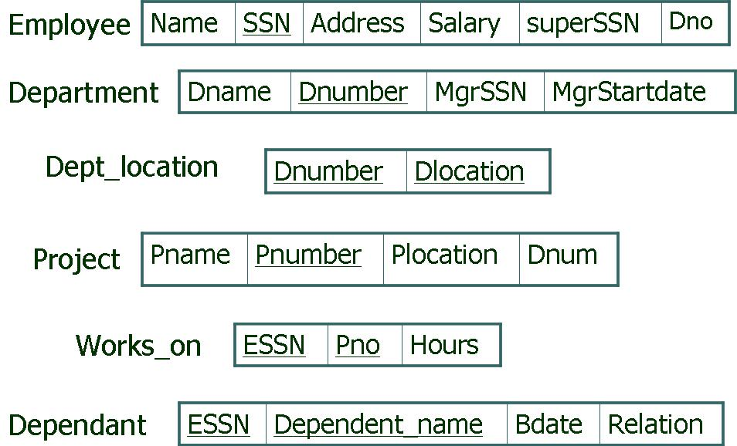

Relational Database State

A relational database state is a set of relations states that belong to the same database. s is the name of the database state.

s = {r1, r2, ..., rn}

A database state that does not satisfy all the integrity constraints is called an invalid state, and a state that satisfies all the constraints is called valid state.
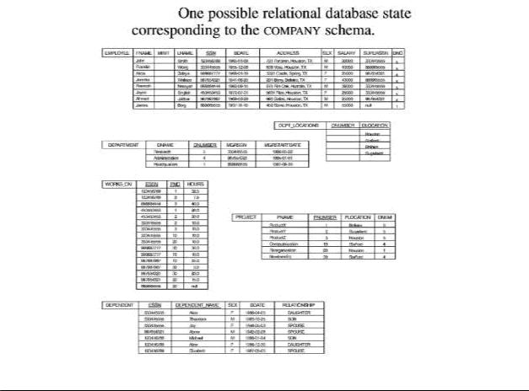

Relational Database Schema

Two relations have one or more same attributes having same domain: o Titles for such attributes may be same or different
o E.g. Dno in Employee,
Dnumber in Department & Dept_location
Dnum in Project

Two relations may have different attributes with same names o name in employee, department and project

Entity Integrity Constraints

Entity Integrity:

- The primary key attributes PK of each relation schema R in S cannot have null values in any tuple of r(R).

  - This is because primary key values are used to identify the individual tuples. Key Constraints & Entity Integrity Constraints are specified on individual relations
Other attributes of R may be similarly constrained to disallow null values, even though they are not members of the primary key.

Referential Integrity Constraints

Referential integrity constraint is specified between two relations and is used to maintain the consistency among tuples in the two relations.

Foreign Key

The foreign key is a column or a set of columns in one (referencing) table that refers to a column or set of columns in another (referenced) table.

o Dno of Employee refers to Dnumber of Department

An attribute in a relation R1 is a foreign key [FK] of R1 that references PK of relation R2 The attribute in FK have the same domains as the primary key [PK] attribute of R2
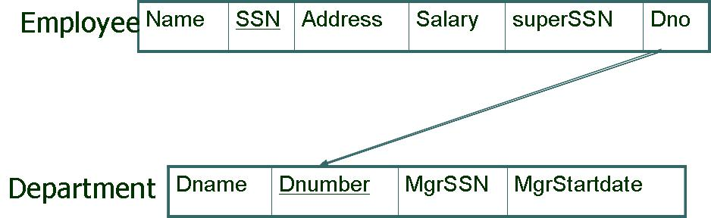

Foreign Key can refer to its own relation

  - SuperSSN in Employee refers to SSN of Employee

R1 → referencing relation R2 → referenced relation t1[FK]=t2[PK]
  - If t1 is from r1(R1)
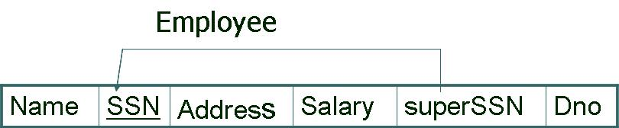
- If t2 is from r2(R2)
- t1 of R1 refers to t2 of R2

A tuple t1 in R1 is said to refer a tuple t2 in R2 if t1[FK] = t2[PK]. However null is possible in FK.
Referential Integrity constraints arise due to the relationship among the entities present in database.
Referential Integrity constraint is specified between two relations.

  - To maintain the consistency among tuples of two relations. Values of the foreign key can be

  - Either null (if it is not part of the primary key of referencing table)

  - If not null, must match with the primary key value of some tuple of the referenced relation.

These two relations are the referencing relation and the referenced relation.

The column in the referencing table must be a primary key in the referenced table. In a relational database schema, many referential integrity constraints are possible.

A Tuple in the referencing relation R1 refers to the other relation R2, must refer existing tuple.
A referential integrity constraint can be displayed in a relational database schema as a directed arc from R1.FK to R2.PK
All Integrity constraints must be specified on the relational database schema if constraints have to be enforced on the relational database states.
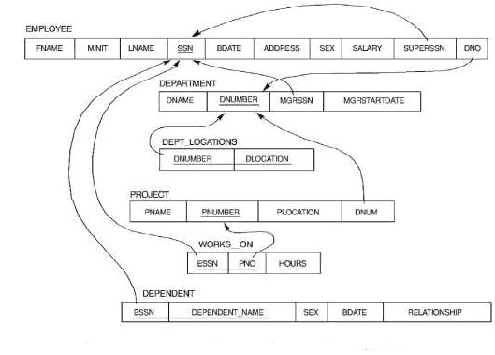

Semantic Integrity Constraints

Semantic Integrity Constraints can be specified and enforced on a relation database. o Salary of an employee should not exceed than 10,00,000
o The max. no. of hours per employee for all projects he or she works on is 56 hrs per week

A general purpose constraint specification language (triggers and assertions) can be used.

Other Constraints

State Constraints

  - All above constraints which are responsible for the valid state of database. Transition Constraints

  - Can be defined to deal with state changes in database.

- Enforced by the application programmes by triggers etc. o Salary of an employee can only increase.

Update Operations, Transactions and dealing with constraints violations

Operations can be categorized into retrievals and updates Update operations are:

- INSERT a tuple. o DELETE a tuple. o MODIFY a tuple.

Update Operations on Relations

Integrity constraints should not be violated during the update operations. Several update operations may have to be grouped together.
Updates may propagate to cause other updates automatically. Thus, it may be necessary to maintain integrity constraints.

Insert operation

Insert can violate any of the four types of constraints: o Domain constraints

  - If an attribute value does not belong to appropriate domain o Key constraints

  - If value of primary key of new tuple already exists in another tuple of the
relation
- Entity constraints

  - If value of primary key of new tuple is null o Referential integrity constraints

  - If value of foreign key refers to a tuple that does not exist.

Example
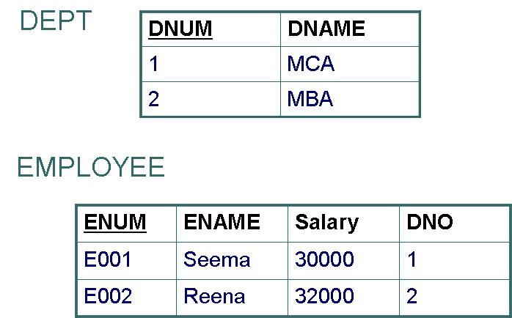

Domain constraints

  - Insert into EMPLOYEE values(‘e003’, ‘Teena’, ‘asfdf’, ‘1’);

  - → Not accepted

Key constraints
  - Insert into EMPLOYEE values(‘e001’, ‘Teena’, 31000, ‘1’);

  - → Not accepted

Entity constraints
  - Insert into EMPLOYEE values(‘’, ‘Teena’, 31000, ‘1’);
- → Not accepted

Referential integrity constraints

  - Insert into EMPLOYEE values(‘’, ‘Teena’, 31000, ‘3’);

  - → Not accepted

Insert into EMPLOYEE values(‘e003’, ‘Teena’, 31000, ‘1’);
  - → Accepted

Delete operation

Delete can violate only Referential integrity constraints

- If the tuple being deleted is referenced by the foreign key from other relation’s tuples
  - delete from DEPT where dname = ‘MBA’;

  - → Not accepted

Due to delete operation violation, three options are possible:

  - Reject the deletion

- Cascade deletion – delete tuples from different relations that refer the tuple that being deleted

- Modify the referencing attribute values Null

Some valid value

  - If FK is part of PK, it can not be NULL Cascade deletion

  - delete from DEPT where dname = ‘MBA’;
- Delete the tuples from DEPT and EMPLOYEE also wherever dname = ‘MBA’ is

satisfied, (may not be feasible)
or

Delete the tuples from DEPT where dname = ‘MBA’ and tuples from EMPLOYEE will be updated to NULL for DNO where dname = ‘MBA’ (feasible)

Update (modify) operation

Generally, it is necessary to specify a condition on the attributes of the relation to select the tuple to be modified
o Updating an attribute other than PK, FK –

----only domain constraint
----i.e. check to confirm that the new value is of the correct data type and domain Modifying a PK → deleting one tuple + inserting a new tuple
  - Constraint violations due to Delete

  - Constraint violations due to Insert

Modifying a FK → new value should refer to an existing tuple in the referenced relation
  - Referential Integrity Violation

The Transaction Concepts
A database application program running against a relational database runs a series of transactions.
A transaction involves reading from the database as well as doing insertions, deletions and modifications to existing values in the database.
Each the transaction should leave the database in a consistent database.

Questions

- Write a short note on relational model.
- What are the different types of constraints which can be specified using DDL?

- What is domain constraint? Discuss.

- Explain key constraints with an example.

- Describe referential integrity constraints with an example.

- Define entity integrity constraints with an example.

- Write short notes on following:

  - Entity Integrity Constraint

  - Referential Integrity Constraint

  - Foreign Key

  - Primary Key

- Discuss the various constraints violation during different update (insert, delete, modification) operations.

Relational Algebra

Relational Algebra

A data model must include a set of operation to manipulate the database. This basic set of operation for relational model is Relational Algebra.
A sequence of relational algebra operations forms a Relational Algebra expression. It provides a formal foundation for relational model operation.

It is used as a basis for implementing and optimizing queries in RDBMS.

Some of its concepts are incorporated into the SQL (standard query language) for RDBMS. These algebraic operations enable a user to specify basic retrieval requests.

The result of retrieval is a new relation, which may be formed from one or more relations. Unary Relational Operations:

  - These operations operate on single relations. Binary Relational Operations:

  - These operations operate on two relations.

Two groups of operations

Set Operations based on mathematical set theory o Union
o Intersection o Difference

o Cartesian product
Operations developed specially for relational database:
o Select -- Unary
- Project -- Unary
o Join -- Binary

Select operation

Select operation is used to select a subset of the tuples from a relation that satisfy a selection condition.

It is a horizontal partitioning of the relation:
  - One partition satisfying the condition will be shown as result.

  - Other partition not satisfying the condition will be discarded. SELECT operation is unary

    - <selection condition> (R)

  - Where σ (sigma) is for select operation
- selection condition is a boolean expression specified on the attributes of Relation R

Clauses of selection condition

- <Attribute name> <comparison operator> <constant value> o <Attribute name> <comparison operator> <Attribute name>
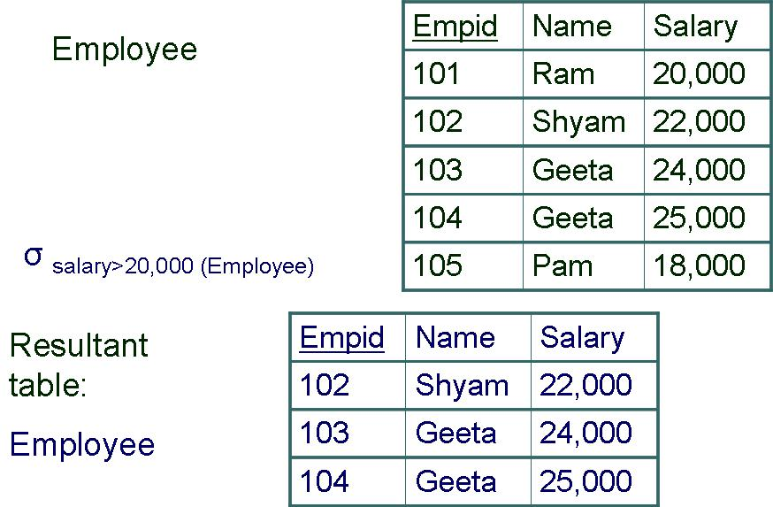

Comparison operator

=, <, >, ≠, ≥,≤ for numeric value or date
=, ≠ for strings of characters

Constant value
  - Value from attribute domain

Degree of resulting relation is same as that of R
No. of tuples in resulting relation <= no. of tuples in R

  - i.e. |σc (R)| <= |R|

Selection condition may be more than one
o i.e. (cond1 and cond2) → true if both are true
- i.e. (cond1 or cond2) → true if any one or both are true
- NOT cond →true if cond is false

Select operation: expression
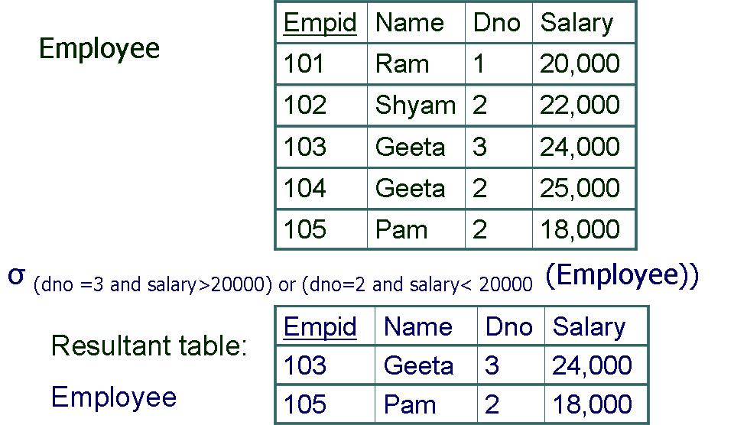

Select operation is Commutative:

σ<cond1> (σ<cond2> (R)) = σ<cond2> (σ<cond1> (R))
  - A sequence of Selects can be applied in any order.

Cascade of Selects can be used through one select using Conjunctive (AND)
σ<cond1> (σ<cond2> (….(σ<condn>(R))……)) = σ<cond1> AND<cond2>AND…… AND<condn> (R)

Select operation: Commutative
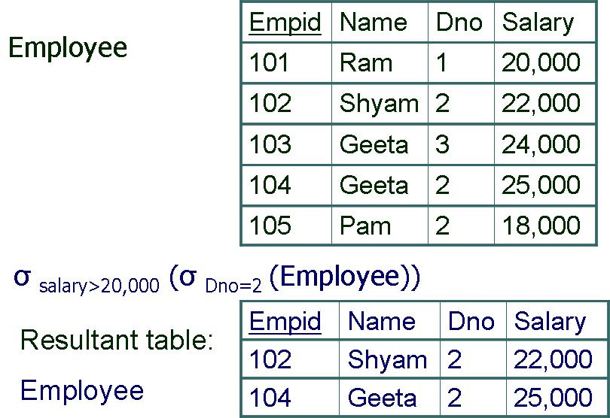

*************************
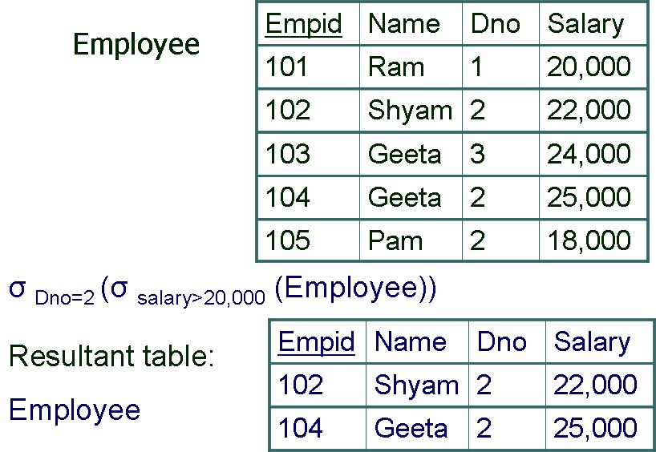

Project Operation

Project operation selects certain columns from relation and discards the rest. It is a vertical partitioning of the relation:
- One partition satisfying the condition will be shown as result.

  - Other partition not satisfying the condition and will be discarded. PROJECT operation is unary

    - <attribute list> (R)

  - Where Π (pi) is for project operation

Attribute list is the desired list of attributes from relation R
Resulting relation has attribute only those specified in list and in same order
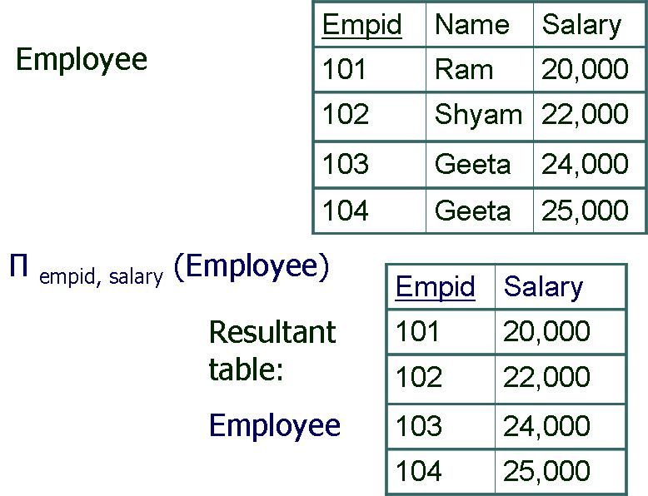



Degree of resulting relation is same as no. of attributes in list No. of tuples in resulting relation?
- If attribute list has Primary key, the no. of tuples will be same as in Relation R
- If attribute list does not have Primary key, the duplicate tuples will be removed to give

valid relation
  - Thus, no. of tuples in resulting relation <= no. of tuples in relation R Project operation is not Commutative:

Π<list1> (Π<list2> (R)) ≠ Π<list2> (Π<list1> (R))

Following is true if list1 is subset of list2, otherwise false

Π<list1> (Π<list2> (R)) = Π<list1> (R)
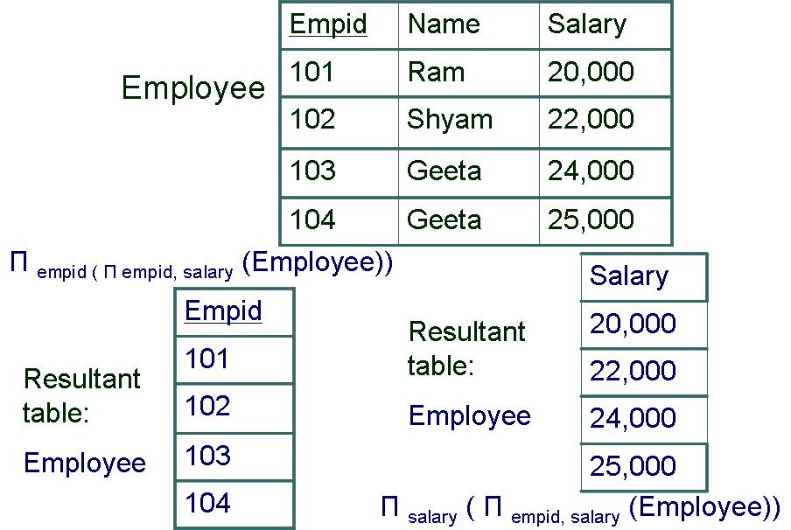

**********************
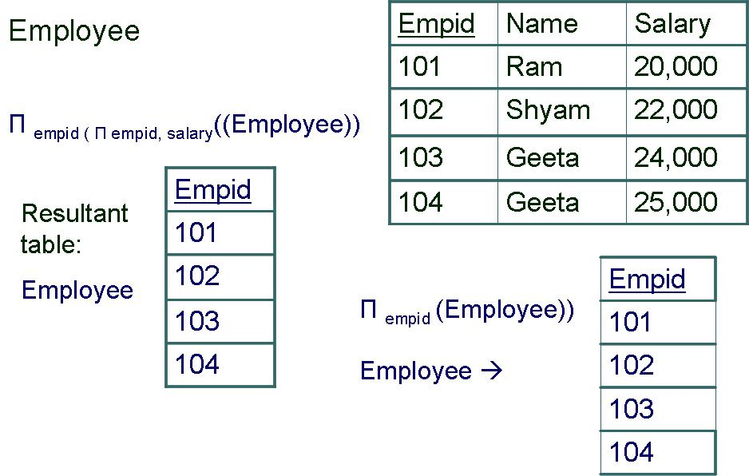

Sequence of operations Operation

Several algebraic expressions:
- As a single relational expression by nesting operations

Π<list1> (σ<cond1> (R))
Or

- Name the intermediate relation and get final result as a series of operations temp ← σ_{<cond1>} (R)
result ← Π_{<list1>} (temp)
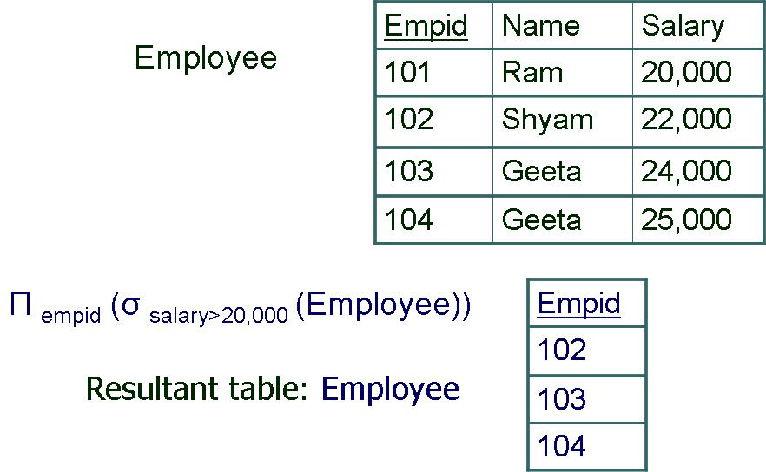

***************************
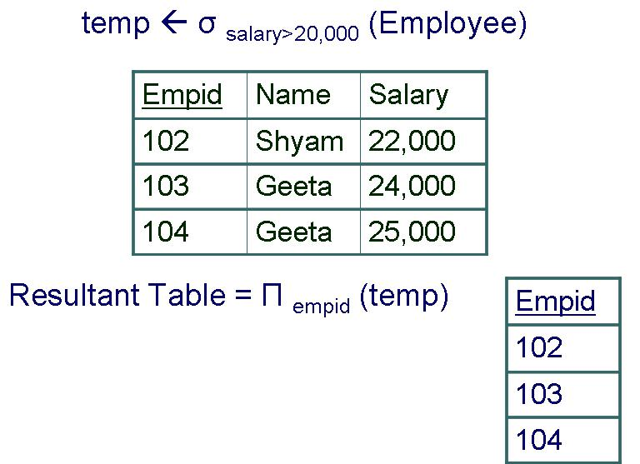

Rename

Relation & attributes can be renamed in resulting relation temp ← σ_{<cond1>} (Employee)
Emp (empid, empname, empsalary) ← Π_{<eid, ename, salary>} (temp)
If no renaming is applied, resulting relation will have same names and order of attributes as parent relation has.

Sequence of operations Operation: Rename resulting relation
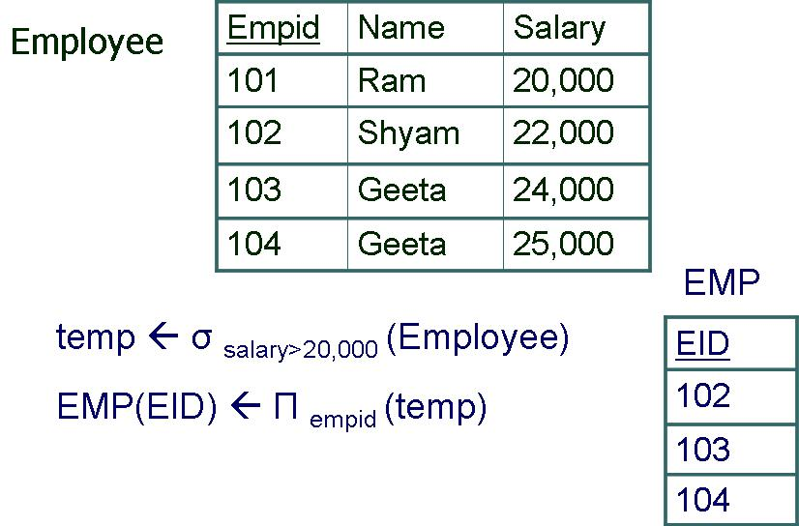

Formal Rename operation

Renaming both relation name and attributes ρS(B1, B2,….Bn) (R)
Renaming only relation name

ρS (R)
Renaming only attributes ρ(B1, B2,….Bn) (R)

Formal Rename operation (ex)

Renaming both relation name and attributes

ρEMPLOYEE(empno, empname,birthdate) (emp)
Renaming only relation name ρEMPLOYEE (emp)
Renaming only attributes

ρ(empno, empname,birthdate) (emp)

Set Theoretic Operation

Binary operation

Both relational should be union compatible

Union compatible has following characteristics:

i.e. for R(A1, A2, ….An) & S(B1,B2,….Bn)
dom(Ai) = dom(Bi) for 1 <= i <=n

  - Degree of both relations should be same. UNION (RUS)

INTERSECTION (R ∩S) MINUS (R-S)

UNION (RUS)

It includes all tuples that are either in R or S or in both Duplicate tuples are eliminated.
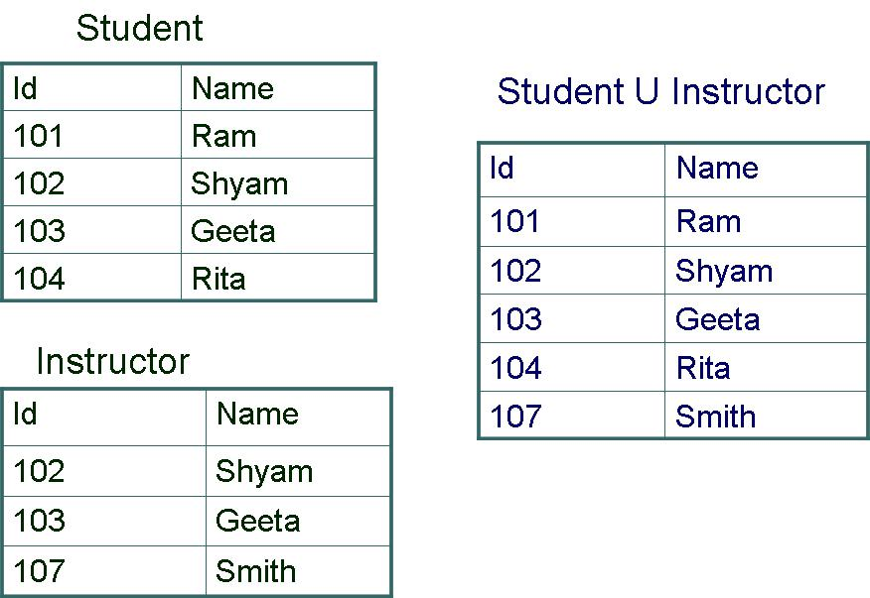

INTERSECTION (R∩S)

It includes all tuples that are in R & S both
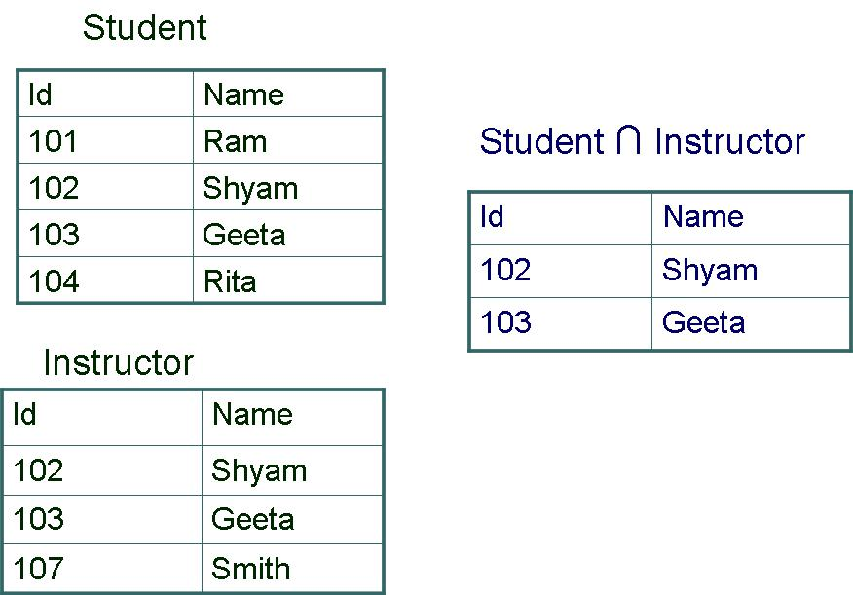

Set difference (MINUS)

(R-S)
It includes all tuples that are in R but not in S
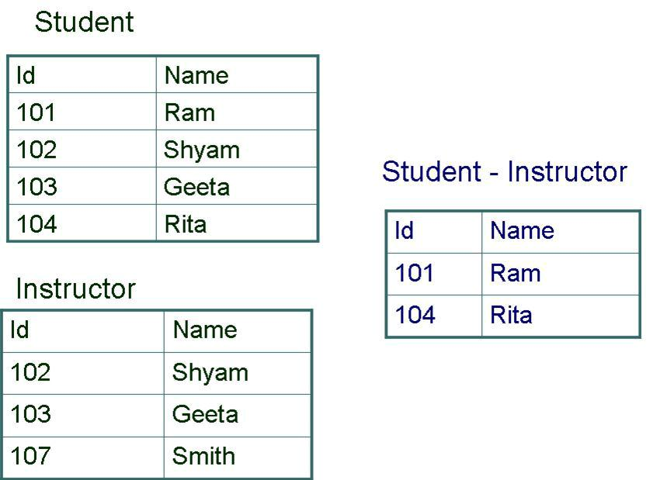

(S-R)

It includes all tuples that are in S but not in R
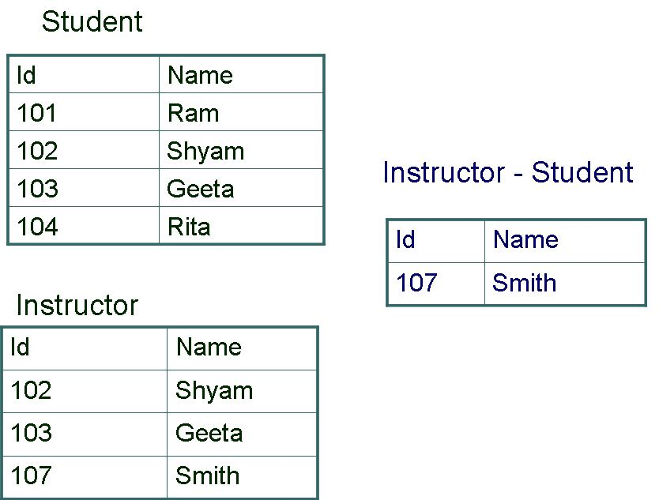

(R-S) ≠ (S-R)
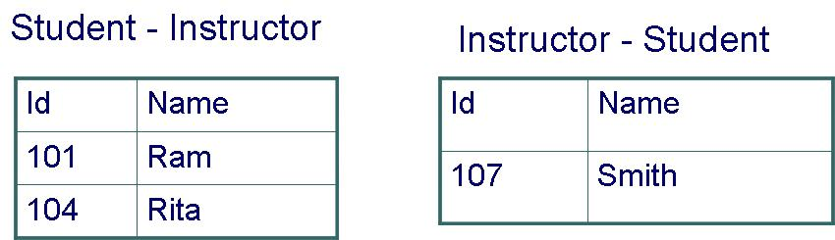

Union & Intersection are: o Commutative

(R U S) = (S U R)
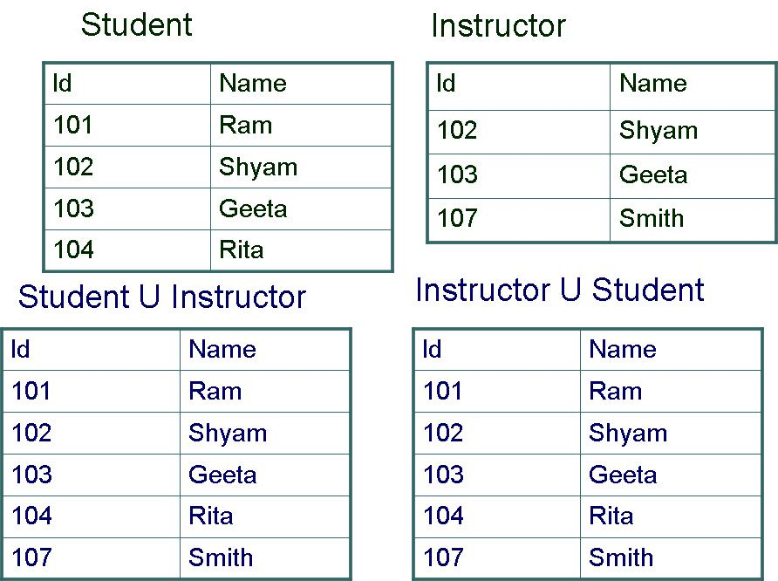

(R ∩ S) = (S ∩ R)
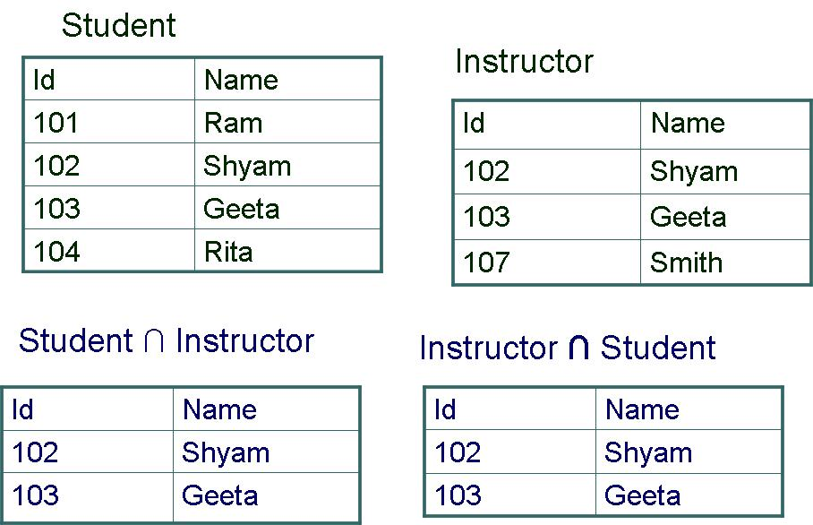

- Associative

(R U (S U T) = (R U S) U T)
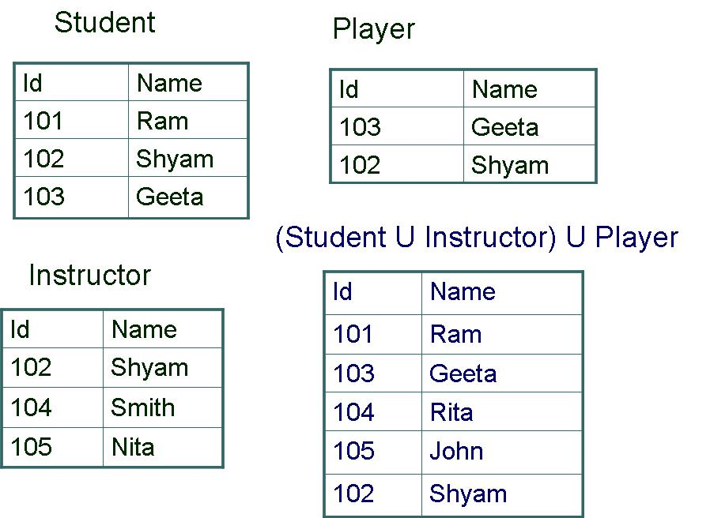

(R ∩ (S ∩ T) = (R ∩ S) ∩ T)
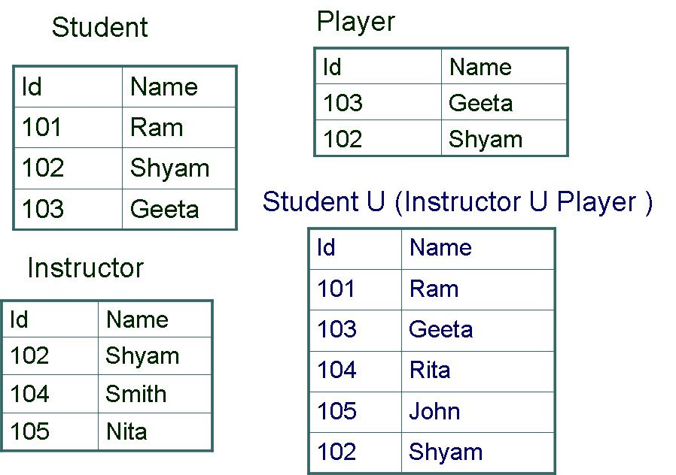

Cartesian Product

Also known as cross product or cross join Binary Operation

Union Compatibility is not required R х S
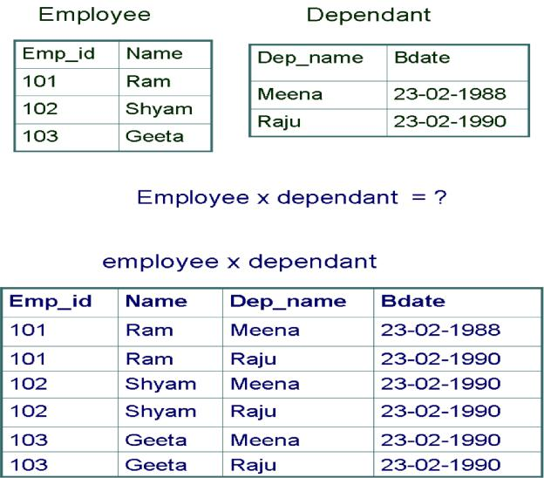

no. of tuples in Resultant relation = no. of tuples in R х no. of tuples in S It includes one tuple from each combination
No. of attributes in Resultant relation = n + m

R(A1, A2,…,An) х S(B1, B2,...,Bn) = Q(A1, A2,…,An, B1, B2,….,Bn)

Result will have some irrelevant tuple which can be further processed by select & project operation

Binary relational Operations

JOIN

DIVISION

JOIN Operation

  -  S It is used to combine related tuples from two relations into single tuples. It allows to process relationships among relations
  - <join condition> S

Attributes in Resultant relation = n + m

R(A1, A2,…..,An) S(B1, B2,….,Bn) =  Q(A1, A2,…..,An, B1, B2,….,Bn)

No. of tuples wherever join condition is satisfied.

JOIN Operation and Cartesian product

In Join, combinations of tuples satisfying joining condition appear in the result.

Whereas in Cartesian product, all combinations of tuples are included in the result.

Join operation can be stated as Cartesian product operation followed by Select operation. A general JOIN condition is of the form

- <condition> AND <condition> AND ….AND <condition> o Each condition is of the form Ai θ Bi

Theta join

Condition is of the form Ai θ Bi where θ is one of the {=,<,>,≥,≤,≠} dom(Ai) = dom(Bi)
Tuples whose join attributes are null do not appear in the result

S1 S1.sid < R1.sid R1

EQUI JOIN

When comparison Operator used is =, is called an EQUI JOIN One or more pairs of attributes that have identical values

EQUI Join operation
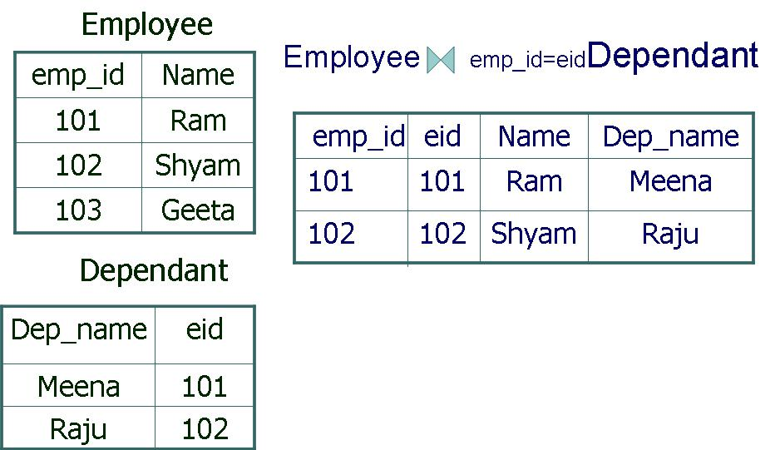

In EQUI JOIN one pair of attribute have identical values in each tuple i.e. one attribute is superfluous, a new JOIN can be applied:

o Natural JOIN i.e. R * S

Both the tables should have one same attribute with same name as joining attribute If attribute is same but name is different (first perform rename than natural join)



If join condition is not satisfied → no tuple in resultant relation If no. of tuples in R = n_{R}
If no. of tuples in S = n_{S}
Tuples in resultant of EQUI JOIN are in between zero and nR * nS Join selectivity ratio = expected size of join result / maximum size

A complete set of relational algebra operation

{σ, п, U, -, х) is a complete set

R ∩ S = (RUS) – ((R-S) U (S-R))

R <condition> S = σ <condition> (R х S) Natural join = п…(σ…(ρ….(R х S)))

But for convenience, different operations are used.
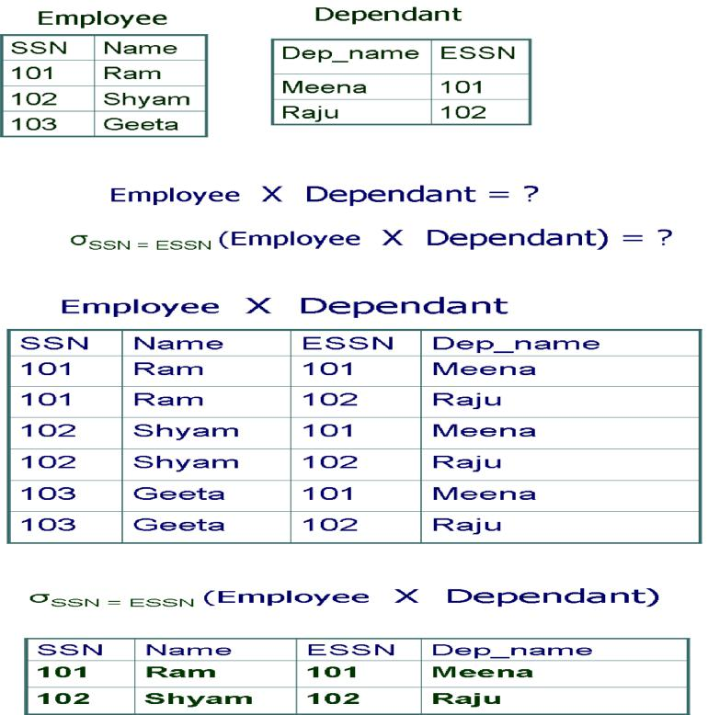

Outer Join Operations

Outer joins are used to keep all the tuples in R, or all those in S, or all those in both relations in the result of the JOIN, regardless of whether or not they have matching tuples in the other relation.

This satisfies the need of queries in which tuples from two tables are to be combined by matching corresponding rows, but without losing any tuples for lack of matching values.

The join operations where only matching tuples are kept in the result, are called inner joins.
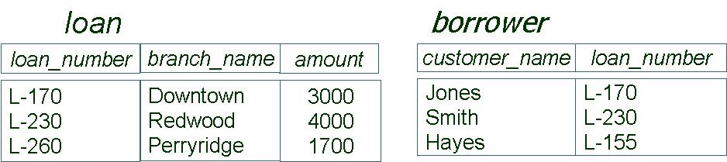

LEFT OUTER JOIN operation keeps every tuple present in the first (left) relation in the result of

R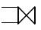 S.

If no matching tuple is found in S, then the attributes of S in the join result are filled with null values.
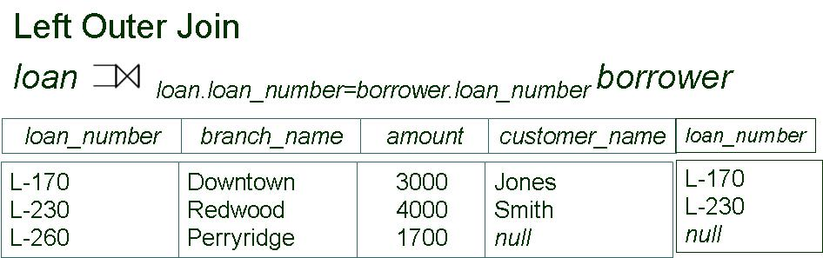

RIGHT OUTER JOIN keeps every tuple present in the second (right) relation S in the result of
R 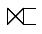S.
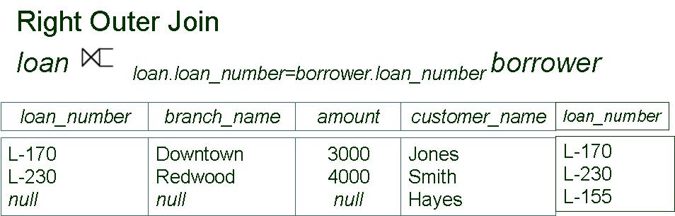

FULL OUTER JOIN keeps all tuples present in both the left and the right relations.

R S
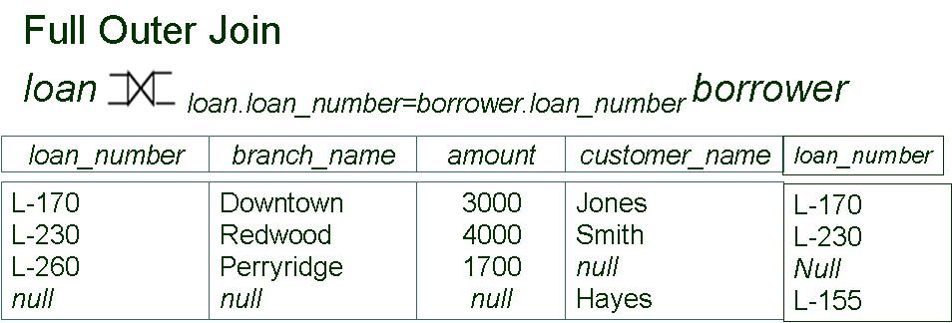

Division operation

Division operation is suited to queries that include the phrase “for all” Denoted by ÷

Operation is applied to two relations

R(Z) ÷ S(X)
Division operation is applied to two relations

R(Z) ÷ S(X) where X is subset of Z and attribute Y of R that is not attribute of S

i.e. (Z-X) = Y

Resultant tuples will have values of Y which is related all the values of X
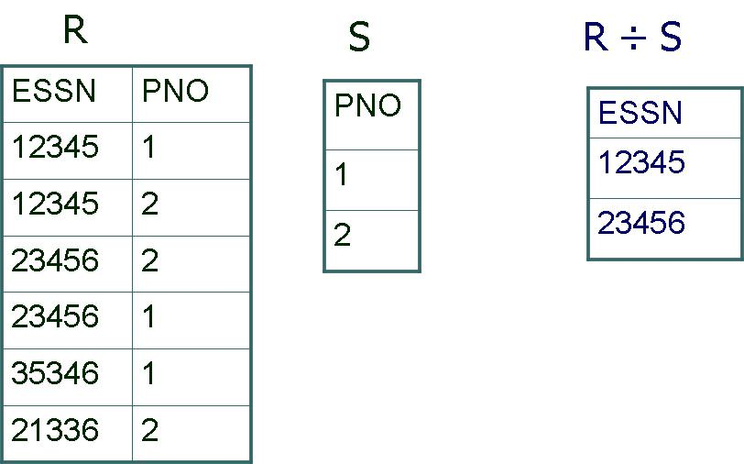

Additional Relational Operations

Generalized Projection

Generalized projection operation extends the projection operation by allowing functions of attributes to be included in the projection list.

ΠF1, F2,….,Fn (R)
Where F₁, F₂,….,F_{n} are functions over the attributes in the relation R and may involve constants.

Generalized Projection (Example)

Relation Given
EMPLOYEE (Ssn, Salary, Deduction, Years_service)

Result Expected

Report (Ssn, Net_salary, Bonus, Tax)

REPORT← ρ(Ssn, Net_salary, Bonus, Tax)

(ΠSsn, Salary – Deduction, 2000* Years_service, 0.25*Salary (EMPLOYEE)

Aggregate functions and Grouping

To specify mathematical aggregate functions on collections of values from the database Sum, Average, Maximum and Minimum can be applied to collections of numeric values. The COUNT function is used to count tuples or values.

  - avg: average value o min: minimum value o max: maximum value o sum: sum of values

o count: number of values

Tuples can be grouped in a relation by the value of some of their attributes and then applying an aggregate function independently to each group.
An AGGREGATE FUNCTION operation, using the symbol  (pronounced ‘script F’), to specify these types of operations as follows:

<grouping attributes>  <function list> (R)

Where <grouping attributes>is a list of attributes of the relation specified in R for which grouping is required, and <function list> is a list of (<function><attributes>) pairs.

<grouping attributes>  <function list> (R)

Dno COUNTSsn (EMPLOYEE)

Dno COUNTSsn , AVERAGESalary(EMPLOYEE)

Dno COUNTSsn, AVERAGESalary(EMPLOYEE)

Result: R(DNO, COUNT_SSN, AVERAGE_SALARY)

COUNTSsn, AVERAGESalary (EMPLOYEE)


Result: R(COUNT_SSN, AVERAGE_SALARY)

Retrieve each department number, the number of the employee in the department, their average salary, while renaming the resulting attributes
ρR (DNO, NO_OF_EMPS, AVG_SAL) (DNO COUNTSsn,AVERAGESalary(EMPLOYEE))

Result: R(DNO, NO_OF_EMPS, AVG_SAL)

Outer Union Operations

This is Union of two tables which are not union compatible.

The attributes that are union compatible are represented only once in the result, and those attributes that are not union compatible from either relation are also kept in the result relation T(X,Y,Z)

STUDENT (Ssn, Name, Department, Advisor)

INSTRUCTOR (Ssn, Name, Department, Rank)

Result of Outer Union

STUDENT_OR_ INSTRUCTOR (Ssn, Name, Department, Advisor, Rank)
Tuple with (Ssn, Name, Department) same combination will appear once in the result.
Tuples appearing only in STUDENT, will have NULL for Rank.

Tuples appearing only in INSTRUCTOR, will have NULL for Advisor.

Examples of queries

Q1: Retrieve the name and address of all employees who work for the 'Research'

department.
Solution:
RESEARCH_DEPT <- σ _{DNAME='Research'} (DEPARTMENT)
RESEARCH_EMPS <- (RESEARCH_DEPT _{DNUMBER = DNO} EMPLOYEE)
RESULT <- π _{fname, lname, address} (RESEARCH_EMPS)

Q2: For every project located in ‘Stafford’, list the project number, the controlling department number, and the department manager’s last name, address and birth date. Solution:

STAFFORD_PROJS<- σ _{PLOCATION=‘Stafford‘} (PROJECT)
CONTR_DEPT <- (STAFFORD_PROJS | DNUM = DNUMBER DEPARTMENT)
PRJ_DPT_MGR <- CONTR_DEPT | MGRSSN = SSN EMPLOYEE)
RESULT <- Π PNUMBER,DNUM, LNAME, ADDRESS,BDATE (PRJ_DPT_MGR)

Q3: Find the names of employee who work on all the projects controlled by department no.

5
Solution:

DEPT5_PROJS(PNO)<-Π_{PNUMBER} (σ _{DNUM=5}(PROJECT))
EMP_PROJ(SSN, PNO)<- Π _{ESSN, PNO}(WORKS_ON)
RESULT_EMP_SSNS<- EMP_PROJ ÷ DEPT5_PROJS
RESULT <- Π _{LNAME, FNAME}(RESULT_EMP_SSNS * EMPLOYEE)

Q4: Make a list of project numbers for projects that involve an employee whose last name is ‘Smith’, either as a worker or as a manager of the department that controls the project. Solution:

SMITHS(ESSN) <- Π_{SSN}(σ_{LNAME=‘Smith’}(EMLPOYEE))
SMITH_WORKER_PROJ <- Π_{PNO}(WORKS_ON * SMITHS)
MGRS <- (EMPLOYEE _{SSN=MGRSSN} DEPARTMENT)
SMITH_MANAGED_DEPTS(DNUM) <- Π_{DNUMBER} (σ _{LNAME=‘Smith’}(MGRS))
SMITH_MGR_PROJS(PNO) <-Π_{PNUMBER}
(SMITH_MANAGED_DEPTS * PROJECT)
RESULT <- (SMITH_WORKER_PROJ U SMITH_MGR_PROJS)

Q5: List the names of all employees with two or more dependents.

(Strictly speaking, this query cannot be done in the basic relational algebra. We have to use the AGGREGATE FUNCTION operation with the COUNT aggregate function. We assume that dependents of the same employee have distinct DEPENDENT_NAME values.) Solution:
T₁(SSN, NO_OF_DEPTS) <- _{ESSN} ڻ COUNT _{DEPENDENT_NAME} (DEPENDENT)

T2<- σNO_OF_DEPTS >=2 (T1)
RESULT <- Π_{LNAME, FNAME}(T₂ * EMPLOYEE )

Q6: Retrieve the names of employees who have no dependents.

Solution:
ALL_EMPS <- Π_{SSN}( EMPLOYEE )
EMPS_WITH_DEPS(SSN) <- Π_{ESSN} (DEPENDENT)
EMP_WITHOUT_DEPS <- ( ALL_EMPS - EMPS_WITH_DEPS )
RESULT<- Π_{LNAME, FNAME}(EMPS_WITHOUT_DEPS * EMPLOYEE )

Q7: List the names of managers who have at least one dependent.

Solution:
MGRS (SSN ) <- Π _{MGRSSN} (DEPARTMENT)
EMPS_WITH_DPS (SSN) <- Π _{ESSN} (DEPENDENT)
MGRS_WITH_DEPS <- (MGRS ∩ EMPS_WITH_DPS )
RESULT <- Π_{LNAME, FNAME}( MGRS_WITH_DEPS * EMPOYEE )

Questions

- Write short notes on following:

a.Select b. Project c. Union d. Intersection e. Difference
f. Cartesian product g. Rename h. Generalized projection
- Aggregate functions & grouping of the attributes
j. Outer union k. Division l. Theta Join m. Equi Join

n. Natural Join o. Outer Join
- Discuss various types of inner joins with examples.

- What is outer joins? Explain different outer join with examples. What is the difference between inner and outer joins?

- Write a short note on relational algebra operation division.

- Any problem (Exercise) having a database and few queries for relational algebraic expressions.

