Unit-4 : Entity Relationship Model

Using High-Level Conceptual Data Models for Database Design
1st Step: Requirements analysis
2nd Step: Conceptual design
3rd Step: Logical design or data model mapping
4th Step: Physical design

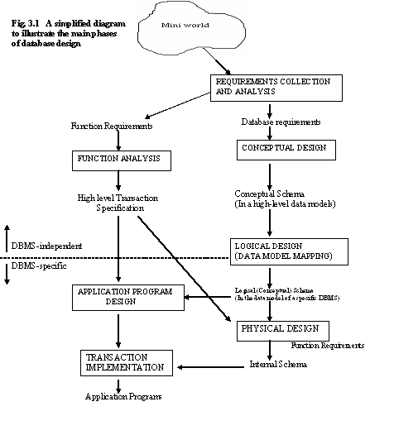1st Step: Requirements analysis
Database designers interview prospective database users to understand and document their data requirements
Two types of requirements
o Functional requirements
o Database requirements

Functional requirements
User defined operations that are applied to the database
Include updates and retrieval
DFDs, Sequence diagram, scenarios can be used to define

Database requirements
Data and data type to be stored
Constraints applied on data

2nd Step: Conceptual design
Create conceptual schema using high level conceptual data model
Conceptual schema is a description of the data requirements of the users and includes entity types, relationships, constraints.
Conceptual schema do not include implementation details and can be used to communicate with non technical users.
It can be used to ensure that all users data requirements are met and no conflict exists

3rd Step: Logical design or data model mapping
Actual implementation of the database using a commercial DBMS
Conceptual schema is transformed from the high level data model into the implementation data model.

4th Step: Physical design
Internal storage structures, access paths, and file organizations for the database files are specified
In parallel with all steps, application programs are designed and implemented as database transactions corresponding to the high level transaction specifications.

ER Model
A database can be modeled as:
o a collection of entities having attributes
o relationship among entities
Entity, Entity type, Entity set
Attributes, Type of attributes
Keys
Relationships, Relationship type
Roles
Constraints

Entities
An entity is an object that has existence and is distinguishable from other objects which can be described.
Each entity has attributes – the particular properties that describe it.
Physical existence
o Person, car, employee etc.
Conceptual existence
o Company, job, university course
An entity lies within the scope of the business world being modeled.

Attributes
Attributes are properties used to describe an entity.
For example an EMPLOYEE entity may have a Name, SSN, Address, Sex, BirthDate
A specific entity will have a value for each of its attributes.
For example a specific employee entity may have Name=‘Ram', SSN='123456789', Address ='731, RR Nagar, Bangalore, Karnataka', Sex='M',
BirthDate='09-JAN-65’
Each attribute has a data type associated with it e.g. integer, string, date etc.
Each attribute must have a unique name across the entity.

Types of Attributes

Simple
Each entity has a single atomic value for the attribute. For example, SSN or Sex.

Composite
The attribute may be composed of several components.
The value of a composite attribute is the concatenation of the values of its simple attributes.
Composition may form a hierarchy where some components are themselves composite.
If components of the composite attributes have to be referred, it is necessary to store the components separately.
If composite attribute is referred only as a whole, there is no need to subdivide it into component attributes e.g. if address has to be referred as a whole only, there
is no need to divide it.
For Example:
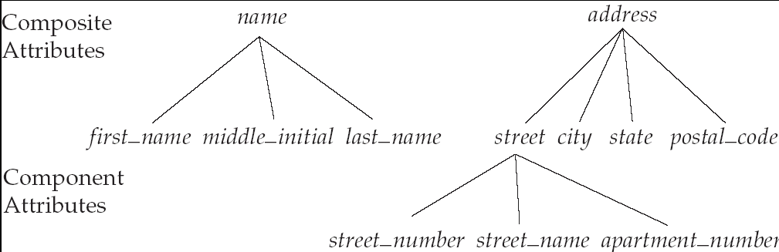Address (Apt#, House#, Street, City, State, ZipCode, Country) Name (FirstName, MiddleName, LastName).

Single-valued
Only single value for a particular entity e.g. DOB

Multi-valued
An entity may have multiple values for that attribute.
Multiple value may have lower and upper bounds on the number of values.

For example,
Color of a CAR: {Color}
phone_numbers: {phone number}

Stored attributes
Stored in the database

Derived attributes
Can be computed from other related attributes
E.g. Birthdate ---stored
Age ----derived
Joining date ------stored
Year of Experience ---derived

Null values
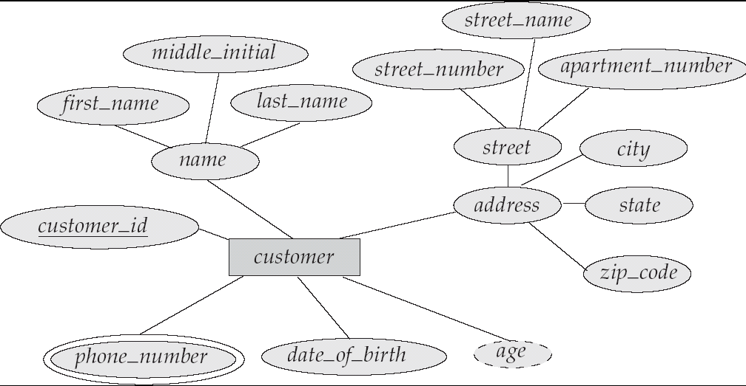 A particular entity may not have the value for a particular attribute
o Value is not applicable
o Value is unknown
A special value NULL is written
e.g. Every employee may not have Fax no.

Complex attributes
Composite attributes can be nested arbitrarily.
Components of a composite attribute can be shown in () and multivalued attribute can be shown in {}.
For example:
{Address_phone (
{phone (Area_code, phone_number)}, Address (Street_Address
(Number, Street, Apartment_No), City, State, Zip)
) }

Entity Type
An entity type defines a collection of entities that have the same attributes
Each entity is defined in database by its name and attributes.
Each entity type must have a name that is unique across the entire model and has a consistent meaning across the modelling team and the end users.

For example,
o EMPLOYEE is an entity type
o PROJECT is an entity type.

Entity set
The collection of all entities of a particular entity type in the database at any point of time is called an entity set.
The entity set is usually referred to using the same name as the entity type.
For example,
EMPLOYEE refers to both
o ‘type of entity’
o ‘set of entity’

Notation
Entity type by rectangular box enclosing the entity type name
Attributes by ovals attached to entity type by straight line
Composite attributes shown by attaching components to it
Multivalued by double oval

Example
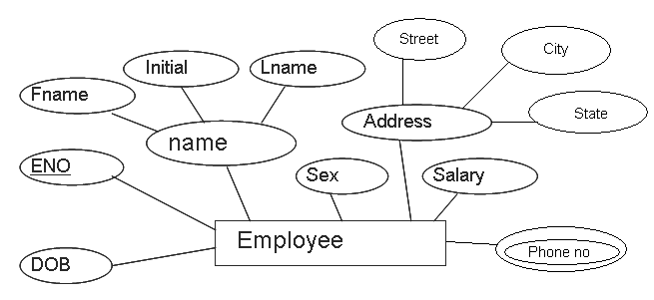

Extension & Intension
An entity type describes the schema or intension for a set of entities that share structure.
The collection of all entities of a particular entity type are grouped into an entity set, is also called the extension of the entity type.

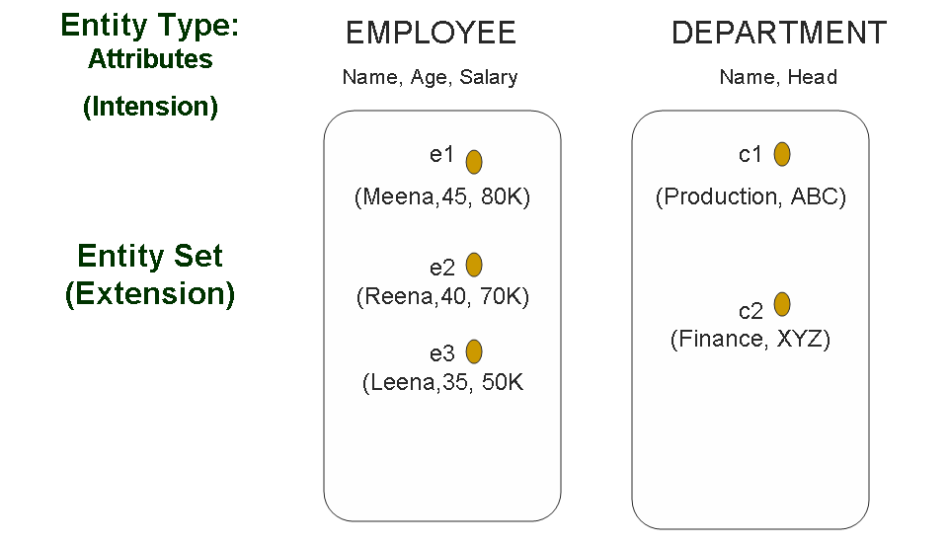

Key attributes
An attribute of an entity type for which each entity must have a unique value is called a key attribute of the entity type.
For example, SSN of EMPLOYEE
(Key attribute defines the each entity of an entity type uniquely)
Uniqueness of key attribute must hold for every extension of the entity type.
It is not the property of a particular extension of the entity type, it is a constraint on all extension of entity type.
A key attribute may be composite.
For example,
o Registration is a composite key of the CAR entity type with components
(Number, State).
Some entity types have more than one key attributes, those attributes can behave as keys on their own separately; they are called candidate keys.
All key attributes should be underlined in ER diagram
Selected key will work as Primary key.
Other potential keys will be Alternate keys.
An entity type may have no key; it is called a weak entity type.

Value Sets (Domains) of attributes
Domain specifies the set of permitted values for each attribute for each individual entity.
For example,
o Birth Date: Range of all valid dates
o Employee Name: All possible range of names
o DeptCode: Set of all department codes
Value sets are specified using the basic data types, size and other constraints.
Value set provides all possible values
Value Sets (Domains) of attributes
A : E P(V)
A is Attribute of E Entity Type having value set V, is a function to the power set
P(V)
For composite attribute
V = P(V1) * P( V2) * ……* P(Vn)
Where V1, V2 ….Vn are the value set of each component of composite arribute.

Relationships
A relationship is an association among two or more entities.
Whenever an attribute of one entity type refers to the attribute of another entity type, some relationship exists.
Specifically a relationship relates two or more distinct entities with a specific meaning
o For example, manager of the DEPARTMENT refers to an employee who manages the department.
o Department of EMPLOYEE refers to the department for which the employee works.

Relationships Type
Relationships of the same type are grouped into a relationship type.
o For example, the WORKS_FOR relationship type in which EMPLOYEEs and DEPARTMENTs entities participate,
o or The MANAGES relationship type in which EMPLOYEEs and
DEPARTMENTs entities participate.
More than one relationship type can exist with the same participating entity types.
For example, MANAGES and WORKS_FOR are distinct relationships between
EMPLOYEE and DEPARTMENT, but with different meanings and different
relationship instances.
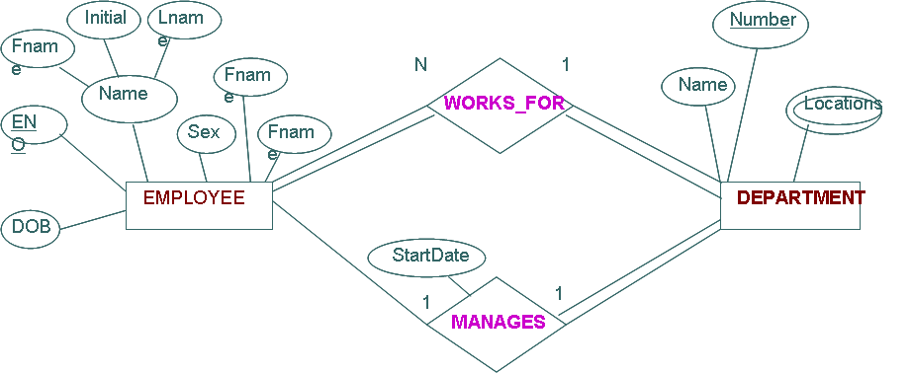

Relationships Set
A relationships set is a set of relationships of the same type.
A relationship set and a relation type are referred to by the same name.
The relationship set R is a set of relationship instances ri, where each ri associates n individual entities (e1, e2, ….., en) and each entity ej in ri is a member of entity
type Ej,
1≤ j ≤ n
E.g. each employee and department participates in the relationship of works_for.

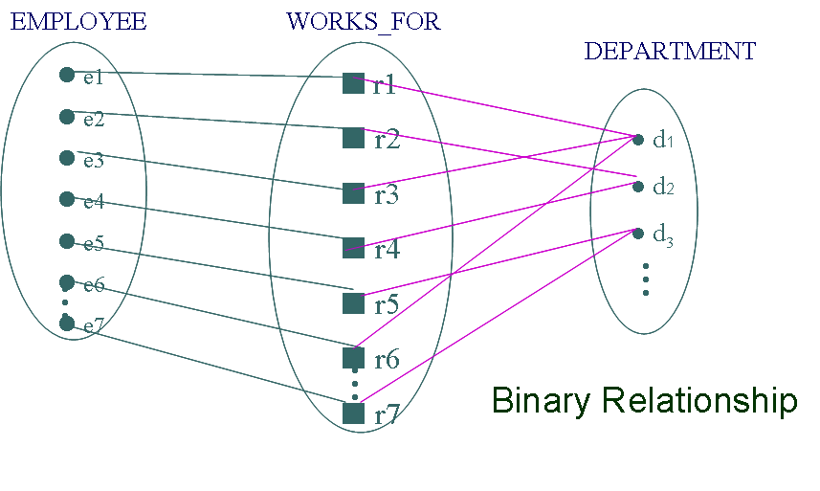Some instances in the WORKS_FOR relationship set, which represents a relationship type WORKS_FOR between Employee and department.

Degree of Relationships Type
The degree of a relationship type is the number of participating entity types.
o Binary Relationship
o Ternary Relationship

Binary Relationship
When two entities participate in relation.
WORKS_FOR is binary relationship and participating entities are EMPLOYEE
and DEPARTMENT

Ternary Relationship
When three entities participate in relation.
SUPPLY is ternary relationship and participating entities are SUPPLIER, PROJECT and PARTS.

Degree of Relationships Type: Example
Some relationship instances in the ‘SUPPLY’ ternary relationship set

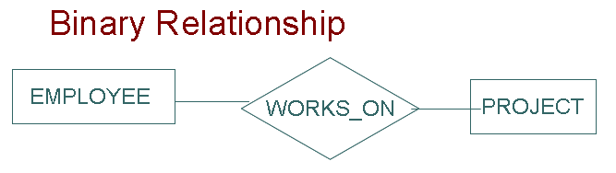
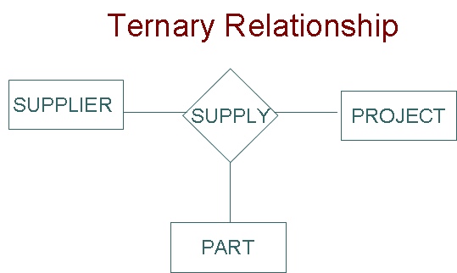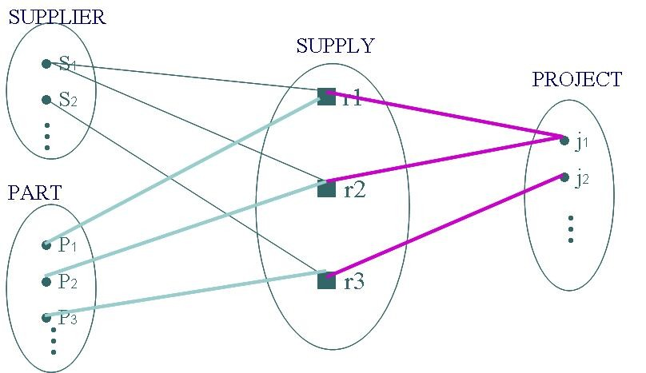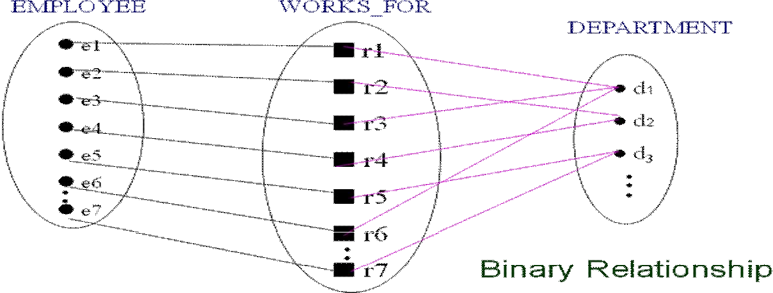

Role names
Each entity type that participate in a relationship type plays a particular role in the relationship.
Role name signifies the role that a participating entity plays in each relationship instance.

For example,
o In the WORKS_FOR relationship type, EMPLOYEE plays the role of employee or worker and DEPARTMENT plays a role of department or employer.
Each participating entity type name can be used as role name.

Recursive relationship
In some cases, same entity participates more than once in a relationship type and plays different roles.
In such cases, role names become necessary for distinguishing the meaning of each participation.
Such relationship types are called Recursive relationship.

Recursive relationship and Roles: Example
A recursive relationship SUPERVISION between EMPLOYEE in the supervisor role (1)
and EMPLOYEE in the subordinate role (2)

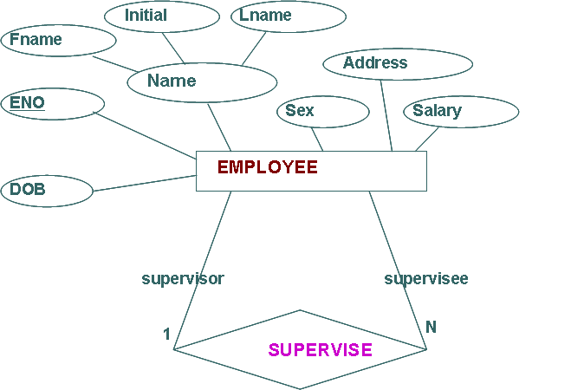

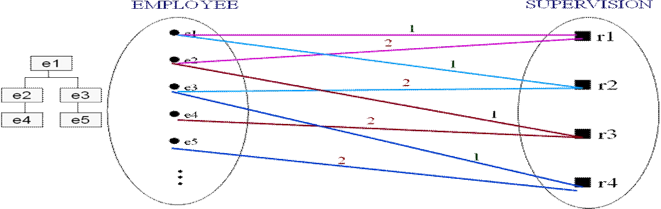

Constraints on Relationships
Structural Constraints on Relationship Types (Also known as ratio constraints) are determined from the mini-world situation.
o Maximum Cardinality (or cardinality ratio)

o Minimum Cardinality (also called participation constraint or existence dependency constraints)

Maximum Cardinality (or cardinality ratio) for Binary relationship
It refers to the number of entities to which another entity can be associated via a relationship set
Cardinality must be one of the following types:
o One to one
o One to many
o Many to one
o Many to many
Shown by placing appropriate number on the link.

One-to-One (1:1) Relationships
An entity in A is associated with at most one entity in B, and an entity in B is associated
with at most one entity in A
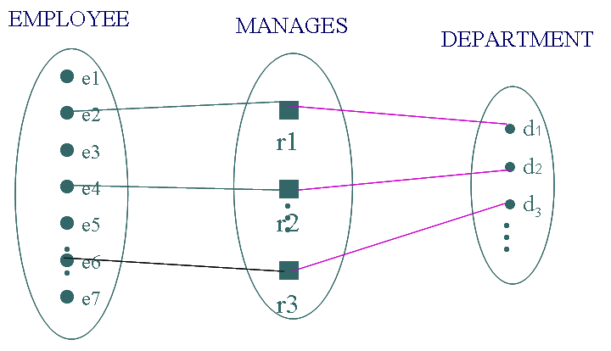

One-to-Many (1:N) Relationships
An entity in A is associated with any number of entities in B, and an entity in B however
can be associated with at most one entity in A,

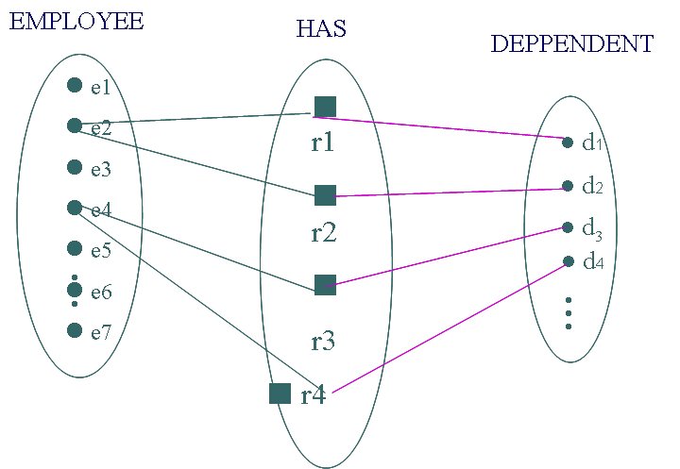1:1 & 1:N Relationships: Example

Many-to-1 (N:1) Relationships
An entity in A is associated with at most one entity in B, and an entity in B however can
be associated with any number of entities in A
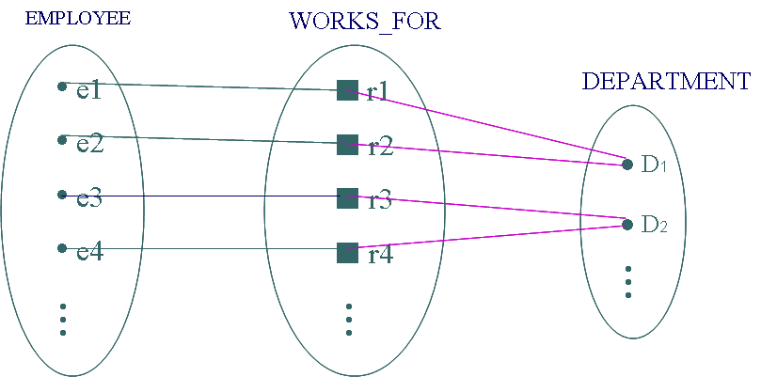

Many-to-Many (N:1) Relationships
An entity in A is associated with any number of entities in B, and an entity in B can also
be associated with any number of entities in A,

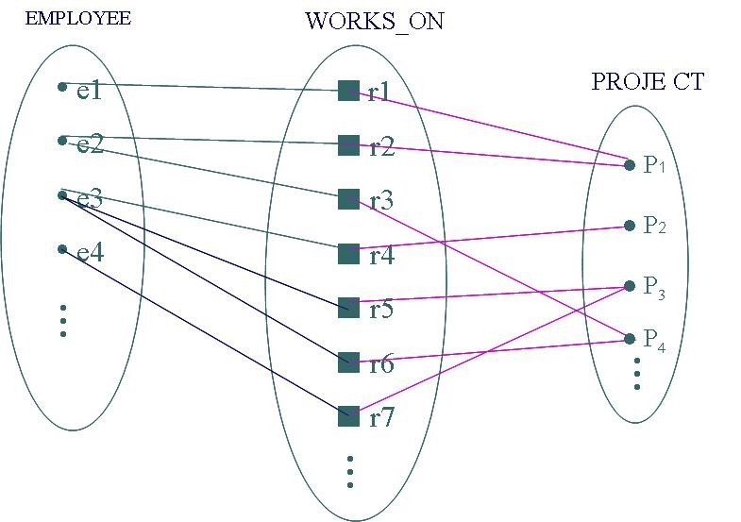

N:1 & N:M Relationships: Example

Participation constraint or existence dependency constraints
The partition constraint specifies whether the existence of an entity depends on its being related to another entity via the relationship type.
o Total Participation
o Partial participation

Total Participation
Total Participation is a constraint when every entity in the entity set participates in at least one relationship in the relationship set.
Total Participation is also called existence dependency.
Shown by double lining the link
For example
o Every employee must work in some department
o Every employee must work on some project

Partial Participation
Partial participation is the constraint when some entities may not participate in any relationship in the relationship set.
Represented by single line link.
o Example: participation of ‘EMPLOYEE’ as manager in relationship type
‘MANAGES’ is partial

Attributes of Relationship types
Relationship types can also have attributes similar to attributes of entity types.
E.g. To record ‘Number of Hours per Week’ that an employee works on a particular project, No_of_hours can be included as an attribute with relationship type ‘Works_on’.
Attribute ‘Manager_start_date’ can be included with relationship type ‘Manages’.

Weak Entity Types
An entity that does not have a key attribute is called weak entity type
A weak entity can not be identified without its owner.
A weak entity type must participate in an identifying relationship type with an owner or identifying entity type.
A weak entity type always has a total participation constraint (existence dependency) with respect to its identifying relationship.
Weak entities are identified by the combination of:

o A partial key of the weak entity type
o The particular entity they are related to in the identifying entity type
For example:
Weak Entity Type: DEPENDENT
Identifying Relationship: HAS_DEPENDENTS
Identifying Entity Type: EMPLOYEE
Partial key of DEPENDENT: Dependent_name
Thus, Primary key of DEPENDENT TABLE: (SSN, Dependent_name)
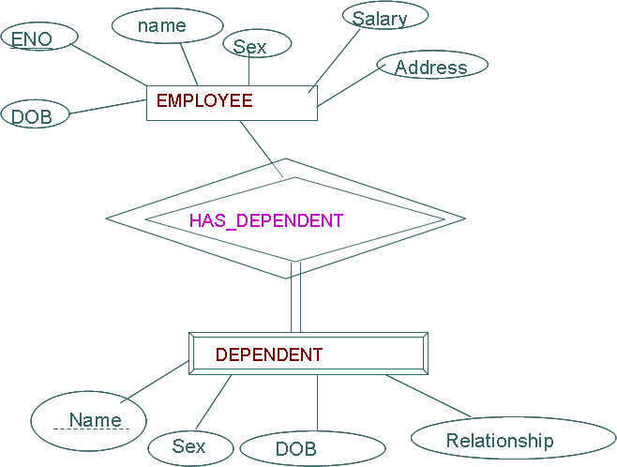

Initial Conceptual Design of COMPANY Database
1. An entity type DEPARTMENT with attributes Name, Number, Location, Manager,
Manager_Start_Date. Location is multivalued. Name & Number are (separate) key
attributes.
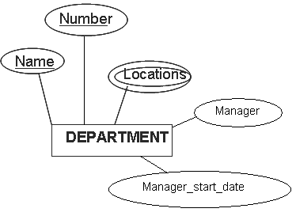

2. An entity type PROJECT with attributes Name, Number, Location, Controlling_Department. Name & Number are (separate) key attributes.

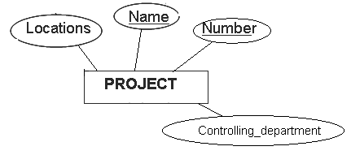

3. An entity type EMPLOYEE with attributes SSN, Name, Sex, Address, Salary, Birth_date, Department and Supervisor. Name & Address are composite,SSN is key attribute. Projects and Number_Of_Hours for which Employee is working.

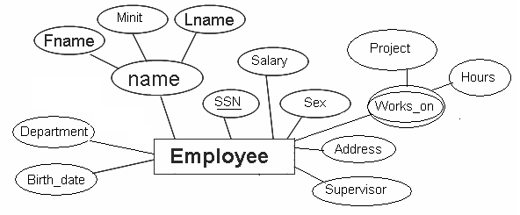

4. An entity type DEPENDENT with attributes Employee_Name, Dependent_Name, Sex, Birth_date, Relationship (to Employee)

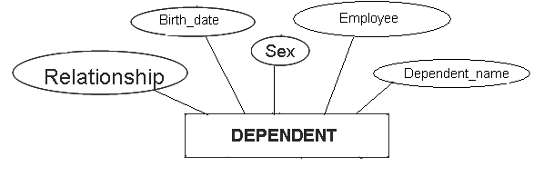

Refining the ER Design for the Company Database
The cardinality ratio and participation constraint of each relationship type in company
database can be determined by the following requirements:

1. ‘manages’ a 1:1 relationship type between employee and department
employee’s participation is partial but department participation is mandatory i.e. total
the attribute StartDate is assigned to the relationship type

2. ‘works_for’, a N:1 relationship type between employee and department
Both participations are total.

3. ‘controls’, a 1:N relationship type between department and project
Participation of project is total but Participation of department is partial

4. ‘supervision’, a 1:N relationship type between employee and employee
Both participation is partial

5. ‘works_on’, a M:N relationship type between employee and project
Both participations are total.
Attribute for this can be No-of-hours.

6. ‘has_dependents’, a 1:N relationship type between employee and dependent
Participation of dependent is total but Participation of employee is partial
Relationship is identifying for weak entity dependent.

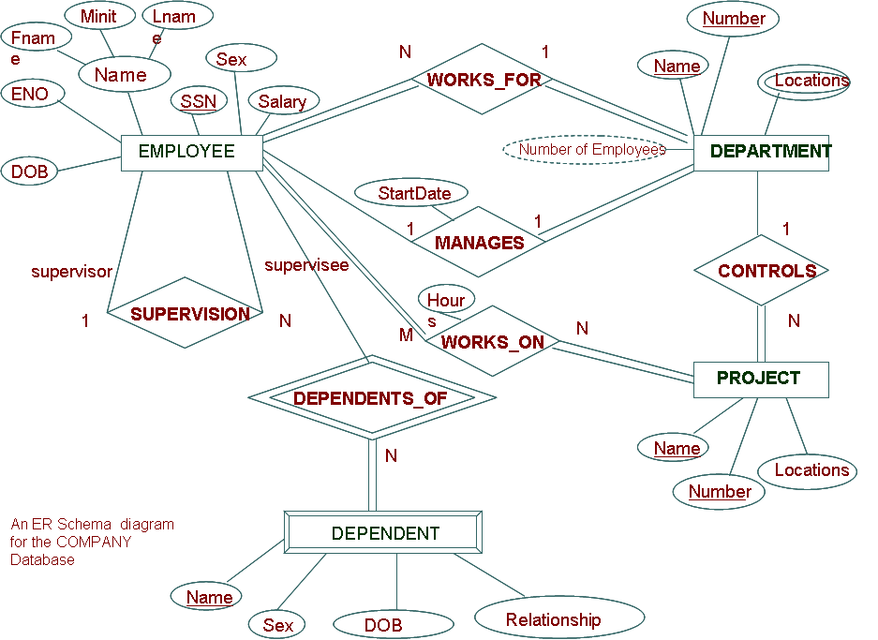

ER diagrams, naming conventions and design issues
In ER diagram, emphasis is on representing the schema rather than the instances.
Schema is much smaller than extensions
Schema is relatively much more stable than extensions
o Schema changes rarely.
o Extensions changes frequently.

Notations for ER Diagrams

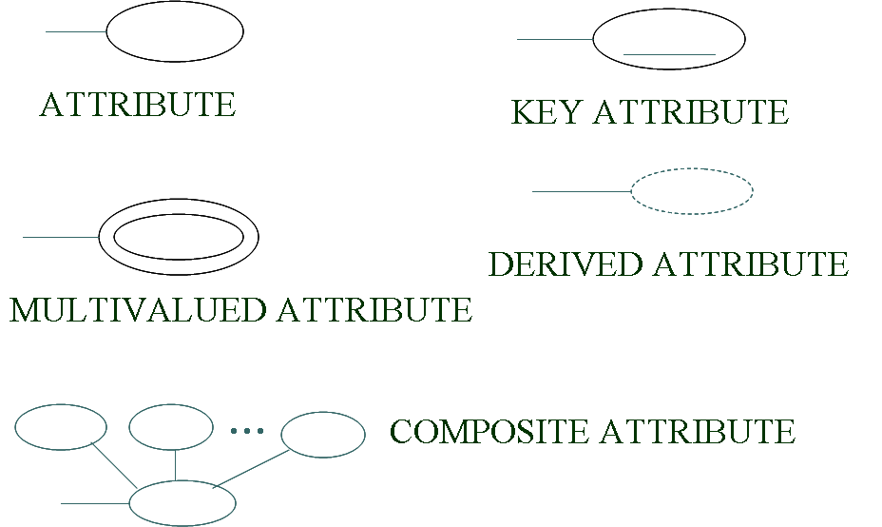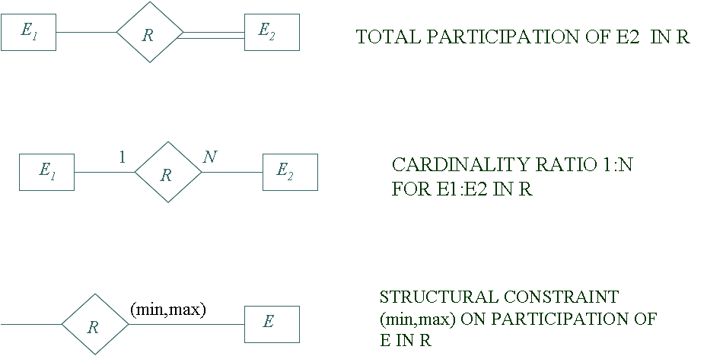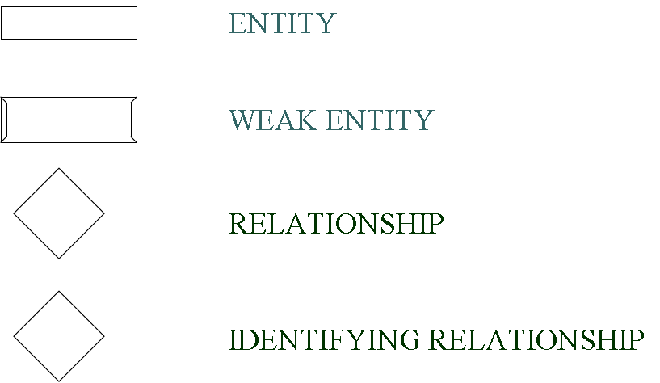

Naming conventions of Schema constructs
Singular names for entity type and relationship type
Entity type & Relationship Type:
o Uppercase
Attribute names:
o Capitalized
Role names:
o Lowercase
Nouns: Entity Type name
Verbs: Relationship Type
Additional Nouns that describe the nouns corresponding to Entity types: Attributes
Binary relationship should be readable
o from left to right
o top to bottom

Design Choices for ER Conceptual Design
Schema design is an iterative process, it continues until the most suitable design is reached.

Questions:
1. Define the following term:
a) Entity b) Attribute c) Key Attribute d) Stored attributes e) Derived attribute f) Partial Key g) Weak entity h) Cardinality ratio
i) Participation constraint j) Recursive relationship k) Composite attribute l) Multi-valued attribute m) Complex attribute n Extension & Intension
2. What is entity type, entity set? Explain the difference between entity, entity type and entity set.
3. Explain the cardinality ratios (mapping cardinalities) and participation constraints
(Existence dependencies) in the Entity-Relationship design.
4. Explain strong and weak entity sets with an example.
5. Explain the different types of attributes which occur in ER model.
6. What is relationship type? Explain the difference between a relationship set and a relationship type?
7. What is a role? When is it necessary to use role names in description or relationship type?
8. Discuss complex attribute with an example.
9. Discuss the degree of relationship.
10. What are the steps to design database? Describe.

Unit-4: Enhanced Entity-Relationship Model

Subclasses, Superclasses, and Inheritance
Specialization and Generalization
Constraints and Characteristics of Specialization and Generalization Hierarchies
Modeling of UNION Types Using Categories
An UNIVERSITY EER Schema

Introduction
EER model is created to design more accurate database schemas
It reflect the data properties and constraints more precisely
it is helpful for database having more complex requirements than traditional applications

Subclasses, Superclasses, and Inheritance
EER model includes all modeling concepts of the ER model
In addition, EER includes:
o Subclasses and superclasses
o Specialization and generalization
o Category or union type
o Attribute and relationship inheritance
Example
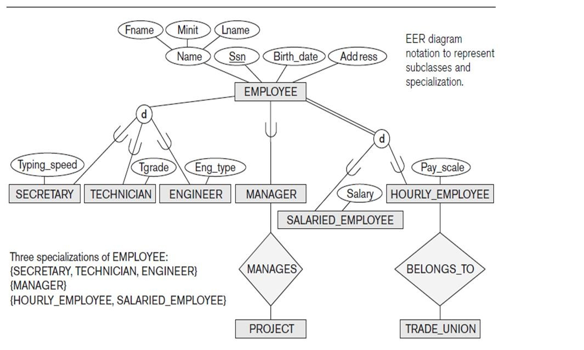

Subclasses and Superclasses
An entity type may have additional meaningful subgroupings of its entities
o Example: EMPLOYEE may be further grouped into:
SECRETARY, ENGINEER, TECHNICIAN, …
• Based on the EMPLOYEE’s Job
MANAGER
• EMPLOYEEs who are managers
SALARIED_EMPLOYEE, HOURLY_EMPLOYEE
• Based on the EMPLOYEE’s method of pay
EER diagrams extend ER diagrams to represent these additional subgroupings, called subclasses or subtypes

Each of these subgroupings is a subset of EMPLOYEE entities
Each is called a subclass of EMPLOYEE
EMPLOYEE is the superclass for each of these subclasses
These are called superclass/subclass relationships:
o EMPLOYEE/SECRETARY o EMPLOYEE/TECHNICIAN o EMPLOYEE/MANAGER
o …
These are also called IS-A relationships
o SECRETARY IS-A EMPLOYEE, TECHNICIAN IS-A EMPLOYEE,….
An entity that is member of a subclass represents the same real-world entity as member of the superclass:
o The subclass member is the same entity in a distinct specific role
o An entity cannot exist in the database merely by being a member of a
subclass; it must also be a member of the superclass
o A member of the superclass can be optionally included as a member of any number of its subclasses
Examples:
o A salaried employee who is also an engineer belongs to the two subclasses:
ENGINEER, and
SALARIED_EMPLOYEE
o A salaried employee who is also an engineering manager belongs to the three subclasses:
MANAGER,
ENGINEER, and
SALARIED_EMPLOYEE
It is not necessary that every entity in a superclass be a member of some subclass

Attribute Inheritance in Superclass / Subclass Relationships
An entity that is member of a subclass inherits
o All attributes of the entity as a member of the superclass
o All relationships of the entity as a member of the superclass

o Example:
SECRETARY (as well as TECHNICIAN and ENGINEER) inherit
the attributes Name, SSN, …, from EMPLOYEE
Every SECRETARY entity will have values for the inherited attributes

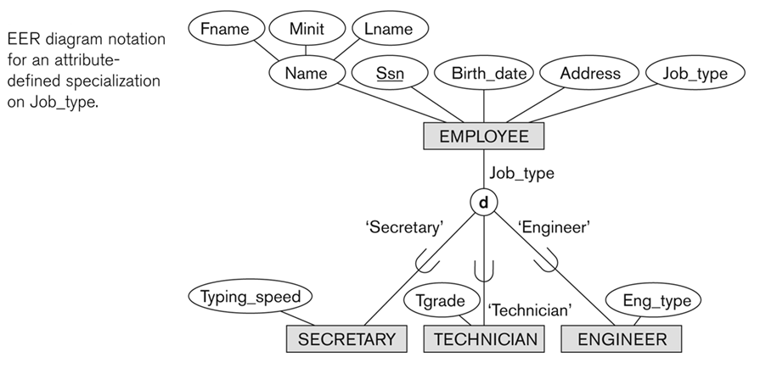

Specialization
Specialization is the process of defining a set of subclasses of a superclass
The set of subclasses is based upon some distinguishing characteristics of the entities in the superclass
o Example: {SECRETARY, ENGINEER, TECHNICIAN} is a specialization of EMPLOYEE based upon job type.
May have several specializations of the same superclass

Example: Another specialization of EMPLOYEE based on method of pay is
{SALARIED_EMPLOYEE, HOURLY_EMPLOYEE}.
o Superclass/subclass relationships and specialization can be diagrammatically represented in EER diagrams
o Attributes of a subclass are called specific or local attributes.
For example, the attribute TypingSpeed of SECRETARY
o The subclass can also participate in specific relationship types.
For example, a relationship BELONGS_TO of
HOURLY_EMPLOYEE
If all subclasses in a specialization have membership condition on same attribute of the superclass, specialization is called an attribute-defined specialization
o Attribute is called the defining attribute of the specialization
o Example: JobType is the defining attribute of the specialization
{SECRETARY, TECHNICIAN, ENGINEER} of EMPLOYEE

In summary, the specialization process allows us to do the following:
Define a set of subclasses of an entity type
Establish additional specific attributes with each subclass

Establish additional specific relationship types between each subclass and other entity types or other subclasses

Generalization
Generalization is the reverse of the specialization process
Several classes with common features are generalized into a superclass;
Example: CAR, TRUCK generalized into VEHICLE;
o both CAR, TRUCK become subclasses of the superclass VEHICLE.
o We can view {CAR, TRUCK} as a specialization of VEHICLE
o Alternatively, we can view VEHICLE as a generalization of CAR and
TRUCK

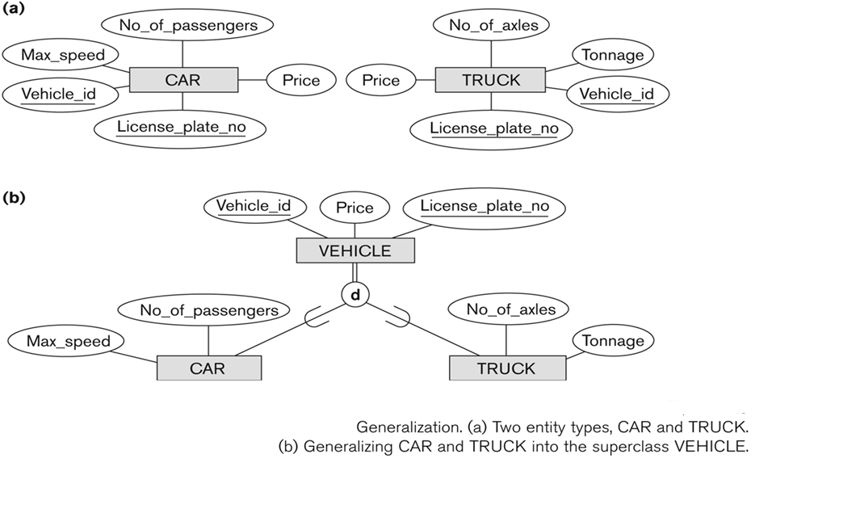
Generalization and Specialization
Data Modeling with Specialization and Generalization
A superclass or subclass represents a collection (or set or grouping) of entities
It also represents a particular type of entity
Shown in rectangles in EER diagrams (as are entity types)
We can call all entity types (and their corresponding collections) classes, whether they are entity types, superclasses, or subclasses

Constraints on Specialization and Generalization
Two basic constraints can apply to a specialization /generalization:
o Disjointness Constraint
o Completeness Constraint
Disjointness Constraint:
o Specifies that the subclasses of the specialization must be disjoint:
o an entity can be a member of at most one of the subclasses of the
specialization
Specified by d in EER diagram
o If not disjoint, specialization is overlapping:
o that is the same entity may be a member of more than one subclass of the
specialization
Specified by o in EER diagram

Completeness Constraint:
o Total specifies that every entity in the superclass must be a member of some subclass in the specialization/generalization
o Shown in EER diagrams by a double line
o Partial allows an entity may not to belong to any of the subclasses
o Shown in EER diagrams by a single line
Hence, we have four types of specialization/generalization:
o Disjoint, total
o Disjoint, partial
o Overlapping, total
o Overlapping, partial
Generalization usually is total because the superclass is derived
from the subclasses.

Example of disjoint partial Specialization

Example of disjoint total Specialization
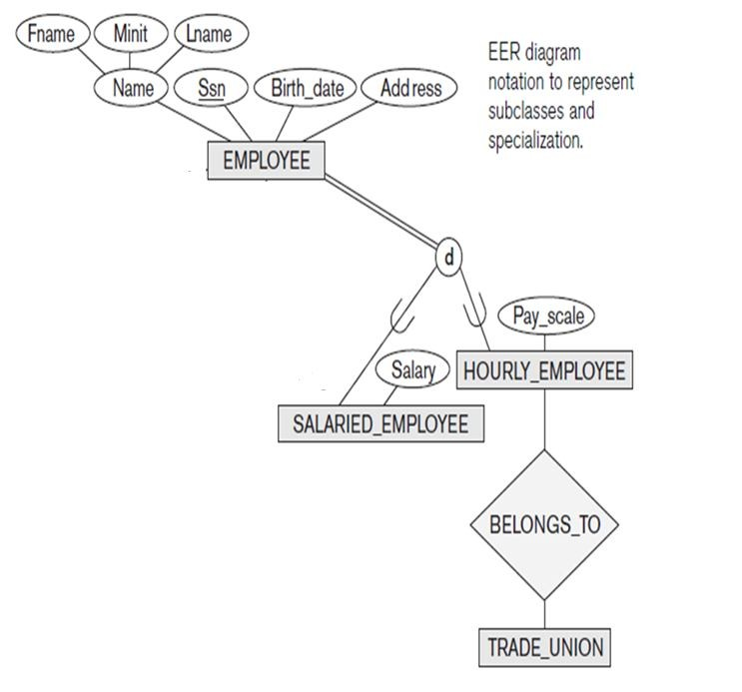

Example of overlapping total Specialization
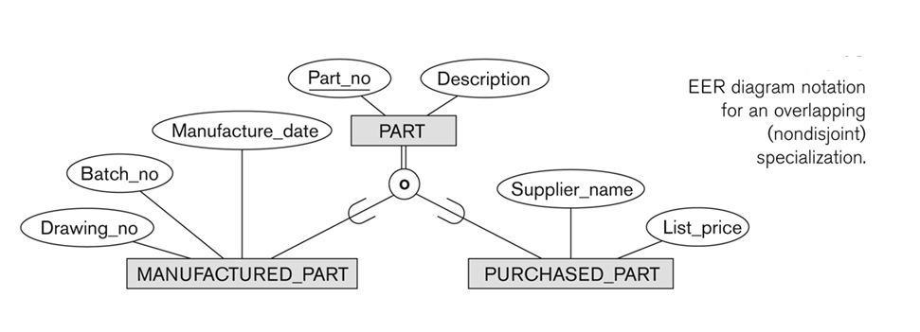

Specialization/Generalization Hierarchies, Lattices & Shared Subclasses
A subclass may itself have further subclasses specified on it
o forms a hierarchy or a lattice
Hierarchy has a constraint that every subclass has only one superclass (called single inheritance); this is basically a tree structure
In a lattice, a subclass can be subclass of more than one superclass (called multiple inheritance)
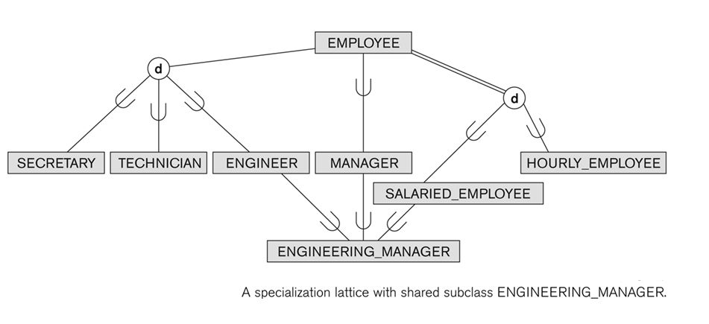
In a lattice or hierarchy, a subclass inherits attributes not only of its direct superclass, but also of all its predecessor superclasses
A subclass with more than one superclass is called a shared subclass (multiple inheritance) and inherits properties from all superclasses
In specialization, start with an entity type and then define subclasses of the entity type by successive specialization
o called a top down conceptual refinement process
In generalization, start with many entity types and generalize those that have
common properties
o Called a bottom up conceptual synthesis process
In practice, a combination of both processes is usually employed

Specialization / Generalization Lattice Example (UNIVERSITY)
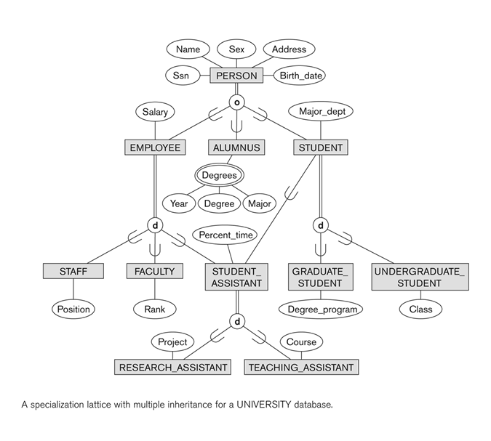

Categories (UNION TYPES)
All of the superclass/subclass relationships we have seen so far have a single superclass
A shared subclass is a subclass in:
o more than one distinct superclass/subclass relationships
o each relationships has a single superclass
o shared subclass leads to multiple inheritance
In some cases, we need to model a single superclass/subclass relationship with more than one superclass
Superclasses can represent different entity types
Such a subclass is called a category or UNION TYPE
Example: In a database for vehicle registration, a vehicle owner can be a
PERSON, a BANK (holding a lien on a vehicle) or a COMPANY.
o A category (UNION type) called OWNER is created to represent a subset of the union of the three superclasses COMPANY, BANK, and PERSON
o A category member must exist in at least one of its superclasses
Difference from shared subclass, which is a:
o subset of the intersection of its superclasses
o shared subclass member must exist in all of its superclasses

Two categories (UNION types): OWNER, REGISTERED_VEHICLE

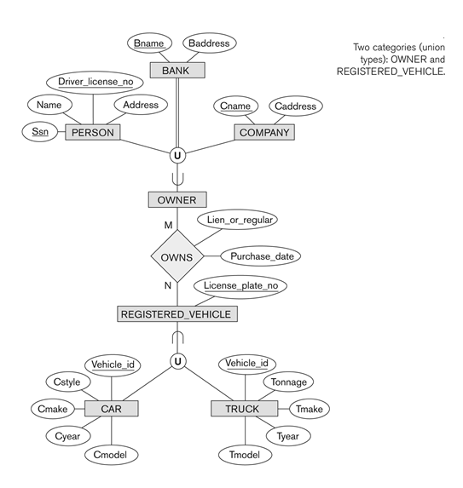
Modeling of UNION Types Using Categories
Union type or a category
Represents a single superclass/subclass relationship with more than one superclass
Subclass represents a collection of objects that is a subset of the UNION of distinct entity types

Attribute inheritance works more selectively
Category can be total or partial
Some modeling methodologies do not have union types

A Sample UNIVERSITY EER Schema, Design Choices, and Formal
Definitions
