NetShield AI
System Architecture & Database Schema

1. System Architecture
NetShield AI follows a layered architecture that separates presentation, backend, business logic, AI inference, data storage, and infrastructure concerns, allowing each layer to scale and evolve independently.
- Presentation Layer – React.js web portal for dashboards, alerts, and analytics
- Backend / API Gateway – FastAPI services handling auth, routing, and access control
- Business Logic Layer – traffic processing, alert orchestration, reporting
- AI / ML Layer – anomaly detection and intrusion prediction models
- Database Layer – PostgreSQL (structured data) + MongoDB (traffic logs, model artifacts)
- Infrastructure Layer – Docker, cloud hosting (AWS/Azure), CI/CD
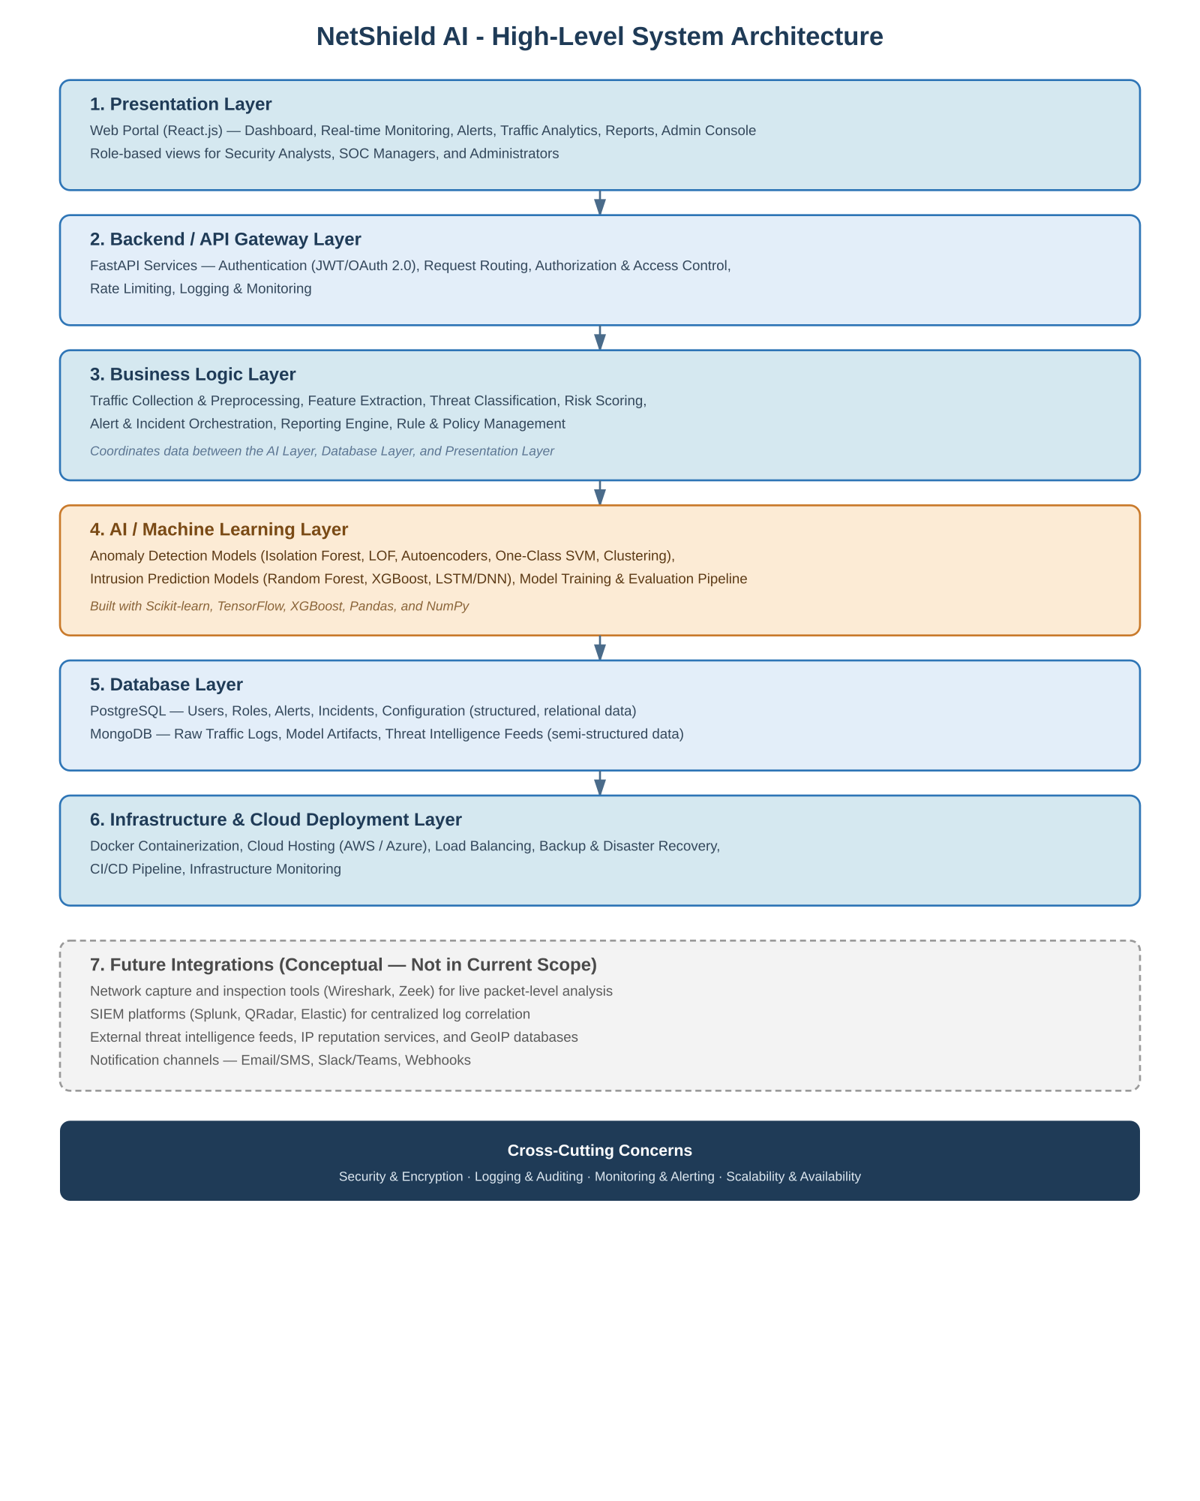
Figure 1 – NetShield AI High-Level System Architecture
A more detailed, component-level view of this architecture — including the API Gateway, the seven-stage monitoring and AI analytics pipeline, external integrations, data storage, and infrastructure — is provided in Figure 1a.

1a. Detailed Architecture View
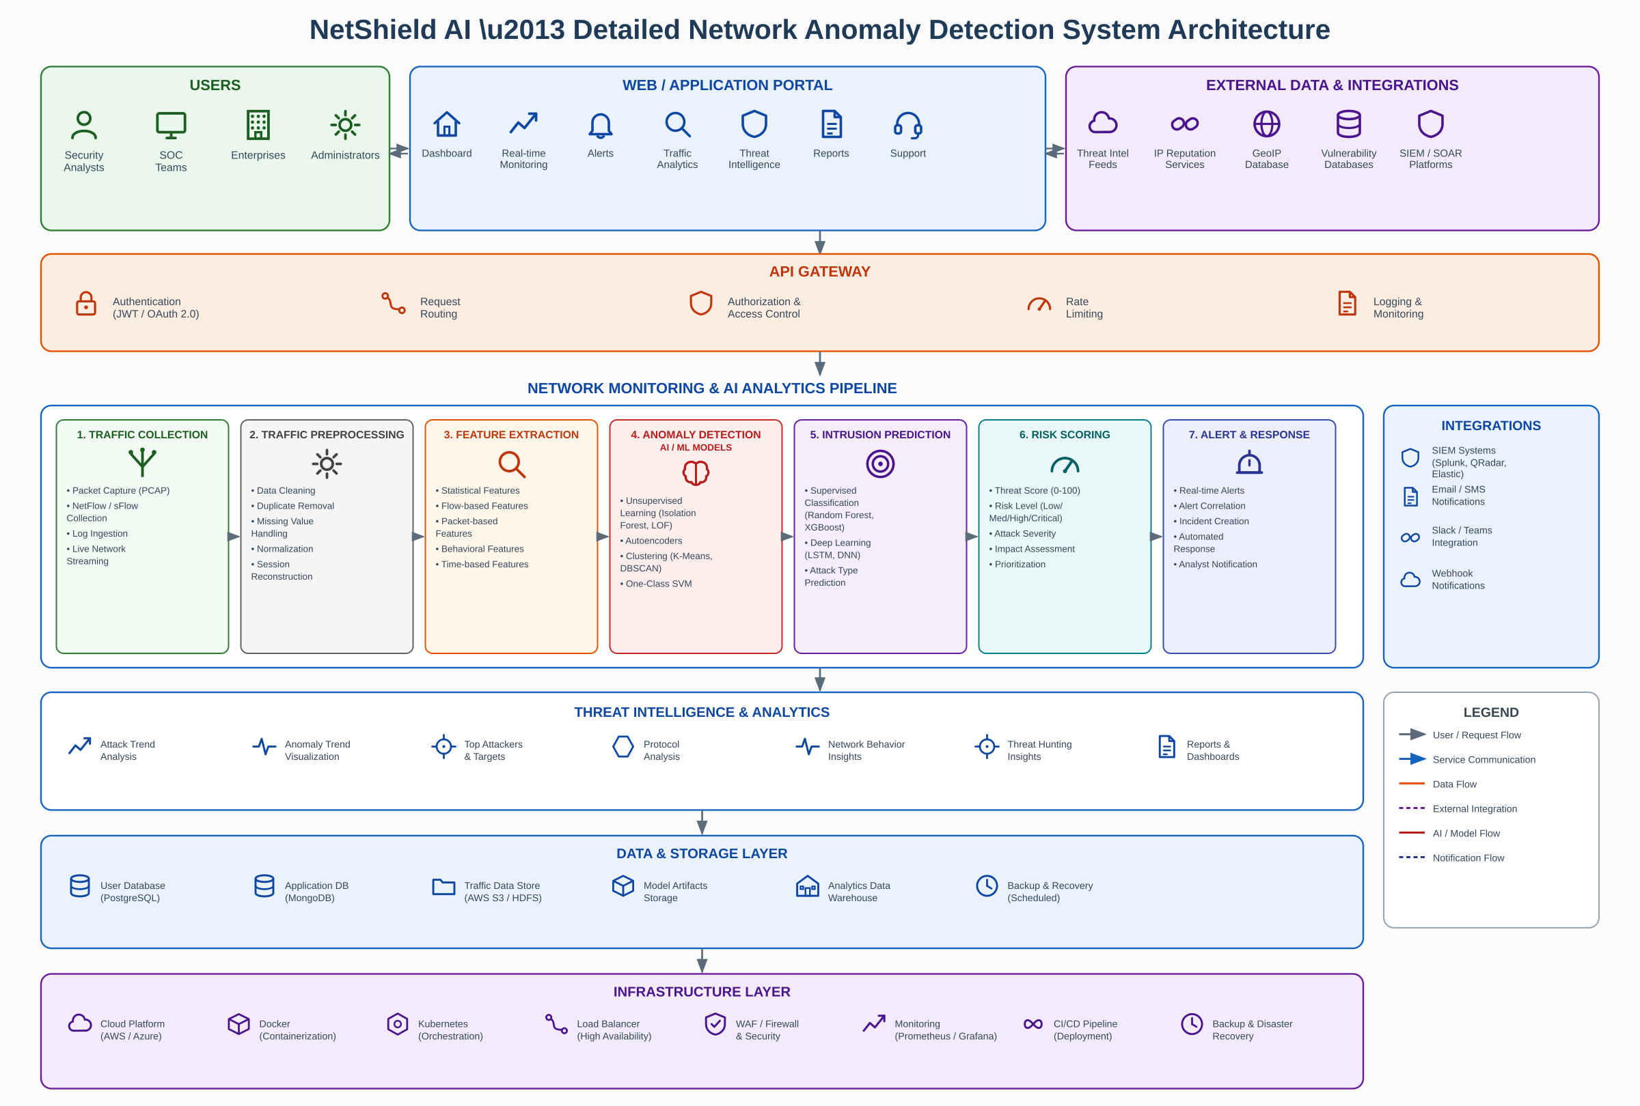
Figure 1a – NetShield AI Detailed System Architecture (component-level view)

2. Database Schema
The conceptual schema below defines the core entities and relationships. It is design-level only; no SQL is included.
Entity | Description | Key Relationships
User | Platform account (analyst, manager, admin) | N:1 Role; 1:N Audit Log, Alert, Incident
Role | Named permission set | 1:N User
Network Traffic Log | Processed traffic/flow records | 1:N Anomaly Event
Anomaly Event | Detected deviation with confidence score | N:1 Traffic Log, Model; 1:1 Alert
Alert | Actionable, prioritized notification | 1:1 Anomaly Event, Incident; N:1 User
Incident | Logged resolution of an alert | 1:1 Alert; N:1 User
Detection Model | Trained AI model version | 1:N Anomaly Event
Audit Log | System/user action record | N:1 User
System Configuration | Platform config key/value store | Standalone
Threat Intelligence Feed | (Future) external enrichment indicators | N:N Anomaly Event
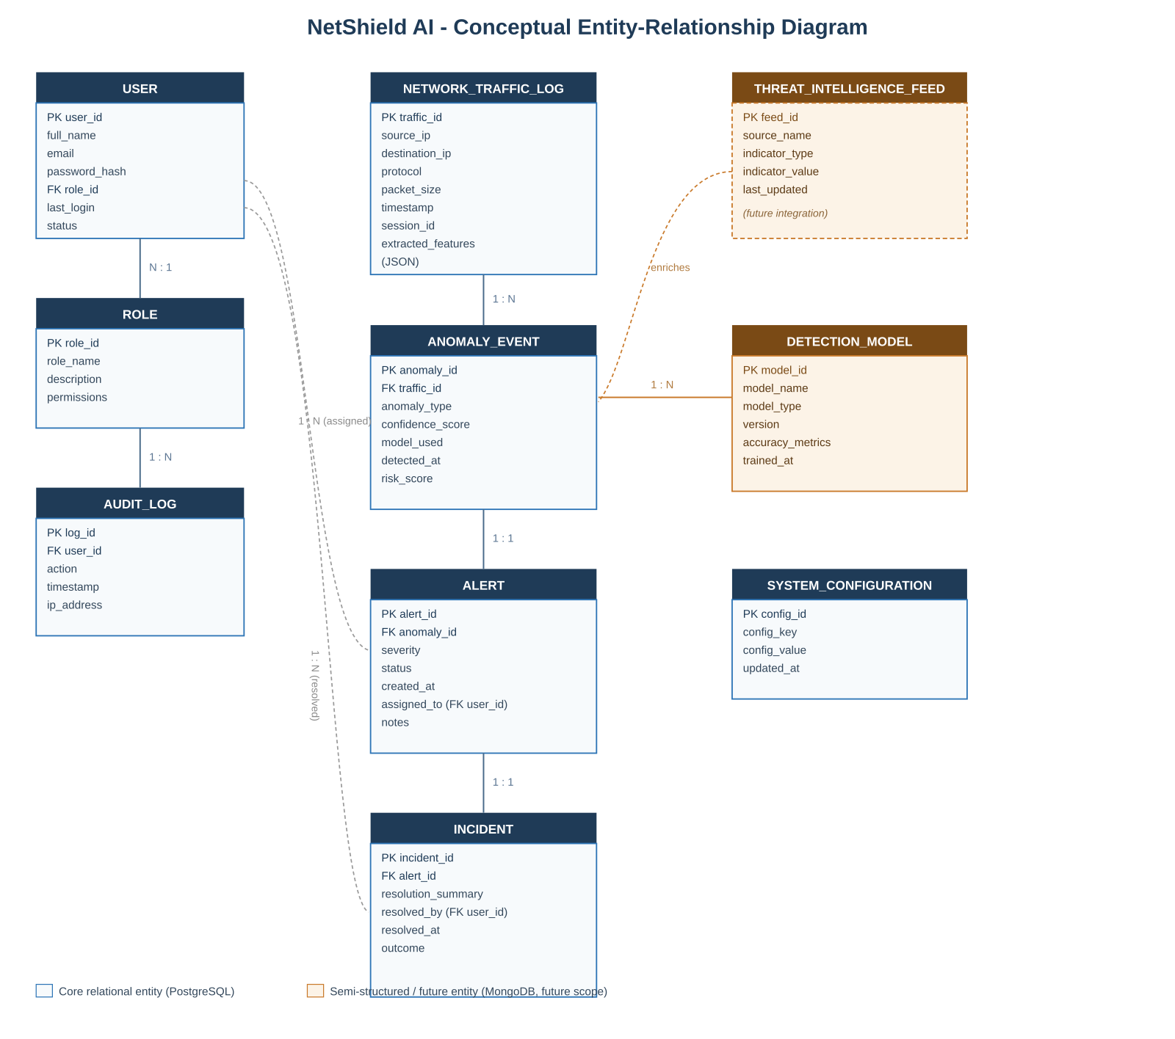
Figure 2 – NetShield AI Conceptual Entity-Relationship (ER) Diagram

