Aratus

Hello. This is a walk-through for the box Aratus on the Try Hack Me platform. The box can be found by following this link: https://tryhackme.com/room/aratus

This was a really fun box. Thank you Binru for putting this together. A big shout out to the people on the discord server who helped me out with this box when I got stuck.

Lassi
Mmmmmmmmm
Gavroche

I can not over state how great the TryHackMe discord channel is. If you are not part of it, jump on. They have plenty of channels and plenty of people to talk with. They will drop new channels when every a new room drops. It is a great place to learn and ask questions.

1. First look:

Once you have joined the room and have the box started, it is time to run a port scan.

Following is the list of ports I found from the scan:

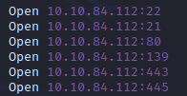
21 – ftp
22 – ssh
80 – http
139, 445 – samba
443 – https

2. Enumerating the ports:

Further down the results we see that we can login via ftp as anonymous. Doing this doesn’t reveal anything except an empty folder. Both websites on 80 and 443 are the same static default pages. Nothing in the source code and running ffuf only revealed a cgi-bin directory. Lets keep looking before we start looking there.

Using the following command we can list out info from the samba service:

This reveals:

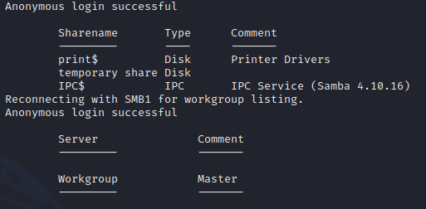
This shows one directory that we might be able to look into, temporary share. Now use smbclient to connect to it so we can look around:

Note the ‘\ ‘ before share. Yes this is needed and it caused me about 30 mins of headache trying to figure out why I could not connect.
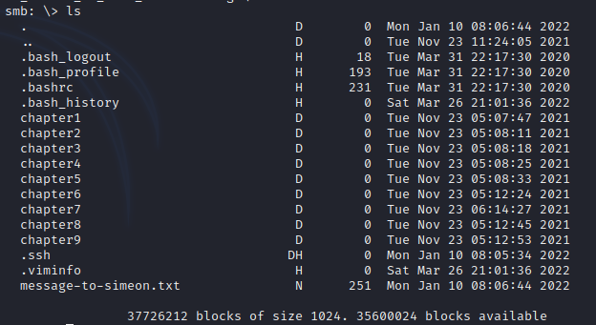
Once connected, ls or dir to see what we have.
Okay! A text file, several folders, and a .ssh folder. Looking into the ssh folder was a bust, no id_rsa. Looking into the chapter folders, you will come across a large amount of text files. Alright, time to pull this down to your local machine to look at them.

3. The hunt begins:

First, issue the following in order, so you can recursively download the folders and the text files.

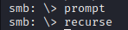
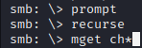
Next, grab the text file. Command is: get mess*.txt

Reading the text file we can see that it is addressed to Simeon from Theodore. Possible names to gain access with. Theo makes mention of Simeon’s book writing and how he needs to move it to /opt. Also talks about how Simeon needs to change his password. Stating that it is everywhere now. Did Simeon use his password in the text in one of the chapters?

Looking at the text files in the Chapter folders we see that they are all the same thing. A bunch of Lorem Ipsum text. Given what Theodore said in the message, the password for Simeon’s login may be one of the words in this text files. After checking that all the files where the same size, I decided to make a password list out of one of them. You will need two terminals for this. On the first, navigate to chapter1/paragraph1.1/.
Once there run:

python3 -m http.server

This is a handy way to host files to be able to access them over the network. One the second terminal runt the following:

cewl http://127.0.0.1:8000/text1.txt > plist

This will go through the text and make a list of all the text from a website. Handy little tool.

4. Foothold:

Now that we have a list and a name, lets try to get access to the machine. Since ssh is open, we will go for that first. Using hydra run the following:

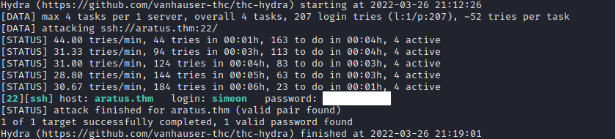
This took a few minutes to run on my kali, but it did find a password!!
Great!! Let’s try and login with it now.
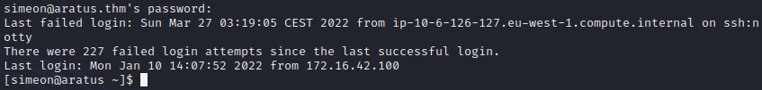
WE ARE IN!!

The first thing I tend to do is check sudo output with:

sudo -l

Sadly, nothing comes up. Having a look around the home directory turns up nothing. Not even the user.txt file. Since we are on a linux machine, the next step would be a tool call linpeas. If you are not familiar with it, here is the link to the gihub:

https://github.com/carlospolop/PEASS-ng/tree/master/linPEAS

Using the python3 -m http.server from earlier, host the file on your machine and use curl to download it to the target box.

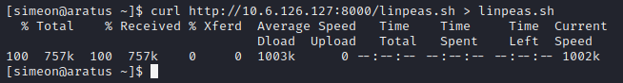
5. Lateral move:

Make sure to use ‘chmod +x linpeas.sh’ to make the script runable. Run it with ‘./linpeas.sh’. Going through the output, you should come across the following output:

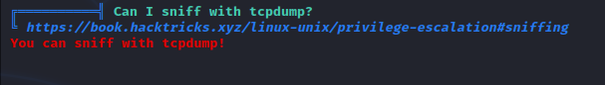
Alright. So. Tcpdump. Cool tool. Basically a terminal wireshark. Thankfully for this box it doesn’t get to complicated on how to use it. First we:
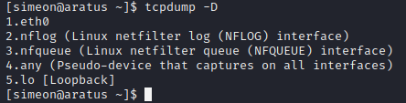
tcpdump -D will list all of the interfaces that you can listen on. If you listen to eth0, you will just get flooded with packets from your ssh connection. So lets listen in on option 5. If there are any automated scripts running, we should be able to see the info there.

Following is the command to listen, specify which interface, and outputting it to a file.

I like to save it to a file, to look through in case there is a flood of info. Also, you will be able to see info that is in the packets, not just the header info that normally prints out on the terminal. Let it run for about 5 minuets. Use ‘CTRL-C’ to stop it. Then use ‘vi test.pcap’ to read the file.

Inside you should come across like the following:

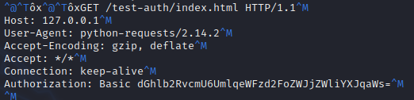
Cool, we found a base64 string. Copy the string and use the following to decode it:

echo ‘BASE64_STRING’ | base64 -d

Now we have another password and who it belongs to. Use ‘su theodore’ to switch to Thedore with the password.
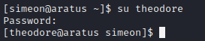

The user.txt file is located in Theodores home folder.
6. Rooting:

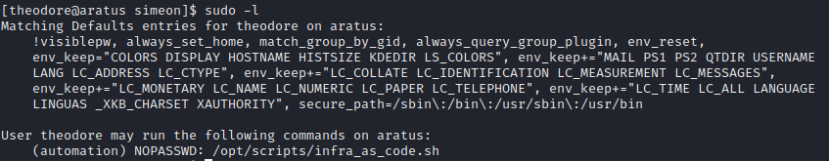
Checking sudo -l shows the following:
So we have a script that we can run as automation user. Take a look at the script to see what it is doing.

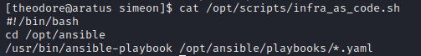
So it changes directories and then using ansible-playbook, it runs several yaml files. There doesn’t seem to be a way we can pass info into the script to do a shell with ansible and we can not edit the file. Let’s go look at the yaml files.

There 5 of them. Looking through them using cat command, we come across something interesting and different from the others:

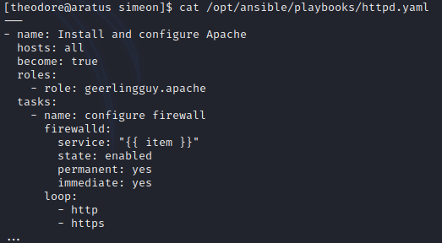
The ones uses ‘roles’ and ‘task’. If you have a look around in /opt/ansible, we will find a folder called roles. Inside is another folder called geerlingguy.apache . Inside of that one, there are several things. Including a folder called roles.
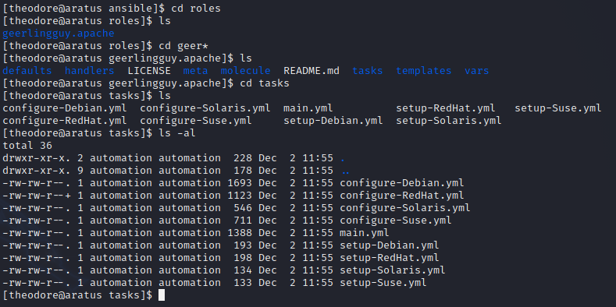
Using ls -al, we can see something interesting. Look closely or you will over look it like I did. For 2 hours I didn’t see this. Yeah, everyone has off days and this was mine. The file ‘configure- RedHat.yml’ has a + next to its permissions. That means we might be able to write to it. Open it with vi and let’s take a look.
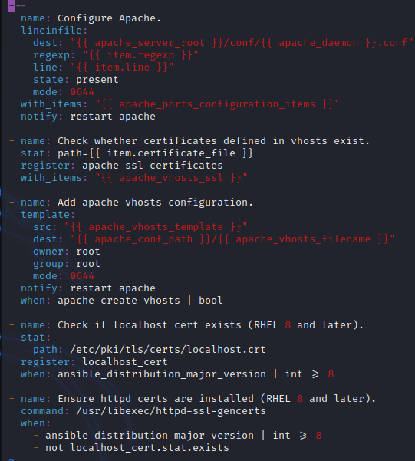

Interesting. This stuff was all new to me on this box. Taking a look at the last couple of entries, we see each item has a name , command, and when variable. Lets see if we can edit the file. Add the following to the end of the file leaving a space after the last entry.

- name: evil script

Trying to save the file, we see that we can. Reopen it and we can see that the new item is still there.
Now let’s try and input our own command. Let’s go with a bash reverse shell. Once entered, the two lines we added should look like this:
Save and get ready to run the file.

Setup nc on your machine to listen to the port you put in the script. Then use the following to run the script:

Make sure to put yes.

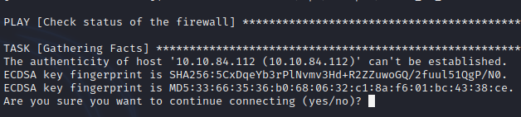
A lot of stuff runs by, but it should stop on the section for our evil script item.

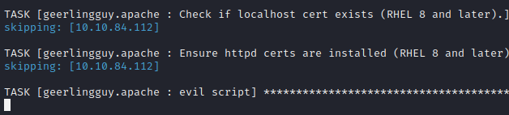
Check your local machine. You should have a connection now.

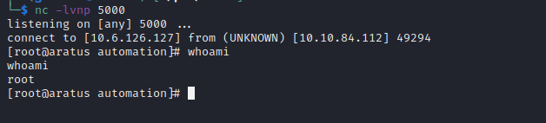
Congrats!! We have root. Grab the flag from /root/root.txt and complete the room.

This was a great room. I learned a lot from this and I hope you did as well.
Again, thank you Biniru!!

