Fuzzy rule based system

Fuzzy logic is multi-valued logic that provides a degree of truth. The value can be any real number between 0 and 1. It is not the probability of truth. Value 0 is 100% false and 1 is 100% truth. Value of 0.7 would mean that it is true to the degree of 0.7. Or in other words it is 70% truth. A fuzzy rule-based system can be described as something that functions based on non-exact reasoning.

One example can be Fuzzy logic system used in washing machines. Clothes are not only clean or dirty. A t-shirt can be a little bit dirty, but some people would say it is more than that. This is a subjective and context sensitive measure. In fuzzy logic, this can be represented by a fuzzy set. In this scenario I can create a fuzzy set of dirty clothes. Then the fuzzy rule based system can fuzzify the input value. The input value can be a number of particles found in water, for example 500. The fuzzified value is called membership function. Let say that the value is 0.3. This means that the t-shirt is 30% dirty.

The next step in a fuzzy logic rule base system is to execute all applicable rules in the rule base. This computes the fuzzy output functions. The rules are in a form IF-THEN statements. In our case it a rule will look like this:

Rule 1 If clothes are dirty and program is economy then detergent will be medium

I assume that there is variable program with set economy and variable detergent with set medium already defined. In this case the system have to use fuzzy logic operator MIN which represents boolean operator AND used in this rule. There are also two other logic operators boolean OR is fuzzy MAX and boolean NOT is fuzzy 1 – value. Lets say that program economy value is 0.5 then we take MIN(0.3, 0.5) which is 0.3 and this is the signal for variable detergent and value medium. Of course, if we have more rules with consequence detergent medium, we would have to calculate the final value. There are several methods and I will use Mamdani Fuzzy models.

The last step is de-fuzzification. It is a process during which the system calculates crisp output value. There are many methods for calculating the crisp value I decided to use centre of gravity. In this method the system calculates the area and centroid for each affected value of a variable. Then it calculates the centre of gravity. This is the resulting output crisp value.

System design
The system should contain 4 modules. First it is necessary to read the rule base provided in a text file and create a datastructure from it. Then the system should have fuzzifier, inference engine and defuzzifier in order to retrieve crisp output value. All of these components are described below.

File parsing and knowledge base building
The first module in the program is a knowledge base builder. It parses the provided file and create one data structure that holds the whole rule base. There is one major function called loadRuleBase and several helper functions. Input to loadRuleBase function is a pointer to a FILE* and output is a structure rule_base*. The format of the input file is as follows:
- Rule base name
- \n
- Rule section containing one or multiple rules
- \n
- variable_name
- \n
- value_name followed by 4 tuple set definition
- \n
- [multiple variable and their sets]
- \n
- measurement in form variable = [0-9]

Structure rule_base has rule list and variable table such as:
struct rule_base {
char *name; // name of rulebase
rule_node *rule_list; // list of rules in rule base
var_sets *var_table; // hash table of variables that each has a hash table of sets
struct measurement *measurements;
}

Where structure rule_node has:
struct rule_node {
int num; //rule number
var_val_pair *head_of_rule; // pointer to list of variable // value pair and it's connectives
var_val_pair *tail_of_rule;
struct rule_node *next; //pointer to the next rule
}

Where structure var_val_pair has:
typedef struct variable_value_pair {
char *name; // variable name
char *value; // value of the variable
char *connective; // connective to the next pair AND, OR, // THEN
struct variable_value_pair *next; // address of the next variable_value_pair
} var_val_pair;

This structure holds always only one rule in singly-linked list. For example:
variable value connective
| | | variable value connective
| | | | | | variable value
| | | | | | | |
Rule 1 If the driving is good and the journey_time is short then the tip will be big

The last connective is going to be an empty string ‘\0’. This determines the end of a rule.

This design can store as much rules and variable value pairs of the rule as computer memory allows.

The second data structure in rule node is var_sets which is stored in a hash table. C language does not have hash table in standard library. Therefore, uthash developed by Troy D. Hanson and other contributors, URL: http://troydhanson.github.com/uthash/ , will be used for this purpose. Every structure holds variable name, number of sets and hash table of sets.
typedef struct variable_fuzzy_sets {
// name of the variable which has many fuzzy sets.
char *var_name; // Also it's hash KEY
int number_of_sets;
struct fuzzy_set *sets_table; // values of sets in hash table
UT_hash_handle hh; // makes this structure hashable
} var_sets;

Where structure fuzzy_set is:
struct fuzzy_set {
char *val_name; // value name is also hash KEY
int tuple[4]; // tuple representing the set
double last_fuzzy_val; // last value after fuzzification
UT_hash_handle hh; // makes this structure hashable
} fuzzy_set;

Because all the variables and their sets are stored in hash table which allows constant-time add, delete and find operations.

Fuzzifier
This module contains two functions. The first one is fuzifySingle. Inputs are current value and tuple representing the set. Outpur is single number in form of double type.
double fuzifySingle(double value, int *tuple);

The second function is fuzifyAll. The first input is hash table of all variables and their sets. The second input is singly-linked list of measurements. The output is int. It can be either 0 if it complets the task successfully or 1 if there is a problem.
int fuzifyAll(var_sets **dptrVarTable, measurement *measurements);

This function iterates through all measurements, find the required variable and calculate fuzzy value for its every set by calling fuzifySingle. The result is stored in every set in the variable last_fuzzy_val.

Inference engine
This module has two functions. The first one is inferenceEngine. Inputs are pointer to a head of singly-linked list which contains all the rules and double pointer to variable hash table that contains all variable and their sets.
set_signal *inferenceEngine(rule_node *ptrRule, var_sets **ptrVarTable);

Where structure set_signal is:
typedef struct set_signal {
char *var_name; // variable name
char *val_name; // HASH KEY - value of the variable
double out_signal; // output signal for value name
UT_hash_handle hh; // makes this structure hashable

} set_signal;

In the inference engine there is created one hash table of this structure that contains all the signals for specific variable and its sets. Then this function returns the pointer to this hash table. The function has two loops. The first one iterates through rule list while there is a new rule and the second loop iterates through variable_value_pair while there is a connective. If the connective is ‘\0’ then the variable_value_pair is recognized as consequence. For more details see inf_engine.c

The second function is addSetSignal that add new structure set_signal to the hash table.

Defuzzifier
It consists of two functions. The first one is areaAndCentroid that takes two inputs and output is an array of two numbers, area and centroid of a set.
double* areaAndCentroid(double signal, int *tuple)

To calculate the area of centroid, first it is necessary to find the length of ‘a’ of a trapezoid.

Figure 1:
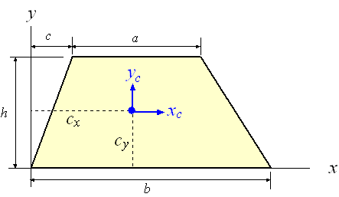

Source: https://www.efunda.com/math/areas/Trapezoid.cfm

Then we can calculate the area with formula: Area = ((a+b)/2)*h
Because we already have an area we can calculate the centroid on axis X with the formula:
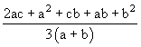

The second function is defuzzify that takes two inputs and return single number that is double. The first input is a pointer to a hash table of struct set_signal that was created in inference engine. The second input is a double pointer to the hash table of variables and their sets. There is one loop which iterates through all struct set_signal in hash table and calculate area and centroid with help of the first function. Then it calculates the output crisp value and returns it.

Implementation and testing of components
Each of the above components were implemented and tested with the example presented in the tutorial.

File parser and knowledge base builder
This component is implemented in the file “rule_base.c”. In order to test this component I wrote simple program that call function loadRuleBase and passes an argument of FILE* to the rule base text file. Then it iterates through every element in the data structure and print them out. For more details see file “test-kb-builder.c”. Example of the output is presented in Figure 2.
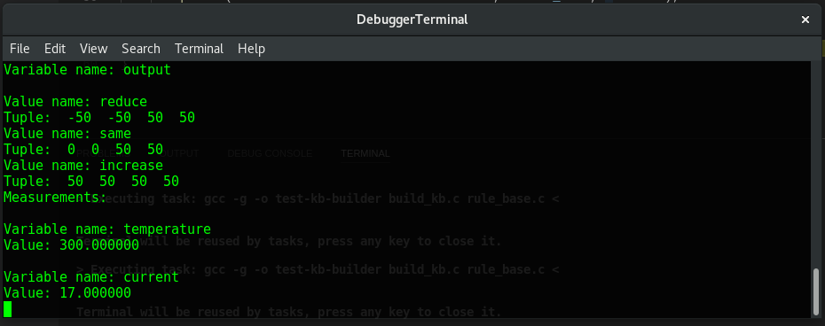
Figure 2:

Fuzzifier
It was implemented as described in section 2.2. See implementation details in the file “fuzzifier.c”. Test results are presented in Figure 3.

Figure 3:
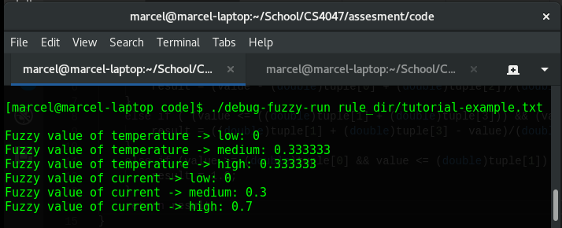

Inference Engine
It was implemented as described in section 2.3. See implementation details in the file “inf_engine.c”. Test results are presented in Figure 4:

Figure 4:
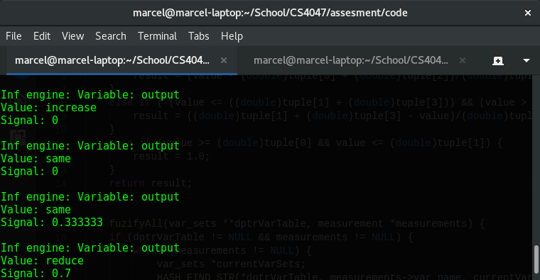

Defuzzifier
It was implemented as described in section 2.4. See implementation details in the file “defuzzifier.c”. I decided that if the input values are out of range then the output value is ‘-nan’. It represents information that the system does not know what should be the output signal. Test results are presented in Figure 5:

Figure 5:
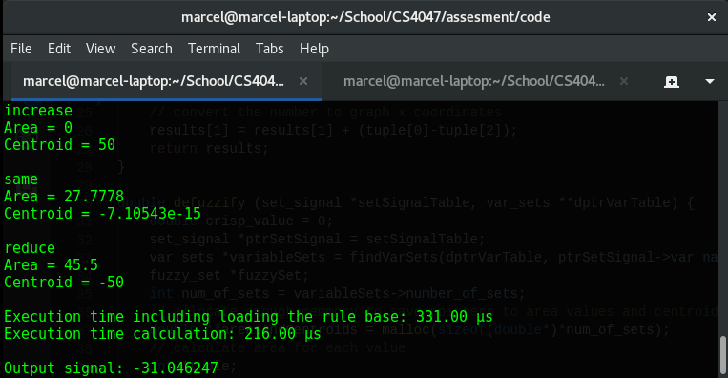

Complete fuzzy rule-based system
The complete fuzzy rule-based system uses all the above described components. They are implemented separately as modules. Every module has its header file and implementation. I wrote very simple program that combines all of the modules in file “run.c”. It takes one argument which is the path to the rule-base text file. Then it does only four calls to functions “loadRuleBase”, “fuzzifyAll”, “inferenceEngine” and “defuzzify”. The modules are very simple to use but are dependent on data structures created for this purpose.

The program needs to be compiled. For this purpose I wrote simple makefile. The user have to use command “make” in terminal in the directory where the makefile and all the other files are.

The output binary file is a console application and has name “fuzzy_run”. It takes one argument which is a path to rule-base text file. The command example is:

$ ./fuzzy_run rule_dir/example.txt

In addition to the output value it also measure the execution time.

Testing and analysis

System limits
In order to describe the system limitation, I first collected some data produced by the system. The following two tables represent data from two different rule-base files. Fields that have orange background represent values out of range.

Tipping rule base. Driving and journey_time are inputs and tip is output.

Washing machine rule base. Weight, dirt and program are inputs and detergent is output.

It can be seen that in some edge cases the fuzzy rule based system outputs values that are valid even though some of the input values are out of range. This behaviour is causes by rules that have OR connective. In the Tipping rule base the behaviour was caused by this specific rule.
Rule 2 If the driving is good or the journey_time is short then the tip will be moderate

I could prevent this by one condition statement that would check if all input values are within a range of defined sets. I did not implement it deliberately. I am convinced that the system behaves correctly in these situations. Imagine a boolean statement: (True or False)
It is Tautology that is always evaluated as True. Now I compare it to the rule above. If the driving is good and it is true to some degree then the tip will be moderate no matter what the second part of the statement says.
On the other hand, if I want to prevent this behaviour then I can write less ambiguous rules with only AND connectives that would prevent such a results.

Improvements
Some of the data structures can be stored in arrays instead of linked lists. Be it variable_value_pair, rule_node and measurement. This should improve performance and decrease the overhead of keeping extra variable for pointer in the data structure. However, This would not be a big difference for small system with only a few tens of rules.
I could also implement several different types of inference engines and several different types of defuzzifiers. They could yield a better results in specific scenarios and the user could simply set which type is desired.
There could be better error handling especially in the rule_base.c file.

Conclusion
The fuzzify system performs well. It calculate crisp output value based on crisp input values with the use of rule base. It is also efficient and fast since it is implemented in C language and does not have a lot of overhead. Since it is split into separate modules, they can be reused in another systems. There is always space for improvements and I would like to implement multiple types of defuzzifiers and inference engines.

