**JOB-A-THON April 2022**

ABC is a car rental company based out of Bangalore. It rents cars for both in and out stations at affordable prices. The users can rent different types of cars like Sedans, Hatchbacks, SUVs and MUVs, Minivans and so on.

In recent times, the demand for cars is on the rise. As a result, the company would like to tackle the problem of supply and demand. The ultimate goal of the company is to strike the balance between the supply and demand in order to meet the user expectations.

The company has collected the details of each rental. Based on the past data, the company would like to forecast the demand of car rentals on an hourly basis.

Training dataset contains 18247 data points.

1. Data
2. Hour
3. Demand

Above mentioned are the 3 dimensions of the given data.

Training data is given for the time range:

Initial data: 2018-08-18

Final date: 20121-02-28

Also, seeing the data it is noticeable that the two columns date and hour can be combined to form one single column giving the timestamp for the row.

The data does not contain any null values, the data is regular and the hours are given in 24 hours format.

We can alternatively view this feature as a class variable which will be AM or PM and provide further information to our model.

Also, the demand variable can be normalized to give values between 0 and 1. This has proven to improve the accuracy of the model.

Plotting the dataset, we can see the evident time series.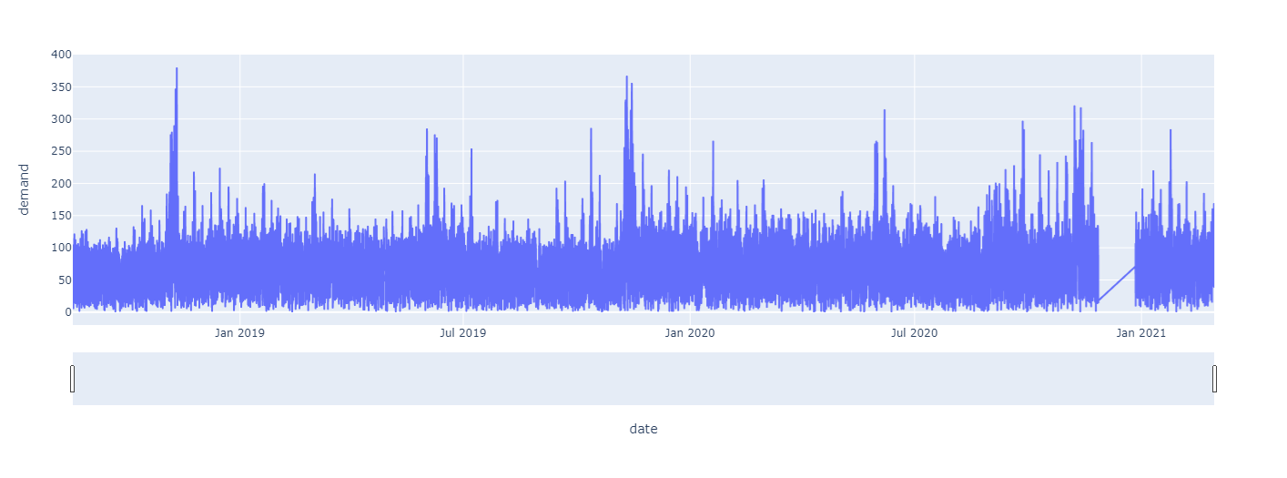

We use the prophet model given by Facebook which is specially designed for the Time Series forecast.

