**DATABASE**

This is table for login entries which stores name, password of the user .

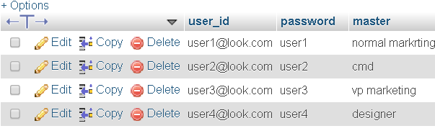

This is a table structure of the database of registration form .It shows all the columns of the table.

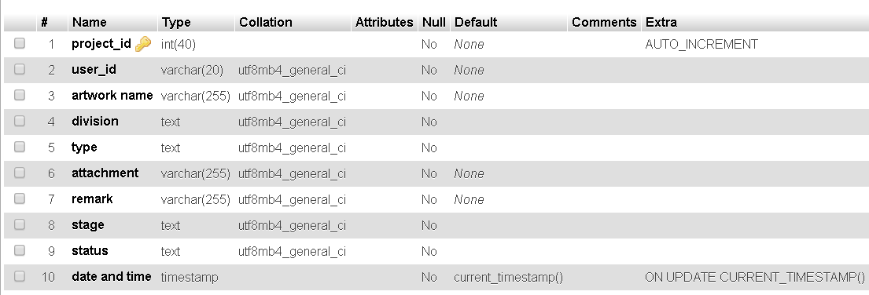

Project­_id is primary key which is auto generated when normal marketing person starts the project.

This will shows all the entries in the table.

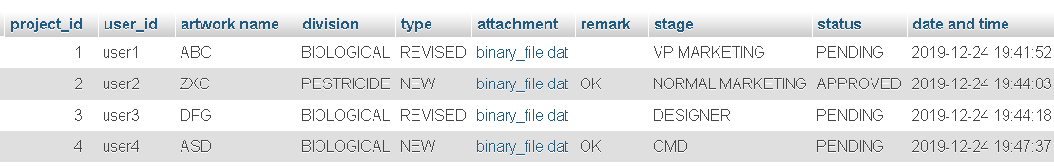

Stage is used to show at what stage artwork is pending or approved.

When the file is uploaded it is store as link in attachment column which we can download

file save as a

link

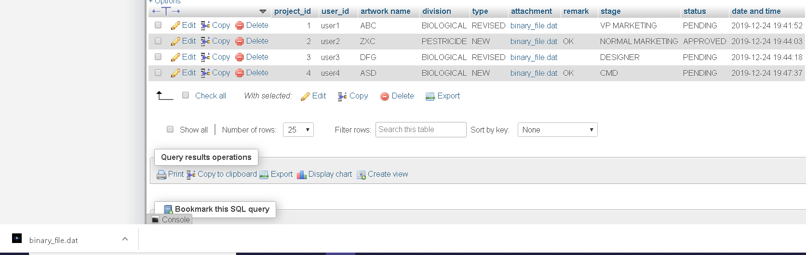

Downloaded file