GANGA

BHAVANI GANDHAM

***Front-End Developer***

# PROFILE

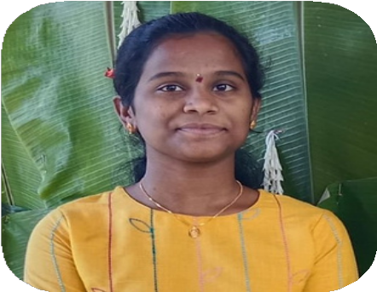

Computer Science Student

I consider myself a

responsible and orderly person.

I am looking forward to my first work

experience.

# CONTACT ME

+91 7815833606

gandhamgangabhavani0@gm ail.com

149,Vivekanandanagar

Kukatpally,

Hyderabad,500072

# EDUCATION

## KRISHNA UNIVERSITY

*BSc(MSC’s) Mathemetics, Statistics*

*,Computers*

## SRI KAKATIYA DEGREE COLLEGE

*2020-2023*

*80%*

# LANGUAGE

English Telugu

# COMPUTER SKILLS

HTML5 CSS

Bootstrap JavaScript Reactjs

SQL



**PROFESSIONAL SKILLS**

Communication Active listening Critical Thinking Problem Solving

Browsing Skills and

Adaptability

**INTERESTS**

Singing

Dancing

Volunteering

Cycling

# EXPERIENCE

I am Working as an

Intern in Social Prachar company as a Java Full Stack Web Developer

since 3 months.

# PROJECTS

 TODO-Application By Using Technologies JavaScript,Html,CSS

 Bootstrap-Animations By Using Technologies

Bootstrap,Html,CSS

 Weather-API

By using Technologies JavaScript,CSS,Html

**GIT HUB PROFILE**

