The Improved MindCare Bot Architecture
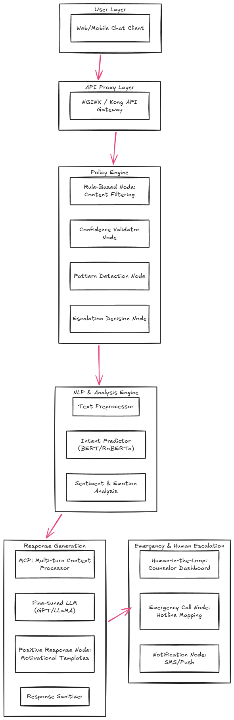
The improved MindCare Bot architecture is designed for maximum safety, scalability, and intelligence. It integrates:
- Multi-layered Intent & Emotion Detection: Transformer-based NLP models and sentiment/emotion analysis detect stress, anxiety, and subtle signs of crisis.
- Policy Engine with Confidence & Pattern Analysis: Ensures safety, enforces escalation rules, and validates low-confidence predictions before responding.
- Positive Response Node & Context Management (MCP): Provides motivational, empathetic responses for non-crisis users while maintaining multi-turn context awareness.
- Human-in-the-Loop & Emergency Handling: High-risk interactions are escalated to counselors or geo-based emergency services (Gemini Maps + Twilio/Vonage).
- Logging, Monitoring & Feedback Loop: ELK stack and Prometheus/Grafana track all interactions, ensuring compliance, observability, and continuous model improvement.
- Fine-Tuned LLMs with Safety Constraints: Guarantees responses are domain-specific, safe, and bounded, preventing generic or unsafe outputs.

Confidence Scoring in Intent Classification
A relevant study, “Intent Classification by the Use of Automatically Generated Knowledge…” (MDPI, 2023), demonstrates the use of a Softmax classifier in a hybrid approach that combines Knowledge Graph Embeddings (KGEs) with pre-trained sentence embeddings like SBERT and MPNet. In this approach, sentence embeddings are augmented with knowledge graph information, and the Softmax layer produces a probability distribution over possible intents. The intent with the highest probability is chosen as the predicted intent, and this is taken as the confidence score of the model.Shortcomings of Softmax Confidence
The primary shortcoming of the Softmax confidence scoring system is its inherent ability to produce a probability distribution even when the model is uncertain or when it encounters out-of-distribution data. The confidence score is more of a relative measure of probability between known classes and not a measure of actual confidence. This leads to the following issues:
- Uncertain predictions with low confidence scores (14%) can still be accepted.
- The model lacks the ability to identify unknown or high-risk inputs.
- Confidence scores can be mis-calibrated and overly confident.
In applications like mental health chatbots, where safety is a concern, a confidence scoring system based solely on Softmax confidence without the use of thresholds, calibration, or uncertainty estimation can be dangerous and misleading.Case Study: Si Le Me (“Are You Dead?”)

Si Le Me (“Are You Dead?”) is a mobile app that became one of the most downloaded paid apps in China due to its minimalist safety design.
The app presents users with a simple daily button to tap to confirm they are okay. If a user fails to check in for a set period (e.g., two days), the system automatically sends an alert to a pre‑selected emergency contact.Lack of Confidence Thresholding

One of the most basic design flaws was the lack of a confidence threshold. In high-risk applications, predictions below a certain confidence threshold (for example, 70%) should trigger the initiation of fallback actions, clarification requests, or escalation to a human expert.

In the current situation, a prediction with only 14% confidence was still accepted and answered in a normal fashion. This result indicates that the system considered the Softmax output to be authoritative rather than indicative of uncertainty. The absence of confidence thresholding safeguards indicates a machine learning pipeline issue (lack of uncertainty handling) and a product design issue (lack of a safety override mechanism in high-risk situations).-----Immediate Action Strategies (Realistic + Responsible)

We don’t want to propose unrealistic things like “calling police automatically.” Instead, propose ethical, consent-based interventions.
- Emergency Support Interface (must-have)
  - Action: Immediately show crisis support options.
  - Example UI: “Call Helpline,” “Chat with Counselor,” “Contact Trusted Person,” “Find Nearby Help.”
  - Example Response: "I'm really sorry you're feeling this way. You deserve support right now. Would you like to talk to someone who can help immediately?"
  - Reference: In India, you can reference the Kiran Mental Health Helpline (1800-599-0019). This makes your solution grounded in reality.
- Human Escalation System
  - Action: Automatically flag the conversation to a trained moderator, counselor dashboard, or support team.
  - System Flow: Risk > 90% → Alert human counselor → Lock automated responses.
  - Concept: This is called human-in-the-loop intervention.
- Location-aware Help Suggestion
  - Action: Without collecting sensitive data automatically, the system can show nearby hospitals, show crisis centers, and suggest emergency numbers.
  - Example: "Help is available near you. Would you like to see nearby support services?"
- Conversation Freeze Mode (very strong idea)
  - Action: When crisis is detected, disable normal chatbot replies and switch to safety-only responses.
  - Example: "Crisis Mode Activated. Only empathetic + support responses allowed."
  - Benefit: This prevents unsafe AI outputs.
Human-in-the-Loop Intervention (Simple Meaning)
It means: When the AI detects a risky or sensitive situation, a real human becomes part of the decision or support process instead of the AI handling it alone. So the AI doesn’t fully “control” the situation — it hands over responsibility when needed.Why This Is Necessary in MindCare Bot

In our case study, the chatbot:
- Misclassified crisis messages
- Gave unsafe responses
- Had no escalation system
That’s dangerous because AI cannot safely handle mental-health crises alone.
The Solution: AI detects risk → human provides support.

