**Name :- Sarvesh Gandhi**

**Mobile no :- 7028242824**

____________________________________________________________________________

**Problem statement** :- “ShopBridge" is an e-commerce application. Need to build functionalities that helps manage different items they would have for sale. This will require a backend solution. As a Backend developer, It would be needing to provide a functional solution that can be consumed by the frontend application.

Create a backend solution for Product module to be used by Product Admin, and perform below actions:

1. Add a new item to the inventory (The item should require a name, description, and price as basic fields, think of additional information that would be useful)

2. Modify an item in the inventory.

3. Delete an item from the inventory.

4. Lists the items in the inventory.

____________________________________________________________________________

**Time taken :-**

Please do your best to keep track of how long you spend on the implementation of each of the, this is for self-timing and to determine estimation accuracy.

1. Data store design :- 45 min

2. API and service logic :- 2 hours

3. Testing :- 1 hour

____________________________________________________________________________

**Summary**

* Created database for ShopBridge in MSSQL
* Total four tables created for the application:-
  + **Product** :- Id, Name, Description, Image, Price, Category, Quantity
  + **Category** :- Id, Name
  + **Contact Us** :- First name , Last name, Mobile no, Email Address & Message
  + **Admin** :- Login username, password

**Key features :-**

* **Search** feature created, to make it easy for consumer to look for any product.
* All API calls are asynchronous.
* Exceptional handling done with Try and Catch block.
* Validation done like - not allowing repeating of Category name
* API created to show Product Quantity which is less than or equal to five.
* Admin can Add, Delete and Modify any item.

____________________________________________________________________________

**Relational Database Diagram**

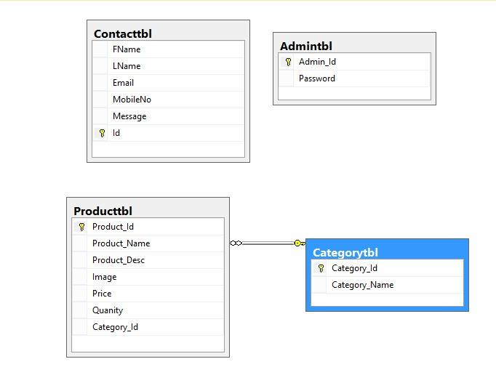

___________________________________________________________________________

**Swagger screenshots**

