OBI Team Overview

Project Overview:

- Open Business Infrastructure (OBI) platform is a kind of monetization engine for AOL/Yahoo and its affiliates by providing generic capabilities for business integration.
- Monetization means both collecting money from as well as paying money to customers, affiliates, publishers, and others. Open Business Infrastructure API’s provide payment (both to as well as from), subscription and contracts, ordering, product catalog and other functionality.

Organizational Structure:

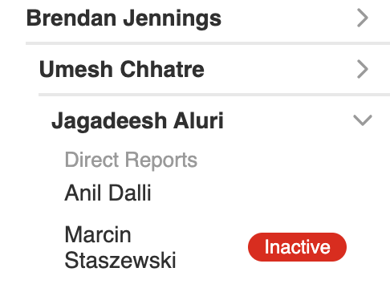

Scope of DevOps Team:
- Craft DevOps solutions that leverage AWS and internal products/service capabilities to support Yahoo's membership and subscription business.
- Treat infrastructure as code and make it scalable using Terraform and shell scripting.
- Provision and maintain services like Lambda, SNS, DynamoDB Database, Fargate, s3, cloud formation, Route53, API Gateway etc., on AWS.
- Monitor performance and ensure system availability and reliability.
- Improving operations by conducting systems analysis and recommending changes in policies and procedures.

Technologies Used
- Cloud : AWS
- CI/CD : Jenkins
- IaaC : Terraform
- Containerization : Docker
- Repository : Git
- Scripting : Shell, Python and Groovy

List of Applications under OBI:

https://docs.google.com/spreadsheets/d/1H2pmKnU1Q89uXYxfaI0bxLCQq1bKjHVqXnt-hdYxKMI/edit#gid=0

Assigning work in project:
- Most of the work gets distributed over the slack
- Opsgenie Alerts receive over mail/slack
- Jira Tickets - ex: https://jira.ouryahoo.com/browse/CLOUDGOV-10184
- Security Fixes and Infra changes are discussed in MSCDI Status call - Michael Renggli

Other teams that we work along with
- MSCDI - Member Services Common Deployment Infrastructure
- CCARE - Customer Care
- WAS - Paid services subscription services
- Corp-Platform - Customer Experience Development

Connect with Team
- Daily Status call with the OBI and MSCDI Team
- Go over the blocked tasks every Monday after the status call
- Team connect every Monday to discuss over the organization changes and status on MSRP Tickets
- Meet for virtual lunch every Friday

