Key Achievements:
• Reduced AWS cloud spend by 60–70% through optimization strategies
• Migrated legacy systems to containerized ECS Fargate environments
• Designed secure multi-environment AWS VPC architectures
• Built reusable Terraform modules to standardize infrastructure
Passionate about automation, reliability engineering, and building highly available cloud platforms.

- In my role as a Senior DevOps / Cloud Engineer, I have extensive experience with various AWS services, which are crucial for this position. I have worked with services such as EC2, ECS/Fargate, S3, Lambda, and CloudWatch. My experience includes provisioning and managing these services to support high-availability web platforms.
- For instance, while working at LTIMindtree, I designed and implemented AWS-based DevOps solutions for large-scale membership platforms like Yahoo and AOL. This involved creating scalable environments using Terraform and CloudFormation, ensuring that the infrastructure could handle significant traffic while maintaining performance and reliability.
- Additionally, I have implemented secure IAM roles and policies, adhering to best practices to ensure compliance and security across the cloud infrastructure. My hands-on experience with these services has equipped me with the skills necessary to architect and design scalable, cloud-native solutions as required in this role.

" First of all, thank you for this opportunity. My name is Gandhi. I have over 20 years of experience in IT, with the last 5 years focused specifically on Cloud DevOps. In my recent roles, I’ve designed and implemented end-to-end DevOps solutions—including CI/CD pipelines and AWS infrastructure—using tools like Git, Docker, and Terraform to support scalable microservices. I specialize in leveraging Infrastructure as Code (IaC) to deploy serverless workloads on ECS and Fargate, which has significantly improved our automation, reliability, and overall operational efficiency
About AOL/Yahoo Project
Client Brief * Open Business Infrastructure (OBI) platform is a kind of monetization engine for AOL/Yahoo and its affiliates by providing generic capabilities for business integration.
Open Business Infrastructure API’s provide payment (both to as well as from), subscription and contracts, ordering, product catalog and other functionality.
• Designed and implemented DevOps solutions leveraging AWS services and internal tools to support Yahoo’s Membership and Subscription platforms.
• Embraced Infrastructure as Code (IaC) principles using Terraform and Shell scripting to build scalable and reusable infrastructure components.
• Provisioned and managed AWS services such as Lambda, SQS, SNS, DynamoDB, Athena, Fargate, S3, CloudFormation, Kinesis, Route53, and API Gateway to enable robust backend systems.
• Monitored application performance, ensured high availability, and optimized resource usage using CloudWatch and other observability tools.
• Enhanced operational efficiency by performing system analysis and proposing improvements in deployment workflows, policies, and procedures.
In this project, we leverage several AWS services to ensure scalability, security, and smooth CI/CD operations:
• Amazon ECS (Elastic Container Service): Used for container orchestration, allowing us to deploy and manage Node.js-based microservices efficiently.
• IAM (Identity and Access Management): Provides secure access control with fine-grained role and policy management.
• Amazon VPC (Virtual Private Cloud): Offers a secure, isolated network environment for all infrastructure components. VPC peering, Private link.
- Route Table is a set of rules (called routes) that act as a traffic controller to determine where network traffic from your subnet or gateway is directed. Each rule specifies a destination (IP range) and a target (the gateway or interface that handles it)
• AWS CloudWatch: Utilized for centralized logging, real-time monitoring of ECS containers, health checks, and custom metrics/alerts.
• AWS Lambda: Handles lightweight serverless tasks such as log processing, notifications, or automation scripts.
• Amazon RDS: Hosts our relational databases with built-in backup, scaling, and high availability features.
• Amazon OpenSearch: Enables search and log analytics for system observability and debugging.
• AWS Systems Manager Parameter Store / Secrets Manager: Manages and securely retrieves configuration and secret values at runtime.
• AWS CodeDeploy: Automates ECS deployments with zero downtime, supports blue/green and rolling updates, and integrates with CloudWatch for deployment monitoring.
AWS CloudFormation is an infrastructure-as-code (IaC) service that allows you to model, provision, and manage AWS resources by writing a declarative template in JSON or YAML
Amazon Bedrock is a fully managed, serverless platform that provides access to leading foundation models (FMs) through a single, unified API. It allows developers to build and scale generative AI applications without managing any underlying infrastructure.
Amazon API Gateway is a fully managed service that allows developers to create, publish, and secure APIs at any scale. It acts as a "front door" for applications to access data or business logic from backend services like AWS Lambda, Amazon EC2, or any web application.
Amazon EBS (Elastic Block Store) is the "hard drive" for your EC2 instances. It provides durable, high-performance block storage volumes that you can attach to any running instance in the same Availability Zone.
Amazon Athena is a serverless query service that directly analyzes data stored in Amazon S3 using standard SQL. This eliminates complex data loading or transformation processes.
AWS Glue extract, transform, and load (ETL) service catalogs, cleans, and transforms data stored in S3 buckets, making it ready for analytics and machine learning (ML) applications.

These services work together to support a secure, automated, and highly available application environment.
DevOps is a set of cultural philosophies, practices, and tools that combines software development (Dev) and IT operations (Ops).
Planning – Collecting the information
Code – Git (version control), code vulnerability test tools (SonarQube, GitHub CodeQL)
Build – Automated build tools will combine source code into machine code (Maven, gradle)
Test – implement strict testing (Unit test, UI test) selenium, Jmeter
Deployment – IaaC tools automate the deployment
Operation – periodic maintenance to monitor
Monitor – Continuous monitoring tools to check security system implemented correctly
Scaling – in virtualisation
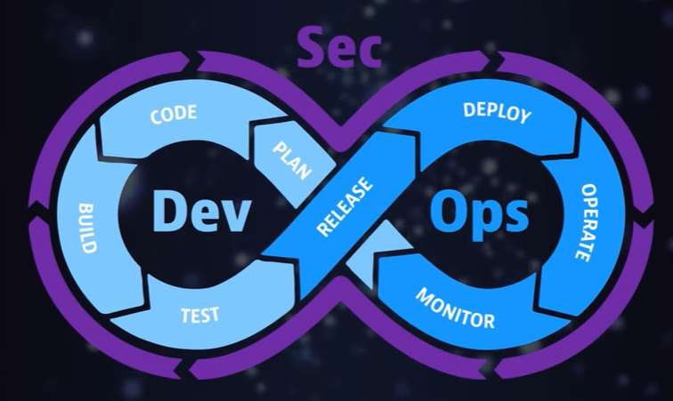
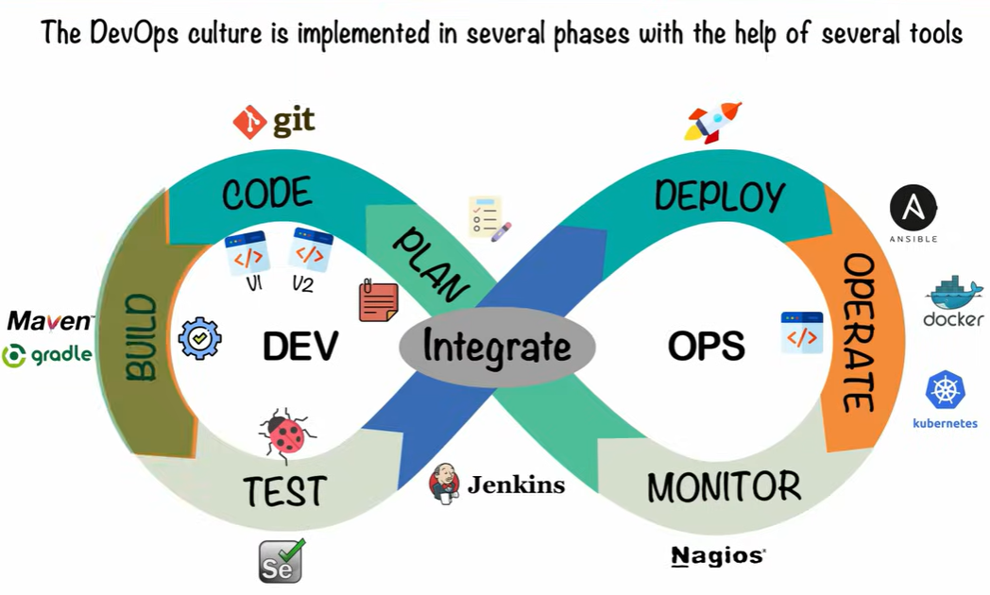
SonarQube | Code Quality | Continuous Integration (Build) | Best for enforcing clean coding standards.
Trivy | Security | Container Build / Registry | Extremely fast scanning for Docker/IaC vulnerabilities.
CodeQL | Deep Security | PR / Code Review | Semantic analysis for complex data-flow vulnerabilities.
New Relic | Operations | Production / Runtime | Real-time observability and performance alerting.

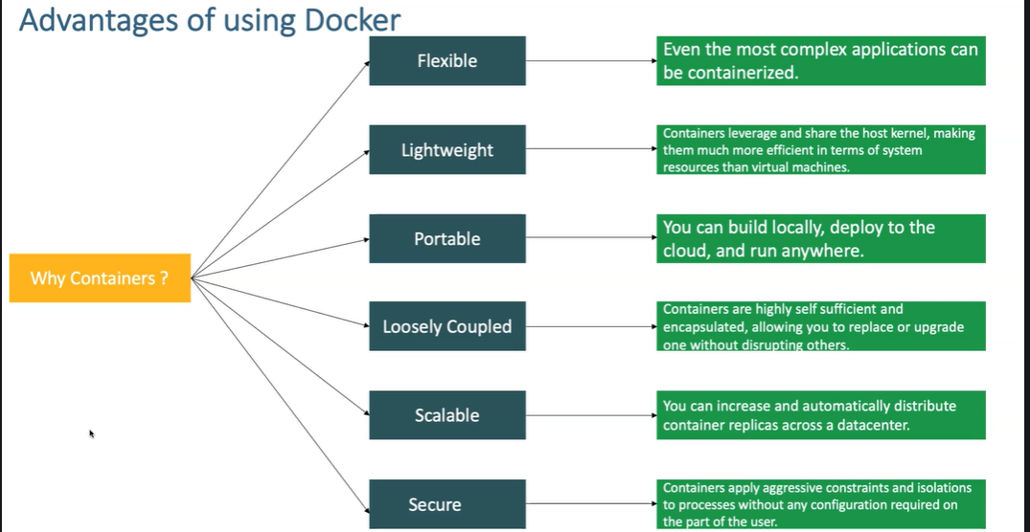
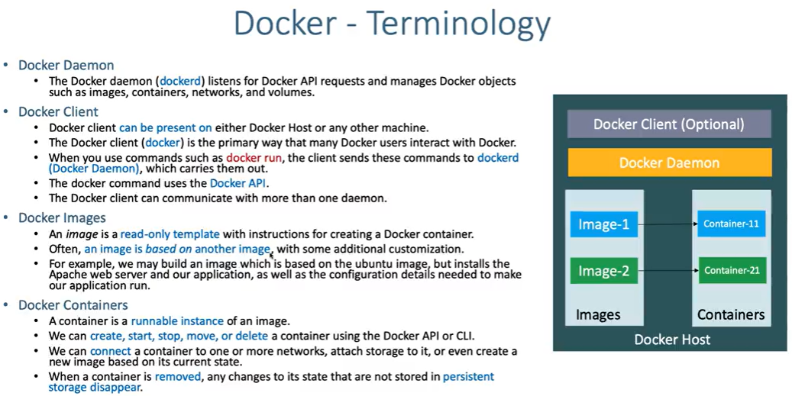
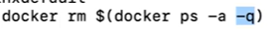
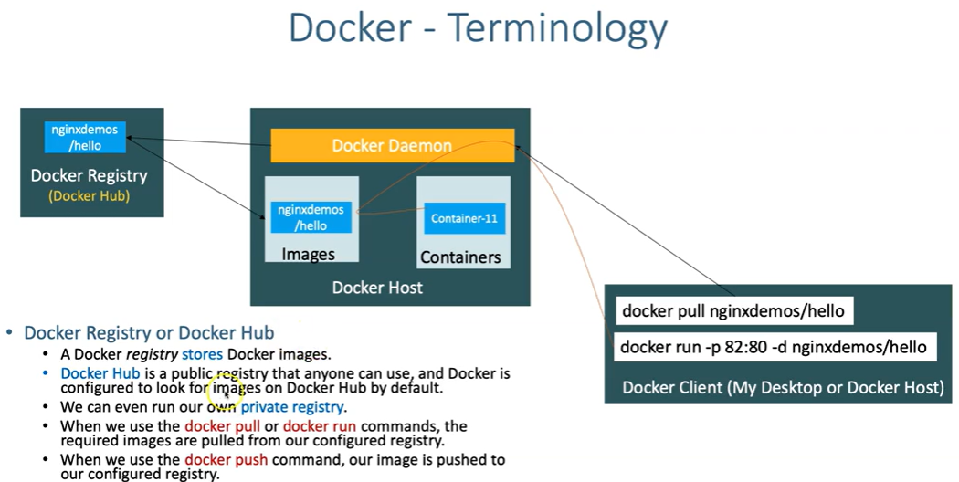

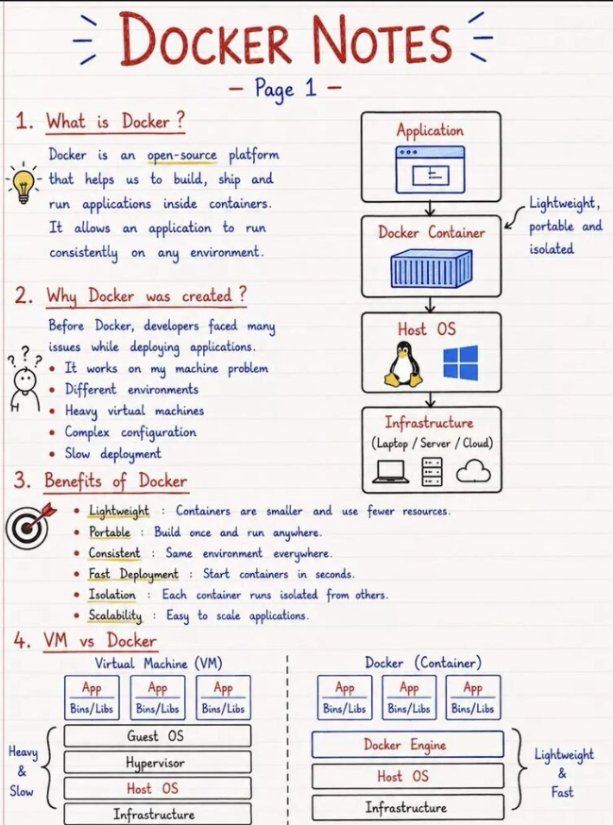
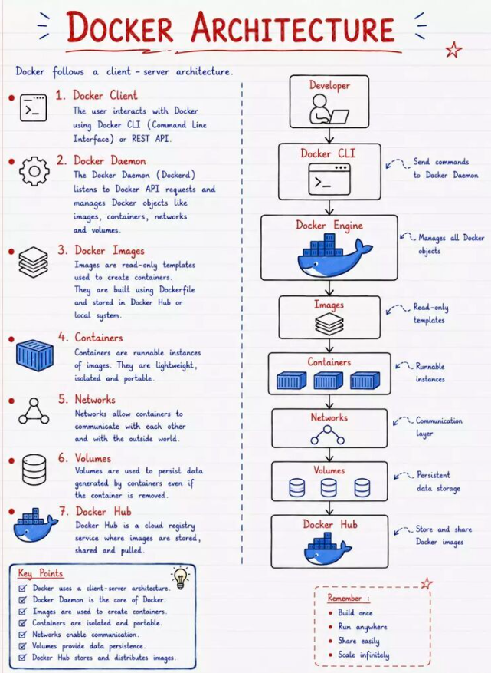

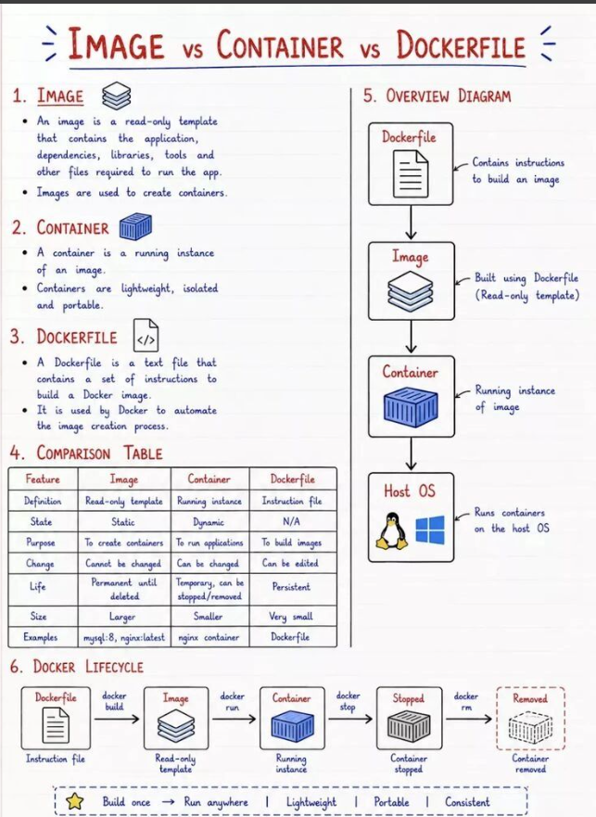
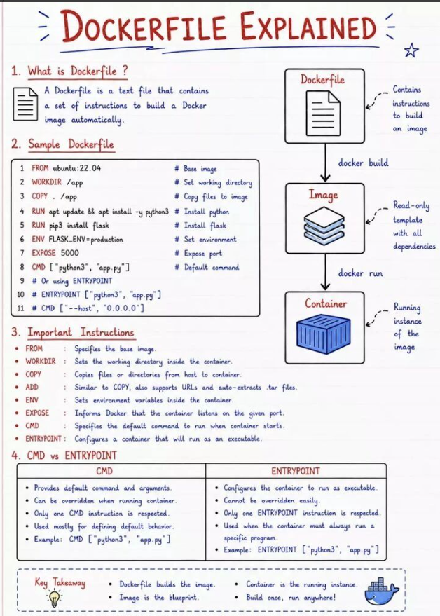
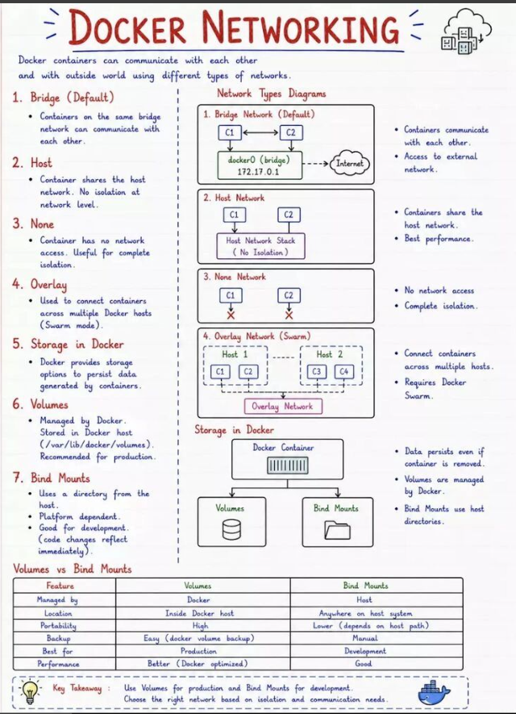
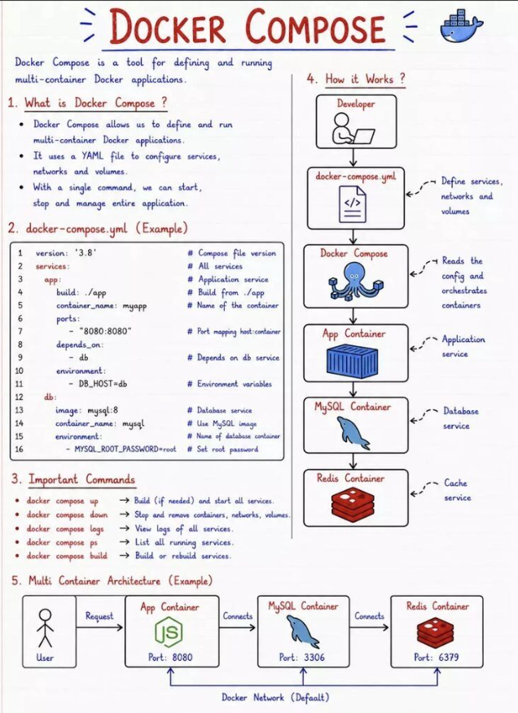
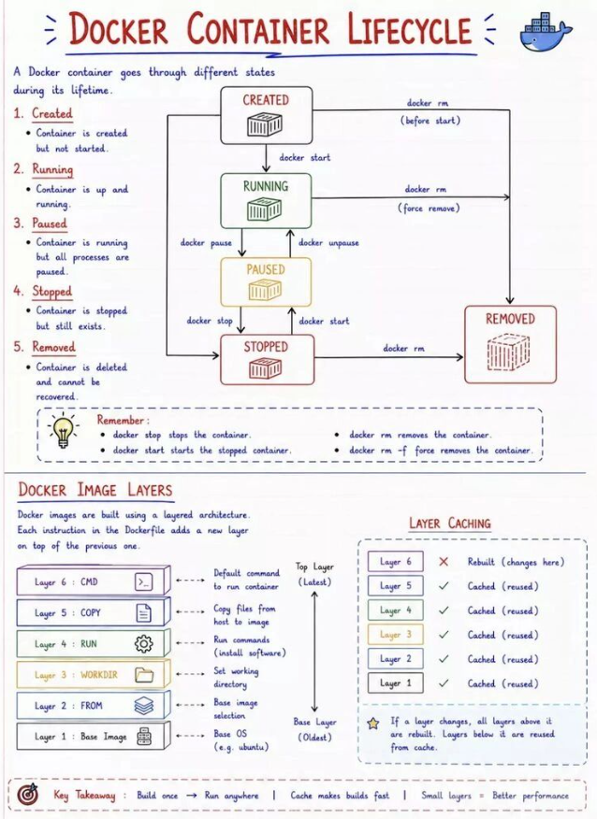
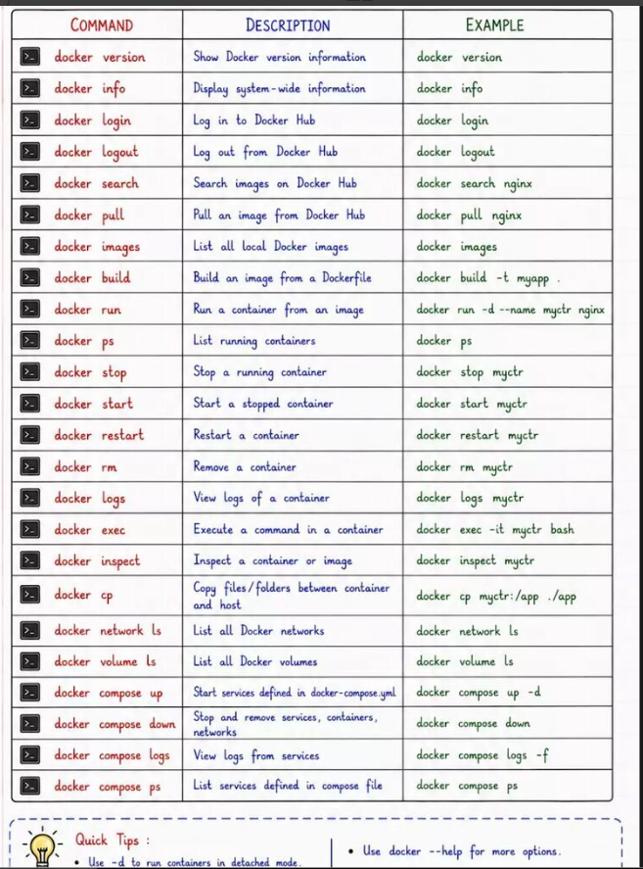
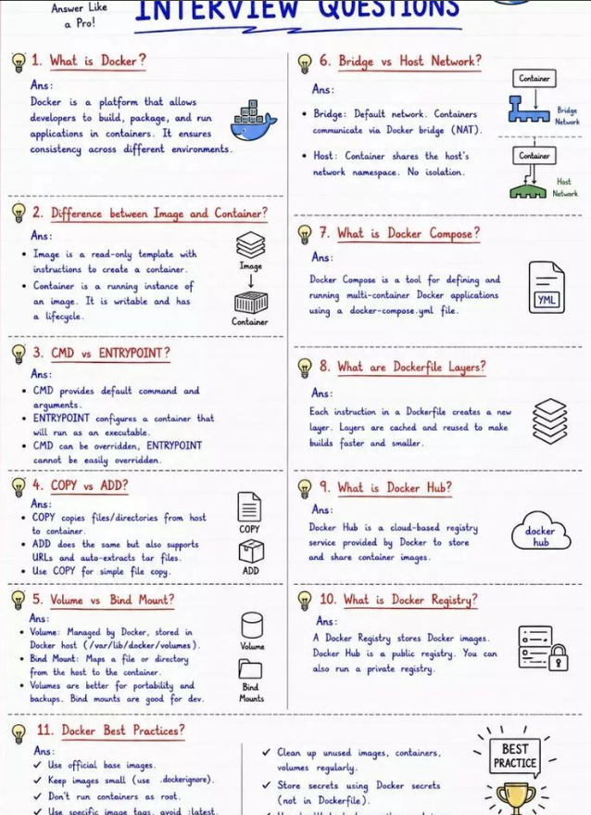

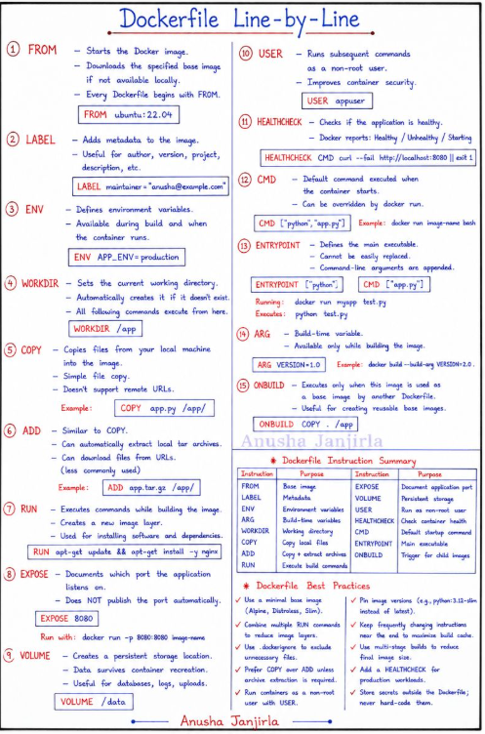
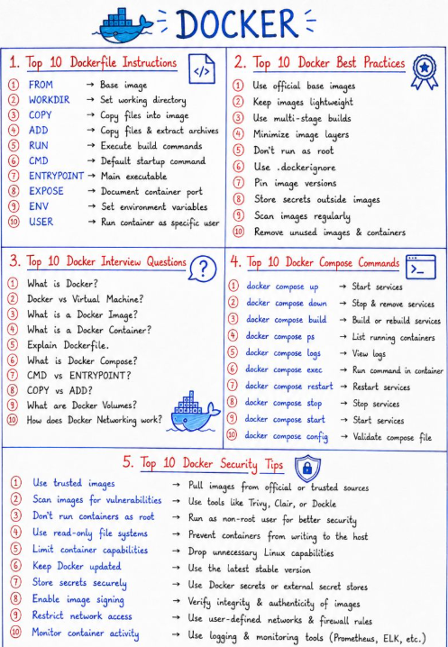
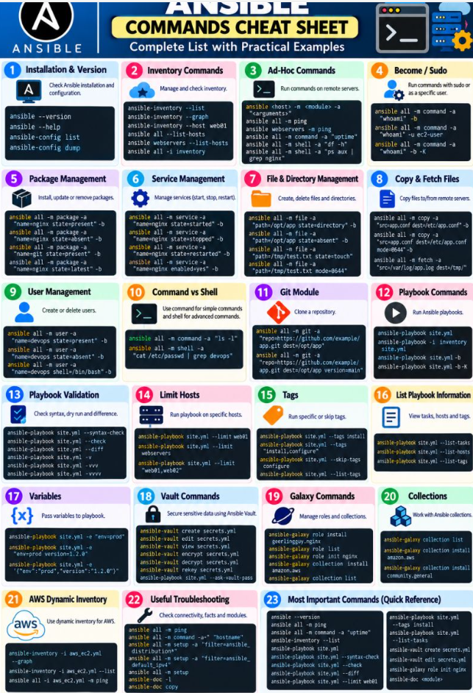
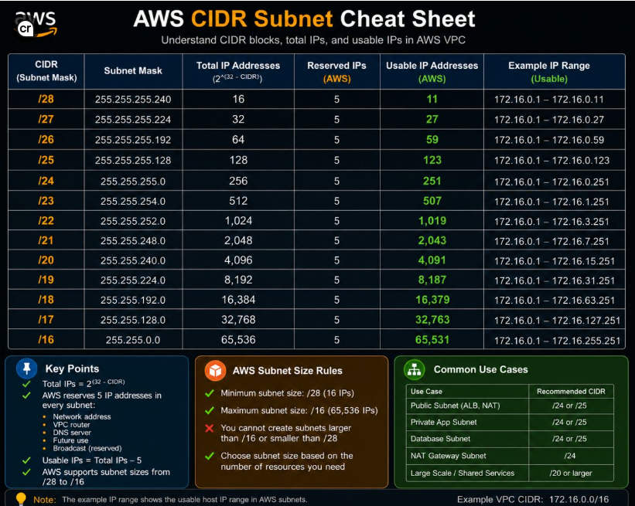

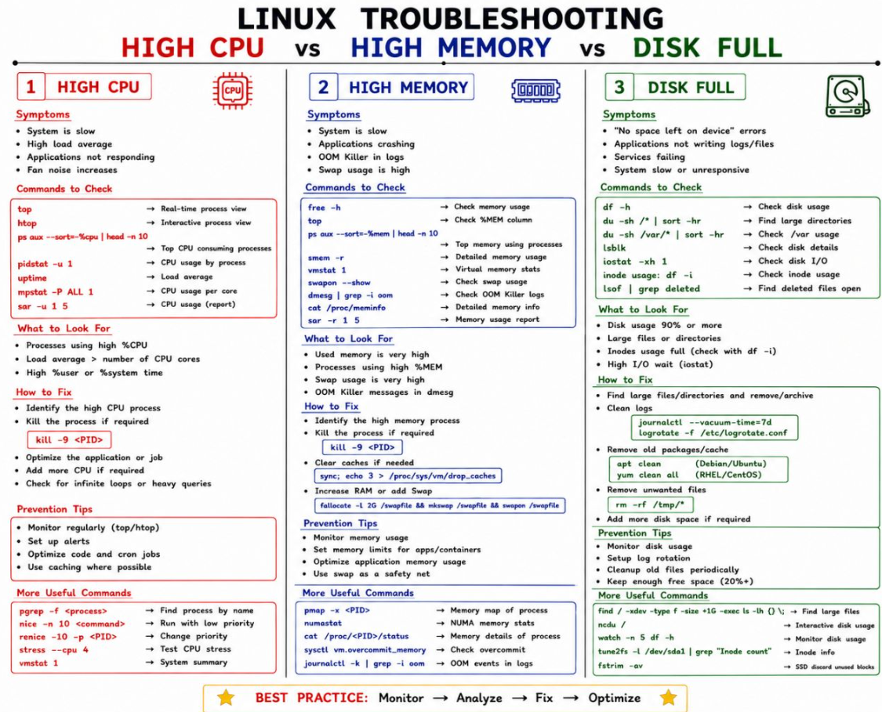
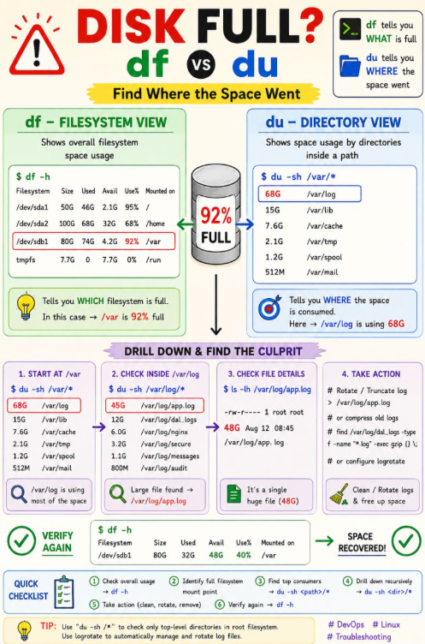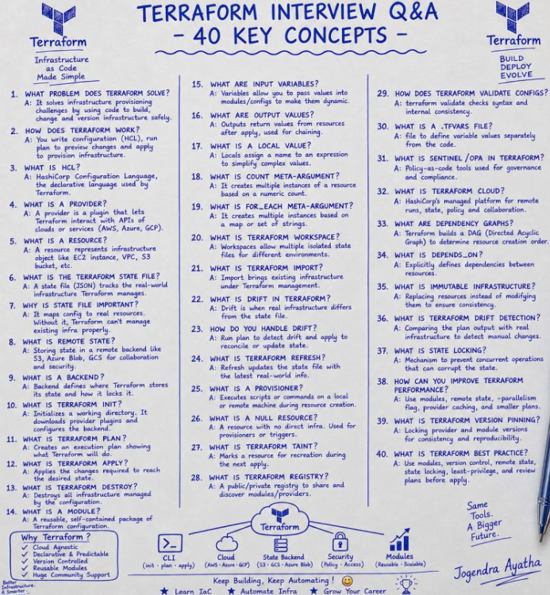
Observability in AWS is the ability to understand the internal state of your systems by analyzing the telemetry data they produce—specifically metrics, logs, and traces. While traditional monitoring tells you that something is wrong (reactive), observability provides the deep insights needed to understand why and how it happened (proactive/investigative).
Observability in AWS using Terraform involves managing the "three pillars"—metrics, logs, and traces—as code. Instead of manually configuring dashboards and alerts in the AWS Console, you use Terraform to provision and connect AWS-managed services like Amazon CloudWatch, Amazon Managed Service for Prometheus (AMP), and AWS X-Ray
Core AWS Observability Components Managed by Terraform
A standard observability platform built via Terraform typically includes these services:
Metrics: Amazon Managed Service for Prometheus (AMP) for high-scale metric storage and Amazon CloudWatch Metrics for AWS-native monitoring.
Logs: Amazon CloudWatch Logs for aggregating structured application and infrastructure logs.
Traces: AWS X-Ray for distributed tracing to visualize how requests travel through your microservices.
Visualization: Amazon Managed Grafana to create unified dashboards that pull data from Prometheus, CloudWatch, and X-Ray into a single view.
AWS Observability Accelerator for Terraform
AWS provides the AWS Observability Accelerator for Terraform, a collection of opinionated modules that simplify the setup of these services. It allows you to:
Automate Deployment, Pre-built Content, Collector Profiles
Key Benefits of "Observability as Code"
- Consistency: Ensures that every environment (Dev, Stage, Prod) has identical monitoring setups, reducing troubleshooting blind spots.
- Reproducibility: Entire dashboards and complex alert logic can be audited and redeployed quickly if needed.
- Reduced Toil: Developers can self-serve their monitoring needs by adding a few lines of Terraform code rather than waiting for a centralized operations team
Feature | Traditional Monitoring | Modern Observability
Goal | Know when a system is down. | Understand why a system is slow/failing.
Data | Mostly Metrics. | Metrics + Logs + Traces (Interlinked).
Approach | Reactive (Fix after alert). | Proactive (Find bottlenecks before crash).
Tool Example | Nagios, Zabbix. | Datadog, Honeycomb, AWS X-Ray.
General Mertrics
CPU, memory and storage utilization, Running task count, TG health check, service discovery(success/failures), Request count, Latency(Target Response Time) HTTP Code 1xx, 2xx, 4xx and 5xx, Container restart, N/w in/out, CPU reserved/utilized, stdout/stderr(from awslogs)
https://github.com/cloudposse/terraform-aws-ecs-cloudwatch-sns-alarms/tree/main
cloudwatch insights explain
In Amazon CloudWatch, Insights refers to a suite of advanced query and analysis features designed to move beyond basic metric tracking. While standard CloudWatch shows you what is happening, the "Insights" tools help you investigate why it’s happening by querying deep telemetry data.
The three primary "Insights" capabilities are:
1. CloudWatch Logs Insights (Log Analysis)
This is an interactive query tool that allows you to search and analyze massive amounts of log data in seconds using a purpose-built query language (Logs Insights QL).
- Key Feature: It can automatically discover fields in JSON logs, allowing you to run complex filters and aggregations (e.g., "Show me the top 20 users with the most 404 errors").
- Recent Update: It now supports OpenSearch PPL and SQL, making it easier for users familiar with those languages to query AWS logs.
- AI Integration: You can use Natural Language Query Generation to ask questions like "Show me the slowest Lambda functions," and the tool will generate the code for you.
2. CloudWatch Metrics Insights (Metric Intelligence)
This is a high-performance, SQL-based query engine used to analyze millions of operational metrics in near real-time.
- Use Case: It helps you identify patterns and outliers across your entire fleet, such as finding which specific Load Balancer is handling the most traffic or which instances have the highest CPU spikes.
- Capacity: It can process approximately 10,000 metrics at a time to surface trends across different environments (e.g., comparing "Production" vs. "Staging" metrics).
3. Specialized Service Insights
AWS also provides "curated" Insights dashboards for specific infrastructure types, which automatically collect the most important data for those services:
- Container Insights: Specifically for ECS, EKS, and Kubernetes on EC2. It tracks memory leaks, container restart failures, and CPU/Network utilization.
- Lambda Insights: Summarizes compute performance for serverless functions, helping you troubleshoot invocation errors, throttles, and memory usage issues.
- Application Insights: Uses machine learning to detect and correlate anomalies across your full application stack (DBs, web servers, and queues) to pinpoint root causes of problems.
Comparison at a Glance
Feature | Primary Data Source | Language Used | Main Benefit
Logs Insights | Application/System Logs | Logs QL, SQL, or PPL | Deep troubleshooting and root-cause analysis.
Metrics Insights | AWS & Custom Metrics | SQL-based | Real-time trend identification at scale.
Service Insights | Service-specific telemetry | Automatic Dashboards | Out-of-the-box monitoring for ECS, EKS, or Lambda.

If this is a monitoring account in CloudWatch cross-account observability, you can select log groups in the source accounts as well as the monitoring account. A single query can query logs from different accounts at once.
You can filter the log groups by log group name, account ID, or account label.
When you select a log group in the Standard log class, CloudWatch Logs Insights automatically detects data fields in the group. To see discovered fields, select the Fields menu near the top right of the page.
A distributed application on EKS is experiencing intermittent 5XX errors. Walk through your troubleshooting framework using AWS observability services.
- Answer:
- Check CloudWatch Alarms and the Application Load Balancer (ALB) Access Logs to pinpoint if the 5XX originates from the proxy or the backend targets.
- Review Container Insights / EKS Enhanced Monitoring to check pod-level CPU, memory exhaustion, or network throttling.
- Query CloudWatch Logs Insights across the application log group to aggregate stack traces or error exceptions.
- Utilize VPC Flow Logs if network drops or security group blocks are suspected.
- Check AWS CloudTrail to rule out any concurrent infrastructure or API throttling changes made during that time window. [1]

Azure:=====
1. Created a CICD flow using Azure DevOps services such as Azure repos, Azure pipeline, Azure boards, Azure test plan, Azure artifact.

2. Vnet:
=====
* Established peering connections between VNets to enable communication between resources in different VNets as if they were on the same network.

* Implement DDoS Protection Standard to safeguard your VNets from distributed denial-of-service (DDoS) attacks.

*Customized routing tables using user-defined routes to control traffic flow within the VNet and between VNets.

*Integrated Azure VNets with various Azure services such as Azure Virtual Machines, Azure Kubernetes Service (AKS), Azure App Service Environments, and more.

* Established secure connections between Azure VNets and on-premises networks over the internet using VPN gateways.

* Connected multiple Azure VNets together to enable cross-VNet communication.

* Configured redundant network configurations, geo-replication, and failover mechanisms to minimize downtime and data loss in the event of disruptions or disasters.

* Integrated Azure VNets with Azure services such as Azure Virtual Machines, Azure Kubernetes Service (AKS), Azure App Service, and Azure SQL Database, enabling seamless communication and data exchange between cloud resources.

3. Azure Blob Storage:
=================
*Created Azure Blob Storage to organize data by creating containers. Configured properties for blobs, such as metadata, content type, cache control settings, and access tier.

*Established lifecycle rules to automatically transition blobs between storage tiers (hot, cool, archive) or delete them based on predefined criteria, such as age or last modified date.

*Created blob versioning to maintain multiple versions of a blob over time. This allows you to track changes and revert to previous versions if necessary.

* Designed and implemented Azure Blob Storage solutions to store and manage large volumes of unstructured data, ensuring high availability, scalability, and durability.

* Developed Azure Blob Storage architecture and deployment strategies based on business requirements and best practices, optimizing storage costs and performance.

* Configured storage accounts, containers, and access policies to secure data at rest and in transit, leveraging encryption, access control, and network security features.

* Implemented data lifecycle management policies to automate data retention, archival, and deletion processes, reducing storage costs and improving data governance.

* Integrated Azure Blob Storage with other Azure services and third-party tools for data ingestion, processing, and analysis, enabling seamless data workflows and analytics insights.

* Monitored Azure Blob Storage performance, usage, and health using Azure Monitor, Log Analytics, and other monitoring tools, proactively identifying and addressing issues.

* Collaborated with cross-functional teams, including developers, architects, and business stakeholders, to define requirements, troubleshoot issues, and deliver solutions that meet business needs.

* Documented Azure Blob Storage configurations, processes, and best practices, providing guidance and training to team members and stakeholders.

4. Azure function:
==============
* Set up monitoring and logging solutions such as Azure Monitor, Application Insights, or Azure Log Analytics to track the performance, health, and usage of Azure Functions.

* Monitored function app performance, execution times, and resource usage using Azure Monitor and Application Insights. Set up alerts and notifications to proactively identify and address issues.

* Designed, developed, and deployed Azure Functions to implement serverless compute solutions for various business use cases, including data processing, event-driven applications, and integration workflows.

* Collaborated with cross-functional teams to gather requirements, design solution architectures, and implement Azure Function applications that meet business needs and performance requirements.

* Leveraged Azure Functions triggers and bindings to seamlessly integrate with Azure services such as Azure Blob Storage, Azure Event Hubs, Azure Cosmos DB, and Azure SQL Database, enabling data-driven workflows and real-time processing.

* Implemented Azure Functions in programming languages Python, selecting the appropriate language and runtime based on project requirements and developer expertise.

* Optimized Azure Function performance and scalability by fine-tuning code, configuring scaling options, and monitoring resource usage using Azure Application Insights and Azure Monitor.

* Implemented security best practices for Azure Functions, including authentication, authorization, and encryption, to protect sensitive data and ensure compliance with regulatory requirements.

* Implemented continuous integration and continuous deployment (CI/CD) pipelines for Azure Functions using Azure DevOps, GitHub Actions, or other CI/CD tools, automating the build, test, and deployment process.

5. Cloud DNS:
===========
* Configured Azure DNS zones, DNS records, and DNS resolution settings to support domain names and hostname resolution for Azure resources, including virtual machines, web applications, and other cloud services.

* Implemented DNS resolution for custom domain names and SSL certificate management to enable secure communication with cloud-based applications and services.

* Integrated Azure Cloud DNS with other Azure services such as Azure Virtual Networks (VNets), Azure App Service, Azure Kubernetes Service (AKS), and Azure Traffic Manager, enabling seamless DNS resolution and traffic routing between cloud resources.

* Implemented DNS monitoring and troubleshooting solutions using Azure Monitor, Log Analytics, and third-party monitoring tools, proactively identifying and addressing DNS issues and performance bottlenecks.

* Implemented DNS security best practices, including DNSSEC (Domain Name System Security Extensions) and DNS-based DDoS protection, to protect against DNS-related threats and ensure the integrity and availability of DNS services.

* Designed, implemented, and managed Azure Cloud DNS solutions to provide scalable and reliable domain name resolution for cloud-based applications and services.

* Collaborated with stakeholders to gather requirements, design DNS architectures, and implement DNS configurations that align with business needs and performance requirements.

6. Azure Monitor:
==============
* Configured Azure Monitor to collect and analyze telemetry data from Azure resources, including virtual machines, databases, web applications, and containers, using Azure Monitor Metrics, Logs, and Application Insights.

* Developed custom monitoring solutions and alerts using Azure Monitor Workbooks, Log Analytics queries, and Azure Monitor Alerting, enabling proactive monitoring and alerting for critical infrastructure and application issues.

* Integrated Azure Monitor with other Azure services such as Azure Automation, Azure Logic Apps, and Azure DevOps, enabling automated remediation, incident response, and workflow automation based on monitoring alerts and insights.

* Implemented security monitoring and compliance reporting solutions using Azure Security Center and Azure Sentinel, leveraging Azure Monitor to collect and analyze security-related telemetry data and detect security threats and vulnerabilities.

* Implemented performance optimization strategies using Azure Monitor, identifying and addressing performance bottlenecks, resource utilization issues, and scalability challenges to improve the reliability and efficiency of Azure cloud services.

* Documented Azure Monitor configurations, monitoring dashboards, and best practices, providing guidance and training to team members and stakeholders.

* Contributed to the Azure community by sharing knowledge, participating in forums, and contributing to open-source projects related to Azure monitoring and management.

7. Azure Sentinel:
=============
* Configured Azure Sentinel to ingest and analyze security telemetry data from various sources, including Azure logs, network traffic, identity and access logs, and third-party security solutions, using built-in connectors and custom data connectors.

* Developed custom detection rules, queries, and workbooks using Azure Sentinel's query language (KQL) and data analysis tools, enabling proactive threat detection, incident investigation, and response automation.

* Integrated Azure Sentinel with other Azure services such as Azure Security Center, Azure Active Directory (Azure AD), Azure Information Protection, and Microsoft Defender for Endpoint, leveraging Azure Sentinel's built-in integration capabilities to correlate security events and streamline incident response workflows.

* Implemented security automation and orchestration solutions using Azure Logic Apps, Azure Functions, and Azure Automation, enabling automated response actions and remediation tasks based on security alerts and incidents detected by Azure Sentinel.

* Conducted threat hunting and security investigations using Azure Sentinel's advanced hunting capabilities, analyzing security data and identifying indicators of compromise (IOCs), suspicious activities, and emerging threats.

* Provided security operations support, including incident triage, escalation, and resolution, collaborating with incident response teams and stakeholders to mitigate security incidents and minimize impact on business operations.

* Documented Azure Sentinel configurations, detection rules, incident response playbooks, and best practices, providing guidance and training to security analysts and SOC teams.

* Contributed to the Azure security community by sharing knowledge, participating in forums, and contributing to open-source projects related to Azure Sentinel and cloud security.

* Designed, implemented, and managed Azure Sentinel solutions to provide intelligent security analytics and threat detection for cloud and hybrid environments.

* Collaborated with security teams and stakeholders to define security monitoring requirements, design Azure Sentinel architectures, and implement security analytics configurations that align with business needs and compliance requirements.

8. SQL Database:
=============
* Optimized database performance and scalability using Azure SQL Database performance tuning techniques, including index optimization, query optimization, and database partitioning, to improve application responsiveness and reduce resource utilization.

* Implemented high availability and disaster recovery (HA/DR) solutions for Azure SQL Database, including geo-replication, active geo-replication, and automatic failover groups, to ensure business continuity and minimize downtime.

* Implemented database monitoring and alerting solutions using Azure Monitor, SQL Database Advisor, and third-party monitoring tools, proactively identifying and addressing database performance issues, security vulnerabilities, and compliance risks.

* Conducted database migrations and upgrades from on-premises databases to Azure SQL Database, leveraging Azure Database Migration Service (DMS) and other migration tools to streamline the migration process and minimize downtime.

* Provided database administration support, including backup and restore operations, database schema changes, user access management, and troubleshooting database issues, ensuring the reliability, availability, and security of Azure SQL Database environments.

* Documented Azure SQL Database configurations, best practices, and troubleshooting procedures, providing guidance and training to database administrators and application teams.

* Contributed to the Azure community by sharing knowledge, participating in forums, and contributing to open-source projects related to Azure SQL Database and cloud database management.

* Provisioned and configured Azure SQL Database instances, databases, and elastic pools to support various workload requirements, including transactional databases, data warehousing, and analytics.

* Designed, implemented, and managed Azure SQL Database solutions to provide scalable, high-performance, and reliable database services for cloud-based applications and workloads.

9. Azure Backup:
=============
* Scheduled and automated database backups using Azure Backup policies, retention rules, and backup frequency settings, optimizing backup schedules and resource utilization to minimize downtime and data loss.

* Implemented backup encryption and security controls using Azure Backup encryption options, including server-side encryption (SSE) and customer-managed keys (CMKs), to protect sensitive data and ensure data privacy.

* Conducted backup testing and recovery drills to validate backup integrity, recovery time objectives (RTOs), and recovery point objectives (RPOs), ensuring readiness for disaster recovery scenarios and compliance audits.

* Monitored backup jobs, backup status, and backup performance using Azure Monitor, Log Analytics, and other monitoring tools, proactively identifying and addressing backup issues, errors, and failures.

* Provided backup administration support, including backup policy management, backup job troubleshooting, backup storage management, and backup reporting, ensuring the reliability, availability, and security of Azure Backup environments.

* Documented Azure Backup configurations, backup and recovery procedures, best practices, and troubleshooting guidelines, providing guidance and training to backup administrators and stakeholders.

* Contributed to the Azure community by sharing knowledge, participating in forums, and contributing to open-source projects related to Azure Backup and cloud data protection.

* Provided backup administration support, including backup policy management, backup job troubleshooting, backup storage management, and backup reporting, ensuring the reliability, availability, and security of Azure Backup environments.

* Documented Azure Backup configurations, backup and recovery procedures, best practices, and troubleshooting guidelines, providing guidance and training to backup administrators and stakeholders.

* Contributed to the Azure community by sharing knowledge, participating in forums, and contributing to open-source projects related to Azure Backup and cloud data protection.

10. Azure VM:
===========
* Configured VM networking settings, including virtual networks (VNets), subnets, IP addressing, and network security settings, to enable secure communication and connectivity between VMs and other cloud resources.

* Implemented high availability and disaster recovery (HA/DR) solutions for VMs, including availability sets, availability zones, and backup/recovery options, to ensure business continuity and minimize downtime.

* Conducted VM performance tuning and optimization using performance monitoring tools, VM performance counters, and resource utilization metrics to improve VM performance, scalability, and efficiency.

* Implemented VM backup and recovery solutions using Azure Backup, Azure Site Recovery, and other backup tools to protect VM data and ensure data integrity and availability.

* Provided VM administration support, including VM provisioning, configuration management, patch management, user access management, and troubleshooting VM issues, ensuring the reliability, availability, and security of Azure VM environments.

* Documented Azure VM configurations, best practices, and troubleshooting procedures, providing guidance and training to system administrators, IT operations teams, and stakeholders.

* Contributed to the Azure community by sharing knowledge, participating in forums, and contributing to open-source projects related to Azure VMs and cloud infrastructure management.

* Selected appropriate VM sizes, operating systems, and configurations based on workload requirements, scalability considerations, and cost optimization strategies.

* Implemented VM security controls and encryption mechanisms, including network security group (NSG) rules, Azure Security Center recommendations, and data encryption, to protect VMs against security threats and vulnerabilities.

11. Azure LB:
==========
* Implemented network security controls and traffic management policies using Azure Load Balancer features such as network security groups (NSGs), access control lists (ACLs), and load balancing rules, to protect against security threats and ensure compliance with security policies.

* Implemented high availability and fault tolerance solutions using Azure Load Balancer, including availability sets, virtual machine scale sets (VMSS), and traffic failover options, to ensure business continuity and minimize downtime.

* Monitored load balancer health, performance, and traffic distribution using Azure Monitor, Log Analytics, and other monitoring tools, proactively identifying and addressing load balancing issues, bottlenecks, and failures.

* Provided load balancer administration support, including load balancer provisioning, configuration management, troubleshooting load balancing issues, and optimizing load balancer performance, ensuring the reliability, availability, and security of Azure Load Balancer environments.

* Configured Azure Load Balancer for various scenarios, including internal and external load balancing, TCP and UDP traffic, and health probes, using Azure Portal, Azure CLI, or Azure Resource Manager (ARM) templates.

12. Azure AD:
==========
* Implemented multi-factor authentication (MFA) and conditional access policies using Azure AD, enforcing strong authentication methods and access controls based on user identity, device health, location, and other contextual factors, to enhance security and compliance.

* Implemented identity synchronization and federation solutions using Azure AD Connect, Azure AD Sync, or other synchronization tools, to synchronize user identities and credentials between on-premises and cloud environments and enable hybrid identity scenarios.

* Integrated Azure AD with other Azure services such as Azure Virtual Machines, Azure Kubernetes Service (AKS), Azure App Service, and Azure SQL Database, leveraging Azure AD authentication and authorization mechanisms to secure access to resources and data.

* Implemented identity governance and lifecycle management solutions using Azure AD Identity Governance features such as access reviews, entitlement management, and privileged identity management (PIM), to ensure compliance with access control policies and regulatory requirements.

* Provided Azure AD administration support, including user provisioning, authentication troubleshooting, access control troubleshooting, and identity lifecycle management, ensuring the reliability, availability, and security of Azure AD environments.

* Configured Azure AD tenants, including user accounts, groups, roles, and permissions, using Azure Portal, Azure CLI, or Azure PowerShell, to manage access to Azure resources and applications.

* Implemented single sign-on (SSO) solutions using Azure AD, integrating Azure AD with on-premises Active Directory, SAML-based identity providers, and third-party identity providers, to enable seamless authentication and access to cloud applications.

13. Azure FrontDoor:
================
* Configured Azure Front Door to accelerate content delivery, improve website responsiveness, and reduce latency for end users by leveraging global load balancing, dynamic site acceleration (DSA), and content caching features.

* Implemented web application firewall (WAF) policies and security rules using Azure Front Door Standard/Premium SKU, including rate limiting, bot protection, cross-site scripting (XSS) protection, and SQL injection protection, to protect against security threats and vulnerabilities.

* Implemented traffic routing and failover strategies using Azure Front Door routing rules, health probes, and priority-based routing options, ensuring seamless failover and disaster recovery for web applications and services.

* Implemented SSL termination, certificate management, and HTTPS enforcement using Azure Front Door, ensuring secure communication and data protection for web applications and services.

* Monitored Front Door health, performance, and traffic patterns using Azure Monitor, Log Analytics, and other monitoring tools, proactively identifying and addressing Front Door issues, bottlenecks, and failures.

* Provided Front Door administration support, including Front Door provisioning, configuration management, troubleshooting Front Door issues, and optimizing Front Door performance, ensuring the reliability, availability, and security of Azure Front Door environments.

* Documented Azure Front Door configurations, best practices, and troubleshooting procedures, providing guidance and training to network administrators, web developers, and stakeholders.

* Contributed to the Azure community by sharing knowledge, participating in forums, and contributing to open-source projects related to Azure Front Door and web content delivery.

14. Traffic Manager:
================
* Configured Azure Traffic Manager profiles, endpoints, and traffic routing methods, including priority, weighted, performance, and geographic routing, to optimize traffic distribution and ensure optimal end-user experience.

* Implemented traffic routing policies and failover strategies using Azure Traffic Manager, including endpoint health monitoring, endpoint monitoring intervals, and DNS-based traffic routing, to ensure seamless failover and disaster recovery for applications and services.

* Integrated Azure Traffic Manager with other Azure services such as Azure App Service, Azure Front Door, Azure CDN, and Azure Virtual Machines, leveraging Traffic Manager's traffic routing capabilities to improve application performance, availability, and scalability.

* Monitored Traffic Manager health, performance, and traffic patterns using Azure Monitor, Log Analytics, and other monitoring tools, proactively identifying and addressing Traffic Manager issues, bottlenecks, and failures.

* Provided Traffic Manager administration support, including Traffic Manager provisioning, configuration management, troubleshooting Traffic Manager issues, and optimizing Traffic Manager performance, ensuring the reliability, availability, and security of Azure Traffic Manager environments.

15. Azure DR strategies:
==================
* Implemented Azure Site Recovery (ASR) solutions to replicate on-premises VMs, physical servers, and Azure VMs to Azure, enabling automated failover and failback processes for disaster recovery scenarios.

* Configured ASR replication policies, recovery plans, and failover groups, including network mapping, VM priority settings, and application consistency settings, to optimize failover processes and recovery objectives.

* Conducted DR testing and validation exercises, including failover tests, disaster recovery drills, and business continuity exercises, to validate DR readiness, identify gaps, and refine DR procedures and runbooks.

* Implemented backup and recovery solutions for Azure resources using Azure Backup, Azure Backup Vault, and other backup tools to protect against data loss and ensure data integrity and availability in the event of a disaster.

* Integrated Azure DR solutions with other Azure services such as Azure Virtual Network (VNet), Azure Load Balancer, Azure Traffic Manager, and Azure Application Gateway, leveraging Azure's networking and traffic management capabilities to optimize DR workflows and ensure seamless failover and failback processes.

* Monitored DR health, performance, and compliance using Azure Monitor, Log Analytics, and other monitoring tools, proactively identifying and addressing DR issues, bottlenecks, and failures.

* Provided DR administration support, including DR plan management, DR testing coordination, troubleshooting DR issues, and optimizing DR performance, ensuring the reliability, availability, and security of Azure DR environments.



