ACTIVITY 1:
IAM users sign-in link customizable: Instead of the Account ID, the customer name can be updated.
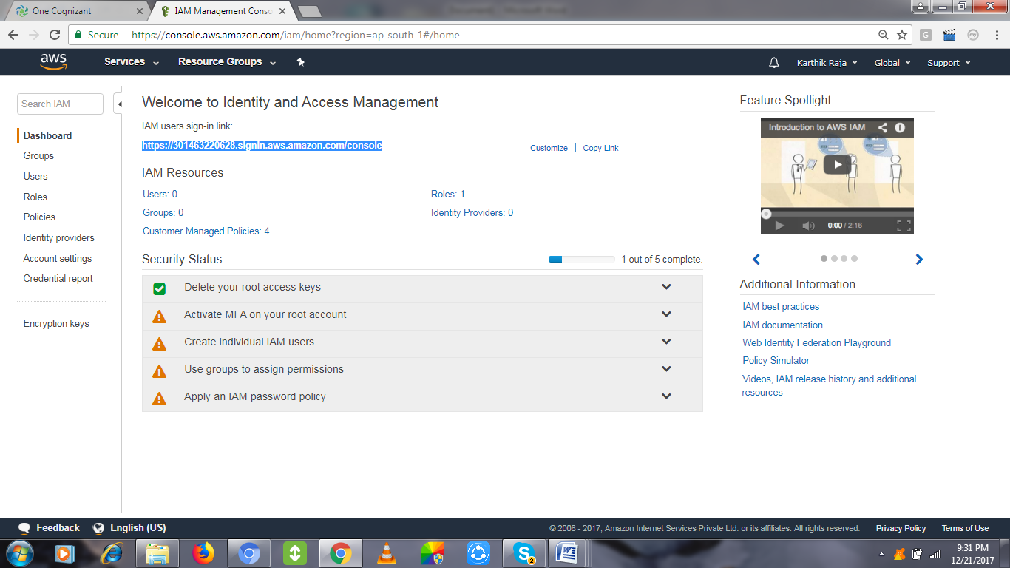
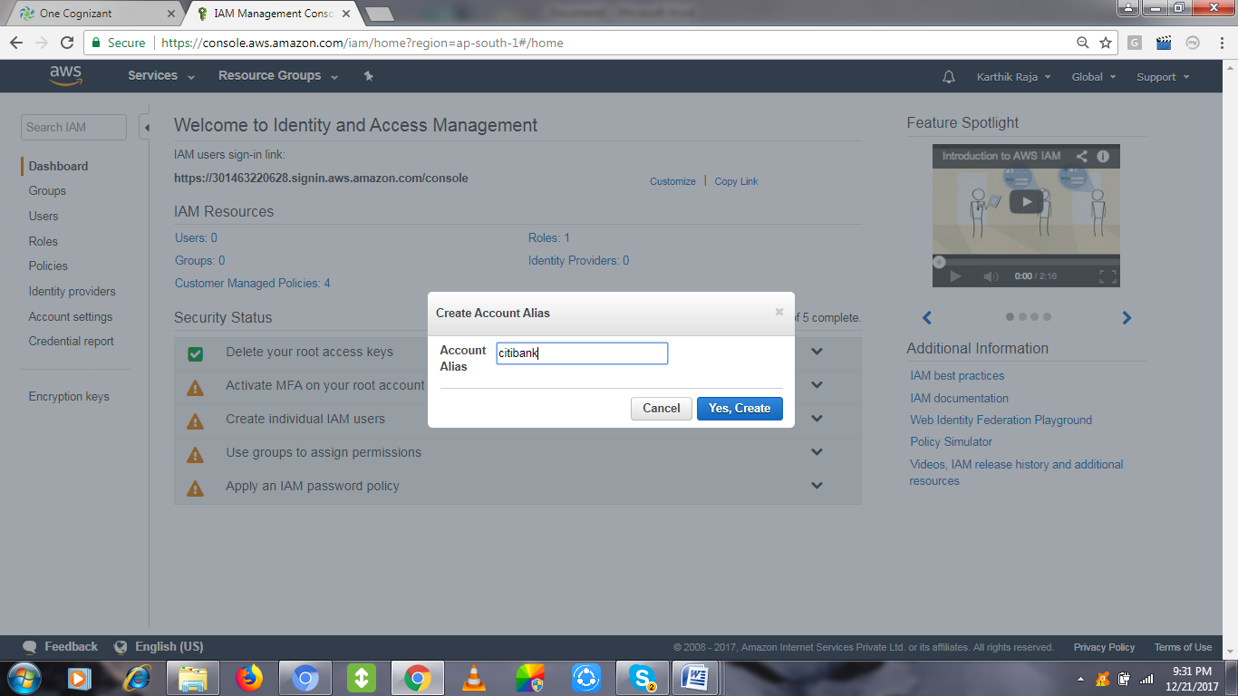
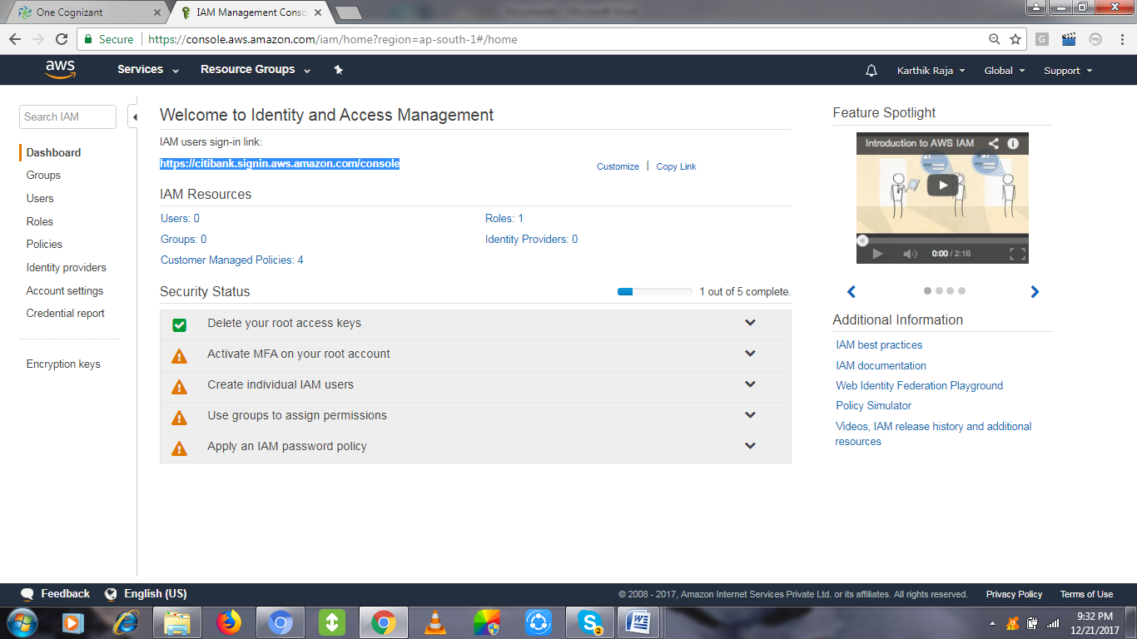

Activity 2:
Group Creation: Click Create New Group
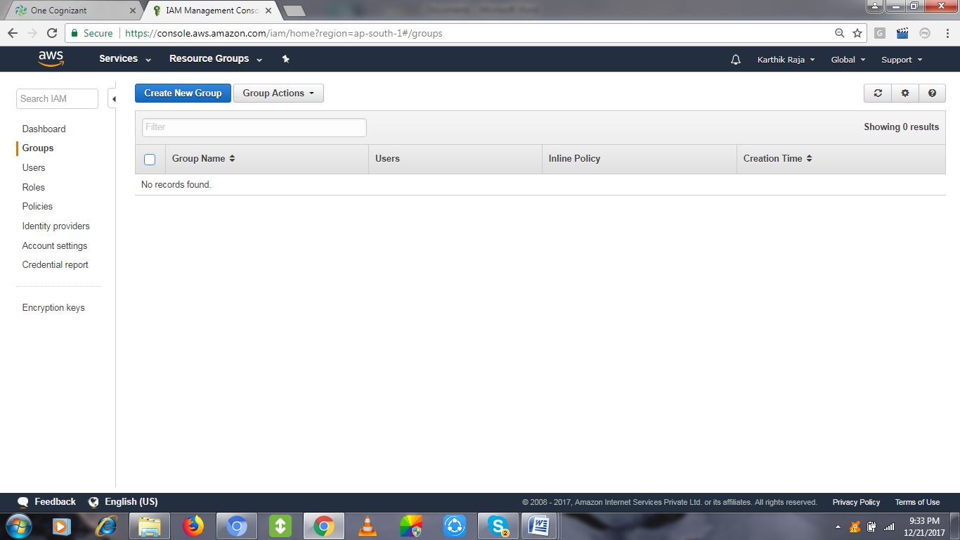
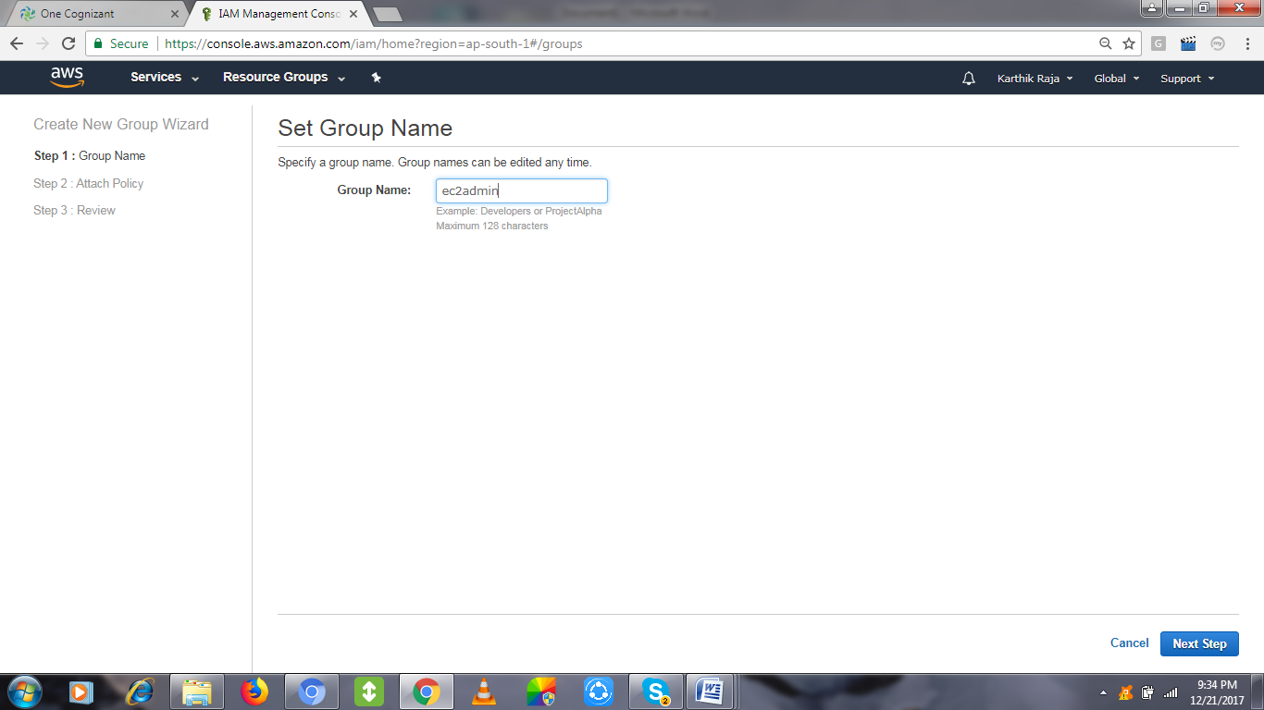
Choose the policy related to the group by using the search tab, like ec2/s3/ any services,
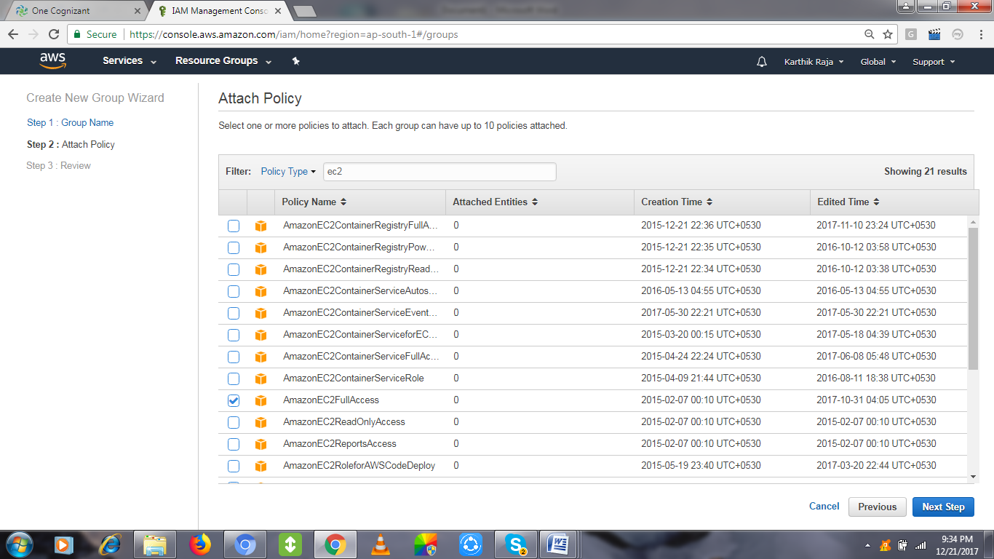
Review the policy & Create Group.
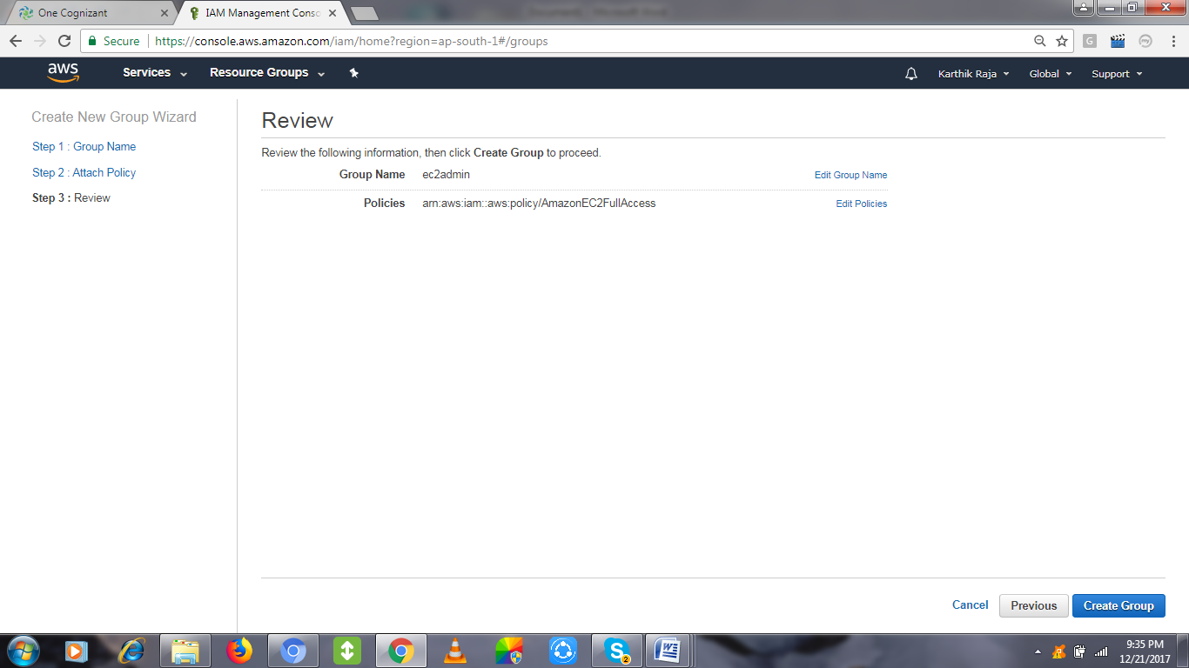

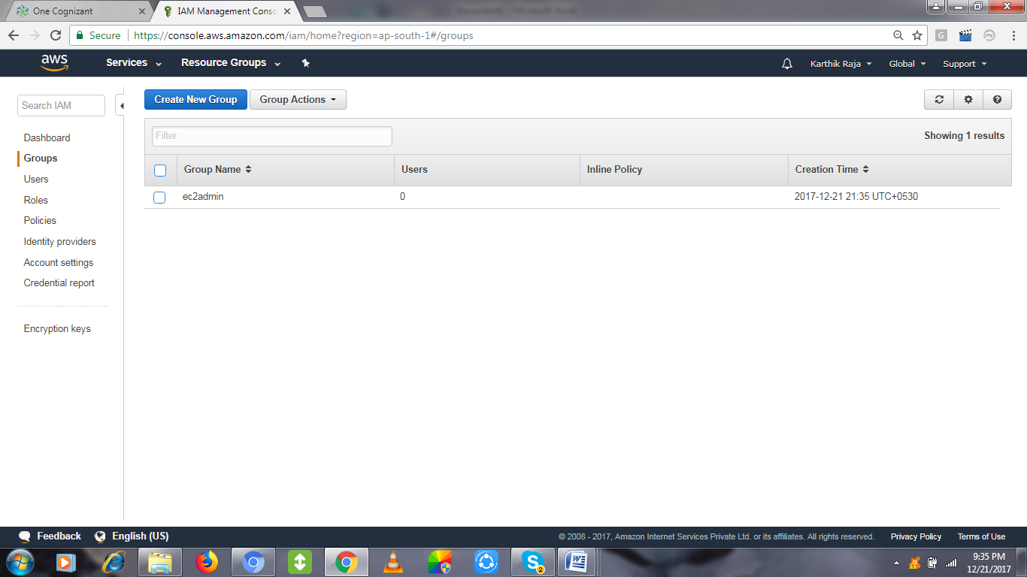

Activity 3:
User Creation by clicking ADD USER.
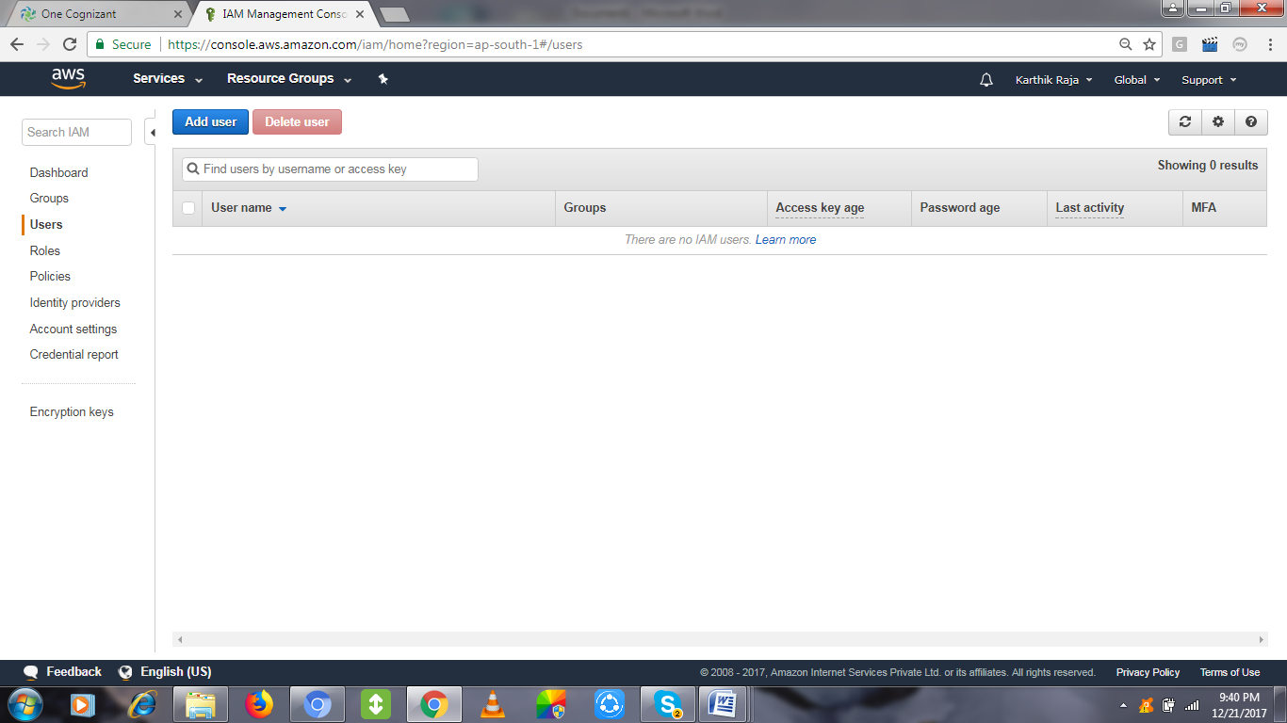

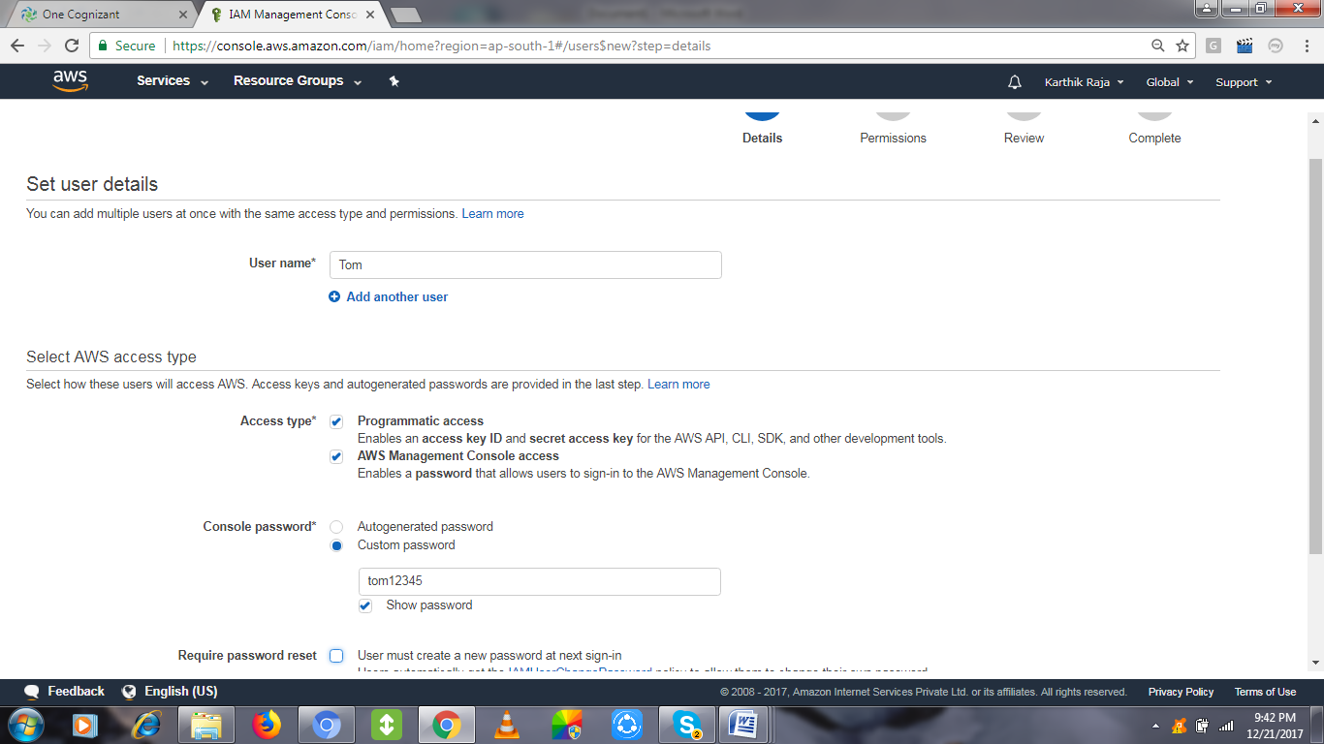

Add the user the existing group o create a group and add.
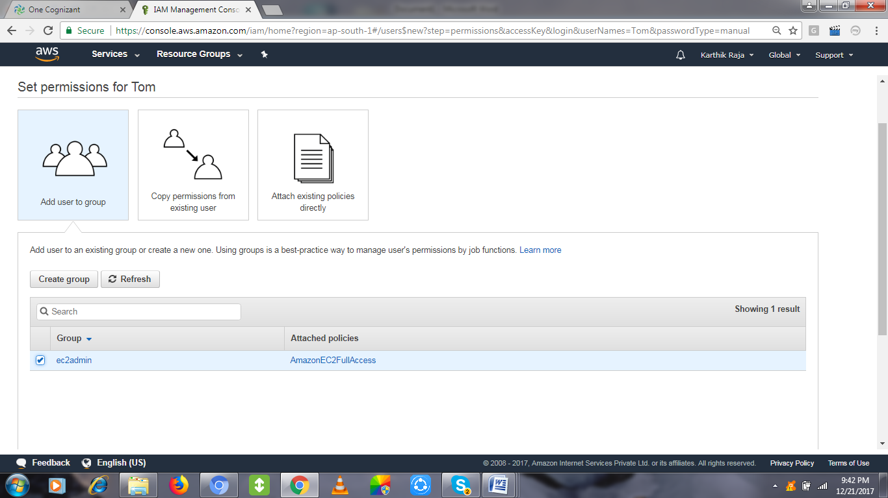
Review and create user finally.
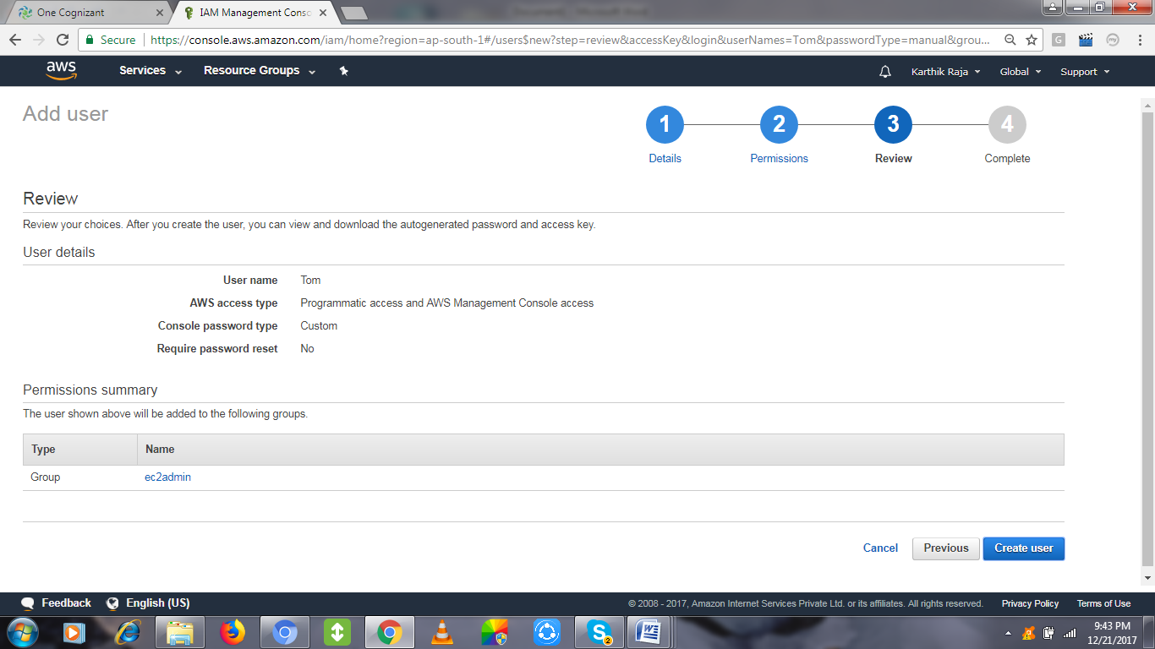

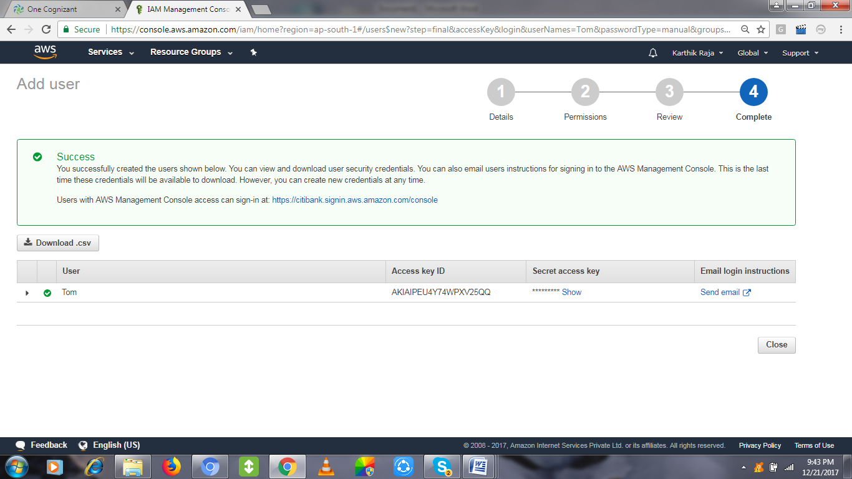
Collect the Access Key ID & Secret access key and keep it safe for rest of the activities.
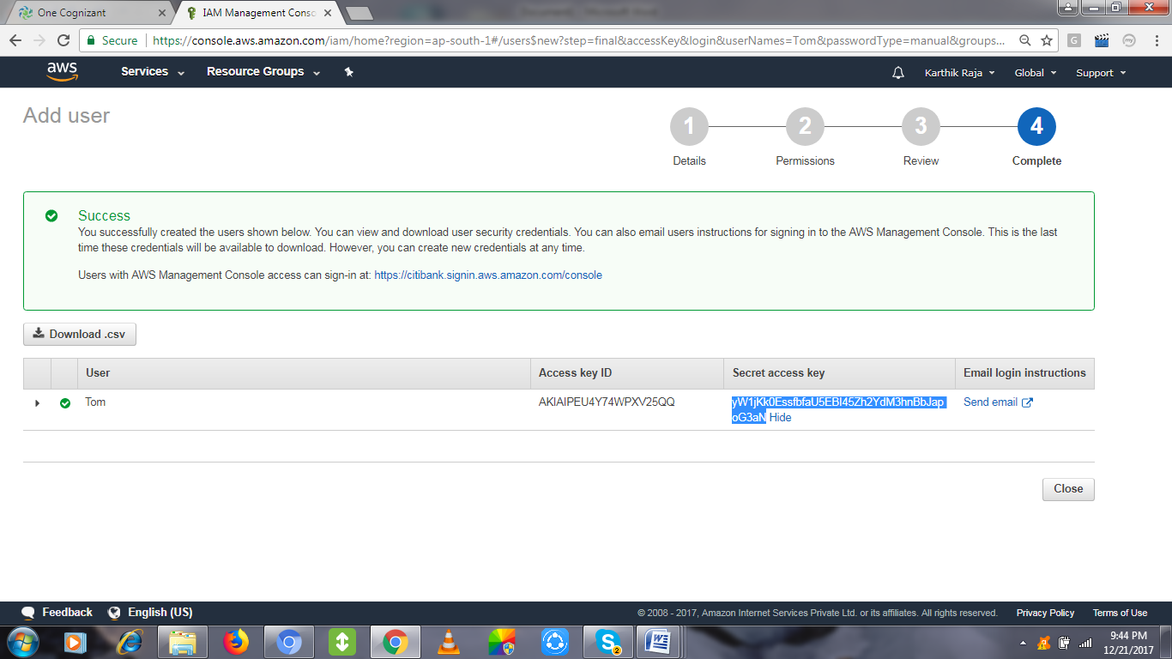

Activity 4:
Policies are already available set of permission, that to be attached for group/user.
We can create a own Policy too, Click Create Policy
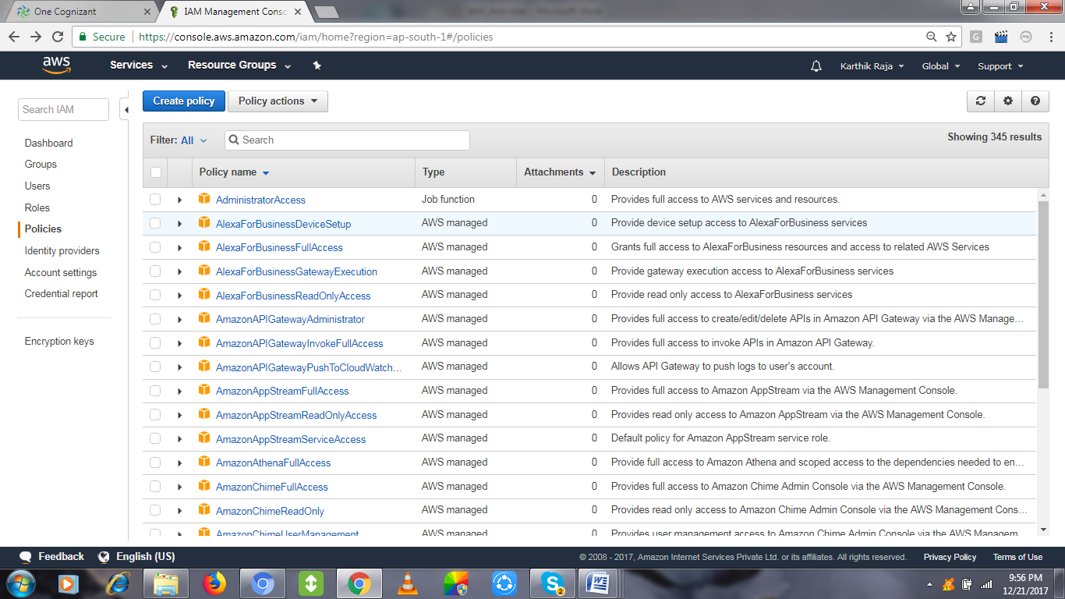
Search the service and pick a portion of access that needs to be provided as permission.
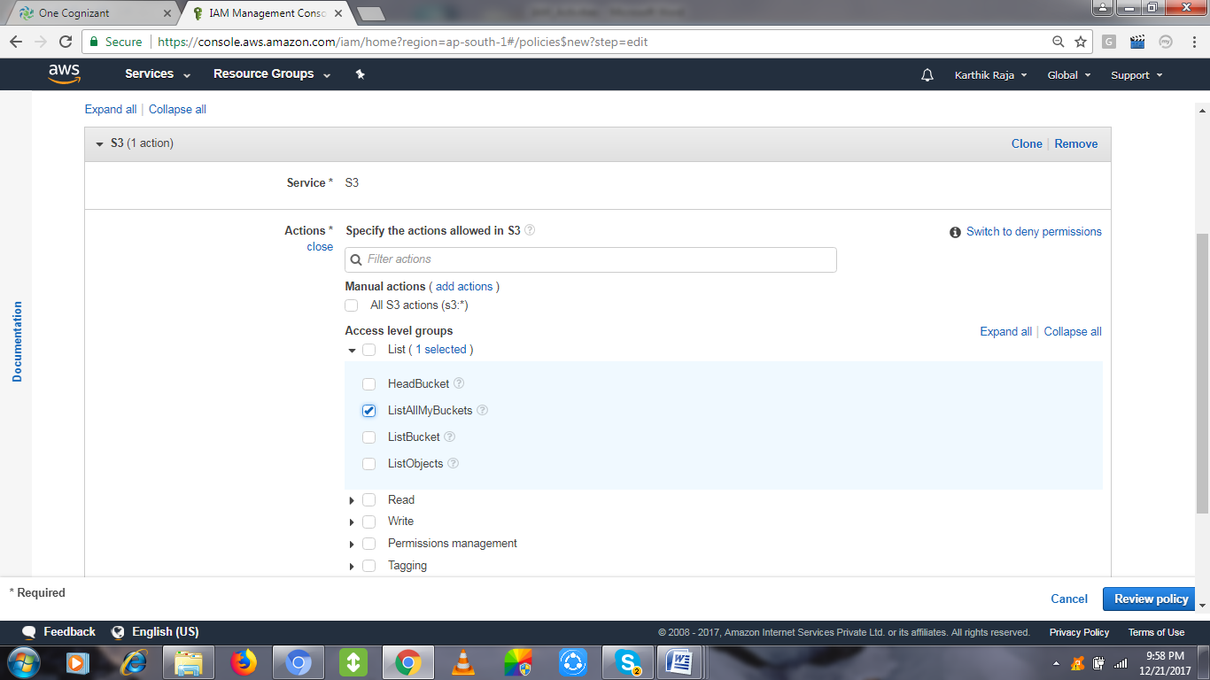
Name the policy, review and create it.
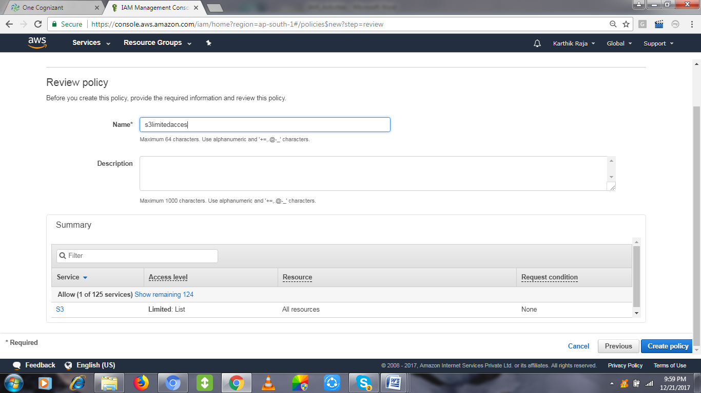
You can check under Customer managed section for the created policy,
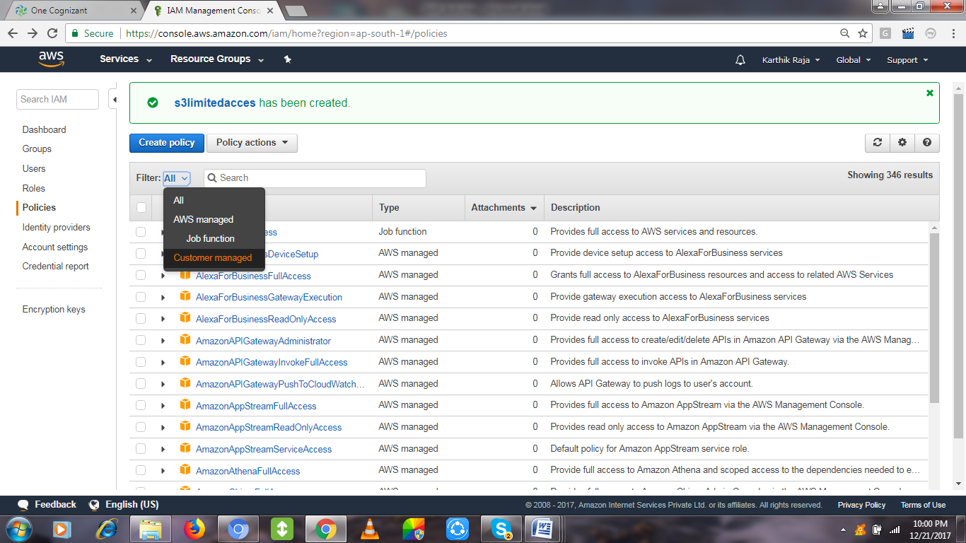
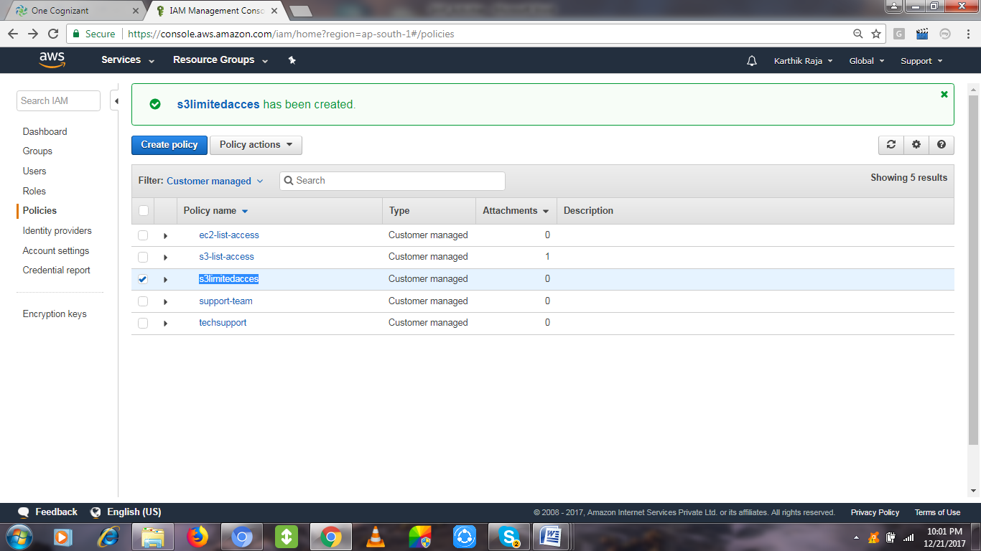

Activity 5:
Role creation by clicking Create Role
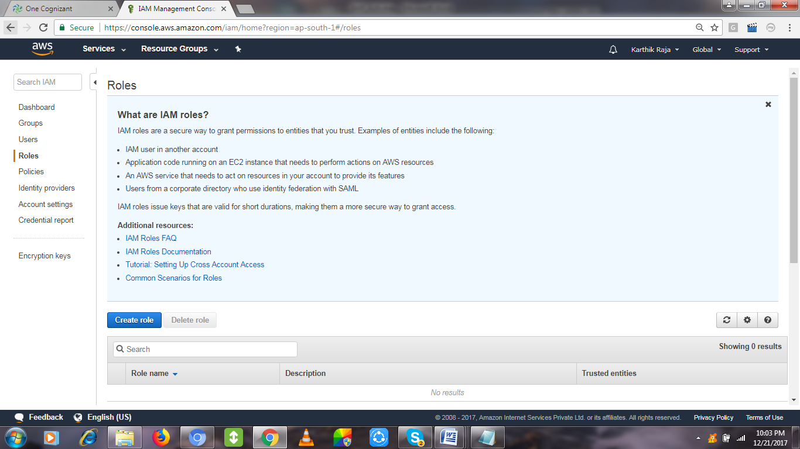

Choose any AWS Resource for allocating Role level mapping for it, Choosing S3
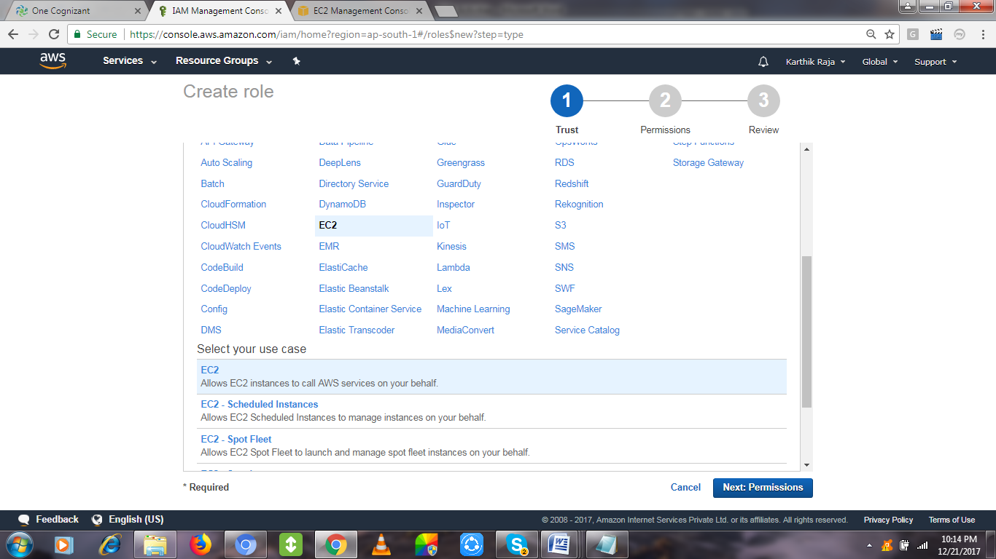
Choosing the customer managed policy, which we created in the earlier activity,
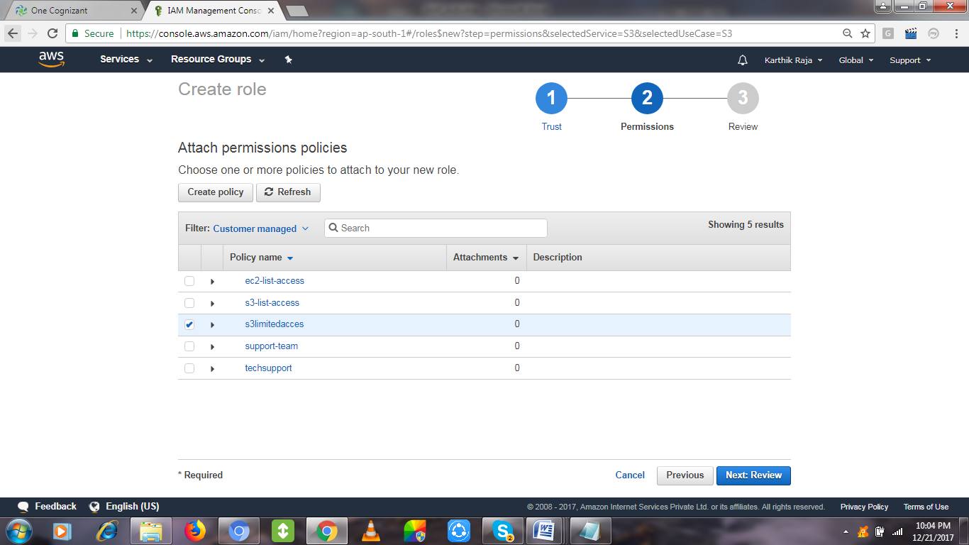

Review and create it with a name for reference to choose this IAM ROLE.
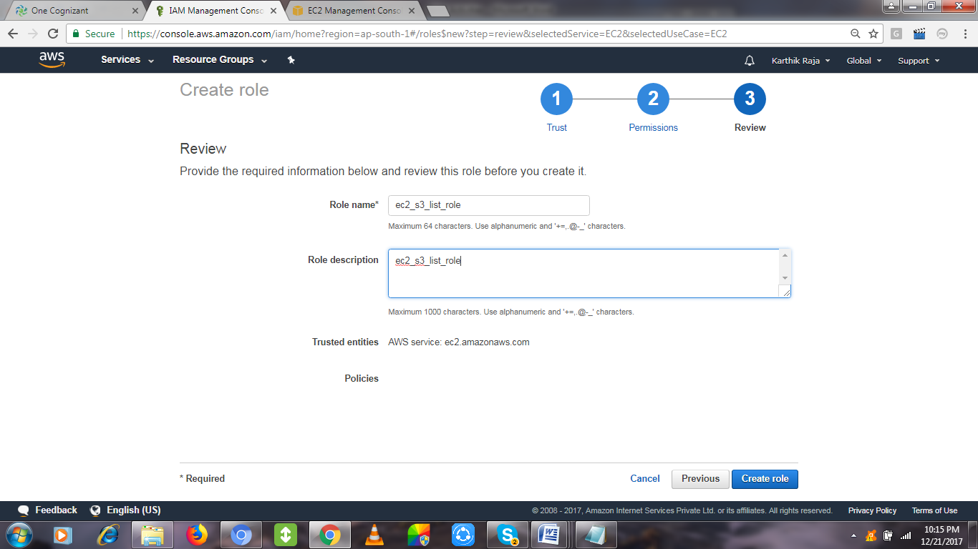

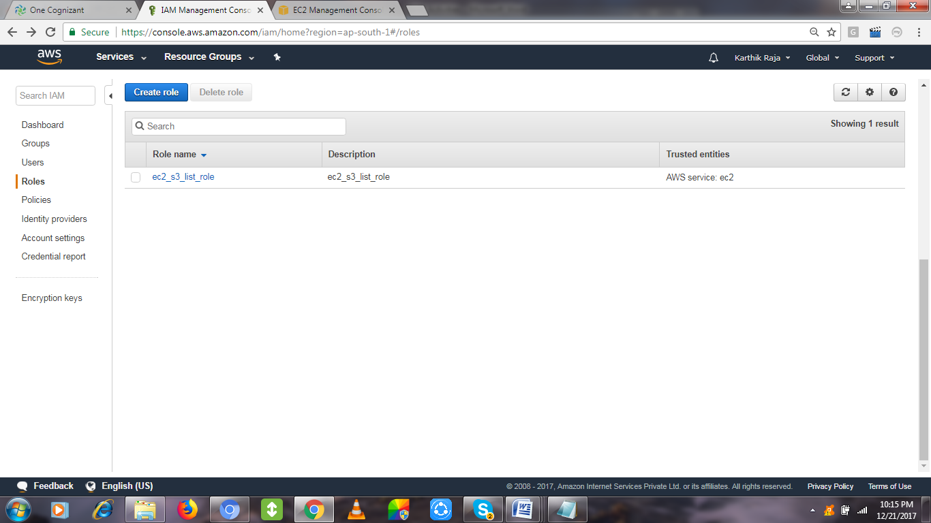

IAM Role Test scenario:
Create an EC2 with IAM Role attached to it, so that after login in into the EC2 server it will not expect
- “aws configuration” to list the S3 listing activity [for which the role has been created].
- Also No access/secret key is required for setting the configuration.
Mapping the created the Role for the Creating EC2:
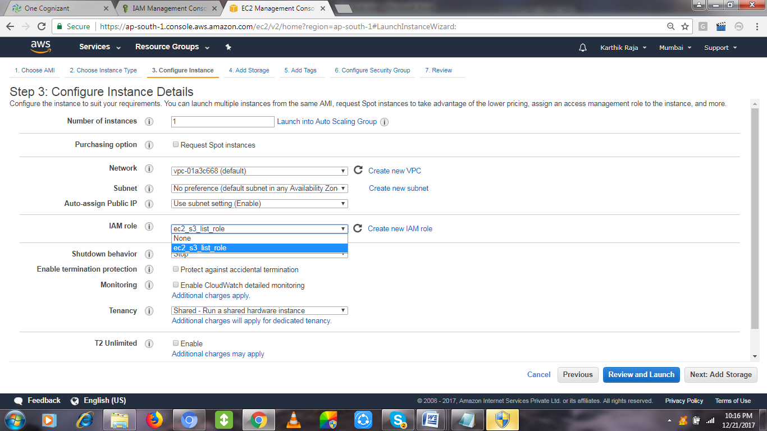
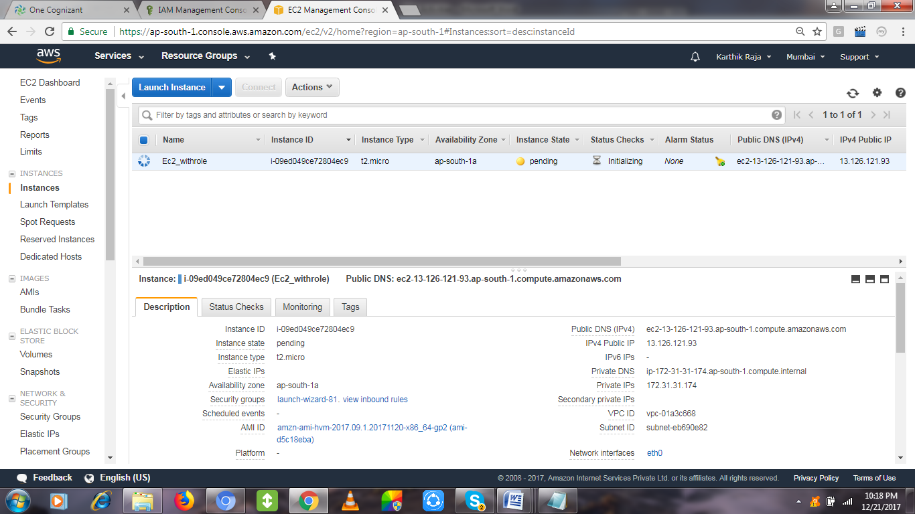

Once login into the EC2 and check with the S3 Bucket Listing command – aws s3 ls
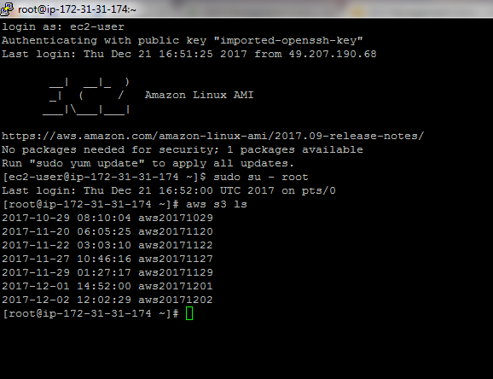
Compare the same by creating an EC2 without attaching the role, you can see the difference.
It will ask Access/Secret Key, etc,.


