Hello World Flutter App Lab
Brief Description
I used the Flutter SDK installed at /Users/parasgandhi/Project/temp/flutter to create a new Flutter project named hello_world_flutter_app. After the project was generated, I updated lib/main.dart to replace the default counter template with a simple Material app that displays a centered Hello World message under a Flutter Lab app bar.
I verified the project by running flutter analyze, flutter test, and flutter build web. The app was then opened from a local build in the browser and screenshots were captured to show the tested output. The current machine does not have an Android SDK installed, and full Xcode is not selected, so Android or iOS simulator execution is blocked until one of those simulator environments is configured.
Screenshots
Chrome test target
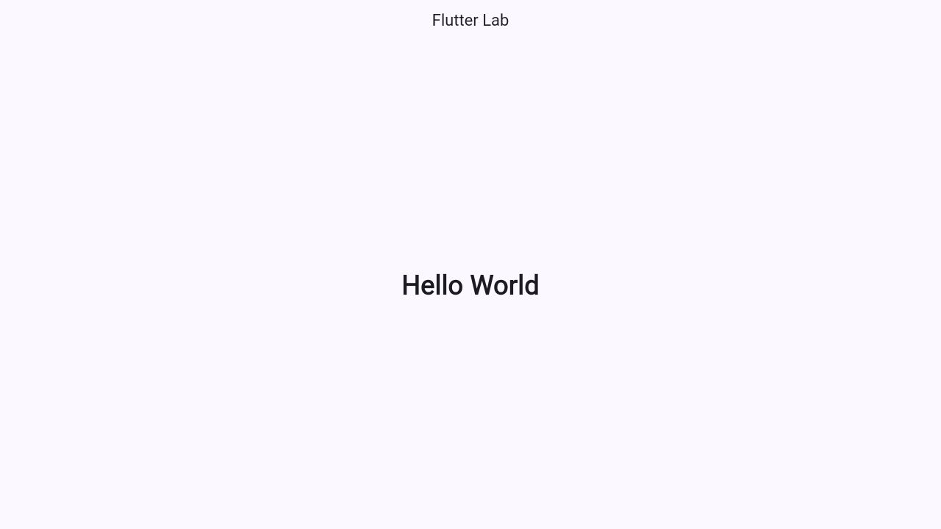
Mobile-sized browser viewport
