Mobile App Lab: UI Design in Flutter
Study Buddy Flutter App
GitHub Repository
Project link: https://github.com/gandhiparas90/m-app
Brief Explanation
My Flutter app is called Study Buddy. It uses both StatelessWidget and StatefulWidget to meet the lab requirements. StudyBuddyApp and HomeScreen are stateless widgets because they display fixed interface elements such as the title, icon, short description, and navigation button. These widgets do not manage changing data internally. The home screen uses Navigator.push to move to the second screen.
The NotesScreen is a StatefulWidget because it manages dynamic content. It includes a TextField controlled by a TextEditingController, a Save Note button, and a Clear Note button. When the user saves or clears a note, setState() updates the _noteText value and rebuilds the screen so the displayed note changes immediately. This demonstrates how stateful widgets handle user interaction and changing UI data.

Screenshots
The screenshots below show the home screen, the empty notes screen, a saved study note, and the cleared note state.
Home screen with the Study Buddy title and navigation button
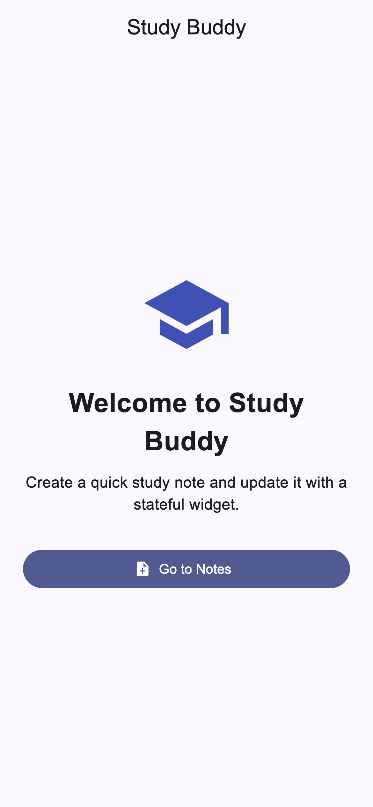

Notes screen before entering text
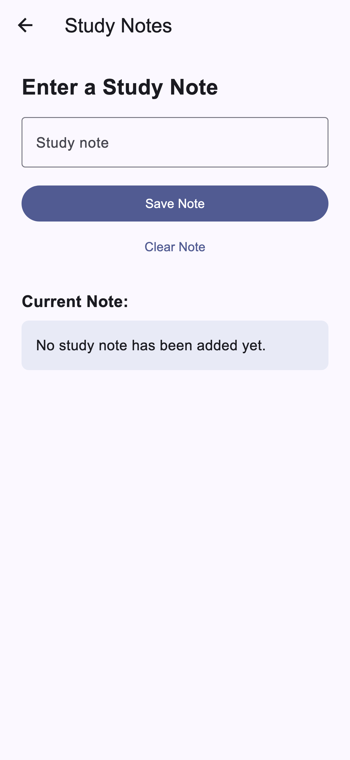

Notes screen after saving a study note
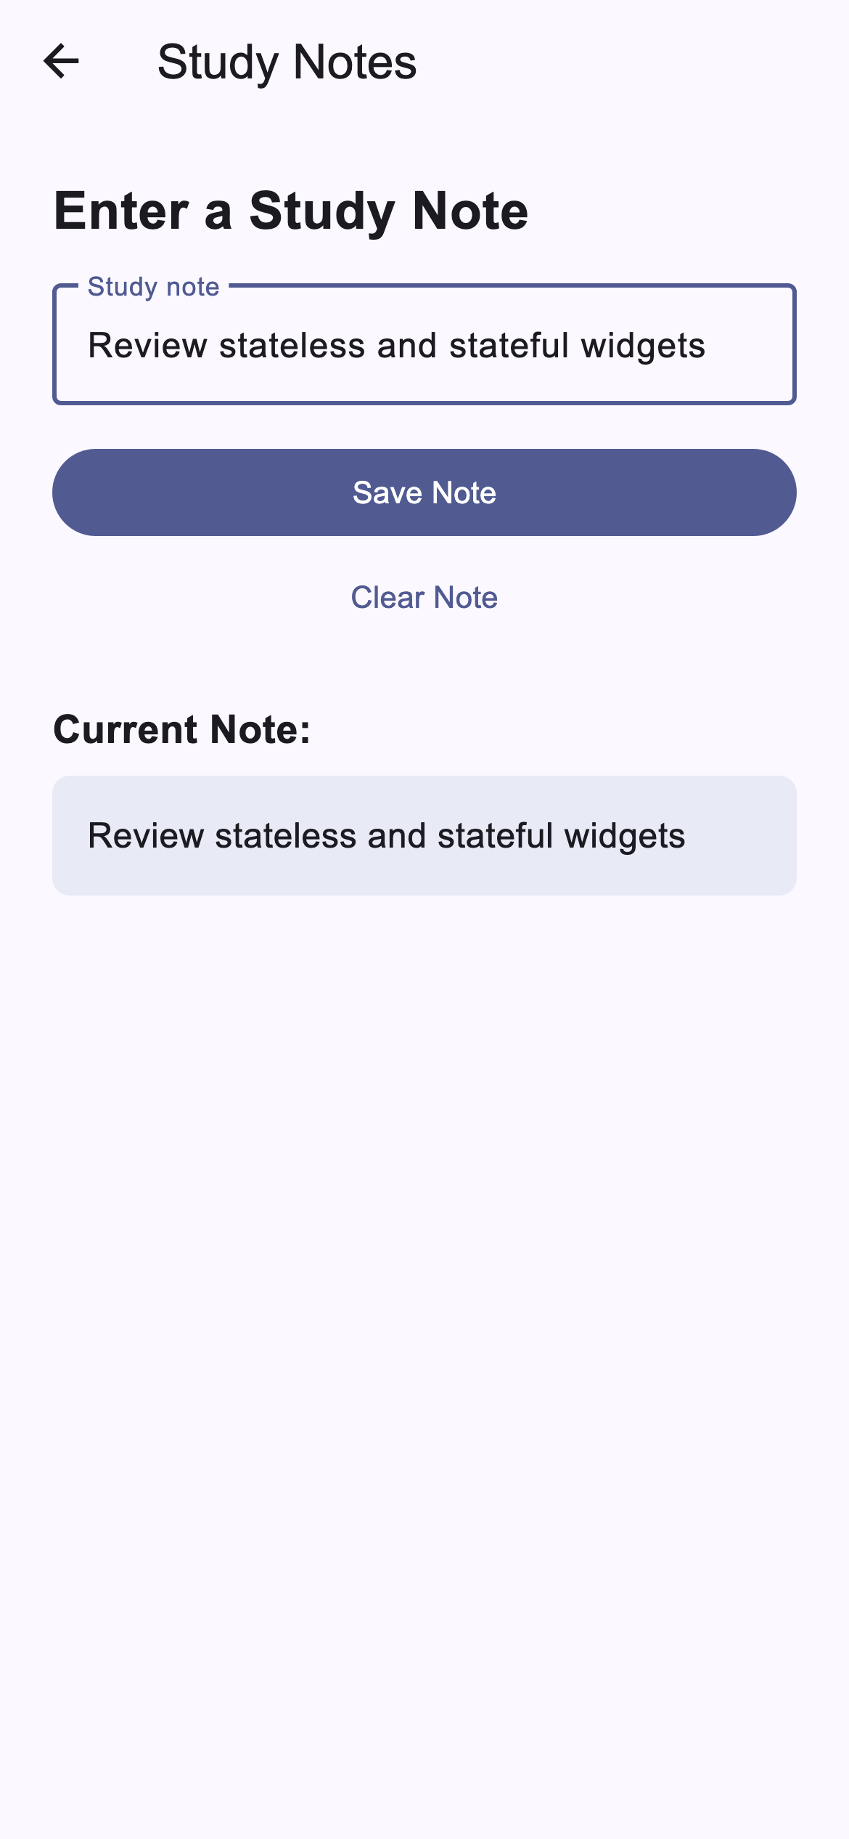

Notes screen after clearing the note
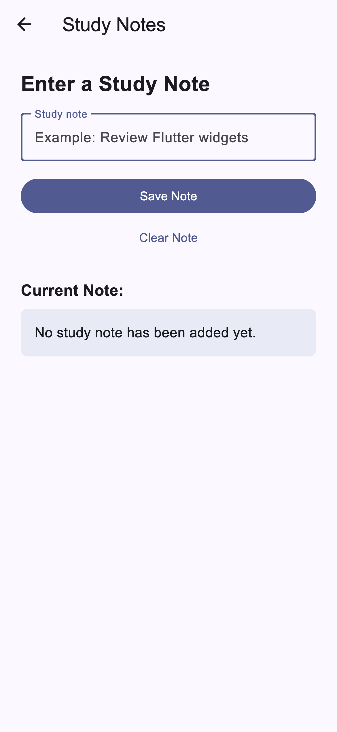
Screenshot Files
These image files are also available in the repository under the screenshots folder.

