Gesture-Controlled Interface
Gesture Studio Flutter App
GitHub Repository
Project link: https://github.com/gandhiparas90/m-app
Reflection
For my gesture-controlled interface lab, I updated my Flutter app into a Gesture Studio experience. I implemented three gestures: tap, long press, and horizontal swipe. The tap gesture changes the main card color and updates the status message. This improves user experience because tapping is one of the most familiar mobile gestures and gives users a direct way to trigger immediate feedback. The long press gesture toggles a focus mode and displays a short SnackBar message. This gives the app a secondary interaction that does not require another permanent button on the screen. The horizontal swipe gesture moves between gesture cards, allowing the user to browse interaction examples in a way that feels natural on a touchscreen.

These gestures support the Chapter 5 idea that mobile interfaces should connect touch input to clear, observable responses. Tap is highly discoverable, while long press and swipe can improve efficiency when they are supported with visible feedback. To make the gestures easier to use, I included a status panel that explains the result of each action. I also kept a reset button visible so users can return to the starting state if they want to try the gestures again.

One challenge I encountered was that the swipe gesture could be triggered too easily during testing. That created a usability concern because users might accidentally move to another card when they only meant to touch the screen. I resolved this by adding a small velocity threshold. If the swipe is too light, the app does not change cards and instead displays a message asking the user to try a stronger swipe. I also refined the layout after testing because the gesture card could overflow on smaller screens. I fixed that by reducing the card height and making the page scrollable.
Reference
Payne, R. (2019). Chapter 5: Mobile user experience and gestures. Course materials.

Screenshots
The screenshots below show the home screen, the initial gesture screen, and the observable results of tap, long press, and swipe interactions.
Home screen
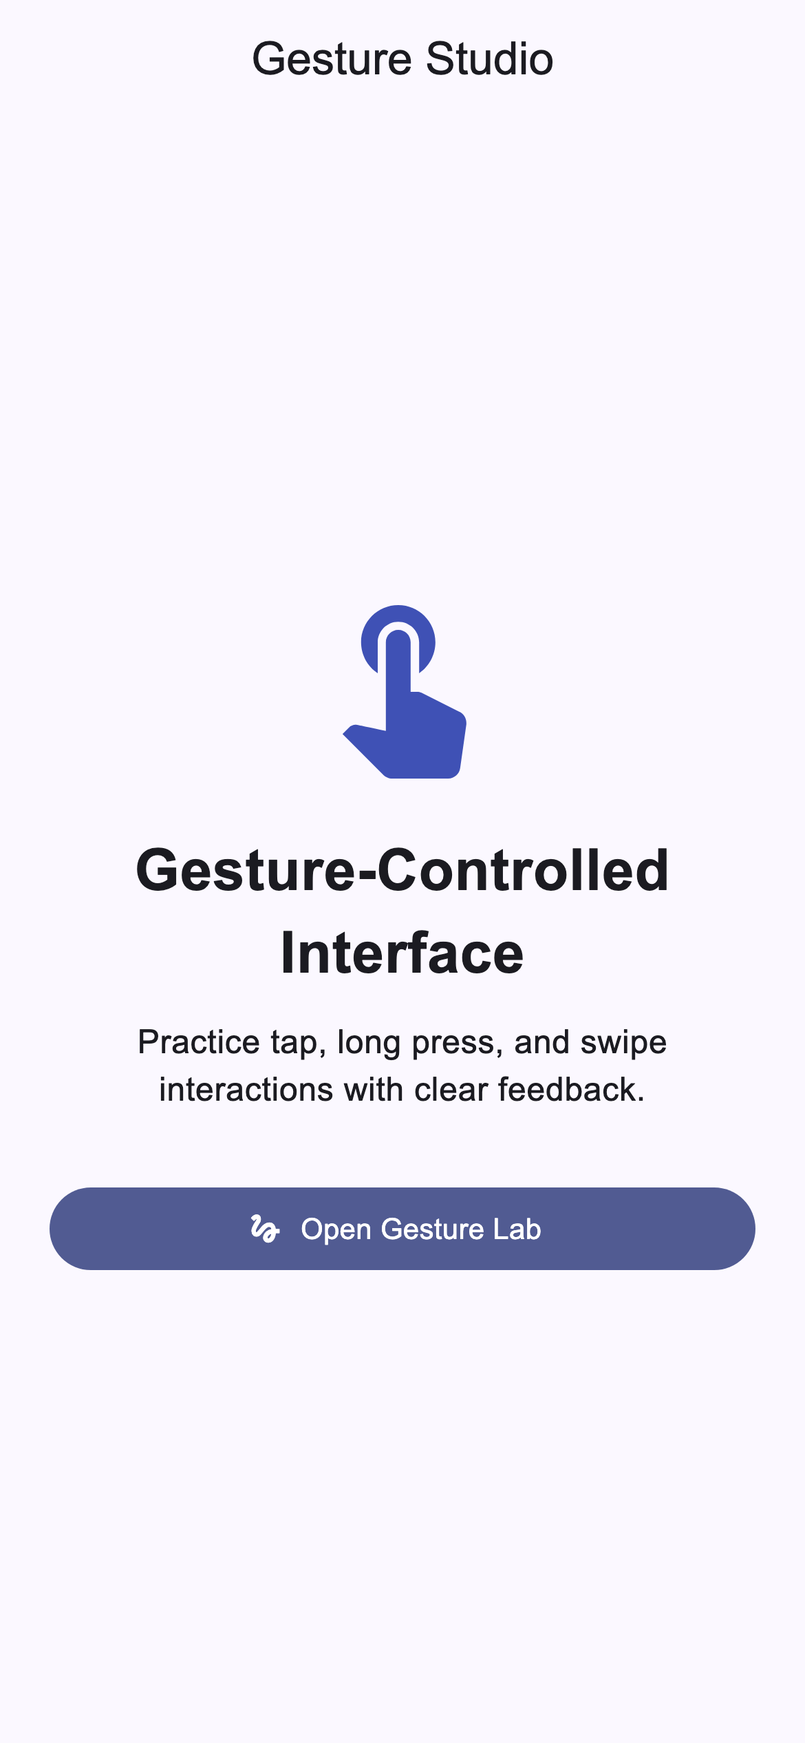

Initial gesture screen
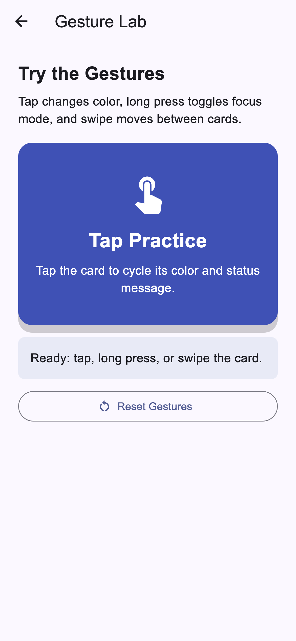

Tap gesture changes the card color and status message
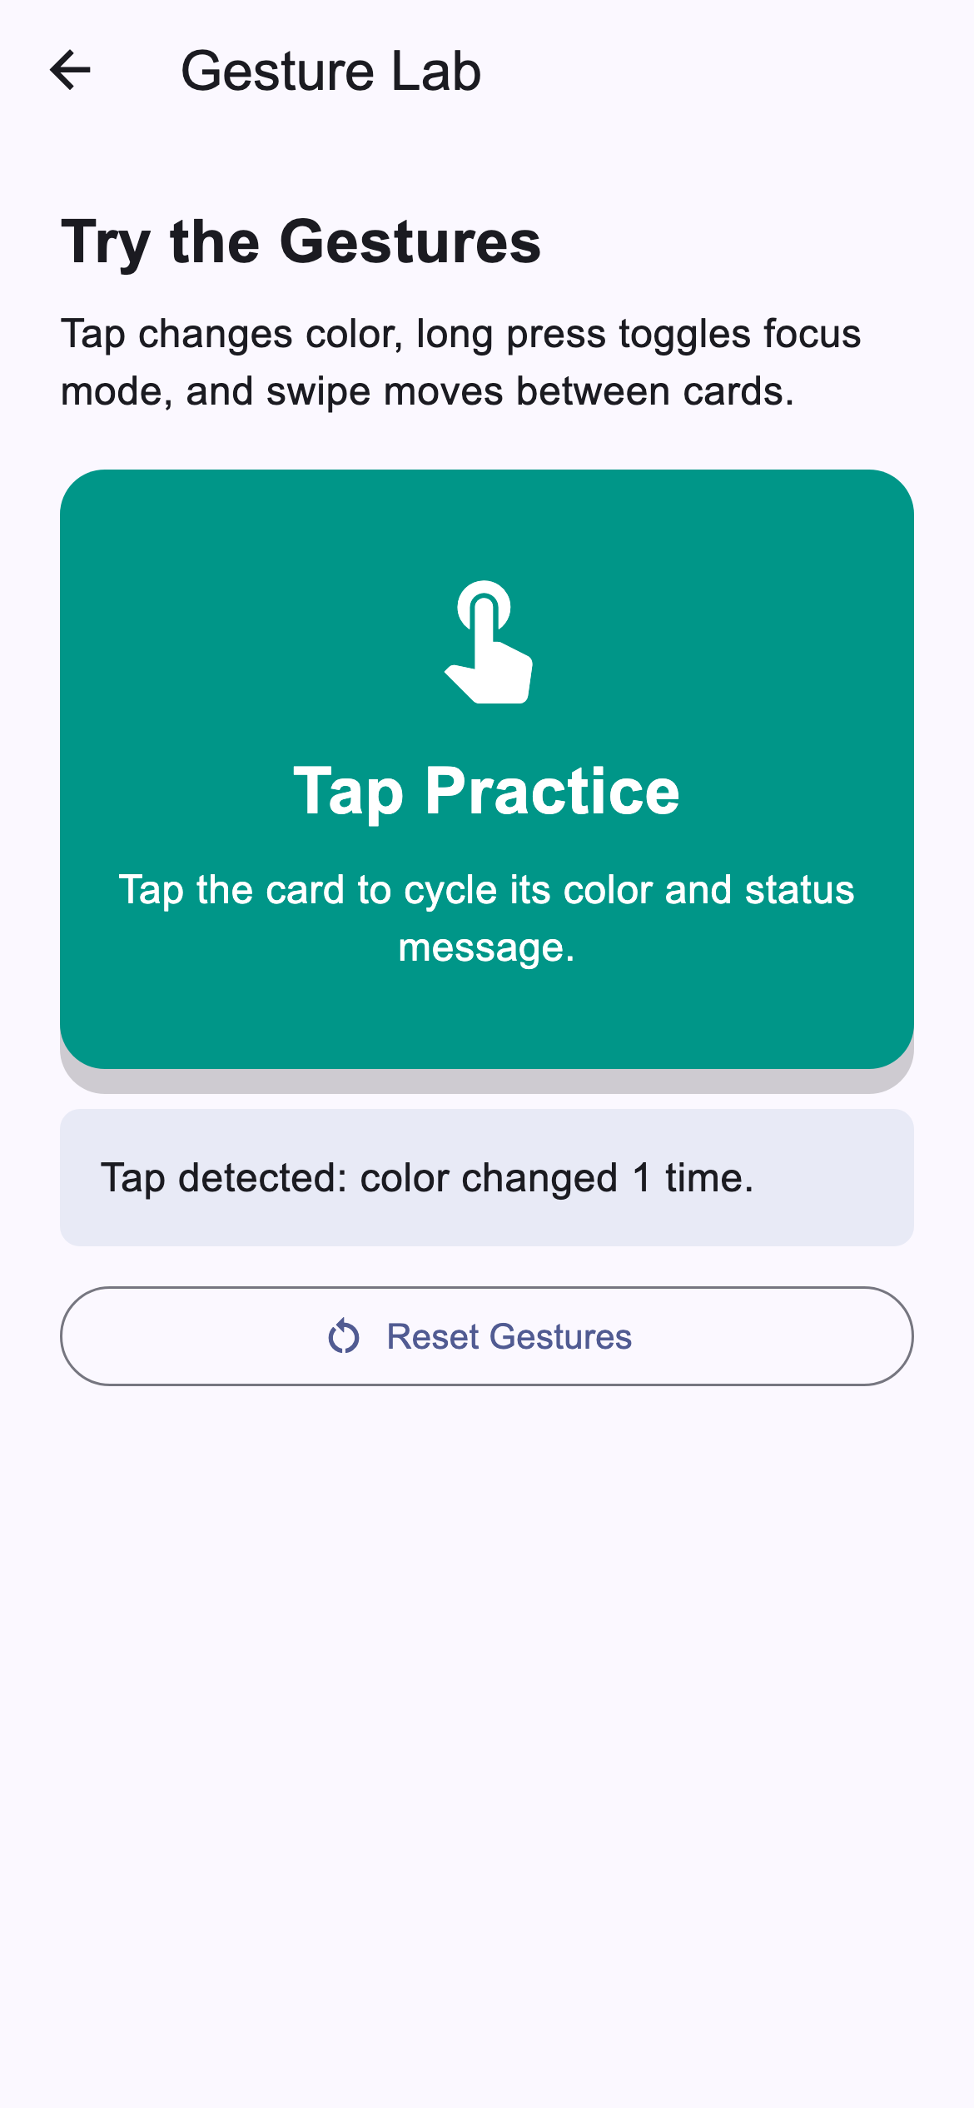

Long press toggles focus mode and displays feedback
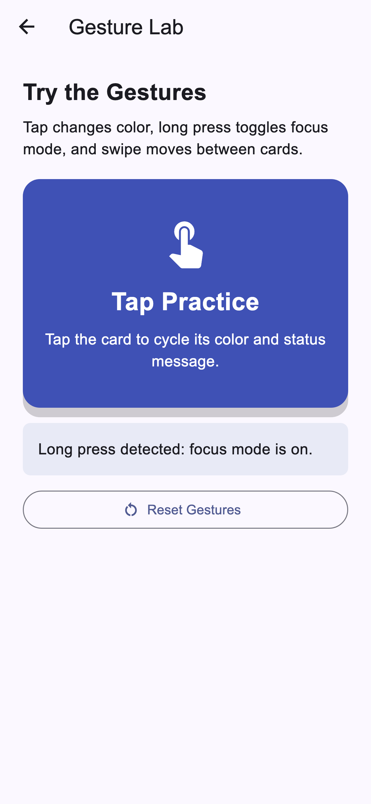

Swipe moves to the next gesture card
