Find my meeting room browser extension is used to quickly identify the meeting room in 4th floor of PIC Prana building.

**Steps to install the extension:**

**Chrome:**

1. Click on the “Settings” option in chrome

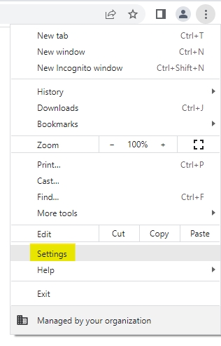

1. Select the “Extension” option from side panel.

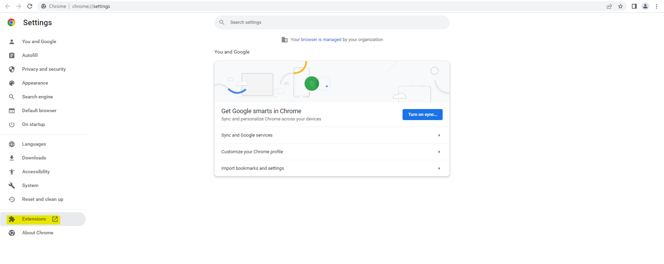

1. Toggle on the “Developer mode” and click on the “Load unpacked” button.

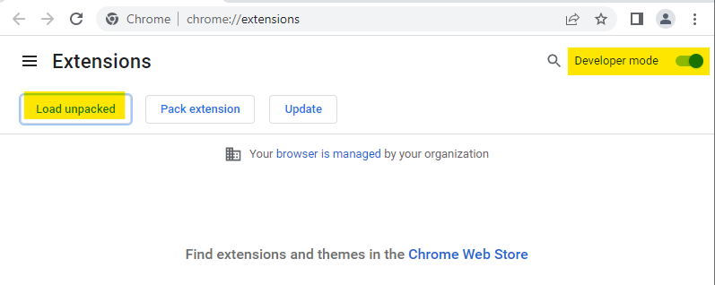

1. Navigate to the folder “find-my-meeting-room” and select it.

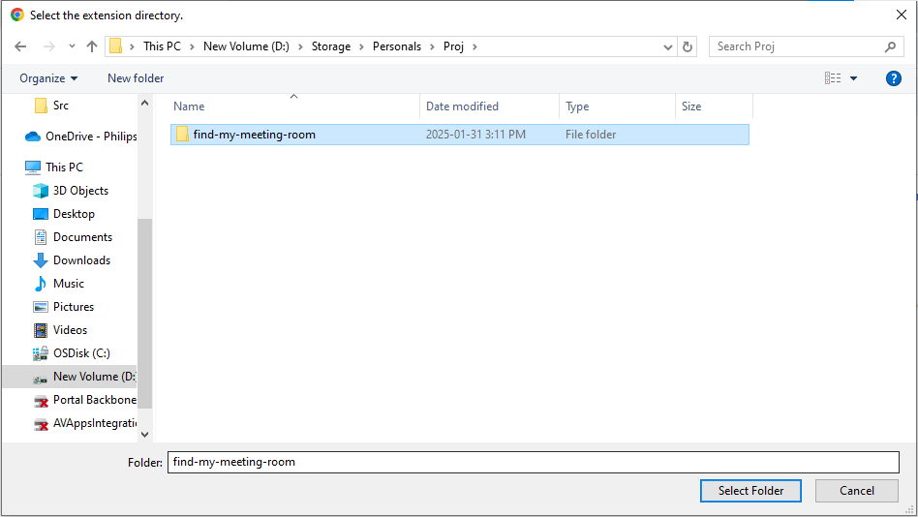

1. Now we should be able to see the extension in the list

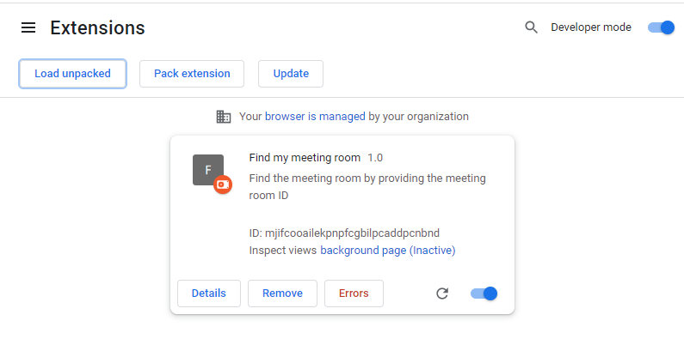

1. On top right corner we can see the extension icon, on click on that we will be able to see the newly imported “Find my meeting room” extension, one can pin it.

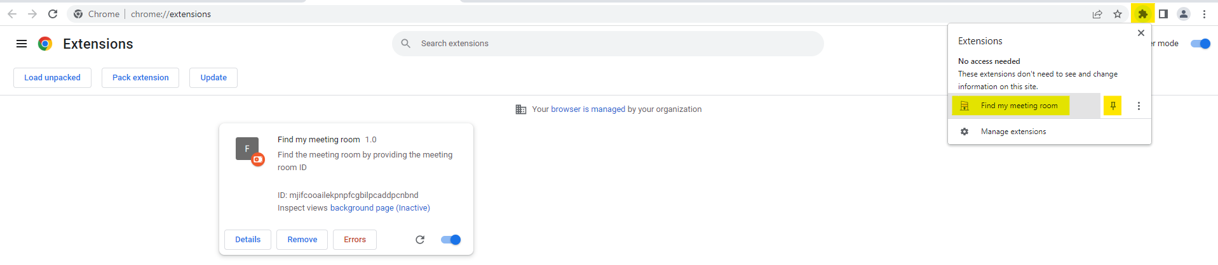

1. A new icon is pinned to the bar and on click on that a new browser window open up.

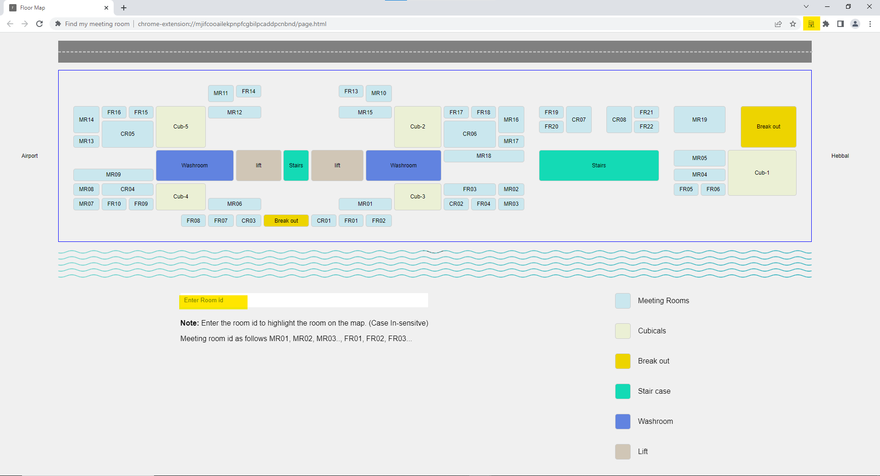

1. Now we can start searching for the room.

Text box will be turned green if the room exists else red color and the respective room is highlighted on map.

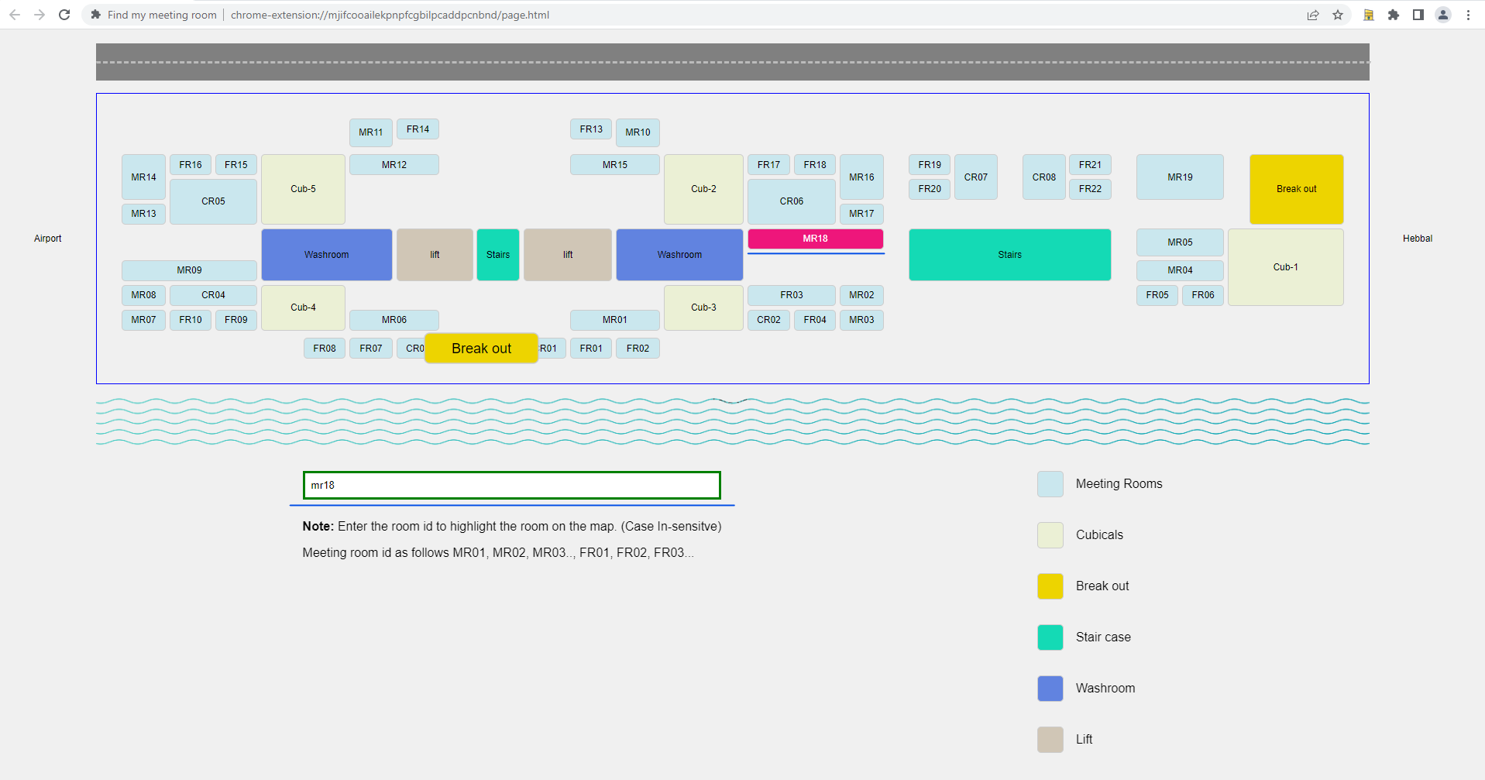

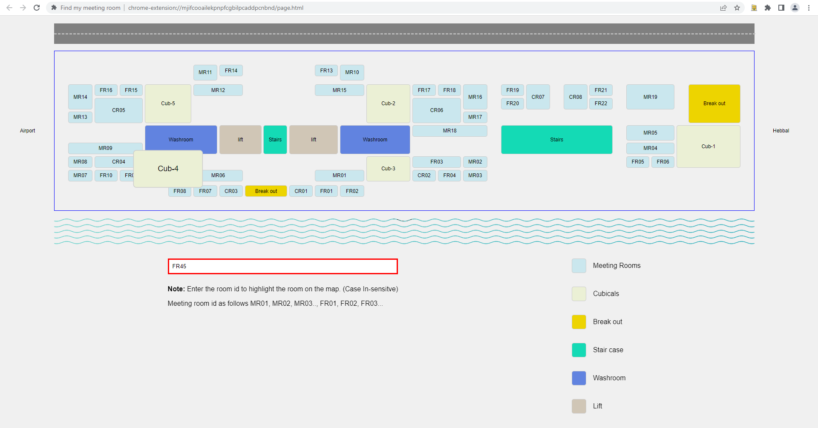

**Microsoft Edge:**

1. Navigate to the URL: “edge://extensions/” , Toggle on the “Developer mode” and click on the “Load unpacked” button.

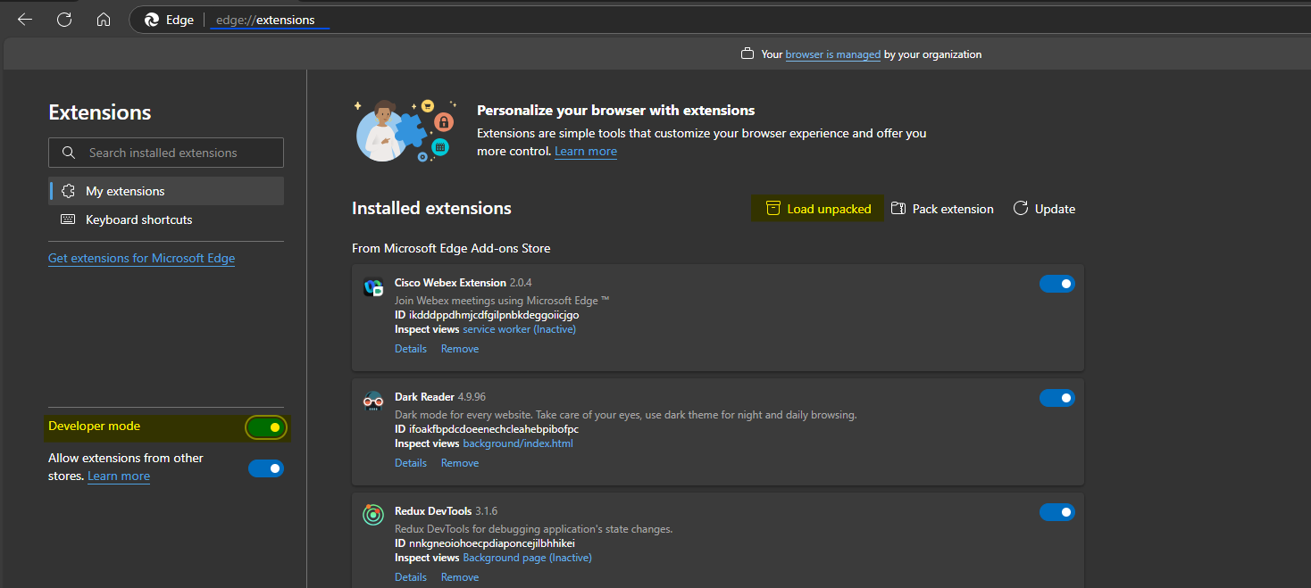

1. Navigate to the folder “find-my-meeting-room” and select it.



1. Now we should be able to see the extension in the list

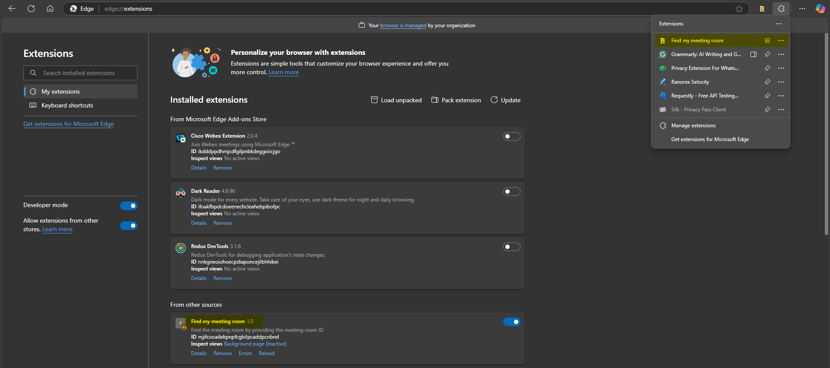

1. A new icon is pinned to the bar and on click on that a new browser window open up.

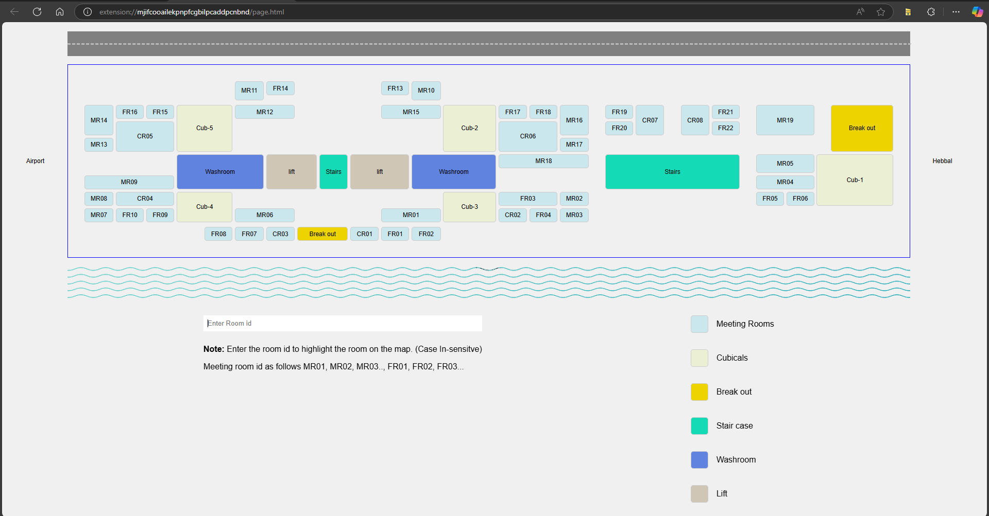

1. Now we can start searching for the room.

Text box will be turned green if the room exists else red color and the respective room is highlighted on map.

