**Capstone Project**

**Instructor: Tayo Ajayi**

**Group-3**

**StorME- Enterprise File Management Solution**

**StorME:**

**System 1: Dell Kernel**

**Issue: Network adapter issue during XenServer installation.**

**Observations:**

* The network adapter is not being detected or functioning correctly in XenServer.
* Possible driver incompatibility with XenServer’s built-in kernel modules.
* Secure Boot was turned off, which might have influenced hardware detection behavior.
* XenServer installation proceeds but lacks network connectivity, which is critical for management and VM provisioning.

**Possible Causes:**

* **Driver Support Issue:** XenServer might not have the necessary drivers for the Dell network adapter.
* **Secure Boot Dependency:** Turning off Secure Boot might have disabled certain drivers embedded in firmware or OS-level protection, leading to network stack issues.
* **BIOS/UEFI Settings Conflict:** Network stack settings might need additional configuration in the UEFI firmware.

These are appropriate screenshots that support my observations.

**\**

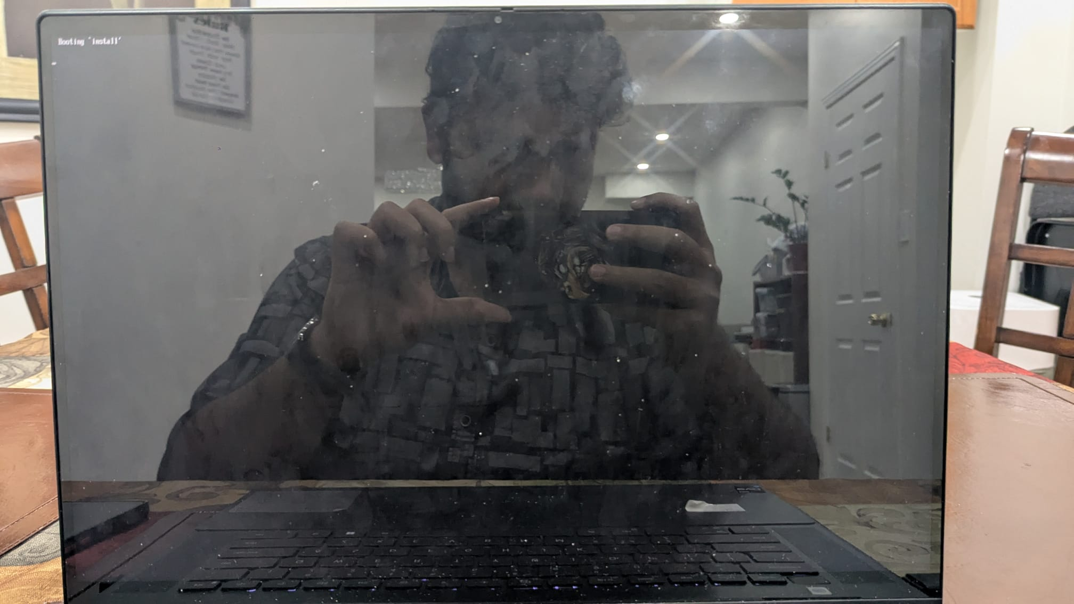

**System 2: Acer Kernel**

**Issue: Shrunk 100GB volume is not detected during XenServer installation.**

**Observations:**

* A 100GB volume was manually shrunk to create space for XenServer.
* During installation, the XenServer setup does not list the intended disk space.\
* BIOS and disk configurations might not align with XenServer's disk requirements.
* Secure Boot was turned off during the installation attempt.

**Possible Causes:**

* **Partition Type Conflict:** The 100GB volume might still be recognized as a formatted partition rather than unallocated space, preventing XenServer from recognizing it.
* **BIOS/UEFI Compatibility Issue:** XenServer may require a different disk format (MBR vs. GPT) based on boot mode (Legacy vs. UEFI).
* **Storage Controller Issue:** Acer Aspire 5 might be using a storage controller that XenServer lacks drivers for.
* **Secure Boot Dependency:** Disabling Secure Boot may have altered disk encryption or recognition settings, affecting the system's ability to detect available partitions.

These are the appropriate screenshots that support my observations.

**System 3: HP kernel**

**Issue: The hard drive is not visible in the boot menu after shrinking a 100GB volume for XenServer.**

**Observations:**

* 100GB volume was created by shrinking an existing partition.
* In the boot menu, the attached hard drive is not listed, making installation impossible.
* Secure Boot was turned off before attempting the installation.
* After Secure Boot was disabled, attempting to switch back to Windows triggered a BitLocker Recovery prompt.

**Possible Causes:**

* **Disk Recognition Issue:** The BIOS/UEFI might not be correctly detecting the XenServer installation media or target drive.
* **Storage Configuration Conflict:** The hard drive might be in RAID or Intel Optane mode, which XenServer does not support natively.
* **BitLocker Encryption Issue:** Disabling Secure Boot likely triggered a security response from BitLocker, preventing normal access to Windows partitions.
* **Boot Order Configuration:** The bootloader might not be properly set to detect the existing drive or XenServer installation.

These are the appropriate screenshots that support my observations.

In conclusion, the installation of XenServer faced recurring issues across multiple systems, including a Dell Inspiron, Acer Aspire 5, HP Pavilion, and two additional systems. The main challenges included network adapter malfunctions (Dell Inspiron), undetected disk partitions (Acer Aspire 5), and missing hard drives in the boot menu (HP Pavilion). Additionally, Secure Boot had to be disabled for installation, which triggered BitLocker recovery when switching back to Windows, causing further complications. The repeated occurrence of these issues across different hardware suggests compatibility problems with XenServer's drivers for network and storage controllers, as well as conflicts with modern UEFI security mechanisms. These challenges highlight the difficulty of deploying XenServer on consumer-grade hardware without additional configurations.