***Abstract -* Presented is a robust and capable set of MEMS temperature sensors with a high dynamic range. One sensor is capable of operating at ranges from -100℃ to 100℃ while the other is from -200℃ to 200℃. The sensor is created using several bimorph beams placed together to form a MEMS comb capacitor. As the cantilevers flex due to temperature changes, so does the capacitance of our sensor. The key manufacturing features that make this structure robust are as follows. A SiO2 layer is grown and coated with Ti to interact with the Al to create a bimorph cantilever beam. Additionally, the fabrication process is relatively simple, resulting in a high yield of manufacturing. The sensors’ changing fringing fields due to the motion of the cantilevers result in a highly reliable sensor. They tend to have higher sensitivity at the upper end of our temperature ranges due to the exponential relationship between capacitance and temperature. The sensors’ frequency responses also have a linear relationship with temperature.**

I. Introduction

For temperature sensors designed for flight applications such as commercial or military aeronautics, it is advantageous to create sensors with a high dynamic range. An array of sensors are often used to monitor many aspects of aircraft, such as external temperature and pressure, as well as internal temperature or pressure in both passenger and pilot areas, and in key components such as jet engines and so on. These sensors are then typically used to determine anomalies in aircraft operations. Due to the quick changes in temperature from both the quick changes in altitude, as well as the extreme heat often generated by aircraft propulsion systems, having a temperature sensor with a high dynamic range is essential.

It is also necessary that the sensors have a robust design capable of withstanding perturbations due to fast movement or even turbulence, while also maintaining a quick response time for critical moments. With a variance of -60 ℃ to 50 ℃ of external temperature on a commercial aircraft and a larger range of about -150 ℃ to 200 ℃ for a military aircraft, temperatures with a dynamic range of -100 ℃ to 100 ℃ or -200 ℃ to 200 ℃ would be beneficial for these applications. Using the example of a commercial sensor, ranges overextending past the -60 ℃ to 50 ℃ thresholds will allow the sensor to undergo minimal stresses while in operation.

A bimorph design (Figure 1) for capacitive sensing is one such sensor with capabilities of high dynamic range and robustness, as well as quick response time which meets the aforementioned criteria. The sensor can also be manufactured relatively cheaply from metal (i.e. Aluminum) and a thermal oxide (SiO2). The sensor also operates passively and needs only to be read to derive a value for temperature, while other typical CMOS sensors would not [2].

**Fig. 1** A series of bimorph beams come together to form a sensor with varying capacitance across temperatures.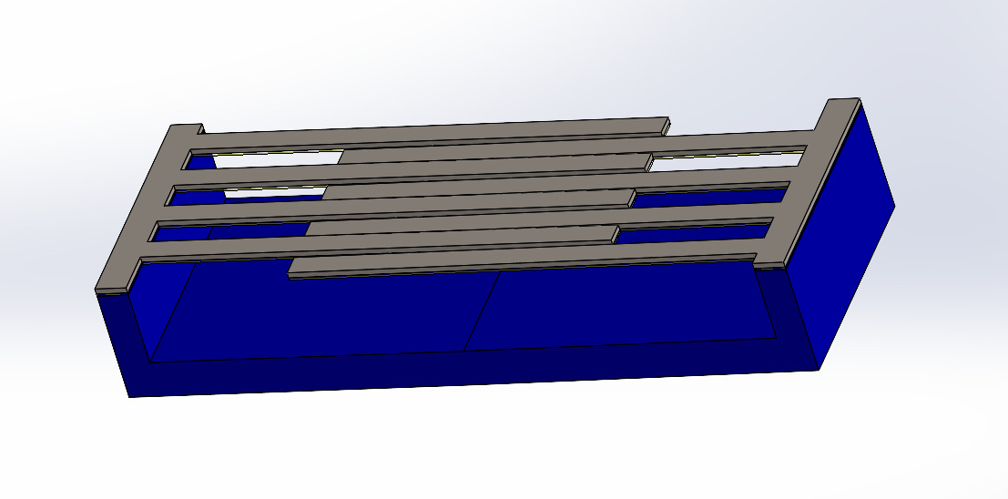

II. Designing Actuation

When designing the particular geometry of our sensor, we take into consideration how we want it to operate along its designed range. It is preferable that the bimorphs lay flat at the sensor’s max operating temperature while also not flexing too much at the minimum operating temperature to avoid compromising the structural integrity of the beams. This creates a sensor that has a direct relationship between temperature and capacitance as it reaches its max capacitance at max temperature.

**Fig. 2** Temperature changes create a moment that actuates the beams as the materials expand or contract.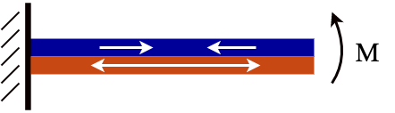

This is achieved by considering the stresses that occur during the manufacturing process and how, at release, the beams will inherently bend upward due to the thermal mismatch of the bimorph structure as in (Figure 2). Then we define the deflection of our beam as the sum of the initial deflection upon release and the deflection due to temperature.

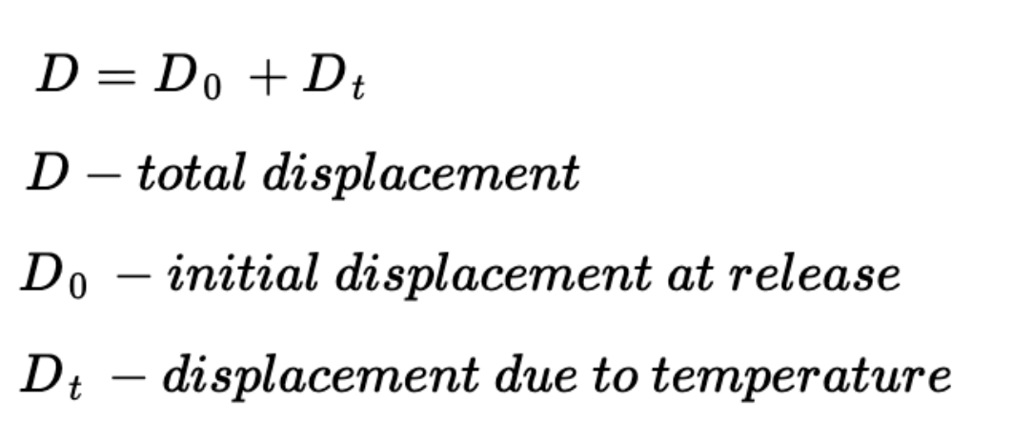

We can then consider the different moments generated upon release and the effective Young's modulus times the moment of inertia of each beam from the constitutive equations as follows.

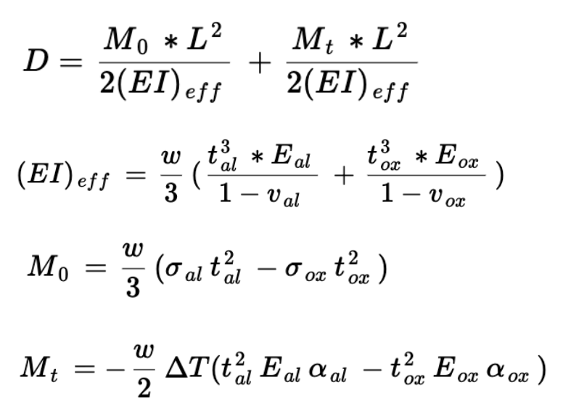

These equations allow us to see the relationship between the geometry of the beams and the deflection generated by temperature where the goal is to achieve results as follows for the commercial sensor range of -100℃ to 100℃. A visualization of the desired effect is shown in (Figure 3).

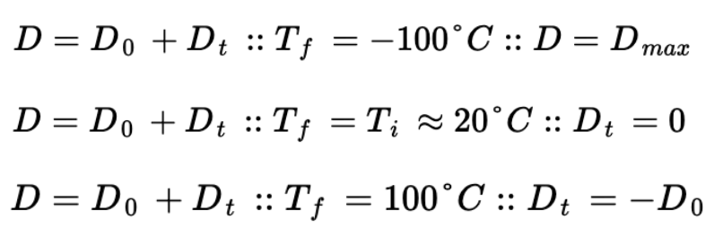

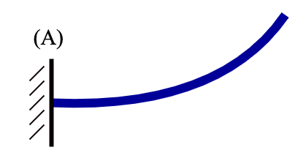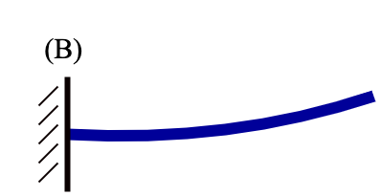

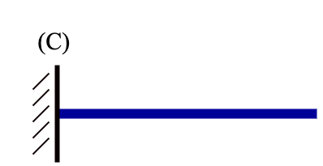

**Fig. 3** Visualization of beam deflection at Minimum temperature(A), room temperature (B), and Max temperature (C).

From the equations, it's clear that the actuation of the beams is reliant on a few factors, namely the thickness of the materials, the beam length, and the material choice itself. In the above equations, we assume Al, but it can be replaced with any metal with the desired properties. A material change would also affect the capacitance of the sensor due to a differing K value. The width of the beams themselves, however, does not affect the actuation of the beams which allows for one design parameter that won't affect the actuation but will affect the capacitance of our sensor.

III. Capacitance of Sensor

Due to the complexity of the fringing field of the sensor, it is difficult to analytically derive a capacitance for the sensor across the temperature range, but it is possible to calculate the max temperature when all beams lay flat, as well as model a general expected pattern from other experimental examples. It is also possible to find the capacitance empirically through either testing or simulation [2] [3].

For calculating the maximum capacitance, we assume the sensor is at maximum temperature and the beams are laying flat. Since our ‘capacitor’ in this instance is Al, it is the only thickness we need to consider. We then model the max capacitance based on a typical comb drive fringe field as follows [4] [1].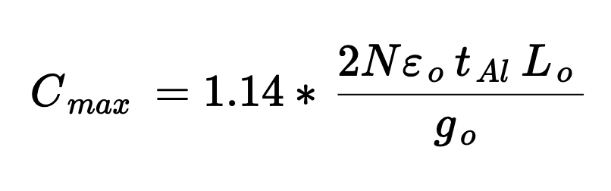

*N - number of combs*

*tAl* - *thickness of Al*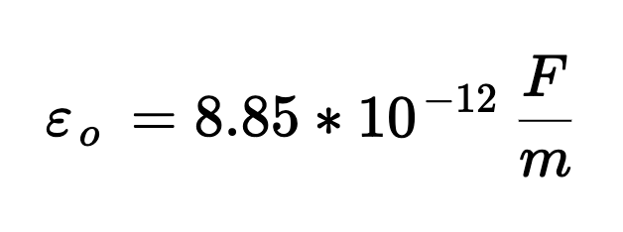

*Lo - comb overlap*

*go - gap between combs*

This gives us the analytical maximum capacitance that our sensor can achieve. Comparing our sensor to other similar sensors, we can expect the minimum capacitance across our range to be around 50% to 75% of our maximum capacitance along with an exponential capacitance curve across our range [2] [3].   
 An essential assumption for this sensor to work is that considering that the maximum stress is known, the deflection experienced by the bimorphs is significantly less than the maximum deflection possible before breaking. Thus, this is so negligible as it experiences about 1% of the maximum force possible. Along with that, the assumption that the thickness of the thin Ti layer was negligible for calculations was made as it is to a nanometer scale and would not impact the sensor at all due to its primary function being just for interfacing Al and SiO2.

These formulas give a relatively easy way to alter the geometry for our sensor while still maintaining a consistent, desired capacitance. While designing for flexures involves changing the thickness, which affects the capacitance, this can be mitigated by changing *go* by either placing the beams closer together or changing the widths of the beams without affecting the actuation we had designed for previously.

IV. Fabrication

Typical manufacturing methods for this type of wireless temperature sensing revolve around the concept of capacitors that are temperature dependent in a resonator method. A key issue with this though is that it is very difficult to find industry-available capacitors at this small scale that achieve the specific design parameters that are targeted for. However, there are thermal capacitors that are formed with bimorph beams to match as we desire. These MEMS bimorph beams typically are made with a metal and oxide bimorph beam such that as the temperature increases, the deflection increases as well, allowing for the calculation of capacitance through the cantilevers. [2]

The fabrication of this MEMS bimorph capacitor sensor of -100 ॰C to 100 ॰C revolves around very common and simple manufacturing processes that can be achieved at any typical fabrication center. The first step requires the creation of oxide (Figure 4.a), which is achieved by placing a silicon wafer of 0.5 μm in a furnace at 1100॰C to grow to the required thickness of 0.65 μm for 1.03 hours. Figure 4.b depicts the before and after of the oxide growth and post-etching process after patterning with a negative resist bright field mask for photoresist deposition and lithography and wet etching. One key thing is that Aluminum cannot stick or grow well on any oxide so a thin layer of Titanium [6] must be applied as an interfacing medium. This adhesion layer of 0.05 μm is applied using PECVD and then used as a medium to deposit the Al layer of 1.5 μm with PVD. An additional layer of photoresist is deposited and patterned using a negative resist dark mask to allow for undercut etching and release of the Silicon substrate and oxide. These bimorph cantilever beams for the sensors are then released with DHF etching for the oxide and silicon DRIE etching using XeF2. (Figure 4.d) The cantilever beams naturally deflect upwards at their resting position due to a process called thermal mismatch during the fabrication process.

a)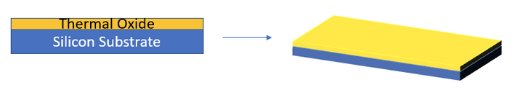

b)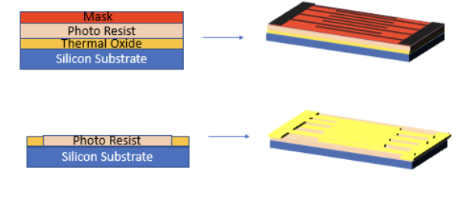

c)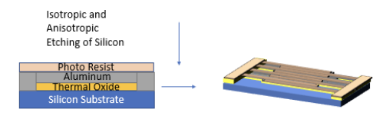

d)

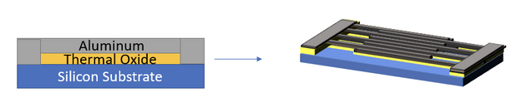

**Fig. 4** Visualization of key fabrication processes: a) Oxide Deposition b) Fin Etching c) Silicon and Oxide Etching and d) Final Sensor

Thermal expansion is a material’s tendency to change shape as it experiences temperature changes. In this case, due to the mismatch of thermal expansion coefficients between the SiO2 and Al, internal stress is generated, causing the cantilever beams to bend upwards at room temperature as their default resting position.

Key benefits of this design and fabrication process are that the robust design and simplicity allow for mass manufacturing and high yield. Integrating into a system as a wireless sensor is also relatively easy to achieve through induction.

V. Results & Discussion

When looking at the results of the sensor derived for temperature ranges between -100 ℃ to 100 ℃, the equations mentioned prior allowed for some manipulation of materials and dimensions to reach the upward distance as desired. As measuring capacitance and resonant frequency versus temperature requires precision machinery, calculations were conducted for estimates of range. As the initial deflections change relative to each beam’s dimensions, there was a clear change in initial deflection as the sensor range increased (Figure 5). Along with that, by altering both the metal and oxide thickness, the deflection range was kept relatively stable, such that the cantilever beams would not reach the silicon substrate layer below or even hyperextend until they snap at their bending limit.

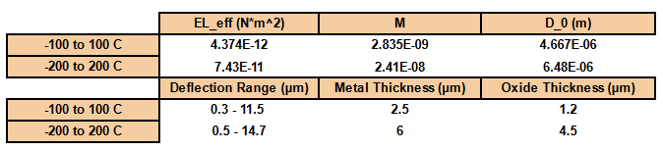

**Fig. 5**  Sensor Characteristics for Two Example Sensors at -100 to 100 ℃ and -200 to 200 ℃

The first example sensor, sensor (a), is the one that ranges between -100 ℃ to 100 ℃, which reaches a maximum deflection of about 11.2 μm. This was modeled by ensuring that the thermal mismatch [5] between the metal and oxide would cause an initial displacement at room temperature such that no additional disturbance would move the initial position of the sensor. (Figure 6) Some key dimensions of this dynamic range wireless sensor are the width of each bimorph being 6μm wide, 120 μm long, and relatively small thicknesses for both layers. The SiO2 layer at 1.2 μm and Al layer at 2.5 μm thick allowed for a simple displacement as temperature changes due to the thermal coefficients and mismatch mentioned prior.

If the additional dynamic range is analyzed of -200 ℃ to 200℃, similar calculations are once again conducted to find new dimensions required for stability and robustness for sensor (b). At this larger range, each cantilever bimorph beam was 6μm wide, 200 μm long, and the thickness was 2.5 times larger than sensor (a). The thin Ti deposition layer can remain the same thickness due to its only obligation to act as a medium for growth. With these new system dynamics, the maximum deflection experienced increases by 3.2 μm compared to sensor (a), but its characteristics at maximum temperature remain the same. At the highest temperature possible, all of the cantilever bimorph beams flatten out and output the highest capacitance at that point. (Figure 7)

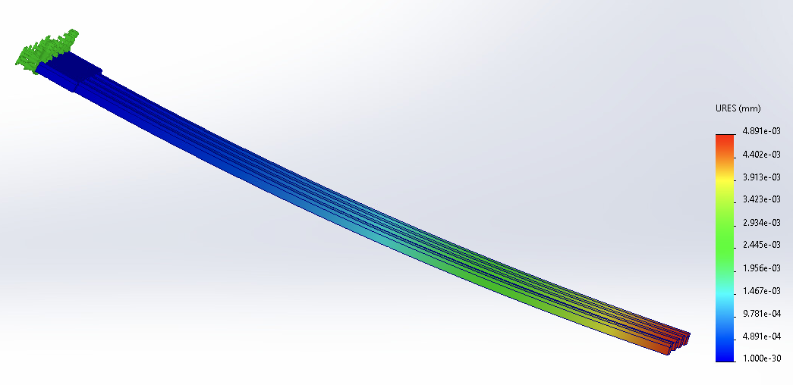

**Fig. 6**  Room Temperature Displacement of Each Beam at Initial Position

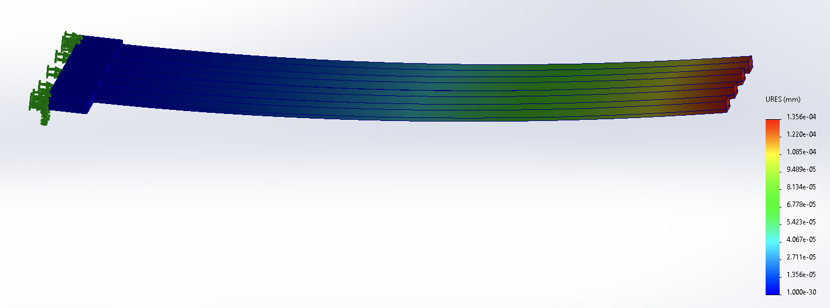

**Fig. 7**  Room Temperature Displacement Experienced at 200 ℃ and 100 ℃

Comparing the two sensors, the resulting sensor achieves the same sensor characteristics of robustness and sensitivity regardless of the dynamic range requirements. By only changing the dimensions of each cantilever, the deflection range remains almost constant and its ability to be implemented wirelessly remains true. As the range increases, the beams typically need to be longer, stronger, and thicker to avoid snapping at the bending point.

An additional key experiment was conducted to test the systems’ robustness as other forces or external interactions get applied. A simulation was run on the beams above such that the maximum deflection of the beams was experienced, which is at their lowest temperatures. As the beams experienced max deflection, an additional force of 0.01N was applied to the entire face. The additional displacement from the force was so minimal that no difference was visible at the stage depicted in Figure 7.

VI. Conclusions

As set out in the aforementioned criteria, the resulting two sensors meet these requirements but with varying degrees of sensing accuracy. The geometry of both sensors allows them to operate at our intended ranges of -100℃ to 100℃ (a) and -200℃ to 200℃ (b). The sensor with the lower dynamic range has higher accuracy but is not viable for the larger temperature range of the other due to the extreme deflections it would experience and the unintentional effect of bending downwards past neutral. Sensor (b) also produces a much smaller deflection relative to sensor (a) resulting in much lower accuracy due to less variance in capacitance across temperatures.

VII. Future Work

Given more time, it would be ideal to simulate the capacitor in COMSOL to get an empirical result for the variance of the capacitance as well as look at how the analytical models we present in this paper might differ in other areas such as the beam deflection due to the inherent stresses of the manufacturing process. Along with that, another interesting parameter that would be nice to analyze is the resonant frequency as that is something that would get impacted as the dimensions of the bimorphs change per dynamic range requirements. Some estimates were generated using analytical calculations as mentioned prior but a simulated result would provide results of higher accuracy.

References

1. Palmer, Harlan B. "The capacitance of a parallel-plate capacitor by the Schwartz-Christoffel transformation." *Electrical Engineering* 56.3 (1937): 363-368.
2. Scott, Sean, Farshid Sadeghi, and Dimitrios Peroulis. "An inherently-robust 300 C MEMS temperature sensor for wireless health monitoring of ball and rolling element bearings." SENSORS, 2009 IEEE. IEEE, 2009.
3. Scott, Sean, and Dimitrios Peroulis. "A capacitively-loaded MEMS slot element for wireless temperature sensing of up to 300 C." 2009 IEEE MTT-S International Microwave Symposium Digest. IEEE, 2009.
4. Tang, William C., et al. "Electrostatic-comb drive of lateral polysilicon resonators." Sensors and Actuators A: Physical 21.1-3 (1990): 328-331.
5. Z. Sun, Z. Tian, L. Weng, Y. Liu, J. Zhang, and T. Fan, “The effect of thermal mismatch on the thermal conductance of Al/Sic and Cu/Diamond Composites,”*AIP Publishing*, 31-Jan-2020.
6. Wojcieszak D, Mazur M, Pokora P, Wrona A, Bilewska K, Kijaszek W, Kotwica T, Posadowski W, Domaradzki J. Properties of Metallic and Oxide Thin Films Based on Ti and Co Prepared by Magnetron Sputtering from Sintered Targets with Different Co-Content. Materials (Basel). 2021 Jul 7;14(14):3797. doi: 10.3390/ma14143797. PMID: 34300716; PMCID: PMC8304873.