<http://localhost:9090/api/product/getproduct/3>

{

    "id": 3,

    "productName": "currentaccount",

    "productType": "salaryAccount"

}

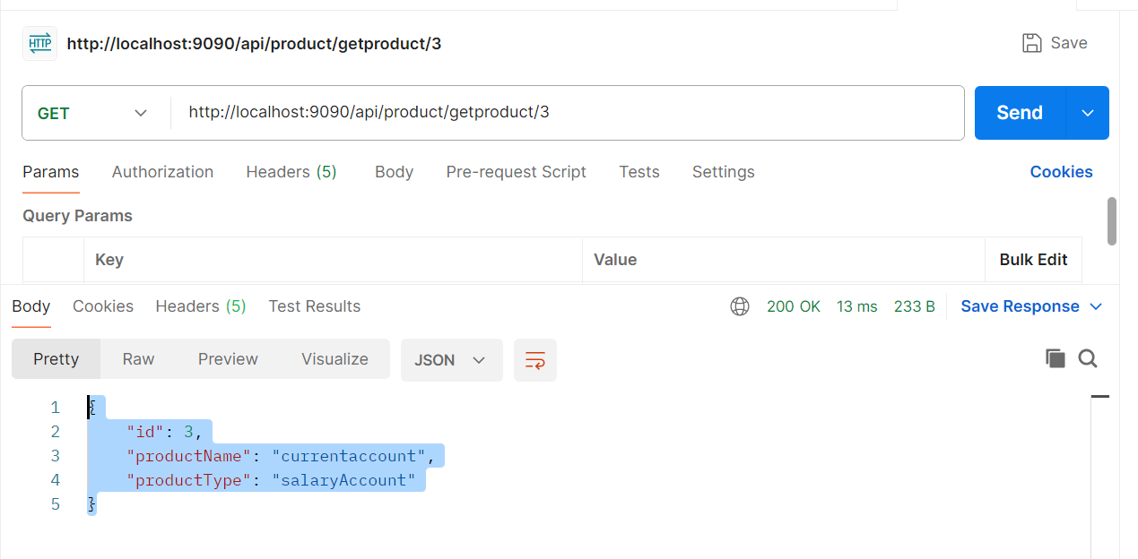

<http://localhost:9090/api/product/createproduct>  
  
postman collection  
Request  
{

    "productName": "saving",

    "productType": "NormalAccount"

}  
Response  
{

    "id": 1,

    "productName": "saving",

    "productType": "NormalAccount"

}

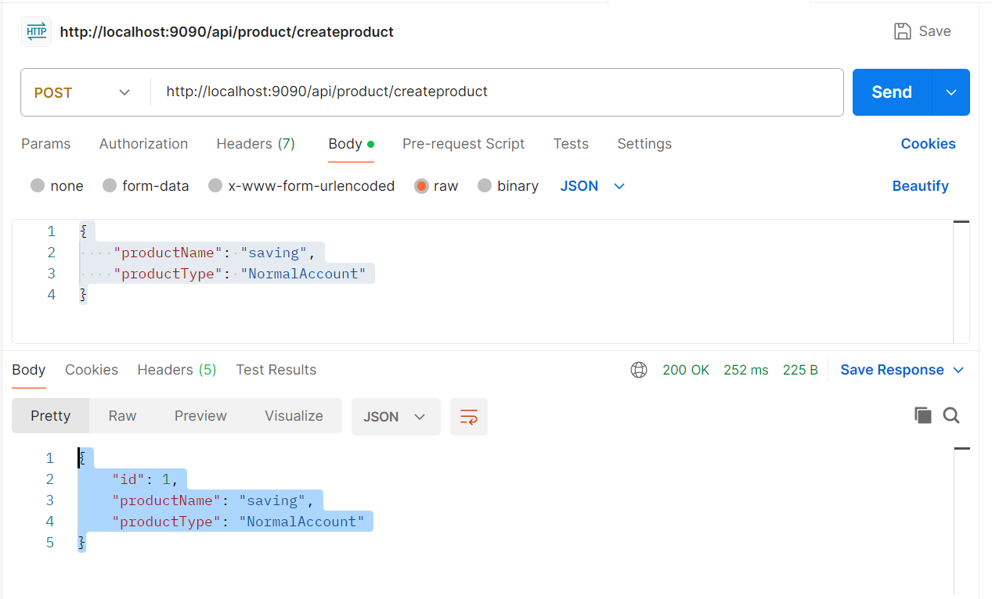

<http://localhost:9090/api/product/updateproduct/2>  
  
{

    "productName": "productUpdate",

    "productType": "updated accunt"

}

{

    "id": 2,

    "productName": "productUpdate",

    "productType": "updated accunt"

}

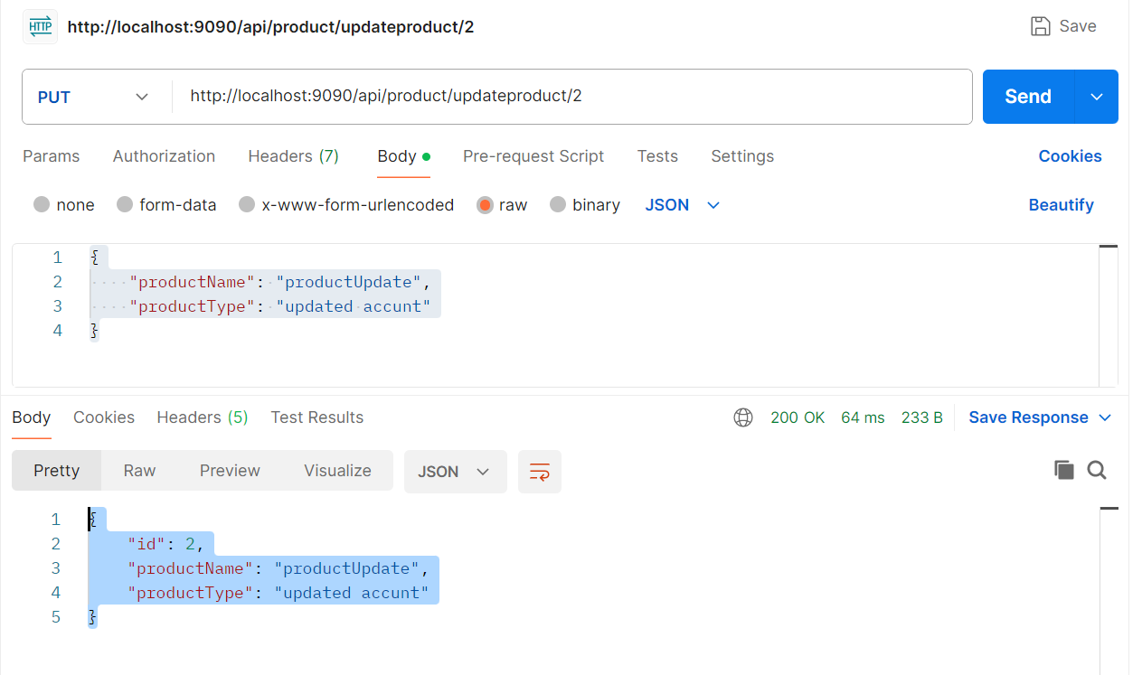

<http://localhost:9090/api/product/products>  
  
{

    "content": [

        {

            "id": 1,

            "productName": "saving",

            "productType": "NormalAccount"

        },

        {

            "id": 2,

            "productName": "productUpdate",

            "productType": "updated accunt"

        },

        {

            "id": 3,

            "productName": "currentaccount",

            "productType": "salaryAccount"

        },

        {

            "id": 4,

            "productName": "dfdfd",

            "productType": "salaryAccount"

        },

        {

            "id": 5,

            "productName": "dfdfd",

            "productType": "salaryAccount"

        },

        {

            "id": 6,

            "productName": "dfdfd",

            "productType": "salaryAccount"

        },

        {

            "id": 7,

            "productName": "dfdfd",

            "productType": "salaryAccount"

        },

        {

            "id": 8,

            "productName": "dfdfd",

            "productType": "salaryAccount"

        },

        {

            "id": 9,

            "productName": "dfdfd",

            "productType": "salaryAccount"

        },

        {

            "id": 10,

            "productName": "retertre",

            "productType": "testing"

        }

    ],

    "pageable": {

        "pageNumber": 0,

        "pageSize": 10,

        "sort": {

            "empty": **true**,

            "sorted": **false**,

            "unsorted": **true**

        },

        "offset": 0,

        "paged": **true**,

        "unpaged": **false**

    },

    "last": **false**,

    "totalPages": 2,

    "totalElements": 12,

    "size": 10,

    "number": 0,

    "sort": {

        "empty": **true**,

        "sorted": **false**,

        "unsorted": **true**

    },

    "first": **true**,

    "numberOfElements": 10,

    "empty": **false**

}

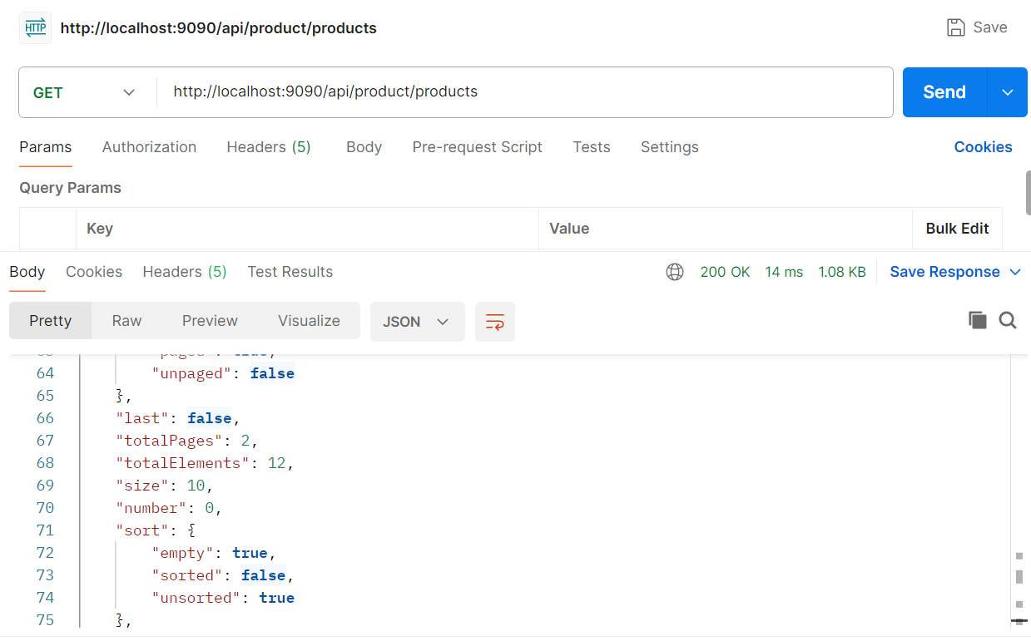

<http://localhost:9090/api/product/getproductfromapi/3>

{

    "id": 3,

    "productName": "currentaccount",

    "productType": "salaryAccount"

}

