**Instances Details:**

**Linux: amzn2-ami-hvm-2.0.20180924-x86_64-gp2 (ami-0e6d2e8684d4ccb3e) 🡪 Jenkins**

**CentOS : Centos Linux 7 (ami-01d5b8c6e4958a724) 🡪 Tomcat**

**\*\*\*\*\*\*\*\*\*\*\*\*\*\*\*\*\*\*\*\*\*\*\*\*\*\*\*\*\*\*\***

[**https://docs.aws.amazon.com/aws-technical-content/latest/jenkins-on-aws/installation.html**](https://docs.aws.amazon.com/aws-technical-content/latest/jenkins-on-aws/installation.html)

**Jenkins Scripts**

* **sudo yum update**
* **yum install java**
* **sudo wget -O /etc/yum.repos.d/jenkins.repo http://pkg.jenkins.io/redhat/jenkins.repo**

**rpm --import** [**https://pkg.jenkins.io/redhat/jenkins.io.key**](https://pkg.jenkins.io/redhat/jenkins.io.key)

* **Yum install jenkins**
* **service jenkins start**
* **service jenkins status**
* **yum install git [For Jenkins tool -> git** availability **in *global tool configuration*]**

**http://ec2-54-174-109-47.compute-1.amazonaws.com:8080**

**add cutom tcp/ip rule to port 8080.**

[**http://ec2-54-174-109-47.compute-1.amazonaws.com:8080/**](http://ec2-54-174-109-47.compute-1.amazonaws.com:8080/)

**Jenkins ->** The WAR file is created.

**\*\*\*\*\*\*\*\*\*\*\*\*\*\*\*\*\*\*\*\*\*\*\*\*\*\*\*\*\*\*\*\*\*\*\*\*\*\*\*\*\*\*\*\*\*\*\*\*\*\*\*\*\*\*\*\*\*\*\*\*\*\*\*\*\*\***

**Tomcat Server Script**

* sudo yum update
* yum install tomcat
* systemctl start tomcat
* systemctl status tomcat
* java –version
* yum install telnet
* telnet ipoftomcat 8080
* whereis tomcat
* cd /usr/share/tomcat/webapps/ -> To check if the default structure with tomcat is up.
* cd /

**************************************************************

**Real time scenario work**:

**In Tomcat Server**

* cat /etc/group | grep tomcat -> Check if **tomcat:x:53:** is displayed
* useradd user
* passwd user
* **Note**: Give password as user when ever there is display of password.
* vi /etc/group
* **Note**: The users will be displayed. Add user to the group. Below is screen shot 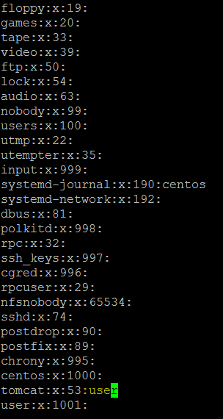
* vi /etc/ssh/sshd_config
* **Note**: Set the PasswordAuthentication as **yes**
* systemctl restart sshd

**In Jenkins Server**

**Jenkins GUI : Build Script.**

#!/bin/sh

sudo su -s /bin/bash jenkins

scp /var/lib/jenkins/workspace/PackageforWarFile/target/addressbook.war [user@172.31.42.34:/usr/share/tomcat/webapps/](mailto:user@172.31.42.34:/usr/share/tomcat/webapps/)

*************************

**on Jenkins server :**

* sudo su -s /bin/bash Jenkins
* ssh-keygen -t rsa
* ssh-copy-id [user@172.31.81.67](mailto:user@172.31.81.67)

**Solution for Permission Issue: NOTE: Fix in Tomcat Server**: If Issue pops up.

* Root user : cd /etc/ssh
* Vi sshd_config
* Set Password Authentication –Yes
* Systemctl restart sshd (To restart)
* ssh-agent bash
* ssh-add

**-to check if jenkins had access to user**

* ssh [user@172.31.81.67](mailto:user@172.31.81.67)

**bash script to run on jenkins post steps**

#!/bin/sh

sudo su -s /bin/bash jenkins

scp /var/lib/jenkins/workspace/package-maven/target/addressbook.war user@172.31.81.67:/usr/share/tomcat/webapps/