

A Project Report On

**School**

**Management**

**System**

**By**

**Batch:** 2022 –7399

**Center: Chennai**

Under the Guidance of,

**Chittaranjan Ghosh.**

**Technical Trainer**

**EduBridge**

(School of coding)

## Introduction:

School Management System manages school information in the college. It improves existing system. It has the facility of maintaining the details of the student, thereby reducing the manual work. It will save time and energy which collecting data. School Management System can be accessed throughout the college.

. **Modules:-**

* School Module
* Student Module
* Teacher Module

I have developed this Application in **Java**

The main objective of the School management system is to reduce manual work and time. It is difficult and time-consuming to collect all the student and teacher detail. To avoid this problem, we have planned to develop a school management system.

.

**Used Software/Tools:**

* **Operating System:** Windows
* This Project edit on Eclipse Studio and Run on java Application.

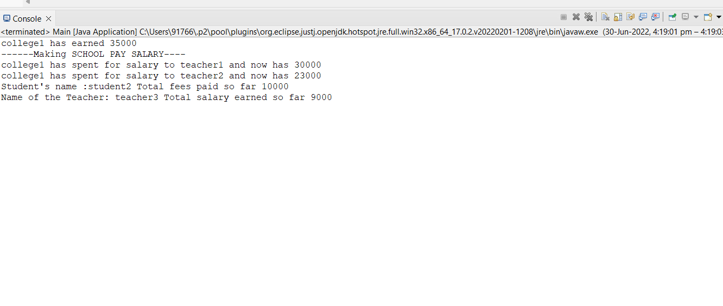

**Thank**

**you…..__­­­­­­___**

**Suggestions?......**