**Functional Requirements**

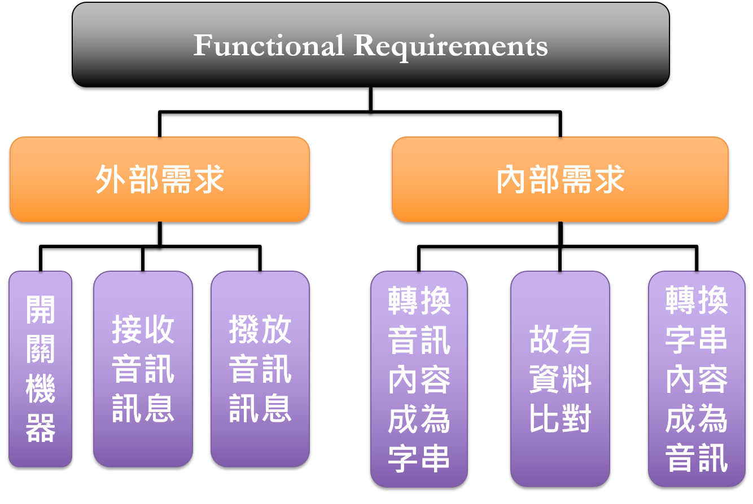

**Requirements Table - Functional Requirements**

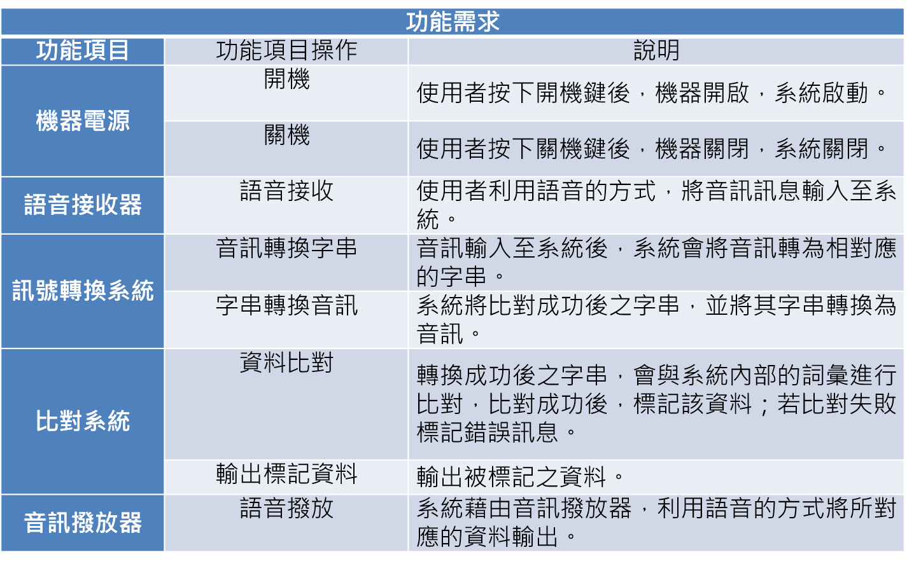

**Class Diagram - Functional Requirements**

