**Functional Requirements**

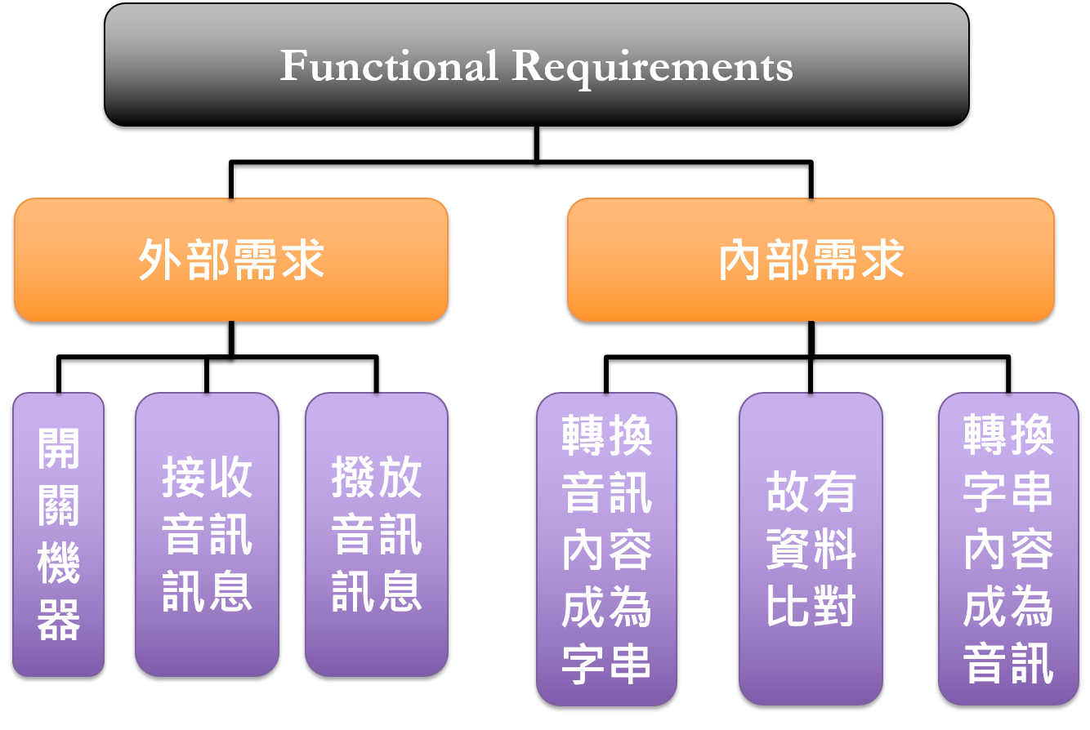

**Requirements Table - Functional Requirements**

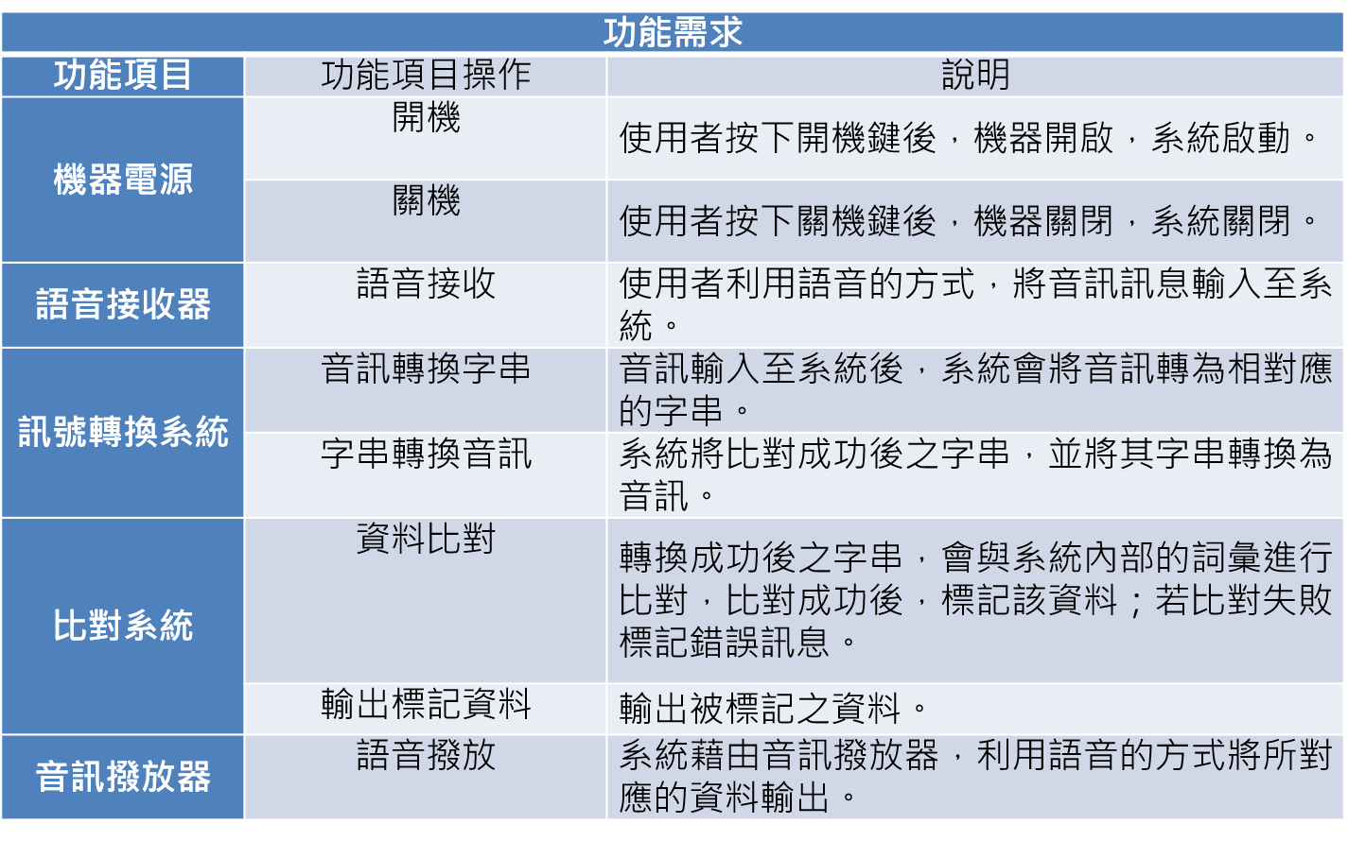

**Non-Functional Requirements**

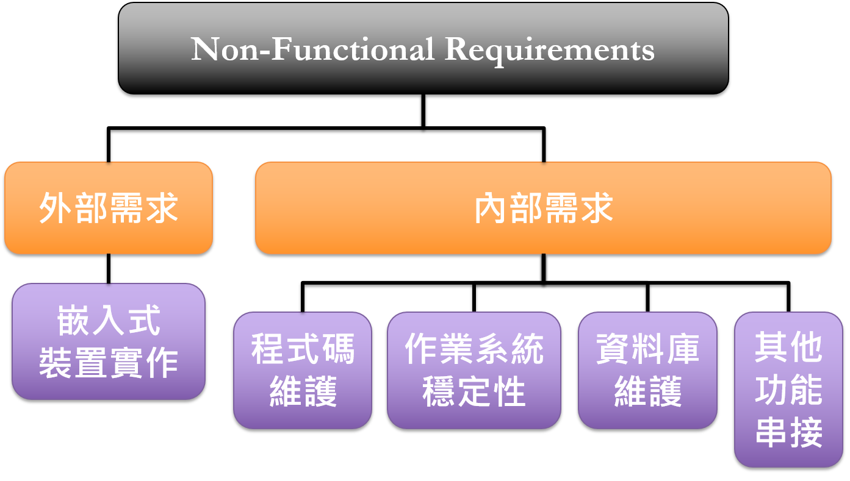

**Requirements Table - Non-Functional Requirements**

