1.

1. (P ⇒ Q) ∧ ¬Q ∧ ¬P

Satisfiabile, nevalida.

|  |  |  |  |  |  |  |
| --- | --- | --- | --- | --- | --- | --- |
| P | Q | ¬P | ¬Q | P ⇒ Q  notat cu A | ¬Q ∧ ¬P  notat cu B | A ∧ B |
| 1 | 1 | 0 | 0 | 1 | 1 | 1 |
| 1 | 0 | 0 | 1 | 0 | 1 | 0 |
| 0 | 1 | 1 | 0 | 1 | 0 | 0 |
| 0 | 0 | 1 | 1 | 1 | 1 | 1 |

1. (P ⇒ Q) ⇒ ((Q ⇒ S) ⇒ ((P ∨ Q) ⇒ R))

Satisfiabile, nevalida.

|  |  |  |  |  |  |  |  |  |  |
| --- | --- | --- | --- | --- | --- | --- | --- | --- | --- |
| P | Q | S | R | P⇒Q  notat cu A | Q⇒S  notat cu B | P ∨Q  notat cu C | C⇒R  notat cu D | B⇒D  notat cu E | A⇒E |
| 1 | 1 | 1 | 1 | 1 | 1 | 1 | 1 | 1 | 1 |
| 1 | 1 | 1 | 0 | 1 | 1 | 1 | 0 | 0 | 0 |
| 1 | 1 | 0 | 1 | 1 | 0 | 1 | 1 | 1 | 1 |
| 1 | 1 | 0 | 0 | 1 | 0 | 1 | 0 | 1 | 1 |
| 1 | 0 | 1 | 1 | 0 | 1 | 1 | 1 | 1 | 1 |
| 1 | 0 | 1 | 0 | 0 | 1 | 1 | 0 | 0 | 1 |
| 1 | 0 | 0 | 1 | 0 | 1 | 1 | 1 | 1 | 1 |
| 1 | 0 | 0 | 0 | 0 | 1 | 1 | 0 | 0 | 1 |
| 0 | 1 | 1 | 1 | 1 | 1 | 1 | 1 | 1 | 1 |
| 0 | 1 | 1 | 0 | 1 | 1 | 1 | 0 | 0 | 0 |
| 0 | 1 | 0 | 1 | 1 | 0 | 1 | 1 | 1 | 1 |
| 0 | 1 | 0 | 0 | 1 | 0 | 1 | 0 | 1 | 1 |
| 0 | 0 | 1 | 1 | 1 | 1 | 0 | 1 | 1 | 1 |
| 0 | 0 | 1 | 0 | 1 | 1 | 0 | 1 | 1 | 1 |
| 0 | 0 | 0 | 1 | 1 | 1 | 0 | 1 | 1 | 1 |
| 0 | 0 | 0 | 0 | 1 | 1 | 0 | 1 | 1 | 1 |

1. ¬(P ⇒ Q) ⇔ ((P ∨ R) ∧ (¬P ⇒ Q))

Satisfiabile, nevalida.

|  |  |  |  |  |  |  |  |  |  |
| --- | --- | --- | --- | --- | --- | --- | --- | --- | --- |
| P | Q | R | ¬P | P⇒Q  notat cu A | P∨R  notat cu B | ¬P ⇒Q  notat cu C | ¬ A | B ∧ C  notat cu D | ¬ A ⇔ D |
| 1 | 1 | 1 | 0 | 1 | 1 | 1 | 0 | 1 | 0 |
| 1 | 1 | 0 | 0 | 1 | 1 | 1 | 0 | 1 | 0 |
| 1 | 0 | 1 | 0 | 0 | 1 | 1 | 1 | 1 | 1 |
| 1 | 0 | 0 | 0 | 0 | 1 | 1 | 1 | 1 | 1 |
| 0 | 1 | 1 | 1 | 1 | 1 | 1 | 0 | 1 | 0 |
| 0 | 1 | 0 | 1 | 1 | 0 | 1 | 0 | 0 | 1 |
| 0 | 0 | 1 | 1 | 1 | 1 | 0 | 0 | 1 | 0 |
| 0 | 0 | 0 | 1 | 1 | 0 | 0 | 0 | 0 | 1 |

1. (P ⇔ Q) ⇔ (¬(P ⇒ ¬Q))

Satisfiabile, nevalida.

|  |  |  |  |  |  |  |
| --- | --- | --- | --- | --- | --- | --- |
| P | Q | ¬Q | P ⇔Q  notat cu A | P ⇒ ¬Q  notat cu B | ¬ B | A ⇔¬ B |
| 1 | 1 | 0 | 1 | 0 | 1 | 1 |
| 1 | 0 | 1 | 0 | 1 | 0 | 1 |
| 0 | 1 | 0 | 0 | 1 | 0 | 1 |
| 0 | 0 | 1 | 1 | 1 | 0 | 0 |

2.

Reguli de reducere

1. (F ⇔ G) ∼ (F ⇒ G) ∧ (G ⇒ F),

|  |  |  |  |  |  |
| --- | --- | --- | --- | --- | --- |
| F | G | F ⇒G  Notat cu A | G ⇒F  Notat cu B | A∧B | F ⇔ G |
| 1 | 1 | 1 | 1 | 1 | 1 |
| 1 | 0 | 0 | 1 | 0 | 0 |
| 0 | 1 | 1 | 0 | 0 | 0 |
| 0 | 0 | 1 | 1 | 1 | 1 |

1. (F ⇒ G) ∼ (¬F ∨ G).

|  |  |  |  |  |
| --- | --- | --- | --- | --- |
| F | G | ¬F | F ⇒G | ¬F ∨ G |
| 1 | 1 | 0 | 1 | 1 |
| 1 | 0 | 0 | 0 | 0 |
| 0 | 1 | 1 | 1 | 1 |
| 0 | 0 | 1 | 1 | 1 |

Reguli pentru comutativitate a) F ∨ G ∼ G ∨ F, b) F ∧ G ∼ G ∧ F, c) F ⇔ G ∼ G ⇔ F.

|  |  |  |  |  |  |  |  |
| --- | --- | --- | --- | --- | --- | --- | --- |
| F | G | F ∨ G | G ∨F | F ∧ G | G ∧ F | F ⇔ G | G ⇔ F |
| 1 | 1 | 1 | 1 | 1 | 1 | 1 | 1 |
| 1 | 0 | 1 | 1 | 0 | 0 | 0 | 0 |
| 0 | 1 | 1 | 1 | 0 | 0 | 0 | 0 |
| 0 | 0 | 0 | 0 | 0 | 0 | 1 | 1 |

Reguli pentru asociativitate

a) (F ∨ G) ∨ H ∼ F ∨ (G ∨ H),

|  |  |  |  |  |  |  |
| --- | --- | --- | --- | --- | --- | --- |
| F | G | H | F ∨ G  Notat cu A | G ∨ H  Notat cu B | A ∨ H | F ∨ B |
| 1 | 1 | 1 | 1 | 1 | 1 | 1 |
| 1 | 1 | 0 | 1 | 1 | 1 | 1 |
| 1 | 0 | 1 | 1 | 1 | 1 | 1 |
| 1 | 0 | 0 | 1 | 0 | 1 | 1 |
| 0 | 1 | 1 | 1 | 1 | 1 | 1 |
| 0 | 1 | 0 | 1 | 1 | 1 | 1 |
| 0 | 0 | 1 | 0 | 1 | 1 | 1 |
| 0 | 0 | 0 | 0 | 0 | 0 | 0 |

b) (F ∧ G) ∧ H ∼ F ∧ (G ∧ H),

|  |  |  |  |  |  |  |
| --- | --- | --- | --- | --- | --- | --- |
| F | G | H | F ∧ G  Notat cu A | G ∧ H  Notat cu B | A ∧ H | F ∧ B |
| 1 | 1 | 1 | 1 | 1 | 1 | 1 |
| 1 | 1 | 0 | 1 | 0 | 0 | 0 |
| 1 | 0 | 1 | 0 | 0 | 0 | 0 |
| 1 | 0 | 0 | 0 | 0 | 0 | 0 |
| 0 | 1 | 1 | 0 | 1 | 0 | 0 |
| 0 | 1 | 0 | 0 | 0 | 0 | 0 |
| 0 | 0 | 1 | 0 | 0 | 0 | 0 |
| 0 | 0 | 0 | 0 | 0 | 0 | 0 |

1. (F ⇔ G) ⇔ H ∼ F ⇔ (G ⇔ H).

|  |  |  |  |  |  |  |
| --- | --- | --- | --- | --- | --- | --- |
| F | G | H | F ⇔ G  Notat cu A | G ⇔ H Notat cu B | A ⇔ H | F ⇔ B |
| 1 | 1 | 1 | 1 | 1 | 1 | 1 |
| 1 | 1 | 0 | 1 | 0 | 0 | 0 |
| 1 | 0 | 1 | 0 | 0 | 0 | 0 |
| 1 | 0 | 0 | 0 | 1 | 1 | 1 |
| 0 | 1 | 1 | 0 | 1 | 0 | 0 |
| 0 | 1 | 0 | 0 | 0 | 1 | 1 |
| 0 | 0 | 1 | 1 | 0 | 1 | 1 |
| 0 | 0 | 0 | 1 | 1 | 0 | 0 |

Reguli de distributivitate

a) F ∨ (G ∧ H) ∼ (F ∨ G) ∧ (F ∨ H),

|  |  |  |  |  |  |  |  |  |
| --- | --- | --- | --- | --- | --- | --- | --- | --- |
| F | G | H | G ∧ H  Notat cu A | | F ∨ G  Notat cu B | F ∨ H  Notat cu C | F ∨ A | B ∧ C |
| 1 | 1 | 1 | 1 | 1 | | 1 | 1 | 1 |
| 1 | 1 | 0 | 0 | 1 | | 1 | 1 | 1 |
| 1 | 0 | 1 | 0 | 1 | | 1 | 1 | 1 |
| 1 | 0 | 0 | 0 | 1 | | 1 | 1 | 1 |
| 0 | 1 | 1 | 1 | 1 | | 1 | 1 | 1 |
| 0 | 1 | 0 | 0 | 1 | | 0 | 0 | 0 |
| 0 | 0 | 1 | 0 | 0 | | 1 | 0 | 0 |
| 0 | 0 | 0 | 0 | 0 | | 0 | 0 | 0 |

b) F ∧ (G ∨ H) ∼ (F ∧ G) ∨ (F ∧ H),

|  |  |  |  |  |  |  |  |
| --- | --- | --- | --- | --- | --- | --- | --- |
| F | G | H | G ∨ H (=A) | F ∧ G (=B) | F ∧ H (=C) | F ∧ A | B ∨ C |
| 1 | 1 | 1 | 1 | 1 | 1 | 1 | 1 |
| 1 | 1 | 0 | 1 | 1 | 0 | 1 | 1 |
| 1 | 0 | 1 | 1 | 0 | 1 | 1 | 1 |
| 1 | 0 | 0 | 0 | 0 | 0 | 0 | 0 |
| 0 | 1 | 1 | 1 | 0 | 0 | 0 | 0 |
| 0 | 1 | 0 | 1 | 0 | 0 | 0 | 0 |
| 0 | 0 | 1 | 1 | 0 | 0 | 0 | 0 |
| 0 | 0 | 0 | 0 | 0 | 0 | 0 | 0 |

c) (F ∨ G) ⇒ H ∼ (F ⇒ H) ∧ (G ⇒ H),

|  |  |  |  |  |  |  |  |
| --- | --- | --- | --- | --- | --- | --- | --- |
| F | G | H | F ∨ G (=A) | F ⇒ H (=B) | G ⇒ H (=C) | A ⇒ H | B ∧ C |
| 1 | 1 | 1 | 1 | 1 | 1 | 1 | 1 |
| 1 | 1 | 0 | 1 | 0 | 0 | 0 | 0 |
| 1 | 0 | 1 | 1 | 1 | 1 | 1 | 1 |
| 1 | 0 | 0 | 1 | 0 | 1 | 0 | 0 |
| 0 | 1 | 1 | 1 | 1 | 1 | 1 | 1 |
| 0 | 1 | 0 | 1 | 1 | 0 | 0 | 0 |
| 0 | 0 | 1 | 0 | 1 | 1 | 1 | 1 |
| 0 | 0 | 0 | 0 | 1 | 1 | 1 | 1 |

Reguli de absorbție:

a) F ∨ (F ∧ G) ∼ F

|  |  |  |  |
| --- | --- | --- | --- |
| F | G | F ∧ G (=A) | F ∨ A |
| 1 | 1 | 1 | 1 |
| 1 | 0 | 0 | 1 |
| 0 | 1 | 0 | 0 |
| 0 | 0 | 0 | 0 |

b) F ∧ (F ∨ G) ∼ F.

|  |  |  |  |
| --- | --- | --- | --- |
| F | G | F ∨ G (=A) | F ∧ A |
| 1 | 1 | 1 | 1 |
| 1 | 0 | 1 | 1 |
| 0 | 1 | 1 | 0 |
| 0 | 0 | 0 | 0 |

Reguli de anihilare:

1. F ∨ ¬F ∼ ⊤, (“tertium non datur”)

|  |  |  |  |
| --- | --- | --- | --- |
| F | notF | T | F ∨ notF |
| 1 | 0 | 1 | 1 |
| 0 | 1 | 1 | 1 |

1. F ∧ ¬F ∼ ⊥,

|  |  |  |  |
| --- | --- | --- | --- |
| F | notF | _|_ | F ∧ notF |
| 1 | 0 | 0 | 0 |
| 0 | 1 | 0 | 0 |

1. F ⇒ F ∼ ⊤

|  |  |  |
| --- | --- | --- |
| F | T | F ⇒ F |
| 1 | 1 | 1 |
| 0 | 1 | 1 |

Reguli pentru negație

1. ¬(¬F) ∼ F, („dublă negaţie”)

|  |  |  |
| --- | --- | --- |
| F | notF | notnotF |
| 1 | 0 | 1 |
| 0 | 1 | 0 |

1. ¬(F ∨ G) ∼ ¬F ∧ ¬G, („De Morgan”)

|  |  |  |  |  |  |  |
| --- | --- | --- | --- | --- | --- | --- |
| F | G | notF | notG | F ∨ G (=A) | not A | notF ∧ notG |
| 1 | 1 | 0 | 0 | 1 | 0 | 0 |
| 1 | 0 | 0 | 1 | 1 | 0 | 0 |
| 0 | 1 | 1 | 0 | 1 | 0 | 0 |
| 0 | 0 | 1 | 1 | 0 | 1 | 1 |

1. ¬(F ∧ G) ∼ ¬F ∨ ¬G, („De Morgan”)

|  |  |  |  |  |  |  |
| --- | --- | --- | --- | --- | --- | --- |
| F | G | notF | notG | F ∧ G (=A) | not A | notF ∨ notG |
| 1 | 1 | 0 | 0 | 1 | 0 | 0 |
| 1 | 0 | 0 | 1 | 0 | 1 | 1 |
| 0 | 1 | 1 | 0 | 0 | 1 | 1 |
| 0 | 0 | 1 | 1 | 0 | 1 | 1 |

1. ¬(F ⇒ G) ∼ F ∧ (¬G)

|  |  |  |  |  |  |
| --- | --- | --- | --- | --- | --- |
| F | G | notG | F ⇒ G (=A) | notA | F ∧ notG |
| 1 | 1 | 0 | 1 | 0 | 0 |
| 1 | 0 | 1 | 0 | 1 | 1 |
| 0 | 1 | 0 | 1 | 0 | 0 |
| 0 | 0 | 1 | 1 | 0 | 0 |

e) ¬(F ⇔ G) ∼ F ⇔ (¬G).

|  |  |  |  |  |  |
| --- | --- | --- | --- | --- | --- |
| F | G | notG | F ⇔ G (=A) | notA | F ⇔ notG |
| 1 | 1 | 0 | 1 | 0 | 0 |
| 1 | 0 | 1 | 0 | 1 | 1 |
| 0 | 1 | 0 | 0 | 1 | 1 |
| 0 | 0 | 1 | 1 | 0 | 0 |

Alte reguli:

1. F ⇒ G ∼ F ⇔ (F ∧ G),

|  |  |  |  |  |
| --- | --- | --- | --- | --- |
| F | G | F ⇒ G | F ∧ G (=A) | F ⇔ A |
| 1 | 1 | 1 | 1 | 1 |
| 1 | 0 | 0 | 0 | 0 |
| 0 | 1 | 1 | 0 | 0 |
| 0 | 0 | 1 | 0 | 1 |

1. F ⇒ G ∼ G ⇔ (F ∨ G).

|  |  |  |  |  |
| --- | --- | --- | --- | --- |
| F | G | F ⇒ G | F ∨ G (=A) | G ⇔ A |
| 1 | 1 | 1 | 1 | 1 |
| 1 | 0 | 0 | 1 | 0 |
| 0 | 1 | 1 | 1 | 0 |
| 0 | 0 | 1 | 0 | 1 |

3.

A-Superman poate sa previna raul

B- Superman vrea sa previna raul

C- Superman previne raul

D- Superman este lipsit de puteri

E- Superman e malefic

F – Superman exista

( A ∧ B ⇒ C ) **∧** ( ¬A ⇒ D) ∧ (B ⇒ E) **∧** ¬C **∧** ( F ⇒ ¬D ∨ ¬E )

Propozitia formata este conectata operatorul si. Pentru ca enuntul sa fie adevarat trebuie ca toate afirmatiile sa fie adevarate.

Avem urmatoarele tabele de adevar:

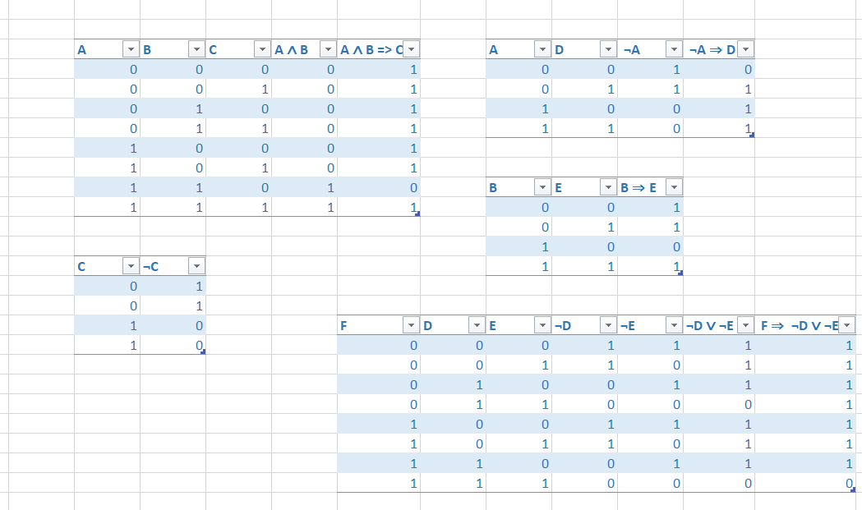

Din cauza primei conditii putem spune ca:

1. ¬A ⇒ D = 1 deci A si D trebuie sa fie diferite de 0.
2. B ⇒ E = 1 deci B trebuie sa fie diferit de 1 si E diferit de 0.
3. F ⇒ ¬D ∨ ¬E = 1. Stergand liniile ce contin E=0, D=0 sau F ⇒ ¬D ∨ ¬E = 0 obtinem urmatorul tabel: 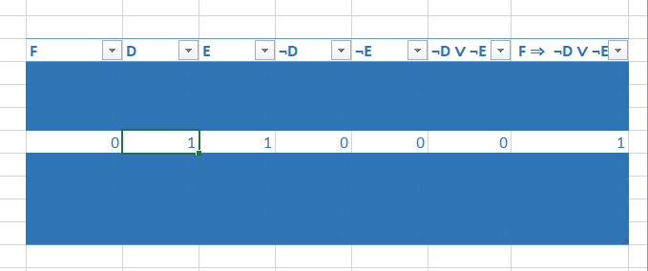

De aici rezulta ca „Superman nu exista” este o consecinta logica a propozitiei.