1. .

* F1, . . . , Fn ⊨ G  ~ ( (F1^F2^...Fn) => G ) (regula de deductie)
* F1, . . . , Fn ⊨ G  ⇔ ( F1 ∧ . . . ∧ Fn ∧ ¬G ) (ipoteza)

Notam cu M= F1^F2^...Fn

Din tabelul de mai jos se poate observa ca pentru a avea M∧ ¬G nesatisfiabil ar trebui sa ignoram cazul in care M=1 si G=0. Iar in acest caz propozitia M=>G este valida, deci M|=G este o consecinta logica .

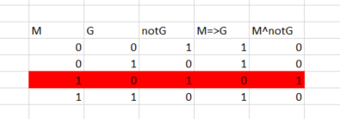

1. .

|  |  |  |  |
| --- | --- | --- | --- |
| **F** | **G** | **F ⇔ G** | **F ~ G** |
| **1** | **1** | **1** | **1** |
| 1 | 0 | 0 | 0 |
| 0 | 1 | 0 | 0 |
| **0** | **0** | **1** | **1** |

1. .

|  |  |  |  |  |  |  |  |
| --- | --- | --- | --- | --- | --- | --- | --- |
| Q | R | P | **notP** | **Q v R** | **Q => notP** | R^P | **not(R^P)** |
| 1 | 1 | 1 | **0** | **1** | **0** | 1 | **0** |
| 1 | 1 | 0 | **1** | **1** | **1** | 0 | **1** |
| 1 | 0 | 1 | **0** | **1** | **0** | 0 | **1** |
| 1 | 0 | 0 | **1** | **1** | **1** | 0 | **1** |
| 0 | 1 | 1 | **0** | **1** | **1** | 1 | **0** |
| 0 | 1 | 0 | **1** | **1** | **1** | 0 | **1** |
| 0 | 0 | 1 | **0** | **0** | **1** | 0 | **1** |
| 0 | 0 | 0 | **1** | **0** | **1** | 0 | **1** |

1. (a) functia prim

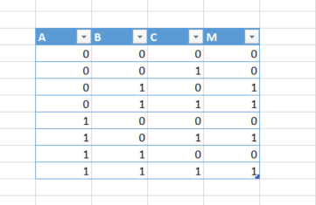

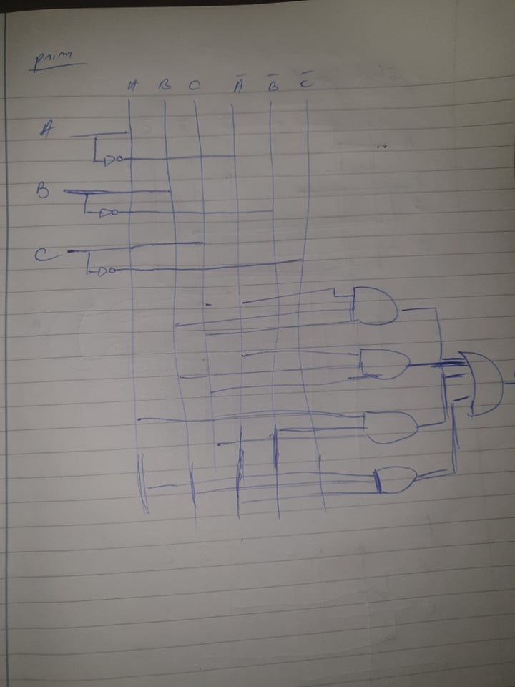

M= (notA^B^notC) V (notA ^B^C) V (A^notB^C) V(A^B^C)

b)

patrat perfect

M=(notA^notB^C)V(A^notB^notC)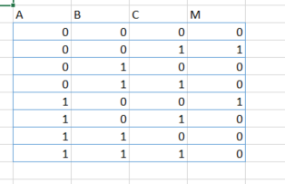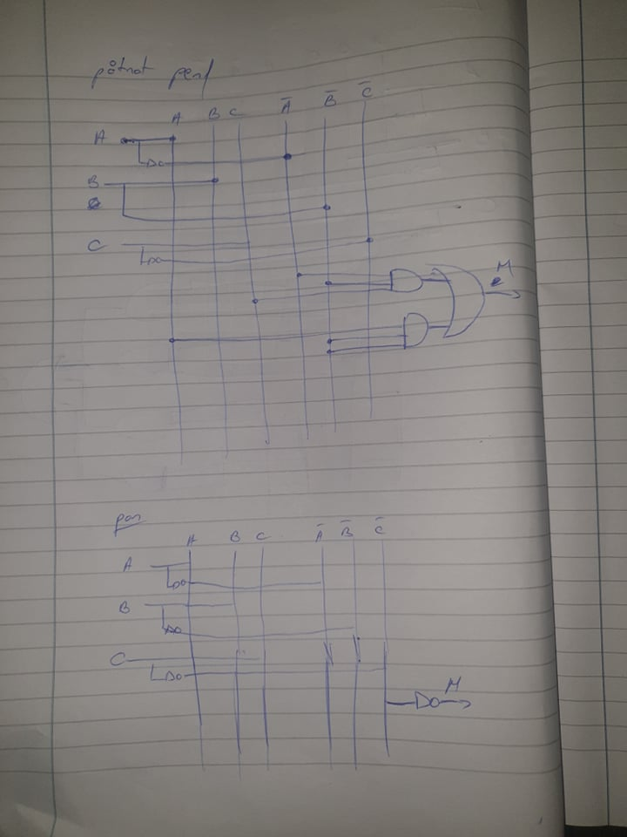

c)

Par

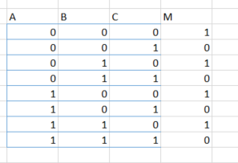

M=notC

Pentru ca in reprezentarea in binar toate cifrele sunt puteri ale lui 2. A=2^2, b=2^1, c=2^0.

Se observa ca suma celor 3 numere da un numar impar doar daca C este 1,deci numarul nostru reprezentat in binar este impar doar daca C=1

5.

