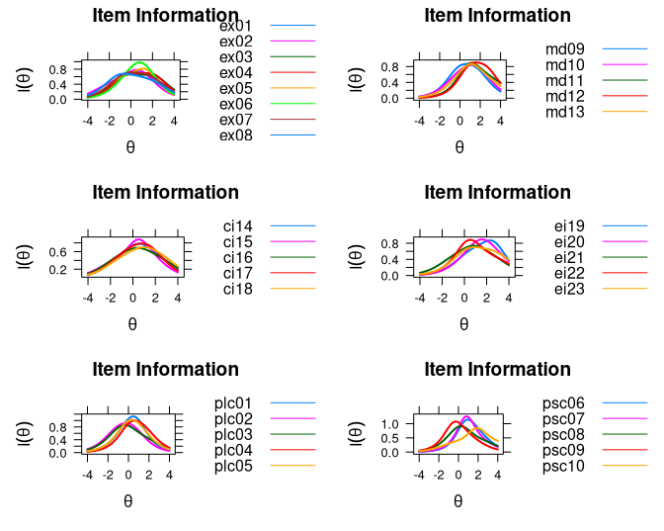

Figure 6. Item information of BAT items