MACHINE LEARNING
NOTES

CONTENTS
INTRODUCTION
1. What Is Machine Learning?
2. Types of Machine Learning
3. Differences between Supervised Learning and Unsupervised Learning and Reinforcement Learning
4. Machine Learning Pipeling
5. Applications of Machine Learning

What Is Machine Learning?

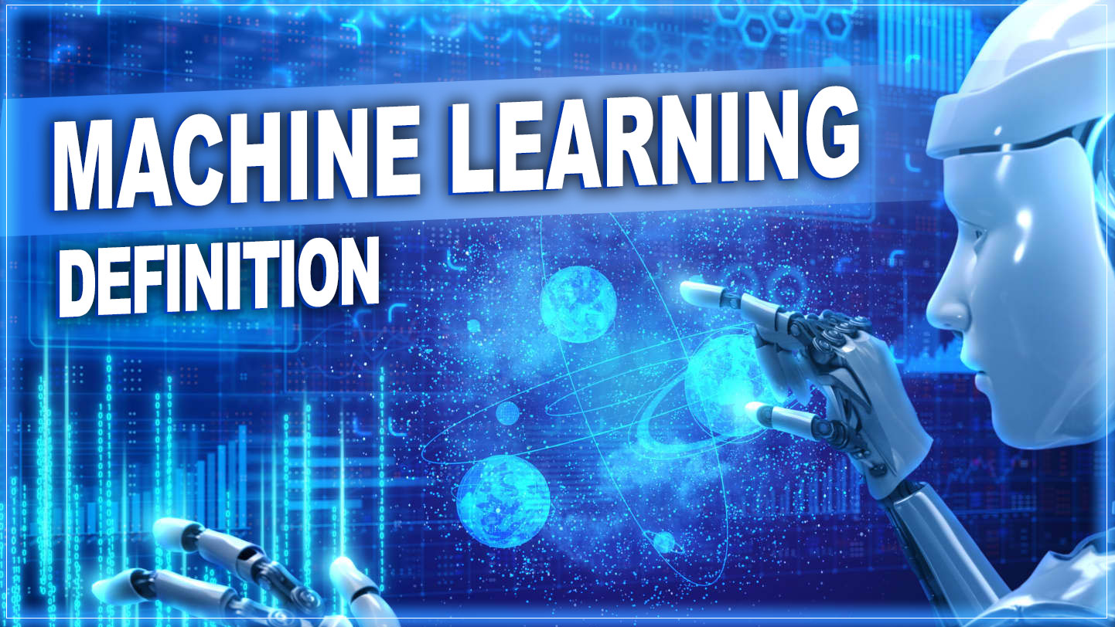

"A process by which computers use data to learn and make decisions without explicit programming."
Machine learning is a common type of artificial intelligence.
Machine learning is a subfield of artificial intelligence that uses algorithms trained on data sets to create models capable of performing tasks that would otherwise only be possible for humans, such as categorizing images, analysing data, or predicting price fluctuations. Today, machine learning is one of the most common forms of artificial intelligence and often powers many of the digital goods and services we use every day.
Machine learning is a subfield of artificial intelligence (AI) that uses algorithms trained on data sets to create self-learning models capable of predicting outcomes and classifying information without human intervention. Machine learning is used today for a wide range of commercial purposes, including suggesting products to consumers based on their past purchases, predicting stock market fluctuations, and translating text from one language to another.
Machine learning is typically the most mainstream type of AI technology in use today. Some of the most common examples of machine learning that you may have interacted with in your day-to-day life include:
Recommendation engines that suggest products, songs, or television shows to you, such as those found on Amazon, Spotify, or Netflix.
Speech recognition software that allows you to convert voice memos into text.
A bank’s fraud detection services automatically flag suspicious transactions.
Self-driving cars and driver assistance features, such as blind-spot detection and automatic stopping, to improve overall vehicle safety.
Machine learning is both simple and complex.
At its core, the method simply uses algorithms – essentially lists of rules – adjusted and refined using past data sets to make predictions and categorizations when confronted with new data. For example, a machine learning algorithm may be “trained” on a data set consisting of thousands of images of flowers that are labeled with each of their different flower types so that it can then correctly identify a flower in a new photograph based on the differentiating characteristics it learned from other pictures.

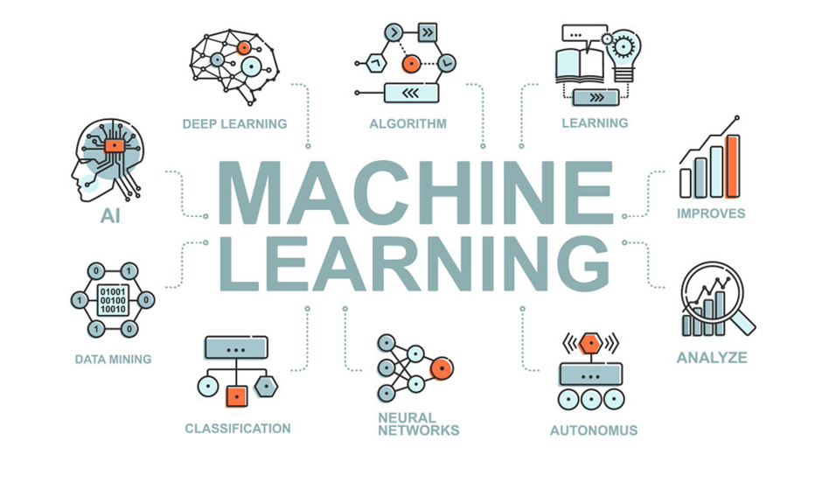
To ensure such algorithms work effectively, however, they must typically be refined many times until they accumulate a comprehensive list of instructions that allow them to function correctly. Algorithms that have been trained sufficiently eventually become “machine learning models,” which are essentially algorithms that have been trained to perform specific tasks like sorting images, predicting housing prices, or making chess moves. In some cases, algorithms are layered on top of each other to create complex networks that allow them to do increasingly complex, nuanced tasks like generating text and powering chatbots via a method known as “deep learning.”
As a result, although the general principles underlying machine learning are relatively straightforward, the models that are produced at the end of the process can be very elaborate and complex.
Machine learning refers to the general use of algorithms and data to create autonomous or semi-autonomous machines. Deep learning, meanwhile, is a subset of machine learning that layers algorithms into “neural networks” that somewhat resemble the human brain so that machines can perform increasingly complex tasks.
Machine learning is a branch of artificial intelligence that enables algorithms to uncover hidden patterns within datasets. It allows them to predict new, similar data without explicit programming for each task. Machine learning finds applications in diverse fields such as image and speech recognition, natural language processing, recommendation systems, fraud detection, portfolio optimization, and automating tasks.

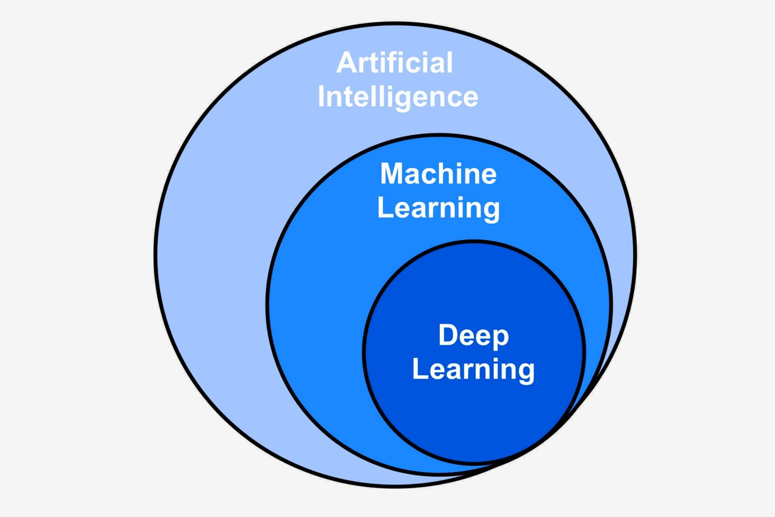

Machine learning (ML) is a field of study in artificial intelligence concerned with the development and study of statistical algorithms that can learn from data and generalise to unseen data, and thus perform tasks without explicit instructions. Within a sub discipline in machine learning, advances in the field of deep learning have allowed neural networks, a class of statistical algorithms, to surpass many previous machine learning approaches in performance.

ML finds application in many fields, including natural language processing, computer vision, speech recognition, email filtering, agriculture, and medicine. The application of ML to business problems is known as predictive analytics.

Statistics and mathematical optimisation (mathematical programming) methods comprise the foundations of machine learning. Data mining is a related field of study, focusing on exploratory data analysis (EDA) via unsupervised learning.
From a theoretical viewpoint, probably approximately correct learning provides a mathematical and statistical framework for describing machine learning. Most traditional machine learning and deep learning algorithms can be described as empirical risk minimisation under this framework.
History of ML
The term machine learning was coined in 1959 by Arthur Samuel, an IBM employee and pioneer in the field of computer gaming and artificial intelligence. The synonym self-teaching computers was also used in this time period
The earliest machine learning program was introduced in the 1950s when Arthur Samuel invented a computer program that calculated the winning chance in checkers for each side, but the history of machine learning roots back to decades of human desire and effort to study human cognitive processes.[10] In 1949, Canadian psychologist Donald Hebb published the book The Organization of Behavior, in which he introduced a theoretical neural structure formed by certain interactions among nerve cells.[11] Hebb's model of neurons interacting with one another set a groundwork for how AIs and machine learning algorithms work under nodes, or artificial neurons used by computers to communicate data.[10] Other researchers who have studied human cognitive systems contributed to the modern machine learning technologies as well, including logician Walter Pitts and Warren McCulloch, who proposed the early mathematical models of neural networks to come up with algorithms that mirror human thought processes.
By the early 1960s, an experimental "learning machine" with punched tape memory, called Cybertron, had been developed by Raytheon Company to analyse sonar signals, electrocardiograms, and speech patterns using rudimentary reinforcement learning. It was repetitively "trained" by a human operator/teacher to recognise patterns and equipped with a "goof" button to cause it to reevaluate incorrect decisions. A representative book on research into machine learning during the 1960s was Nils Nilsson's book on Learning Machines, dealing mostly with machine learning for pattern classification. Interest related to pattern recognition continued into the 1970s, as described by Duda and Hart in 1973.[14] In 1981, a report was given on using teaching strategies so that an artificial neural network learns to recognise 40 characters (26 letters, 10 digits, and 4 special symbols) from a computer terminal.
Tom M. Mitchell provided a widely quoted, more formal definition of the algorithms studied in the machine learning field: "A computer program is said to learn from experience E with respect to some class of tasks T and performance measure P if its performance at tasks in T, as measured by P, improves with experience E."[16] This definition of the tasks in which machine learning is concerned offers a fundamentally operational definition rather than defining the field in cognitive terms. This follows Alan Turing's proposal in his paper "Computing Machinery and Intelligence", in which the question, "Can machines think?", is replaced with the question, "Can machines do what we (as thinking entities) can do?"
Modern day Machine Learning algorithms are broken into 3 algorithms types: Supervised Learning Algorithms, Unsupervised Learning Algorithms, and Reinforcement Learning Algorithms.
Current Supervised Learning Algorithms have objectives of classification and regression.
Current Unsupervised Learning Algorithms have objectives of clustering, dimensionality reduction, and association rule.
Current Reinforcement Learning Algorithms focus on decisions that must be made with respect to some previous, unknown time and are broken down to either be studies of model based methods, and model free methods.
In 2014 Ian Good fellow and others introduced generative adversarial networks (GANs) with realistic data synthesis.[19] By 2016 Alpha Go obtained victory against top human players using reinforcement learning techniques.[20] Shortly after, transformer architectures obtained natural language processing, powering the now popular large language models advancing generative AI and multimodal applications
By the early 1960s, an experimental "learning machine" with punched tape memory, called Cybertron, had been developed by Raytheon Company to analyse sonar signals, electrocardiograms, and speech patterns using rudimentary reinforcement learning. It was repetitively "trained" by a human operator/teacher to recognise patterns and equipped with a "goof" button to cause it to reevaluate incorrect decisions.[12] A representative book on research into machine learning during the 1960s was Nils Nilsson's book on Learning Machines, dealing mostly with machine learning for pattern classification.[13] Interest related to pattern recognition continued into the 1970s, as described by Duda and Hart in 1973.[14] In 1981, a report was given on using teaching strategies so that an artificial neural network learns to recognise 40 characters (26 letters, 10 digits, and 4 special symbols) from a computer terminal
Modern day Machine Learning algorithms are broken into 3 algorithms types: Supervised Learning Algorithms, Unsupervised Learning Algorithms, and Reinforcement Learning Algorithms.
Current Supervised Learning Algorithms have objectives of classification and regression.
Current Unsupervised Learning Algorithms have objectives of clustering, dimensionality reduction, and association rule.
Current Reinforcement Learning Algorithms focus on decisions that must be made with respect to some previous, unknown time and are broken down to either be studies of model based methods, and model free methods.
In 2014 Ian Good fellow and others introduced generative adversarial networks (GANs) with realistic data synthesis.[19] By 2016 Alpha Go obtained victory against top human players using reinforcement learning techniques.[20] Shortly after, transformer architectures obtained natural language processing, powering the now popular large language models advancing generative AI and multimodal applications.

2. Types of Machine Learning

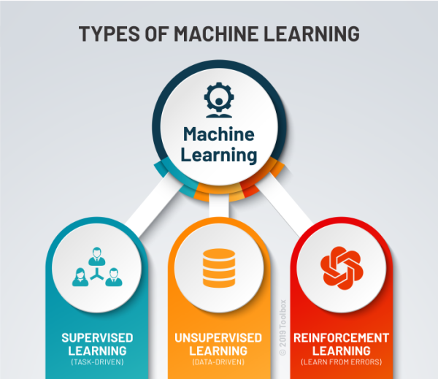

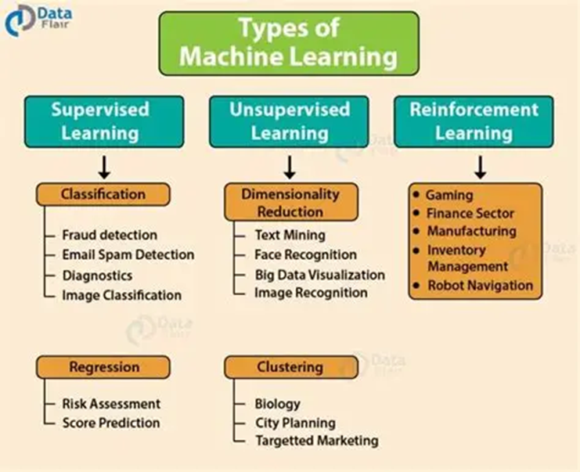
Supervised Learning
Unsupervised Learning
Reinforcement Learning

Supervised learning:
Supervised learning, the algorithm is trained on labeled data, meaning each input example is paired with a corresponding output or label. The goal is for the model to learn the relationship between inputs and outputs so it can make accurate predictions on new, unseen data.
Labeled Data: The training dataset includes both inputs and their correct outputs (labels). For example, an image of a fruit might be labeled as "apple" or "banana."
Guided Learning: The algorithm iteratively adjusts its predictions based on the labeled data, akin to a teacher supervising the learning process.
Output Prediction: The model learns a mapping function to predict outputs for new inputs.
Consider a dataset of house prices:
Inputs: Features like size, location, and number of rooms.
Outputs: The actual price of the house.
The model learns from this labeled data to predict house prices for new properties.

Types of Supervised Learning

Classification: Predicts categorical outputs (e.g., spam vs. not spam).
Regression: Predicts continuous outputs (e.g., house prices or stock values).

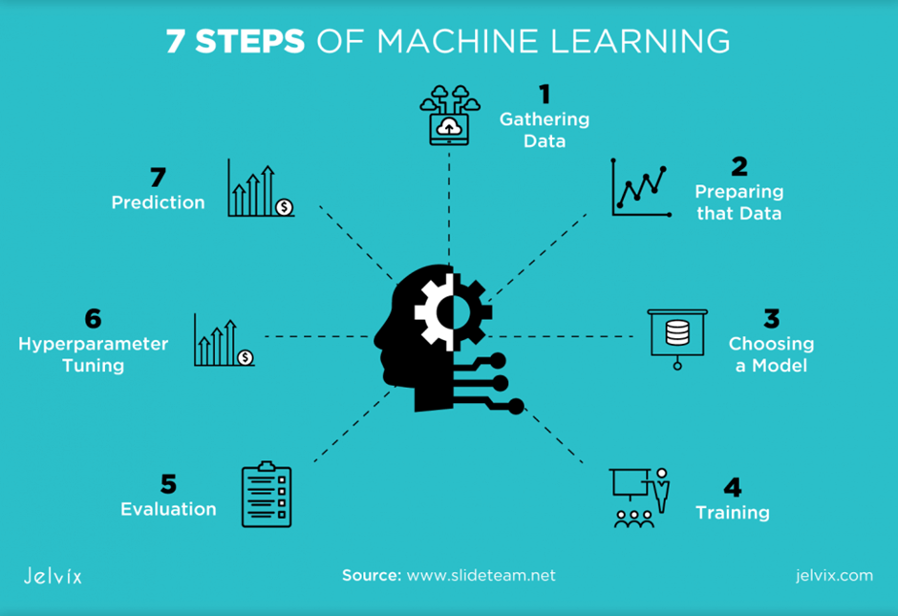

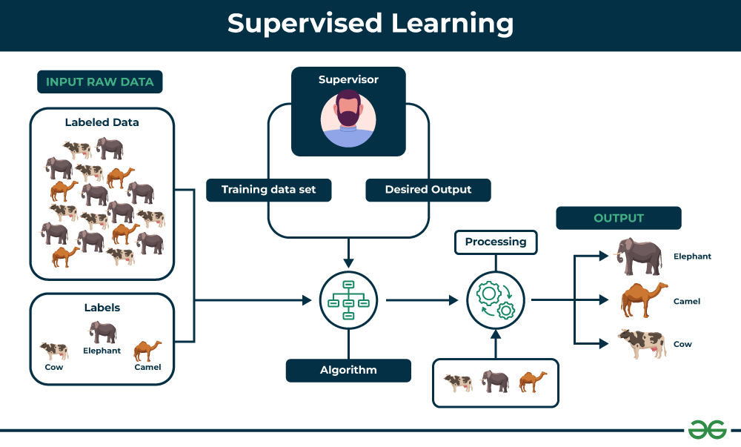

Machine learning is the branch of Artificial Intelligence that focuses on developing models and algorithms that let computers learn from data and improve from previous experience without being explicitly programmed for every task.In simple words, ML teaches the systems to think and understand like humans by learning from the data.

In this article, we will explore the various types of machine learning algorithms that are important for future requirements. Machine learning is generally a training system to learn from past experiences and improve performance over time. Machine learning helps to predict massive amounts of data. It helps to deliver fast and accurate results to get profitable opportunities.
There are several types of machine learning, each with special characteristics and applications. Some of the main types of machine learning algorithms are as follows:

Supervised Machine Learning
Unsupervised Machine Learning
Reinforcement Learning
Let's understand it with the help of an example.
Example: Consider a scenario where you have to build an image classifier to differentiate between cats and dogs. If you feed the datasets of dogs and cats labelled images to the algorithm, the machine will learn to classify between a dog or a cat from these labelled images. When we input new dog or cat images that it has never seen before, it will use the learned algorithms and predict whether it is a dog or a cat. This is how supervised learning works, and this is particularly an image classification.

Types of Supervised Learning
Supervised learning is classified into two types of algorithms:
1. Regression
A regression is used to predict continuous values such as house prices, stock prices or temperature. Regression algorithms learn how to connect input data to a specific number or value.
Some common regression algorithms include:
Linear Regression
Polynomial Regression
Lasso Regression
Ridge Regression

2. Classification
A classification is used to predict categorical values such as whether a customer will buy or not, whether an email is spam or not or whether a medical image shows a tumor or not. Classification algorithms learn how to connect input data to the probability of belonging to different groups or categories.
Some of the most common classification algorithms include:
Logistic Regression
Support Vector Machines
Decision Trees
Random Forests
Naive Bayes

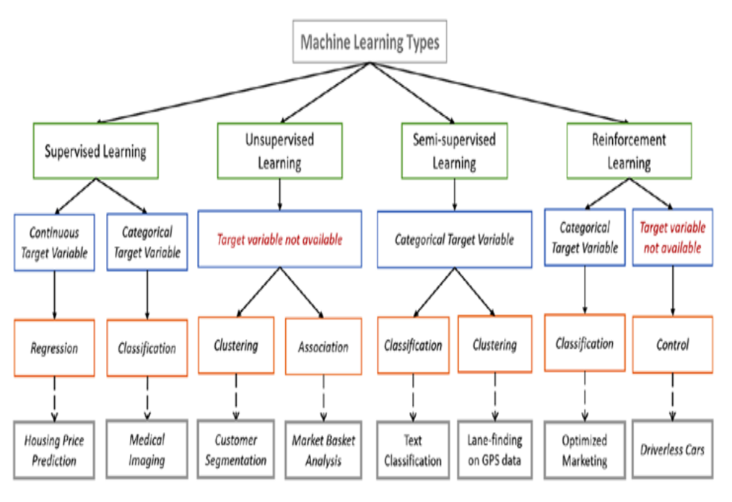

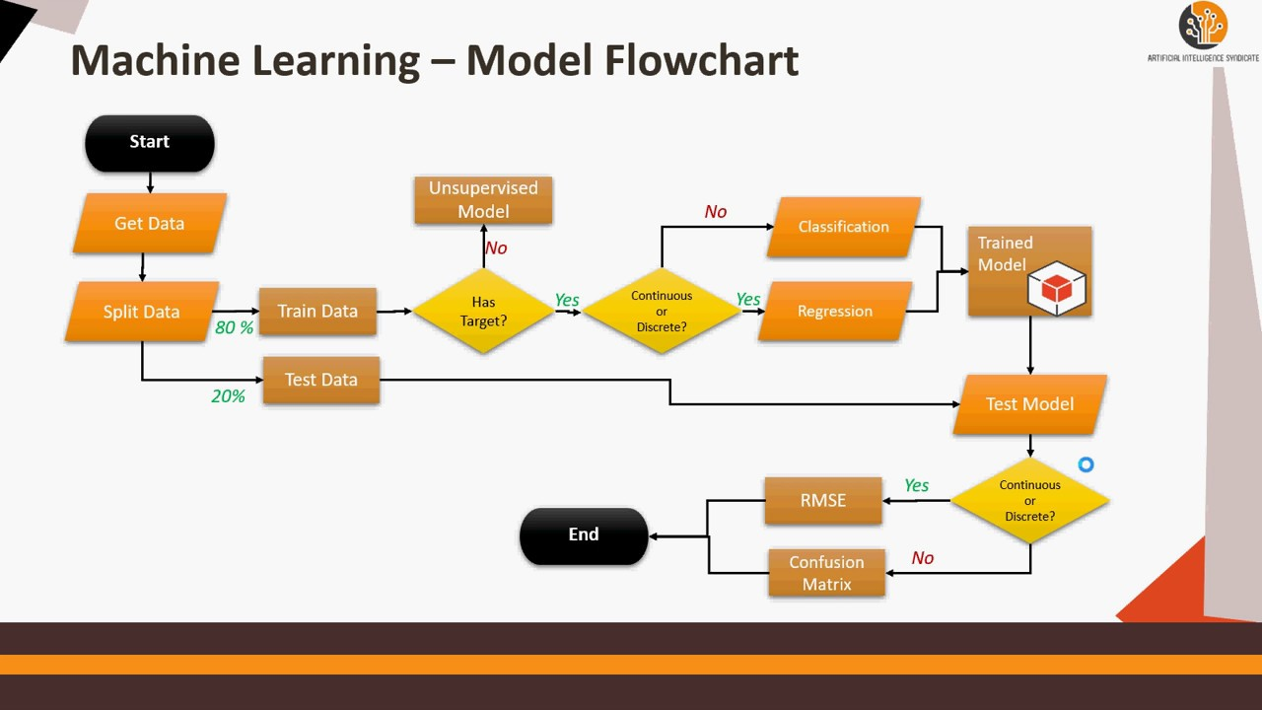

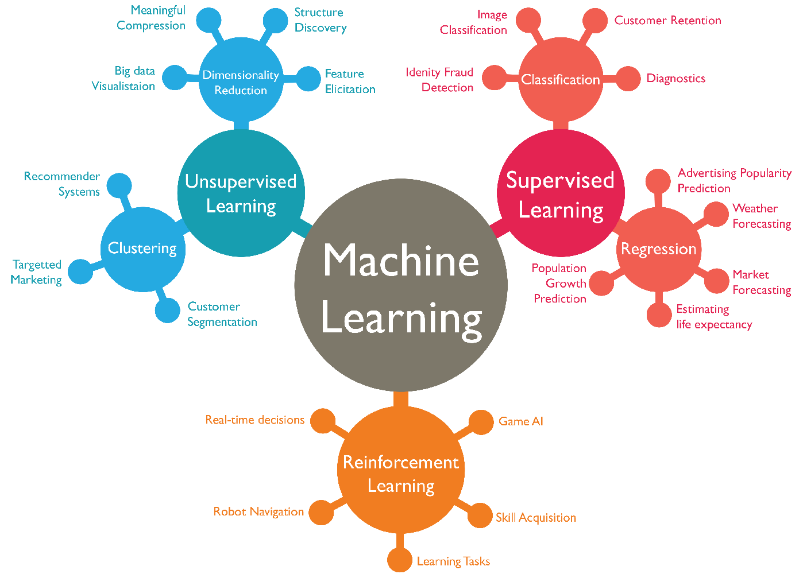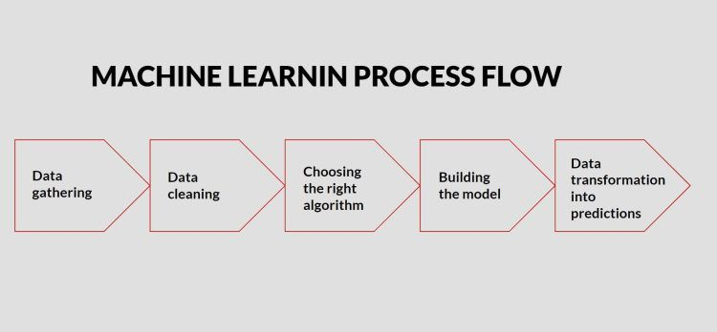

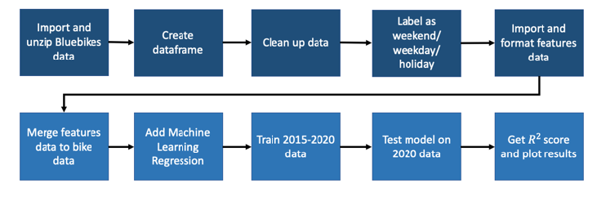

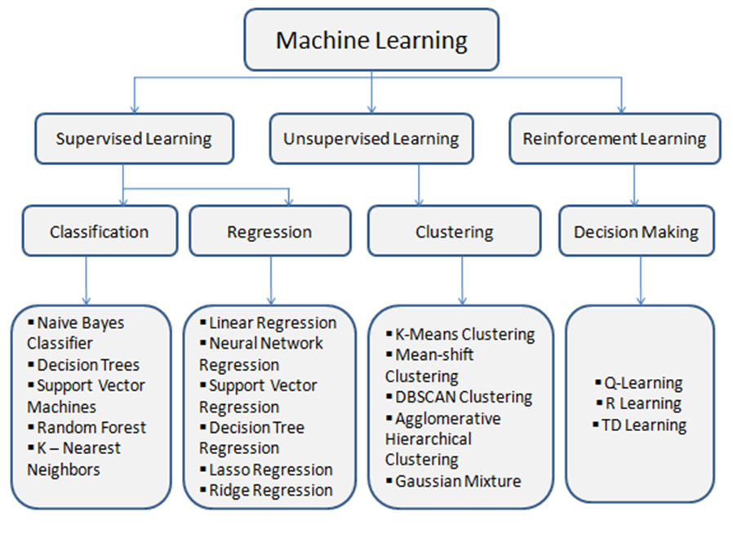

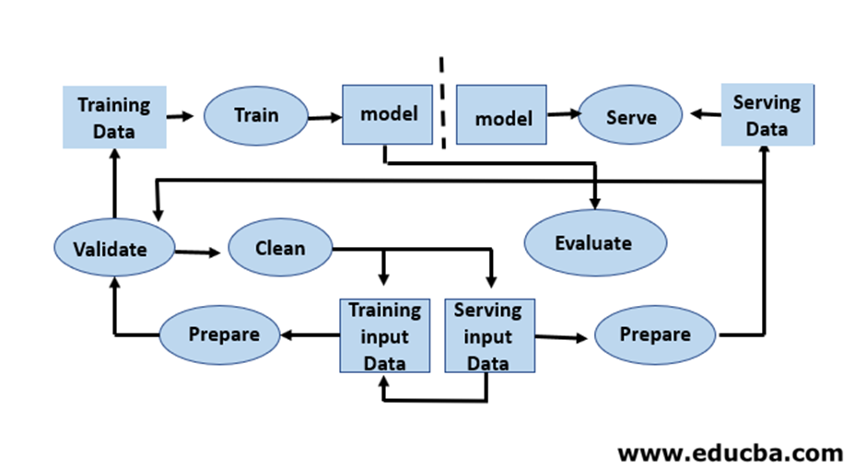

Image classification: It can automatically classify images into different categories such as animals, objects or scenes helps in the tasks like image search, content moderation and image-based product recommendations.
Medical diagnosis: It can assist in medical diagnosis by analysing patient data such as medical images, test results and patient history to identify patterns that suggest specific diseases or conditions.
Fraud detection: They can analyse financial transactions and identify patterns that shows fraudulent activity which helps financial institutions prevent fraud and protect their customers.
Natural language processing (NLP): It plays a important role in NLP tasks including sentiment analysis, machine translation and text summarization which enables m
Advantages of Supervised learning machines to understand and process human language effectively.

It learns from labeled examples to make accurate predictions on new, unseen data.
With more data and training, these models increases their accuracy which leads to better performance and more reliable predictions.
It works well for many tasks from detecting spam emails to predicting house prices as it has the ability to handle various computational challenges.
It can handle both classification (sorting data into categories) and regression (predicting numbers) which makes it flexible for different problems.

Disadvantages of Supervised learning
It requires a well-labeled dataset where each input has a corresponding output. Creating such datasets takes a lot of time, money and effort and can sometimes have mistakes, this makes supervised learning hard to use.
It works well on many tasks but can struggle with very complex or unstructured problems like understanding patterns or abstract ideas that doesn't relate to what it was trained on.
These models can sometimes overfit the training data which means they perform well on training data but poor on new, unseen data.
These models often need constant updating with new labeled data to stay accurate as real-world data changes over time.
What is unsupervised learning?
Part of machine learning which works differently from supervised because there is no teacher (supervisor) involved to guide the machine. In this approach the machine is given with data that has no labels or categories. It analyzes the data on its own to find patterns, groups or relationships without any prior knowledge. The machine learns by discovering hidden structures within the data without being told what the correct output should be.

For example, unsupervised learning can analyze animal data and group the animals by their traits and behaviour. These groups might represent different species which allows the machine to organize animals without any prior labels or categories.

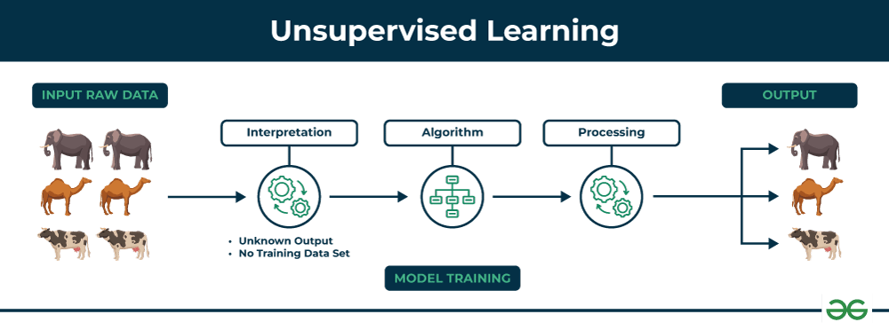
Example to understand
Imagine we have a machine learning model trained on many unlabeled images of dogs and cats. The model has never seen any labeled example that says “dog” or “cat” before so it doesn’t know how these animals look like.
Now, if we give the model a new image that contains both dogs and cats it won’t be able to directly label them as “dog” or “cat.” It will group parts of the image based on similarities and differences in features like shape or texture. It might separate the image into two groups one with dog-like features and other with cat-like features.
This happens because unsupervised learning doesn’t rely on prior knowledge or training with labeled data. It finds patterns and organizes data on its own helps in discovering information that wasn’t given before.

Types of Unsupervised Learning
Unsupervised learning is divided into two categories of algorithms:
1. Clustering
A clustering is used to group similar data points together. Clustering algorithms work by repeatedly moving data points closer to to the center of their group (cluster) and farther from points in other groups. This helps the algorithm to create clear and meaningful clusters. Some popular clustering algorithms include:
K-means clustering
Hierarchical clustering
Principal Component Analysis (PCA)
Singular Value Decomposition (SVD)
Independent Component Analysis
Gaussian Mixture Models (GMMs)
Density-Based Spatial Clustering of Applications with Noise (DBSCAN)
Association rule learning
An association rule learning used to find patterns and relationships between different items in a dataset. It looks for rules like “people who buy X often also buy Y”.
Some common Association rule learning algorithms include:
Apriori Algorithm
Eclat Algorithm
FP-Growth Algorithm

Supervised vs Unsupervised Machine Learning
Parameters | Supervised machine learning | Unsupervised machine learning
Input Data | They are trained on labeled data. | They are trained on unlabeled data.
Computational Complexity | Simpler method | Computationally complex
Accuracy | Highly accurate | Less accurate
No. of classes | No. of classes is known | No. of classes is not known
Data Analysis | Uses offline analysis | Uses real-time analysis of data
Algorithms used | Linear and Logistics regression, KNN Random forest, multi-class classification, decision tree, Support Vector Machine, Neural Network etc. | K-Means clustering, Hierarchical clustering, Apriori algorithm etc.
Output | Desired output is given. | Desired output is not given.
Training data | Use training data to infer model. | No training data is used.
Complex model | It is not possible to learn larger and more complex models with supervised learning. | It is possible to learn larger and more complex models with unsupervised learning.
Model | We can test our model. | We cannot test our model.
Supervision | Supervised learning needs supervision to train the model. | Unsupervised learning does not need any supervision to train the model.
Classification | Divided into two types:  - Regression  - Classification | Divided into two types:  - Clustering  - Association
Feedback | It has feedback mechanism. | It has no feedback mechanism.
Time Consumption | It's more time consuming. | It's less time consuming.
Example | Optical character recognition. | Find a face in an image.

Applications of Machine Learning

Applications of Machine Learning (ML)
Machine Learning (ML) is a branch of Artificial Intelligence (AI) that enables systems to learn from data and improve their performance over time without explicit programming. It is widely used across industries to automate tasks, make predictions, and derive insights. Below are some key applications of ML:
Healthcare and Medical Diagnosis ML is transforming healthcare by analyzing large datasets to assist in diagnosis and treatment. It is used for disease detection (e.g., cancer, pneumonia), predictive analytics to assess risks, and accelerating drug discovery by predicting compound interactions.
Smart Assistants and Human-Machine Interaction Virtual assistants like Siri, Alexa, and Google Assistant rely on ML for natural language processing and speech recognition. Chatbots powered by ML provide 24/7 customer support, while voice search and transcription tools enhance accessibility.

Personalized Recommendations ML powers recommendation systems in platforms like Netflix, Spotify, and Amazon. By analyzing user behavior, these systems suggest relevant content, products, or services, enhancing user engagement and satisfaction
Fraud Detection and Financial Forecasting In finance, ML detects fraudulent transactions by identifying anomalies in spending patterns. It is also used for credit scoring, loan risk assessment, and stock market predictions, enabling smarter financial decisions
Autonomous Vehicles and Smart Mobility Self-driving cars use ML for tasks like computer vision (recognizing traffic signals and pedestrians), sensor fusion (combining data from cameras and LiDAR), and behavior prediction (anticipating actions of other drivers). ML also optimizes traffic systems and predictive maintenance
Generative AI and Content Creation Generative AI, a subset of ML, creates original content such as text, images, and videos. Applications like ChatGPT and DALL-E rely on deep learning models to generate human-like responses and creative outputs

Speech Recognition and Customer Service ML enables speech-to-text systems and virtual agents that assist in customer service. These systems handle FAQs, provide personalized advice, and improve accessibility
Computer Vision ML is used in computer vision for tasks like facial recognition, medical imaging, and autonomous navigation. It helps derive actionable insights from visual data
Robotic Process Automation (RPA) ML automates repetitive tasks in industries, improving efficiency and reducing human intervention. Examples include automated stock trading and document processing

Machine Learning continues to evolve, offering transformative solutions across domains. However, challenges like data privacy, bias, and ethical concerns must be addressed to ensure responsible use.

