
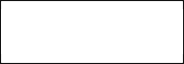
MALLA REDDY UNIVERSITY
Set-1
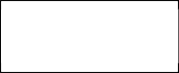
SoE - B.Tech - Department of CSE
R-22

IV Year - I Semester Minor-II Examination
Subject: E-Commerce Subject Code: MR22-1CS0191
Date: 12/11/2025(AN) Duration: 1Hr 15 Minutes Max. Marks: 15

Hall Ticket No.
Note: Answer any Three Questions. All Questions Carry Equal Marks 3 * 5 = 15M

Q.No | Question | Bloom level | CO | Mark
1) | Explain E-mail marketing, electronic marketplaces and portals? | L3 | 3 | 5 M
2) | Write about different advertising methods in ecommerce? | L4 | 4 | 5 M
3) | Write notes on following: a) Content Marketing b) Collaborative Computing | L5 | 5 | 5 M
4) | Write notes on following: a) Digital Certificate b) E-Logistic | L5 | 5 | 5 M

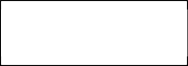
Course Instructor(s) Course Coordinator HOD DEAN
Set-2


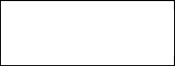
MALLA REDDY UNIVERSITY
R-22
SoE - B.Tech - Department of CSE

IV Year - I Semester Minor-II Examination
Subject: E-Commerce Subject Code: MR22-1CS0191
Date: 12/11/2025(AN) Duration: 1Hr 15 Minutes Max. Marks: 15

Hall Ticket No.
Note: Answer any Three Questions. All Questions Carry Equal Marks 3 * 5 = 15M

Q.No | Question | Bloom level | CO | Mark
1) | What are the risks involved in Electronic Payment Systems? | L3 | 3 | 5 M
2) | How do we achieve workflow automation in e-business environment? | L4 | 4 | 5 M
3) | What is Supply Chain Management? Why is it important in e-business environment? | L5 | 5 | 5 M
4) | Write short notes on any TWO topics. A) E-brokerage. B) Digital Signatures. | L4 | 4 | 5 M

