For TPE, we give the below text before they register/sign in. we might have to give a similar text

(can be UAT comment)

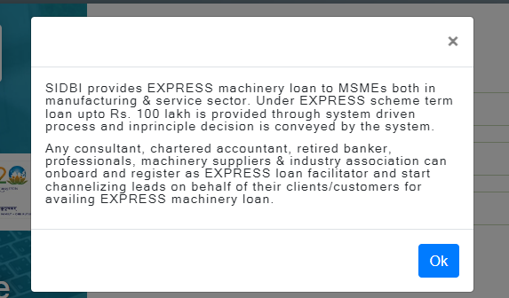

Terms and conditions – to show below on click

