Phase 4:

Air Quality Assessment of TamilNadu

# Model Building:

**Clustering Analysis:**

Use unsupervised learning techniques like K-Means clustering or DBSCAN to group your data into clusters based on the available features (SO2, NO2, RSPM/PM10). This can help identify patterns or similarities in air quality data.

# Importing Libraries:

The code begins by importing the necessary Python libraries, including Pandas for data handling, NumPy for numerical operations, Scikit-Learn for machine learning, and Matplotlib for data visualization.

import pandas as pd import numpy as np

from sklearn.cluster import KMeans import matplotlib.pyplot as plt

# Feature Selection:

The code selects the features (independent variables) to be used for clustering, which are 'SO2,' 'NO2,' and 'RSPM/PM10.' These features will be used to determine the clusters.

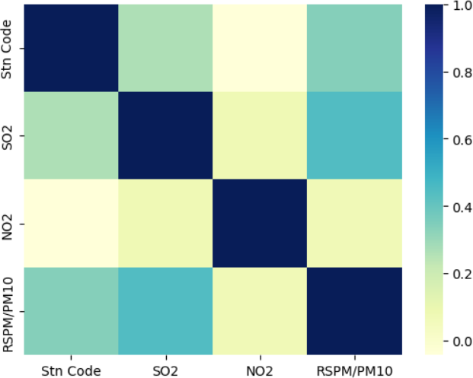import seaborn as sns sns.heatmap(data.corr(),cmap='YlGnBu')

X = data[['SO2', 'NO2', 'RSPM/PM10']]

# Feature Standardization:

The features are standardized using the StandardScaler from Scikit-Learn. Standardization ensures that all features have a mean of 0 and a standard deviation of 1, which is important for K-Means clustering.

from sklearn.preprocessing import StandardScaler scaler = StandardScaler()

X = scaler.fit_transform(X) inertia = []

for k in range(1, 11):

kmeans = KMeans(n_clusters=k, random_state=0).fit(X) inertia.append(kmeans.inertia_)

# Determine the Optimal Number of Clusters:

The code then uses the Elbow method to find the optimal number of clusters (K). It iterates through different values of K and calculates the inertia, which is the sum of squared distances from data points to their assigned cluster centers. The Elbow method plots these inertias for various K values to help you identify the "elbow point" where increasing K doesn't significantly reduce the inertia.

plt.figure(figsize=(8, 6))

plt.plot(range(1, 11), inertia, marker='o', linestyle='--') plt.title('Elbow Method for Optimal K') plt.xlabel('Number of clusters (K)')

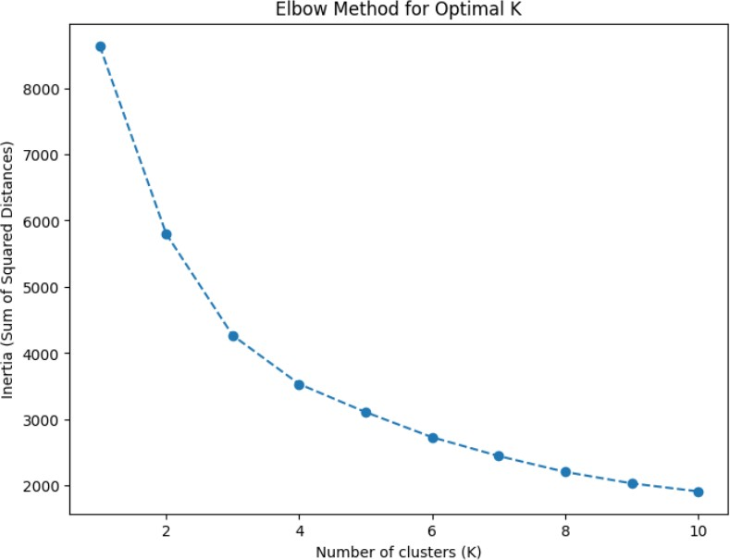plt.ylabel('Inertia (Sum of Squared Distances)') plt.show()

# K-Means Clustering:

After determining the optimal K (in this case, K = 3), the code performs K-Means clustering using the KMeans algorithm from Scikit-Learn. The clusters are assigned to the 'Cluster' column in the dataset.

kmeans = KMeans(n_clusters=2, random_state=0) data['Air Quality'] = kmeans.fit_predict(X)

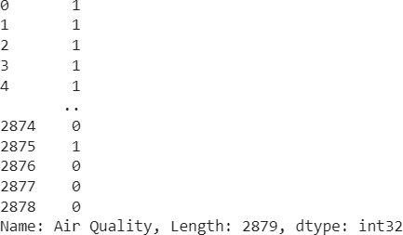

plt.figure(figsize=(8, 6))

plt.scatter(X[:, 0], X[:, 1], c=data['Air Quality'], cmap='viridis') plt.title('K-Means Clustering Results')

plt.xlabel('SO2') plt.ylabel('NO2') plt.show()

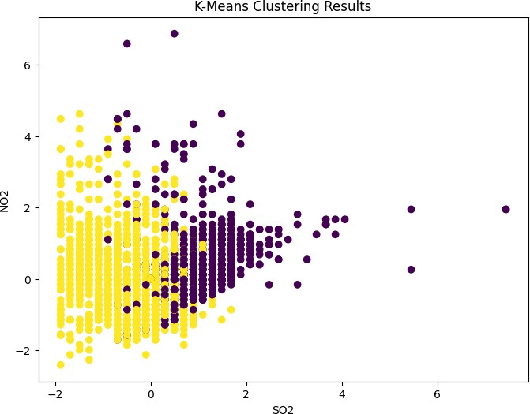

# Visualization and Insights:

1. The RSPM/PM10 and Air Quality relationship is weakly influenced by SO2.
2. RSPM/PM10 44 has the highest Air Quality at 16.63, out of which SO2 2 contributed the most at 1.
3. Air Quality is most unusual when City/Town/Village/Area is Trichy, Coimbatore and Mettur.
4. Chennai is the most frequently occurring category of City with a count of 1000 items with Air Quality values (34.7 % of the total).
5. Over all air qualities, the average of NO2 is 22.14, the average of RSPM/PM10 is 62.49,the average of SO2 is 11.5.

Tab 1



Values

|  |  |  |  |  |  |  |  |  |  |  |  |  |  |  |  |  |  |  |  |  |  |  |  |  |  |  |  |  |  |  |  |  |  |  |  |  |  |  |  |  |  |  |
| --- | --- | --- | --- | --- | --- | --- | --- | --- | --- | --- | --- | --- | --- | --- | --- | --- | --- | --- | --- | --- | --- | --- | --- | --- | --- | --- | --- | --- | --- | --- | --- | --- | --- | --- | --- | --- | --- | --- | --- | --- | --- | --- |
| Air Quality by SO2 and RSPM/PM10 | | | | | | | | | | | | | | | | | | | | | | | | | |  | | |  | | |  | | | RSPM/PM10  180K  RSPM/PM10 | | | NO2  63.7K  NO2 | | | | |
| Air Quality (Avera… | | | | | | | | | | | | | | | | | | | | | | | | | |  | | |  | | |  | | |
|  | | | | | | | | | | | | | | | | | | | | | | | | | |  | | |  | | |  | | |
| 0 | | | | |  | | |  | | | 1 | |  | |  | |  | |  | |  | |  | | |  | | |  | | |  | | |
| 16 | | | | | 24 | | |  | | | 32 | |  | | 40 | |  | | 48 | |  | | 56 | | |  | | | 63 | | |  | | |
| 2 20 | | | | |  | | | 28 | | |  | | 36 | |  | | 44 | |  | | 52 | |  | | | 60 | | |  | | | 67 | | |
|  |  |  |  |  | |  |  | |  |  |  |  |  |  |  |  |  |  |  |  |  |  |  |  |  | |  |  | |  |  | |  |  |
|  |  |  |  |  | |  |  | |  |  |  |  |  |  |  |  |  |  |  |  |  |  |  |  |  | |  |  | |  |  | |  |  |
|  |  |  |  |  | |  |  | |  |  |  |  |  |  |  |  |  |  |  |  |  |  |  |  |  | |  |  | |  |  | |  |
|  |  |  |  |  | |  |  | |  |  |  |  |  |  |  |  |  |  |  |  |  |  |  |  |  | |  |  | |  |  | |  |  |
|  |  |  |  |  | |  |  | |  |  |  |  |  |  |  |  |  |  |  |  |  |  |  |  |  | |  |  | |  |  | |  |  |
| SO2 | | | | | | | | | | | | | | | | | | | | | | | | | | | | | | | | | | | Air Quality by City/Town/Village/Area  City/Town/Village/Area  Trichy Thoothukudi Chennai  Madurai Cuddalore Salem  Mettur Coimbatore  0.41  0.99 0.52  0.69  0.94  0.78  0.88  0.79 | NO2, SO2 and RSPM/PM10 by Air Quality | | | | | |  |
|  | | | | | | | | | | | | | | | | | | | | | | | | | | | | | | | | | | | Measures | | | | | |  |
| 33.1K | | | | | | | | | | | | | | | | | | | | | | | | | | | | | | | | | | | NO2 | 150,000 | | SO2 |  | RSPM/PM10 |  |
| SO2 | | | | | | | | | | | | | | | | | | | | | | | | | | | | | | | | | | | 100,000 | | | | | |  |
| Air Quality | | | | | | | | | | | | | | | | | | | | | | | | | | | | | | | | | | |  | | | | | |  |
|  | | | | | | | | | | | | | | | | | | | | | | | | | | | | | | | | | | | 50,000 | | | | | |  |
|  | | | | |  | | | 0 | | |  | |  | |  | |  | |  | |  | | 1 | | |  |  |  |  |  |  |  |  |  |  | 0 | |  | 0 |  | 1 |
|  | | | | | | | | | | | | | | | | | | | | | | | | | | | | | | | | | | | Air Quality | | | | | |  |