Project Title**:** **Tour Planner**

**Abstract**

Users visit travel agencies for booking tours, hotels. The agencies maintains records of booking manually which is time taking and difficult. So, we develop online website called "Tour Planner" which automates and manages all tours and travel operations, such as user registration, searching and booking tour package. The administrator can add tours, hotels, and guides information to create a tour package. In this website users registers and login with their credential and search for tour packages and book a package sitting at their home or from anywhere. While booking a package the user does online payment through credit/debit card. The user can also cancel the booking at any time in the website. Users of this website can give feedback about the services provided by this agency so that they can improve the services time to time. This website is user friendly and easy to use by the users with minimum knowledge on browsing.

**Introduction**

Tour operation means organizing and managing tour packages for people to travel and explore different places. Almost everyone takes a break from their usual routine and travels somewhere for enjoyment, which is managed by a system called Tour Planner.

Tour Planner is a website helps customers arrange a trip from wherever they are in the world. It makes it easy to plan and book a trip without leaving their home. One website can show everything they need to know about different places and travel options all around the world. All the information is in one website. The administrator adds tour packages, tour places in each package, hotels information, and guides information; price etc. in the website.

Customers creates account in the website and logins to access tour information and package details and also have access to book a tour. Customers are allowed to pay amount online and get confirmation in their account regarding their bookings. The administrator can view and verify information about bookings on their booking page. This is a simple way to book tour. Anyone can use it.

Understand everything about it. This website helps manage tourism businesses.

**Problems identified in this project are**

1. The attackers can program to insert useless information in registration page to create bot accounts.

1. This project contains sensitive information like customer details, username, passwords, credit card details, mobile numbers, emails etc. Any data that is given in the website are in plain text which can be understandable to anybody and have less security to data.
2. SQL Injection techniques can be used by attackers to execute malicious SQL statements to break security measures and get entire data from database. Using SQL injection they can corrupt existing data by updating, adding useless data, deleting existing data in database

**Solutions for above problems**

1. In this project we implement captcha protection so that robot/programs cannot create accounts and instead only humans can create accounts. It prevents adding of useless data.
2. Every sensitive data like username, password, credit/debit card details, mobile numbers, emails etc., is stored in the database in encrypted format so that the data is secure and un-understandable format to un-authorized users.
3. For registration we implement captcha and otp confirmation to complete so that only humans can create accounts and that to be limited.
4. While login we implement captcha and a security question to answer by the user who wants to login which allows only humans can solve it and allows to access the website.

1. For online payment an otp is sent to registered mobile for online payment to book a tour package.
2. In this project we used parameterized queries like prepared statements and to prevent SQL injections and provide security to website and data.

**Modules in this project**

1. **Admin Module:** In this module admin adds tour packages, adds guides and hotel information. He can view the records of customers their bookings, feedbacks etc.
2. **User Module:** In this module the user registers and login in the website and searches for tour package then book it.
3. **Payment Module:** In this module the user do online payment for the tour booked and while booking the system sends an OTP to registered mobile to complete the payment process.
4. **OTP module:** This module sends OTP to registered mobile for conformation of registration of user to overcome un-authorized users to register. It also sends OTP to mobile for successful completion of payment in the website.
5. **Feedback Module:** In this module users can give feedback about the services provided by the company and company takes decisions based on the feedbacks for improving their business.

**Tour Planner Architecture diagram**

**Software requirements:-**

1. **Front end web technologies:** Html , CSS, Javascript, Bootstrap 5
2. **Back end language:** PHP
3. **Database:** MySql
4. **Server:** Wamp or Xampp
5. **Browser:** Mozilla Firefox, Chrome, Safari, Internet Explorer etc.

**Hardwar requirements:-**

1. **Processor:** Intel or Athlon or Apple
2. **RAM:** 4 GB or above
3. **Hard drive:** 400 GB or above

**Payment flow diagram**

2

Payment Gateway

Tour Planner Payment

1

3

Input payment details

Sends OTP to user mobile

USER

5

Input otp

4

OTP Verification

Correct otp

Payment Success

6

7

Payment Failed

**Features of the project that we implemented in this project are..**

1. Administrator can login into the website and can add and manage the tour places and tour packages with images.
2. Administrator can also add guides to hotels where the tourists resides.
3. Administrator can view the bookings made by the customers and can also view the feedbacks given by the customers.
4. Administrator can view the payments details of tour bookings by customers.
5. Guides can register and login into the site and can view the hotel details at which tourists come and can meet them for taking them for visiting the sites.
6. Customers can register and login into the website and can search for the tour packages according to their requirements.
7. Customers can book a tour package and can pay the package amount online.
8. Customers can view the booking history.
9. Customers can give feedback about the services and tour places in the website to the administrator.

**Securities provided to the website and data in this project**

1. In the website prepared statements database programming is implemented to overcome SQL Injections to make website and data secure.
2. Captcha like I am not robot feature is implemented in the project while registration, login and online payment so that only humans can operate the site and website become secure.
3. In login page of customer we have provided a security math question which can be solved by humans and not by the robots and make more secure the site.
4. While registration an OTP is sent to the registered mobile using firebase and after OTP verification only the registration will be completed.
5. While online payment in the website an OTP is sent to registered mobile for verification and after successful verification only the payment will be done so that only proper customers of the site can to payment.

**Database tables used in this project development**

create table admin

(username varchar(30) primary key,

password varchar(30) not null);

create table hotel

(hotel_id int primary key auto_increment,

hotel_name varchar(100) not null,

hotel_type varchar(60) not null,

address varchar(300),

city varchar(60),

state varchar(60),

country varchar(60),

zipcode varchar(15),

mobile varchar(15),

email varchar(15),

latitute varchar(30),

longitute varchar(30),

hotel_pic varchar(150),

password varchar(100));

create table guides

(guide_id int primary key auto_increment,

guide_name varchar(60) not null,

address varchar(500) not null,

mobile varchar(15) not null,

email varchar(60) unique,

guide_pic varchar(150),

password varchar(100));

create table tour_places

(place_id int primary key auto_increment,

place_name varchar(100),

description varchar(500),

tour_pic varchar(150),

address varchar(500),

latitute varchar(30),

longitute varchar(30));

create table tour_package

(package_id int primary key auto_increment,

package_name varchar(100),

package_description varchar(300),

package_pic varchar(150),

price float,

start_date date,

end_date date);

create table tour_package_places

(tour_place_id int primary key auto_increment,

package_id int,

place_id int,

foreign key (package_id) references tour_package(package_id),

foreign key (place_id) references tour_places(place_id));

create table tour_package_guide_hotel

(tour_id int primary key auto_increment,

tour_place_id int,

hotel_id int,

guide_id int,

foreign key (tour_place_id) references tour_package_places(tour_place_id),

foreign key (hotel_id) references hotel(hotel_id),

foreign key (guide_id) references guides(guide_id));

CREATE TABLE customers (

customer_id int(11) primary key AUTO_INCREMENT,

customer_name varchar(50) DEFAULT NULL,

address varchar(300) DEFAULT NULL,

zipcode varchar(15) DEFAULT NULL,

mobile varchar(15) DEFAULT NULL,

email varchar(50) unique,

pic varchar(150),

password varchar(30) DEFAULT NULL,

registerDate date DEFAULT NULL

) ;

create table cart

(cart_id int primary key auto_increment,

customer_id int,

package_id int,

package_name varchar(100),

price float,

foreign key (package_id) references tour_package(package_id),

foreign key (customer_id) references customers(customer_id));

CREATE TABLE accounts (

acc_number varchar(50) unique NOT NULL,

cust_name varchar(50) DEFAULT NULL,

address varchar(200) DEFAULT NULL,

mobile varchar(20) DEFAULT NULL,

email varchar(50) DEFAULT NULL,

card_type varchar(50) NOT NULL,

card_no varchar(50) DEFAULT NULL,

exp_date varchar(10) DEFAULT NULL,

cvv int(11) DEFAULT NULL,

balance float DEFAULT NULL,

PRIMARY KEY (card_no)

) ;

CREATE TABLE payments (

payment_id int(11)primary key AUTO_INCREMENT,

payment_date datetime,

package_id int,

customer_id int,

payment_type varchar(30),

card_type varchar(100),

card_no varchar(100),

exp_date varchar(100),

cvv varchar(100),

price float,

foreign key (package_id) references tour_package(package_id),

foreign key (customer_id) references customers(customer_id),

foreign key (card_no) references accounts(card_no));

create table feedback

(feedback_id int primary key auto_increment,

feedback_date date,

customer_id int,

package_id int,

feedback varchar(300),

rating int,

foreign key (package_id) references tour_package(package_id),

foreign key (customer_id) references customers(customer_id));

**Screen shots of Customers**

1. Customer new registration page where two way authentication is checked for securing the registration by customers.

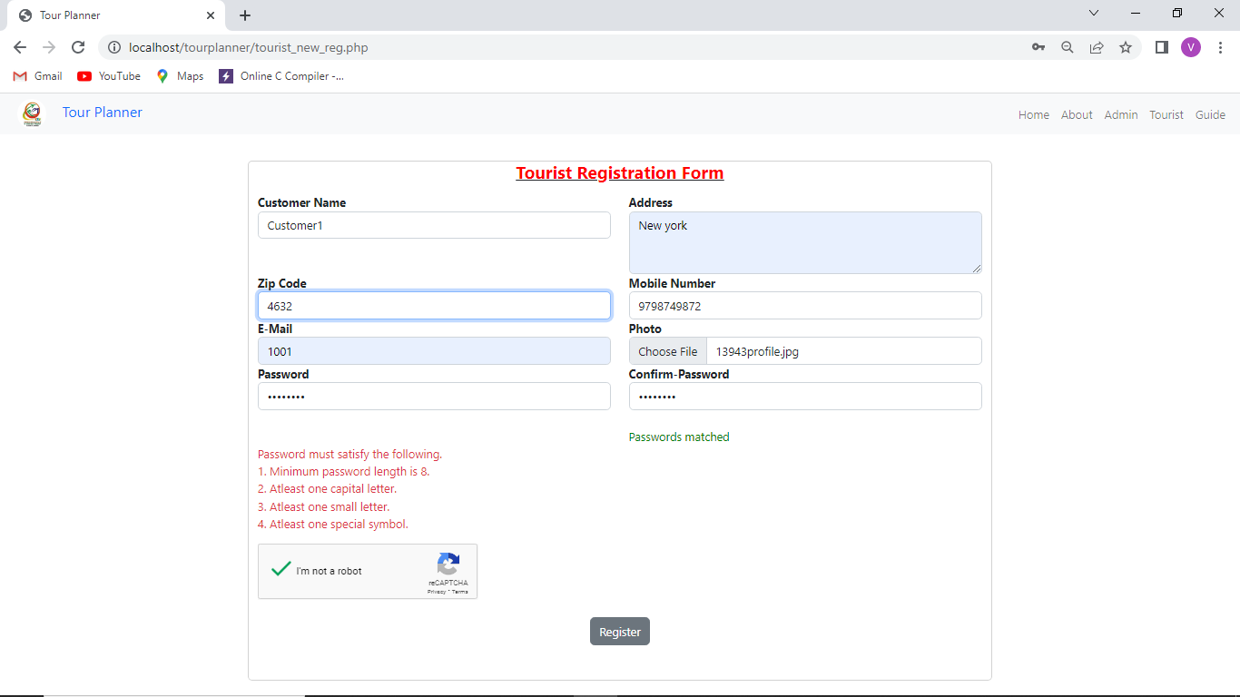

1. After filling the above registration form and captcha check we get opt verification page as

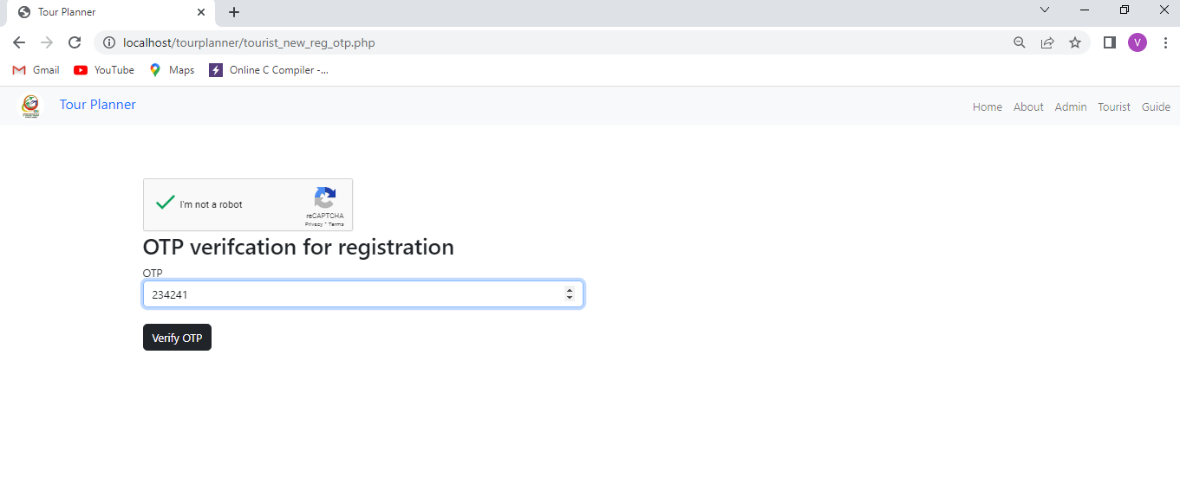

After verification of OTP then login page for customer is shown.

1. Customer Login page where the customers give email, password , answer for security question and captcha check and clicks on login button for enter into website.

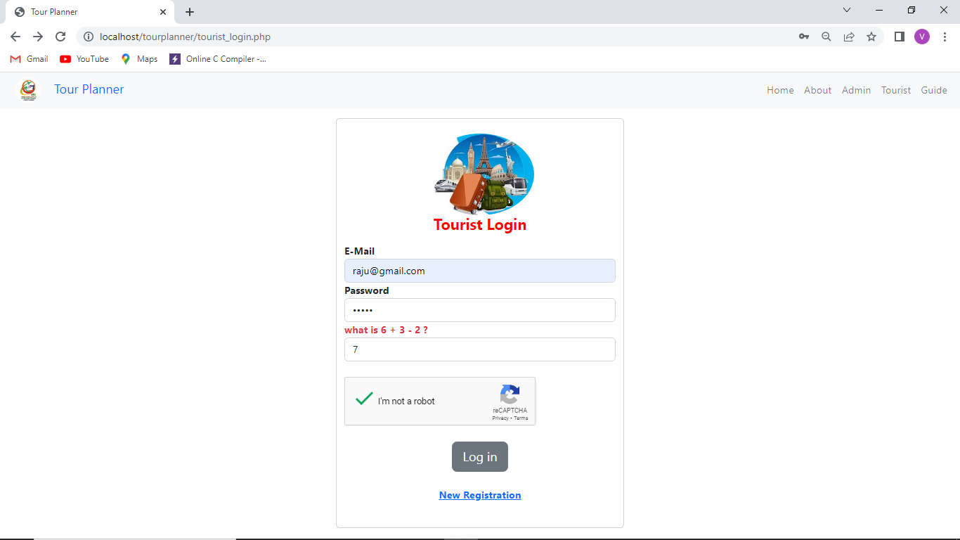

All these activities provide login security in the project.

1. After successfully login customers get the home page as

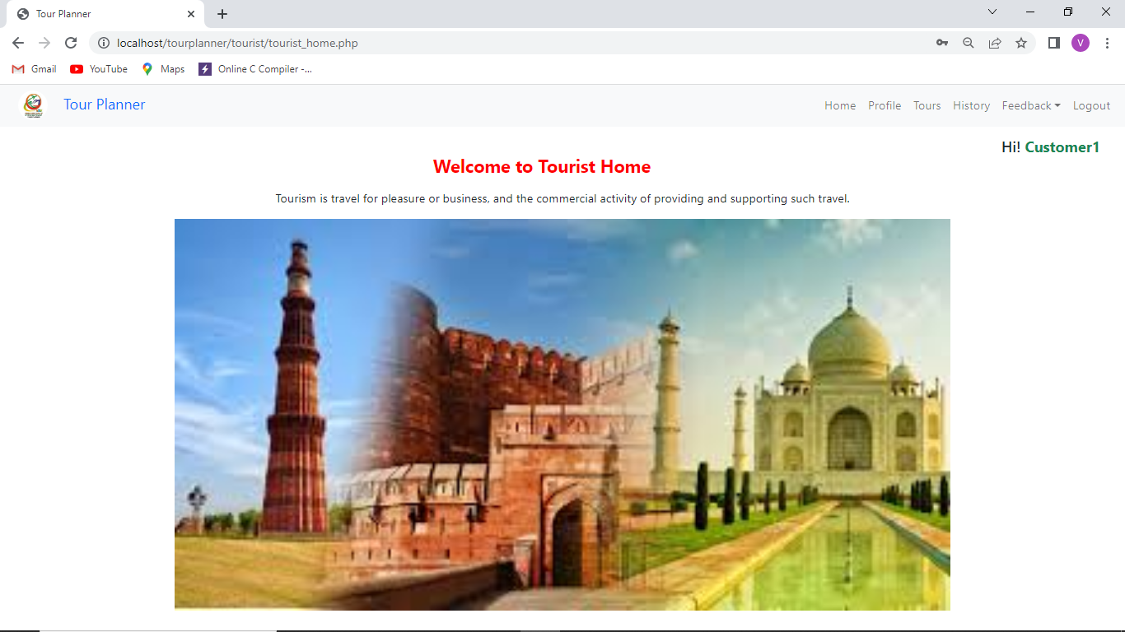

1. When tours menu item is clicked we get the page as

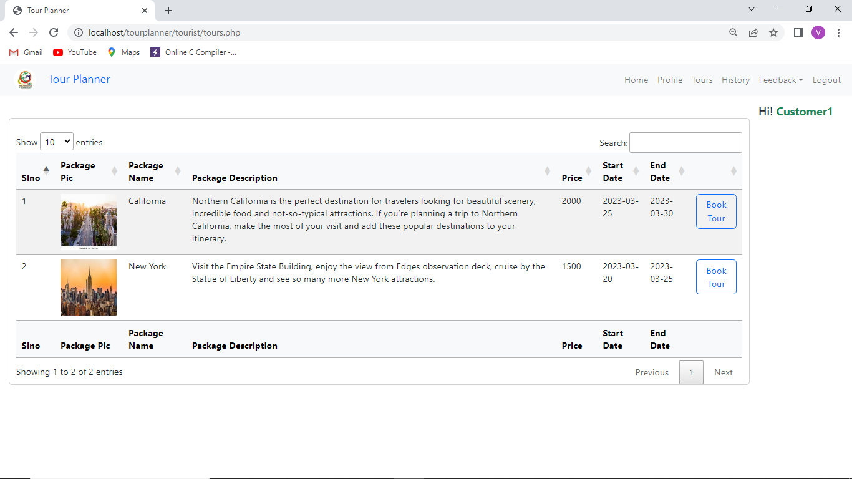

1. When we click on the Book tour we the next page where it shows tour details as

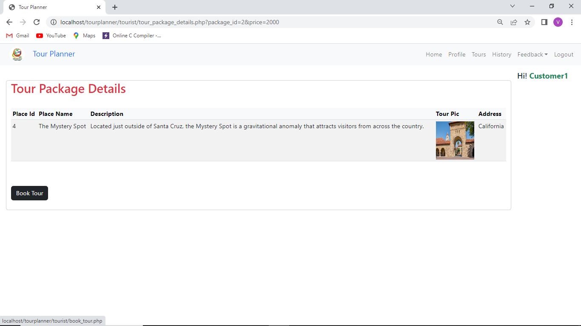

1. If we click on the Book tour button in the above page we get payment page as

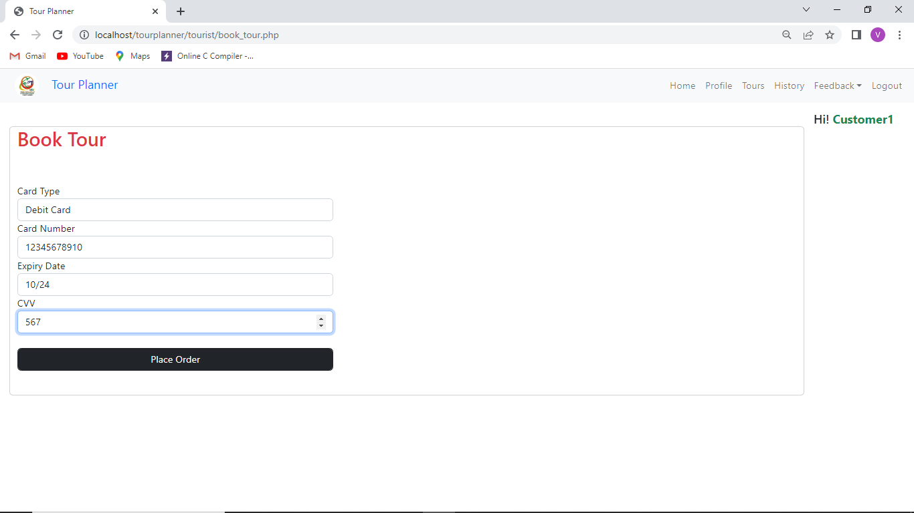

1. After giving card details then it send OTP to the registered mobile to complete the payment as

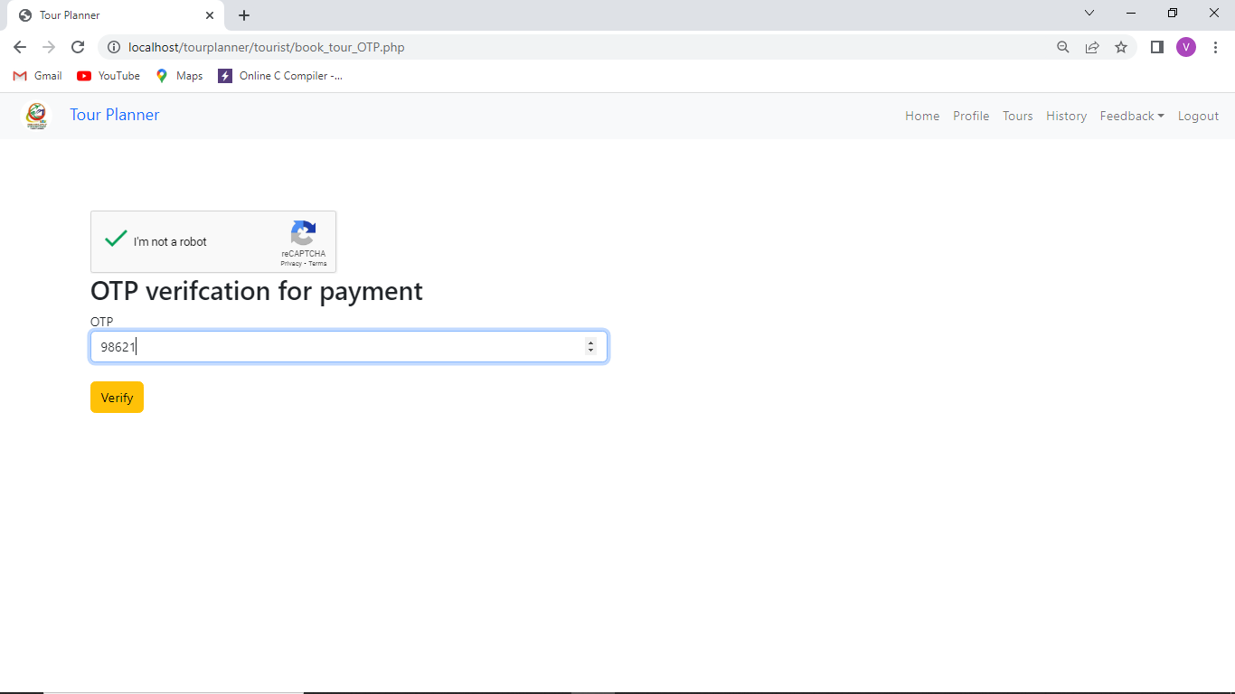

1. After OTP verification payment will be completed and can see the booking history as

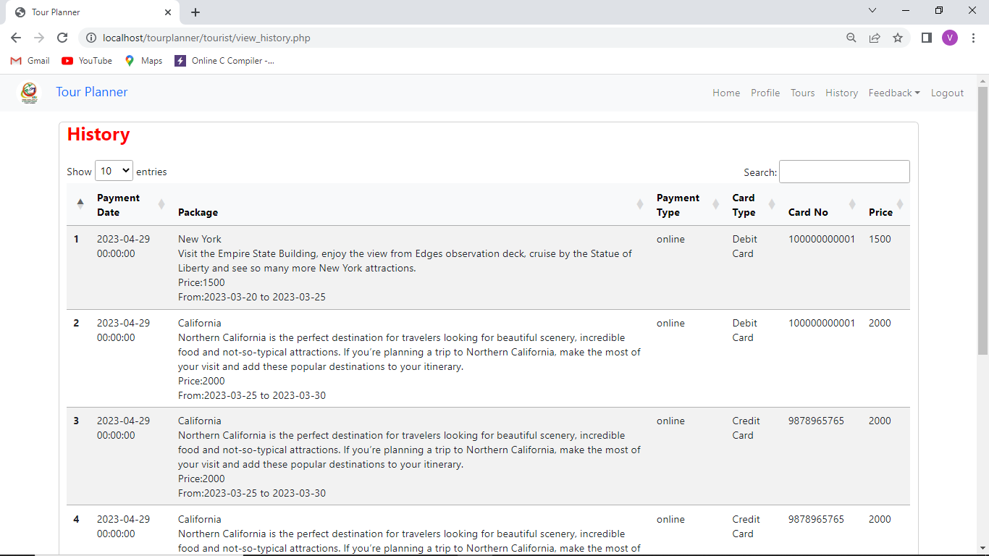

1. Customer can give the feedback in feedback page as

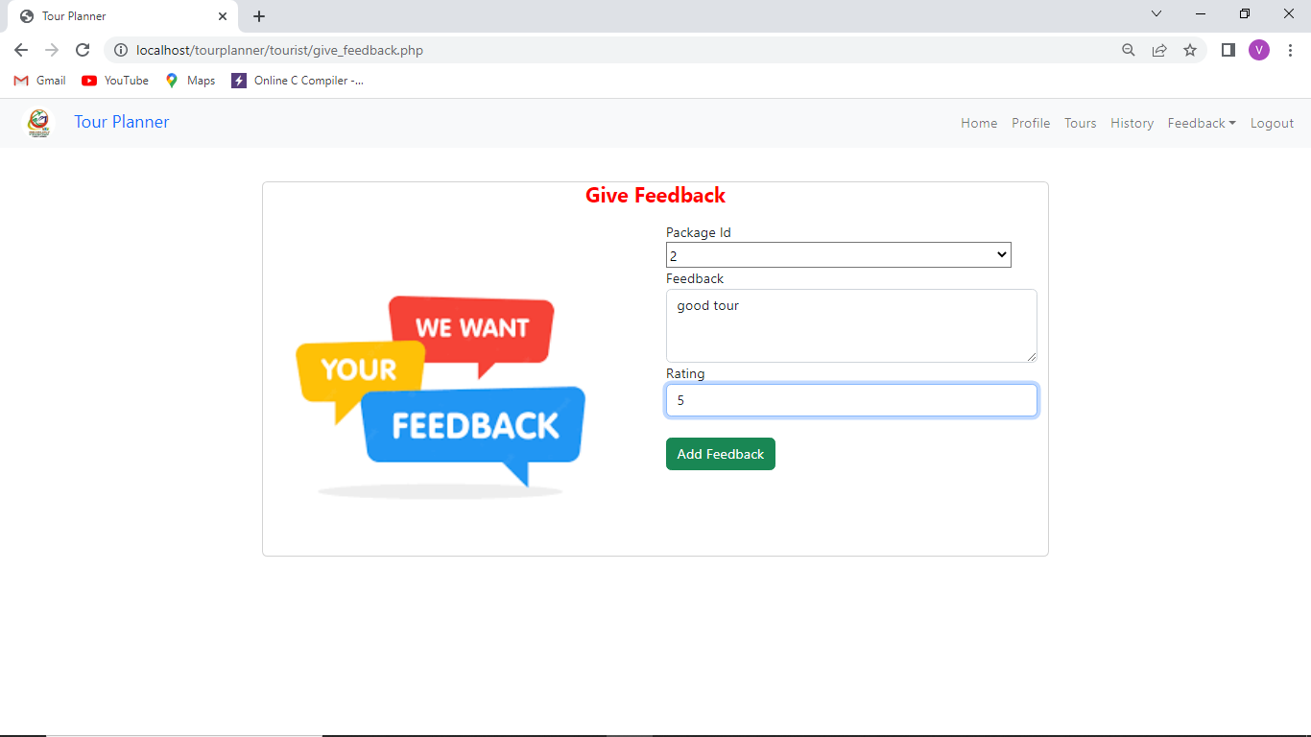

**Screen shots of administrator activities**

1. Admin login page

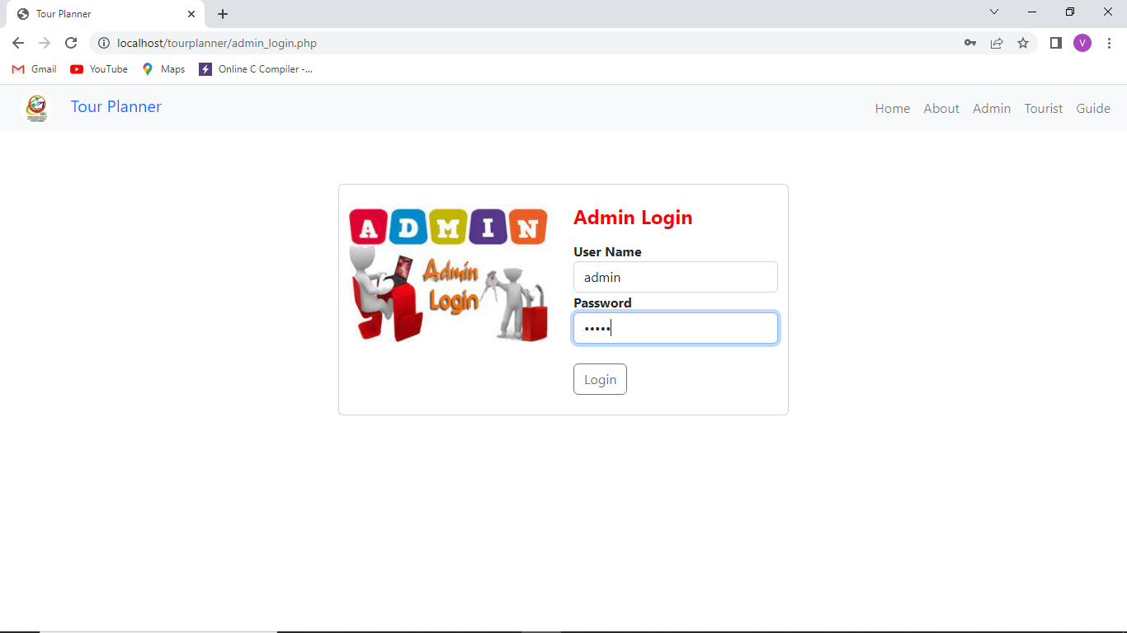

2.Admin home page

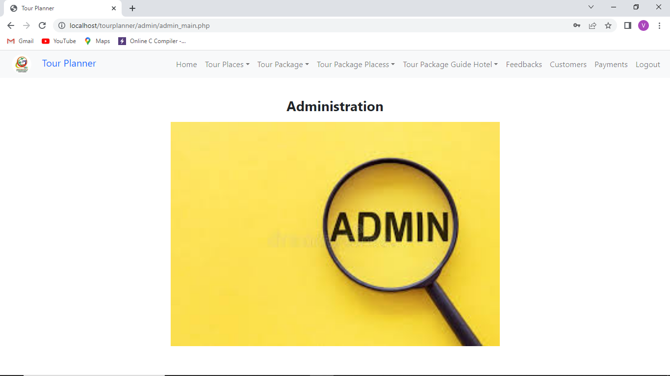

3.Add tour places

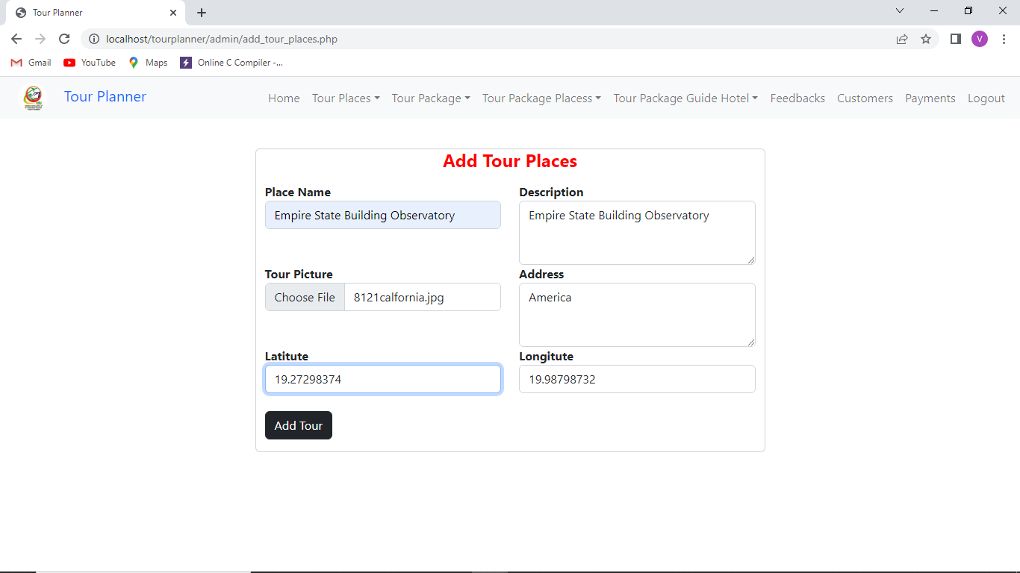

4.Manage tour places

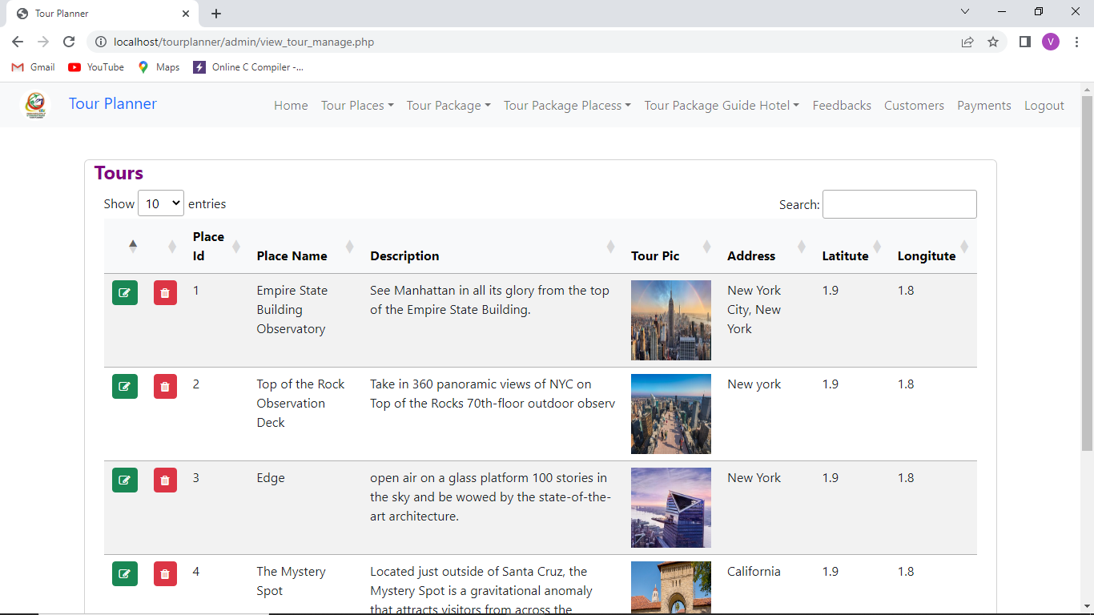

**5.Add tour package**

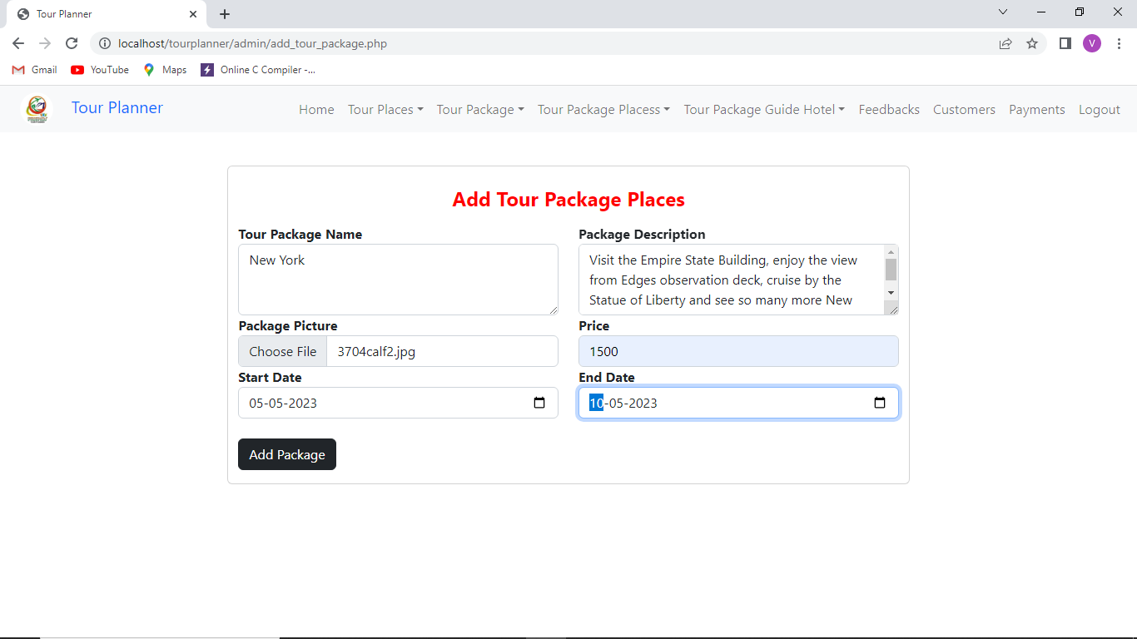

**6.Manage tour packages**

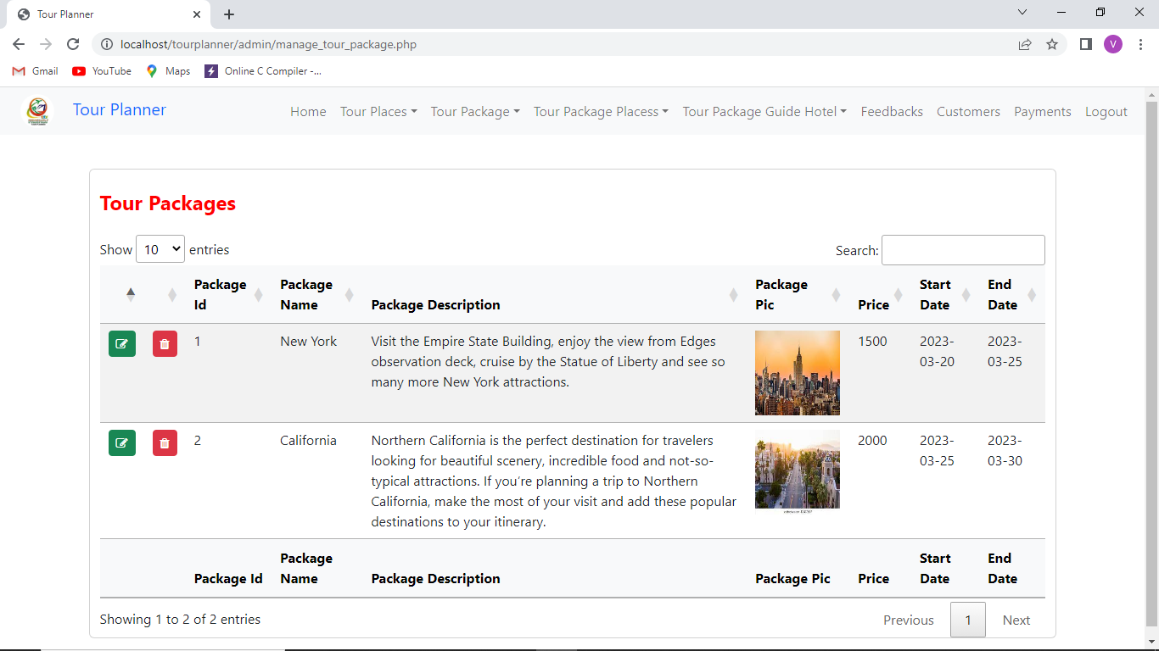

7.Add guide to hotel

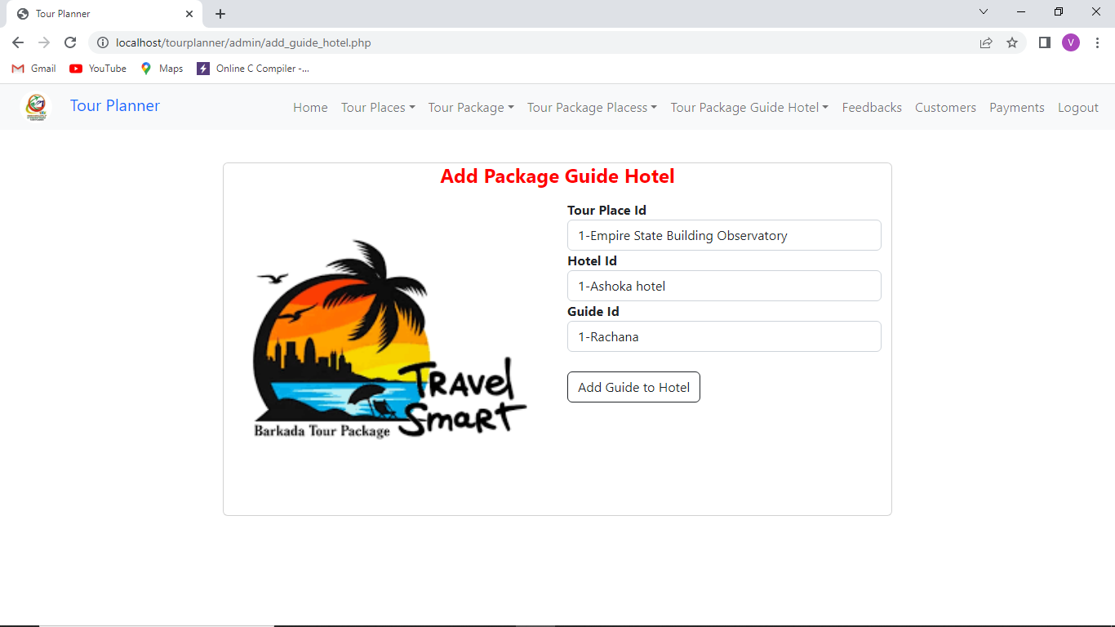

8.View feedbacks by admin

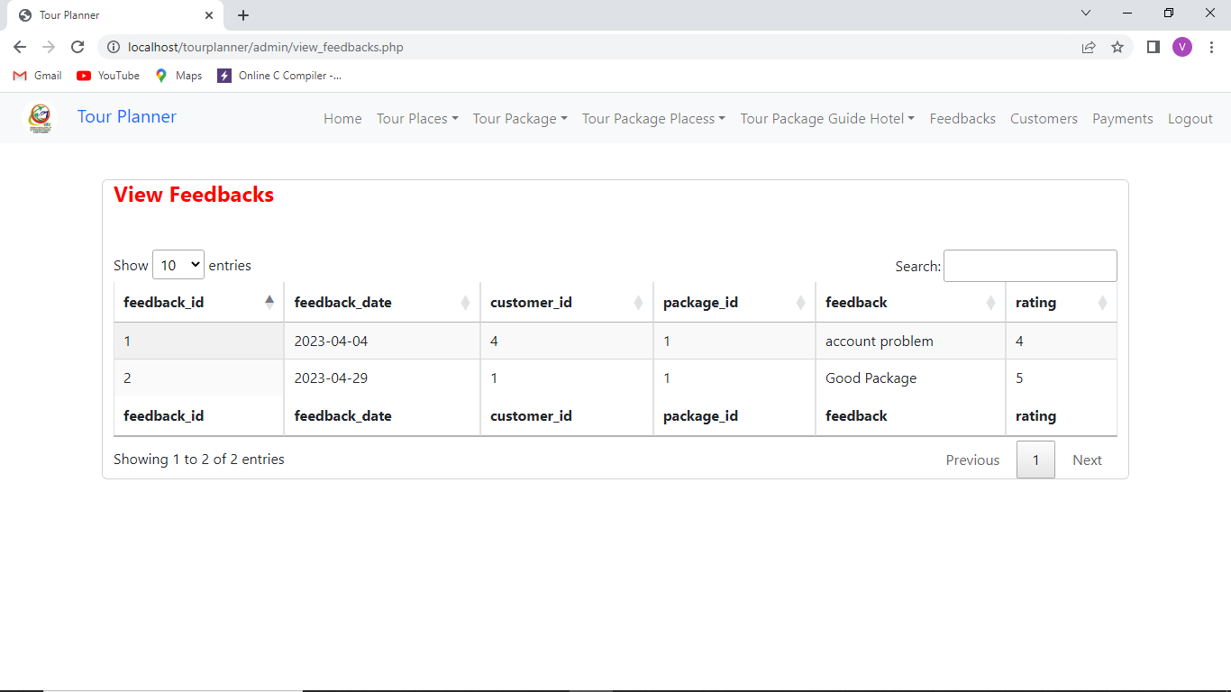

9.view customers by admin

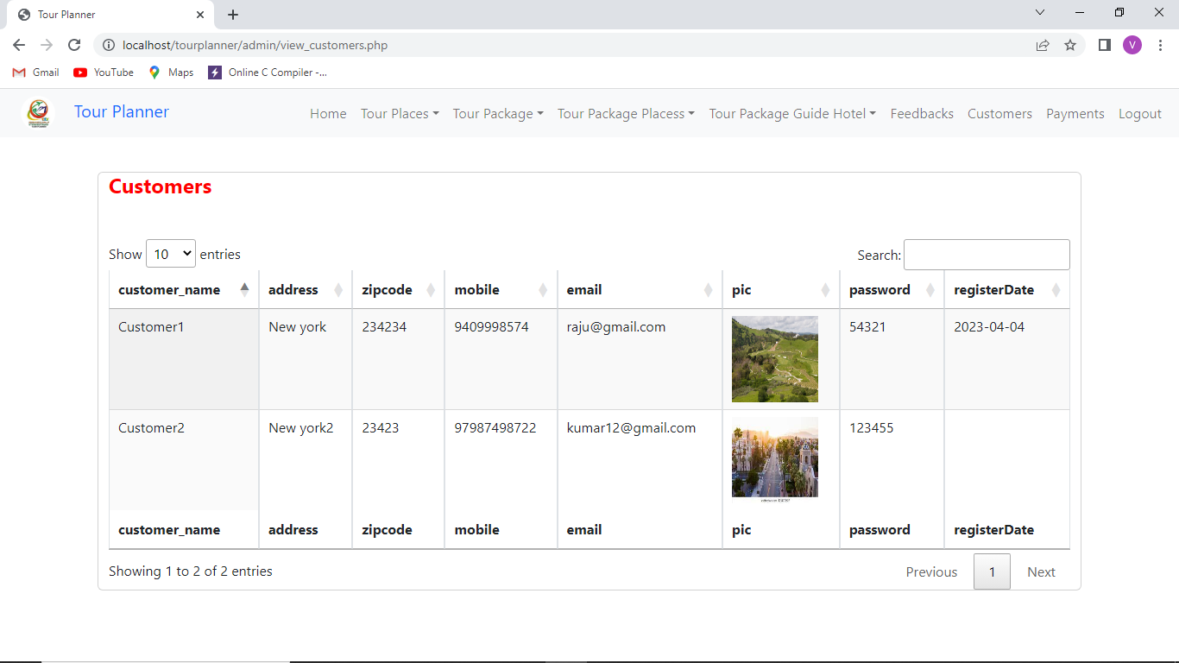

1. Admin view payments

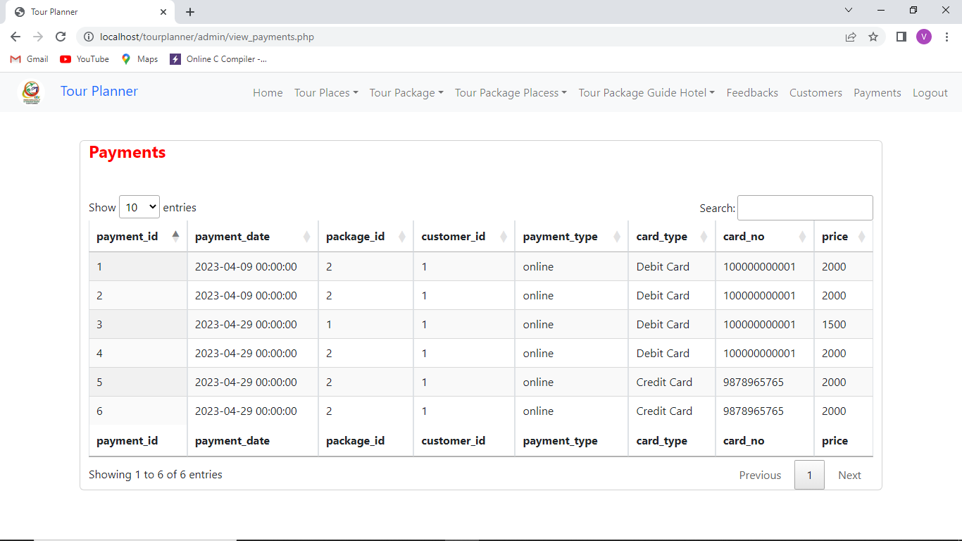

**Conclusion**

Here we have developed a website Tour Planner when can give the clients with the specified tourism direction required anytime and anyplace. The Tour Planner site contributes a sensible way for the clients to look and book tour packages and plan their trips, since it gives point by point data around the visitor places counting depiction and pictures. This extend permits clients to book visit bundles and pay online through web and gives lodgings for staying at visitor places additionally gives the guides for traveler for appearing places. The clients are given with visit booking history and the clients can moreover can give feedback and ratings for tour places or packages they visited in the site.

**Future Works**

The following features can be extended to this project/website in the future for enhancing.

1. Mobile application for this website should be made because customer can easily operate and become more popular.
2. Payment gateway like razorpay or paypal etc can be integrated for the real time payment while booking the tours.
3. Google maps can be implemented to show the routes for the tour places that they can reach easily from their places.
4. We can also implement nearby places to visit along with the routes while visiting the tour places.