**INVESTIGATING CUSTOMER CHURN IN BANKING**

A Mini Project Report Submitted

In partial fulfillment of the requirement for the award of the degree of

**Bachelor of Technology**

**In**

**Artificial Intelligence and Data Science**

**by**

## G.GANESH - 21N31A7221

## G. AKANKSHA - 21N31A7222

**CH KASHYAP - 21N31A7212**

Under the Guidance of

**Dr. HARI KRISHNA SIR**

**Assoc. Professor**

**Computational Intelligence Department**

**MRCET**



**DEPARTMENT OF COMPUTATIONAL INTELLIGENCE**

**MALLA REDDY COLLEGE OF ENGINEERING AND TECHNOLOGY**

(Affiliated to JNTU, Hyderabad)

**ACCREDITED by AICTE-NBA**

**Maisammaguda, Dhulapally post, Secunderabad-500014.**

**2020-2024**

**DECLARATION**

## I hereby declare that the project entitled “Investigating customer churn in banking ” submitted to Malla Reddy College of Engineering and Technology, affiliated to Jawaharlal Nehru Technological University Hyderabad (JNTUH) for the award of the degree of Bachelor of Technology in Artificial Intelligence and Data Science is a result of original research work done by me.

It is further declared that the project report or any part thereof has not been previously submitted to any University or Institute for the award of degree or diploma.

**G.GANESH(21N31A7221)**

**G.AKANKSHA(21N31A7222)**

**CH.KASHYAP(21N31A7212)**



**CERTIFICATE**

This is to certify that this is the bonafide record of the project titled **“Investigating customer churn in banking”**submittedby**G.GANESH(21N31A7221),G.AKANKSHA(21N31A7222),CH.KASHYAP(21N31A7212)** of B-Tech in the partial fulfillment of the requirements for the degree of **Bachelor of Technology** in **Artificial Intelligence And Data Science** , Dept. of CI during the year 2023-2024. The results embodied in this project report have not been submitted to any other university or institute for the award of any degree or diploma.

**DR. SHIVA RATNA SAI Dr. D. Sujatha**

Assoc. Professor **HEAD OF THE DEPARTMENT**

**DR.HARI KRISHNA**

Internal Guide

**EXTERNAL EXAMINER**

# **ACKNOWLEDGEMENT**

We feel honored and privileged to place our warm salutation to our college Malla Reddy College of Engineering and technology (UGC-Autonomous), our Director ***Dr. VSK Reddy*** who gave us the opportunity to have experience in engineering and profound technical knowledge.

We are indebted to our Principal ***Dr. S. Srinivasa Rao*** for providing us with facilities to do our project and his constant encouragement and moral support which motivated us to move forward with the project.

We would like to express our gratitude to our Head of the Department ***Dr. D. Sujatha*** for encouraging us in every aspect of our system development and helping us realize our full potential.

We would like to thank our application development guide as well as our internal guide

**Dr. HARI KISHNA SIR (Assoc. Professor),** for his structured guidance and never-ending encouragement. We are extremely grateful for valuable suggestions and unflinching co-operation throughout application development work.

We would also like to thank all supporting staff of department of CI and all other departments who have been helpful directly or indirectly in making our application development a success.

We would like to thank our parents and friends who have helped us with their valuable suggestions and support has been very helpful in various phases of the completion of the application development.

By

**G.GANESH(21N31A7221)**

**G.AKANKSHA(21N31A7222)**

**CH.KASHYAP(21N31A7212)**

**ABSTRACT**

* In the banking sector, customer attrition refers to the situation where individuals cease using a bank's products and services for a period and subsequently sever ties with the institution.
* Hence, ensuring customer retention is paramount in today's fiercely competitive banking landscape. Moreover, a robust customer base not only instills trust but also facilitates referrals from existing clients, thereby aiding in attracting new customers.
* Given these factors, minimizing client attrition emerges as a critical objective for banks.
* Our research focuses on leveraging bank data to predict which users are likely to discontinue using the bank's services and transition into paying customers.
* Through the application of diverse machine learning algorithms, we conduct a thorough analysis of the data and present a comparative assessment based on various evaluation metrics.
* By scrutinizing this data, the bank can identify patterns and proactively engage with customers at risk of attrition to enhance retention efforts.

**TABLE OF CONTENTS**

**S.No. Topic**

CHAPTER 1: INTRODUCTION

1.1: Purpose

1.3: Scope of project

1.4: Project features

CHAPTER 2: SYSTEM REQUIREMENTS

2.1 H/W & S/W Requirements

2.2 Functional Requirements

CHAPTER 3: TECHNOLOGIES USED

CHAPTER 4: SYSTEM DESIGN

4.1: UML Diagrams

CHAPTER 5: IMPLEMENTATION

5.1 Source Code

5.2 Output Screens

CHAPTER 6: CONCLUSION

1. **INTRODUCTION:**

Customer attrition, or churn, occurs when customers end their relationship with a business, including in banking where they close accounts or stop using services. Understanding and managing churn is crucial for financial stability and reputation. High churn leads to revenue loss and indicates underlying issues like poor customer experience. By analyzing churn patterns, banks can retain customers, enhance profitability, and improve overall customer experience, gaining a competitive edge in the industry.

**1.1 Purpose:**

Optimizing doctor availability and appointment allocation through digital technology and AI integration revolutionizes healthcare by efficiently matching patient needs with doctor schedules. By leveraging AI algorithms to predict demand, these systems ensure optimal allocation of appointments, reducing wait times and enhancing patient access. They streamline doctor schedules, improving resource utilization, enhancing patient care quality, and fostering a more efficient healthcare ecosystem. This integration promotes data-driven decision-making, boosts patient satisfaction, and optimizes operational workflows, ultimately shaping a more effective and patient-centric healthcare landscape.

Top of Form

* 1. **Scope of project:**

The scope of this project encompasses developing a comprehensive digital platform that utilizes AI-driven algorithms to optimize doctor availability and appointment allocation. It involves building an intuitive user interface for patients and healthcare providers, integrating with existing healthcare systems, implementing predictive models for appointment demand, and continuously refining the scheduling process. The project aims to enhance patient access, improve healthcare resource management, and elevate the overall efficiency and quality of healthcare services through intelligent scheduling practices.

**1.3 Project Features­­­:**

1. **AI-Driven Scheduling:** Utilizes machine learning algorithms to predict appointment demand, optimizing doctor schedules based on historical data and real-time insights.
2. **Doctor Availability Management:** Allows doctors to input their schedules, preferences, and availability, ensuring accurate scheduling aligned with their working hours and specialties.
3. **Patient-Centric Booking:** Provides an intuitive interface for patients to easily book appointments, consider preferred doctors, dates, and times, enhancing their access to healthcare services.
4. **Real-time Adjustments:** Dynamically adapts schedules to accommodate urgent cases, cancellations, or unforeseen circumstances without disrupting the overall system.
5. **Data Analytics:** Utilizes data analytics to evaluate scheduling efficiency, patient outcomes, and feedback, continuously improving the algorithm's accuracy and performance.
6. **Integration with Healthcare Systems:** Seamlessly integrates with Electronic Health Record (EHR) systems, hospital management software, or other existing healthcare infrastructure to ensure data consistency and streamline operations.
7. **Security and Compliance:** Implements robust security measures to protect sensitive patient information and ensures compliance with healthcare regulations such as HIPAA, GDPR, etc.
8. **User-Friendly Interfaces:** Develops intuitive interfaces for both healthcare providers and patients, facilitating easy navigation, appointment management, and access to pertinent information.
9. **Scalability:** Designed to scale with the growing needs of healthcare facilities, accommodating increased patient demand and evolving scheduling requirements.
10. **Continuous Improvement:** Aims for continual refinement and optimization of scheduling algorithms based on evolving patient needs, doctor preferences, and operational insights.

Top of Form

# **2.SYSTEM REQUIREMENTS**

# 

**2.1 Hardware Requirements:**

* Servers and Computing Hardware.
* Networking Equipment.
* Mobile Devices or Terminals.
* Display Screens or Monitors.
* Storage Devices.
* Backup and Redundancy Systems.

**2.2 Software requirements:**

* Database Management System.
* Appointment Scheduling Software.
* AI&ML Frameworks.
* Integration Tools&API’s.
* Data Analysis And Visualization Tools.
* Mobile/Web Development Tools.
* Cloud/Server Infrastructure.

**2.3 Existing System:**

**Google Health's Appointment Booking AI:** Google Health has been working on AI-powered tools to improve healthcare, including appointment scheduling. Their system uses AI to analyze patterns and optimize the allocation of appointments, making it easier for patients to find suitable time slots.

**Kyruus:** Kyruus offers a platform that uses AI to match patients with the right healthcare providers based on various factors, such as clinical expertise, location, and appointment availability.

**2.4 Proposed System:**

The proposed system is an AI-integrated healthcare scheduling platform designed to optimize doctor availability and appointment allocation. Leveraging advanced AI algorithms, it aims to revolutionize the scheduling process by predicting and managing appointment demand more efficiently. The system will feature a user-friendly interface for both healthcare providers and patients, allowing doctors to input their availability and preferences while enabling patients to easily book appointments based on their needs and preferred timings. Real-time adjustments and dynamic scheduling will accommodate changes, ensuring a seamless experience for both parties. The system will integrate with existing healthcare infrastructure, ensuring data consistency and compliance with regulatory standards. Continuous refinement through data analysis will drive improved scheduling accuracy, leading to enhanced patient access, streamlined workflows, and elevated healthcare service quality

**3.TECHNOLOGIES USED :**

**Backend Development:** Python (Flask/Django), databases (PostgreSQL/MongoDB)

**AI and Machine Learning:** Scikit-learn, TensorFlow/PyTorch for predictive models

**Frontend Development:** HTML, CSS, JavaScript (Vue.js/React.js/Angular)

**Integration and APIs:** EHR and hospital management system integration

**Cloud Services:** AWS, Azure, Google Cloud for hosting and storage

**Security Measures:** Encryption, SSL, compliance with data protection standards

**Data Analytics and Monitoring:** Tools for analyzing scheduling efficiency and system performance

**Testing and CI/CD:** PyTest, Selenium for testing; Jenkins, GitLab CI for continuous integration/deployment

**4. SYSTEM DESIGN**

**4.1 System Architecture**

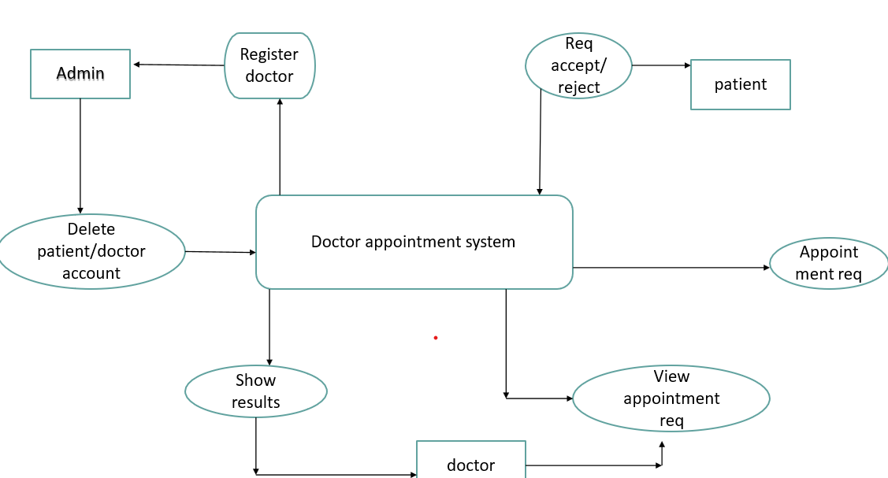

**4.2 UML Diagrams**

#### **4.2.1 Class Diagram**

#### 

Class diagrams model class structure and contents using design elements such as classes, packages and objects. Class diagram describe the different perspective when designing a system-conceptual, specification and implementation. Classes are composed of three things: name, attributes, and operations. Class diagram also display relationships such as containment, inheritance, association etc. The association relationship is most common relationship in a class diagram. The association shows the relationship between instances of classes.

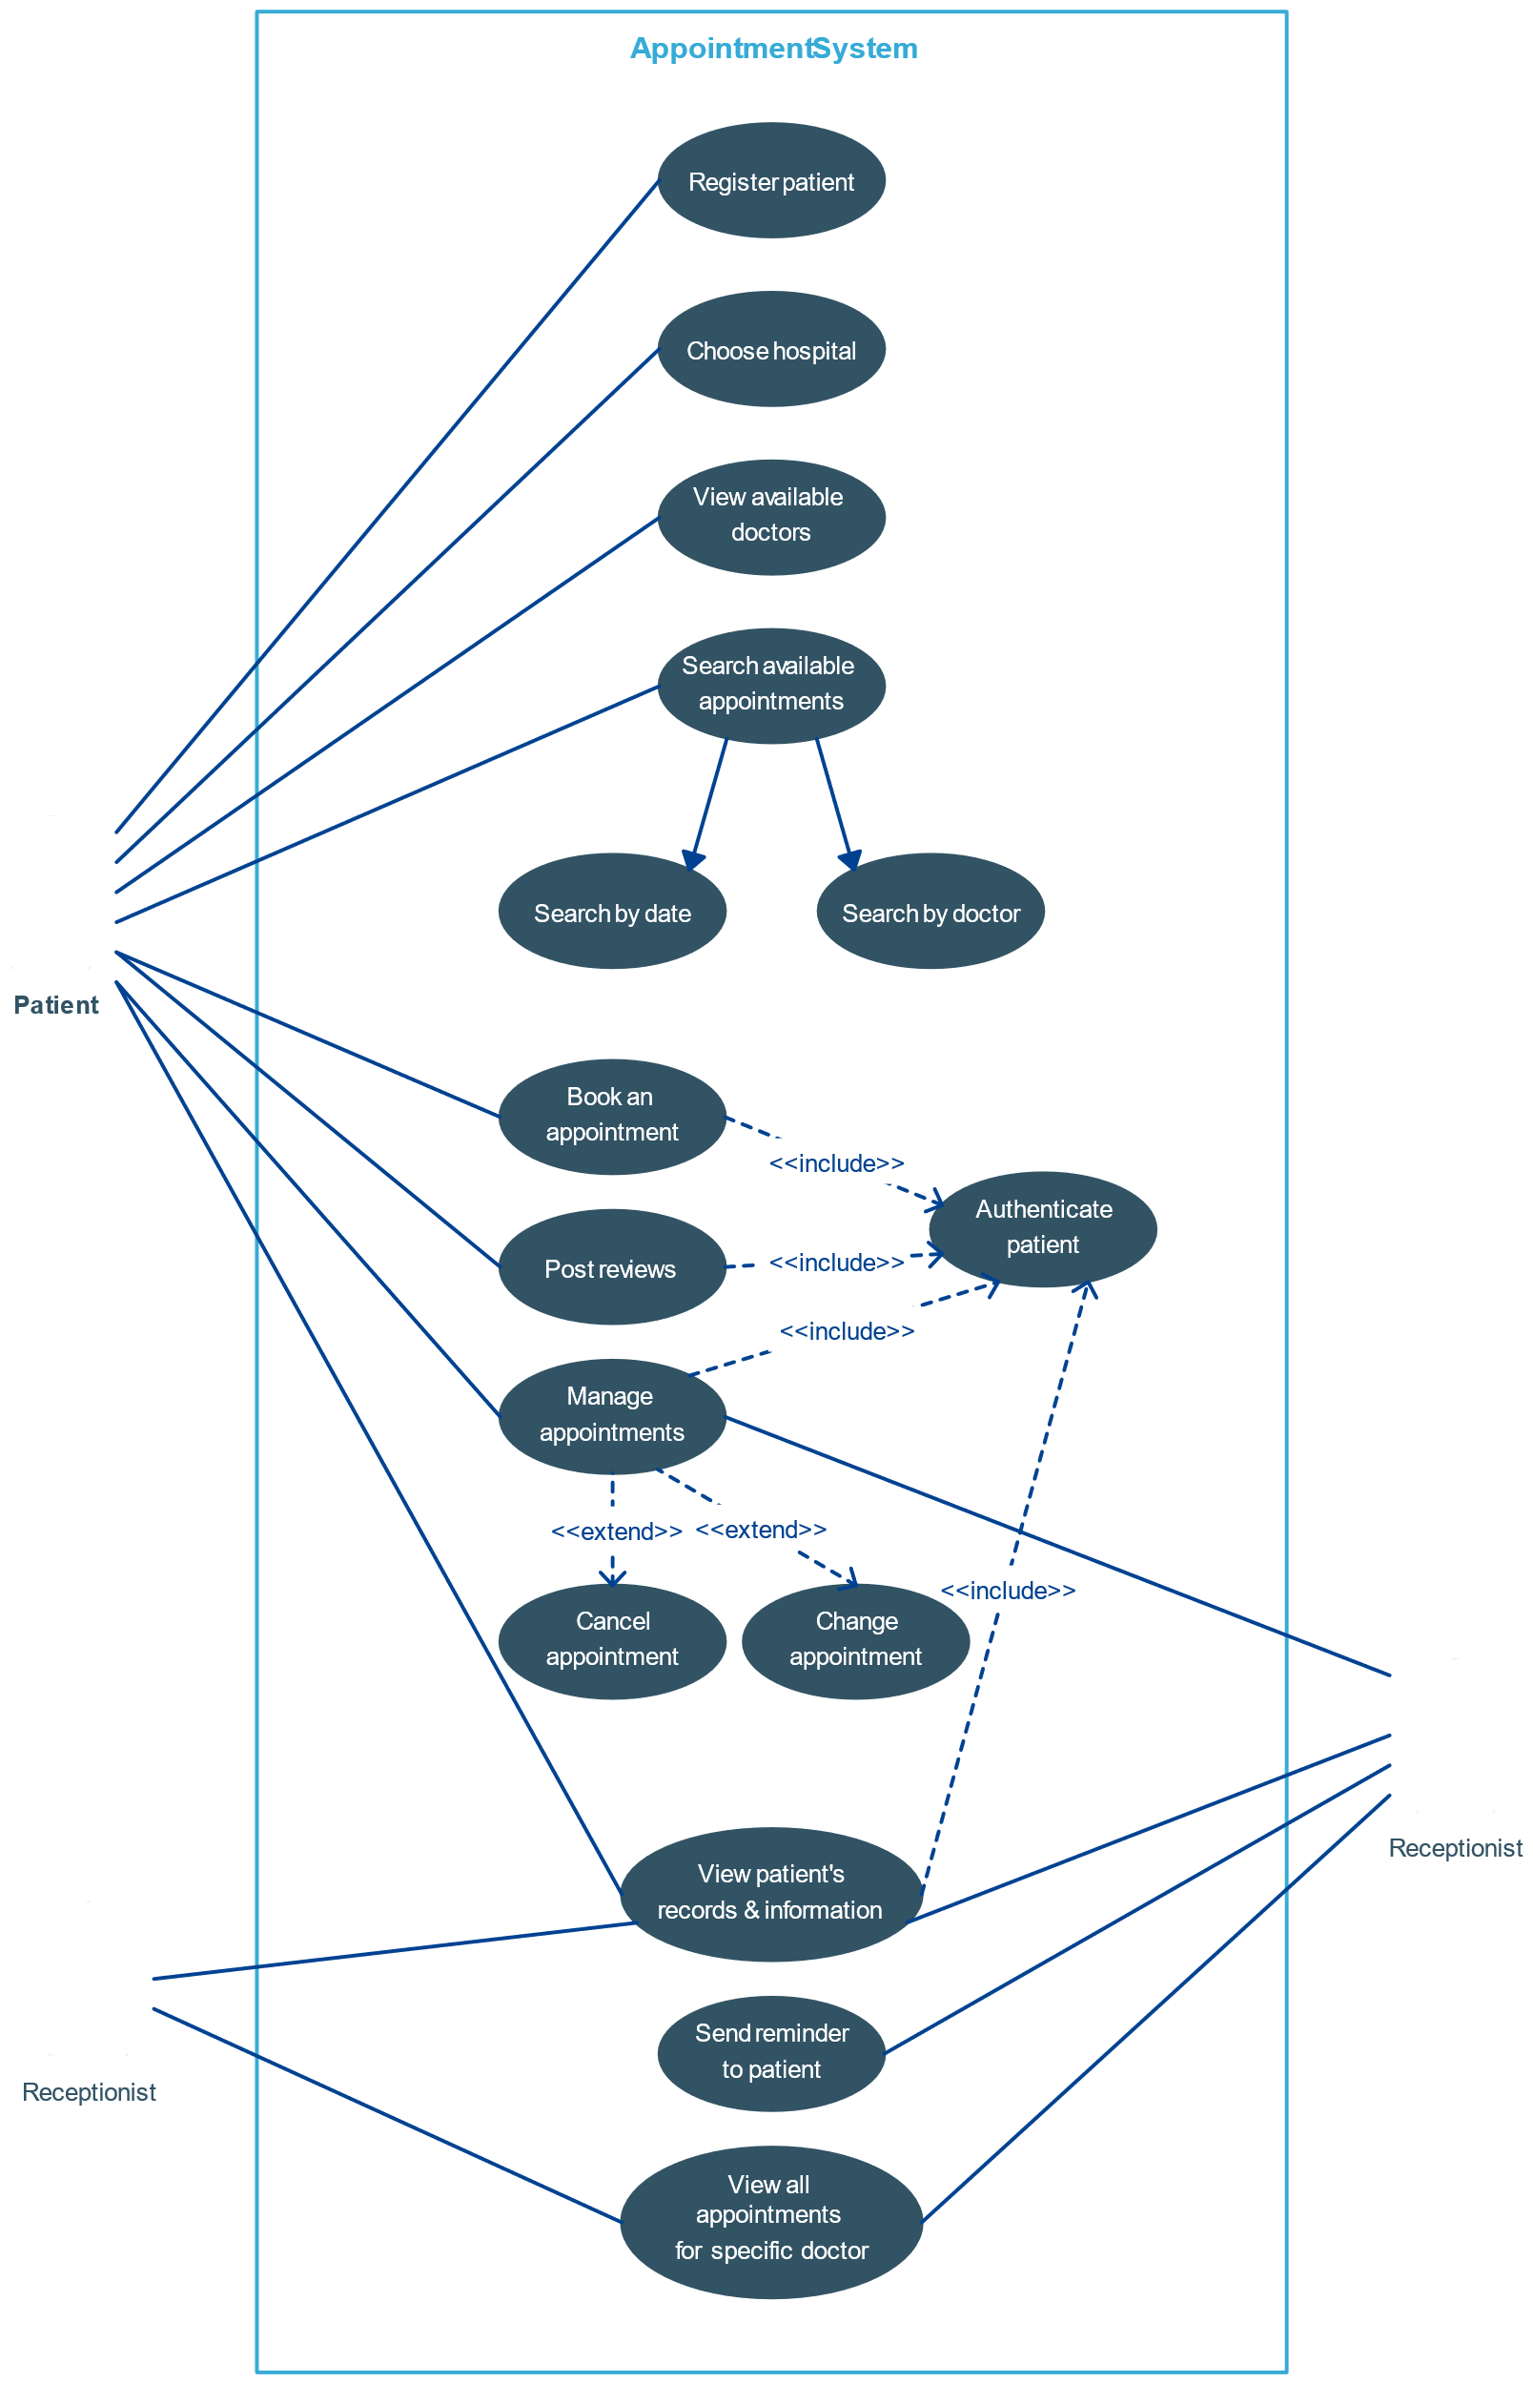

#### **4.2.2 Sequence Diagram**

#### 

Sequence diagram displays the time sequence of the objects participating in the interaction. This consists of the vertical dimension (time) and horizontal dimension (different objects).

Objects: An object can be thought of as an entity that exists at a specified time and has a definite value, as well as a holder of identity. A sequence diagram depicts item interactions in chronological order. It illustrates the scenario's objects and classes, as well as the sequence of messages sent between them in order to carry out the scenario's functionality. In the Logical View of the system under development, sequence diagrams are often related with use case realisations. Event diagrams and event scenarios are other names for sequence diagrams. A sequence diagram depicts multiple processes or things that exist simultaneously as parallel vertical lines (lifelines), and the messages passed between them as horizontal arrows, in the order in which they occur. This enables for the graphical specification of simple runtime scenarios.

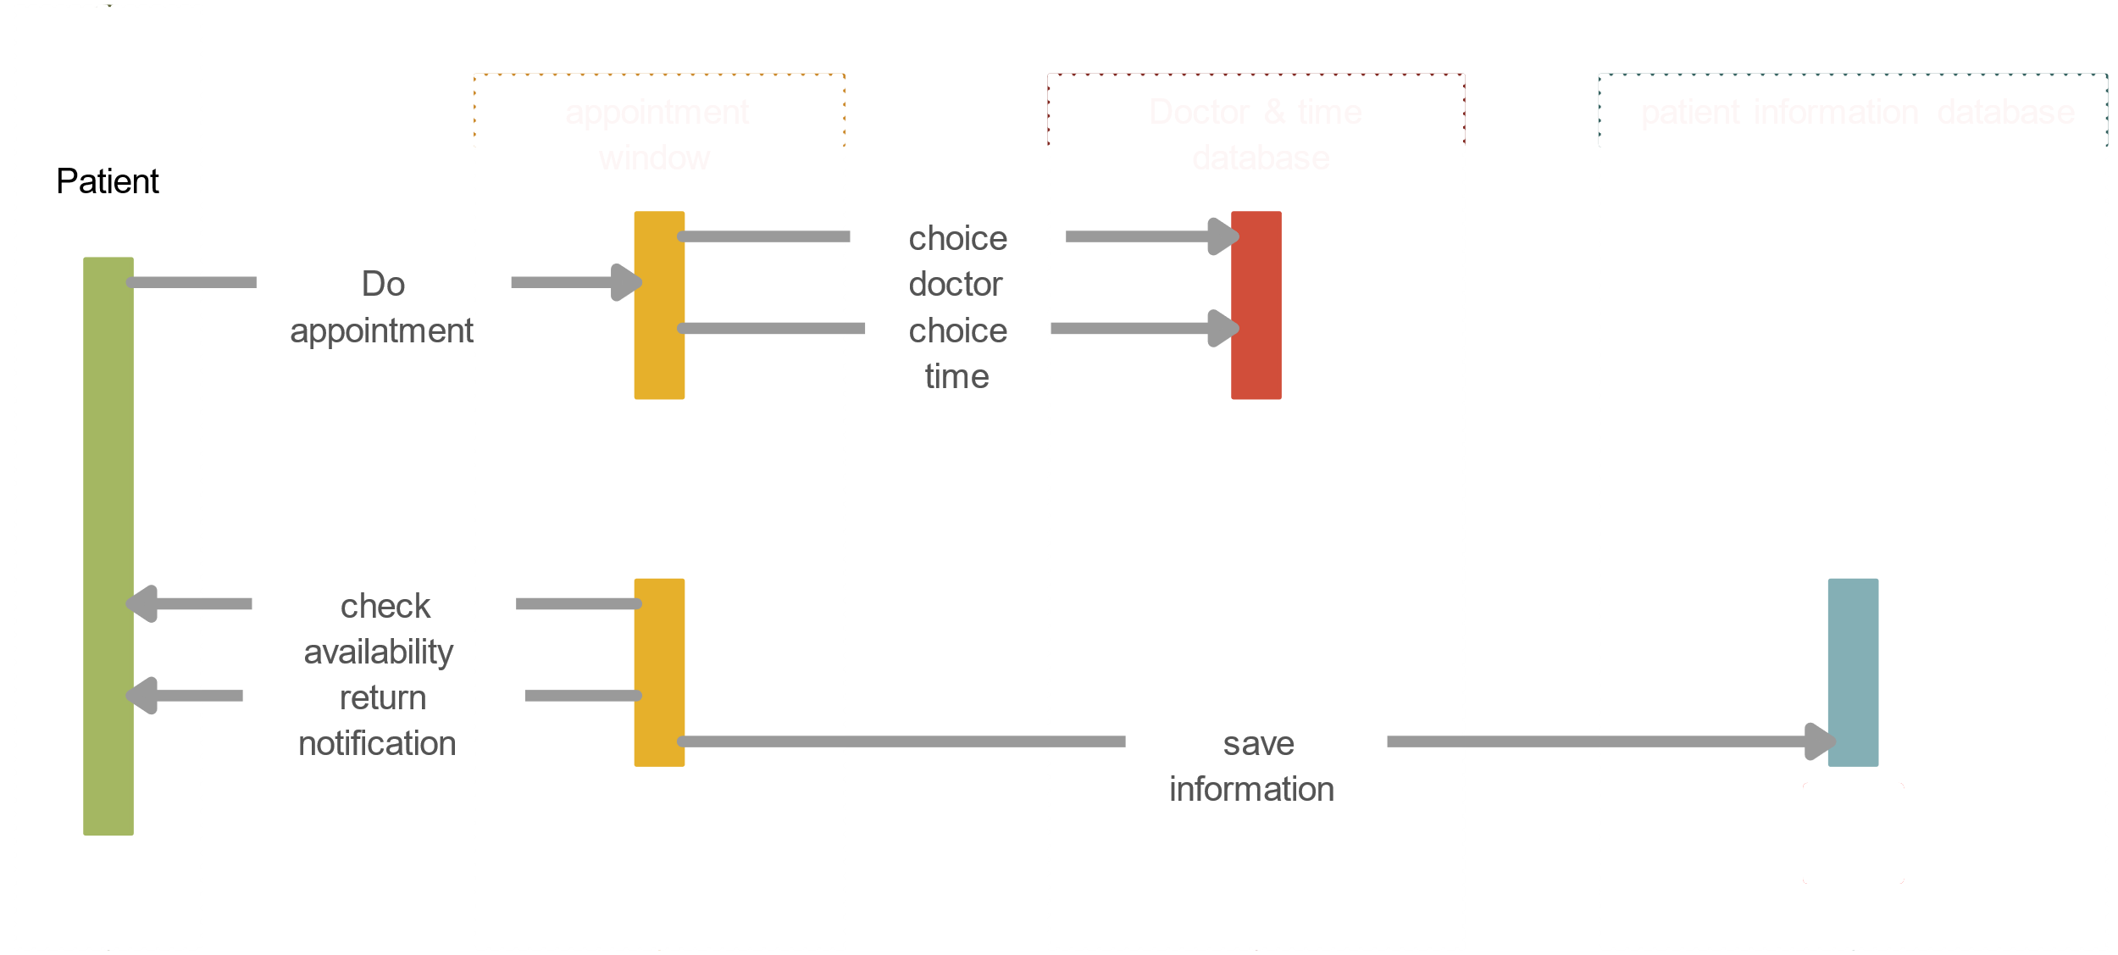

**5.IMPLEMENTATION**

**5.1: Code**

**FRONTEND CODE:**

**<!DOCTYPE html>**

**<html>**

**<head>**

**<title>Doctor Appointment Scheduler</title>**

**</head>**

**<body>**

**<h1>Doctor Appointment Scheduler</h1>**

**<form id="AppointmentForm">**

**<label for="doctor">Select Doctor:</label>**

**<select id="doctor" name="doctor">**

**<option value="Dr. Smith">Dr. Smith</option>**

**<option value="Dr. Johnson">Dr. Johnson</option>**

**<!-- Add more doctors here -->**

**</select><br><br>**

**<label for="date">Select Date:</label>**

**<input type="date" id="date" name="date"><br><br>**

**<label for="time">Select Time:</label>**

**<input type="time" id="time" name="time"><br><br>**

**<label for="patient">Patient Name:</label>**

**<input type="text" id="patient" name="patient"><br><br>**

**<button type="submit">Schedule Appointment</button>**

**</form>**

**<div id="response"></div>**

**<script>**

**const form = document.getElementById('appointmentForm');**

**const responseDiv = document.getElementById('response');**

**form.addEventListener('submit', function(event) {**

**event.preventDefault();**

**const formData = new FormData(this);**

**const data = Object.fromEntries(formData.entries());**

**fetch('/api/schedule_appointment', {**

**method: 'POST',**

**headers: {**

**'Content-Type': 'application/json'**

**},**

**body: JSON.stringify(data)**

**})**

**.then(response => response.text())**

**.then(result => {**

**responseDiv.innerHTML = result;**

**})**

**.catch(error => {**

**console.error('Error:', error);**

**});**

**});**

**</script>**

**</body>**

**</html>**

**BACKEND CODE:**

**from flask import Flask, render_template, request**

**app = Flask(__name__)**

**# Mock data - Doctor availability**

**doctor_availability = {**

**"Dr. Smith": ["Monday", "Wednesday", "Friday"],**

**"Dr. Johnson": ["Tuesday", "Thursday"],**

**# Add more doctors with their availability**

**}**

**# Endpoint for doctor availability**

**@app.route('/api/doctor_availability', methods=['GET'])**

**def get_doctor_availability():**

**return doctor_availability**

**# Endpoint for scheduling appointments**

**@app.route('/api/schedule_appointment', methods=['POST'])**

**def schedule_appointment():**

**data = request.json**

**doctor = data['doctor']**

**date = data['date']**

**time = data['time']**

**patient = data['patient']**

**# Simple logic to check if doctor is available on the given date**

**if doctor in doctor_availability and date in doctor_availability[doctor]:**

**return f"Appointment scheduled with {doctor} on {date} at {time} for {patient}"**

**else:**

**return f"{doctor} is not available on {date}"**

**# Frontend rendering**

**@app.route('/')**

**def index():**

**return render_template('index.html')**

**if __name__ == "__main__":**

**app.run(debug=True)**

**5.2: Output Screens:**

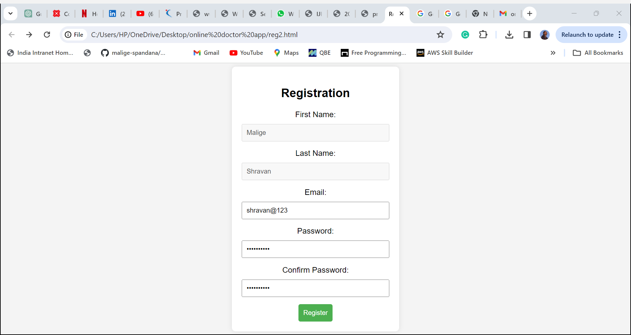

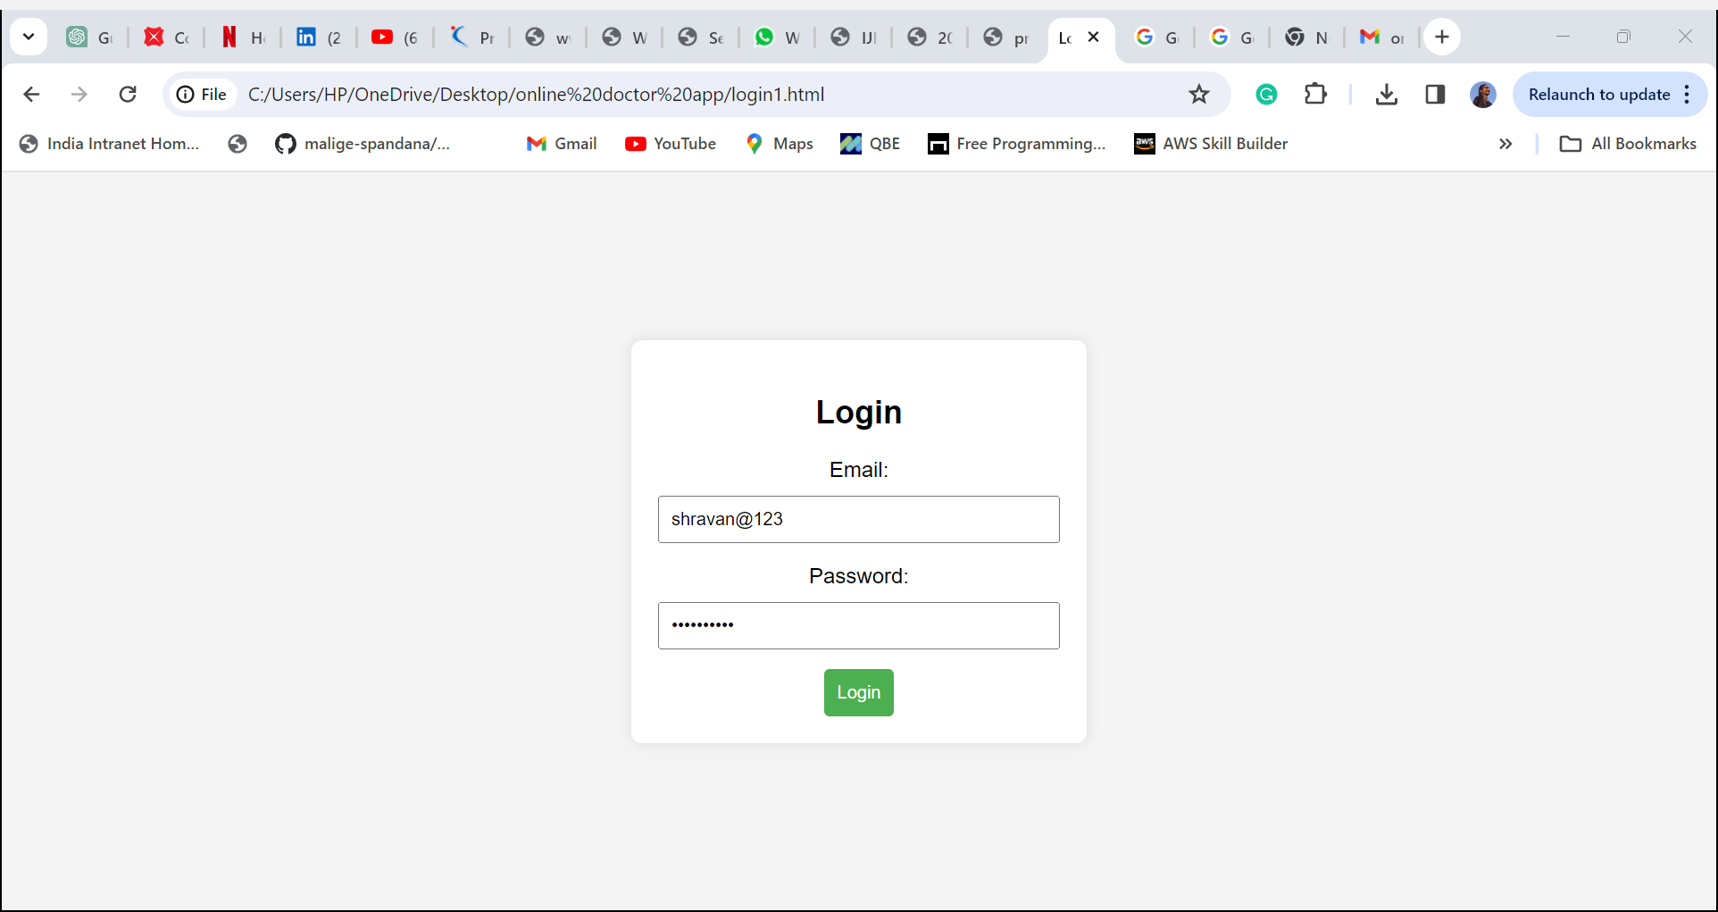

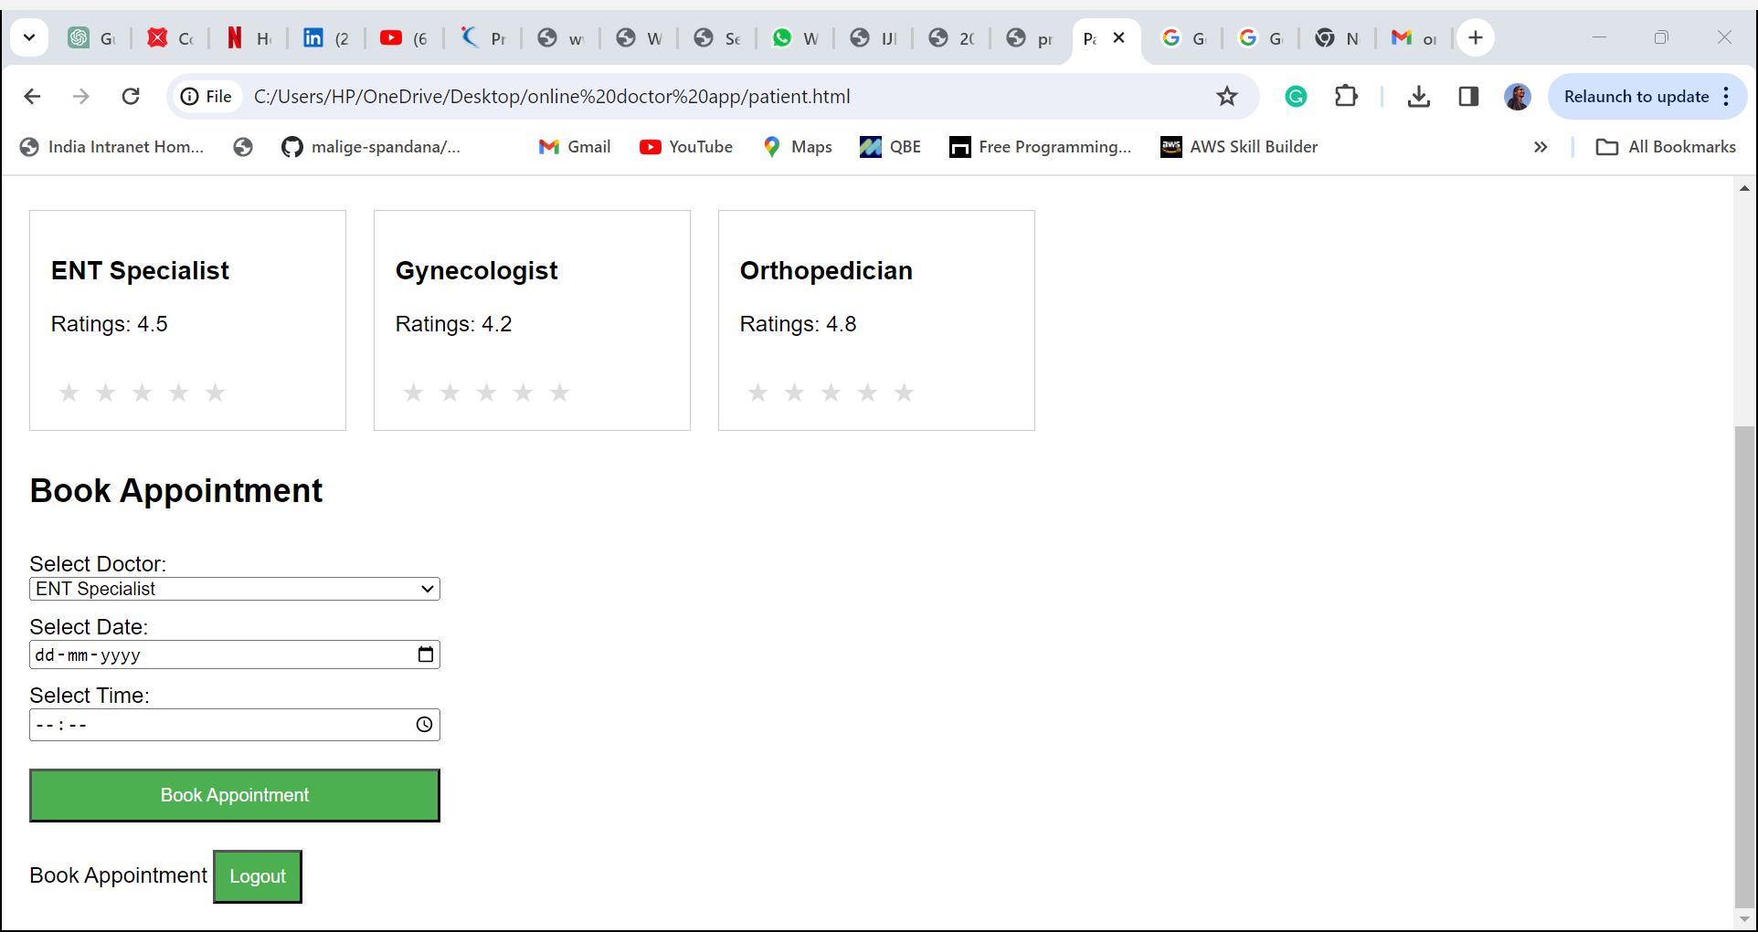

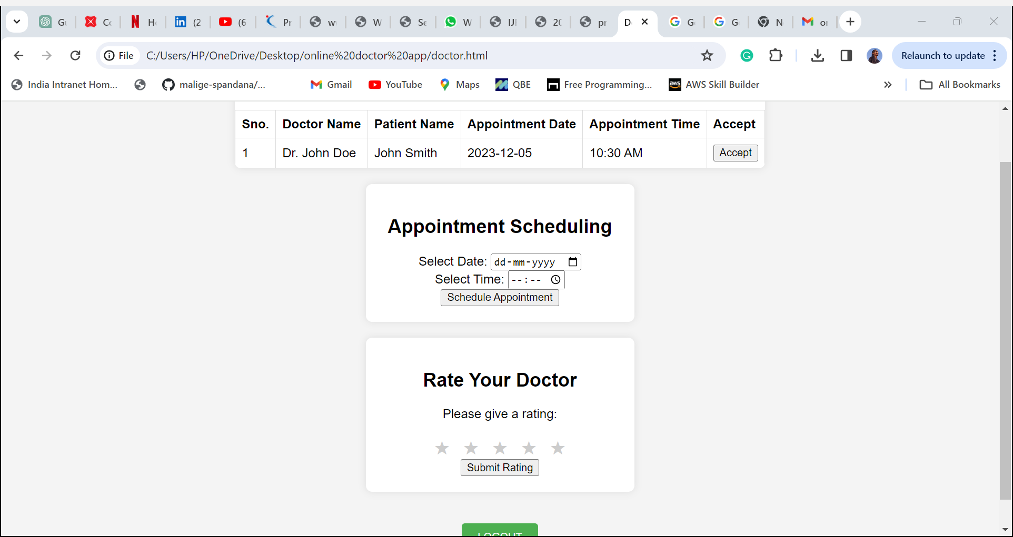

**6.CONCLUSION:**

* **The proposed system presents a pioneering approach to hospital operations by integrating RFID technology, face detection, AI-driven optimization, and personalized appointment management. Its unique blend of technologies tailored for healthcare ensures efficient doctor availability, precise appointment allocation, and continuous improvement while prioritizing patient privacy and compliance. This comprehensive solution aims to elevate hospital efficiency, enhance patient care, and streamline the appointment process, distinguishing itself as an innovative and holistic approach in the healthcare industry.**

## 