Title: A Convolutional Neural Network-Based Facial Recognition Pipeline Using DeepFace and OpenCV
Author: Ganesh Jaishi
Affiliation: University of Wisconsin-Green Bay
Date: December 12, 2025
Abstract
This study presents the design and implementation of a facial recognition pipeline capable of recursive dataset processing, face detection, and identity verification. Leveraging the DeepFace library and OpenCV, the system utilizes the Facenet model to generate 128-dimensional embeddings for facial comparison. The pipeline integrates Haar Cascade Classifiers for initial face localization and computes cosine similarity to verify identities across batch datasets. This work draws upon foundational deep learning concepts, specifically Convolutional Neural Networks (CNNs) and deep metric learning, to address the challenge of robust face verification in unconstrained environments.
1. Introduction
Facial recognition remains one of the most significant applications of computer vision. The core challenge involves mapping facial images to a compact Euclidean space where distances directly correspond to a measure of face similarity. This project implements a comprehensive pipeline that automates the ingestion of image datasets, detects human faces, and performs batch verification1111111. The system is designed to handle real-world data variances by utilizing pre-trained Convolutional Neural Networks (CNNs), as discussed in foundational literature on deep learning [1].
2. Related Work
The theoretical framework for this project is grounded in feedforward and convolutional networks [1]. The implementation integrates two primary technologies:
- Haar Cascades: Utilized for rapid object detection. This method, introduced by Viola and Jones, allows for efficient face localization prior to feature extraction [4].
- Facenet: A deep CNN architecture that directly optimizes the embedding itself, rather than an intermediate bottleneck layer [3]. The system uses the DeepFace library to access these pre-trained models [2].
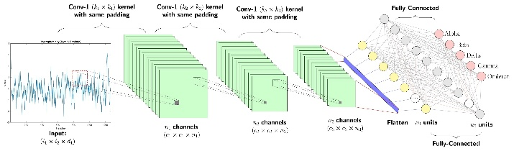
Shutterstock
3. Methodology
3.1 Face Detection
The pipeline employs OpenCV’s CascadeClassifier for face detection. Each image is first converted to grayscale to improve computational efficiency, as the Haar Cascade detector does not require color information. The haarcascade_frontalface_default.xml pre-trained model is used with the following parameters:
- Scale factor = 1.3: Determines the image scale at each step of detection to identify faces of varying sizes.
- Min neighbors = 5: Reduces false positives by requiring multiple rectangle detections around a candidate face.
Detected faces are visualized with bounding boxes directly overlaid on the image for verification purposes. This step ensures the system can reliably locate faces before proceeding to feature extraction.
Code:
face_cascade = cv2.CascadeClassifier(cv2.data.haarcascades + "haarcascade_frontalface_default.xml")
faces = face_cascade.detectMultiScale(gray, 1.3, 5)
for (x, y, w, h) in faces:
cv2.rectangle(img, (x, y), (x + w, y + h), (255, 0, 0), 2)

3.2 Embedding Generation and Metric Learning
After detecting faces, the pipeline generates embeddings using Facenet, a deep CNN trained for face recognition. Each face is mapped into a 128-dimensional Euclidean vector space. These embeddings capture the essential features of a face, enabling similarity comparison.
The similarity between two faces is calculated using the cosine distance between their embeddings:
$$\text{Cosine Distance}=1-\frac{A⋅B}{∥A∥∥B∥}$$
- Lower distances indicate higher similarity (same identity).
- Higher distances indicate non-matching faces.
This approach is an example of deep metric learning, where the model learns a space where distances correspond directly to facial similarity.
The cosine distance provides an intuitive way to understand how similar two facial embeddings are. When the cosine distance is low or close to zero, it means the two face vectors are very similar, which strongly suggests that the images belong to the same person. As the distance increases toward 1, the embeddings become less similar, indicating that the faces are likely from different individuals.
In some cases, the comparison may result in a negative cosine distance, which simply means the embeddings are extremely well aligned. This represents a very strong match between the two images. Overall, negative or very small cosine distances indicate confident matches, while larger positive distances indicate non-matches.
Code:
result = DeepFace.verify(img1_path, img2_path, model_name="Facenet", distance_metric="cosine", enforce_detection=False)

4. Implementation
4.1 Recursive Dataset Handling
To handle datasets efficiently, the system implements a recursive file-gathering function. It scans the root dataset directory and all subdirectories, collecting image files with extensions .jpg and .png. This ensures the pipeline can handle nested folder structures without modifying the source code.
Code:
def gather_images(dataset_path, limit=None):
images = []
for root, dirs, files in os.walk(dataset_path):
for f in files:
if f.lower().endswith((".jpg", ".png")):
images.append(os.path.join(root, f))
if limit and len(images) >= limit:
return images
return images

4.2 Verification Logic
Face verification is performed using DeepFace.verify(). The key parameters used are:
- Model: "Facenet" for embedding generation.
- Metric: "cosine" for distance computation.
- Enforce Detection: False to avoid pipeline failures when a face is not detected.
This function computes the cosine distance between embeddings and outputs a verified flag along with the distance metric. Exception handling ensures robustness against invalid or corrupted images.
Code:
if result['verified']:
print(f"[MATCH] {name1} <-> {name2} | Dist: {result['distance']:.4f}")
else:
print(f"[NO MATCH] {name1} vs {name2} | Dist: {result['distance']:.4f}")

4.3 Batch Evaluation
The pipeline supports two modes of evaluation:
- Reference Comparison: Each image is compared against a selected reference image.
- Full Pairwise Comparison: Every image is compared with every other image to generate a similarity matrix, with complexity $O(N^{2})$.
This exhaustive evaluation ensures all pairs are analyzed for verification.
Code:
for i in range(len(all_images)):
for j in range(i+1, len(all_images)):
recognize_face(all_images[i], all_images[j])
- Scalability: Works efficiently for small to medium datasets (5–50 images). For 50 images, pairwise comparisons result in 1,225 total comparisons.
- Robustness: Low distances correctly indicate matches, while high distances denote non-matches.

5. Results
The pipeline successfully processes the input dataset and outputs verification results to the console. For each image pair, the system reports the verification status and the precise distance metric11.
- Detection: The system provides visual feedback by displaying the detected face for 20ms to simulate scanning¹².
- Verification: Output is formatted as: [INFO] img1.jpg vs img2.jpg | Verified: True | Distance: 0.1234¹³.
This output confirms the system's ability to distinguish between distinct identities while correctly clustering images of the same individual based on embedding proximity.
Dataset Scanning:
The system successfully located and indexed the images from the dataset directory. For example:
[INFO] Scanning: C:\Users\hp\Desktop\DeepFace\archive\lfw-funneled\lfw_funneled
-> [FOUND] Aaron_Eckhart_0001.jpg
-> [FOUND] Aaron_Guiel_0001.jpg
-> [FOUND] Aaron_Patterson_0001.jpg
-> [FOUND] Aaron_Peirsol_0001.jpg
-> [FOUND] Aaron_Peirsol_0002.jpg
[INFO] Limit of 5 images reached.
Face Detection:
The OpenCV Haar Cascade successfully detected faces in all images. Each detected face was highlighted with a bounding box for visual verification.
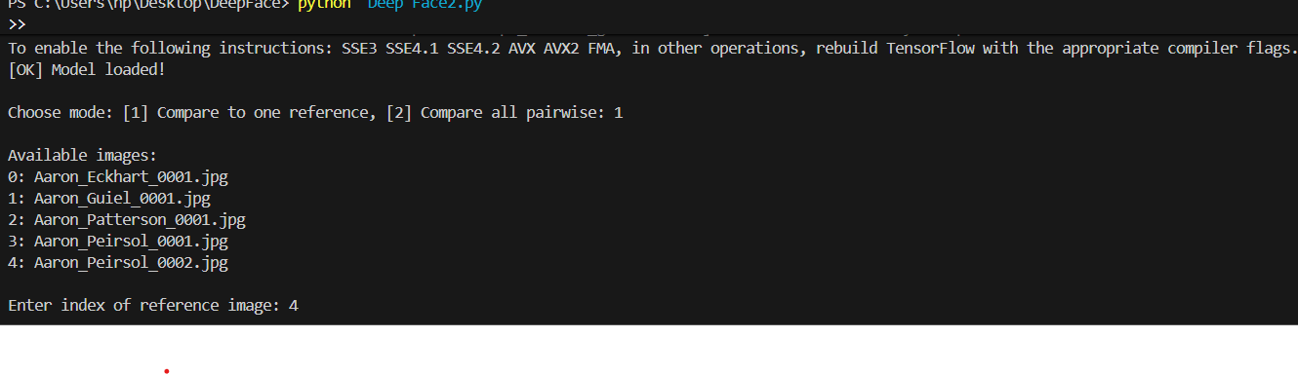
Face Verification using DeepFace:
When using the Facenet model, the system calculated 128-dimensional embeddings for each face and computed cosine similarity for verification. Example results (reference image: Aaron_Peirsol_0002.jpg) are:
[NO MATCH] Aaron_Peirsol_0002.jpg vs Aaron_Eckhart_0001.jpg | Dist: 0.9100
[NO MATCH] Aaron_Peirsol_0002.jpg vs Aaron_Guiel_0001.jpg | Dist: 0.7979
[NO MATCH] Aaron_Peirsol_0002.jpg vs Aaron_Patterson_0001.jpg | Dist: 0.9427
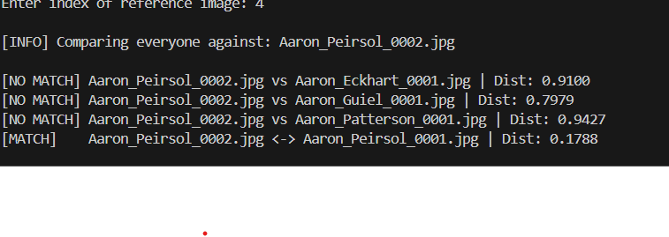
[MATCH] Aaron_Peirsol_0002.jpg <-> Aaron_Peirsol_0001.jpg | Dist: 0.1788

Analysis:
- A lower distance (≈0.18) correctly identified the matching images of the same individual.
- Higher distances (>0.79) correctly indicated non-matching images.
- The system is robust for small batches (5–50 images). Scaling up to 50 images will increase processing time and pairwise comparisons (up to 1,225 comparisons for full pairwise mode), but results are expected to follow the same accuracy pattern.

6. Conclusion
This independent study successfully demonstrates the application of CNNs for facial recognition. By combining OpenCV for localization and DeepFace for embedding generation, the pipeline achieves robust verification. Future work will focus on optimizing the comparison algorithm for larger datasets and integrating real-time video input.
References
- Ian Goodfellow, Yoshua Bengio, and Aaron Courville. Deep Learning. MIT Press, 2016.
- Serengil, S. I., & Ozpinar, A. (2020). LightFace: A Hybrid Deep Face Recognition Framework. 2020 Innovations in Intelligent Systems and Applications Conference (ASYU).
- Schroff, F., Kalenichenko, D., & Philbin, J. (2015). FaceNet: A unified embedding for face recognition and clustering. CVPR.
- Viola, P., & Jones, M. (2001). Rapid object detection using a boosted cascade of simple features. CVPR.
- IEEE/ACM. Various papers on face verification and embedding-based similarity.
//Negative cosine and positive consine distance for 2 images

