LAB NO. 1 : ITERATIVE ALGORITHMS
EXPERIMENT NO: 1
TITLE : TO DESIGN AND IMPLEMENT BUBBLE SORT ALGORITHM.
1. THEORY
The bubble sort algorithm compares every adjacent element. If the first element is greater than the second, it swaps them. This is done for every pair of adjacent elements starting from the first two elements to last two elements. At the end of pass 1 greatest element takes its proper place.
The whole process is repeated except for the last one so that at each pass the comparisons become fewer.

2. PROGRAM
#include<stdio.h>
#define max 100
int i, j;
int* sort(int array[], int size)
{
int temp;
for(i = 0; i<size-1; i++) {
for(j = 0; j< size-i-1; j++) {
if(array[j] > array[j+1]) {
temp = array[j];
array[j] = array[j+1];
array[j+1] = temp;
}
}
}
return array;
}
void printArray(int array[], int size) {
for(i = 0; i < size; i++) {
printf("\t%d", array[i]);
}
}
int main()
{
int array[max],size;
printf("-------------------Bubble Sort Demo--------------------\n\n");
printf("Note:Number of elements must be:\n-->less than 100\n-->+ve integer\n");
printf("Please Enter No. of elements you want to sort: ");
scanf("%d", &size);
printf("Please Enter %d elements: ", size);
for(i=0; i<size; i++)
scanf("%d", &array[i]);
printf("Your Input is: ");
printArray(array, size);
printf("\nSorted array: ");
printArray(sort(array, size), size);
return 0;
}

Output:
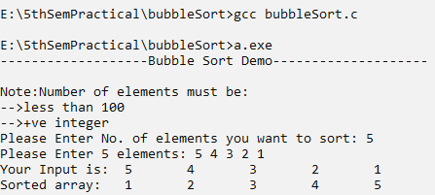

4. ANALYSIS
The number of comparisons in bubble sort is,
1+2+3+......+(n-1) = n(n-1)/2 = O(n^2)
Clearly, the graph shows the n^2 nature of the bubble sort. There is no best case linear complexity for this algorithm.
Space Complexity: Since no extra space besides 3 variables are needed for sorting, space complexity = O(n).

5. CONCLUSION
Hence from the experiment above we were able to implement a bubble sort algorithm to sort an unsorted list or array.

EXPERIMENT NO: 2
TITLE : TO DESIGN AND IMPLEMENT INSERTION SORT ALGORITHM
1. THEORY
Insertion sort is a simple sorting algorithm that works similar to the way you sort playing cards in your hands. The array is virtually split into a sorted and an unsorted part. Values from the unsorted part are picked and placed at the correct position in the sorted part.

Algorithm
To sort an array of size n in ascending order:
1: Iterate from arr[1] to arr[n] over the array.
2: Compare the current element (key) to its predecessor.
3: If the key element is smaller than its predecessor, compare it to the elements before. Move the greater elements one position up to make space for the swapped element.

2. PROGRAM
(SOURCE CODE)
#include<stdio.h>
#define max 100
int i, j;
int* sort(int array[], int size)
{
for(i = 1; i < size; i++) {
int key = array[i];
j = i-1;
while(j >= 0 && array[j] > key) {
array[j+1] = array[j];
j--;
}
array[j+1] = key;
}
return array;
}
void printArray(int array[], int size) {
for(i = 0; i < size; i++) {
printf("\t%d", array[i]);
}
}
int main()
{
int array[max],size;
printf("-------------------Insertion Sort Demo--------------------\n\n");
printf("Note:Number of elements must be:\n-->less than 100\n-->+ve integer\n");
printf("Please Enter No. of elements you want to sort: ");
scanf("%d", &size);
printf("Please Enter %d elements: ", size);
for(i=0; i<size; i++)
scanf("%d", &array[i]);
printf("Your Input is: ");
printArray(array, size);
printf("\nSorted array: ");
printArray(sort(array, size), size);
return 0;
}
3. OUTPUT
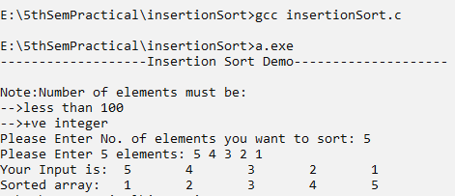

4. ANALYSIS
Best case: It occurs when the array is already sorted. Therefore the best case complexity of insertion sort is O(n).
Worst case: It occurs when the array is in the decreasing order. We need to compare every element with each element in the entire sorted sub-array. Therefore, the worst case complexity of insertion sort is O(n^2).
5. CONCLUSION
Hence we learnt to implement insertion sort algorithms from the above program.

EXPERIMENT NO: 3
TITLE : TO DESIGN AND IMPLEMENT SELECTION SORT ALGORITHM
1. THEORY
The selection sort algorithm sorts an array by repeatedly finding the minimum element (considering ascending order) from the unsorted part and putting it at the beginning.Let n be the size of an array a[n], the selection sort works as follows:
Pass1: Find the location of the smallest element in the list of n elements, a[0],a[1],....a[n-1] and interchange this element and a[0].
Pass 2: Find the location of the smallest element in the sub list of n-1 elements a[1], a[2],-----a[n-1] and then interchange this element and a[1],....and soon.
At the final stage we will get
a[0]<=a[1]<=a[2]<=.......<=a[n-1]

2. PROGRAM
(SOURCE CODE)
#include<stdio.h>
#define max 100
int i, j;
int* sort(int array[], int size)
{
int least, pos, temp;
for(i=0; i<size;i++){
least = array[i];
pos = i;
for(j = i+1; j<size; j++) {
if(array[j] < least) {
least = array[j];
pos = j;
}
}
temp = array[pos];
array[pos] = array[i];
array[i] = temp;
}
return array;
}
void printArray(int array[], int size) {
for(i = 0; i < size; i++) {
printf("\t%d", array[i]);
}
}
int main()
{
int array[max],size;
printf("-------------------Selection Sort Demo--------------------\n\n");
printf("Note:Number of elements must be:\n-->less than 100\n-->+ve integer\n");
printf("Please Enter No. of elements you want to sort: ");
scanf("%d", &size);
printf("Please Enter %d elements: ", size);
for(i=0; i<size; i++)
scanf("%d", &array[i]);
printf("Your Input is: ");
printArray(array, size);
printf("\nSorted array: ");
printArray(sort(array, size), size);
return 0;
}
3. OUTPUT
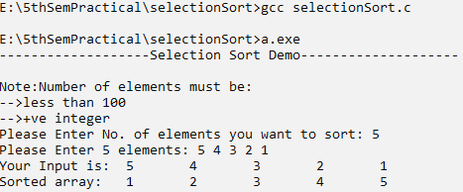

4. ANALYSIS
Inner loop executes for n-1 times when i=0, n-2 when i=1 and soon. Therefore total running time T(n)= n-1+n-2+n-3…..+1. There is no best case complexity for this algorithm but the sort operation can be reduced.

5. CONCLUSION
From the program above, we learnt to implement a selection sort to sort items in a list of finite items.

EXPERIMENT NO: 4
TITLE : TO DESIGN AND IMPLEMENT LINEAR SEARCH ALGORITHM
- THEORY
Linear search is a very simple search algorithm. In this type of search, a sequential search is made over all items one by one. Every item is checked and if a match is found then that particular item is returned, otherwise the search continues till the end of the data collection.

- PROGRAM
(SOURCE CODE)
#include<stdio.h>
#include<stdbool.h>
#include<ctype.h>
#define max 100
int i, j;
int search(int array[], int size, int key, bool repeat)
{
int pos = -1;
char c;
if(repeat) { //to demonstrate multiple search
// linear search actually starts from here
printf("\nPlease Enter The Item you want to search: ");
scanf("%d", &key);
for(i = 0; i<size; i++) {
if(key == array[i])
pos = i;
}
if(pos == -1)
printf("Search Item Not Found!");
else
printf("The search item is %dth Element",pos+1);
printf("\nDo you want to search another item?(y/n): ");
scanf(" %c", &c);
if(toupper(c) == toupper('y'))
search(array, size, key, true);
else
search(array, size, key, false);
}
return 0;

}
void printArray(int array[], int size) {
for(i = 0; i < size; i++) {
printf("\t%d", array[i]);
}
}
int main()
{
int array[max] = {5,4,3,2,1};
int size = 5;
printf("-------------------Linear Search Demo--------------------\n\n");
printf("The list is: ");
printArray(array, size);
search(array, size, 0, true);
return 0;
}

- OUTPUT
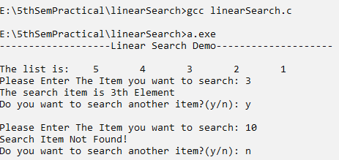

- ANALYSIS
The time complexity of the Linear search algorithm is O(n). Linear search is rarely used practically because other search algorithms such as the binary search algorithm and hash tables allow significantly fast-searching comparison to Linear search.

- CONCLUSION
From the program above, we learnt to implement a linear search algorithm for searching any item in a list of finite items. Here, we have performed a search and returned the index of the searched item.

LAB NO.2 : DIVIDE & CONQUER
EXPERIMENT NO: 1
TITLE : TO DESIGN AND IMPLEMENT MERGE SORT ALGORITHM
1. THEORY
Like QuickSort, Merge Sort is a Divide and Conquer algorithm. It divides the input array into two halves, calls itself for the two halves, and then merges the two sorted halves. The merge() function is used for merging two halves. The merge(arr, l, m, r) is a key process that assumes that arr[l…m] and arr[m+1..r] are sorted and merge the two sorted subarrays into one.
Divide: N size of array divided recursively until the size of each sublist is equal to 1.
Conquer/merge: After the complete division process the algorithm merges the adjacent list into a single solution list recursively. The process of merging is combining the two sorted sublists into a single sorted list.

2. PROGRAM
(SOURCE CODE)
#include<stdio.h>
#define max 100
int i, j;
int merge(int array[], int low, int mid, int high)
{
int k, b[max]; i = low; j = mid + 1;
for(k = low; k <= high; k++) {
if(i > mid) {
b[k] = array[j];
j++;
} else if(j > high) {
b[k] = array[i];
i++;
} else if(array[i] < array[j]) {
b[k] = array[i];
i++;
} else {
b[k] = array[j];
j++;
}
}
for(k = low; k<=high; k++) {
array[k] = b[k];
}
}
int* sort(int array[], int low, int high)
{
int mid;
if(low < high) {
mid = (low + high)/2;
sort(array, low, mid);
sort(array, mid+1, high);
merge(array, low, mid, high);
}
return array;
}
void printArray(int array[], int size) {
for(i = 0; i < size; i++) {
printf("\t%d", array[i]);
}
}
int main()
{
int array[max],size;
printf("-------------------Merge Sort Demo--------------------\n\n");
printf("Note:Number of elements must be:\n-->less than 100\n-->+ve integer\n");
printf("Please Enter No. of elements you want to sort: ");
scanf("%d", &size);
printf("Please Enter %d elements: ", size);
for(i=0; i<size; i++)
scanf("%d", &array[i]);
printf("Your Input is: ");
printArray(array, size);
printf("\nSorted array: ");
printArray(sort(array, 0, size-1), size);
return 0;
}

3. OUTPUT
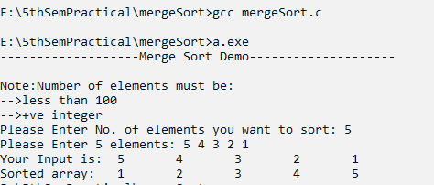

4. ANALYSIS
Let the number of items in the input array is n. Let T(n) be the total running time of merge sort algorithm then T(n/2) will be the running time of algorithm when n=n2 and One merge operation will require linear time since there are almost n comparisons. Therefore, the recurrence relation of algorithm is T(n)=2T(n/2) + n, n>1
= 1, n ==1
5. CONCLUSION
Merge sort uses a divide-and-conquer method to recursively sort the elements of a list while Bubble, Insertion and Selection have a quadratic time complexity that limits its uses to a small number of elements. Merge sort uses divide-conquer to speed up the sorting.

EXPERIMENT NO: 2
TITLE : TO DESIGN AND IMPLEMENT QUICK SORT ALGORITHM
1. THEORY
Quick sort is based on divide and conquer approach. Partition of the array about an element is done and that element is called pivot element.. The methods of partitioning are given below:
I. Choose the first element of array as pivot.
II. Set the left marker ‘L’ at the first element and right marker ‘R’ at the last element of the array.
III. While L<R , repeat
- Increase L by 1(move right) until A[L]<=pivot
- Decrease R by 1(move left) until A[R]>pivot
- If L<R, exchange A[L] with A[R]
- If R<L, exchange (A[R],pivot)
- Return R

2. PROGRAM
(SOURCE CODE)
#include<stdio.h>
#define max 100
int i, j;
int partition(int array[], int left, int right)
{
int pivot, temp;
i= left; j= right; pivot = array[left];
while( i < j) {
while(array[i] <= pivot && i <= right)
i++;
while(array[j] > pivot && j >= left)
j--;
if(i < j) {
temp = array[i];
array[i] = array[j];
array[j] = temp;
}
temp = array[j];
array[j] = pivot;
array[left] = temp;
}
return j;
}
int* sort(int array[], int low, int high)
{
int partitionIndex;
if(low < high) {
partitionIndex = partition(array, low, high);
sort(array, low, partitionIndex-1);
sort(array, partitionIndex+1, high);
}
return array;
}
void printArray(int array[], int size) {
for(i = 0; i < size; i++) {
printf("\t%d", array[i]);
}
}
int main()
{
int array[max],size;
printf("-------------------Quick Sort Demo--------------------\n\n");
printf("Note:Number of elements must be:\n-->less than 100\n-->+ve integer\n");
printf("Please Enter No. of elements you want to sort: ");
scanf("%d", &size);
printf("Please Enter %d elements: ", size);
for(i=0; i<size; i++)
scanf("%d", &array[i]);
printf("Your Input is: ");
printArray(array, size);
printf("\nSorted array: ");
printArray(sort(array, 0, size-1), size);
return 0;
}

3. OUTPUT
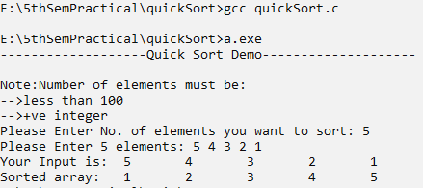

4. ANALYSIS
Best case: It occurs when the partitioning procedure partitions the array into approximately two equal halves. In this case the quick sort runs much faster, It means this case occurs when the array is either in ascending or descending order. The best case complexity of quick sort is O(nlogn).
Worst case: It occurs when the partitioning procedure produces one subproblem with n-1 elements and one with zero element everytime. So the worst case complexity of quick sort is O(n^2).

5. CONCLUSION
From the program above, we learnt to implement a quick sort to sort items in a list of finite items.

EXPERIMENT NO: 3
TITLE : TO DESIGN AND IMPLEMENT BINARY SEARCH ALGORITHM
1. THEORY
Binary Search is based on divide and conquer, useful to search on list of items when the list is in sorted order.(It doesn’t work when the array is unsorted).
General Idea: To Search an item K divide the list into two sublists of size n/2. Then compare item K with the middle element.
- If it matches, return the middle item.
- If K < mid item, search the item K in the left sub array recursively.
- If K > mid item, search the item K in the right subarray recursively.
- If not found until the last recursion, return search unsuccessful.

2. PROGRAM
(SOURCE CODE)
#include<stdio.h>
#define max 100
int i, j;
int search(int array[], int left, int right, int key)
{
if(left == right) {
if(key == array[left])
return left;
else
return -1;
} else {
i = (left + right)/2;
if(key == array[i])
return i;
else if(key < array[i])
return search(array, left, i-1, key);
else
return search(array, i+1, right, key);
}
}
void printArray(int array[], int size) {
for(i = 0; i < size; i++) {
printf("\t%d", array[i]);
}
}
int main()
{
int array[max] = {1,2,3,4,5};
int size = 5; int key;
printf("-------------------Binary Search Demo--------------------\n\n");
printf("The list is: ");
printArray(array, size);
printf("\nPlease Enter The Item you want to search: ");
scanf("%d", &key);
j=search(array, 0, size-1, key);
if(j == -1)
printf("Search Item Not Found!");
else
printf("The search item %d is %dth Element",key,j+1);
return 0;
}
3. OUTPUT
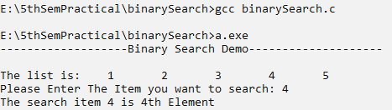

4. ANALYSIS
In binary search the list of size n is divided into size n/2 at each step. Since we search recursively in one direction either left or right.
In the first step of dividing the search item is compared with the mid element and the list is reduced to size n/2.
In the second step, the n/2 size list is reduced to n/2² list.
In the third step, the n/2² size list is reduced to n/2³ list and so on.
In iᵗʰ step the n/2ᶦ ⁻ ¹ size is reduced to n/2ᶦ.

So to the end of recursive step n/2ᶦ = 1
=> n = 2ᶦ
=> i = logn
So the maximum number of comparison and division is i = logn

Therefore, Time Complexity, T(n) = O(logn).

5. CONCLUSION
The binary search algorithm is a widely used algorithm in the computational domain. It is a simple, reliable, and efficient search algorithm that can work well on both big and small datasets.

LAB NO. 3 : DYNAMIC PROGRAMMING
EXPERIMENT NO.1
TITLE : TO DESIGN AND IMPLEMENT ALGORITHM TO SOLVE 0-1 KNAPSACK PROBLEM
- THEORY
Statement: A thief has a bag or knapsack that can contain maximum weight W of his loot. There are n items and the weight of ith item is wi and it worth vi. An amount of item can be put into the bag is 0 or 1 i.e. xi is 0 or 1. Here the objective is to collect the items that maximize the total profit earned. Let W=Capacity of Knapsack n=No. of items w = {w1, w2, …………, wn} = weights of items V= {v1, v2, v3, ………, vn} = value of items C[i, w] = maximum profit earned with item i and with knapsack of capacity w then The recurrence relation for 0/1 knapsack problem is given as:
C[i, w] = 0 if i=0 or w=0
C[i, w] =C[i-1,w] if wi > w
C[i, w] = Max{vi + C[i-1,w-wi], c[i-1,w] if i>0 and w>wi

- PROGRAM
(SOURCE CODE)
#include<stdio.h>
#define max 100
int i, j;
void printTable(int noOfItems, int capOfKn, int wtOfItem[], int costOfItem[],int selectedCost[][max])
{
printf("\ni\twt\tcost\t\t\tWeight Of Knapsack--->\n");
printf("-------------------------------------------------------------------\n");
printf("\t\t\t");
for(i = 0; i<=capOfKn; i++)
printf("%d\t",i);
for(i = 0; i<=noOfItems; i++) {
printf("\n%d\t%d\t%d\t",i, wtOfItem[i], costOfItem[i]);
for(j = 0; j <= capOfKn; j++) {
printf("%d\t", selectedCost[i][j]);
}
}

}
int knapSack(int capOfkn, int noOfItems, int costOfItems[], int wtOfItems[])
{
int totalCost = 0; int totalWeight = 0;
int selectedCost[max][max];
for(j = 0; j <= capOfkn; j++)
selectedCost[0][j] = 0;//first row all 0
for(i = 1; i <= noOfItems; i++)
selectedCost[i][0] = 0; //first column all 0
for(i = 1; i<=noOfItems; i++) {
for(j = 1; j<=capOfkn; j++) {
if(wtOfItems[i] <= j) {
if(selectedCost[i-1][j-wtOfItems[i]] + costOfItems[i] > selectedCost[i-1][j])
selectedCost[i][j] = selectedCost[i-1][j-wtOfItems[i]]+costOfItems[i];
else
selectedCost[i][j] = selectedCost[i-1][j];
} else
selectedCost[i][j] = selectedCost[i-1][j];
}
}
printTable(noOfItems, capOfkn, wtOfItems, costOfItems, selectedCost);
printf("\n\nItems To Be Added In Knapsacks Are:\n");
i=noOfItems; j=capOfkn;
while(i > 0 && j > 0) {
if(selectedCost[i][j] == selectedCost[i-1][j])
i--;
else {
printf("%dth Item with %d wt and %d Cost\n", i, wtOfItems[i], costOfItems[i]);
totalCost += costOfItems[i]; totalWeight +=wtOfItems[i];
i--;
j-=wtOfItems[i];
}
}
printf("\nTotal Profit otained: %d \n Total Weight added: %d", totalCost, totalWeight);
return 0;
}
int main()
{
int noOfItems,wtOfItems[max], costOfItems[max],capOfKn;
printf("Enter The Capacity Of Knapsack: ");
scanf("%d", &capOfKn);
printf("Enter The Total no. Of Items: ");
scanf("%d", &noOfItems);
printf("Enter Weights of %d Items in order:", noOfItems);
printf("\n(Input starts from 0 to %d, so please Enter 0 first and then proceed) ",noOfItems);
for(i=0; i <= noOfItems; i++)
scanf("%d", &wtOfItems[i]);
printf("Enter Costs of %d Items in order:", noOfItems);
printf("\n(Input starts from 0 to %d, so please Enter 0 first and then proceed) ",noOfItems);
for(i=0; i <= noOfItems; i++)
scanf("%d", &costOfItems[i]);
knapSack(capOfKn, noOfItems, costOfItems, wtOfItems);
}
- OUTPUT
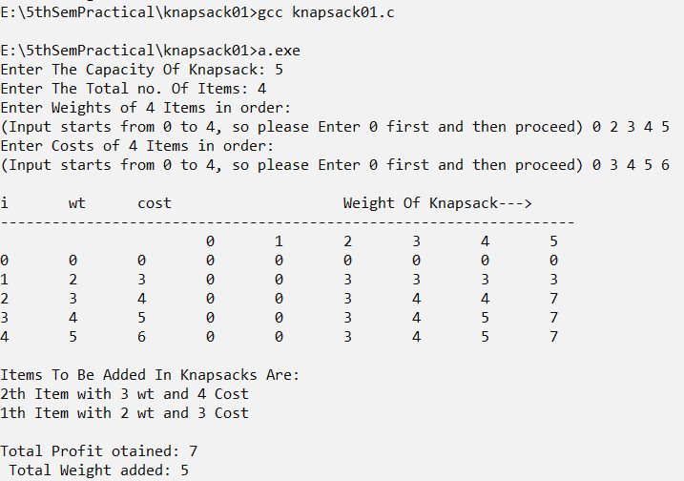
- ANALYSIS
For run time analysis examining the above algorithm the overall run time of the algorithm is O(nW).
- CONCLUSION
From the experiment above, we learnt to implement dynamic programming in 0-1 Knapsack problems, hence maximizing the profit.

EXPERIMENT NO.2
TITLE : TO DESIGN AND IMPLEMENT ALGORITHM TO SOLVE LONGEST COMMON SUBSEQUENCE PROBLEM
- THEORY
This method is used to test the matching or similarities between the two strings. Given two sequences X = (x1, x2, …………,xm) and Z = (z1, z2, ……… ,zk), we say that Z is a subsequence of X if there is a strictly increasing sequence of k indices (i1, i2, ……… ik) (1 ≤ i1 < i2 < ……….. < ik) such that Z = (Xi1, Xi2 ………. Xik).
For example, let X = (ABRACADABRA) and let Z = (AADAA), then Z is a subsequence of X. Given two strings X and Y, the longest common subsequence of X and Y is a longest sequence Z that is a subsequence of both X and Y.
Recurrence relation for LCS:
Let xi and yj represent any two sequences of characters. L[i, j] represents the LCS of xi and yj then its recurrence relation is,
L[i, j] = 0 if i=0 or j=0
L[i, j] = L[i-1, j-1]+1 if xi = yj
L[i, j] = max {L[i-1, j], L[i, j-1]} if i>0 , j>0 and xi≠ yj

- PROGRAM
(SOURCE CODE)
#include<stdio.h>
#include<ctype.h>
#include<string.h>
#define max 100
int i,j;
int printTable(char x[], char y[], int number[][max],char character[][max])
{
int lengthX = strlen(x);
int lengthY = strlen(y);
printf("\t\t\t");
for(i = 0; i < lengthY; i++)
printf("%c\t", y[i]);
printf("\n-------------------------------------------------------------------------------------\n");
printf("\t\t");
for(i = 0; i <= lengthY; i++)
printf("%d\t",i);
for(i = 0; i<=lengthX; i++) {
if(i == 0)
printf("\n\t%d\t", i);
else
printf("\n%c\t%d\t", x[i-1], i);
for(j = 0; j <= lengthY; j++) {
printf("%d%c\t", number[i][j],character[i][j]);
}
}
printf("\nThe Longest Common Subsequence is:");
return 0;
}
int printLcs(char character[max][max], char x[], int lengthX, int lengthY)
{
if(lengthX == 0 || lengthY == 0)
return 0;
else if(character[lengthX][lengthY] == 'd') {
printLcs(character, x, lengthX-1, lengthY-1);
printf("%c", x[lengthX]);
} else if(character[lengthX][lengthY] == 'u')
printLcs(character, x, lengthX-1, lengthY);
else
printLcs(character, x, lengthX, lengthY-1);
}
int lcs(char x[], char y[])
{
int number[max][max];
char character[max][max];
int lengthX = strlen(x);
int lengthY = strlen(y);
for(i=0; i<=lengthX; i++)
number[i][0] = 0;
for(j=0; i<=lengthY; j++)
number[0][j] = 0;
for(i = 1; i<=lengthX; i++) {
for(j=1; j<=lengthY; j++) {
if(x[i] == y[j]) {
number[i][j] = number[i-1][j-1]+1;
character[i][j] = 'd';
} else if(number[i-1][j] >= number[i][j-1]) {
number[i][j] = number[i-1][j];
character[i][j]= 'u';
} else {
number[i][j] = number[i][j-1];
character[i][j] = 'l';
}
}
}
printTable(x, y, number, character);
printLcs(character, x, lengthX, lengthY);
return 0;
}
int main()
{
char x[max], y[max];
printf("Enter the first character sequence: ");
scanf(" %s", &x);
printf("Enter the Second character sequence: ");
scanf(" %s", &y);
printf("Your Sequences are:\n");
printf("X: <");
for(i = 0; i<strlen(x); i++)
printf("%c\t", x[i]);
printf(">\n");
printf("Y: <");
for(j = 0; j<strlen(y); j++)
printf("%c\t", y[j]);
printf(">\n\n");
lcs(x, y);
}

- OUTPUT
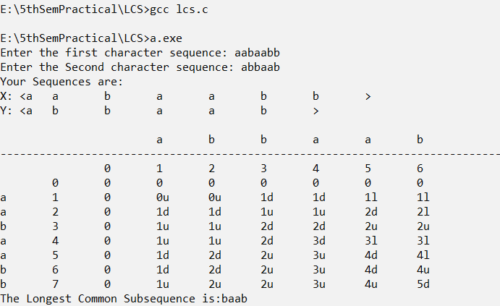

- ANALYSIS
The above algorithm can be easily analyzed for running time as O(mn), due to two nested loops. The space complexity is O(mn).

- CONCLUSION
Hence, from the experiment above, we learnt to implement dynamic approach in solving longest common subsequence problem.

LAB 4. GREEDY ALGORITHMS
EXPERIMENT NO.1 : TO DESIGN AND IMPLEMENT ALGORITHM TO SOLVE FRACTIONAL KNAPSACK PROBLEM

- THEORY
A thief has a bag or knapsack that can contain maximum weight W of his loot. There are n items and the weight of ith item is wi and it worth vi. Any amount of item can be put into the bag i.e. xi fraction of item can be collected, where 0<=xi<=1. Here the objective is to collect the items that maximize the total profit earned. Here we arrange the items by ratio vi/wi.

- PROGRAM
(SOURCE CODE)
#include<stdio.h>
#define max 100
int i, j;
void printTable(int noOfItems, float wtOfItem[], float costOfItem[],float cpw[])
{
printf("\nItem\tweight\t\tcost\t\tcpw");
for(i=0; i<noOfItems; i++) {
printf("\n%d\t%f\t%f\t%f", i, wtOfItem[i],costOfItem[i], cpw[i]);
}

}
int knapSack(float capOfkn, int noOfItems, float costOfItems[], float wtOfItems[], float cpw[])
{
float remCap = capOfkn; i = 0;j=0;
float knItemCost = 0;
while (i < noOfItems)
{
if(remCap >= wtOfItems[i]){
remCap-=wtOfItems[i];
knItemCost += costOfItems[i];
}
i++;
}
if(remCap > 0) {
while (j < noOfItems) {
if(remCap >= cpw[j]) {
remCap -= 1.000;
knItemCost+=cpw[j];
}
j++;
}
}
printf("\nTotal Cost of Items Added In Knapsack:%f\n", knItemCost);

}
int main()
{
float wtOfItems[max], costOfItems[max],capOfKn, cpw[max];
int noOfItems;
printf("Enter The Capacity Of Knapsack: ");
scanf("%f", &capOfKn);
printf("Enter The Total no. Of Items: ");
scanf("%d", &noOfItems);
printf("Enter Weights of %d Items in order:", noOfItems);
for(i=0; i < noOfItems; i++)
scanf("%f", &wtOfItems[i]);
printf("Enter Costs of %d Items in order:", noOfItems);
for(i=0; i < noOfItems; i++)
scanf("%f", &costOfItems[i]);
// calculate cost per unit weight
for(i = 0; i< noOfItems; i++)
cpw[i] = costOfItems[i]/wtOfItems[i];
printTable(noOfItems, wtOfItems, costOfItems, cpw);
knapSack(capOfKn, noOfItems, costOfItems, wtOfItems, cpw);
}

- OUTPUT
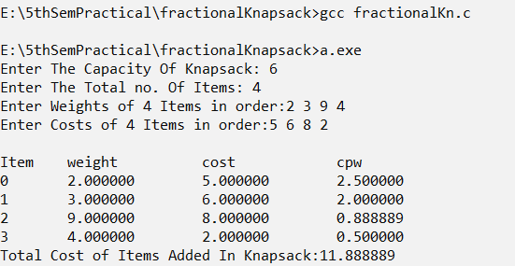

- ANALYSIS
We can see that the above algorithm just contain a single loop i.e. no nested loops the running time for above algorithm is O(n). However our requirement is that v[1 … n] and w[1 … n] are sorted, so we can use sorting method to sort it in O(n log n) time such that the complexity of the algorithm above including sorting becomes O(n log n).

- CONCLUSION
Hence, we were able to implement a greedy approach in fractional knapsack problems.

EXPERIMENT 2: TO DESIGN AND IMPLEMENT ALGORITHM TO SOLVE JOB SEQUENCING PROBLEM

- THEORY:
In job sequencing problem, the objective is to find a sequence of jobs which is completed within their deadlines and gives maximum profit.
Let us consider a set of n given jobs which are associated with deadlines and profit is earned, if a job is completed by its deadline. These jobs need to be ordered in such a way that there is maximum profit.It may happen that all of the given jobs may not be completed within their deadlines.
Assume the deadline of ith job Ji is di and the profit earned is pi. Hence, the optimal solution of this algorithm is a feasible solution with maximum profit.
Thus, D(i)>0 for 1<=i<=n
Initially these jobs are ordered according to profit.

- PROGRAM
SOURCE CODE
#include <stdio.h>
#define MAX 100
typedef struct Job {
char id[5];
int deadline;
int profit;
} Job;
void jobSequencingWithDeadline(Job jobs[], int n);
int minValue(int x, int y) {
if(x < y) return x;
return y;
}
int main(void) {
//variables
int i, j;
//jobs with deadline and profit
Job jobs[5] = {
{"j1", 2, 60},
{"j2", 1, 100},
{"j3", 3, 20},
{"j4", 2, 40},
{"j5", 1, 20},
};
//temp
Job temp;
//number of jobs
int n = 5;
//sort the jobs profit wise in descending order
for(i = 1; i < n; i++) {
for(j = 0; j < n - i; j++) {
if(jobs[j+1].profit > jobs[j].profit) {
temp = jobs[j+1];
jobs[j+1] = jobs[j];
jobs[j] = temp;
}
}
}
printf("%10s %10s %10s\n", "Job", "Deadline", "Profit");
for(i = 0; i < n; i++) {
printf("%10s %10i %10i\n", jobs[i].id, jobs[i].deadline, jobs[i].profit);
}
jobSequencingWithDeadline(jobs, n);
return 0;
}
void jobSequencingWithDeadline(Job jobs[], int n) {
int i, j, k, maxprofit;
int timeslot[MAX];
int filledTimeSlot = 0;
int dmax = 0;
for(i = 0; i < n; i++) {
if(jobs[i].deadline > dmax) {
dmax = jobs[i].deadline;
}
}
for(i = 1; i <= dmax; i++) {
timeslot[i] = -1;
}
printf("dmax: %d\n", dmax);
for(i = 1; i <= n; i++) {
k = minValue(dmax, jobs[i - 1].deadline);
while(k >= 1) {
if(timeslot[k] == -1) {
timeslot[k] = i-1;
filledTimeSlot++;
break;
}
k--;
}
if(filledTimeSlot == dmax) {
break;
}
}
printf("\nRequired Jobs: ");
for(i = 1; i <= dmax; i++) {
printf("%s", jobs[timeslot[i]].id);
if(i < dmax) {
printf(" --> ");
}
maxprofit = 0;
for(i = 1; i <= dmax; i++) {
maxprofit += jobs[timeslot[i]].profit;
}
printf("\nMax Profit: %d\n", maxprofit);
}

- OUTPUT
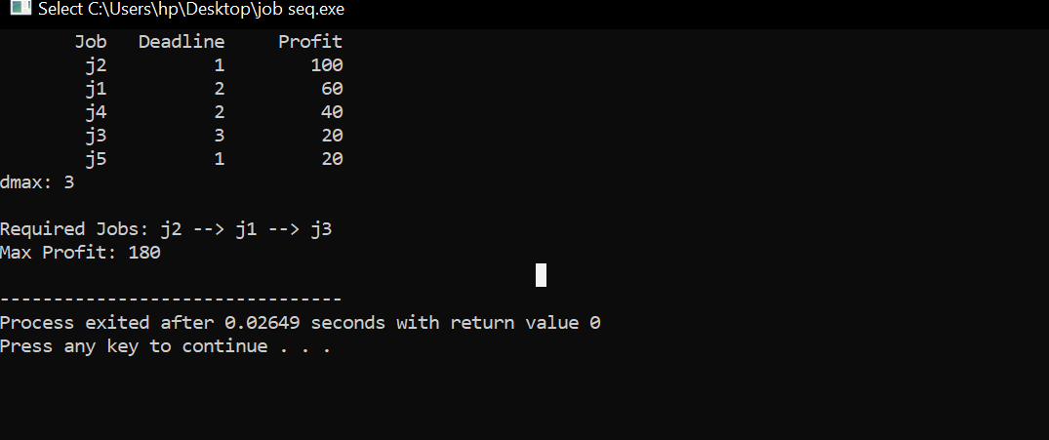

- ANALYSIS
The time complexity of this algorithm is O(n^2).

- CONCLUSION
Hence, we learnt to implement a greedy approach to optimize solutions in solving job sequencing problems.

