MACHINE LEARNING

Predictive Text

Daniel I. 01FB15ECS086

Durga Akhil M. 01FB15ECS097

Ganesh K. 01FB15ECS104

Rahul R. Bharadwaj 01FB15ECS366

Contents

Problem Statement 2

Dataset Details. 2

ML Techniques 3

Design Document 5

Results Markov Chains 9

Results RNN 11

References 12

# PROJECT REVIEW

## Problem Statement:

## To create a system which, given input as a part of a complete English sentence, can predict the next word in the sentence or generate the next sequence of words.

## Dataset Details:

1.  [Corpus of Contemporary American English (COCA)](http://corpus.byu.edu/coca/)

* About Dataset: The Corpus of Contemporary American English (COCA) is the largest freely-available corpus of English, and the only large and balanced corpus of American English.
* Attributes: We will be using a subset of COCA mainly from [here](https://www.ngrams.info/download_coca.asp). Hence, we will be using two, three, four and five-gram inputs to train the model each time.
* Instance count: Each of the n-gram datasets contains the following number of n-grams:
  + 2-gram: 1,020,386
  + 3-gram: 1,020,010
  + 4-gram: 1,034,308
  + 5-gram: 1,044,269
* This was the primary dataset for testing the goodness of fit for every other dataset as it was exhaustive. We also trained using this dataset for next-word prediction as well as generating text.

2. [Wikipedia Corpus](https://corpus.byu.edu/wiki/)

* About dataset: This corpus contains the full text of [Wikipedia](http://en.wikipedia.org/wiki/), and it contains 1.9 billion words in more than 4.4 million articles.
* Attributes: Wikipedia Corpus contains Wikipedia pages scraped and dumped into text files. Since it is only for testing, we used random articles with a total of 2286765 words.
* Usage: The corpus is pre-processed using following steps:
  + Read all the lines of the input file.
  + Remove all unwanted characters and punctuations.
  + Remove lines with very few words.
  + Convert everything to lower-case.
  + Run a sliding window on the words
* This was the primary dataset with which we used to learn the model and apply goodness of fit test.

## ML Techniques:

*Chosen:*

Following are the methods we shall employ and eventually compare the results to discover which is better for the given dataset

*Markov Chain*

A Markov chain is "a [stochastic model](https://en.wikipedia.org/wiki/Stochastic_model) describing a [sequence](https://en.wikipedia.org/wiki/Sequence) of possible events in which the probability of each event depends only on the state attained in the previous event." A common method of reducing the complexity of n-gram modeling is using the [Markov Property](https://en.wikipedia.org/wiki/Markov_property). The Markov Property states that the probability of future states depends only on the present state, not on the sequence of events that preceded it. This concept can be elegantly implemented using a [Markov Chain](https://en.wikipedia.org/wiki/Markov_chain) storing the probabilities of transitioning to a next state. Also compared to RNNs its much faster to implement and provides a fairly good accuracy to complexity trade-off.

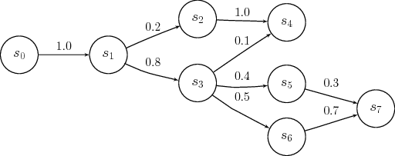

Figure 1 Example of Markov Chain

*Recurrent Neural Networks:*

RNN is a neural network which has recurrent connections, unlike feedforward networks. The major benefit is that with these connections the network is able to refer to previous states and can therefore process arbitrary sequences of input.

* RNNs make use of sequential information. A traditional neural network assumes  
  that all inputs (and outputs) are independent of each other.
* Since our project is to predict text, it is crucial to know the information from  
  previous states, i.e. the previous words to predict the next word.
* RNNs are called recurrent because they perform the same task for every element of  
  a sequence, with the output depending on the previous computations.
* RNNs thus have a “memory” element to capture information from previous  
  calculations.

## A recurrent neural network and the unfolding in time of the computation involved in its forward computation.

Figure 2 A typical RNN looks like one shown above. A RNN is unrolled (or unfolded) over time into a full network.

## 

## Need for LSTM and its advantages over RNN:

Two major problems with RNN: Vanishing and Exploding gradients.

* Vanishing Gradients: In traditional RNNs the gradient signal can be multiplied a large number of times by the weight matrix. Thus, the magnitude of the weights of the transition matrix can play an important role. If the weights in the matrix are small, the gradient signal becomes smaller at every training step, thus making learning very slow or completely stops it. This is called vanishing gradient.
* Exploding Gradients: refers to the weights in this matrix being so large that it can cause learning to diverge.

LSTM stands for Long Short Term Memory, is a special kind of RNN that learns long-term dependencies. The memory cell of LSTM is composed of four elements: input, forget and output gates and a neuron that connects to itself.

## Design Document:

#### Markov Chains

Consider bigram model: Input: "I am Sam. Sam I am. I do not like green eggs and ham."

Listing the bigrams starting with the word I results in: I am, I am., and I do. If we were to use this data to predict a word that follows the word I we have three choices and each of them has the same probability (1⁄3) of being a valid choice.

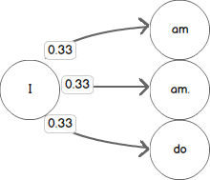

Figure 4 Modeling this using a Markov Chain results in a state machine with an approximately 0.33 chance of transitioning to any one of the next states.

We can add additional transitions to our Chain by considering additional bigrams starting with am, am., and do. In each case, there is only one possible choice for the next state in our Markov Chain given the bigrams we know from our input text.

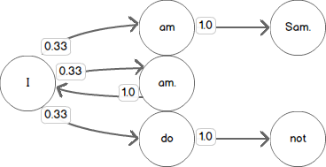

Figure 5 Each transition from one of these states therefore has a 1.0 probability.

Pseudo-Code (Python)

Create bigrams:

1. >>>  s  =  "I am Sam. Sam I am. I do not like green eggs and ham."
2. >>>  tokens  =  s.split(" ")
3. >>>  bigrams  =   [(tokens[i],  tokens[i  +  1])  for  i  in  range(0,  len(tokens)  -  1)]
4. >>>  bigrams[('I',  'am'),   ('am',  'Sam.'),   ('Sam.',  'Sam'),   ('Sam',  'I'),   ('I',  'am.'),   ('am.',  'I'),   ('I',  'do'),   ('do',  'not'),   ('not',  'like'),   ('like',  'green'),   ('green',  'eggs'),   ('eggs',  'and'),   ('and',  'ham.')]

Markov Chain: I am Sam.

1. {
2. 'I': ['am'],
3. 'am': ['Sam.'],
4. }

Add Sam I am.

1. {
2. 'I': ['am', 'am.'],
3. 'am': ['Sam.'],
4. 'Sam': ['I'],
5. }

Thus, give an input 'am', we get 'Sam.'

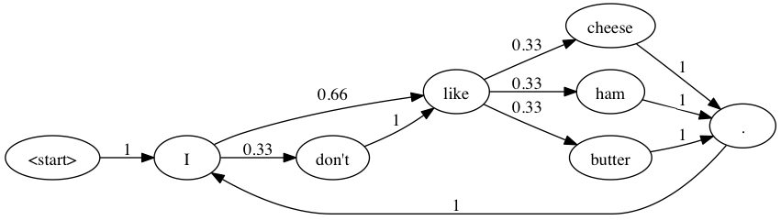

Figure 6 An example of fully modeled Markov Chain

#### Recurrent Neural Networks

Architectural Design

In order to train our recurrent neural network, we use a large text file (we have used the Harry Potter books) as input. This large text file undergoes preprocessing and is stored in the form of two arrays X and Y defined as:

X:   
which is a three dimensional array of the form X[i, t, char_indices[char]] where i is the index of each sentence, t is the index of each letter in each sentence and char_indices[char] indicates the letter encountered. Therefore, X is like the given input matrix.

Y:  
which is a two dimensional array of the form Y[i, char_indices[next_chars[i]]] where i is the index of each sentence and char_indices[next_chars[i]] indicates the letter which is encountered after encountering SEQUENCE_LENGTH (set to 40) characters of the sentence. Therefore, Y is like the expected output matrix.

We iterate through the text file at a step size of 3 characters, scanning through all characters, till SEQUENCE_LENGTH (store in list of sentences) and storing the next expected character after SEQUENCE_LENGTH (store in list of next_char). This is then used in the creation of the X and Y matrices.

Example:   
For sequence length of 10 and step size of 3, the string

“Today is a Monday”

gets converted to:

Sentences = [“Today is a”, “ay is a Mo”, “is a Monda”] Next_chars = [“ ”, “n”, “y”]

X and Y are initially all initialized to False

Then, we update X and Y such that

1. X[0][0][‘T’] = True
2. X[0][1][‘o’] = True
3. Y[0][‘’] = True
4. Y[1][‘n’] = True

And so on.

BUILDING THE RNN MODEL

We use a Single LSTM layer with 128 neurons which accepts input of shape ( the length of a sequence, the number of unique characters in our dataset). A fully connected layer (for our output) is added after that.

It has 57(number of unique characters) neurons and softmax for activation function:

1. model = Sequential()
2. model.add(LSTM(128, input_shape = (SEQUENCE_LENGTH, len(chars))))
3. model.add(Dense(len(chars)))
4. model.add(Activation('softmax'))

Our model is trained for many number of epochs using RMSProp optimizer and uses 5% of the data for validation:

1. optimizer = RMSprop(lr = 0.01)
2. model.compile(loss = 'categorical_crossentropy', optimizer = optimizer, metrics = ['accuracy'])
3. history = model.fit(X, y, validation_split = 0.05, batch_size = 128, epochs = 20, shuffle = True).history

RMSprop has been developed independently around the same time stemming from the need to resolve Adagrad's radically diminishing learning rates.

PSEUDO-CODE:

def prepare_input(text):

x = np.zeros((1, SEQUENCE_LENGTH, len(chars)))

for t, char in enumerate(text):

    x[0, t, char_indices[char]] = 1.

return x

def sample(preds, top_n=3):

preds = np.asarray(preds).astype('float64')

preds = np.log(preds)

exp_preds = np.exp(preds)

preds = exp_preds / np.sum(exp_preds)

return heapq.nlargest(top_n, range(len(preds)), preds.take)

def predict_completion(text):

original_text = text

generated = text

completion = ''

while True:

    x = prepare_input(text)

    preds = model.predict(x, verbose=0)[0]

    next_index = sample(preds, top_n=1)[0]

    next_char = indices_char[next_index]

    text = text[1:] + next_char

    completion += next_char

    if len(original_text + completion) + 2 > len(original_text) and

next_char == ' ':

        return completion

def predict_completions(text, n=3):

x = prepare_input(text)

preds = model.predict(x, verbose=0)[0]

next_indices = sample(preds, n)

return [indices_char[idx] + predict_completion(text[1:] + indices_char[idx]) for idx in next_indices]

## Results Markov Chain:

Figure 7

Table 1 Classification Accuracy and Error Rate for Wikipedia Corpus on COCA Dataset

|  |  |  |
| --- | --- | --- |
| N-gram | classification accuracy | Error Rate |
| 2 | 92.44 | 7.6 |
| 3 | 95.84 | 4.16 |
| 4 | 93.53 | 6.47 |
| 5 | 93.042 | 6.958 |

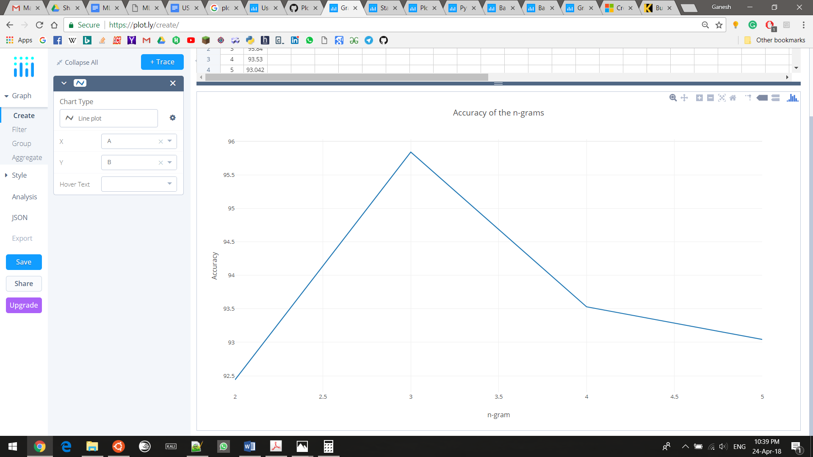

Figure 8 Accuracy of 2 to 5 gram

Table 2 Spoken and Written American English Dataset Accuracy

|  |  |  |  |  |  |
| --- | --- | --- | --- | --- | --- |
| N-gram | w_acad | w_fic | w_mag | w_news | w_spok |
| 2 | 67.89 | 62.83 | 66.74 | 68.91 | 67.84 |
| 3 | 72.97 | 69.27 | 68.76 | 71.98 | 70.29 |
| 4 | 71.67 | 66.54 | 67.45 | 70.27 | 69.92 |
| 5 | 70.23 | 67.78 | 67.23 | 69.89 | 69.02 |

Conclusion:

Thus, Markov Chains are very simple but effective tools for statistically modeling random processes. It is fairly simple to train compared to other models with similar levels of accuracy and very fast to query once learnt.

Although it is quite effective for predictive text, recent developments in Neural Networks has made Markov Chains the second options as models Like RNN have shown to give better results once trained properly.

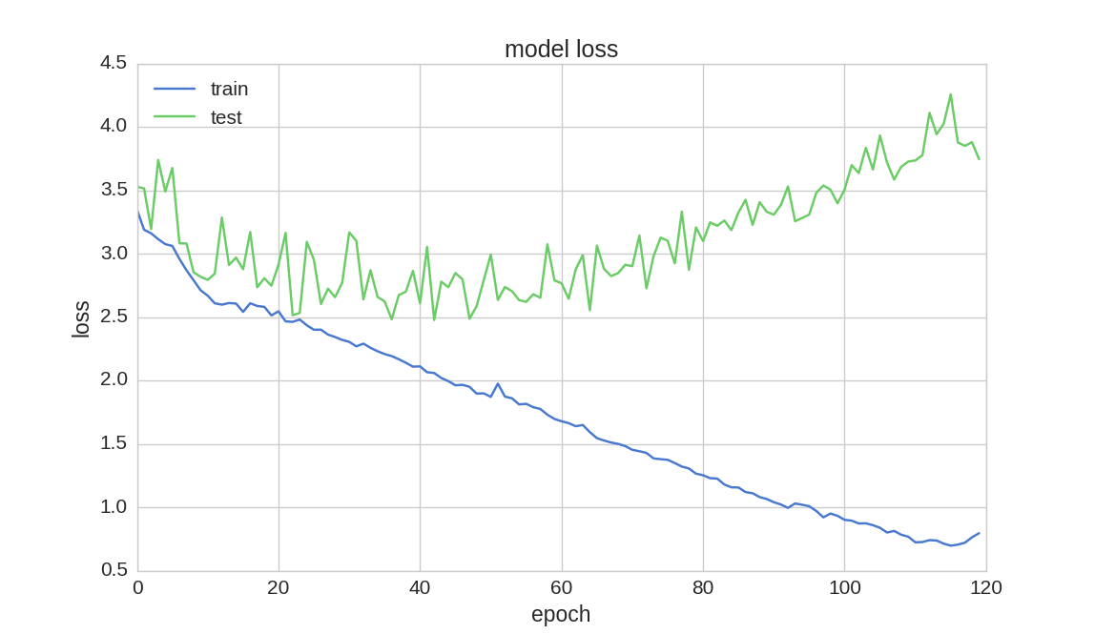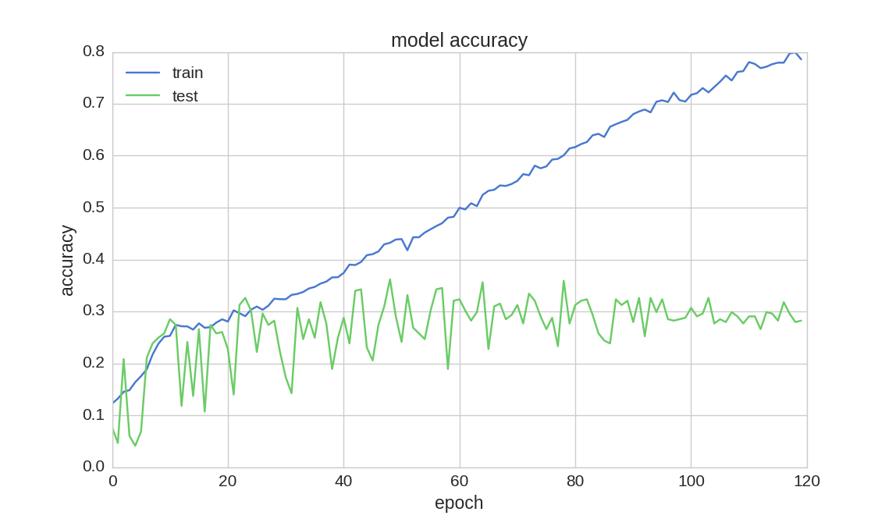Results RNN

Figure 10 Loss for each epoch

Figure 9 Accuracy for each epoch

When trained for 120 epochs, we have obtained a training accuracy of 78.57.

Comparison:

* The RNN is more accurate than the n-gram model because it can retain more history than just the previous 2 tokens and using word vectors instead of discrete tokens for each word allows it to generalize and make predictions from similar words, not just exact matches.
* The RNN takes longer to train (e.g. 8 hours vs 8 seconds, about 4000x longer), but would easily be able to fit into memory for applications like phone text entry - it also performs word predictions a bit slower than the n-gram, but not enough to be noticeable to an end-user.

References:

* Language Model: <https://en.wikipedia.org/wiki/Language_model>
* Markovian Property: <https://en.wikipedia.org/wiki/Markov_property>
* Markov Chain: <https://en.wikipedia.org/wiki/Markov_chain>
* Dataset:
  + <https://www.ngrams.info/download_coca.asp>
  + <https://corpus.byu.edu/coca/>
* RNN: <https://en.wikipedia.org/wiki/Recurrent_neural_network>
* Implementations:
  + <https://github.com/chfoo/tellnext>
  + <https://sookocheff.com/post/nlp/ngram-modeling-with-markov-chains/>