CHAPTER 1
INTRODUCTION

With the advent of internet as the main platform for providing services, there is a need to provide secure communication and data integrity. To provide this form of group communication[3] privacy, it is important that members of the group can establish a common secret key for encrypting group communication data. To illustrate the utility of this type of applications, consider a group of people in a peer-to-peer or ad hoc network having a closed and confidential meeting. Since they do not have a previously agreed upon common secret key, communication between group members is susceptible to eavesdropping. To solve the problem, one needs a secure distributed group key agreement[1] protocol so that people can establish and authenticate a common group key for secure and private communication. This type of key agreement protocols is both distributed and contributory in nature. Each member of the group contributes its part to the overall group key. It is important to point out that the type of distributed group key agreement protocols is very different from traditional centralized group key management protocols.

  - CENTRALIZED KEY MANAGEMENT

Centralized protocols rely on a centralized key server to efficiently distribute the group key. In those approaches, group members are arranged in a logical key hierarchy known as a key tree. Using the tree topology, it is easy to distribute the group key to members whenever there is any change in the group membership (e.g., a new member joins or an existing member leaves the group). But they suffer a drawback of a single point of failure. If the centralized keys server fails, the entire communication for all groups managed by the server also fails. Further heavy computation load is put on the key server, since all the work for rekeying carried out by only the server.

1.2 DISTRIBUTED COLLABRATIVE KEY MANAGEMENT

In the distributed key agreement protocols considered, there is no centralized key server available. By collaborative[6] one means, each group member contributes its own part of information towards the group key, hence whenever there is a membership event (a member joins or leaves) the group key changes. The key agreement protocol is also dynamic in nature, i.e., the protocol remains efficient even when the occurrences of join/leave events are very frequent. This arrangement is justified in many situations—e.g., in peer-to-peer or ad hoc networks where centralized resources are not readily available. Moreover, an advantage of distributed protocols over the centralized protocols is the increase in system reliability, because the group key is generated in a shared and contributory fashion and there is no single-point-of-failure.

  - OVERVIEW OF THE PROJECT

- Instead of using individual rekeying operations, Interval-based distributed rekeying algorithms are used. The interval-based approach provides rekeying efficiency for dynamic peer groups while preserving both distributed (i.e., no centralized key server is involved) and contributory (i.e., each member contributes to the resulting group key) properties.

- A distributed Messaging application is developed with the facility of managing groups that implements interval based rekeying algorithm.

- A SEcure Communication Library (SECL) that realizes the interval-based algorithms is developed. The library provides a programming interface for the development of secure group-based applications.

- A comparison of performances of distributed key management and centralized key management is done.
  - ORGANISATION OF APPLICATION
User Login
Initialize User’s public key and profile
Transmit public key values to all other users
Functions
Group Management
P2P Management

Create
Group
Join
Group
Leave
Group
Delete
Group
Offline
Message
Address
Book
Logout

Rekeying Based on Interval Timing
Messaging
Exit
Get group key

Update Key Value
Encrypt Message and Send Data

Figure.1.1 Organisation Flow Chart
The forthcoming chapters provide a description of Tree based Diffie Hellman protocol and interval based rekeying.
CHAPTER 2
TREE BASED GROUP DIFFIE HELLMAN PROTOCOL

Tree based Diffie Hellman protocol[1] is basically an extension of Diffie Hellman key exchange for two members. A brief overview of Diffie Hellman key exchange protocol is presented here:

2.1 DIFFIE HELLMAN KEY EXCHANGE PROTOCOL

In the special case of a communication group having only two members, these members can create a group key using the Diffie Hellman[3] key exchange protocol. In the protocol, members and use a cyclic group of prime order with the generator. They can generate their secret exponents and respectively. Members can compute their public key and send it to other members .Since both members know their own exponent, they can each raise the other party’s public key to the exponent and produce a common group key. The group key K_{v} can be calculated as follows after key exchange:
Kv = (Received Public Key) ^{(Own Private Key)} mod p
Where p is the prime number. Using the common group key, and can encrypt their data to prevent eavesdropping by intruders. In this paper proposals based on the tree-based group Diffie Hellman protocol, several group key agreement protocols for a dynamic communication group in which members are located in a distributed fashion and can join and leave the group at any time have been made.

2.2 GROUP KEY AGREEMENT USING TGDH

To efficiently maintain the group key in a dynamic peer group with more than two members, the tree based group Diffie-Hellman (TGDH) protocol proposed. Each member maintains a set of keys, which are arranged in hierarchical binary tree. A node ID_{v} is to every tree node. For a given node v, there is a secret (or private) key K_{v} and a blinded (or public) key BK_{v}. All arithmetic operations are performed in a cyclic group of prime order p with the generator α. Therefore, the blinded key of node v can be generated by
BK_{v} = α ^{Kv} mod p

Each leaf node in the tree corresponds to the individual secret and blinded keys of a group member M_{i}. Every member holds all the secret keys along its key path starting from its associated leaf node up to the root node. Therefore, the secret key held by the root node is shared by all the members and is regarded as the group key. Figure.2.1 illustrates a possible key tree with six members M₁ to M₆. For example, member M₁ holds the keys at nodes 7,3,1 and 0. The secret key at node 0 is the group key of this peer group.
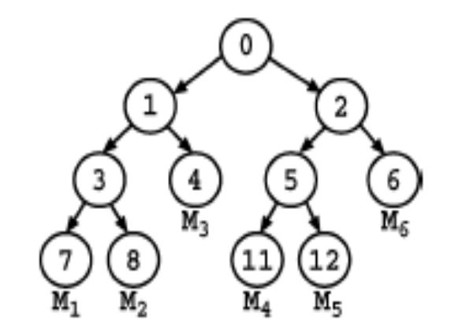
Figure 2.1 Key Tree used in TGDH Protocol

The node ID of the root node is set to 0. Each non leaf node v consists of two child nodes whose node ID’s are given by 2v+1 and 2v+2. Based on the Diffie Hellman protocol, the secret key of a nonleaf node v can be generated by the secret key of one child node of v and the blinded key of another child node of v. Mathematically, it is evident that,

K_{v} = (BK_{2v+1}) ^{K}_{2v+2} mod p
= (BK_{2v+2}) ^{K}_{2v+1} mod p
= α ^{K}_{2v+1} ^{K}_{2v+2} mod p

Unlike the keys at non leaf nodes, the secret key at a leaf node is selected by its corresponding group member through a secure pseudo random number generator.

Since the blinded keys are publicly known, every member can compute the keys along its key path to the root node based on its individual secret key. To illustrate, consider the key tree in Figure.2.2. Every member M_{i} generates its own secret key and all the secret keys along the path to the root node. For example, member M₁ generates K₇ the secret and it can request the blinded key BK₈ from M₂, BK₄ from M₃ and BK₂ from M4, M₅ or M₆.Given M₁’s secret key K₇ and the blinded key BK₈, M₁ can generate the secret key K₃. Given the blinded key BK₄ and the newly generated secret key K₃, M₁ can generate the secret key K₁. Given the secret key K₁ and the blinded key BK₂, M₁ can generate the secret key K₀ at the root. From that point on, any communication in the group can be encrypted based on the secret key (or group key) K₀.
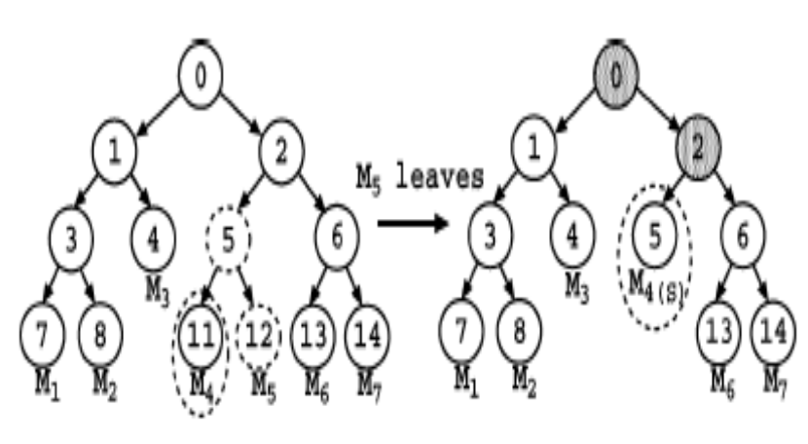
Figure 2.2 Membership Leave Event

To provide both backward confidentially (i.e., joined members cannot access previous communication data) and forward confidentially (i.e., left members cannot access future communication data), rekeying, which means renewing the keys associated with the nodes of the key tree, is performed whenever there is any group membership change including any new member joining or any existing member leaving the group. Let us first consider individual rekeying, meaning that rekeying is performed after every single join or leave event. Figure.2.2 depicts a member leave event. Suppose that member M₅ leaves the system. Node 11 is then promoted to node 5, and nodes 2 and 0 become renewed nodes, defined as the non leaf nodes whose associated keys in the key tree are renewed. Also, member M₄ renews the secret keys K₂ and K₀ .
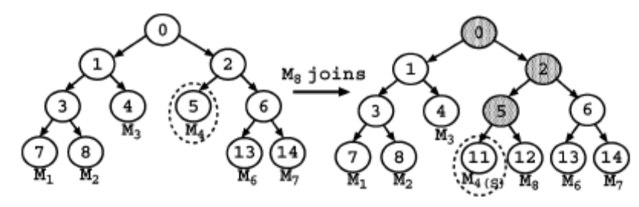
Figure 2.3 Membership Join Event

Figure.2.3 illustrates a new member M₈ that wishes to join the group. M₈ has to first determine the insertion node under which M₈ can be inserted. To add a node, say v' (or tree, say T’) to the insertion node, a new node, say n’, is first created. Then the subtree rooted at the insertion node becomes the left child of the node n’, and the node v' (or the root node of the tree T’) becomes the right child of the node n’. The node n’ will replace the original location of the insertion node. The insertion node is either the rightmost shallowest position such that the join does not increase the tree height or the root node if the tree is initially well balanced (in this case, the height of the resulting tree will be increased by 1).

Based on the above leave and join events in Figure 2.2 and Figure 2.3, one can find that one rekeying operation can be reduced if one can simply change the association of node 12 from M₅ to M₈. Interval-based rekeying is thus proposed such that rekeying is performed on a batch of join and leave requests so as to reduce the number of rekeying operations. Members carry out rekeying operations at regular rekeying intervals.

CHAPTER 3
INTERVAL BASED REKEYING

As discussed earlier TGDH rekeying is done for every join and leave event, but Interval-based rekeying maintains the rekeying frequency regardless of the dynamics of join and leave events, with a tradeoff of weakening both backward and forward confidentialities as a result of delaying the update of the group key. A implementation interval-based distributed rekeying algorithms termed the Rebuild algorithm[1] and the Queue-batch algorithm[1]. Interval based algorithms provide better efficiency than individual rekeying with the increase in the number of membership events.

3.1 ASSUMPTIONS

The interval-based algorithms are developed based on the following assumptions:

- All members are trusted in the key establishment process.

- The group communication satisfies view synchrony [6] that defines reliable and ordered message delivery under the same membership view. Intuitively, when a member broadcasts a message under a membership view, the message is delivered to same set of members viewed by the sender. Note that this view-synchrony property is essential not only for group key agreement, but also for reliable multipoint-to-multipoint group communication in which every member can be a sender.

- Rekeying operations of all members are synchronized to be carried out at the beginning of every rekeying interval.
- When a new member sends a join request, it also includes its individual blinded key.
- All members know the existing key tree structure and all the blinded keys within the tree.
- All messages are delivered in the order which they are sent.

The following notations are adopted in our description. Let T denote the existing key tree. Assume L ≥ 0 that existing members M^{L} = {M₁, M₂,…., M_{L}} wish to leave and J ≥ 0 new members M^{J} = {M₁, M₂,…., M_{J}} wish to join the group within a rekeying interval.

  - KEY TREE CONSTRUCTION
A linear-time method to create a key tree is to use a queue. This assures that the tree height is kept has minimum as possible. M is a set of members of a group. The algorithm used to construct a key tree is given below
CONSTRUCT KEY TREE ( M ):
- Start with as many leaves as there are members.
- Enqueue all leaf nodes into the queue.
- While there is more than one node in the queue:
  - Dequeue the latest two nodes.
  - Create a new internal node with the two nodes which were just removed as its children (the order in which the nodes are attached to the parent is irrelevant).
  - Peform any computations that are required for assigning values to parent node from its children.
  - Enqueue the new node into the rear end of the queue.
- Dequeue the remaining one from the queue
- Assign it to the root of the key tree.

3.3 REBUILD ALGORITHM

The motivation of the Rebuild algorithm is to minimize the resulting tree height so that the rekeying operations for each group member can be reduced. At the beginning of every rekeying interval, one reconstructs the whole key tree with all existing members that remain in the communication group, together with the newly joining members. The resulting tree is a left-complete tree, in which the depths of the leaf nodes differ by at most one and those deeper leaf nodes are located at the leftmost positions. The pseudo code of the Rebuild algorithm to be performed by every member is given below

REBUILD (T, M ^{J}, J, M ^{L}, L)
- Obtain all members from T and store them in M’
- Remove the L leaving members in M ^{l} from M’
- Add the J new members in M ^{j} to M’
- Create a new binary tree T’ based on members in M’ and set T = T’
- Elect all members to be sponsors
- Rekey renewed nodes and broadcast new blinded keys in T

Figure 3.1 shows the scenario where members leave and a new member joins the communication group. Based on the algorithm, the resulting key tree consists of five members and has all non-leaf nodes renewed.

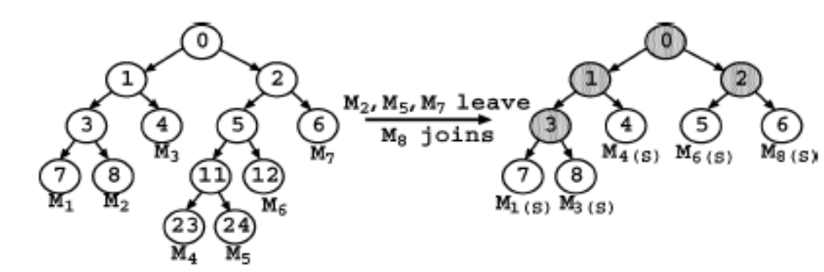
Figure 3.1 Illustration of Rebuild Algorithm

Rebuild is suitable for some cases, such as when the membership events are so frequent that one can directly reconstruct the whole key tree for simplicity, or when some members lose the rekeying information and the simplest way of recovery is to rebuild the key tree.

3.4 QUEUE BATCH ALGORITHM

The previous approach performs all rekeying steps at the beginning of every rekeying interval. This results in high processing load during the update instance and thereby delays the start of the secure group communication. A more effective algorithm called the Queue-batch algorithm is used to reduce the rekeying load. Its intuition is to reduce the rekeying load by pre-processing the joining members during the idle rekeying interval. The Queue-batch algorithm is divided into two phases, namely the Queue subtree phase and the Queue-merge phase.

The first phase occurs whenever a new member joins the communication group during the rekeying interval. In this case, one appends this new member in a temporary key tree. The second phase occurs at the beginning of every rekeying interval and merges the temporary tree (which contains all newly joining members) to the existing key tree. The pseudo-codes of the Queue subtree phase and the Queue-merge phase are given below
QUEUE-SUBTREE (T’)
- if (A new member joins)
- if (T’ == NULL) /* no new members in T’ */
- Create a new tree T’ with the only one new member;
- else /* there are new members in T’ */
- Find the insertion node
- Add the new member to T’
- Rekey renewed nodes
QUEUE-MERGE (T , T’ , M ^{l}, L)
- if (L == 0) {/* there is no leave */
- Add T’ to either the shallowest node (which need not be the leaf node) of T such that the merge will not increase the resulting tree height, or the root node of T if the merge to any locations will increase the resulting tree height
- } else { /* there are leaves */
- Add T’ to the highest leave position of the key tree T
- Remove remaining L -1 leaving leaf nodes and promote their siblings
- }
- Rekey renewed nodes

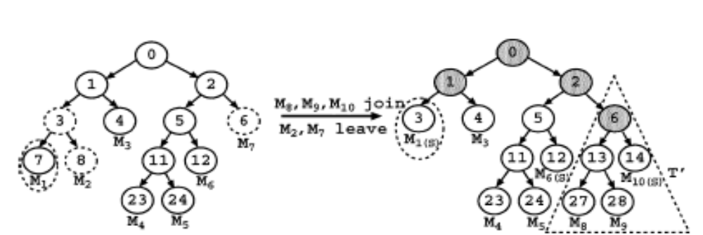
Figure 3.2 Illustration of Queue Batch Algorithm

The Queue-batch algorithm is illustrated in Figure 3.2, where members M₈, M₉ and M₁₀ wish to join the communication group, while M₂ and M₇ wish to leave. Then the rekeying process is as follows:

1. In the Queue subtree phase, the three new members, and first form a tree. The temprorary tree constructed is called T’.

2. In the Queue-merge phase, the tree is added at the shallowest position, which is at node 6.

3. Rekeying is done nodes that lie along the path to the root for those leaf nodes where there has been a change.

4. Finally, all members can compute the group key.

CHAPTER 4
DESIGN AND FUNCTIONALITY

The interval based algorithms are implemented in a distributed messaging application. The entire design of the project can be split into three parts based upon purpose. The overall architecture if the project is shown below

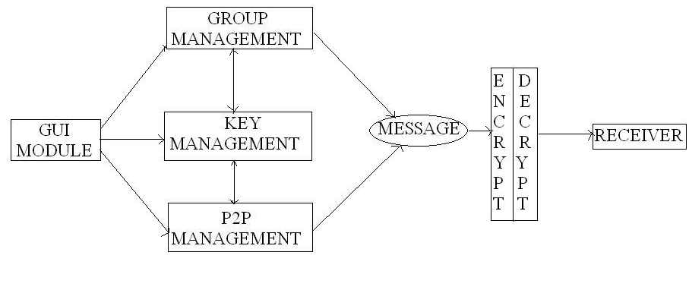
Figure 4.1 Architecture

4.1 GROUP MANAGEMENT

The group management design involves the following functions

CREATE GROUP:

Keeping track of created groups, members who join and leave groups.

BROADCAST GROUP:

Informing those who are interested who are members of the groups and
keeping track of the owner of the group.

ADD MEMBER:

Starting key process daemon which periodically recomputes the key for that group.

REMOVE MEMBER:

Informing members when a group is deleted and providing facility between the two interval based algorithms for group management.

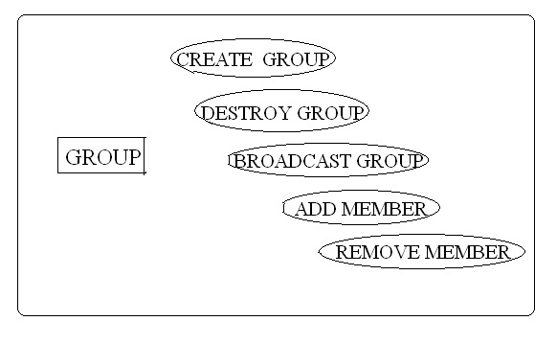
Figure 4.2 Group Management

4.2 KEY MANAGEMENT
The key management design involves the following tasks
CONSTRUCT:

Constructing a key tree to arrive at a common group key. The key tree is constructed so as to minimize the height of the tree.

PRUNE KEY TREE:

Prune the key tree to remove paths of deleted members.

GRAFT KEY TREE:

Graft new paths in the key tree to add new members to the key tree.

RENEW:

Searching the cache to retrieve public key values of members to construct non leaf nodes in the key tree from leaf nodes.

SEARCHING CACHE:

Renewing the nodes along the path to the root for nodes where there has been change in values.

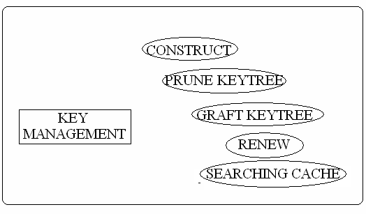
Figure 4.3 Key Management

4.3 PEER TO PEER MANAGEMENT

PEER TO PEER (P2P) management deals with providing functionalities between individual users. The functions are summarized below

PERSISTENCE:

Providing persistent environment for each user i.e., the groups which they are part of and the members of groups are saved, when the user logs off. They are retrieved when the same user logs in from the serialized object in the file.

FILE TRANSFER:

Providing a facility for File Transfer between individual users, who are currently online.

ADDRESS BOOK:

Providing an individual address book for each user, so they can save user ids.

OFFLINE MESSAGING:

Providing a facility for handling offline messages, so that users can send messages to other users who are not online. The message will be delivered to them when the user logs back in.

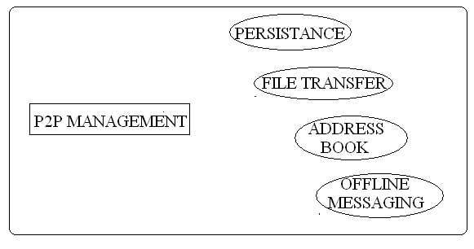
Figure 4.4 P2P Management
4.4 CIPHER MANAGEMENT

This is module is basically is used to provide functions cryptographic algorithm used for encryption and decryption for the messages to be sent using the group key. The cryptographic algorithms can be either use public key encryption algorithms or symmetric key encryption. For the transmission of public keys Diffie Hellman is used between individual users, while RC4 is used for encrypting group communication messages. A detailed explanation of RC4 and symmetric encryption cipher is provided in chapter 7.
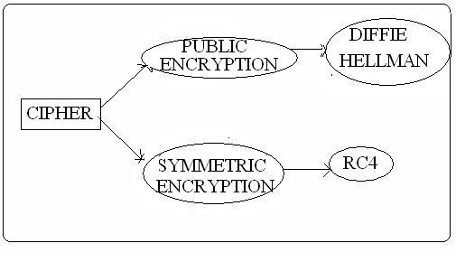
Figure 4.5 Cipher Management

4.5 SECURE COMMUNICATION LIBRARY (SECL)

To facilitate development other group based applications certain classes have been designed such that they are generic in nature. These classes have been put under separate java package called “secl”. This package provides services for group management, key management and cipher management described in the above sections. A detailed description of the classes which make up the secl package, class hierarchy diagram and services they provide is described in chapter 7.

CHAPTER 5
COMMUNICATION PROTOCOL

The group communication protocol [3][4] is developed in the transport layer. The communications protocol is restricted to two classes i.e. Send and Receive. They take care of sending the messages, parsing the messages and processing the received messages. Figure 5.1 illustrates communication protocol. A brief description of the messages transferred between users is given after the diagram.

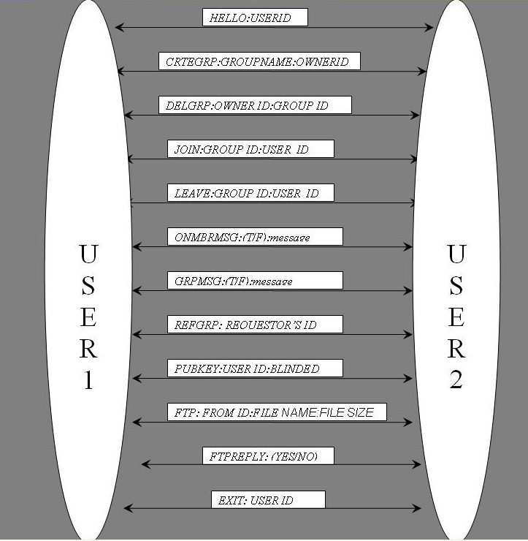
Figure 5.1 Communication protocol

1. USER ID:
FORMAT: NAME@HOSTNAME#IP#PORT#PUBLIC KEY
This gives the format how each user id is constructed. It’s constructed from user’s name, host machine name, IP address, port which is he using and public key.

2. HELLO:
FORMAT: HELLO: USER ID
This message is used to announce a new user who has jus logged in, by a multicast or broadcast message within a network. User id refers to the id of the user who has just logged in.

3. GROUP ID:
FORMAT: NAME@HOSTNAME#IP#PORT
This shows how group id is constructed. Name here refers to group name. Host name, IP address and port refer to the machine details of the user who created the group.

4. CRTEGRP:
FORMAT: CRTEGRP:GROUPNAME:OWNERID
This message is used to announce a creation of a new group to all the members by a broadcast or a multicast within the network.

5. DELGRP:
FORMAT: DELGRP:OWNER ID:GROUP ID
This message is only allowed to be sent by the group owner to tell he wants to delete a group he has created.
6. JOIN:
FORMAT: JOIN:GROUP ID:USER ID
This message is broadcasted to transmit a particular user wants to join a specified group.
7. LEAVE:
FORMAT: LEAVE:GROUP ID:USER ID
This message is broadcasted to transmit a particular user wants to leave from the specified group.

8. ONMBRMSG:
FORMAT: ONMBRMSG:(T/F):message
This message used to transmit messages for peer to peer individual messaging. The second field with the value ‘T’ indicates message is an online message. ‘F’ indicates message is offline message, hence should be parsed for date and time.

9. GRPMSG:
FORMAT: GRPMSG:(T/F):message
This message used to transmit messages for group members of a particular group. The second field with the value ‘T’ indicates message is an online message. ‘F’ indicates message is offline message, hence should be parsed for date and time.

10. REFGRP:
FORMAT: REFGRP: REQUESTOR’S ID
This message is basically a solicitation to all group owners to transmit the list of groups the created and the list of members present in the groups. This can be used if the group view is out of synchrony with the rest of the members.

11. PUBKEY:
FORMAT: PUBKEY:USER ID:BLINDED KEY
This message is used for transmitting public key of the user to others.

12. FTP:
FORMAT: FTP: FROM ID:FILE NAME:FILE SIZE
This message is used initiate a File transfer offer to particular user. It starts separate thread to handle FTP using TCP.

13. FTPREPLY:
FORMAT: FTPREPLY: (YES/NO)
This message is sent via TCP to reject or accept the offered File transfer offer made by the user.

14. EXIT:
FORMAT: EXIT: USER ID
This message is sent as a broadcast to inform the list of online users that the specified user with the user id has logged off.

CHAPTER 6
IMPLEMENTATION

The project was developed using NetBeans IDE 6.0 for Java software development. Since the application is developed in Java, hence could be run in any platform without any recompilation.

6.1 REQUIREMENTS

6.1.1 HARDWARE CONFIGURATION

- Processor – Intel Pentium 4
- Clock Speed – 1.71 GHz (Minimum)
- RAM – 512 MB
- Main Board Chipset – INTEL810e chipset
- Network – Local Intranet with minimum 100 Mbps connectivity

6.1.2 SOFTWARE CONFIGURATION

- Operating system – Windows XP
- Software – J2SE 1.506
- NetBeans 6.0 IDE

6.2 NETBEANS
NetBeans[5] refers to both a platform for the development of Java desktop applications, and an integrated development environment (IDE) developed using the NetBeans Platform. The NetBeans Platform allows applications to be developed from a set of modular software components called modules. A module is a Java archive file that contains Java classes written to interact with the NetBeans Open APIs and a manifest file that identifies it as a module. Applications built on modules can be extended by adding new modules. Since modules can be developed independently, applications based on the NetBeans platform can be easily and powerfully extended by third party developers.
The NetBeans Platform is a reusable framework for simplifying the development of other desktop applications. When an application based on the NetBeans Platform is run, the platform's main class is executed. Available modules are located, placed in an in-memory registry, and the modules' startup tasks are executed. Generally, a module's code is loaded into memory only as it is needed. Applications can install modules dynamically. The platform offers services common to desktop applications, allowing developers to focus on the logic specific to their application. The Graphical User Interface (GUI) builder within NetBeans allows you to drag and drop GUI elements within a frame, provides free hand design of the GUI necessary for the application. A screen shot of the NetBeans IDE is shown
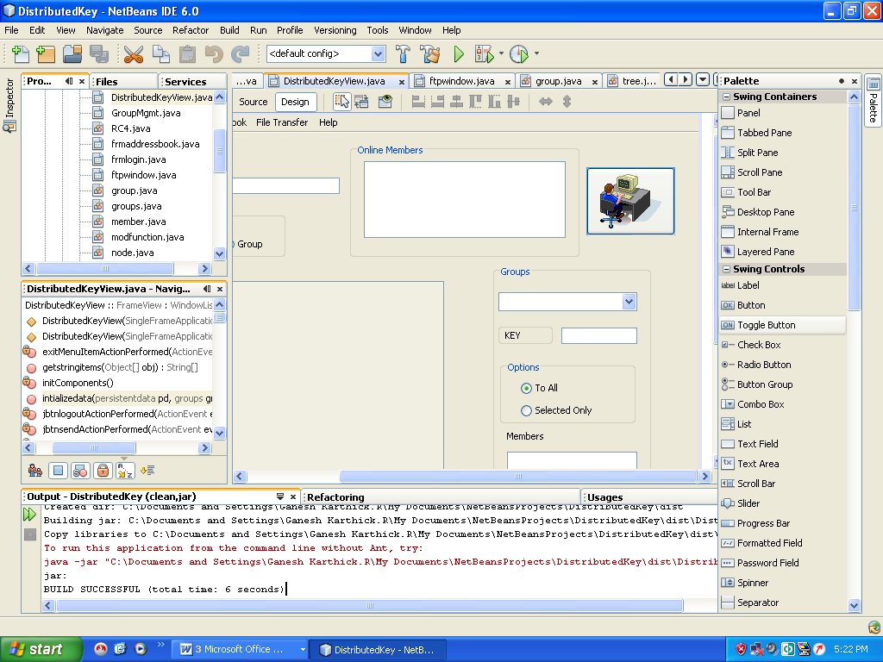

Figure 6.1 NetBeans IDE 6.0

6.3 CLASS ENTITY DIAGRAM

The class entity diagram shows the various classes that have been created for developing Distributed Messaging Application. The various classes can be classified on the basis of their purpose design such as group management, GUI Handler, Cipher Management, Key Management, Communication management and P2P Management. Some classes might overlap in their functionality to fall under more than one category of use.

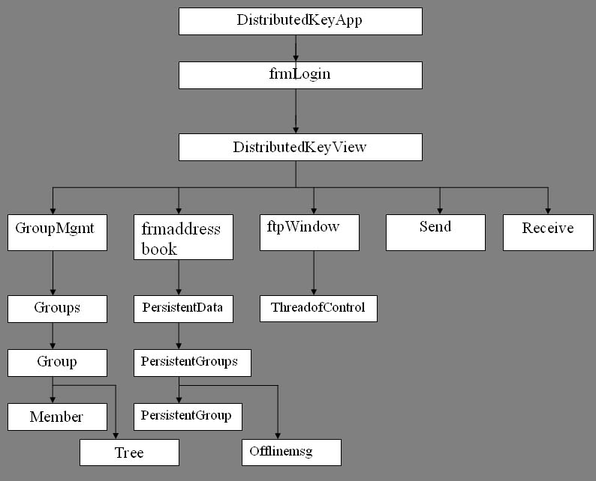
Figure 6.2 CLASS ENTITY DIAGRAM
6.4 GROUP MANAGEMENT CLASSES

The group management class arrangement is shown below. Each group runs a separate key daemon for recomputing the key. There five classes which together provide group management functionalities they are described one below after the diagram

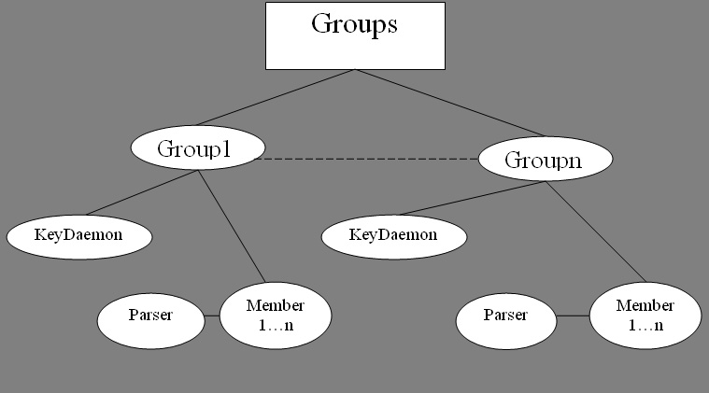

Figure 6.3 Group Management Class Diagram

- Groupmgmt:

This class handles GUI component of the group management. One can use this class to create and delete a group, to view groups and their list of members, to join and leave a group and finally refresh the list of groups available, if one feels if group membership view is out of synchrony with other users.

- Groups:

This class contains the list of groups that have been so far created. The list of groups is stored using a vector list. It also contains facilities for adding a group, removing a group, retrieving a specific group from the list of group using group id, updating a specific group using group id and starting the key daemon associated with the specific group. Group object is aggregated inside Groups class hence it takes charge initializing group objects which are instantiated inside the group class.

- Group:

This class contains the group attributes such as the group owner, the user under which group instance is present, group key, algorithm field (to decide which algorithm to run), key daemon for periodically recomputing key, the key tree of the group, node cache value which contains cached public key values, an instance modfunction class which is used to compute modulo operation, a timer which schedules key daemon periodically and the list of members who are part of the group and the ability to add and remove members from the group.

- Member:

This class contains individual member details such as user name, password, private and public key of the user, host name, IP address and port which the user process is listening to. It uses the services of the parser class to parse a user id and extract the user information. It also provides facilities to get and set attributes of member class.

- Parser:

The main function of this class to parse the given id (it may be group id or the user id) and retrieve information like name, host name, IP address, port and public key etc. the only difference between the group and user id is the extra public key attached to user id. By default parsing for user id carried out.

6.5 KEY MANAGEMENT CLASSES

There six classes which take care of the key management functions. Key management functions essentially deal with renewing of nodes where changes have occurred and updating the group. All classes here make use of an instance of modfunction class, to compute mod value for generating public key from private key and also during Diffie Hellman key exchange. They are described below after the class diagram

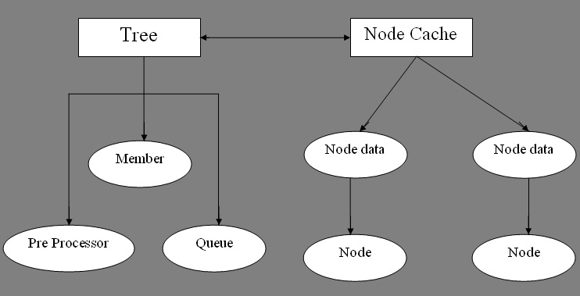
Figure 6.4 Key Management Class Diagram

- Tree:

This class provides methods for construction of methods. It constructs tree using an instance of nodes class. It provides methods to find the shallowest point in the key tree, so that the temporary tree from Queue sub tree phase can be attached to it. It also takes care of merging the temporary sub tree with actual key tree during queue merge phase.

- Node:

This class is basically stripped down version of the member class. Each node that is part of the tree has following properties. Public and private key of the node, the id of its left and right siblings and the depth at which node occurs.
- Nodedata:

This class is even a simpler version of the node class specifically designed for optimized search. It has key field, set of ids field along with the count giving the number of ids. This class primarily used to store public key values as a part of cached data.

- Nodecache:

This class is responsible for maintaining the cached public values. This class provides methods for searching the cache based upon ids with their count, updating cached value and removing cached content. Multiple ids are separated by a colon. The fact TGDH key construction is commutative but not associative is taken advantage of while searching and maintaining the cache content. Using this property enables one reduce the cache size by half. Nodecache class returns an instance of nodedata. Public key values are added to the cache during the initial handshake protocol.

- Preprocess:

This class is used to preprocess the nodes during the time in between the keying updates. It’s responsible for constructing the temporary sub tree. It uses a vector to handle multiple nodes.

- Queue:

This class is uses a vector to implement a First in First Out (FIFO) queue. It provides default queuing services like enqueue, dequeue and peek etc.

6.6 GUI HANDLER CLASSES

The GUI is constructed using Java Swing Layout Extensions and Java Applications Framework. It is possible to configure the application to use default Swing GUI or use native operating system’s GUI. The entire consists of five windows managed by six classes. They are described below

- DistributedKeyApp:

This is class contains the main function for the launch of the application. It extends from SingleFrameApplication class in the Swing Application Framework. It also decides which window is going to be launched first and allows you to configure the windows parameters.

- DistributedKeyView:

This class is applications main window. It contains menu’s to choose various options. It also defines objects for groups, nodecache, send, receive, frmaddressbook, ftpwindow and persistentdata. It uses the services of the above mentioned objects for a variety of purposes.

- Frmlogin:

This is the login window. Here details of the system which the user logs in such as IP address, host name and port are displayed. The user enters user name and password to login. A hash of user name and password is used to generate the private key for the user, from which the user’s public key is generated.

- Frmaddressbook:

This class displays the addressbook to the users. The user can add online members to his address book and save them. It makes use of persistent data to save the contacts list.

- Ftpwindow:

This window handles file transfer offer and request between users. The same window is used for acceptance and offer. Depending on the whether it is an offer or request some buttons and GUI components are hidden and some are displayed. It also spans a separate thread to carry file transfer via TCP.

- Groupmgmt:

This class as described earlier is used to group management functions like creation and deletion of a group and membership events (joining or leaving of member from a group) and refreshing of groups.

6.7 CIPHER MANAGEMENT CLASSES

Cipher management deals with encryption and decryption of given message. The application uses RC4 for encrypting messages. However the class RC4 is used as pluggable module and hence any other suitable symmetric algorithm can be chosen. RC4 was chosen primarily used it can be used to perform on the fly encryption. It has a speed of 45 Mbps. The cipher management classes are described below after the diagram

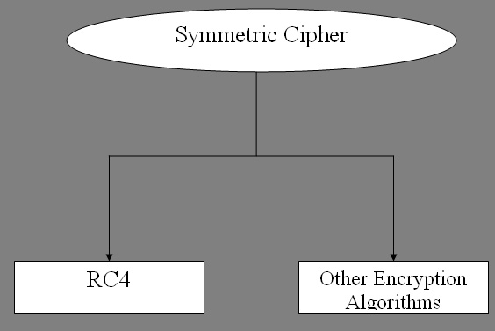
Figure 6.5 Cipher Management Classes

- RC4:

This class implements RC4 algorithm. Encryption and decryption can be for bytes as well as strings. Facilities are provided multiple key lengths.

- Modfunction:

Most cryptographic algorithms involve finding mod value of a very large number raised to a exponent. Hence modfunction uses bit stream of number to compute mod value for numbers. The modfunction can be expressed as follows mathematically
A^{m} mod n = (∩_{bi≠0} [A ^{(2^i)} mod n]) mod n
Where m is exponent, it can be binary as b_{k}, b_{k-1},.…, b₀ and we are finding A^{m} over modulo n.

- Symmetriccipher:

This is an abstract class that contains essential properties common to all symmetric cipher. RC4 class is obtained by extending this class. Any other encryption algorithm that one might wish to do so can be done so by extending this abstract class and implementing their algorithm in extended class.

6.7.1 RC4 ALGORITHM
RC4[4] generates a pseudorandom stream of bits (a key stream) which, for encryption, is combined with the plaintext using XOR; decryption is performed the same way. (This is similar to the Vernam cipher except that pseudorandom bits, rather than random bits, are used.) To generate the key stream, the cipher makes use of a secret internal state which consists of two parts:
- A permutation of all 256 possible bytes (denoted "S" below).
- Two 8-bit index-pointers (denoted "i" and "j").
The permutation is initialized with a variable length key, typically between 40 and 256 bits, using the key-scheduling algorithm (KSA). Once this has been completed, the stream of bits is generated using the pseudo-random generation algorithm (PRGA).The key-scheduling algorithm is used to initialize the permutation in the array "S". "Key length" is defined as the number of bytes in the key and can be in the range 1 ≤ key length ≤ 256. First, the array "S" is initialized to the identity permutation. S is then processed for 256 iterations in a similar way to the main PRGA algorithm, but also mixes in bytes of the key at the same time.
for i from 0 to 255
S[i] := i
endfor
j := 0
for i from 0 to 255
j := (j + S[i] + key[i mod keylength]) mod 256
swap(S[i],S[j])
endfor

For as many iterations as are needed, the PRGA modifies the state and outputs a byte of the key stream. In each iteration, the PRGA increments i, adds the value of S pointed to by i to j, exchanges the values of S[i] and S[j], and then outputs the value of S at the location S[i] + S[j] (modulo 256). Each value of S is swapped at least once every 256 iterations. The pseudo code PRGA is given below
i := 0
j := 0
while GeneratingOutput:
i := (i + 1) mod 256
j := (j + S[i]) mod 256
swap (S[i],S[j])
output S[(S[i] + S[j]) mod 256]
endwhile

The output of PRGA is used with XOR operation along with the plain text to get the cipher text. For decryption cipher text is used along with the output of the PRGA in a XOR operation to get the plain text back.

6.8 PEER TO PEER MANAGEMENT CLASSES

The peer to peer (P2P) management classes provide offline messaging, file transfer and address book facility. The various classes used for P2P management are described below

- Offlinemsg:

This class takes care of all offline messaging. When message is sent and client is offline, the message is passed to offlinemsg class, it makes note things such as date and time message was sent, from which group message was from and stores them. This class is seralizable.

- Persistentgroups:

The purpose this is to basically store the list of persistentgroup objects. This class is also serializable and uses a vector to implement to store persistent group objects.

- Persistentgroup:

This class contains attributes of the group such as group owner, members, group key etc. this class also implements serializable interface. It uses a vector to store members.

- Persistentdata:

This root of all classes i.e. it encapsulates all other persistent classes (those classes which implements serialiazable). It provides services for adding and removing members from address book, group management and offline messaging facilities. This instance of this object is serialized whenever a user logs off. While initializing the groups when the user logs in the object is read from file and used to setup address book and groups object.

6.9 COMMUNICATION MANAGEMENT CLASSES

The communication management classes are responsible transmitting and reception of messages. Apart from this they also process received messages. Processing is done with the help of services offered by other classes. There are two classes here which are described below
- Send:

This class responsible for sending messages to users. It provides methods to sending point to point messages, multicast and broadcast messages. Before sending a message it checks whether a user is online or offline. If the user is offline, the message is saved using service of persistentdata. Apart from this class also takes variable that tells whether application is run across a network or in a stand alone system, depending on which messages are sent to different machines in network or different ports in the same system.

- Receive:

This class responsible receiving messages sent to the user. It also processes all the messages received. It runs separate thread of control to receive all the messages. The kind of processing that is done for each message is according to the communications protocol described in the earlier chapter.

CHAPTER 7
CENTRALIZED VERSUS DECENTRALIZED GROUP KEY MANAGEMENT

In this section, a comparison of centralized logical key tree (LKT) and interval based algorithms is made. Similar to the interval-based algorithms, there is a key tree in the LKT approach is a binary tree and that the keys of the tree nodes are computed based on the TGDH protocol. Among the group’s members, a group controller is selected that centrally renews the group key at periodic rekeying intervals. The group controller knows the keys of all the nodes in the key tree and that a newly joining member sends its individual secret key to the group controller via a secure channel. At the beginning of a rekeying interval, the group controller first rekeys all (non leaf) renewed nodes using the TGDH protocol. It then encrypts the updated secret key of each renewed node with the respective secret keys of the child nodes via any symmetric encryption algorithm. Afterward, it broadcasts the encrypted keys to the group. Every member, upon receiving the encrypted keys, decrypts the keys along its key path with the secret keys it holds.
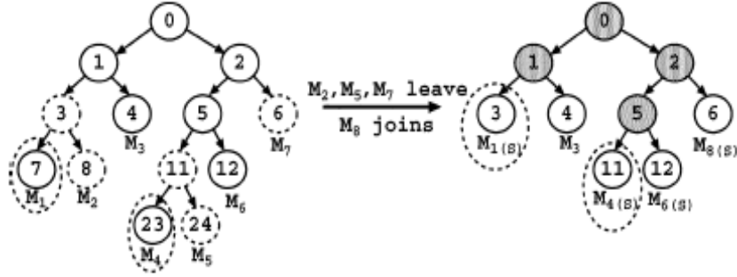
Figure 7.1 Logical Key Tree
Figure 7.1 is used to illustrate the LKT approach. Suppose that M₁ is the group controller. It first rekeys all renewed nodes as in the TGDH protocol. It then broadcasts to the group the following encrypted keys: {(K₀)₁, (K₀)₂, (K₁)₃, (K₁)₄, (K₂)₅, (K₂)₆, (K₅)₁₁, (K₅)₁₂}, where (K_{i}) _{j} refers to the secret key K_{i} of parent node i encrypted by the secret key K_{j} of the child node j. For example, in order for member M₃ to obtain the group key K₀, it first decrypts (K₁)₄ with K₄, followed by (K₀)₁ with K₁.
The group controller broadcasts the encrypted keys using the view synchronous communication model as in the interval-based algorithms. While the group controller can broadcast the encrypted keys via the point-to-multipoint multicast, such a communication, model has two limitations. First, if the underlying group communication is multipoint-to-multipoint-based such that every member can be a sender, setting up an extra multicast channel will be an overload. Also, it is possible for the group controller to leave the group. All other members have to detect the group controller’s departure and install a new membership view in order to select another group controller. The group controller’s departure, however, cannot be detected with the unilateral point-to-multipoint multicast. View synchrony is essential for reliable multipoint-to-multipoint group communication regardless of which group key management approach is being used.
The performance of the LKT approach can be quantified as follows. Since the encryption of the updated secret keys can be achieved with any inexpensive symmetric encryption algorithm, the computation cost of the LKT approach is mainly due to the exponentiation operations of renewing the secret keys. Furthermore, since the group controller uses the view-synchronous communication model as in the interval-based algorithms, the communication costs of the LKT approach and interval-based algorithms mainly differ by the number of keys (either encrypted or blinded) broadcast to the group and the number of rounds required to generate the group key.

TABLE 7.1
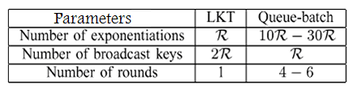
Table 7.1 compares the performance metrics of both LKT and Queue-batch schemes, where R denotes the number of renewed nodes, and the numbers of exponentiations and rounds for Queue-batch. As compared to our interval-based algorithms, the LKT approach requires fewer exponentiations and only one round to update the group key. However, all its exponentiations are carried out within the single group controller, while our interval-based algorithms scatter the computational load among all group members. In addition, the LKT approach broadcasts two encrypted copies of the updated secret key for each renewed node, while the interval-based algorithms broadcast only the corresponding blinded key. This implies that the interval-based algorithms save half of the number of broadcast keys. More importantly, the interval-based algorithms have better fault tolerance by eliminating the single-point-of-failure problem inherent in the centralized LKT approach.

CHAPTER 8
RESULTS AND ANALYSIS

8.1 INDIVIDUAL REKEYING AND INTERVAL BASED REKEYING

Here a comparison of the interval based rekeying and individual rekeying is done. Given a number of join and leave requests, the individual rekeying approach first processes one by one the join requests followed by the leave requests. The program had been run over mulitple rekeying intervals and the average results have been computed. Figure 8.1 illustrates the performance differences between individual rekeying and the Queue-batch algorithm. One can observe that Queue-batch performs much better than the individual rekeying method, especially under high join and high leave probabilities. Therefore, the interval based rekeying algorithms can reduce the computation and communication costs of the group are highly dynamic.

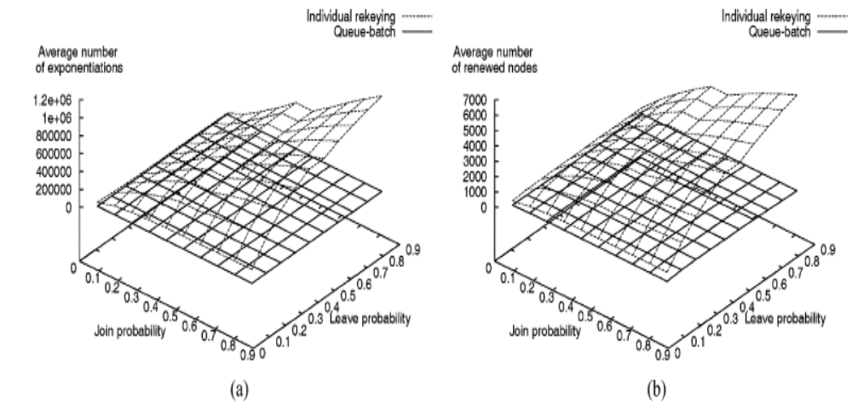

Figure 8.1 Individual rekeying (a) and Interval based rekeying (b)

The following table illustrates number of computations that have taken place over a period of fifteen key interval runs. The time in between key daemon runs (T_{R}) is set to 3 ms.

TABLE 8.1

S.No | Cumulative  Time interval  (ms) | Key Daemon  Interval Run  (Nth Run) | Cumulative Membership Events | Number of Computations
1 | 3 | 10 | 0 | 0
2 | 6 | 11 | 0 | 0
3 | 9 | 12 | 0 | 0
4 | 12 | 13 | 1 | 1
5 | 15 | 14 | 1 | 0
6 | 18 | 15 | 1 | 0
7 | 21 | 16 | 1 | 0
8 | 24 | 17 | 1 | 0
9 | 27 | 18 | 2 | 1
10 | 30 | 19 | 2 | 0
11 | 33 | 20 | 2 | 0
12 | 36 | 21 | 2 | 0
13 | 39 | 22 | 2 | 0
14 | 42 | 23 | 3 | 1
15 | 45 | 24 | 3 | 1

8.2 VARIATION OF REKEYING INTERVAL

Here the rekeying interval for Queue-batch algorithm and rebuild algorithm is varied over different leave probablities. Queue batch algorithm does not reconstruct the whole key tree as rebuild algorithm during rekeying interval. Thus, the key tree may become unbalanced after some rekeying intervals. Here one considers how Queue-batch performs if we reconstruct the key tree using the Rebuild algorithm every T_{R} rekeying intervals, where T_{R} is called the reset interval. This approach keeps the tree balanced at the cost of executing the Rebuild algorithm. The program had been run with different rekeying intervals with the join probability is fixed at 0.5 and leave probabilities are set at 0.25, 0.5, and 0.75. Figure 8.2 depicts that the performance of Queue-batch remains approximately constant even at high reset intervals, meaning that Queue-batch can still preserve its performance without reconstructing the key tree after a long period of rekeying. This shows the robustness of the Queue-batch algorithm in maintaining a relatively balanced tree. This property is important because it can reduce the average costs of exponentiations and renewed nodes in the system.

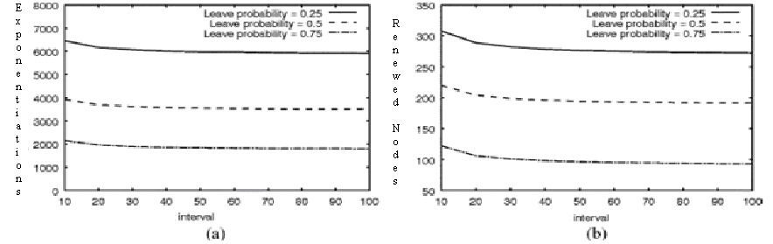

Figure 8.2 Results for varying Rekeying intervals (a) Average number of exponentiations (b) Average number of renewed nodes

8.3 ANALYSIS IN TERMS OF NUMBER OF ROUNDS

A round is defined as the period during which the group members compute the secret keys as far up the key tree as they can. At the end of each round, all individual members of the group have to update their group key. In the analysis, rekeying is performed in lock-step, meaning that the of secret key computations are carried out in a single step. Figure 8.3 illustrates the average numbers of rounds required for Rebuild and Queue-batch. At high leave probabilities, Queue-batch saves three to four rounds as compared to Rebuild. The savings are due to the preprocessing of join requests at the Queue subtree stage. A fewer number of rounds is incurred as less message overhead is involved in processing rekeying messages and storing message headers.
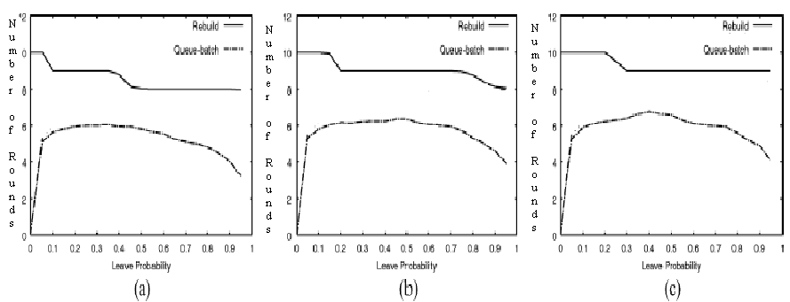

Figure 8.3 Average Number of Rounds for Rebuild and Queue Batch Algorithm (a) Join probability = 0.25 (b) Join probability = 0.5 (c) Join probability = 0.75

From the above analysis one can observe that the interval-based algorithms outperform the individual rekeying approach in terms of both computation and communication costs and that Queue-batch performs the best among the interval-based algorithms. It also demonstrates its robustness in keeping the key tree balanced and its capability in minimizing the number of rounds required to update the group key.
8.4 SNAPSHOTS

A series of screenshots showing the output of the application is presented here:

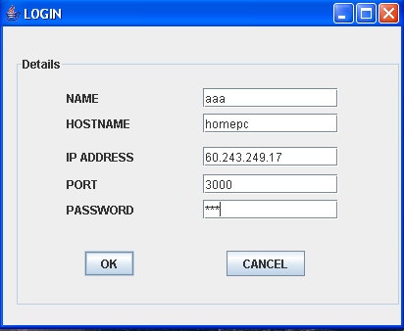
Figure 8.4 Login Window

The above figure shows the login window. The system’s details such as hostname and IP address are displayed. The user enters the user name and password to login.

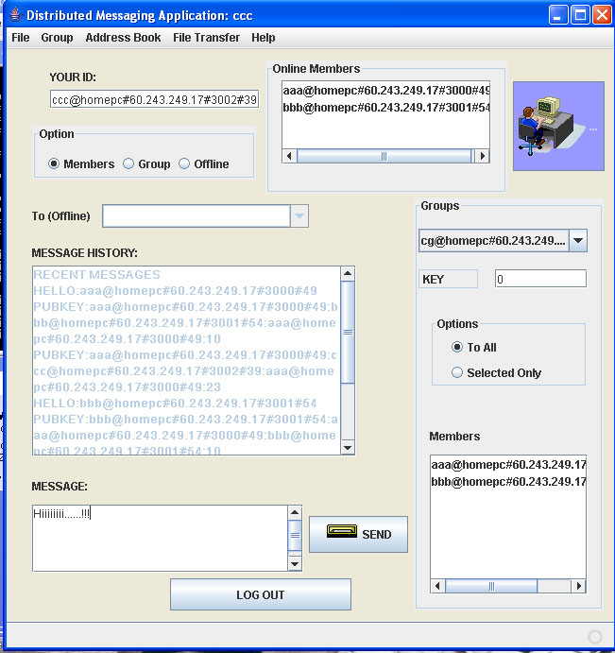
Figure 8.5 Applications Main Window

This represents the main application window. All other services provided by the application can be accessed by this window. The list of online members as well as various groups that are available for joining along with its members and group key is displayed here.

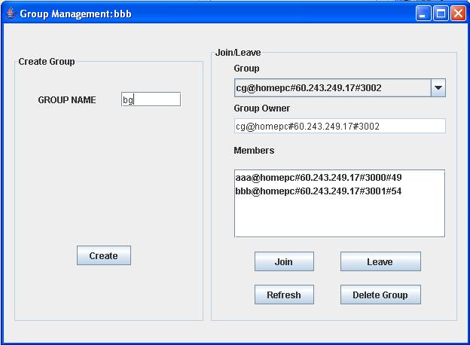
Figure 8.6 Group Management Window

This is the group management window. Here one can create, join, leave and delete groups. The refresh button is provided here is used to refresh group members of various members, if the user feels view synchrony of the group is not up to date.

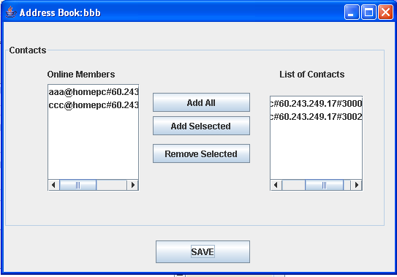

Figure 8.7 Address Book

Address book is shown in the above figure. User can add online members to his address book and save them. Contacts are saved to a dat file with user’s id using object serialization technique.

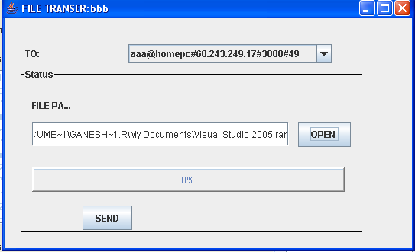
Figure 8.8 File Transfer Offer Window

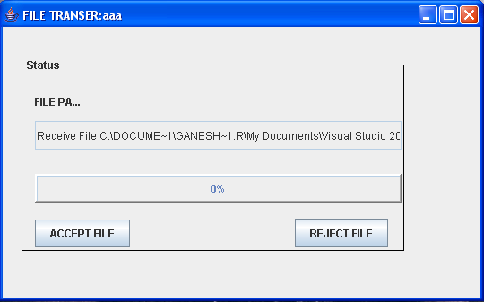
Figure 8.9 File Transfer Accept Window

The above two windows represents the File transfer windows at the server and client side. By clicking on the open window, user can browse through files he wants to send. A TCP connection is opened for file transfer with separate thread dedicated to it. At the receiver’s side, one can choose to accept the file or reject the file.

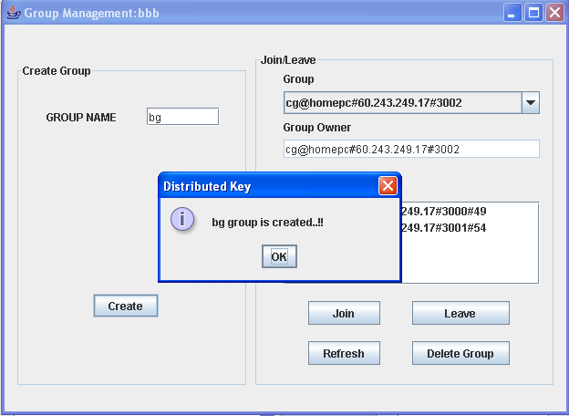
Figure 8.10 Group Creation

The above figure shows the process of group creation event. When the user enter a name and clicks on create group, a broadcast message is sent to all the users with the group name and the group owner. This message is handled by other users by creating a group with the name and specified owner in their groups object.

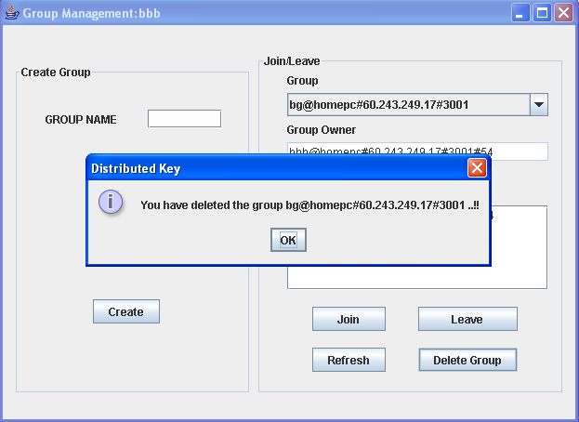
Figure 8.11 Group Deletion

Group deletion operation is shown in the above window. Here the owner broadcasts a message to all members, asking them to delete the group from the groups list. The processing of this message is similar to create message.
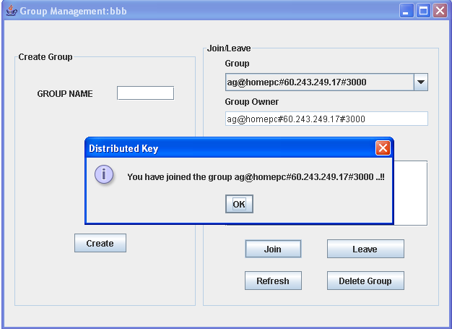

Figure8.12 Group Joining Event

The group join event is illustrated in the above. The user who wishes to join the group transmits a message to all other users giving his user id and the group id of the group which he wants to join. After processing this message all the users add the user to member’s list of the specified group.

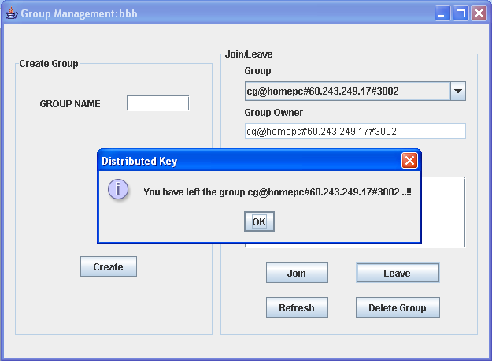

Figure 8.13 Group Leave Event

The above figure shows the group leave event. The user constructs leave message with the group id and own user id to other members. When the other members get the message, they remove the user id from the list of members of that group.

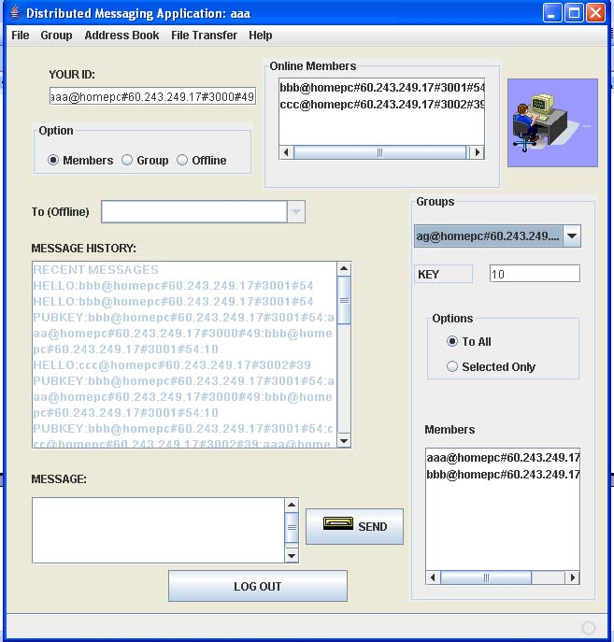
Figure 8.14 Before Membership Join Event members of Group ag are shown

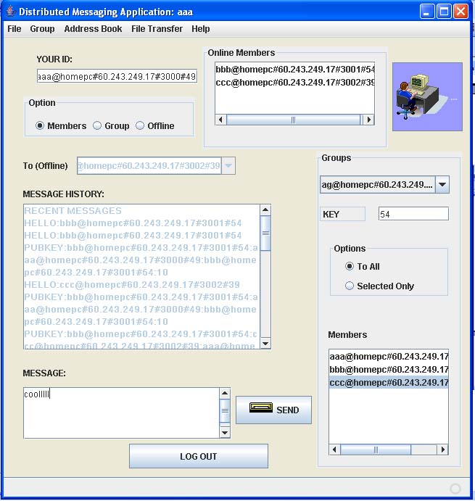
Figure 8.15 After Membership Join Event (A member ccc has joined the grop ag and Key Value has changed)

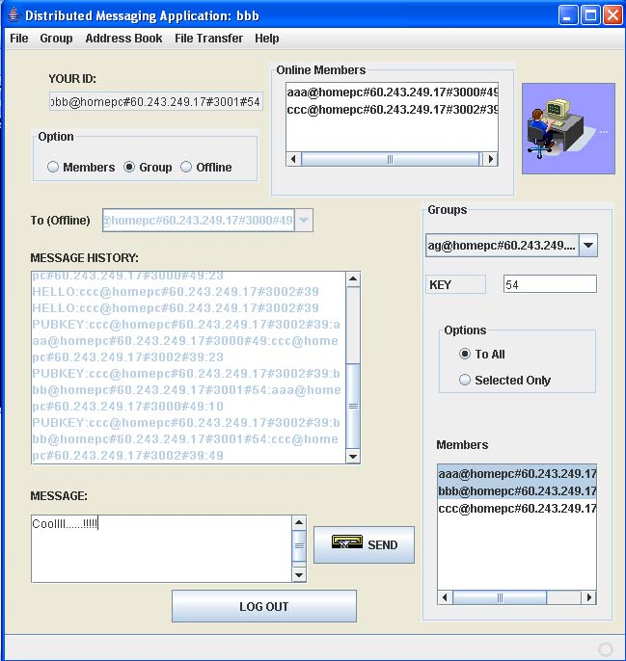
Figure 8.16 Before Message Sending (Message is sent to group aa from bb)

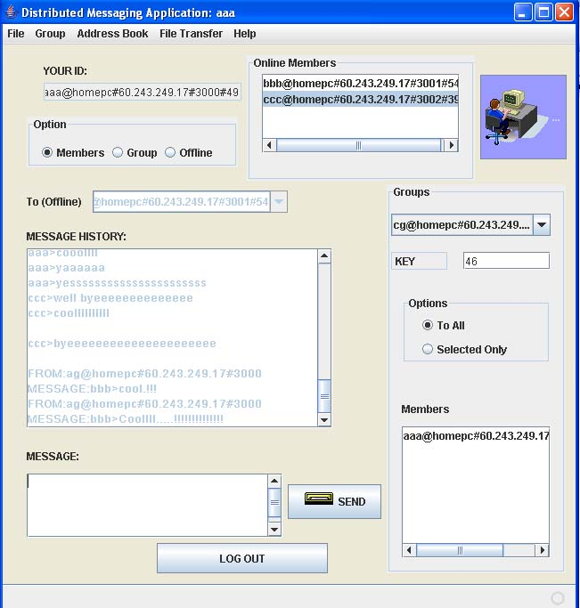
Figure 8.17 After Message Delivery (Message is delivered to one of the group members aa and it is shown in message history text area)

CHAPTER 9
CONCLUSION

Several distributed collaborative key agreement protocols for dynamic peer groups have been implemented. The key agreement setting is performed in which there is no centralized key server to maintain or distribute the group key. From the implementation it can be shown that one can use the TGDH protocol to achieve such distributive and collaborative key agreement. To reduce the rekeying complexity, interval-based approach is used to carry out rekeying for multiple join and leave requests at the same time, with a tradeoff between security and performance. From the analysis, it’s evident that the Interval based algorithm can significantly reduce both computation and communication costs when there exists highly frequent membership events.

REFERENCES

[1] Patrick P. C. Lee, John C. S. Lui and David K. Y. Yau, April 2006, Distributed Collaborative Key Agreement and Authentication Protocols for Dynamic Peer Groups, IEEE/ACM Transactions on Networking, Vol. 14, pp 1-10

[2] Andrew S. Tanenbaum, 2001, “Computer Networks”, 3rd Edition Prentice Hall, Englewood cliffs.

[3] Andrew S. Tanenbaum, 2001, “Distributed Operating System”, 3rd Edition Pearson Education.

[4] William Stallings, 2003, “Cryptography and Network Security – Principles and Practices”, 3rd Edition, Pearson Education.

[5] Dane Nourie, May 2007, “Getting Started With the NetBeans IDE Tutorial”,
http://java.sun.com/developer/onlineTraining/tools.

[6] Y. Amir, Y. Kim, C. Nita-Rotaru, J. L. Schultz, J. Stanton, and G. Tsudik, May 2004, “Secure group communication using robust contributory key Agreement”, IEEE Transactions on. Parallel Distributed. Systems, pages. 1–30.

