1. INTERVAL BASED REKEYING AND INDIVIUAL REKEYING
The following table illustrates number of computations that have taken place over a period of fifteen key interval runs. The time in between key daemon runs (T_{R}) is set to 3 ms.

TABLE 1.1 INTERVAL BASED REKEYING
S.No | Cumulative  Time interval  (ms) | Key Daemon  Interval Run  (Nth Run) | Cumulative Membership Events | Cumulative Number of Computations
1 | 3 | 10 | 0 | 0
2 | 6 | 11 | 0 | 0
3 | 9 | 12 | 0 | 0
4 | 12 | 13 | 1 | 1
5 | 15 | 14 | 1 | 0
6 | 18 | 15 | 1 | 0
7 | 21 | 16 | 2 | 1
8 | 24 | 17 | 2 | 0
9 | 27 | 18 | 2 | 0
10 | 30 | 19 | 2 | 0
11 | 33 | 20 | 3 | 1
12 | 36 | 21 | 3 | 0
13 | 39 | 22 | 3 | 0
14 | 42 | 23 | 4 | 1
15 | 45 | 24 | 4 | 0
16 | 48 | 25 | 4 | 0
17 | 51 | 26 | 4 | 0
18 | 54 | 27 | 5 | 1
19 | 57 | 28 | 5 | 0
20 | 60 | 29 | 5 | 0
The following table illustrates number of computations that have taken place over a period of fifteen membership events for individual rekeying.

TABLE 1.1 INDIVIUAL BASED REKEYING

S.No | Rounds  (Nth run) | Cumulative Membership Events | Number of Computations
1 | 10 | 1 | 1
2 | 11 | 2 | 2
3 | 12 | 3 | 1
4 | 13 | 4 | 1
5 | 14 | 5 | 2
6 | 15 | 6 | 2
7 | 16 | 7 | 1
8 | 17 | 8 | 2
9 | 18 | 9 | 1
10 | 19 | 10 | 2
11 | 20 | 11 | 2
12 | 21 | 12 | 2
13 | 22 | 13 | 1
14 | 23 | 14 | 2
15 | 24 | 15 | 1

The table below shows the comparison of individual rekeying and interval based rekeying with regard to cumulative number of events and cumulative number of computations.

TABLE 2.2 COMPARISON OF BOTH REKEYING METHODS
INDIVIUAL REKEYING (T_{R}=3ms) |  |  | INTERVAL BASED REKEYING(No Time Interval)
Nth Run | Cumulative Membership Events at Nth Run | Cumulative Number of Computations | Nth Run | Cumulative Membership Events at Nth Run | Cumulative Number of Computations
10 | 1 | 1 | 13 | 1 | 1
11 | 2 | 3 | 16 | 2 | 2
12 | 3 | 4 | 20 | 3 | 3
13 | 4 | 5 | 23 | 4 | 4
14 | 5 | 7 | 27 | 5 | 5

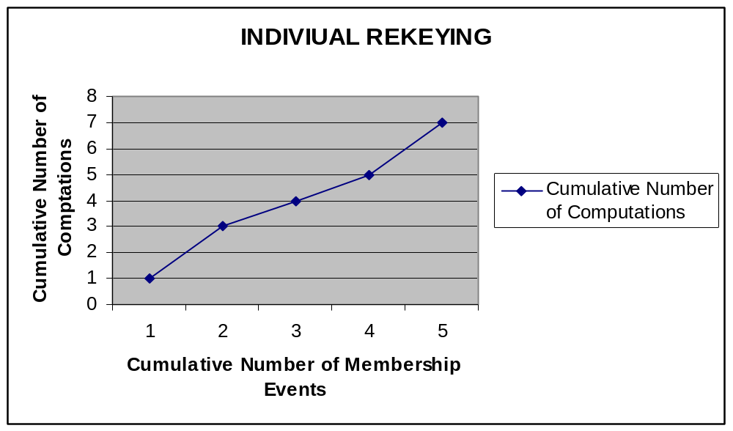
Fig 1.1 Indiviual Rekeying
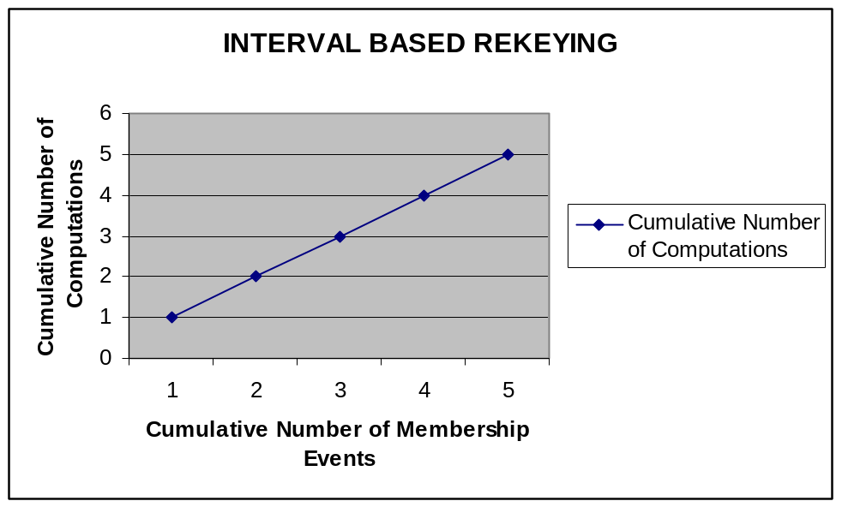
Fig 1.2 Interval Based Rekeying

From the above table one can infer that the number of computations for interval based rekeying is less than individual rekeying for the same number of membership events.

2. CENTRALIZED LOGICAL KEY TREE (LKT) AND INTERVAL BASED REKEYING

Here R is the number of renewed nodes
TABLE 2.1
Parameters | Centralized Logical Key Tree | Interval based Rekeying
Number of Computations | R | 10R to 30R
Number of Broadcast keys | 2R | R

Table above compares the performance metrics of both LKT and Interval based rekeying schemes, where R denotes the number of renewed nodes, and the numbers of computations and rounds for Interval based rekeying. As compared to our interval-based algorithms, the LKT approach requires fewer computations. However, all its computations are carried out within the single group controller, while our interval-based algorithms scatter the computational load among all group members. In addition, the LKT approach broadcasts two encrypted copies of the updated secret key for each renewed node, while the interval-based algorithms broadcast only the corresponding blinded key. This implies that the interval-based algorithms save half of the number of broadcast keys. More importantly, the interval-based algorithms have better fault tolerance by eliminating the single-point-of-failure problem inherent in the centralized LKT approach.

