Data Acquisition, Cleaning, and Preprocessing
A Case Study Using the Titanic Passenger Dataset
Prepared by: Bhusare Ganesh Pravin
Role: Virtual Data Science with Python Trainee
Task 1: Data Acquisition, Cleaning, and Preprocessing
Date: 26/09/2006
GitHub Repository: [https://github.com/ganesh-mlhub/titanic-data-cleaning-preprocessing.git]

1. Objective
The objective of this task is to demonstrate the end-to-end process of acquiring a publicly available dataset, exploring its structure, identifying data quality issues, and applying cleaning and preprocessing techniques using Python. The report documents each decision made during the process, the rationale behind it, and its expected impact on any downstream analysis or modeling.
The dataset chosen for this task is the well-known Titanic passenger dataset, which records details of the passengers aboard the RMS Titanic, including demographic information, ticket class, fare paid, and survival outcome. This dataset was selected because it contains realistic data quality issues — missing values, skewed distributions, and outliers — that are representative of problems encountered in real-world data science work, while still being small enough to document thoroughly within the scope of this task.

2. Data Acquisition
Data Source: The dataset was obtained from a public GitHub mirror of the classic Kaggle Titanic dataset (originally published by Kaggle for the 'Titanic: Machine Learning from Disaster' competition). The direct CSV source used is:
https://raw.githubusercontent.com/datasciencedojo/datasets/master/titanic.csv
Collection Method: The file was downloaded programmatically and loaded directly into a pandas DataFrame:
import pandas as pd
import numpy as np

df = pd.read_csv("data/titanic_raw.csv")
print(df.shape) # (891, 12)
The raw dataset contains 891 rows and 12 columns, covering passenger demographics (Age, Sex), travel details (Pclass, Ticket, Fare, Cabin, Embarked), family relationships (SibSp, Parch), and the target variable (Survived).

3. Initial Data Exploration
Before any cleaning was performed, the dataset was explored to understand its structure, data types, and overall quality. This step is critical because it determines which cleaning strategies are appropriate later on.
df.info()
df.describe()
df.describe(include=['object'])
df.isnull().sum()
df.duplicated().sum()

3.1 Data Types & Structure
Column | Dtype | Non-Null Count | Notes
PassengerId | int64 | 891 | Unique identifier, not predictive
Survived | int64 | 891 | Target variable (0/1)
Pclass | int64 | 891 | Ticket class (1/2/3)
Name | object | 891 | Contains extractable titles
Sex | object | 891 | male / female
Age | float64 | 714 | 19.87% missing
SibSp | int64 | 891 | Siblings/spouses aboard
Parch | int64 | 891 | Parents/children aboard
Ticket | object | 891 | Alphanumeric, low predictive value
Fare | float64 | 891 | Right-skewed, has outliers
Cabin | object | 204 | 77.10% missing
Embarked | object | 889 | 0.22% missing

3.2 Missing Value Summary
Column | Missing Count | Missing %
Cabin | 687 | 77.10%
Age | 177 | 19.87%
Embarked | 2 | 0.22%
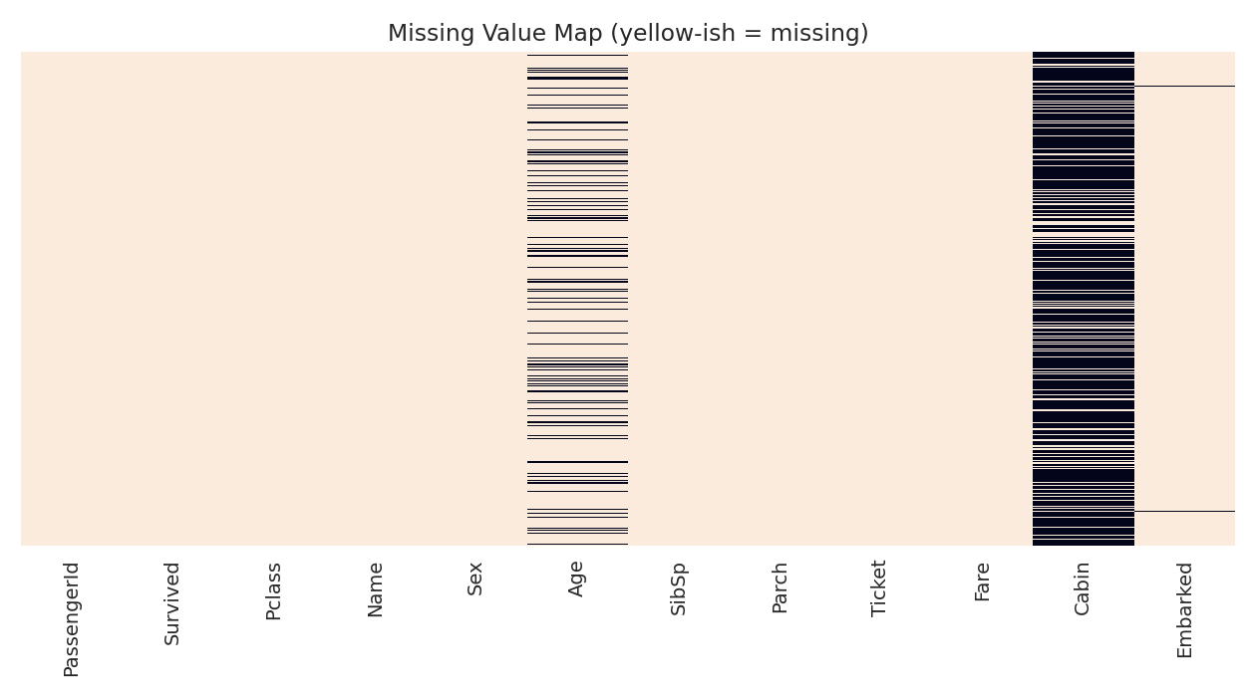
Figure 1. Heatmap of missing values across the raw dataset (dark bands = missing).
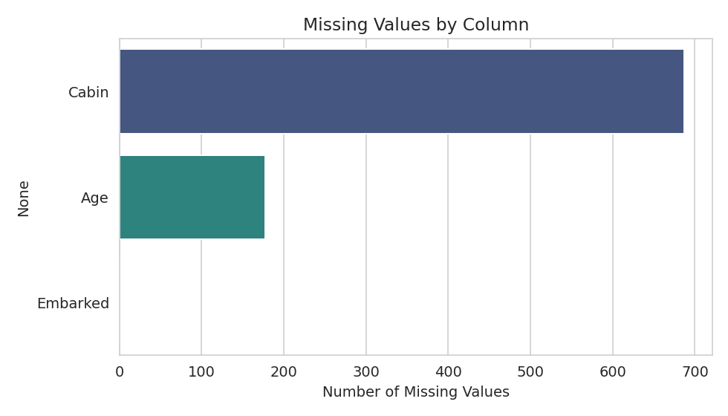
Figure 2. Count of missing values by column.
No duplicate rows were found in the raw dataset (df.duplicated().sum() == 0), so duplicate removal was not a major concern here, though the check was still performed as standard practice.

4. Handling Missing Values
Each column with missing data required a different strategy, chosen based on the proportion of missing data, the column's data type, and its relationship to other variables.

4.1 Embarked (0.22% missing)
Only 2 rows were missing the port of embarkation. Given the negligible proportion, these were imputed with the mode (most frequent category), which is a safe and standard approach for a small number of missing categorical values.
mode_embarked = df['Embarked'].mode()[0]
df['Embarked'] = df['Embarked'].fillna(mode_embarked)
# Result: filled with 'S' (Southampton)

4.2 Age (19.87% missing)
Age is a numeric column with a meaningful proportion of missing data and a right-skewed distribution containing some outliers, so filling with the overall mean would be distorted by extreme values. Instead, missing ages were imputed using the median Age within each Pclass and Sex group, since passenger class and gender in this dataset are correlated with typical age ranges (e.g., first-class passengers and crew skewed older). This group-wise approach preserves more of the underlying structure of the data than a single global fill value.
df['Age'] = df.groupby(['Pclass', 'Sex'])['Age']\
.transform(lambda x: x.fillna(x.median()))
df['Age'] = df['Age'].fillna(df['Age'].median()) # safety fallback

4.3 Cabin (77.10% missing)
With over three-quarters of values missing, imputing the Cabin field directly would mean fabricating the vast majority of the column rather than recovering real information — this would introduce more noise than signal. Instead, the presence or absence of a recorded cabin was preserved as a new binary feature, HasCabin, since having a recorded cabin number is itself informative (it correlates with higher-class tickets in the original dataset). The raw Cabin column was then dropped.
df['HasCabin'] = df['Cabin'].notnull().astype(int)
df = df.drop(columns=['Cabin'])
This decision was one of the key judgment calls in the task: rather than force an imputation strategy onto a mostly-empty column, the missingness itself was converted into a usable feature.

5. Outlier Detection & Treatment
Outliers were identified using the 1.5 × IQR (Interquartile Range) rule, a standard, distribution-agnostic method for flagging extreme values.
def iqr_outlier_count(series):
q1, q3 = series.quantile(0.25), series.quantile(0.75)
iqr = q3 - q1
lower, upper = q1 - 1.5*iqr, q3 + 1.5*iqr
return series[(series < lower) | (series > upper)]
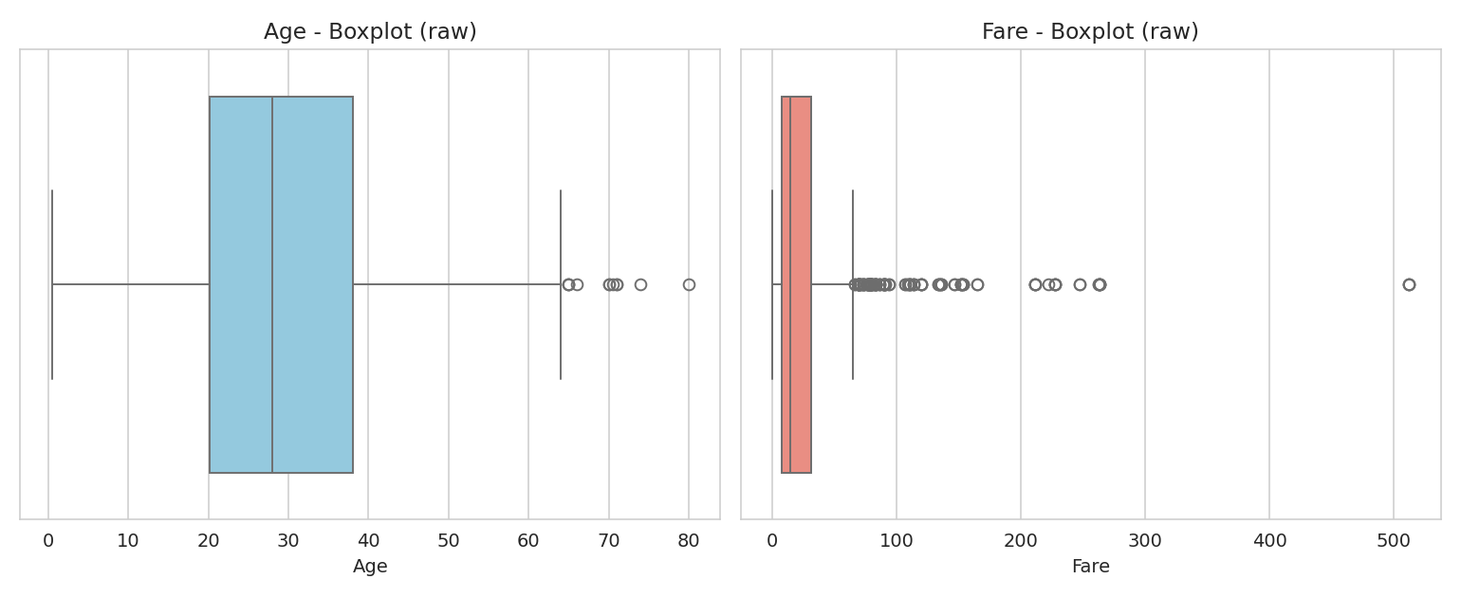
Figure 3. Boxplots of Age and Fare before treatment, showing extreme values in Fare.
Age had 11 outliers (1.5% of non-null values) beyond the fence of roughly [-6.7, 64.8]. These correspond to elderly passengers, which are biologically plausible and not data entry errors, so they were retained without modification.
Fare had 116 outliers (13.0% of values) beyond an upper fence of about 65.63, including a maximum fare of 512.33. These almost certainly correspond to first-class suites and group bookings recorded under a single ticket, so they are legitimate values rather than errors. Because deleting 13% of the data would discard real passengers and bias the sample toward lower fares, the outliers were capped (winsorized) at the upper fence rather than removed. This limits the influence of extreme values on later statistical analysis or model training while preserving every row.
q1, q3 = df['Fare'].quantile(0.25), df['Fare'].quantile(0.75)
iqr = q3 - q1
upper_fence = q3 + 1.5 * iqr
lower_fence = max(0, q1 - 1.5 * iqr)
df['Fare_capped'] = df['Fare'].clip(lower=lower_fence, upper=upper_fence)
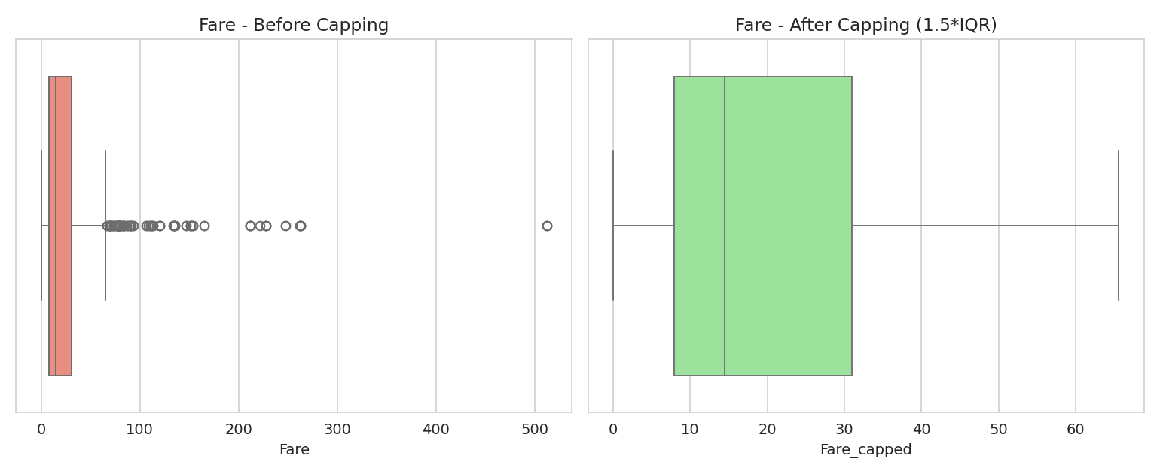
Figure 4. Fare distribution before and after 1.5×IQR capping — extreme values pulled in without removing rows.
The original Fare column was retained alongside the new Fare_capped column so that the transformation remains fully traceable and reversible.

6. Inconsistency & Data Quality Checks
Several additional checks were run to catch inconsistent or suspicious entries:
- Duplicate rows: none found (0 duplicates).
- Fare == 0: 15 rows had a fare of exactly 0. These were flagged rather than removed, as they plausibly represent crew members or complimentary tickets rather than data errors.
- Text normalization: Sex and Embarked values were stripped of whitespace and standardized in case (defensive cleaning, even though no inconsistent casing was found in this dataset).
- Range sanity checks: asserted Age is within [0, 100] and Fare is non-negative after cleaning — both passed.
df['Sex'] = df['Sex'].str.strip().str.lower()
df['Embarked'] = df['Embarked'].str.strip().str.upper()
assert df['Age'].between(0, 100).all()
assert df['Fare'].ge(0).all()
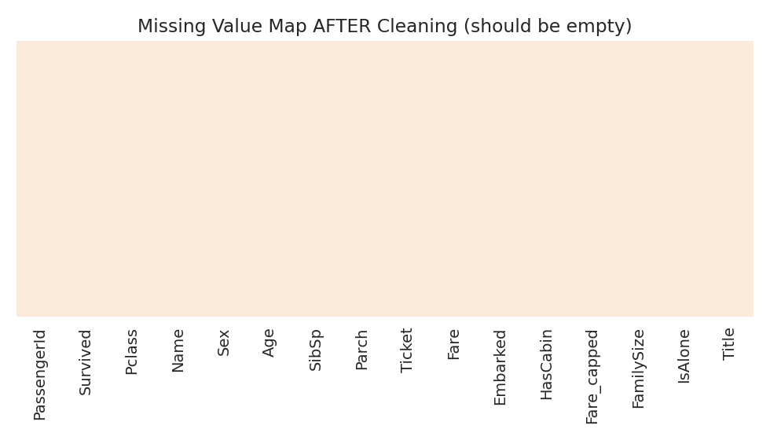
Figure 5. Missing value map after cleaning — no missing values remain.
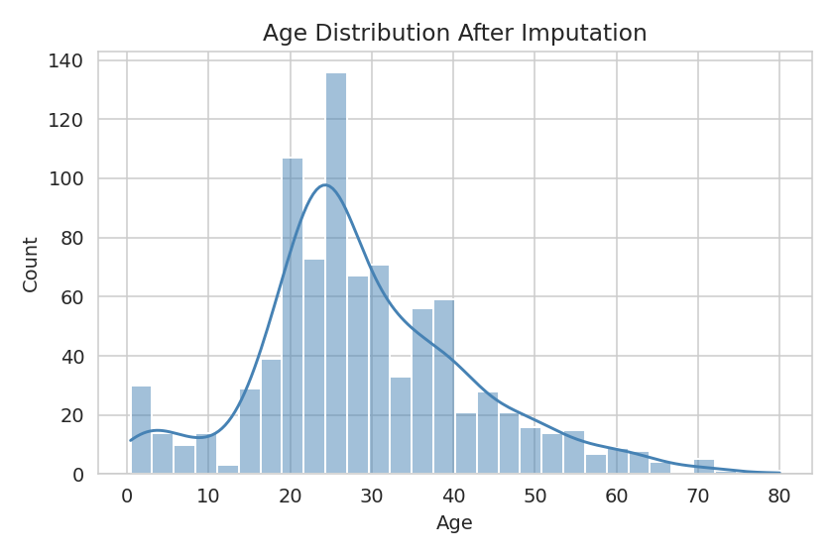
Figure 6. Age distribution after group-wise median imputation.

7. Feature Engineering & Preprocessing
Beyond cleaning, several preprocessing steps were applied to prepare the dataset for downstream machine learning or statistical analysis:

7.1 Feature Engineering
df['FamilySize'] = df['SibSp'] + df['Parch'] + 1
df['IsAlone'] = (df['FamilySize'] == 1).astype(int)
df['Title'] = df['Name'].str.extract(r',\s*([^\.]+)\.')
rare_titles = df['Title'].value_counts()[df['Title'].value_counts() < 10].index
df['Title'] = df['Title'].replace(rare_titles, 'Rare')
FamilySize and IsAlone were derived from SibSp and Parch to capture whether a passenger was traveling alone (previous survival analyses of this dataset show this is a meaningful predictor). Title was extracted from the Name field, and rare titles (fewer than 10 occurrences) were grouped into a single 'Rare' category to avoid an overly sparse categorical feature.

7.2 Encoding Categorical Variables
Categorical columns (Sex, Embarked, Title) were one-hot encoded using pandas.get_dummies with drop_first=True to avoid multicollinearity (the dummy variable trap) in any downstream linear model.
df_encoded = pd.get_dummies(df, columns=['Sex', 'Embarked', 'Title'],
drop_first=True)

7.3 Feature Scaling
Numeric features with different scales (Age, Fare_capped, FamilySize) were standardized using scikit-learn's StandardScaler (zero mean, unit variance), which is important for distance-based or gradient-based models that are sensitive to feature magnitude.
from sklearn.preprocessing import StandardScaler
scaler = StandardScaler()
num_cols = ['Age', 'Fare_capped', 'FamilySize']
df_encoded[[c + '_scaled' for c in num_cols]] = scaler.fit_transform(df_encoded[num_cols])

7.4 Removing Non-Predictive Columns
PassengerId, Name, and Ticket were dropped from the final preprocessed dataset as they are identifiers or free-text fields with no direct predictive value once Title and family-size features had been extracted from them.

8. Before / After Summary
Metric | Raw Dataset | Cleaned Dataset | Preprocessed Dataset
Rows | 891 | 891 | 891
Columns | 12 | 16 | 20
Missing values (total) | 866 | 0 | 0
Duplicate rows | 0 | 0 | 0
Fare outliers (>1.5×IQR) | 116 (present) | 116 (capped) | capped, scaled

9. Challenges Faced & How They Were Overcome
- Deciding how to treat the Cabin column: with 77% missing, standard imputation methods (mean/median/mode) would have manufactured data rather than recovered it. This was resolved by converting missingness itself into a binary feature (HasCabin) instead of imputing the raw values.
- Choosing between deleting and capping Fare outliers: deleting the 116 outlier rows (13% of the dataset) risked biasing the sample by disproportionately removing wealthier or group-ticket passengers. Capping (winsorizing) at the 1.5×IQR fence was chosen instead, preserving all rows while limiting the influence of extreme values on statistics like the mean and standard deviation.
- Age imputation without introducing bias: a single global median or mean would have ignored the fact that age varies systematically by class and gender in this dataset. Group-wise median imputation (by Pclass and Sex) was used to make the fill values more representative of the sub-population they belong to.
- Balancing thoroughness with avoiding over-engineering: several possible extra features (e.g., deck extracted from Cabin, ticket prefix parsing) were considered but excluded once it became clear the underlying columns were too sparse or too noisy to add reliable signal within the scope of this task.

10. Potential Impact of Preprocessing on Subsequent Analysis
The choices made in this pipeline have direct consequences for any analysis or modeling performed downstream:
- Group-wise Age imputation preserves the class/gender-based age structure that a global mean/median fill would have flattened, which should make any model or analysis using Age more faithful to real patterns — but it also means the imputed values are estimates, not observed facts, and should be interpreted with that caveat in exploratory analysis.
- Converting Cabin into HasCabin retains a strong survival signal (cabin-recorded passengers were disproportionately first-class) without pretending to know the exact cabin for 77% of passengers — but it also discards any finer-grained information (e.g., deck level) that a more sophisticated imputation approach might have recovered.
- Capping Fare outliers reduces the risk that a handful of extreme values dominate a mean, a regression coefficient, or a distance-based clustering result — but it also compresses genuine variation at the high end, which could slightly understate the fare gap between the wealthiest passengers and everyone else if that gap itself were the subject of study.
- One-hot encoding and scaling are necessary preparatory steps for most scikit-learn models, but they also mean the final dataset is one specific numeric representation of the original categorical/text information — a different modeling approach (e.g., a tree-based model) could have used the categorical columns directly without one-hot encoding or scaling.
In short, every cleaning and preprocessing decision is a trade-off between preserving as much real signal as possible and reducing noise, and each one should be re-examined in light of the specific downstream analysis or model being built.

11. Conclusion
This task walked through the full data preparation lifecycle on the Titanic dataset: acquiring the raw data from a public source, exploring its structure, identifying and addressing missing values and outliers using justified, context-aware strategies, checking for other inconsistencies, and finally engineering and preprocessing features into a model-ready dataset. The final preprocessed dataset contains 891 rows and 20 columns with zero missing values, standardized numeric features, and one-hot encoded categorical variables, ready for exploratory analysis or machine learning.

12. Deliverables & Repository
- titanic_data_cleaning.py — single, self-contained Python script covering the entire pipeline (acquisition, exploration, cleaning, outlier treatment, feature engineering, and preprocessing)
- requirements.txt — Python dependencies needed to run the script
- data/titanic_raw.csv — original, unmodified dataset (downloaded automatically on first run)
- outputs/titanic_cleaned.csv — cleaned dataset (missing values handled, outliers capped)
- outputs/titanic_preprocessed.csv — fully preprocessed, encoded, and scaled dataset
- images/ — all charts generated during exploration and cleaning
- This report (Data_Cleaning_Report.docx)
GitHub Repository Link: [https://github.com/ganesh-mlhub/titanic-data-cleaning-preprocessing.git]

