**BUILDING MANAGEMENT SYSTEM USING ATMEGA 328**

**ABSTRACT:**

The system supports various sensor and its functionality with a very practical and convenient cost system configuration. In various ways, the design and implementation of BMS (Building management system) and fulfilment of many type of green project today, but it uses technology to provide for a superior space. With the help of these system we reduces the human effort. The key features of our project is to opening and closing gate via RFID module, common area lighting, door opening and closing with the help of keypad and fire detection and alert to main system. All the hardware sensor and components are put into a best demonstration model with the motive of the test of the system and presentation in real-time. With the help of these model, the smart BMS environment is animated and correlated function becomes simple understood. BMS is reliable circuit that takes over the task of controlling various system used in it.

As rising concept, building automation integrates many applications which can support different usages. For example; a servo motor can be used to control the door; on the other hand it is suitable for pet feeding. Similarly, all domestic activities can be adapted to automation concept by the help of facilitating the electronic components.

The remote access renders it more practical and useful in the home environment. When all of hardware based services and user friendly interface are combined in a system, the rise of building automation system is inevitable. For such combination, security is a significant issue. As an exemplary solution of this problem, in our system, motion sensors and door controls are utilized in order to get information about unusual activities like a burglar at home. Moreover; gas, smoke and fire sensors give constant information about extraordinary situations and raise alarm. Hence; a home accident and maybe massive disaster can be prevented. Due to all of these reasons, building automation systems are favorable and feasible in terms of answering to user requirements.

**INTRODUCTION:**

In today’s world, there is a persistent requirement for automated appliances. With the expansion in the way of life, there is a sense of urgency for creating circuits that would facilitate the complexity of life. While planning an intelligent building, a Building service engineer, an Architect & Hardware Engineer is required, but in the case of the ordinary building, a Building service engineer and an Architect are enough. For many years, buildings that offer comfortable, a flexible and energy efficient living environment at a minimal cost has been the expectation of building owners and occupiers. To achieve this goal, a variety of advanced building technologies have been developed in the past two decades, aiming to improve the building performance to satisfy a variety of human needs and environmental sustainability. Building automation frameworks are the smart systems that include a combination of suitable software and hardware which are utilized for automation of computer systems. These system ease usage of important functions such as gate opening, door opening, lighting, fire extinction, and security. Some building automation systems can also provide an emergency alert service. However, current building applications have a some common problem, such as comprehensive functions operate in isolation, can’t be managed in overall fashion although overall management’s tremendous potential in future applications.

European Union supported Building as a Service (BaaS) project deals with this various problem which aims to provide a comprehensive software platform for present and future commercial building management and building innovation, with flexible and cost-efficient integration of mentioned services, an overall management idea is targeted. As a rising idea, building automation coordinates numerous applications which can support different usages. For instance; a dc motor engine can be utilized to control the gate and door; on the other hand, this work has been supported by 9140003 ITEA BaaS/Tubitak. it is appropriate for pet sustaining. Essentially, all household exercises can be adjusted to the computerization idea by the assistance of encouraging the electronic component. The remote access renders it progressively down to earth and valuable in the home condition. At the point when the majority of the equipment based administrations and easy to use interface are joined in a framework, the ascent of building computerization framework is inescapable. For such a blend, security is a huge issue.

The main aim of the system is that it utilizes the RFID framework which is the eventual fate of electronic correspondence. Here we likewise supplant the microcontrollers prior utilized, which is a mini processor that is both a microcontroller just as a server. The vehicle that should be approved is given a RFID tag with an exceptional number. Presently when the vehicle comes to close to the door RFID tag peruses the code, and send a flag to raspberry pi which checks for the relating subtleties of the one of a kind number and on the off chance that it matches with the spared information in the database, at that point it again makes an impression on the engine which opens the entryway.

As a commendable arrangement of this issue, in our framework, motion sensor i.e., IR sensors and entryway controls are used so as to get data about strange exercises like a robber at home. In addition; gas, smoke and flame sensors give steady data about exceptional circumstances and raise caution. In this project, building automation system is developed by composing circuit that involves smart home functionalities which connected with sensors which are controlled by an Android based application. The fundamental controls like lights, door, gate, fire and gas alarms are all included in this project. However, system’s functionality is display in real-time by an unique developed demonstration model which shows system properties clearly and possible benefits of smart building automation system in a modeled home environment.

**GOALS:**

The main goals of our system is, Central controlling facility Automate and take control of various operations, manages all the systems which coordinates various systems to provide a comfortable working environment in an efficient way. To provide a best facility in building area and reduces the human effort.

**OBJECTIVE:**

The main objective of our system is to provide building automation in building area like opening and closing gate via RFID card, smart common area lighting depends on object motion or human motion, smart door lock system using keypad as well as fire detection and alert to main system etc.

**PURPOSE:**

Behind choosing this project, automated central control system in all modern big buildings is very important and necessary for the qualitative improvement of the working conditions as well as rational energy distribution. All buildings system have some form of mechanical and electrical system in order to provide the functional necessary for maintaining exact working environment.

**BLOCK DIAGRAM:**

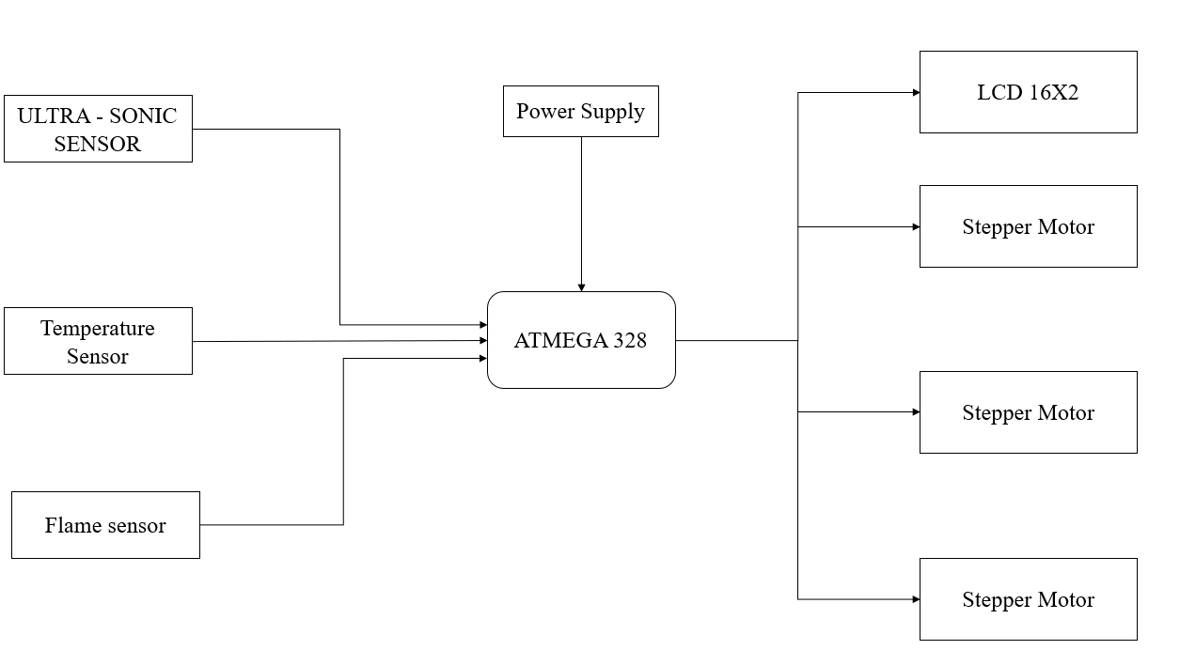

**FLOW CHART:**

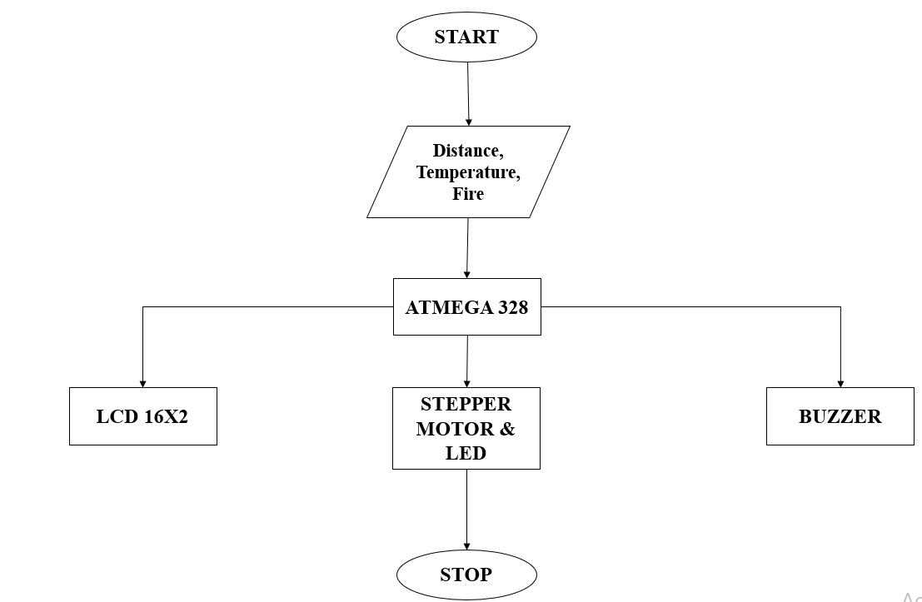

**WORKING MODEL:**

**Building Automation Systems:**

Most basic criteria for building automation operation for commercial buildings are to ensure comfort for users and security of the building, by controlling building technological infrastructure, while minimizing energy consumption. The comfort means providing optimal conditions of indoor thermal parameters and indoor air quality and parameters of indoor lighting of a workplace and common areas. The security means to execute the functionality of occupancy monitoring, controlling who has access to protected areas of the building and alarming by I&HAS.

**Smoke Alarm System:** Smoke evacuation systems are vital to the safety of building living people and other visitors in your building. The system detect the smoke contain then system gave the alert message. A smoke or fire is detected with the help of MQ3 sensor. A smoke evacuation system identifies where the smoke originates from and controls the movement of the smoke so it does not reach exit areas and other safe zones within the building. Whenever smoke or fire is detected that time buzzer or alert system will be active.

**Fire Alarm System:** Flame detecting sensors are designed to respond to the presence of a flame or fire, or the by-product of a fire. There are various types of flame detectors. When there is fire in the building buzzer rings and everyone in the will be aware of fire accident and can get rid of situation.

**Gate Open:** In this model user uses the RFID card for the gate open and close. When the peoples entering into the building RFID card is required. Unauthorized people cannot enter in the building. Security is increased by this system.

**Light Model:** In this module the wastage of energy is reduces. In this model the system on the light depend on the person availability of the people. When person move from corridor then light will be ON/OFF. We use IR sensor for detect the object or motion in corridor or common area for glowing lights or LED.

**ULTRA SONIC SENSOR:**

An ultrasonic sensor is an electronic device that measures the distance of a target object by emitting ultrasonic sound waves, and converts the reflected sound into an electrical signal. Ultrasonic waves travel faster than the speed of audible sound (i.e. the sound that humans can hear). Ultrasonic sensors have two main components: the transmitter (which emits the sound using piezoelectric crystals) and the receiver (which encounters the sound after it has travelled to and from the target). In order to calculate the distance between the sensor and the object, the sensor measures the time it takes between the emission of the sound by the transmitter to its contact with the receiver. The formula for this calculation is [D = ½ T x C](https://www.arrow.com/en/research-and-events/articles/ultrasonic-sensors-how-they-work-and-how-to-use-them-with-arduino) (where D is the distance, T is the time, and C is the speed of sound ~ 343 meters/second).

Ultrasonic sensors are used primarily as [proximity sensors](https://www.fierceelectronics.com/sensors/what-a-proximity-sensor). They can be found in automobile self-parking technology and anti-collision safety systems. Ultrasonic sensors are also used in robotic obstacle detection systems, as well as manufacturing technology. [In comparison to infrared (IR) sensors](https://www.maxbotix.com/articles/ultrasonic-or-infrared-sensors.htm) in proximity sensing applications, ultrasonic sensors are not as susceptible to interference of smoke, gas, and other airborne particles. Ultrasonic sensors are also used as [level sensors](https://www.fierceelectronics.com/sensors/what-a-level-sensor) to detect, monitor, and regulate liquid levels in closed containers (such as vats in chemical factories). Most notably, ultrasonic technology has enabled the medical industry to produce images of internal organs, identify tumors, and ensure the health of babies in the womb.

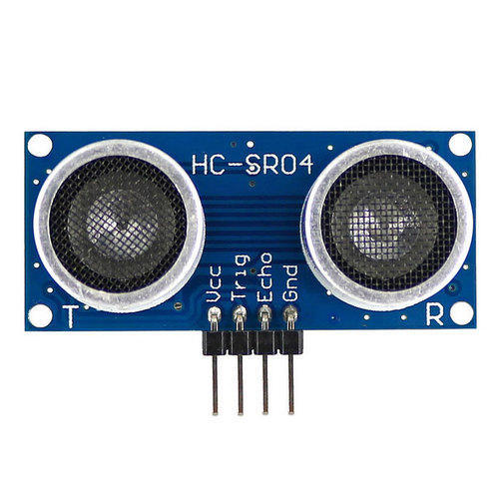

**TEMPERATURE SENSOR:**

[Thermistors](https://www.littelfuse.com/products/Temperature-Sensors.aspx) are thermally sensitive resistors whose prime function is to exhibit a large, predictable and precise change in electrical resistance when subjected to a corresponding change in body temperature. Negative Temperature Coefficient (NTC) thermistors exhibit a decrease in electrical resistance when subjected to an increase in body temperature and Positive Temperature Coefficient (PTC) thermistors exhibit an increase in electrical resistance when subjected to an increase in body temperature. U.S. Sensor Corp, acquired by Littelfuse in 2017, produces thermistors capable of operating over the temperature range of -100° to over +600° Fahrenheit. Because of their very predictable characteristics and their excellent long-term stability, thermistors are generally accepted to be the most advantageous sensor for many applications including temperature measurement and control.When a thermistor is used in a circuit where the power dissipated within the device is not sufficient to cause "self heating", the thermistor's body temperature will follow that of the environment. Thermistors are not "self heated" for use in applications such as temperature measurement, temperature control or temperature compensation.When a thermistor is used in a circuit where the power dissipated within the device is sufficient to cause "self heating", the thermistor's body temperature will be dependent upon the thermal conductivity of its environment as well as its temperature. Thermistors are "self heated" for use in application such as liquid level detection, air flow detection and thermal conductivity measurement.

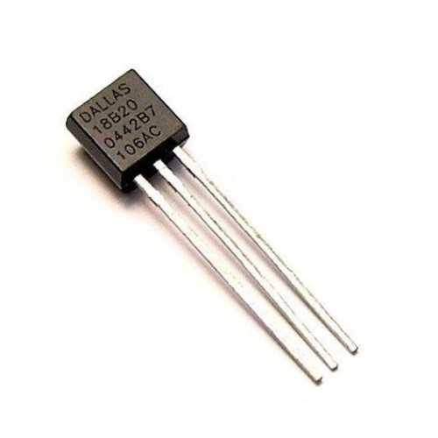

**FIRE DETECTION SENSOR:**

Multi-infrared detectors make use of algorithms to suppress the effects of background radiation (blackbody radiation), again sensitivity is reduced by this radiation.Triple-IR flame detectors compare three specific wavelength bands within the IR spectral region and their ratio to each other. In this case one sensor looks at the 4.4 micrometer range while the other sensors look at reference wavelengths both above and below 4.4. This allows the detector to distinguish between non-flame IR sources and actual flames which emit hot CO2 in the combustion process. As a result, both detection range and immunity to false alarms can be significantly increased. IR3 detectors can detect a 0.1m2 (1 ft2) gasoline pan fire at up to 65 m (215 ft) in less than 5 seconds. Triple IRs, like other IR detector types, are susceptible to blinding by a layer of water on the detector's window.

Most IR detectors are designed to ignore constant background IR radiation, which is present in all environments. Instead they are designed to detect suddenly changing or increasing sources of the radiation. When exposed to changing patterns of non-flame IR radiation, IR and UV/IR detectors become more prone to false alarms, while IR3 detectors become somewhat less sensitive but are more immune to false alarms.

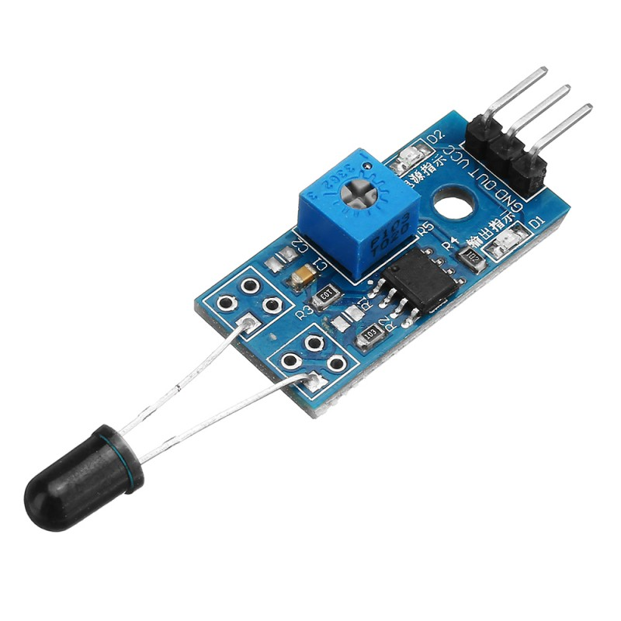

**CODE:**

#include <avr/io.h>

#include <avr/interrupt.h>

#include <util/delay.h>

#include <stdlib.h>

static volatile int pulse = 0;

static volatile int i = 0;

int main(void)

{

int16_t count_a = 0;

char show_a[16];

DDRD = 0b11111011;

_delay_ms(50);

GICR |= 1<<INT0;

MCUCR |= 1<<ISC00;

sei();

while(1)

{

PORTD |= 1<<PIND0;

_delay_us(15);

PORTD &= ~(1<<PIND0);

count_a = pulse/58;

Send_A_String("Distance Sensor");

GoToMrLCDLocation(1,2);

Send_A_String("Distance=");

itoa(count_a,show_a,10);

Send_A_String(show_a);

Send_A_String(" ");

GoToMrLCDLocation(13,2);

Send_A_String("cm");

GoToMrLCDLocation(1,1);

}}

ISR(INT0_vect)

{

if(i == 0)

{

TCCR1B |= 1<<CS10;

i = 1;

}

else

{

TCCR1B = 0;

pulse = TCNT1;

TCNT1 = 0;

i = 0;

}

}

**SCREENSHOTS:**

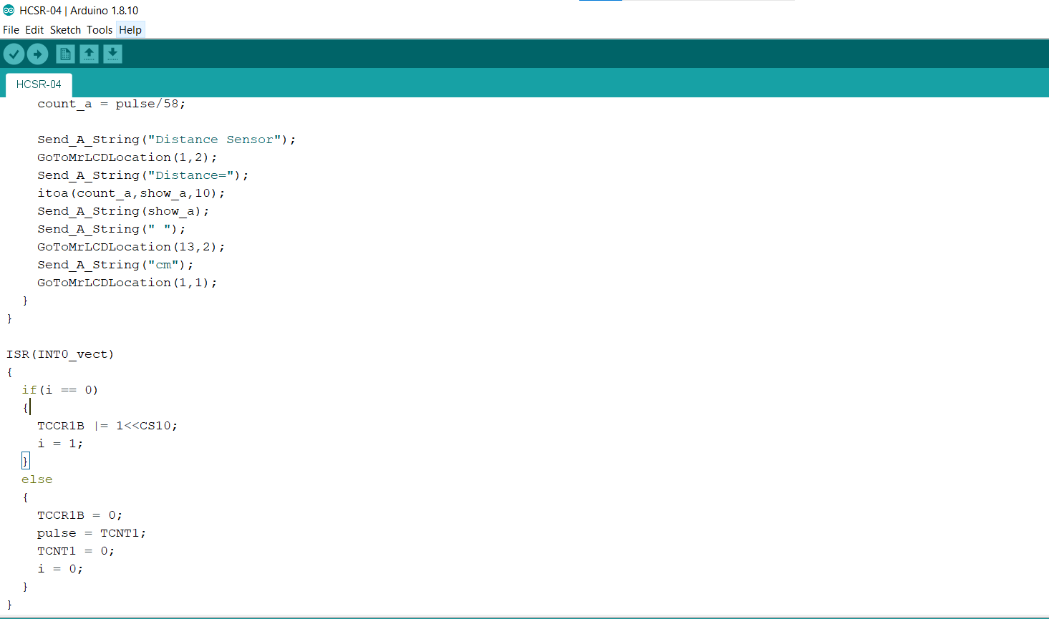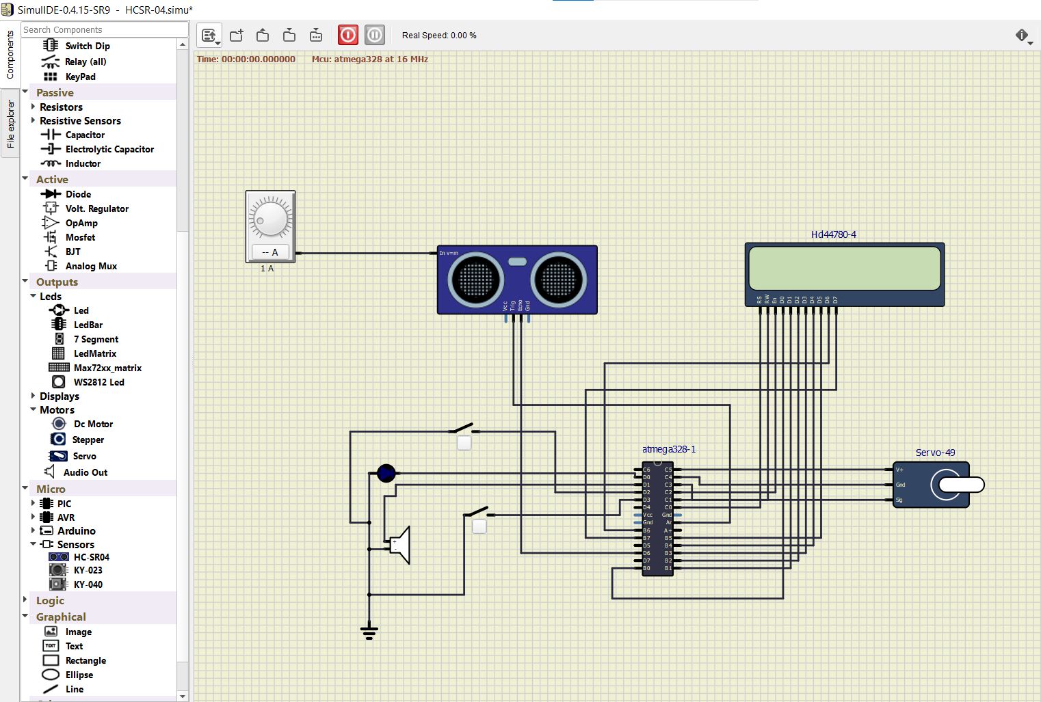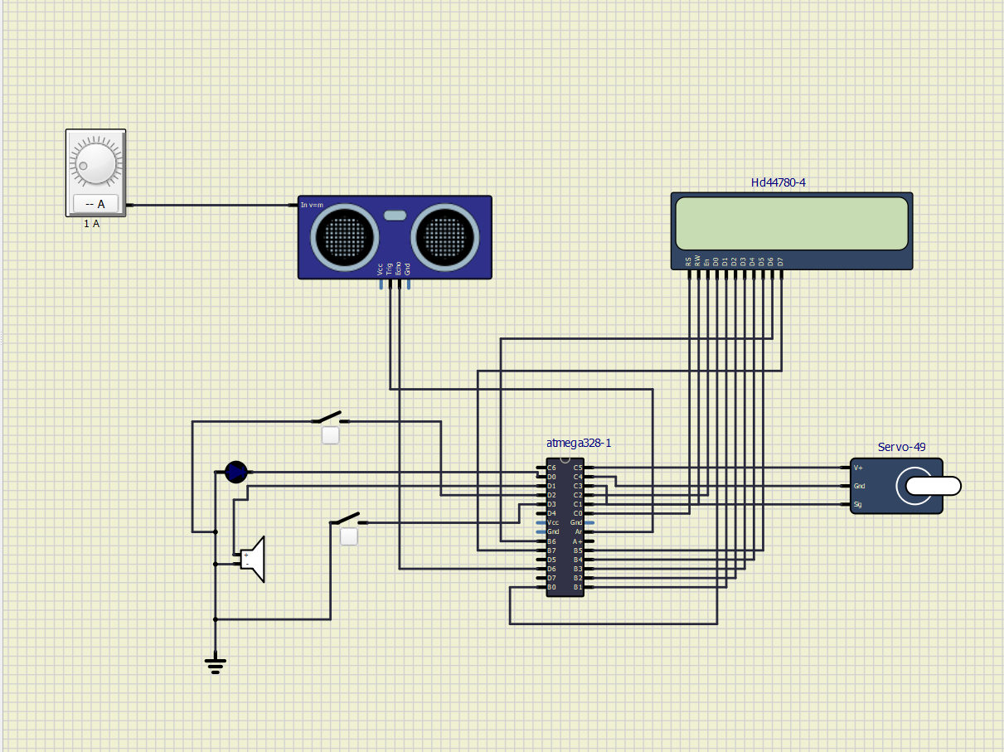

**ADVANTAGES:**

* Increasing the value of your business and property.•
* Providing sustainable solutions to your building infrastructure and the environment.
* Providing security for your property, building, its’ occupants, and business assets such as IT data and resources.
* Providing indoor environmental safety and comfort through your HVAC system.

**CONCLUSION:**

For the most part, we can say that the intelligent building management system is a set of software and hardware for monitoring and controlling different sections of a building. In this 21st century with the advent of the several artificial intelligent technology the work places became very cozy to work with. It has changed the uncondensed working environment leading to the increased output and also lessen the running cost to a certain extent. Lighting efficiency it will cut down the electricity bills. But any how today the cost of such equipment’s to make a building artificially intelligent is a costly means. With the increase in demand of such systems the cost of these will become affordable as more and more builders will be using such systems in future