

Functional Safety Concept Lane Assistance

**Document Version: 1.0**



# Document history

|  |  |  |  |
| --- | --- | --- | --- |
| Date | Version | Editor | Description |
| 05/24/18 | 1.0 | Ganesh Prabakaran | Initial |
|  |  |  |  |
|  |  |  |  |
|  |  |  |  |
|  |  |  |  |

# Table of Contents

Contents

Document history 2

Table of Contents 2

Purpose of the Functional Safety Concept 3

Inputs to the Functional Safety Concept 3

Safety goals from the Hazard Analysis and Risk Assessment 3

Preliminary Architecture 4

Description of architecture elements 4

Functional Safety Concept 5

Functional Safety Analysis 5

Functional Safety Requirements 6

Refinement of the System Architecture 8

Allocation of Functional Safety Requirements to Architecture Elements 8

Warning and Degradation Concept 9

# Purpose of the Functional Safety Concept

Functional Safety Concept documents the high level system requirements. These requirements are allocated to different parts of the item architecture. Technical safety requirements will be derived from these safety concepts. Instruction on how to validate and verify the requirements are presented as well.

# Inputs to the Functional Safety Concept

## Safety goals from the Hazard Analysis and Risk Assessment

|  |  |
| --- | --- |
| **ID** | **Safety Goal** |
| Safety_Goal_01 | The oscillating steering torque from the Lane Departure Warning function shall be limited |
| Safety_Goal_02 | The Lane Keeping Assistance function shall be time limited, and additional steering torque shall end after a given time interval so the driver cannot misuse the system for autonomous driving. |

## Preliminary Architecture

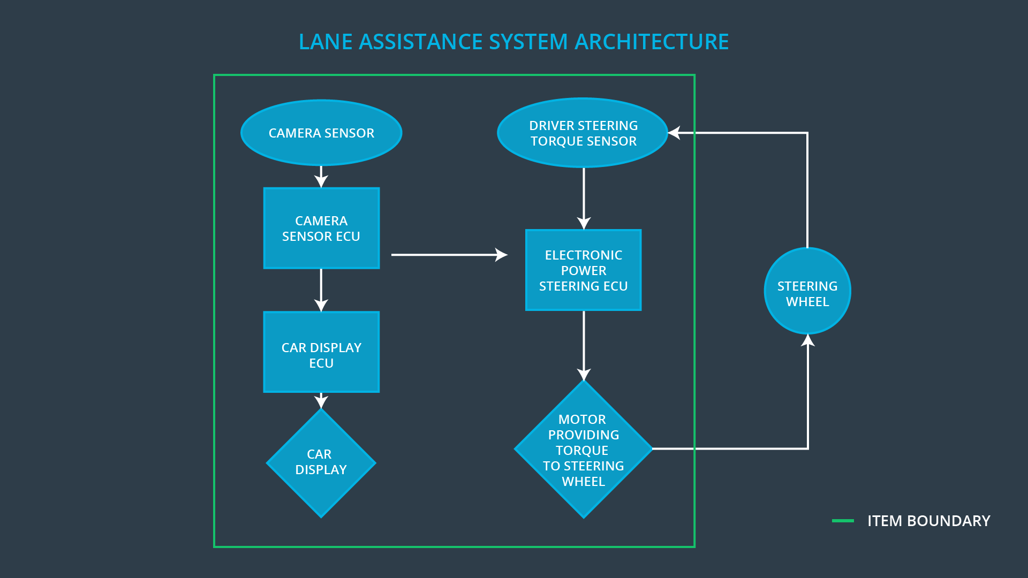

Fig 1 Lane Assistance System Preliminary Architecture

[Image source: https://udacity.com]

### Description of architecture elements

|  |  |
| --- | --- |
| **Element** | **Description** |
| Camera Sensor | Captures images from the front view of the car to assist in lane detection. |
| Camera Sensor ECU | Performs computation on the captured images to detect lanes and find the position of the car with respect to the lane |
| Car Display | Provides visual indication to the driver such as (1) whether the system is ON or OFF and (2) the car is steering off the lane etc |
| Car Display ECU | This ECU Receives input from the camera sensor ECU when the car is steering off the lane and signals the car display to turn on the warning light. |
| Driver Steering Torque Sensor | This sensor captures the steering wheel angular displacement initiated by the driver and sends it to the Electronic Power Steering ECU |
| Electronic Power Steering ECU | This ECU adds input from both driver steering torque sensor and along with the deviation compared with Camera Sensor ECU and provides steering torque amplitude to the steering wheel motor |
| Motor | Motor provides steering torque to the steering wheel based on the amplitude received from the Electronic Power steering ECU |

# Functional Safety Concept

The functional safety concept consists of:

* Functional safety analysis
* Functional safety requirements
* Functional safety architecture
* Warning and degradation concept

## Functional Safety Analysis

|  |  |  |  |
| --- | --- | --- | --- |
| **Malfunction ID** | **Main Function of the Item Related to Safety Goal Violations** | **Guidewords (NO, WRONG, EARLY, LATE, MORE, LESS)** | **Resulting Malfunction** |
| Malfunction_01 | Lane Departure Warning (LDW) function shall apply an oscillating steering torque to provide the driver a haptic feedback | MORE | The lane departure warning function applies an oscillating torque with very high torque amplitude (above limit) |
| Malfunction_02 | Lane Departure Warning (LDW) function shall apply an oscillating steering torque to provide the driver a haptic feedback | MORE | The lane departure warning function applies an oscillating torque with very high torque frequency (above limit) |
| Malfunction_03 | Lane Keeping Assistance (LKA) function shall apply the steering torque when active in order to stay in ego lane | NO | The lane keeping assistance function is not limited in time duration which leads to misuse as an autonomous driving function. |

## Functional Safety Requirements

Lane Departure Warning (LDW) Requirements:

|  |  |  |  |  |
| --- | --- | --- | --- | --- |
| **ID** | **Functional Safety Requirement** | **ASIL** | **Fault Tolerant Time Interval** | **Safe State** |
| Functional  Safety  Requirement  01-01 | The lane departure warning system shall ensure the lane departure oscillating torque amplitude is not exceeding Max_Torque_Amplitude. | C | 50ms | Set Oscillating Torque amplitude to zero when fault is detected |
| Functional  Safety  Requirement  01-02 | The lane departure warning system shall ensure the lane departure oscillating torque frequency is not exceeding Max_Torque_Frequency. | C | 50ms | Set Oscillating Torque frequency to zero when fault is detected |

Lane Departure Warning (LDW) Verification and Validation Acceptance Criteria:

|  |  |  |
| --- | --- | --- |
| **ID** | **Validation Acceptance**  **Criteria and Method** | **Verification Acceptance**  **Criteria and Method** |
| Functional  Safety  Requirement  01-01 | Prove that the chosen value of max torque amplitude is an appropriate value.  Validate by a test how drivers react to different torque amplitudes. | Verify the lane departure warning sets to zero within the 50 ms fault tolerant time interval when the torque amplitude crosses the limit.  Perform a software test by inserting a fault into the system and see what happens. |
| Functional  Safety  Requirement  01-02 | Prove that the chosen value of max torque amplitude is an appropriate value.  Validate by a test how drivers react to different torque frequencies | Verify the lane departure warning sets zero within the 50 ms fault torlerant time when the torque frequency crosses the limit.  Perform a software test by inserting a fault into the system and see what happens. |

Lane Keeping Assistance (LKA) Requirements:

|  |  |  |  |  |
| --- | --- | --- | --- | --- |
| **ID** | **Functional Safety Requirement** | **ASIL** | **Fault Tolerant Time Interval** | **Safe State** |
| Functional  Safety  Requirement  02-01 | Lane keeping assistance function shall be time limited and the additional steering torque shall end after a given timer interval so that the driver cannot misuse the system for autonomous driving | B | 50 | Lane keeping assistance function should stop applying extra torque after the fault tolerant time interval |

Lane Keeping Assistance (LKA) Verification and Validation Acceptance Criteria:

|  |  |  |
| --- | --- | --- |
| **ID** | **Validation Acceptance**  **Criteria and Method** | **Verification Acceptance**  **Criteria and Method** |
| Functional  Safety  Requirement  02-01 | Test and validate that the max duration chosen really did dissuade drivers from taking their hands off the wheel. | Verify that the system really does set to zero if the lane keeping assistance every exceeded max duration. |

## Refinement of the System Architecture

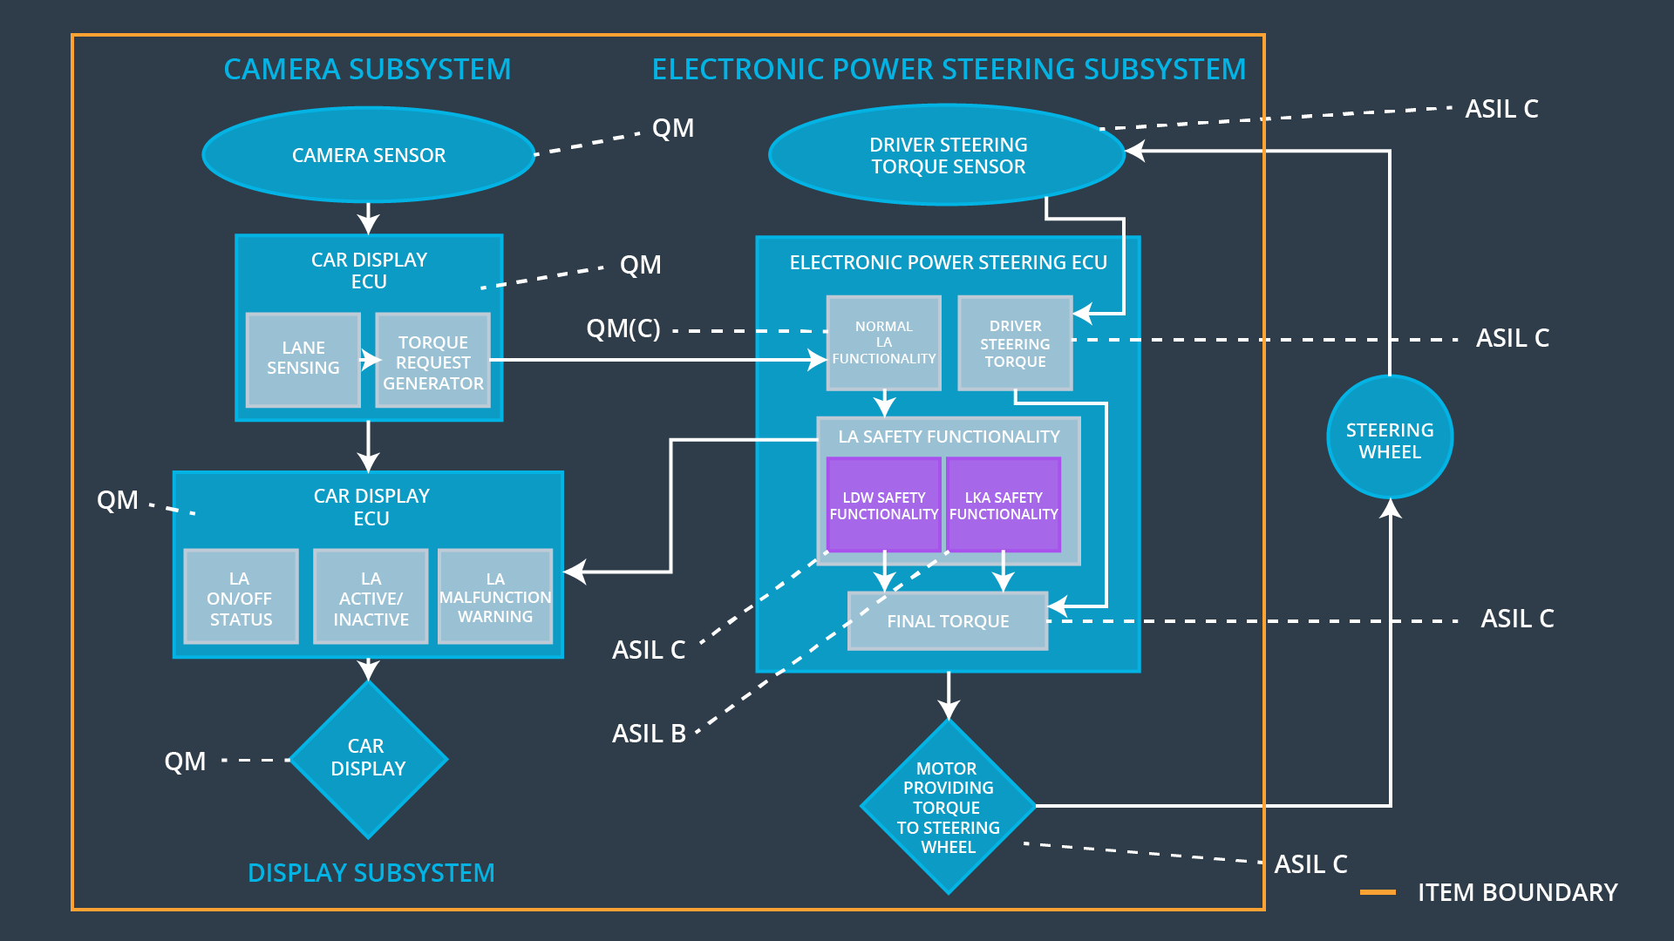

Fig 2 Refined Lane Assistance System Architecture

[Image source: https://udacity.com]

## Allocation of Functional Safety Requirements to Architecture Elements

|  |  |  |  |  |
| --- | --- | --- | --- | --- |
| **ID** | **Functional Safety Requirement** | **Electronic Power Steering ECU** | **Camera ECU** | **Car Display ECU** |
| Functional  Safety  Requirement  01-01 | The lane departure warning system shall ensure the lane departure oscillating torque amplitude is not exceeding Max_Torque_Amplitude. | **X** |  |  |
| Functional  Safety  Requirement  01-02 | The lane departure warning system shall ensure the lane departure oscillating torque amplitude is not exceeding Max_Torque_Frequency. | **X** |  |  |
| Functional  Safety  Requirement  02-01 | Lane keeping assistance function shall be time limited and the additional steering torque shall end after a given timer interval so that the driver cannot misuse the system for autonomous driving | **X** |  |  |

## Warning and Degradation Concept

|  |  |  |  |  |
| --- | --- | --- | --- | --- |
| **ID** | **Degradation Mode** | **Trigger for Degradation Mode** | **Safe State invoked?** | **Driver Warning** |
| WDC-01 | Lane Departure Functionality set to zero | Malfunction_01,Malfunction_02 | Yes | Lane Departure Malfunction warning on display |
| WDC-02 | Lane Keeping Assistance Functionality set to zero | Malfunction_03 | Yes | Lane Keeping Assistance Malfunction warning on display |