PRIVATE · FOR GANESH
Demo playbook
What to prepare, show, say, avoid, and ask.
Matches the product at commit f482cfe · sample files in demo/sample-files
Goal of the meeting
Not a signature. Learn their real monthly pain, get 50–100 real invoices to test on, and agree a dated next step.

1. Before the meeting
✓ | Task | How
☐ | Database up to date | cd backend && .venv/bin/alembic upgrade head
☐ | Start the app | ./run.sh → http://localhost:3000
☐ | Fresh account | Register your firm; Settings → Workspaces → create “Tapi Fabrics Pvt Ltd”; open it
☐ | AI for Q&A (optional) | Settings → AI providers: add a key. Without one, skip step 8
☐ | Files ready | demo/sample-files (keep the annual report for step 8)
☐ | Present from PDF | demo/KnowledgeHub-AI-Demo.pdf (fonts embedded); PPTX as backup
☐ | Rehearse + record | Run steps 1–9 once (≈12 min); screen-record as a backup

2. Meeting plan (25 minutes)
Time | What | Notes
0–5 | Ask first (section 6) | Before showing anything; write answers down
5–17 | Demo (section 3) | Use their words from the questions
17–22 | Roadmap + pilot (slides 14–15) | Ask them to rank the roadmap
22–25 | Next step | Date to receive invoices, who sends them, when you show results

3. Demo script
Order matters: approve invoice_03 BEFORE setting up the client rules (step 5 before step 6), otherwise it is flagged as billed to another client.

Step 1 · Upload
Do Documents → drag in invoice_01…06 and whatsapp-photo-invoice.png. Wait for Ready.
Say “Bills come as PDFs, scans and WhatsApp photos. All of them go in here, and scans are read automatically.”
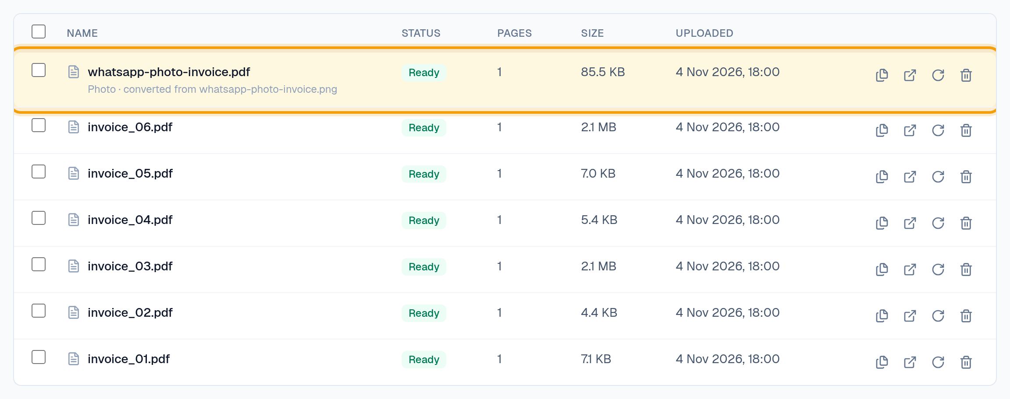

Step 2 · PDF tools
Do Pages icon on any PDF: click pages, show 'One document per page'. Tick two invoices → Merge.
Say “A vendor sends 20 bills in one PDF? One click, 20 invoices. No other PDF software.”
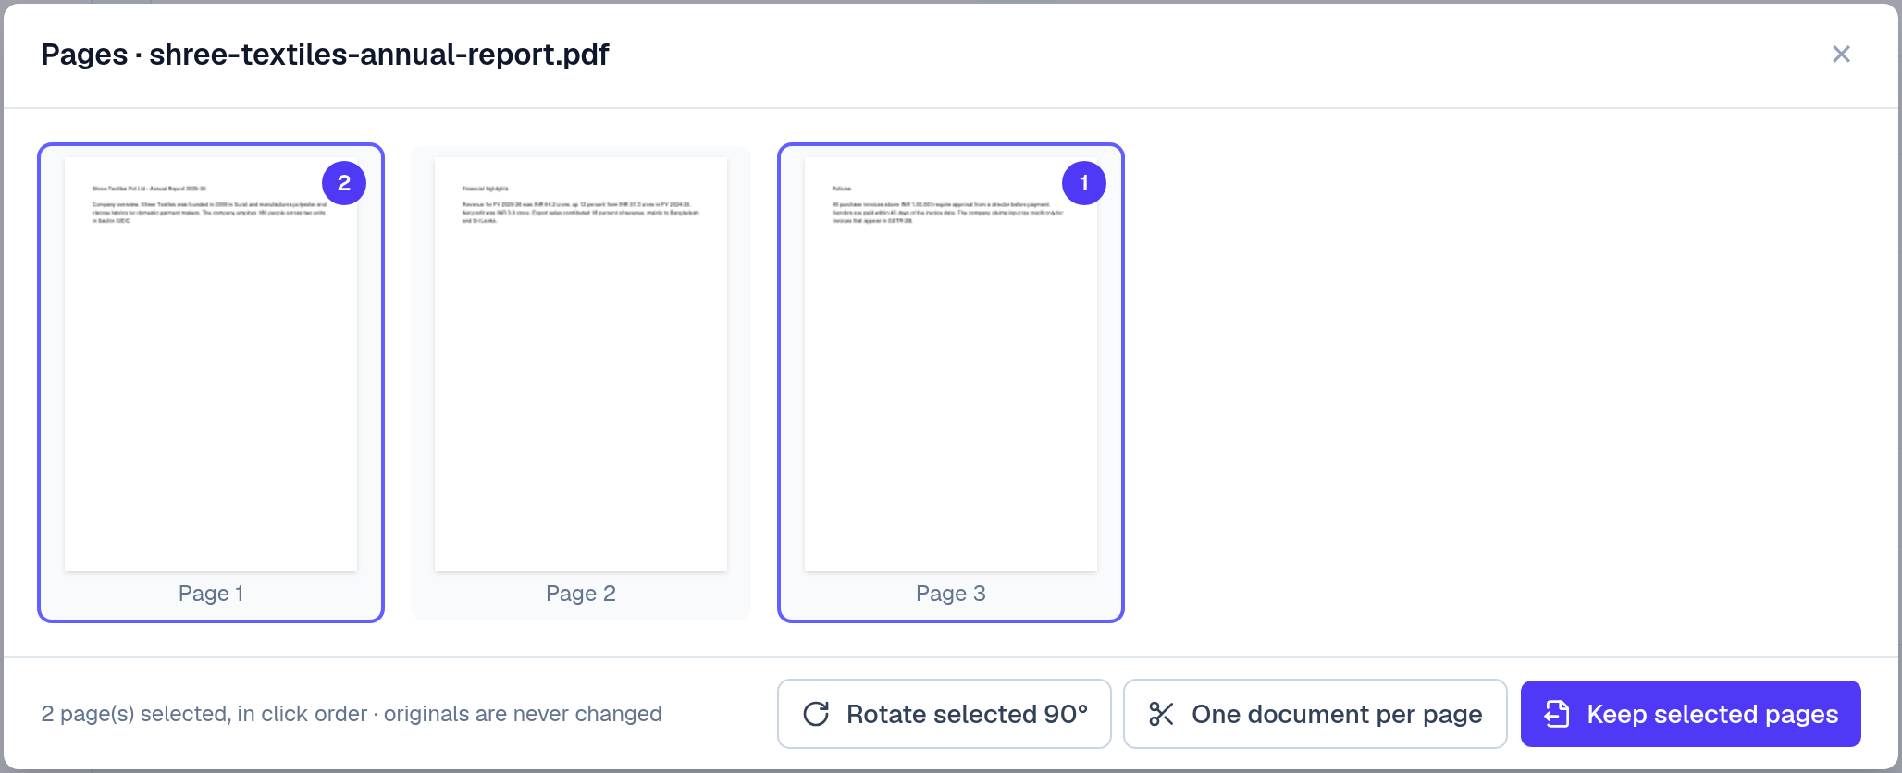

Step 3 · Wrong total
Do Review → Extract new → open invoice_05.
Say “The bill doesn't add up: ₹100 off. Your team would only find this later, if at all.”
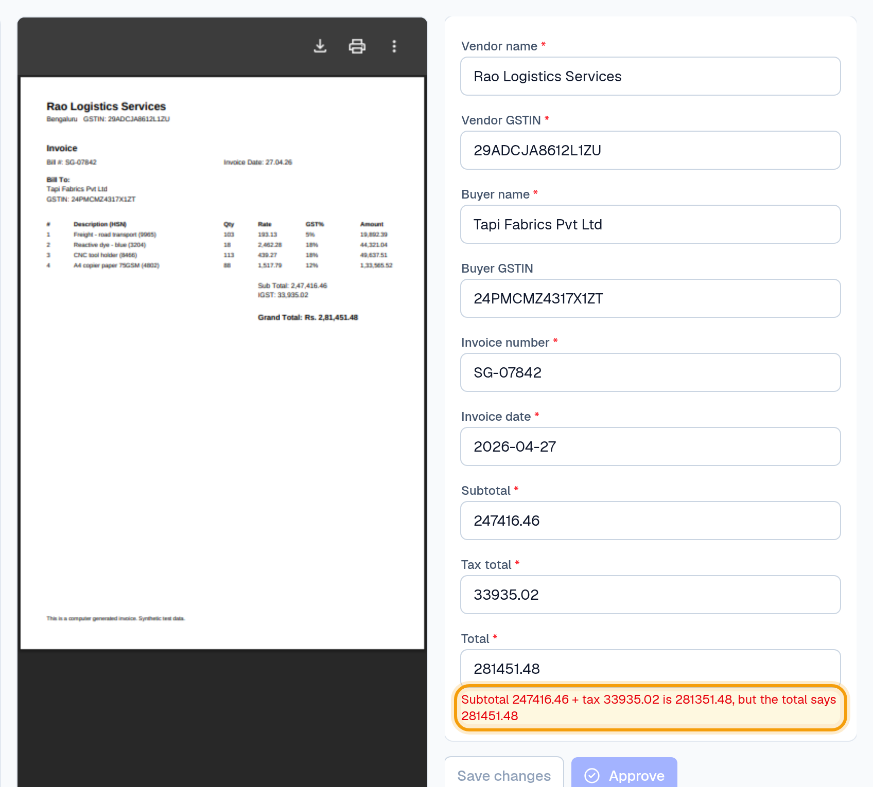

Step 4 · Duplicate photo
Do Open whatsapp-photo-invoice.pdf.
Say “The client sent the same bill as PDF and as a photo. Caught, and approval is blocked.”
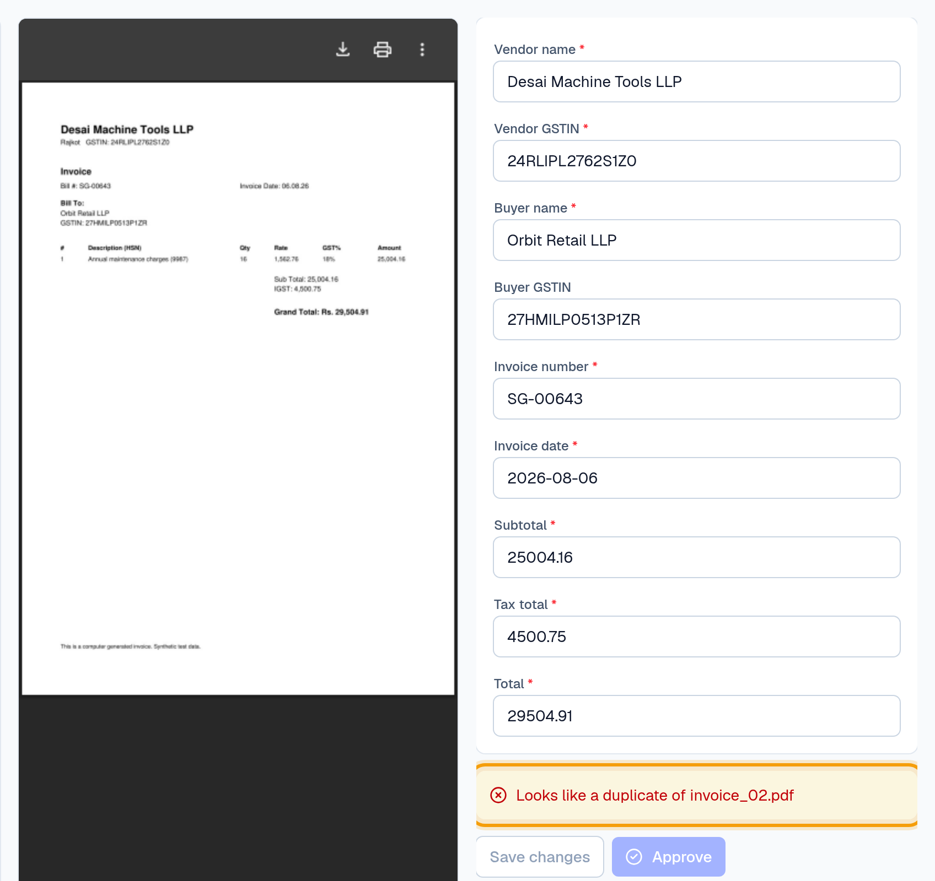

Step 5 · Fix, approve, Excel
Do Open invoice_03 (scan). Fix anything misread (e.g. vendor name). Approve → Excel.
Say “Nothing leaves without approval, and every correction is recorded. Today Excel; Tally next.”
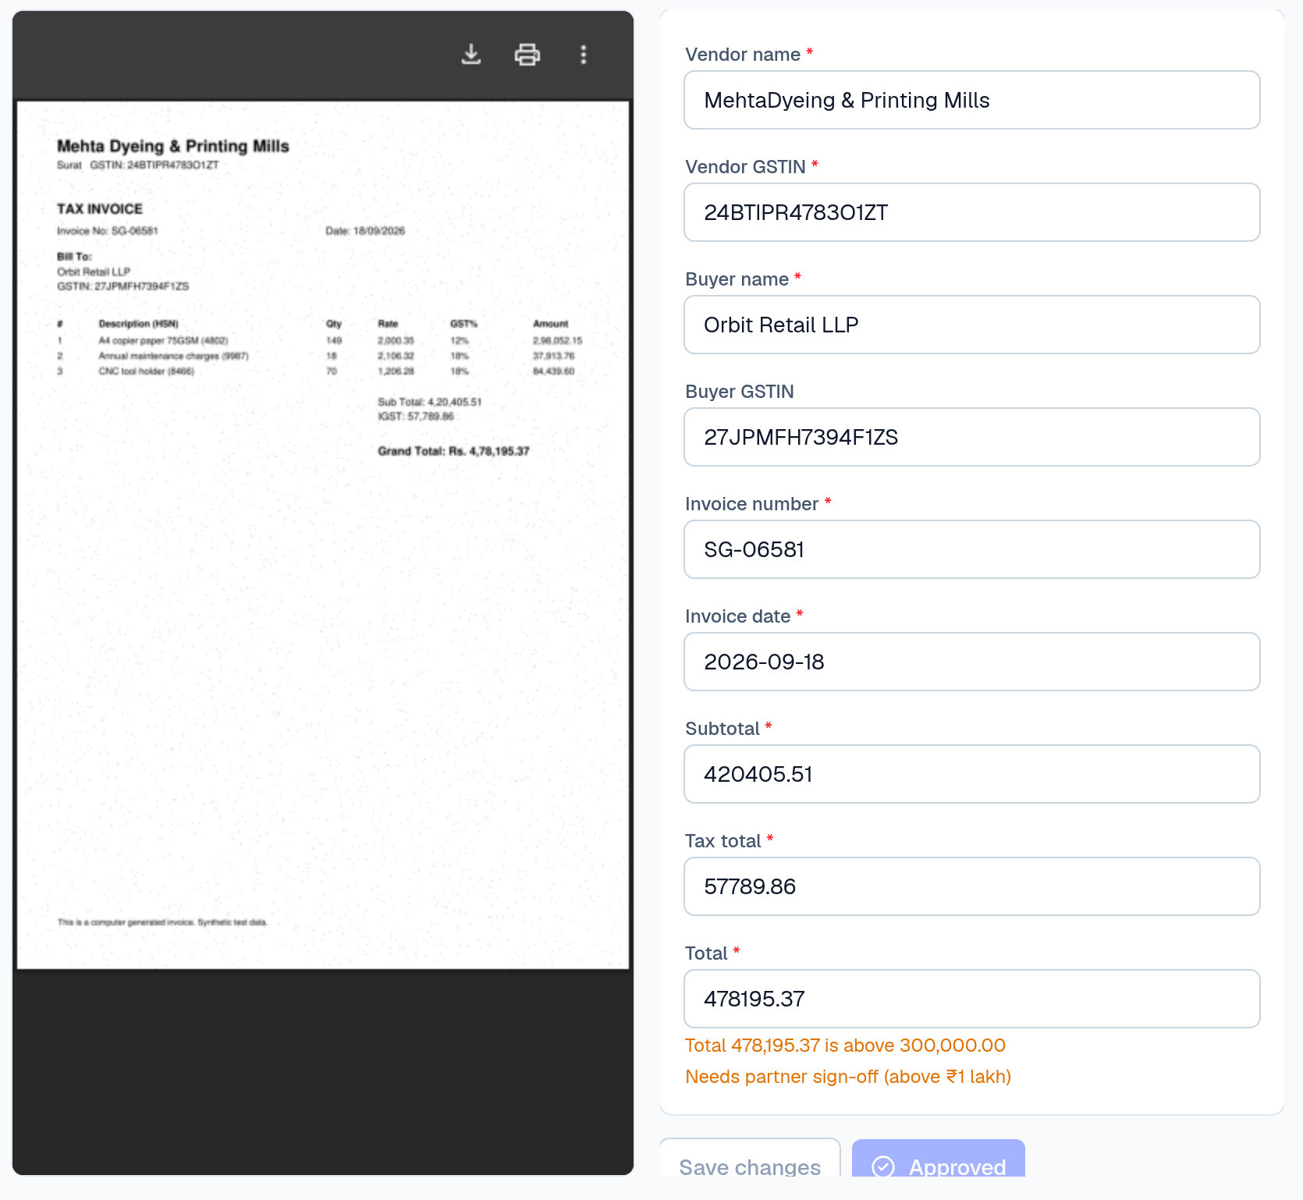

Step 6 · Client rules
Do Rules → tick 'Billed to this client', GSTIN 24NPIDW9674Y1ZH; tick 'Large amount'; add their own custom rule. Save.
Say “What's one check your seniors always do? Let's add it now.”
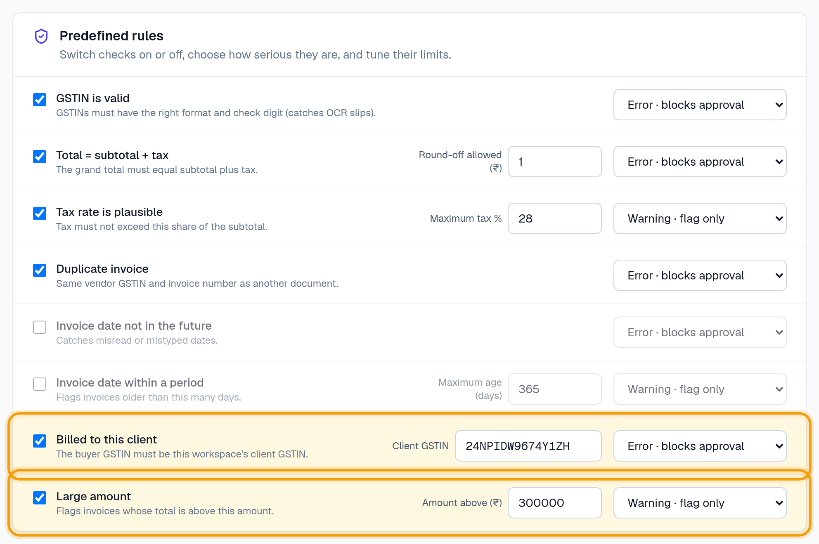

Step 7 · Wrong client GSTIN
Do Review → invoice_05.
Say “Right name, wrong GSTIN: credit isn't claimable. Flagged automatically.”
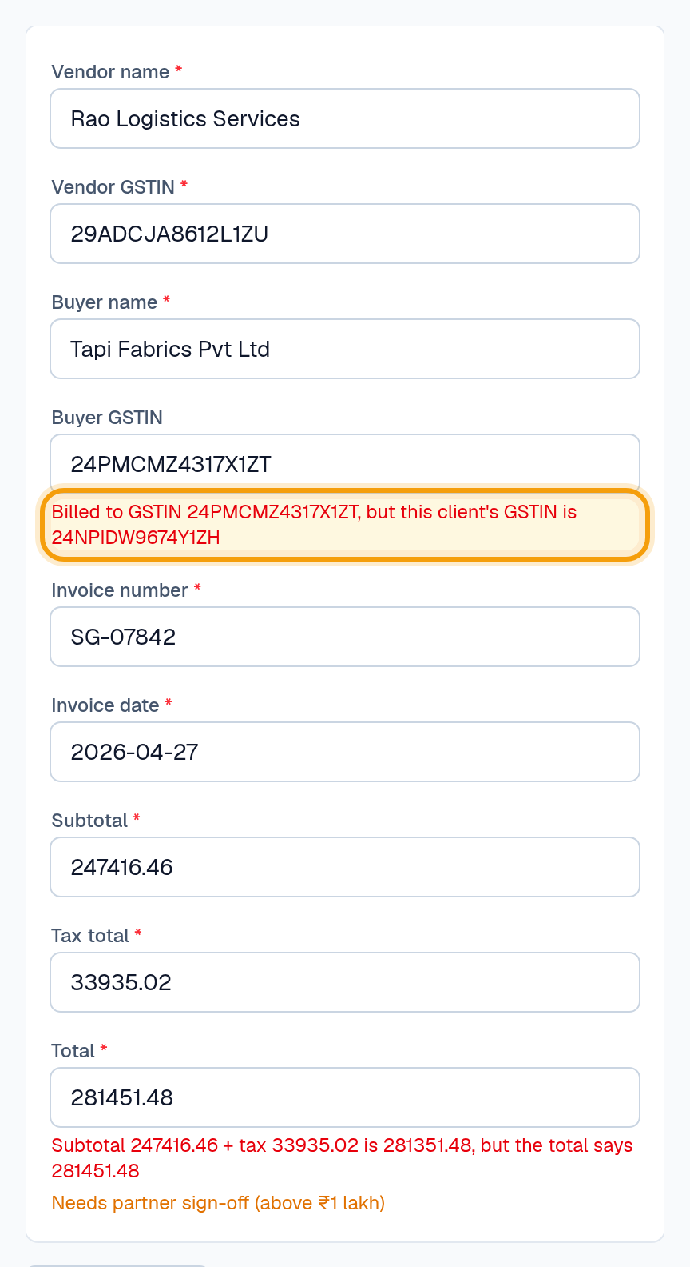

Step 8 · Ask the documents
Do Upload shree-textiles-annual-report.pdf. Research → Start conversation → “Which purchase invoices need director approval before payment?” → click [1].
Say “Answers only from the client's documents, with the page.”
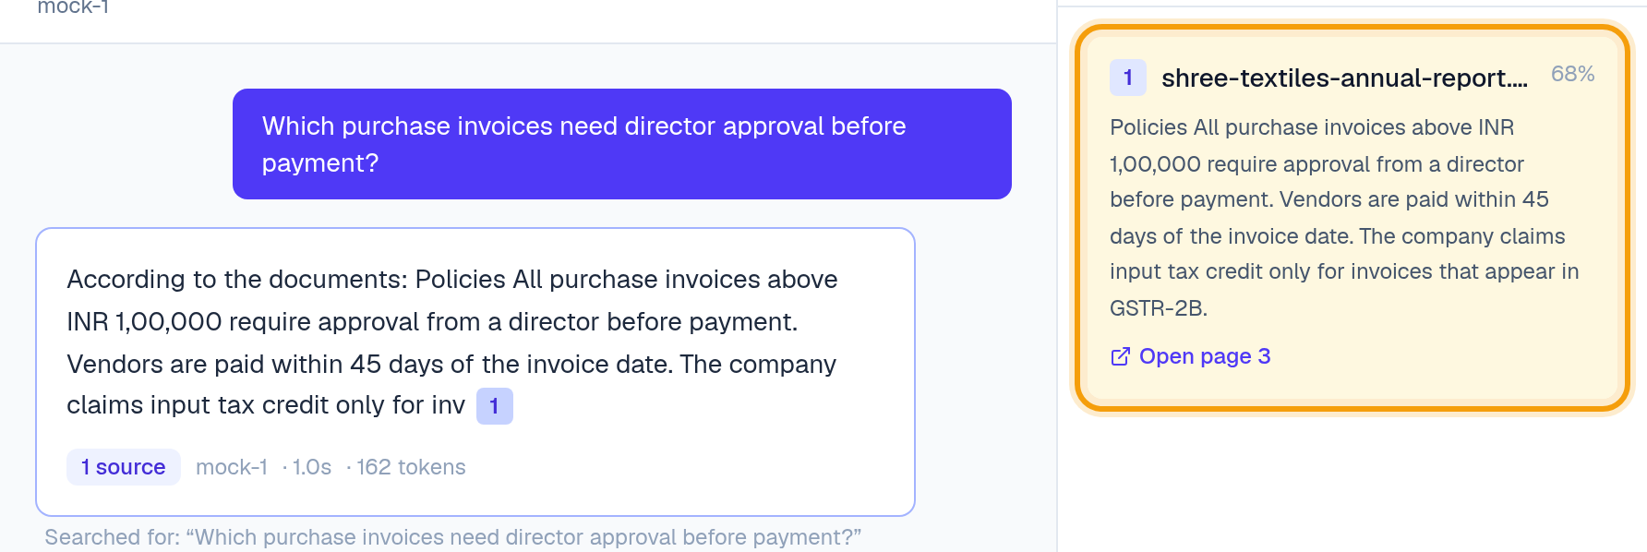

Step 9 · Trust
Do Settings → Activity.
Say “Who changed which figure, when and from where.”
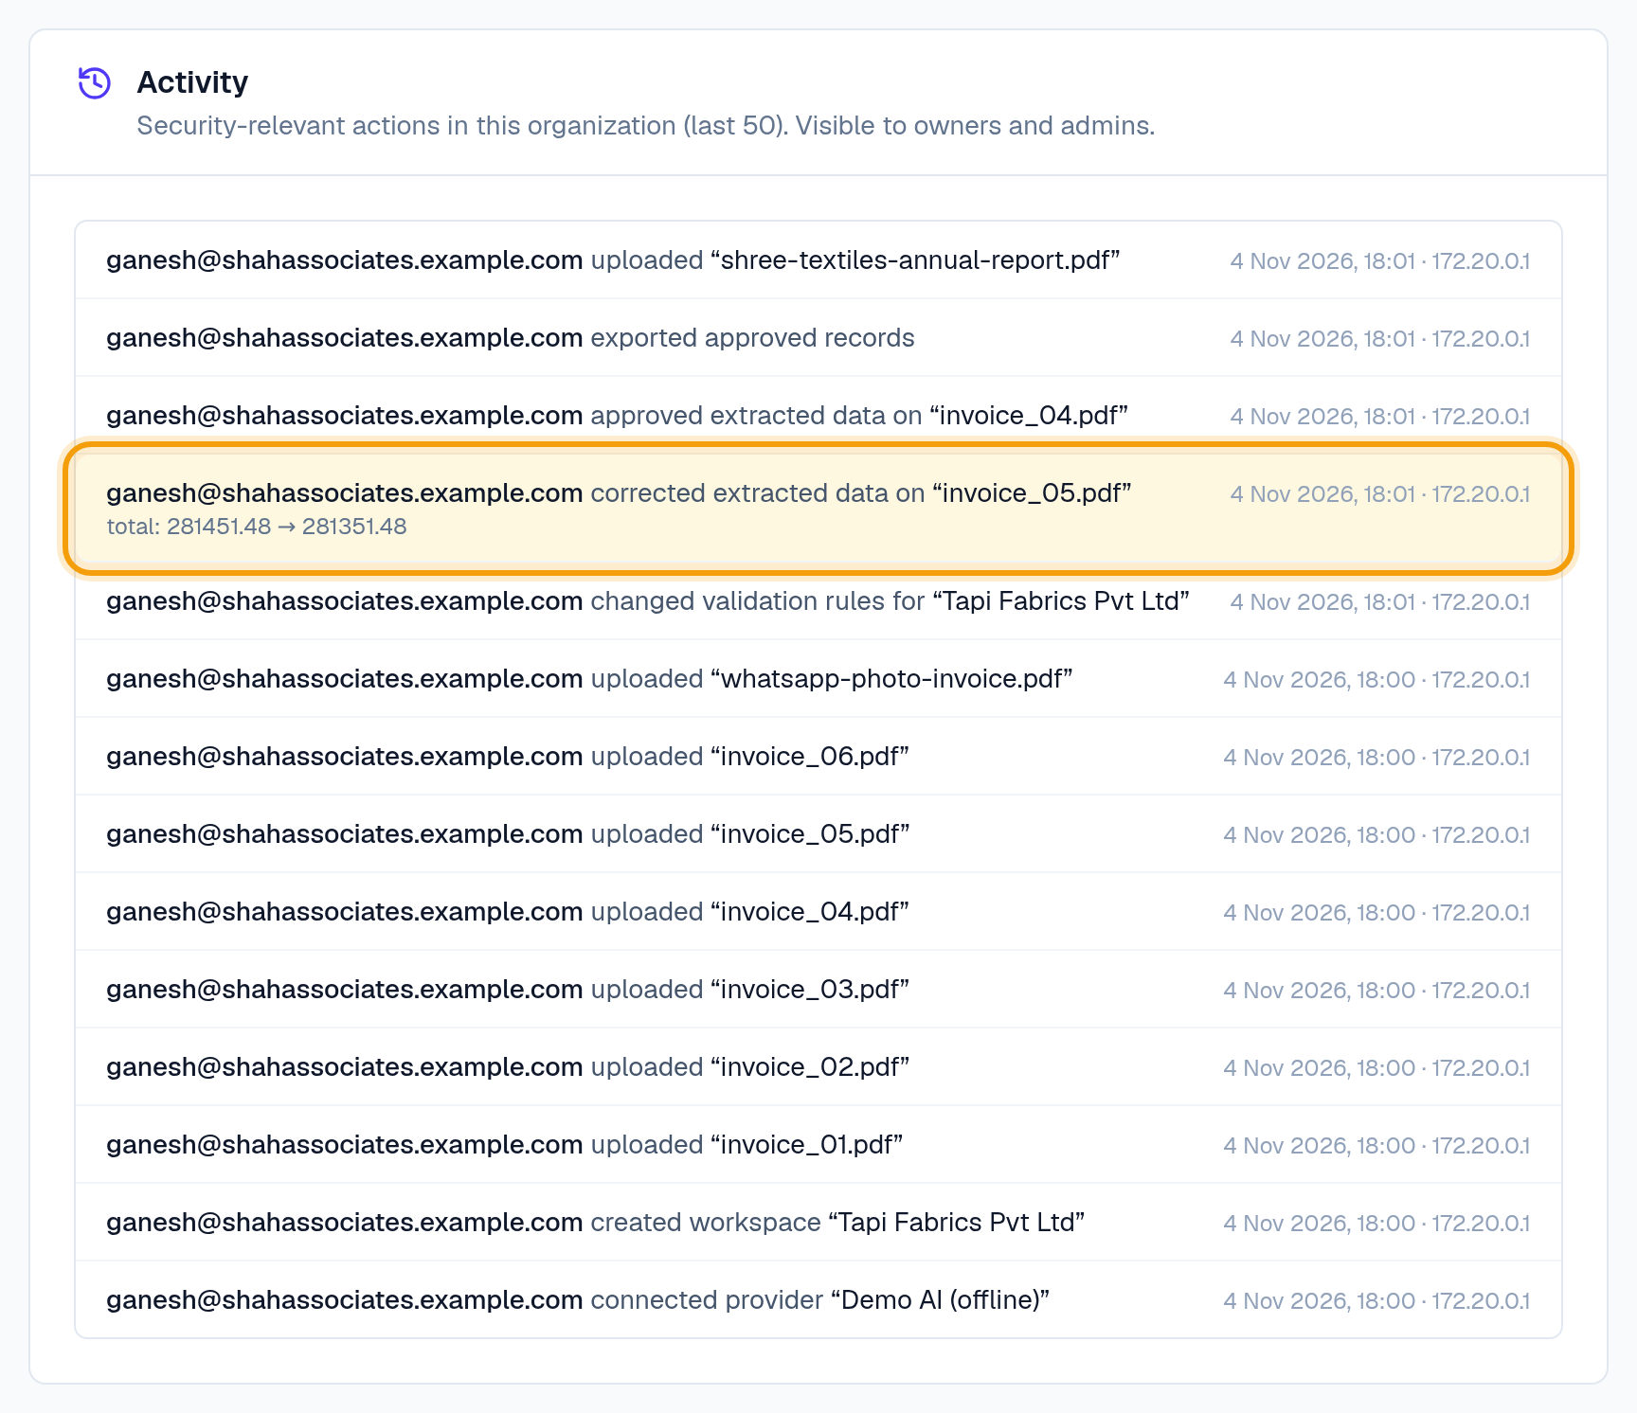

4. What NOT to claim
Don't claim | Reality today | Say instead
It catches wrong GST | Only the total and overall tax %. invoice_04 has a wrong GST amount that is NOT flagged. Don't open invoice_04. | Line-item and GST-rate checks are next.
It posts to Tally | Excel only. | Tally export is next; we'd build it with you.
It does GSTR-2B | Not built. | Would 2B matching save you more time than Tally export?
98% accurate | Measured only on generated invoices. | Let's measure it on your invoices.
Works on any photo | JPG/PNG yes, iPhone HEIC no; poor photos read worse. | Send real photos; we'll show you.

5. Objections
They say | You answer
Is our data safe? | Each firm and client fully separated (tested), every action logged, keys encrypted. No formal certification yet: don't claim one.
We already use Tally. | We don't replace Tally. We give you checked data before it goes in; Tally export is next.
What if it misreads? | That's why there's review: nothing is exported until a person approves, and every fix is recorded.
We tried Suvit / others. | Ask what they liked and why they stopped. Our angle: rules per client, full audit trail, local support.
How much? | Free pilot for founding firms; pricing after we prove time saved on your data.

6. Ask BEFORE the demo
# | Question | Their answer
1 | Walk me through last month's GSTR-3B filing for one client.
2 | Which step took longest? Who did it?
3 | When did something last go wrong? What did it cost?
4 | What have you tried to fix that?
5 | How do purchase bills get into Tally today? How long per client?
6 | Do clients send bills on WhatsApp?
7 | Which tools have you tried (Suvit, others)? Why stop or stay?
8 | Can we test on 50–100 of your invoices?

7. After the meeting
- Log the conversation in docs/CA-pain-discovery.md and update the hypothesis tally.
- Send a thank-you message the same day, with the agreed next step and the Overview document.
- If they share invoices: run them, note every wrong field, measure real accuracy.

